Supporting Information

Flexible and efficient perovskite quantum dot solar cells via hybrid interfacial architecture

Long Hu,^{2,3} Qian Zhao,⁴ Shujuan Huang,³ Jianghui Zheng,^{5,7} Xinwei Guan,² Robert Patterson,⁵ Jiyun Kim,² Lei Shi,⁵ Chun-Ho Lin,² Qi Lei,² Dewei Chu,² Wan Tao,² Soshan Cheong,⁶ Richard D. Tilley,⁶ Anita W. Y. Ho-Baillie,^{5,7} Joseph M. Luther,⁸ Jianyu Yuan,^{1,}* and Tom Wu²

¹Institute of Functional Nano & Soft Materials (FUNSOM), Jiangsu Key Laboratory for Carbon-Based Functional Materials & Devices, Soochow University, Suzhou, Jiangsu 215123, P. R. China.
²School of Materials Science and Engineering, University of New South Wales (UNSW), Sydney, NSW, 2052, Australia.
³School of Engineering, Macquarie University, Sydney, NSW 2109, Australia
⁴ School of Materials Science and Engineering, Nankai University, Tianjin 300350, China.
⁵Australian Centre for Advanced Photovoltaics, University of New South Wales, Sydney, Australia
⁶Electron Microscope Unit, Mark Wainwright Analytical Centre, UNSW, Sydney, NSW, 2052, Australia.
⁷School of Physics, University of Sydney Nano Institute, The University of Sydney, NSW, 2006, Australia.
⁸National Renewable Energy Laboratory, Golden, CO 80401, USA.
*To whom correspondence should be addressed. E-mail: jyyuan@suda.edu.cn

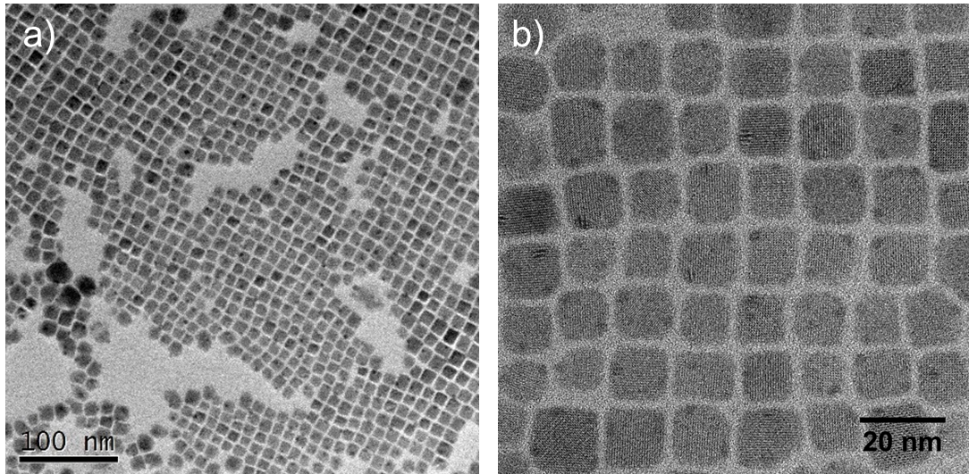
Figure S1. The TEM images of CsPbI₃ CQDs from (a) control and (b) PCBM/QD hybrid solutions.

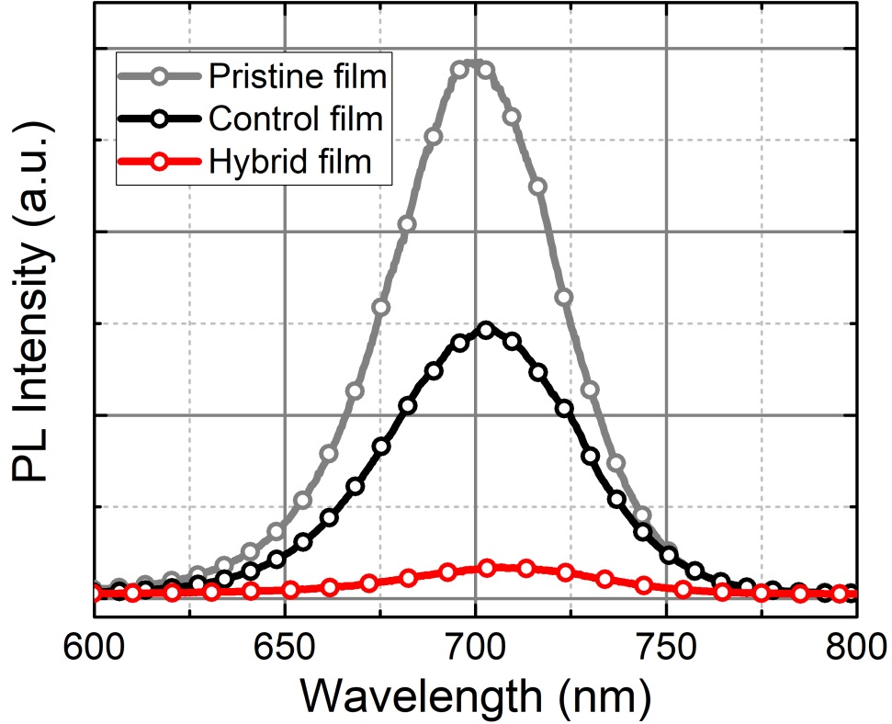
Figure S2. Steady state PL spectra of pristine, control and hybrid CsPbI₃ QD films
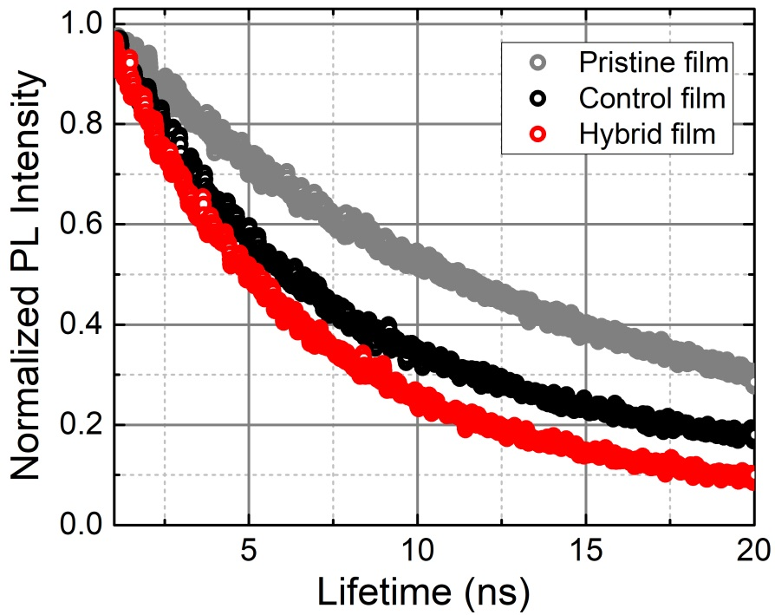
Figure S3. Time-resolved PL spectra of pristine, control and hybrid CsPbI₃ QD films
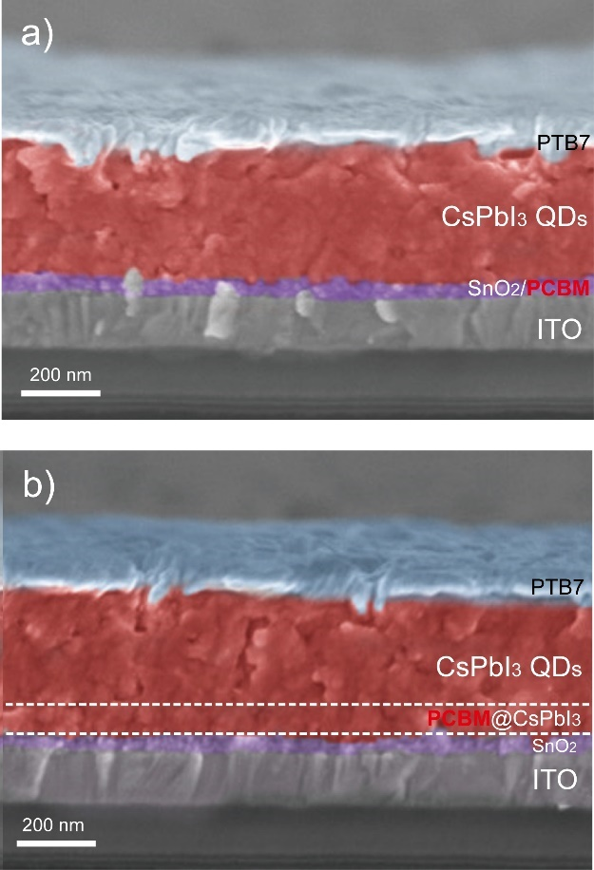
Figure S4. Cross-sectional SEM images of (a) control and (b) target devices.

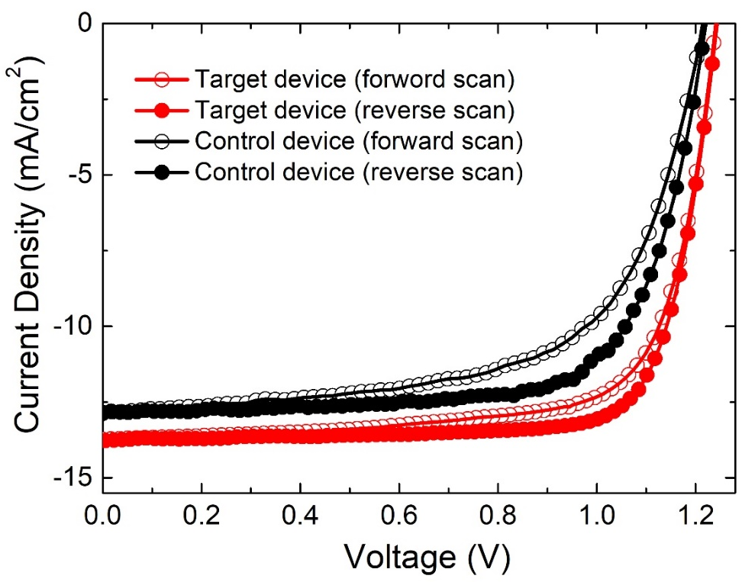
Figure S5. The J-V curves of target and control device under reverse and forward scanning.

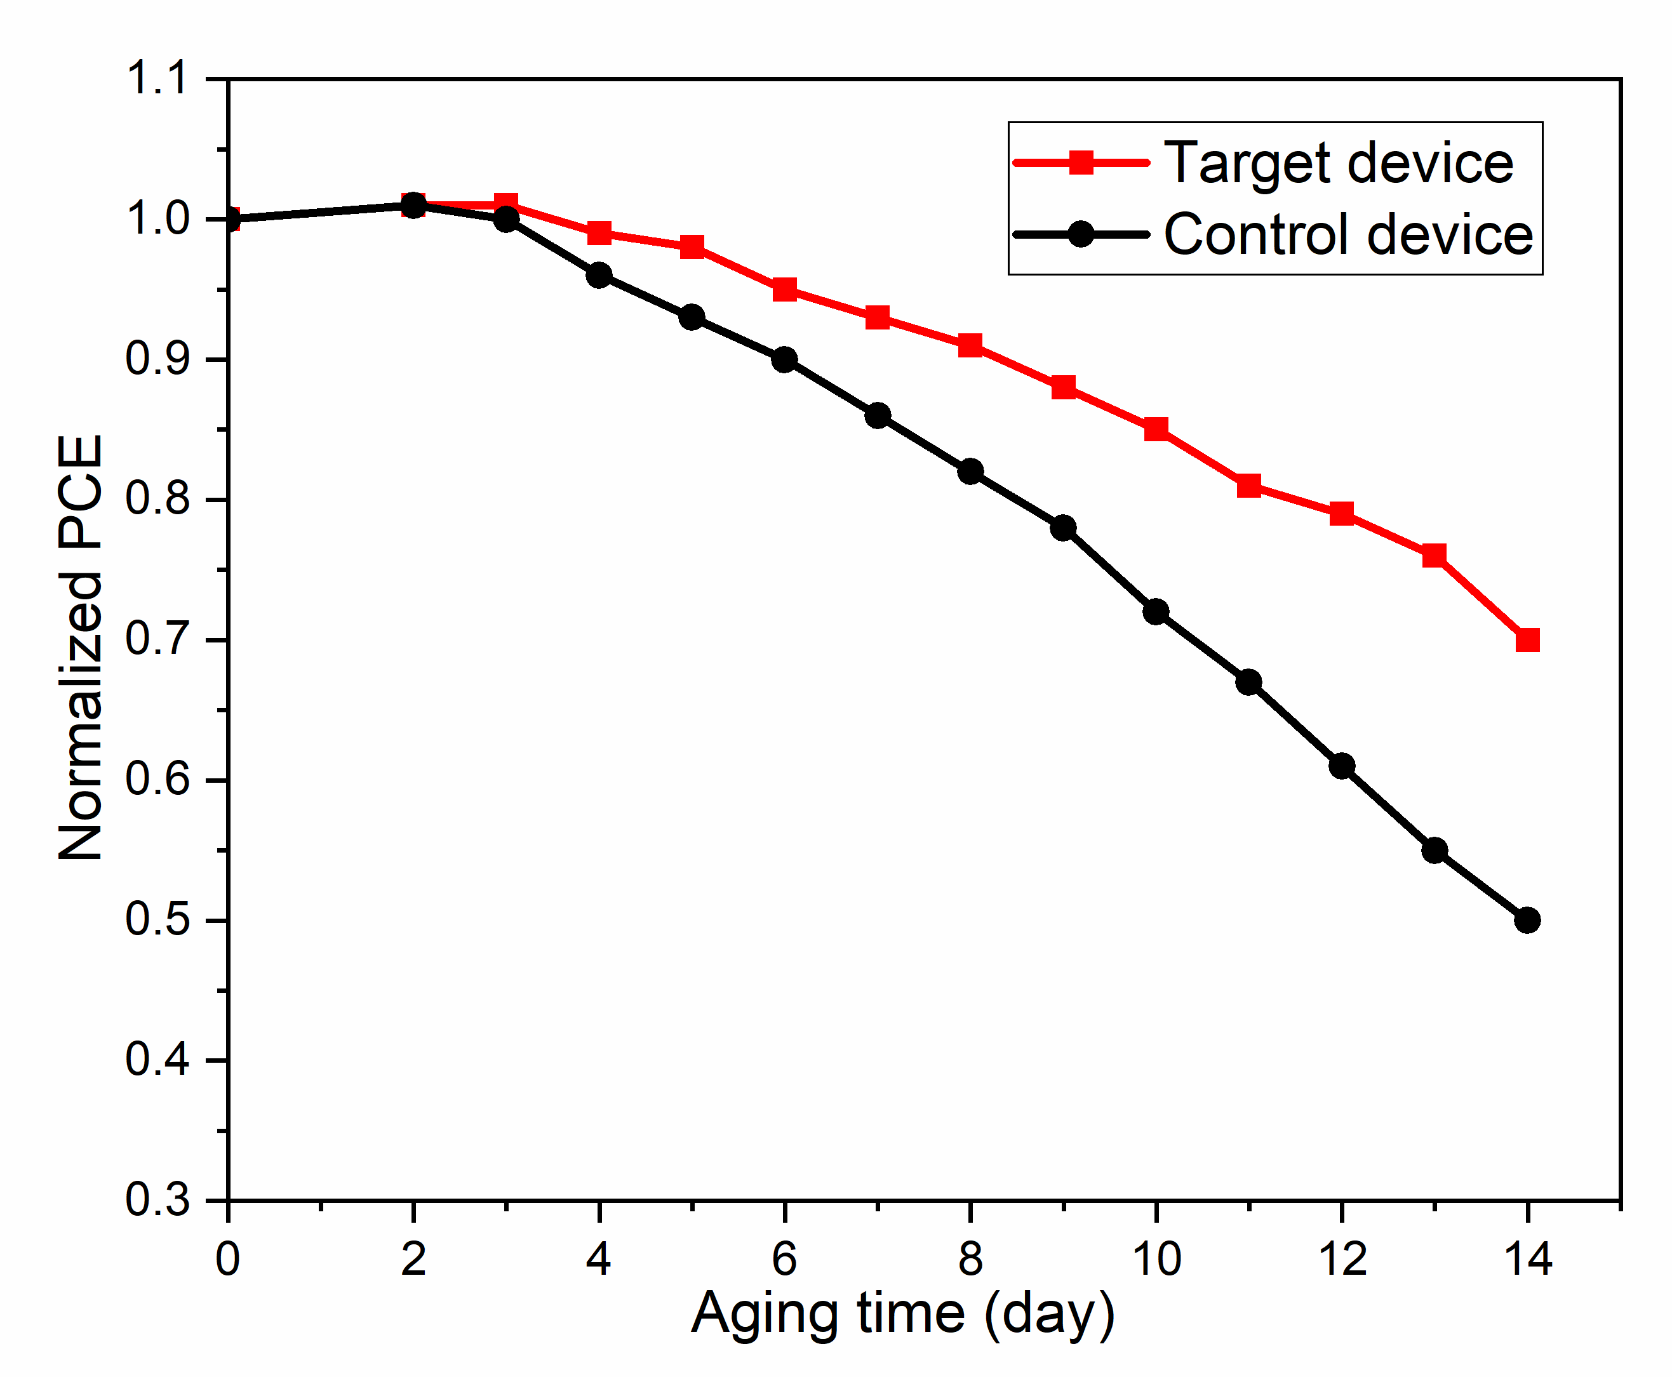
Figure S6. Stability of corresponding CsPbI₃ QD solar cells under dark conditions in a dry air atmosphere.

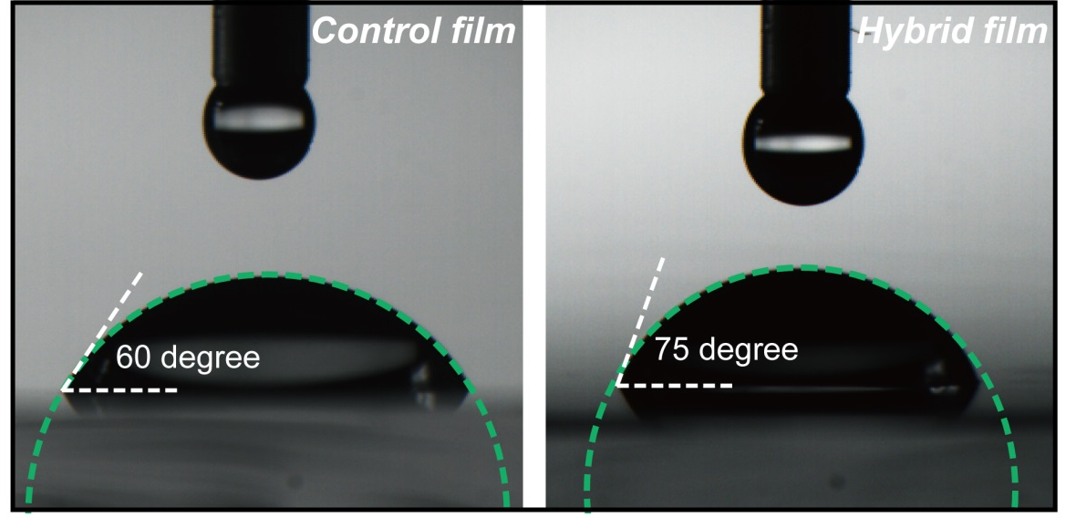
Figure S7. Contact angle of a water drop on the control and the hybrid films.

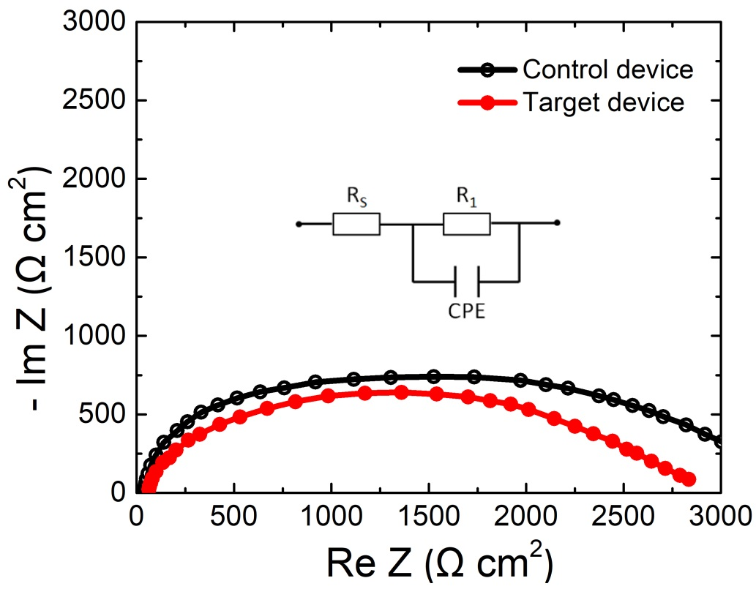
Figure S8. EIS curves of champion control and target devices (inset: equivalent circuit).
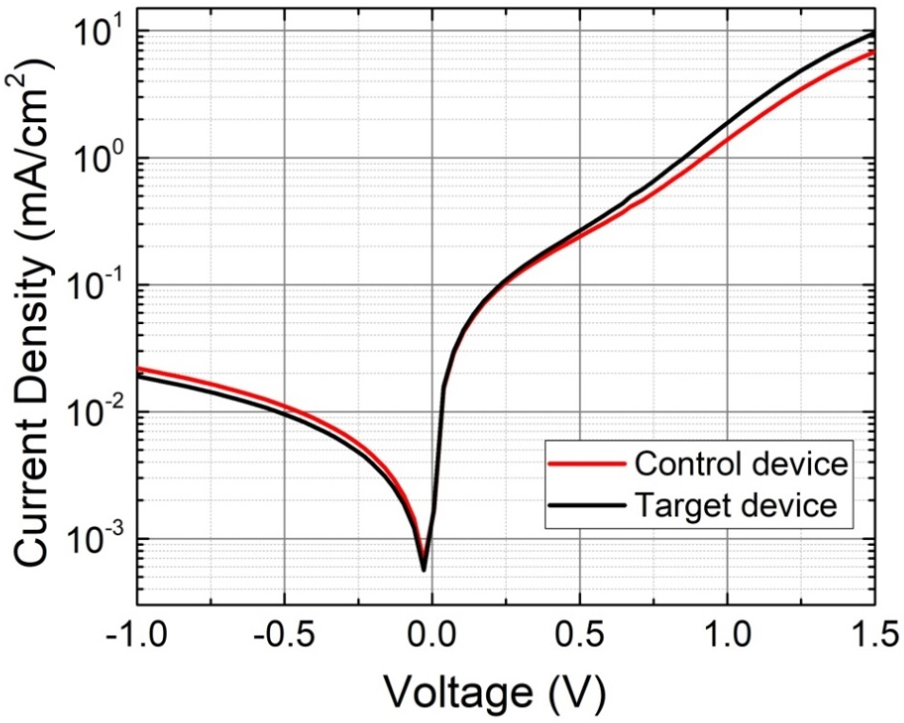
Figure S9. Dark current curves of the control and target devices

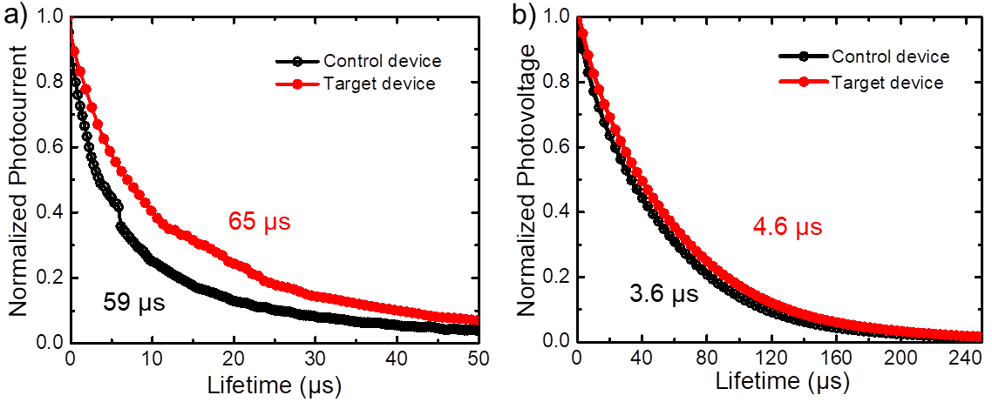
Figure S10. Transient photocurrent (a) and photovoltage (b) curves in optimal control and target devices.
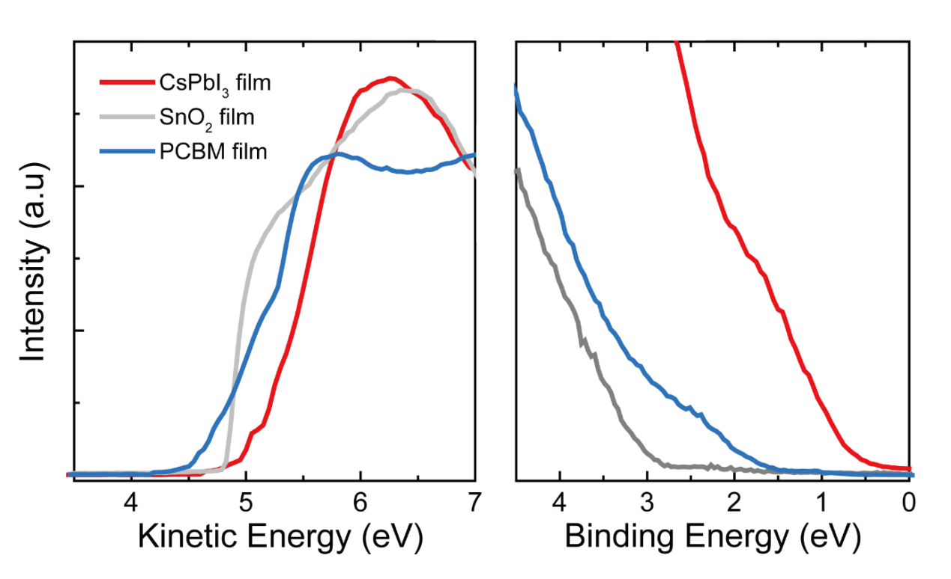
Figure S11. (a) Ultraviolet photoelectron spectroscopy (UPS) cutoff edge (b) Valence band spectra of CsPbI₃ film, SnO₂ film and PCBM film from UPS measurements.

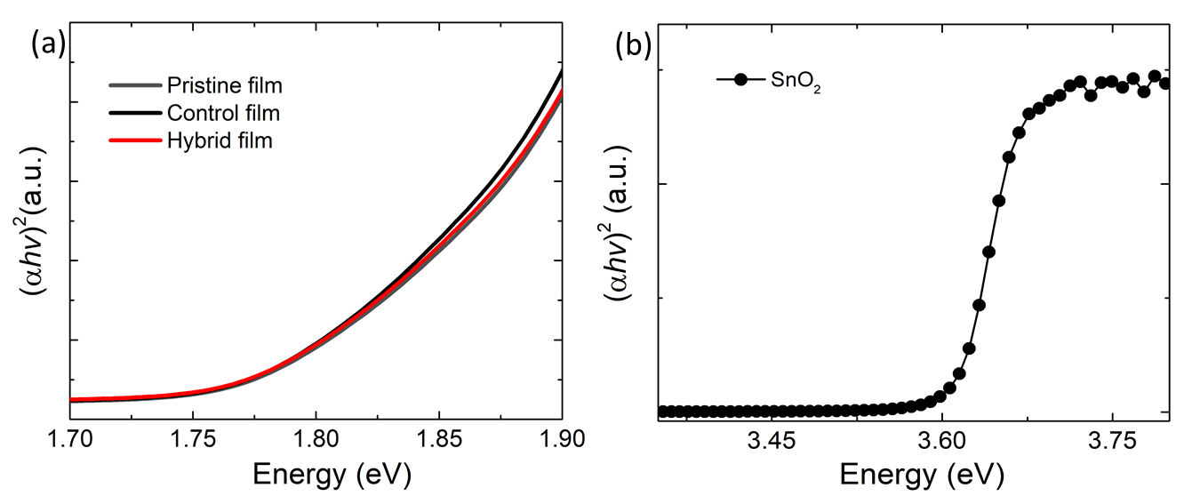
Figure S12. Bandgap of (a) three types of films (b) SnO₂ film.

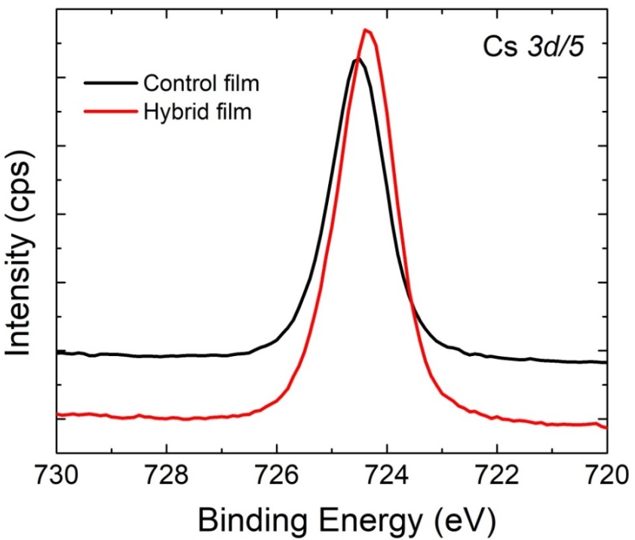

Figure S13. XPS signals of Cs 3d/5.

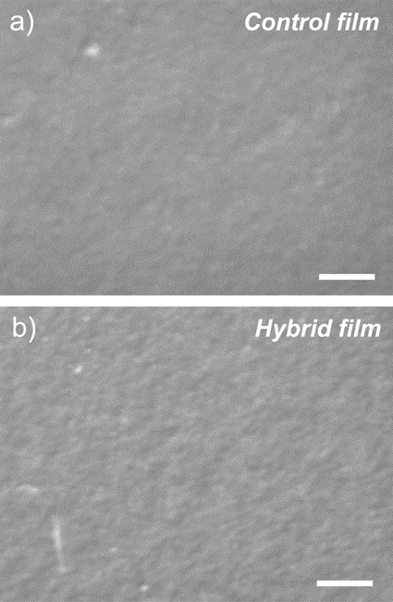

Figure S14. SEM images of (a) control CsPbI₃ QD and (b) PCBM@CsPbI₃ QD hybrid films, scale bar: 1 µm
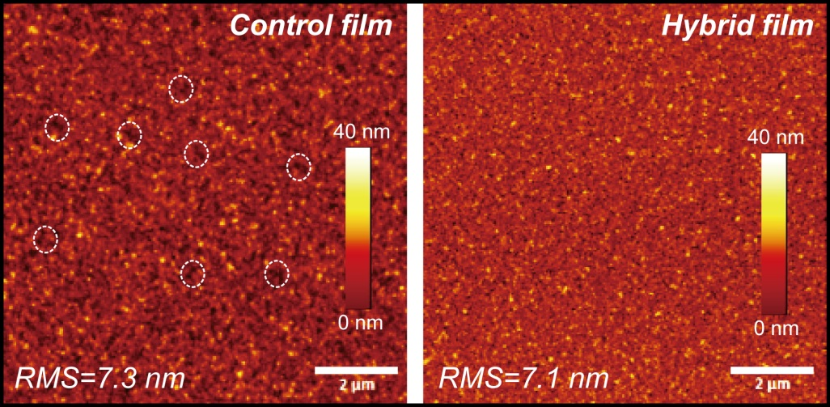
Figure S15. AFM height images of the control and the hybrid films.
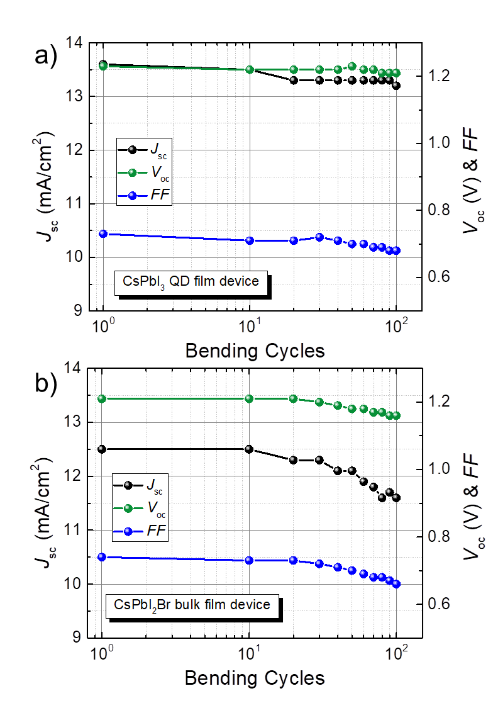
Figure S16. J_{sc}, V_{oc} and FF of flexible CsPbI3 QD (a) and CsPbI2Br bulk film devices as a function of bending cycles.

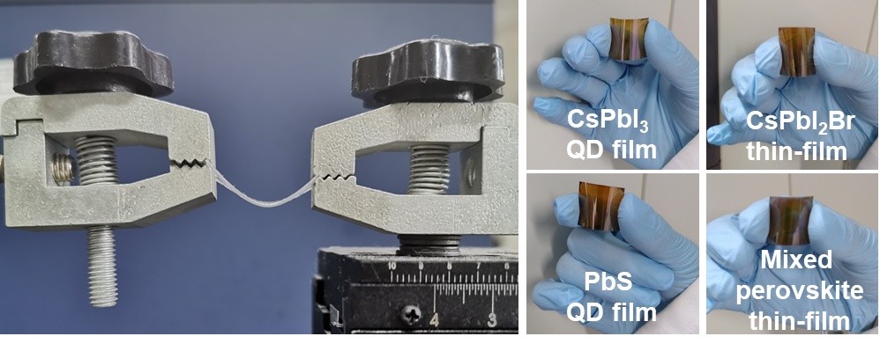
Figure S17. Image of bending robot and flexible films.

Table S1. Statistics of CsPbI₃ QD solar cell performance with varied QD absorber layers based on 24 devices for each condition
Hybrid:Control | V_{oc}  (V) | J_{sc}  (mA∙cm⁻²) | FF | PCE  (%)
0:3 | 1.24  (1.21±0.02) | 11.4  (11.0±0.8) | 0.74  (0.72±0.03) | 10.5  (9.6±0.4)
0:4 | 1.23  (1.22±0.02) | 13.6  (13.3±0.7) | 0.74  (0.73±0.02) | 12.4  (11.9±0.4)
0:5 | 1.22  (1.20±0.03) | 13.4  (13.1±0.8) | 0.72  (0.72±0.03) | 11.8  (11.6±0.5)
1:3 | 1.26  (1.24±0.04) | 13.9  (13.5±0.8) | 0.76  (0.74±0.03) | 13.3  (12.4±0.7)
1:4 | 1.26  (1.24±0.03) | 15.2  (14.4±0.9) | 0.78  (0.76±0.03) | 15.1  (14.6±0.6)
1:5 | 1.22  (1.20±0.05) | 14.4  (13.9±1.0) | 0.74  (0.72±0.04) | 13.0  (12.0±0.7)
2:3 | 1.25  (1.23±0.05) | 13.9  (14.1±1.0) | 0.72  (0.73±0.04) | 13.8  (13.1±0.8)
2:4 | 1.23  (1.19±0.05) | 13.8  (13.2±1.1) | 0.71  (0.69±0.04) | 12.1  (10.8±0.9)

Table S2. Summary of device information, efficiency and stability of CsPbI₃-QD solar cells and flexible QD solar cells reported so far.
Device architecture | QDs | Rigid device  PCE | Flexible device PCE | Reference
FTO/TiO₂/QDs/spiro-OMeTAD/MoO_{x}/Al | CsPbI₃ | 10.77% | - | Science 354 (2016) 92.
FTO/TiO₂/QDs/spiro-OMeTAD/MoO_{x}/Al | CsPbI₃ | 13.4% | - | Sci. Adv. 3 (2017) eaao4204.
FTO/TiO₂/QDs/spiro-OMeTAD/MoO_{x}/Al | CsPbI₃ | 13.47% | - | ACS Nano 12 (2018) 10327.
FTO/TiO₂/QDs/PTB7/MoO₃/Ag | CsPbI₃ | 12.55% | - | Joule 2 (2018) 2450.
FTO/TiO₂/QDs/PTAA/Au | CsPbI₃ | 11.64% | - | Adv. Energy Mater. 8 (2018) 1800007.
ITO/TiO₂/QDs/spiro-OMeTAD/MoO_{x}/Al | CsPbI₃ | 13.67% | - | Nat. Commun. 10 (2019) 2842.
FTO/TiO₂ /QDs /PTAA /MoO_{x}/Ag | CsPbI₃ | 12.30% | - | ACS Energy Lett. 4 (2019) 2571.
FTO/TiO₂/QDs/spiro-OMeTAD/MoO_{x}/Ag | CsPbI₃ | 12.40% | - | Nano Energy 66 (2019) 104130.
FTO/TiO₂ /QDs /PTAA/MoO₃/Ag | CsPbI₃ | 14.1% | - | Adv. Energy Mater. 9 (2019) 1900721.
FTO/TiO₂ /QDs/PTB7 /MoO₃/Ag | CsPbI₃ | 12.27% | - | J. Mater. Chem. A 7 (2019) 20936.
FTO/c-TiO₂/QDs/spiro-OMeTAD/Au | CsPbI₃ | 11.87% | - | Adv. Funct. Mater. 29 (2019) 1900991.
ITO/SnO₂/QDs/spiro-OMeTAD/Au | CsPbI₃ | 9.6% | - | Nat. Energy 5 (2020) 79.
FTO/TiO₂/QDs/spiro-OMeTAD/Au | CsPbI₃ | 14.32% | - | J. Am. Chem. Soc. 142 (2020) 3775.
FTO/TiO₂ /QDs/QD:Polymer/PTAA/MoO₃/Ag | CsPbI₃ | 13.8% | - | J. Mater. Chem. A 8 (2020)  8104.
FTO/TiO₂ /QDs /PTAA/MoO₃/Ag | CsPbI₃ | 15.2% |  | Adv. Mater. 32 (2020) 2001906.
FTO/TiO₂ /QDs /PTAA/MoO₃/Ag | CsPbI₃ | 14.9% |  | Adv. Mater. 32 (2020) 2000449.
PET/ITO/ZnMgO/QDs/PbS-EDT/Au | PbS | - | 9.4% | ACS Nano 8 (2017) 8478.
PEN/Ag NWs/AZO/QDs/PbS-EDT/Au | PbS | - | 9.9% | Energy Environmental Sci. 11 (2018) 354.
PET/ITO/ZnO/QDs/PbS-EDT/Au | PbS | - | 5.1% | Adv. Energy. Mater. 8 (2018) 1700809.
PET/ITO/TiO₂/QDs/MoO₃/Al | PbS | - | 1.8% | Energy Environmental Sci. 6 (2013) 1565.
Glass (PET)/ITO/ SnO₂/QD:PCBM/QDs/ PTB7/MoO₃/Ag | CsPbI₃ | 15.1% | 12.3% | This Work

