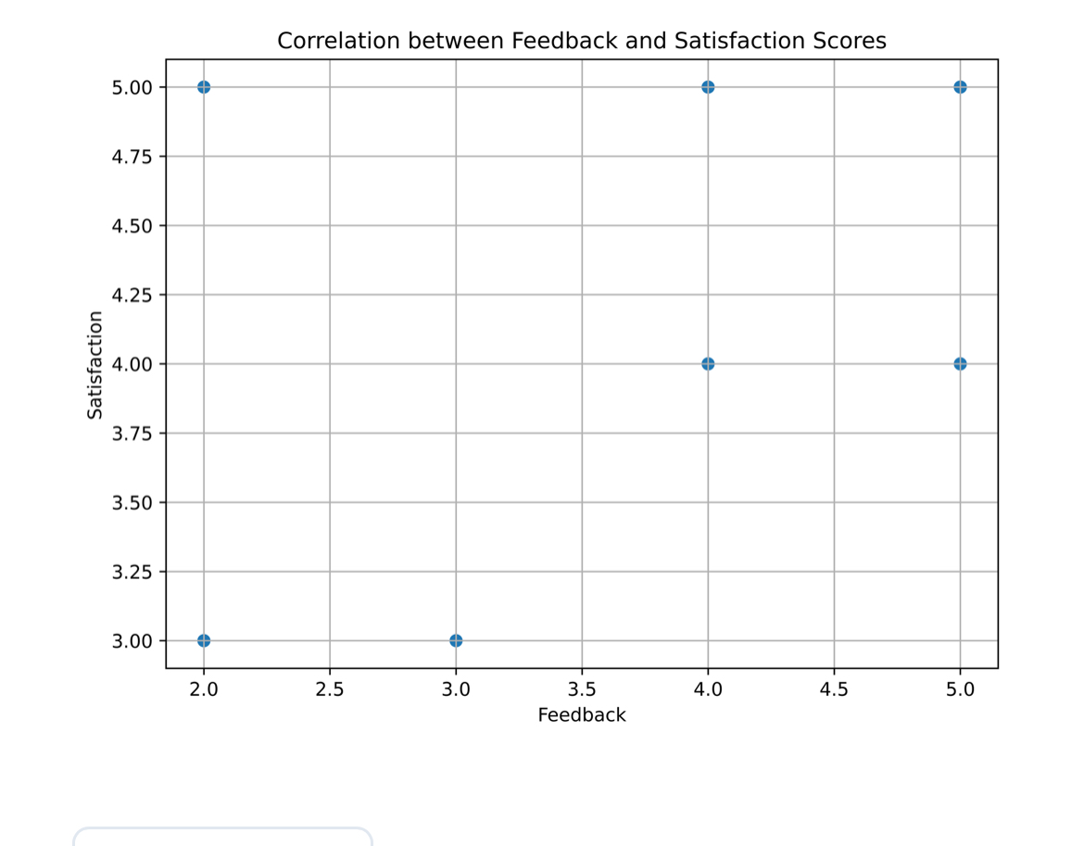
Table 1 Correlation between Feedback & Satisfaction Scores

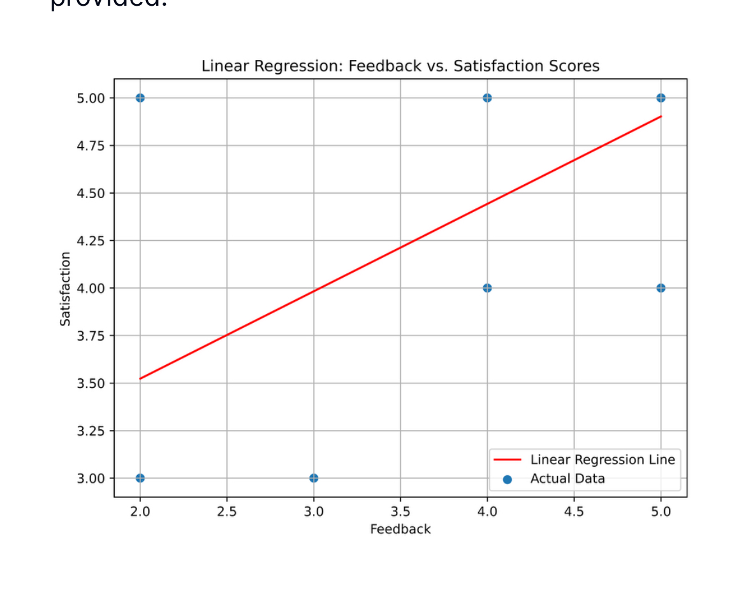
Table 2 Linear Regression Feedback versus satisfaction Scores

