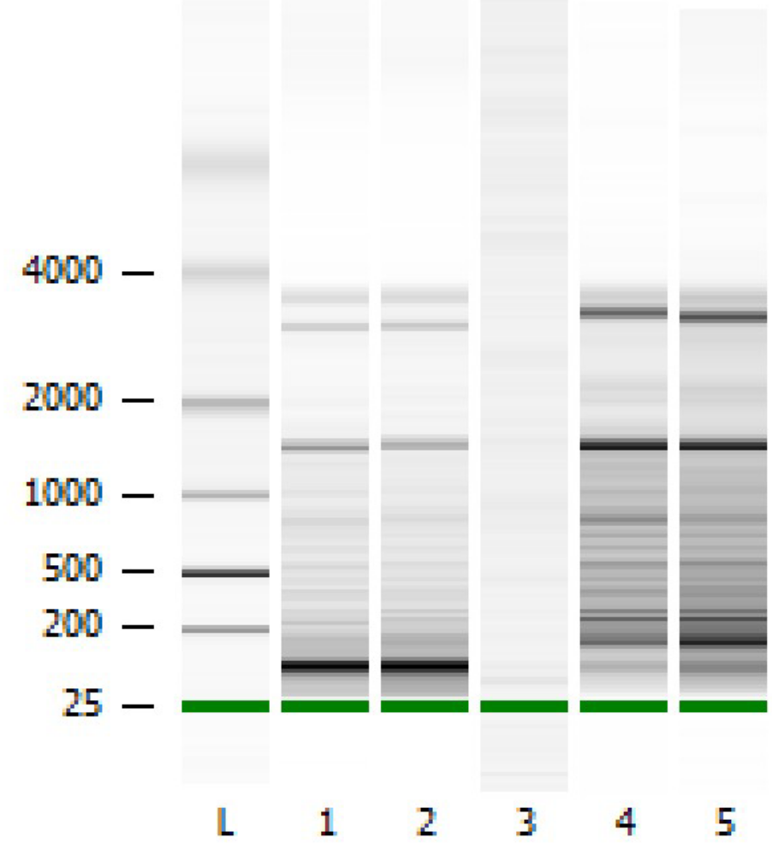

Supplementary Figure 1 Results of RNA Pico assy (Bioanalyzer 2100). Lanes 1 and 2 are replicates of mitochondrial RNA from WT strain. Lane 3 is empty. Lanes 4 and 5 are replicates of polyadenylated RNA. Increase in size for short RNAs is clearly visible.

rnle1F | CGCTAATACGACTCACTATAGGTAAAGGAGAGGTAATTGAAAAACTAGAG
rnle1R | TATATCTCTATATAAAGGGACTAACAG
rnle2F | CGCTAATACGACTCACTATAGGCAAAATTGAACAGGGTAATACCGCTAGAG
rnle3R | CAAAGATAGATAGTTATTATTAGTATGG
TU1_F | CGCTAATACGACTCACTATAGGATCATGGATTAATGGTAAATCACTCG
TU1_R | CATTCTATCGTCTTAACCTAGAATTGAAC
TU1b_F | CGCTAATACGACTCACTATAGGATGTCCTTAATTAGTGGAATCGC
TU1b_R | GGAGGCCTATAGGCCTCCGGGCC
TU2_F | CGCTAATACGACTCACTATAGGCTCACATAATAGGTAACCTGGGAATGTC
TU2_R | CCCACCCGATACTTAGTGAATACATACG
TU3_F | CGCTAATACGACTCACTATAGGTAGATCTATGATCTACGGGTGGGTAGG
TU3_R | GATCGGTTTATAGGTAGAGAGATATCTCC
TU04_F | CGCTAATACGACTCACTATAGGCCTATTCTATTCCCCACCTACCTC
TU04_R | CGGGCTCAGGTTAACTTGTATAGTG
COX1e1F | CGCTAATACGACTCACTATAGGCATTATGTTTCCACATGTATGAGTTCCC
COX1e2R | CTAATGTAATTACATAAAATAAGTGCTCG
COX1e4F | CGCTAATACGACTCACTATAGGCCAGAGGTATATATTATCATCATACCTG
COX1e5R | GAATATTTATATTTGTTGTATTAATATTG
TU5_F | CGCTAATACGACTCACTATAGGGAGATCGGAGATCTCGGGCTATAAGAG
TU5_R | CTCATCCGAGGGACCTATAACGAATAC
COBe1F | CGCTAATACGACTCACTATAGGATATAGGTAACTGACCGGATTAAGTTCC
COBe1R | GCATTCACATCTCTCATAATATGCTC
COBe2F | CGCTAATACGACTCACTATAGGTATTGTTTAGTGTACGGGCAAATGAG
COBe3R | CAAAGAATTTGGATCGGGTGGATGTTACC
rns_F | CGCTAATACGACTCACTATAGGATCGGGTGGTGGGGCCAGCCCACC
rns_R | GTTATAGATACATAACCCCACCTACC
TU7_F | CGCTAATACGACTCACTATAGGGATTCCCTACTCCTCCTTATAATGCCC
TU7_R | CTAAATCACGGGCGGGTGCAGGTCTAG
TU8_F | CGCTAATACGACTCACTATAGGGGATTAATTCCTTATGGGTTCGAATCC
TU8_R | CTTATTATACTTTGCAATAGATAGACTC

Supplementary Table 1 Primers used for template amplification for in vitro transcription.

name | sequence
rnl5 | CTAGCACCCGCCCCTAAGGGCGGGTCTCTCTAC
rnl10 | CCATCCACCCGACCTCCGGTCGGGTGGATCTG
rnl14 | CACTGCAAGTACTATTTCACTGAGCTCCCTGTGG
rnl19 | TTGCTGCGACCGTGAGGTTGAGCCTAGACGAC
rnl22 | GGCCCGACCAAAGGTCGGGCCATCTATTACATTG
rns6 | ATCGAGGATGGCCCGGCCTCCTCTGGAGGACGG

Supplementary Table 2 Probes used for ribodepletion procedure.

Supplementary Figure 2 Immunodetecition of m6A in FTO-treated and untreated mitochondrial RNA. Oligonucleotides containing m6A modifications were used as positive control and unmodified oligonucleotides served as negative control.

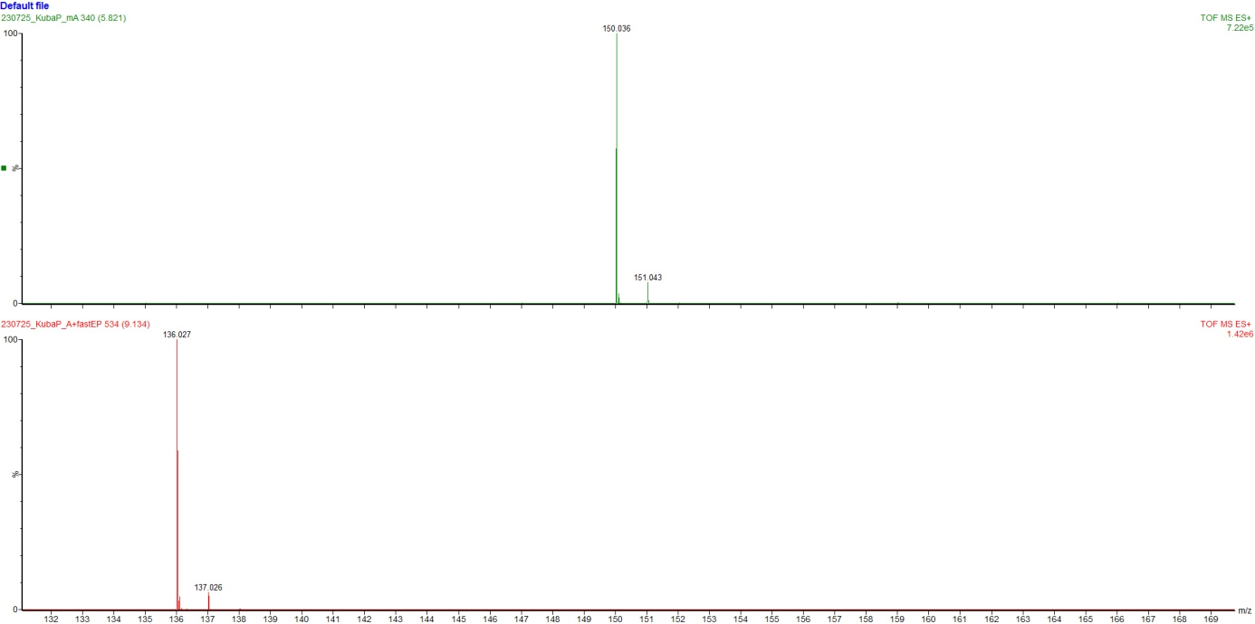
Supplementary Figure 3 LC-MS reference spectra for m6A (top track) unmodified adenosine (bottom track).
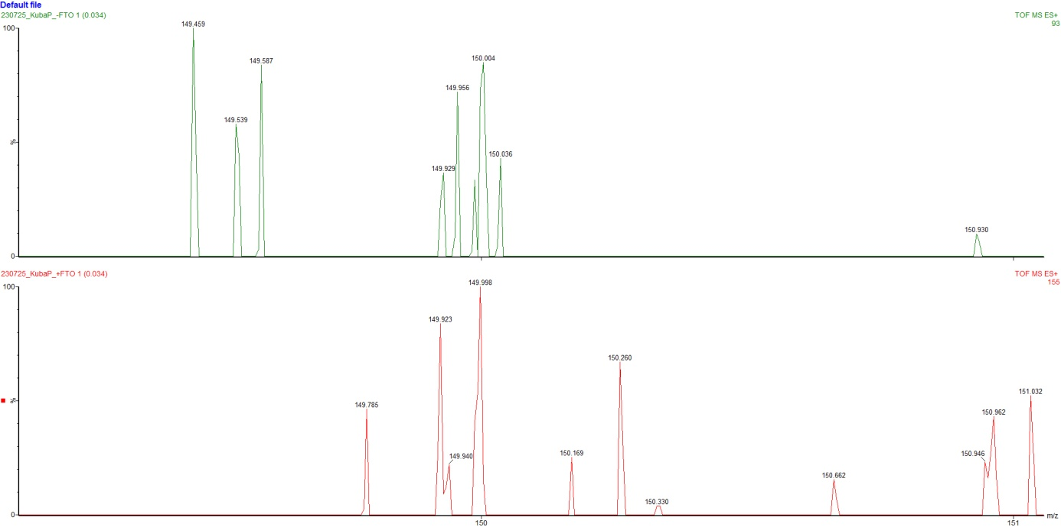
Supplementary Figure 4 LC-MS reference spectra for untreated mitochondrial RNA (top track) and RNA that was treated with FTO (bottom track).

WTvsFTO
ID | coverage_1 | coverage_2 | stoichiometry_1 | stoichiometry_2 | stoichiometry_diff | statistic | pval_U | ratio
COB_581_ATGTATGCA | 155 | 153 | 0.618421053 | 0.35106383 | 0.267357223 | 3.9202856 | 8.84E-05 | 1.762
COB_855_CCTGATAAA | 101 | 165 | 0.28 | 0.135714286 | 0.144285714 | 3.4691977 | 0.000522 | 2.063
COX1_1144_TATTATCAA | 201 | 142 | 0.432692308 | 0.22826087 | 0.204431438 | 4.0959761 | 4.20E-05 | 1.896
COX1_1417_GTGTATTAG | 107 | 170 | 0.448275862 | 0.215517241 | 0.232758621 | 3.6262549 | 0.000288 | 2.08
rnl_1430_TGATACCTG | 3908 | 1982 | 0.714883898 | 0.432868672 | 0.282015226 | 16.755058 | 5.20E-63 | 1.652
rnl_2165_TAGGACTGT | 6265 | 7224 | 0.086737549 | 0.039554062 | 0.047183487 | 18.662303 | 1.00E-77 | 2.193
rnl_303_TGTTATTGA | 5041 | 518 | 0.839223028 | 0.460273973 | 0.378949056 | 19.170082 | 6.58E-82 | 1.823
rns_1395_TGAAATACA | 788 | 4385 | 0.582 | 0.322939866 | 0.259060134 | 12.009027 | 3.19E-33 | 1.802
WTvsIVT
ID | coverage_1 | coverage_2 | stoichiometry_1 | stoichiometry_2 | stoichiometry_diff | statistic | pval_U | ratio
COB_581_ATGTATGCA | 155 | 4425 | 0.618421053 | 0.402448657 | 0.215972395 | 4.5769338 | 4.72E-06 | 1.537
COB_855_CCTGATAAA | 101 | 3703 | 0.28 | 0.153134635 | 0.126865365 | 4.2347002 | 2.29E-05 | 1.828
COX1_1144_TATTATCAA | 201 | 1525 | 0.432692308 | 0.269311065 | 0.163381243 | 4.7154845 | 2.41E-06 | 1.607
COX1_1417_GTGTATTAG | 107 | 1606 | 0.448275862 | 0.230769231 | 0.217506631 | 3.9997841 | 6.34E-05 | 1.943
rnl_1430_TGATACCTG | 3908 | 1512 | 0.714883898 | 0.453453453 | 0.261430445 | 14.480915 | 1.60E-47 | 1.577
rnl_2165_TAGGACTGT | 6265 | 7976 | 0.086737549 | 0.04939809 | 0.037339458 | 18.323129 | 5.41E-75 | 1.756
rnl_303_TGTTATTGA | 5041 | 518 | 0.839223028 | 0.460273973 | 0.378949056 | 19.170082 | 6.58E-82 | 1.823
rns_1395_TGAAATACA | 788 | 4385 | 0.582 | 0.322939866 | 0.259060134 | 12.009027 | 3.19E-33 | 1.802
FTOvsSYNT
ID | coverage_1 | coverage_2 | stoichiometry_1 | stoichiometry_2 | stoichiometry_diff | statistic | pval_U | ratio
COB_581_ATGTATGCA | 153 | 4425 | 0.35106383 | 0.402448657 | -0.051384827 | -1.175729 | 0.239703 | 0.872
COB_855_CCTGATAAA | 165 | 3703 | 0.135714286 | 0.153134635 | -0.017420349 | 0.3658226 | 0.714497 | 0.886
COX1_1144_TATTATCAA | 142 | 1525 | 0.22826087 | 0.269311065 | -0.041050195 | -1.018156 | 0.308604 | 0.848
COX1_1417_GTGTATTAG | 170 | 1606 | 0.215517241 | 0.230769231 | -0.015251989 | -1.066457 | 0.286217 | 0.934
rnl_1430_TGATACCTG | 1982 | 1512 | 0.432868672 | 0.453453453 | -0.020584781 | -1.568336 | 0.116803 | 0.955
rnl_2165_TAGGACTGT | 7224 | 7976 | 0.039554062 | 0.04939809 | -0.009844028 | -0.810311 | 0.417762 | 0.801
rnl_303_TGTTATTGA | 518 | 3723 | 0.460273973 | 0.432085561 | 0.028188411 | 1.2910593 | 0.196683 | 1.065
rns_1395_TGAAATACA | 4385 | 6108 | 0.322939866 | 0.287267456 | 0.03567241 | -0.464552 | 0.642253 | 1.124
WTvsIVT to WTvsFTO
ratio of ratios | diff minus diff
0.872319547 | -0.051384828
0.886241612 | -0.017420349
0.847573306 | -0.041050195
0.933908045 | -0.01525199
0.954604423 | -0.020584781
0.80072048 | -0.009844029
0.999999999 | 2.85399E-10
1.000000001 | 3.69711E-10
Supplementary Table 3 An extended version of Table 3, with k-mer parameters for WTvsFTO, WTvsIVT and FTOvsIVT comparisons in CHEUI.
ID | Start | End | Epinano RawScore | Nanopolish RawScore | Tombo RawScore | Nanocompore RawScore | Epinano Score | Nanopolish Score | Tombo Score | Nanocompore Score | Epinano Status | Nanopolish Status | Tombo Status | Nanocompore Status | Kmer
rnl | 307 | 311 | 4.19273743 | 2.954874904 | 3.15123089 | 5.490177361 | 5.324378 | 1.441397309 | 5.8966261 | 2.140860831 | YES | NO | YES | NO | gttattgac
ID | Start | End | Epinano RawScore | Nanopolish RawScore | Tombo RawScore | Nanocompore RawScore | Epinano Score | Nanopolish Score | Tombo Score | Nanocompore Score | Epinano Status | Nanopolish Status | Tombo Status | Nanocompore Status | Merged Score | Kmer
rns | 1396 | 1400 | 1.87254055 | 8.490303991 | 2.08938549 | 1.368337618 | 1.383822 | 4.568465183 | 3.4387663 | 0.194158165 | NO | NO | NO | NO | 0.558135 | gttgaaata
COB | 856 | 860 | 8.09992862 | NA | 2.13024272 | NA | 2.727497 | NA | 2.290924 | NA | NO | NO | NO | NO | 0.147959 | tacctgata

Supplementary Table 4 MoP2 k-mers from WTvsIVT comparison overlapping with k-mers detected in CHEUI m6A pipeline. MoP2 supported k-mer is marked in blue. High-scoring raw k-mers are marked in red.

 | WT |  | delPET |  | delDSS
 | WT_1506 | WT_2803 | delPET_1104 | delPET_1105 | delDSS_0505 | delDSS_2106
total | 159599 | 117772 | 267785 | 46601 | 530222 | 57419
merged unique | 281222 |  | 318998 |  | 599775
secondary | 3 |  | 6 |  | 13
supplementary | 3848 |  | 4606 |  | 12121
mapped | 120460 (42.83%) |  | 219135 (68.69%) |  | 491121 (81.88%)

Supplementary Table 5 Number of reads basecalled from each sequencing run (MultiQC) and read statistics for merged mapping of each strain (obtained via featureCounts)

WT |  |  | WT_RD |  |  | WT_FTO
transcript_name | percentage | est_count | transcript_name | percentage | est_count | transcript_name | percentage | est_count
rnl | 96.99% | 57801 | rnl | 65.87% | 12169 | rnl | 60.62% | 14409
tS(GCU) | 1.57% | 934 | rns | 7.07% | 1306 | rns | 32.61% | 7752
rns | 0.85% | 506 | tS(GCU) | 3.37% | 623 | COB | 1.29% | 306
tL(UAA) | 0.11% | 64 | tY(GUA) | 3.16% | 583 | ATP9 | 0.98% | 234
ATP8.t01 | 0.07% | 41 | tH(GUG) | 3.05% | 563 | COX1 | 0.97% | 230
ATP9.t01 | 0.06% | 35 | tD(GUC) | 2.76% | 510 | ATP6 | 0.72% | 172
tQ(UUG) | 0.05% | 28 | tL(UAA) | 2.48% | 459 | NAD5 | 0.52% | 124
tH(GUG) | 0.05% | 27 | tN(GUU) | 2.23% | 412 | NAD1 | 0.42% | 101
tY(GUA) | 0.04% | 24 | tQ(UUG) | 1.34% | 247 | NAD3 | 0.40% | 95
NAD4L.t01 | 0.03% | 17 | tV(UAC) | 1.32% | 243 | tS(GCU) | 0.38% | 90
ATP6.t01 | 0.03% | 16 | tT(UGU) | 0.94% | 173 | COX3a | 0.35% | 84
tC(GCA) | 0.02% | 11 | tA(UGC) | 0.82% | 152 | NAD4 | 0.27% | 65
COX1 | 0.02% | 9 | ATP9.t01 | 0.65% | 121 | NAD2 | 0.11% | 25
NAD5.t01 | 0.02% | 9 | tS(UGA) | 0.58% | 108 | tL(UAA) | 0.07% | 17
COX3a.t01 | 0.01% | 8 | NAD2.t01 | 0.55% | 101 | tQ(UUG) | 0.04% | 10
COB | 0.01% | 8 | tR(UCU) | 0.48% | 89 | tS(UGA) | 0.03% | 8
NAD6.t01 | 0.01% | 7 | tF(GAA) | 0.37% | 68 | NAD6 | 0.03% | 7
tF(GAA) | 0.01% | 6 | tG(UCC) | 0.36% | 67 | tY(GUA) | 0.03% | 7
COX2.t01 | 0.01% | 6 | COX1 | 0.28% | 51 | ATP8 | 0.03% | 7
tG(UCC) | 0.01% | 6 | NAD6.t01 | 0.27% | 50 | tH(GUG) | 0.03% | 6
NAD2.t01 | 0.01% | 5 | ATP6.t01 | 0.27% | 49 | NAD4L | 0.02% | 5
tN(GUU) | 0.01% | 4 | COB | 0.24% | 44 | tN(GUU) | 0.02% | 4
NAD1.t01 | 0.01% | 4 | COX3a.t01 | 0.22% | 40 | tG(UCC) | 0.01% | 3
tT(UGU) | 0.01% | 3 | NAD5.t01 | 0.21% | 38 | tD(GUC) | 0.01% | 3
NAD3.t01 | 0.01% | 3 | NAD1.t01 | 0.18% | 34 | tV(UAC) | 0.01% | 2
tR(UCU) | 0.00% | 2 | tK(UUU) | 0.17% | 32 | COX2 | 0.00% | 1
tD(GUC) | 0.00% | 2 | NAD4L.t01 | 0.16% | 30 | tF(GAA) | 0.00% | 1
tS(UGA) | 0.00% | 2 | NAD4.t01 | 0.15% | 27 | tR(UCU) | 0.00% | 1
tK(UUU) | 0.00% | 1 | tW(UCA) | 0.14% | 25 | tM(CAU) | 0.00% | 1
tI(GAU) | 0.00% | 1 | tC(GCA) | 0.07% | 13
tR(ACG) | 0.00% | 1 | COX2.t01 | 0.06% | 11
tV(UAC) | 0.00% | 1 | tM(CAU)2 | 0.06% | 11
tL(UAG) | 0.00% | 1 | NAD3.t01 | 0.05% | 9
NAD4.t01 | 0.00% | 1 | ATP8.t01 | 0.03% | 6
 |  |  | tP(UGG) | 0.03% | 5
 |  |  | tI(GAU) | 0.02% | 3
 |  |  | tE(UUC) | 0.01% | 2
 |  |  | tR(ACG) | 0.01% | 1

Supplementary Table 6 Read counts from MoP2 preprocess module (mapped with minimap2 and estimated by nanocount) for WT strain, WT strain following partial ribodepletion (WT_RD) and WT strain following ribodepletion and FT treatment (WT_FTO).

Gene ID | WT ONT minimap2+BWA | WT ONT minimap2 | WT Ion Torrent
tA(UGC) | 3.98% | 0.36% | 2.61%
COX2 | 0.22% | 0.88% | 0.99%
tN(GUU) | 0.00% | 0.00% | 0.00%
NAD6 | 0.04% | 0.15% | 0.17%
NAD1 | 0.04% | 0.14% | 0.44%
COX3a | 0.14% | 0.30% | 0.85%
tK(UUU) | 1.70% | 0.20% | 0.23%
tL(UAA) | 7.75% | 8.91% | 1.26%
tY(GUA) | 9.70% | 6.49% | 4.92%
tH(GUG) | 10.89% | 5.01% | 1.02%
tT(UGU) | 3.23% | 0.50% | 0.24%
tE(UUC) | 4.65% | 0.16% | 0.05%
ATP9 | 0.10% | 0.73% | 1.37%
tI(GAU) | 1.40% | 0.27% | 0.02%
ATP6 | 0.04% | 0.24% | 0.89%
ATP8 | 0.03% | 1.26% | 0.32%
tP(UGG) | 2.09% | 0.11% | 0.05%
tC(GCA) | 1.77% | 6.89% | 0.91%
tG(UCC) | 4.57% | 1.10% | 0.74%
COX1 | 1.30% | 6.42% | 4.72%
tR(UCU) | 0.19% | 0.10% | 0.04%
tV(UAC) | 3.26% | 1.27% | 0.30%
tW(UCA) | 1.45% | 0.38% | 0.19%
tF(GAA) | 7.87% | 1.43% | 0.17%
tR(ACG) | 0.00% | 0.00% | 0.00%
NAD2 | 0.13% | 0.51% | 0.49%
NAD3 | 0.02% | 0.03% | 0.11%
COB | 0.56% | 2.85% | 2.99%
tM(CAU) | 1.84% | 0.03% | 0.06%
rns | 4.43% | 23.37% | 70.41%
NAD4L | 0.03% | 0.16% | 0.05%
NAD5 | 0.11% | 0.54% | 0.94%
tQ(UUG) | 4.06% | 2.69% | 0.01%
tD(GUC) | 6.90% | 3.04% | 0.43%
tS(GCU) | 11.71% | 21.94% | 0.85%
tS(UGA) | 3.23% | 1.01% | 0.47%
tL(UAG) | 0.41% | 0.11% | 0.02%
NAD4 | 0.07% | 0.41% | 0.66%
tM(CAU)2 | 0.08% | 0.00% | 0.00%

Supplementary Table 7 Relative read abundances for ONT reads mapped with minimap2 (in long transcript and short transcript modes) and with minimap2 and BWA compared to Ion Torrent reads.

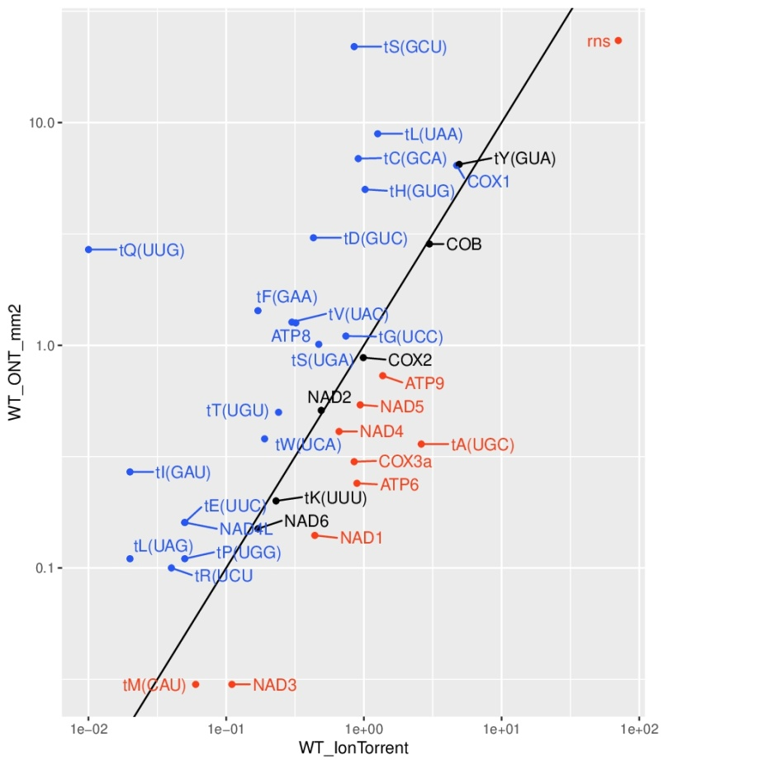
A

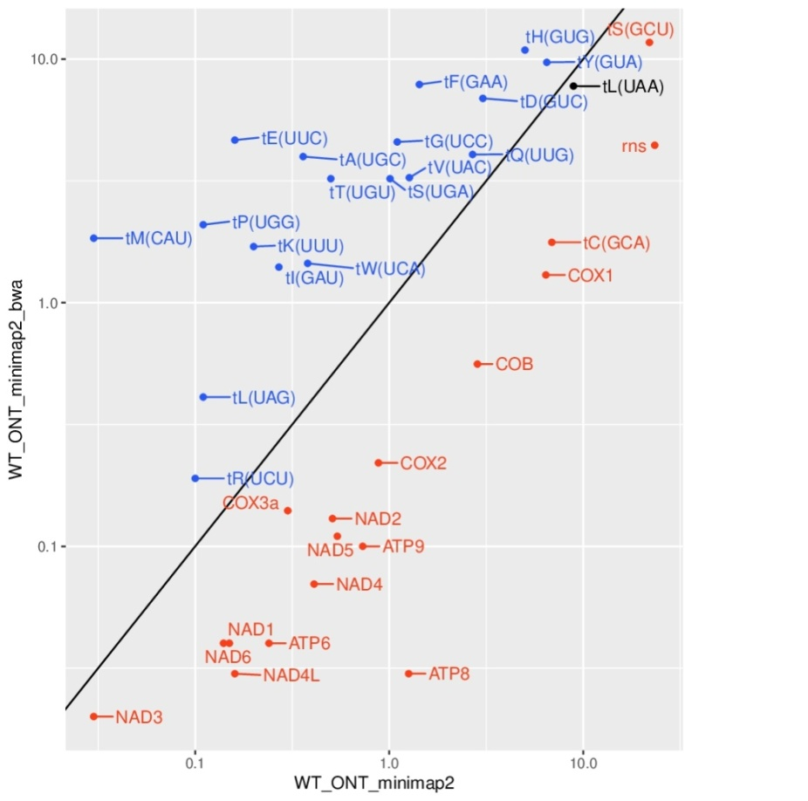
B

Supplementary Figure 5 Scatter plot of relative abundances of reads corresponding to mitochondrial genes (excluding rnl). A - a comparison between ONT reads mapped with minimap2 and Ion Torrent reads; B - a comparison between ONT reads mapped with minimap2 and with minimap2+BWA. Color coding convention is the same as in Table 1.

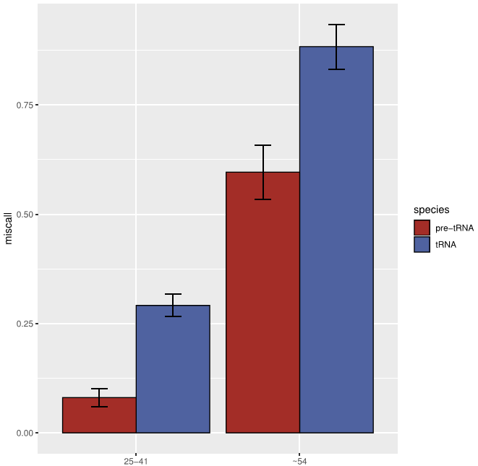

Supplementary Figure 6 Fraction of reads containing T-C miscalls for putative pseudouridine (ψ) sites in mature tRNAs and pre-tRNAs for position ~54 and positions 25-41 detected with ELIGOS. Error bars correspond to standard error. Presented data includes all putative ψ positions in mitochondrial tRNAs, excluding those where the coverage for pre-tRNA transcripts was below 10.

position | strand | transcript | ref | miscall | putative modification
4019 | + | tN(GUU) | G | G→C | m⁷G
4042 | + | tN(GUU) | A | A→G | inosine
10832 | - | tK(UUU) | G | G→C | m⁷G
11561 | + | tL(UAA) | A | A→G | inosine
11562 | + | tL(UAA) | G | G→C | m⁷G
11704 | + | tH(GUG) | G | G→C | m⁷G
11816 | + | tT(UGU) | A | A→G | inosine
11873 | + | tE(UUC) | G | G→C | m⁷G
12790 | - | tI(GAU) | A | A→G | inosine
13981 | - | tP(UGG) | G | G→C | m⁷G
13982 | - | tP(UGG) | G | G→C | m⁷G
13993 | - | tP(UGG) | A | A→G | inosine
14234 | - | tG(UCC) | G | G→C | m⁷G
21172 | + | tV(UAC) | G | G→C | m⁷G
21245 | + | tW(UCA) | G | G→C | m⁷G
21316 | + | tW(UCA) | G | G→C | m⁷G
21425 | + | tR(ACG) | G | G→C | m⁷G
21444 | + | tR(ACG) | A | A→G | inosine
31527 | + | tQ(UUG) | G | G→C | m⁷G
31587 | + | tD(GUC) | G | G→C | m⁷G
31655 | + | tS(GCU) | G | G→C | m⁷G
Supplementary Table 8 Putative positions of m⁷G and inosine modifications detected via miscall analysis with ELIGOS.

GeneName | IsoformName | WT | ⵠCaPET127 | ⵠCaDSS1
rnl | rnl_mature | 0,719705 | 0,704302 | 0,644808
rnl | rnl_unspliced | 0,005421 | 0,006292 | 0,027194
rnl | rnl_unsp_i1 | 0,007046 | 0,007176 | 0,025057
rnl | rnl_unsp_i2 | 0,267828 | 0,28223 | 0,302941
COB | COB_mature | 0,20169 | 0,074202 | 0,001999
COB | COB_unspliced | 0,632774 | 0,809783 | 0,888422
COB | COB_unsp_i1 | 0,074735 | 0,043781 | 0,011054
COB | COB_unsp_i2 | 0,090801 | 0,072234 | 0,098526
COX1 | COX1_mature | 0,053388 | 2,28E-125 | 0
COX1 | COX1_unspliced | 0,562555 | 0,577923 | 0,736253
COX1 | COX1_unsp_i1 | 2,66E-92 | 1,25E-60 | 8,35E-197
COX1 | COX1_unsp_i2 | 1,54E-38 | 1,60E-07 | 1,18E-08
COX1 | COX1_unsp_i3 | 9,47E-45 | 0,009614 | 8,47E-06
COX1 | COX1_unsp_i4 | 4,18E-81 | 5,16E-122 | 2,74e-321
COX1 | COX1_unsp_i12 | 2,60E-26 | 0,025062 | 0,001247
COX1 | COX1_unsp_i13 | 1,11E-97 | 2,73E-27 | 1,80E-22
COX1 | COX1_unsp_i23 | 0,000171 | 0,053264 | 0,002115
COX1 | COX1_unsp_i34 | 0,011206 | 0,008776 | 0,027046
COX1 | COX1_unsp_i14 | 3,02E-115 | 4,57E-60 | 1,29E-189
COX1 | COX1_unsp_i24 | 8,82E-12 | 0,020892 | 3,80E-09
COX1 | COX1_unsp_i123 | 0,108793 | 0,054631 | 0,013747
COX1 | COX1_unsp_i234 | 0,192698 | 0,213311 | 0,130115
COX1 | COX1_unsp_i134 | 2,30E-83 | 0,005241 | 0,011422
COX1 | COX1_unsp_i124 | 0,053261 | 1,25E-05 | 0,045912

Supplementary Table 9 Relative abundances of mitochondrial transcript isoforms in WT and deletion strains of C. albicans. This table contains raw LIQA output data corresponding to Table 6.

