Supplementary information (SI)
Advanced Catalytic Approaches for Synthesizing 1,2-dihydro-1-aryl-3H-naphtho[1,2-e]-[1,3]oxazin-3-one Derivatives through Electrophilic Substitution Reactions using Mono- and Bimetallic Phosphate Catalysts: A Study of Co₃(PO₄)₂ and CoCa₃(HPO₄)(PO₄)₂(OH)
Achraf EL HALLAOUI^{1 *}, Nouhaila FERRAA¹, Yousssef MERROUN¹, Soukaina CHEHAB², Said BOUKHRIS¹, Mounia Bennani Ziatni¹, Hicham HASSOUNE³, Abdelaziz SOUIZI¹ and Rachida GHAILANE¹
¹Organic Chemistry, Catalysis, and Environment Laboratory, University of Ibn Tofail, Faculty of Sciences, Po Box 133, 14000 Kenitra, Morocco
²Higher Institute for Nursing Professions and Health Techniques of Rabat-Annex Kenitra- Ministry of Health and Social Protection, Morocco
³Department of Chemical and Biochemical Sciences (CBS), Mohammed VI Polytechnic University (UM6P), Hay Moulay Rachid Ben Guerir, 43150, Morocco
Email: achraf.el.hallaoui@uit.ac.ma
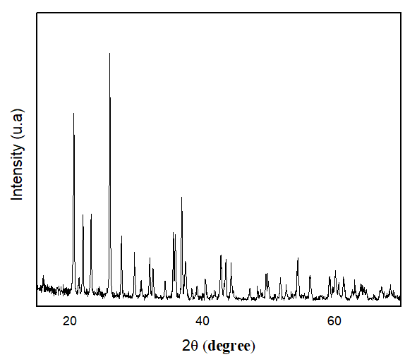
Figure s1. XRD spectrum of Co₃(PO₄)₂ catalyst
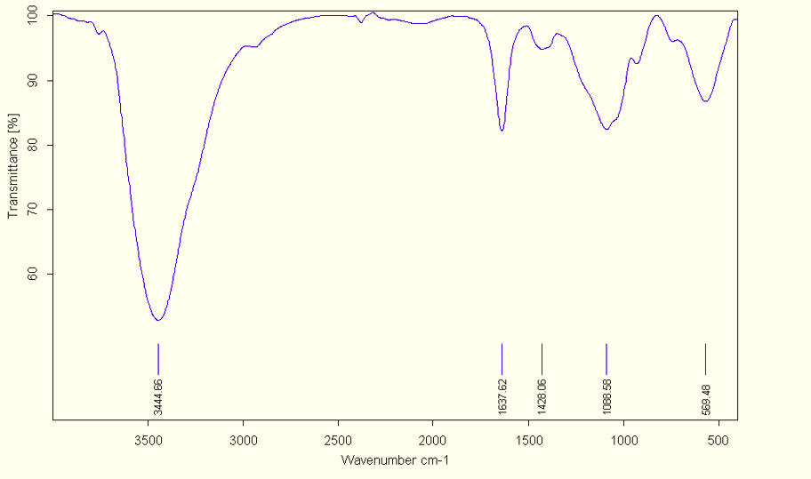
Figure s2. FTIR spectrum of Co₃(PO₄)₂ catalyst
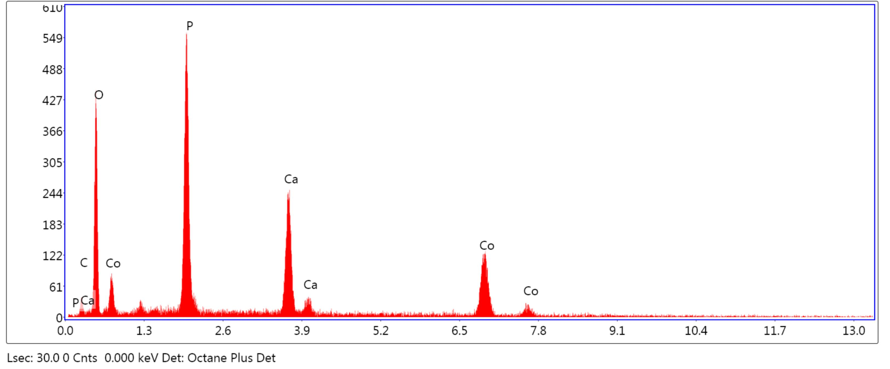
C K |  |  |  |  |  | 2.9 |  |  |  |  |  |  | 5.8 |  | 4.2 |  |  |  | 34.7 |  |  |  | 0.0057 |  |  | 1.1447 |  |  |  | 0.9213 |  |  |  | 0.1728 |  |  |  |  |  |  | 1.0000
O K |  |  |  |  |  | 41.7 |  |  |  |  |  |  | 62.3 |  | 162.5 |  |  |  | 10.2 |  |  |  | 0.1077 |  |  | 1.0987 |  |  |  | 0.9445 |  |  |  | 0.2351 |  |  |  |  |  |  | 1.0000
P K |  |  |  |  |  | 18.7 |  |  |  |  |  |  | 14.4 |  | 303.5 |  |  |  | 4.8 |  |  |  | 0.1382 |  |  | 0.9648 |  |  |  | 1.0032 |  |  |  | 0.7575 |  |  |  |  |  |  | 1.0105
CaK |  |  |  |  |  | 13.5 |  |  |  |  |  |  | 8.0 |  | 166.4 |  |  |  | 4.4 |  |  |  | 0.1242 |  |  | 0.9505 |  |  |  | 1.0331 |  |  |  | 0.9383 |  |  |  |  |  |  | 1.0349
CoK |  |  |  |  |  | 23.2 |  |  |  |  |  |  | 9.4 |  | 118.0 |  |  |  | 4.7 |  |  |  | 0.2014 |  |  | 0.8301 |  |  |  | 1.0599 |  |  |  | 0.9951 |  |  |  |  |  |  | 1.0491
Figure s3. SEM/EDAX analysis of Co₃(PO₄)₂ catalyst
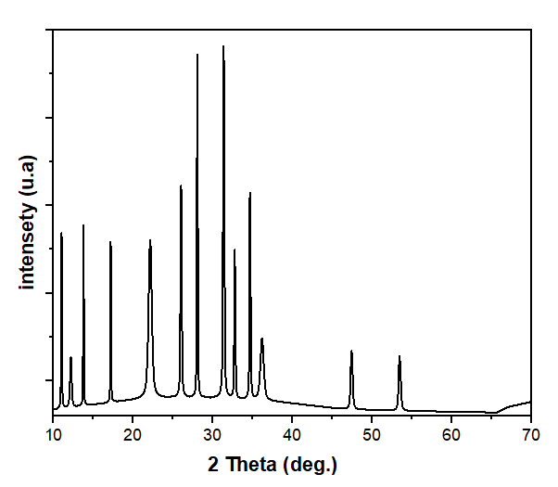
Figure s4. XRD spectrum of CoCa3(HPO4)(PO4)2(OH)
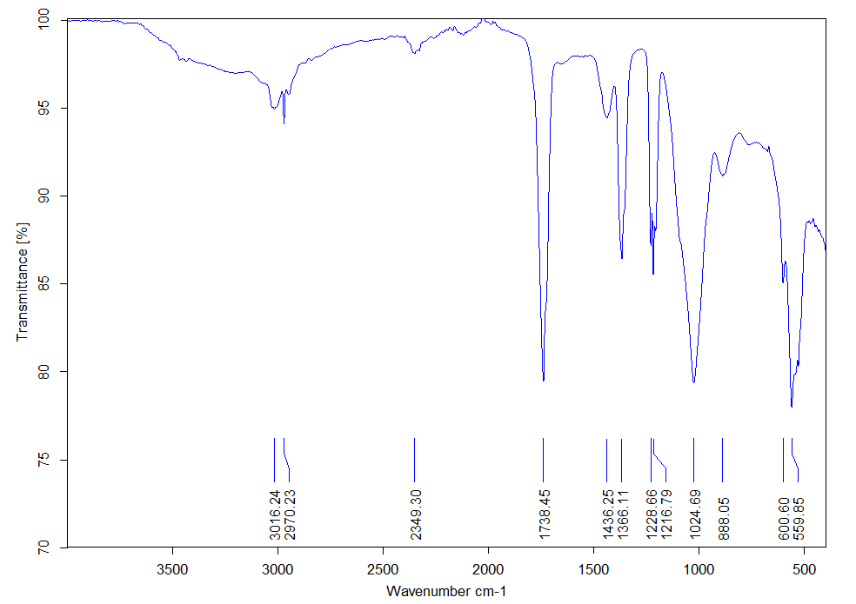
Figure s5. FTIR spectrum of CoCa3(HPO4)(PO4)2(OH)
Table s1. Elemental analysis of the prepared support
Ref. Ech | P₂O₅ | Co | CaO
Ref. Ech | w.t % | w.t % | w.t %
Prepared Support | 46.31 | 19.61 | 36.92

