Supplementary information for

Ultrasensitive SERS detection and efficient flotation removal of nanoplastics from water using bubble-spouting micromotor swarms

Ning An^{1,2§}, Jintao Li^{1,2§}, Liyan Zhao^{1,2§}, Shaojing Su³, Qundong Xia¹, Zhiruo Zhao¹, Cao Bi⁴, Lulu Qu⁵*, Hongliang Zhang³, Yaqin Liao³*, Mi Yan^{1,6}, and Shikuan Yang^{1,2,6}*
¹School of Materials Science and Engineering, Zhejiang University, Hangzhou 310027, China
²Department of Medical Oncology, The First Affiliated Hospital, Zhejiang University School of Medicine, Hangzhou 310003, China
³Dec Academy of Science and Technology, Co., Ltd.
⁴Core Facilities, Zhejiang University School of Medicine, Hangzhou, 310003, China
⁵School of Chemistry and Materials Science, Jiangsu Normal University, Xuzhou, Jiangsu, 221116, China
⁶State Key Laboratory of Baiyunobo Rare Earth Resource Researches and Comprehensive Utilization, Baotou Research Institution of Rare Earths, Baotou 014030, China
§These authors contributed equally
*Corresponding author. Email: shkyang@zju.edu.cn (S.K.); luluqu@jsnu.edu.cn (L.Q.); liaoyq@dongfang.com (Y.L.)

Part I. Description of the videos
Supplementary Video 1: Ag/Co micromotors continuously ejecting microbubbles to capture PS nanoplastics.
Supplementary Video 2: Oxygen concentration increase around the Ag/Co micromotor during decomposition of H₂O₂ simulated by COMSOL.
Supplementary Video 3: Moving behavior of the Ag/Co micromotors ejecting oxygen bubbles at point A, B, and C in PC solutions.
Supplementary Video 4: A spirally moving Ag/Co micromotor in H₂O₂ aqueous solution propelled by oxygen bubbles.
Supplementary Video 5: Moving behavior of the Ag/Co micromotors in H₂O₂ aqueous solutions with different concentrations.
Supplementary Video 6: Magnetically moving the Ag/Co micromotors.
Supplementary Video 7: Magnetically steering the moving direction of the bubble-spouting Ag/Co micromotors.
Supplementary Video 8: Magnetically stirring the PS nanosphere suspensions promoted the attachment of the PS nanospheres onto the micromotors.
Supplementary Video 9: A microbubble capturing PS nanospheres.

Part II. Supplementary figures

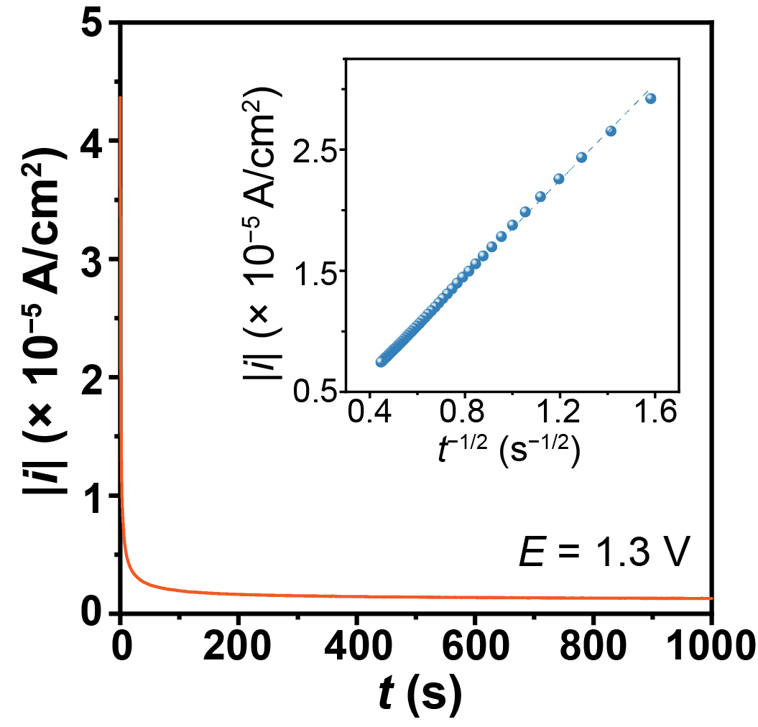
Supplementary Fig. 1 Chronoamperometric curve at 1.3 V. Inset: Plot of the i–t^{−1/2} relationship.

The current decay at the potential of 1.3 V followed the Cottrell equation:
 | $$i\left(t\right)=\frac{{nFD}^{\frac{1}{2}}C}{π^{\frac{1}{2}}t^{\frac{1}{2}}}$$ | (S1)
where n, F, D, C, and t are the elerctron transfer number, Faraday constant, the diffusion coefficient of Ag⁺ ions, the concentration of Ag⁺ ions in the bulk electrolyte, and the electrodeposition time, respectively.

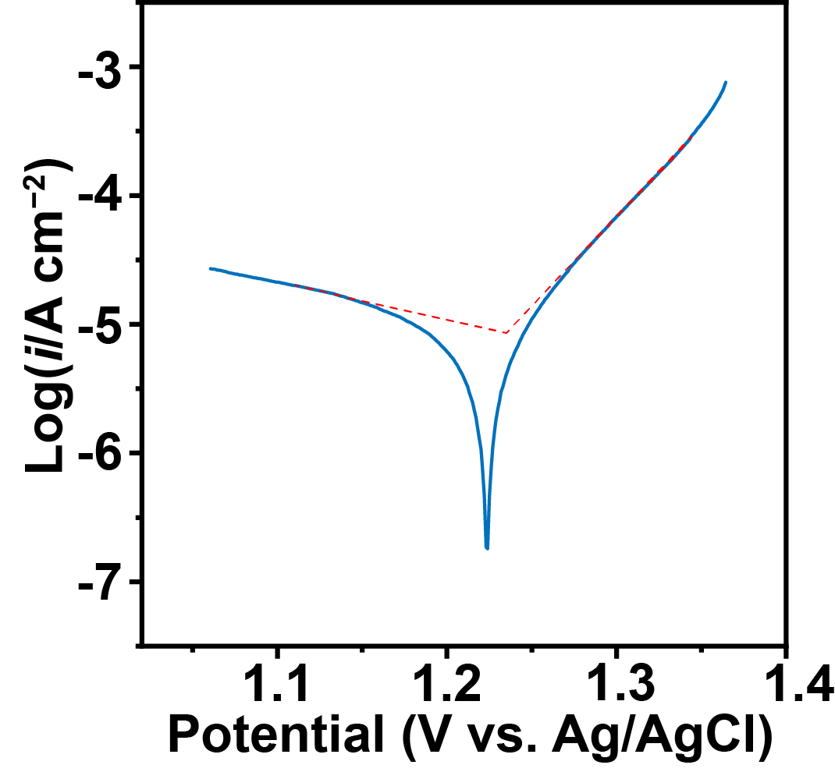
Supplementary Fig. 2 Tafel plot of the Au electrode pre-deposited with Ag₇O₈NO₃ in 0.06 M AgNO₃, 0.1 M KNO₃, and 0.16 M H₃BO₃. Scan rate: 1 mV/s.

According to the Tafel plot, the equilibrium potential for the Ag₇O₈NO₃ electrodeposition was approximately 1.24 V (vs. Ag/AgCl), with an exchange current density of 9 × 10⁻⁶ A/cm². From the anode Tafel equation (equation S2), the anode transfer coefficient (β) was calculated to be 0.82 based on the slope of the anode Tafel plot.
 | $$=\frac{2.3RT}{βF}lgi_{0}−\frac{2.3RT}{βF}lgi$$ | (S2)

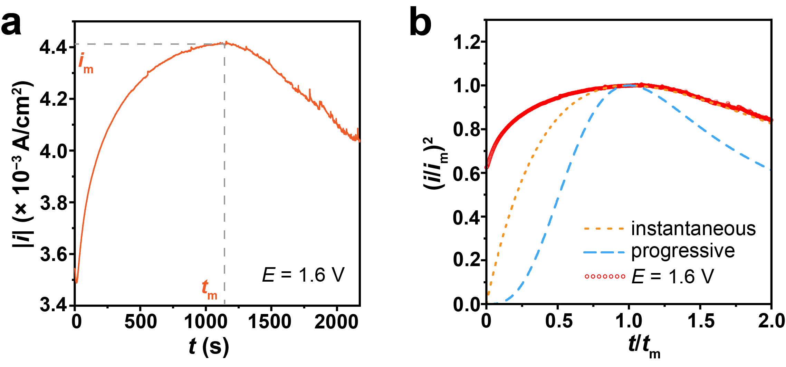
Supplementary Fig. 3 (a) Chronoamperometric curve at 1.6 V. (b) Dimensionless chronoamperometric curve after subtracting the double-layer charging time period.

The dimensionless forms of the chronoamperometric curves for instantaneous and progressive nucleation were expressed as equation S3 and S4, respectively.
 | $$\frac{I^{2}}{I_{m}^{2}}=\frac{1.9542}{t/t_{m}}{\left\{1−\exp\left[−1.2564\left(\frac{t}{t_{m}}\right)\right]\right\}}^{2}$$ |  | (S3)
 | $$\frac{I^{2}}{I_{m}^{2}}=\frac{1.2254}{t/t_{m}}{\left\{1−\exp\left[−2.3367{\left(\frac{t}{t_{m}}\right)}^{2}\right]\right\}}^{2}$$ |  | (S4)

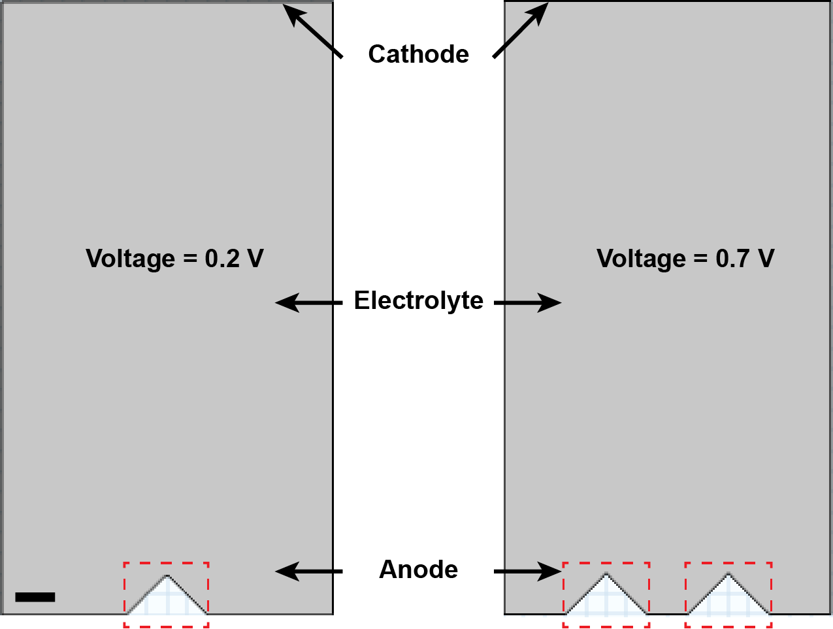
Supplementary Fig. 4 Model used for the simulation of the deposition of Ag₇O₈NO₃. The red dotted frame indicates the Ag₇O₈NO₃ micropyramids serving as the anodes. Scale bar: 2 μm.

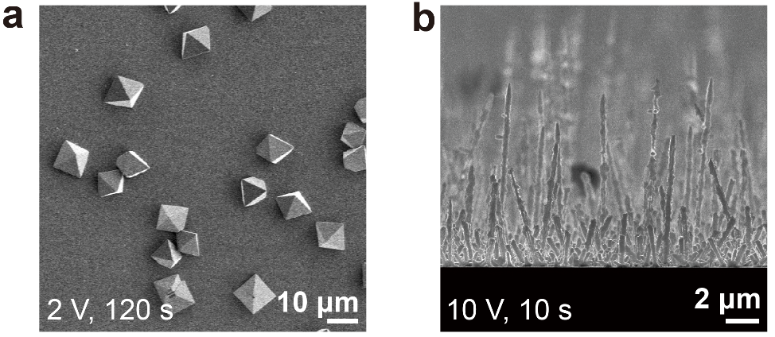
Supplementary Fig. 5 (a) Ag₇O₈NO₃ micropyramids electrodeposited at 2 V for 120 s. (b) Ag₇O₈NO₃ nanorods electrodeposited at 10 V for 10 s.
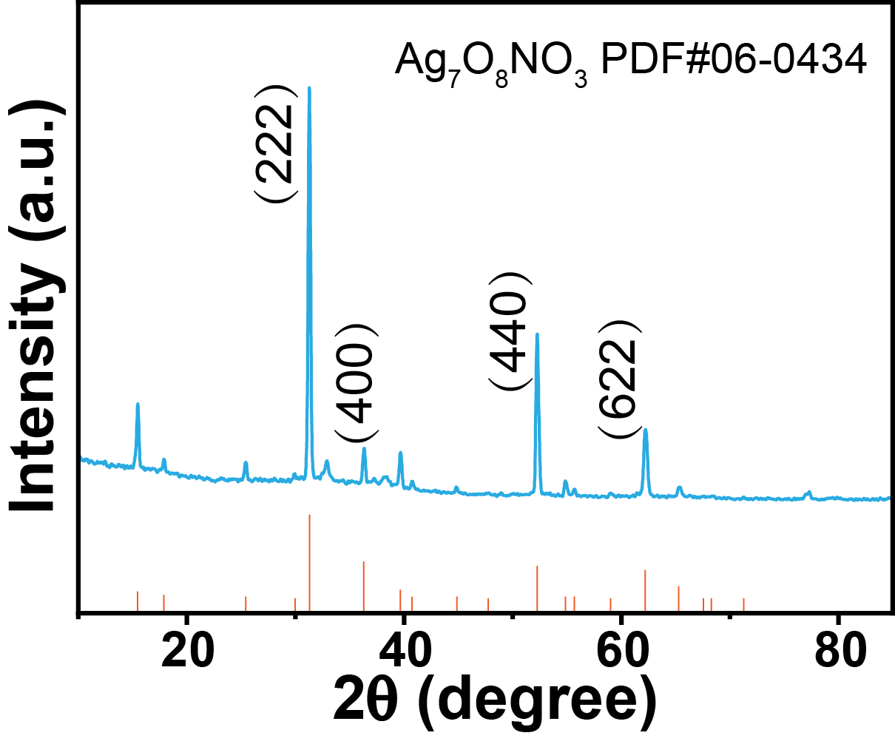
Supplementary Fig. 6 XRD pattern of the electrodeposited Ag₇O₈NO₃ MBPs.

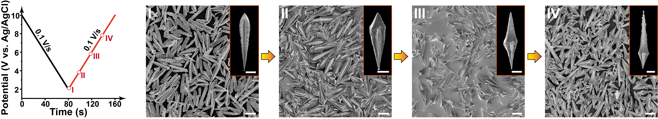
Supplementary Fig. 7 Morphology evolution of Ag₇O₈NO₃ microstructures during the gradually increasing process of the potential. (I) to (IV): Uniform Ag₇O₈NO₃ microstructures selectively peeled off from the electrode surface by ultrasonic treatment after the potential rising to 2 V, 4 V, 6 V, and 8 V, respectively. Inset: a single Ag₇O₈NO₃ microstructure. Scale bar: 10 μm, inset, 5 μm.

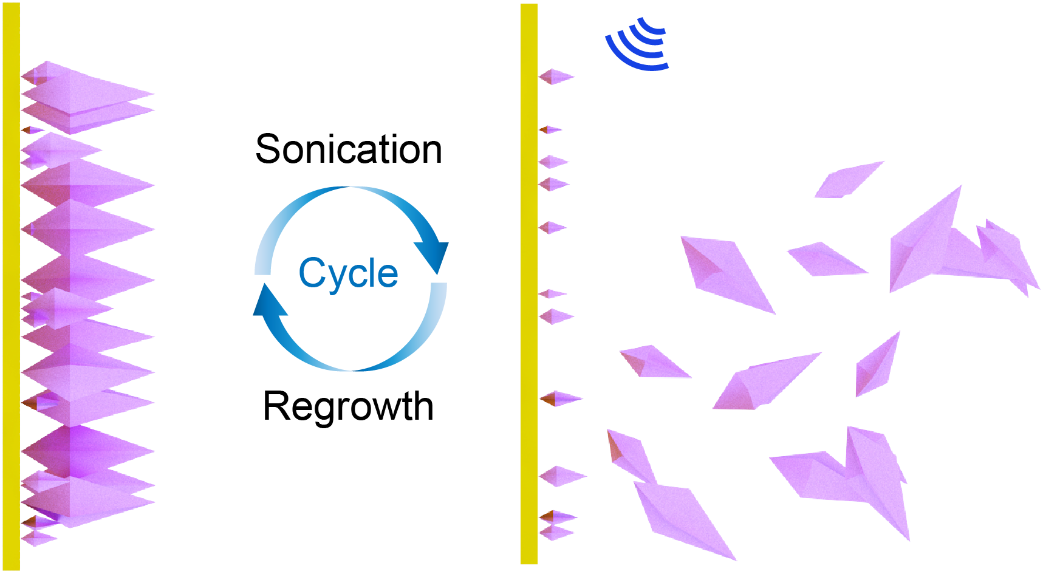
Supplementary Fig. 8 Schematic of the high-throughput production of Ag₇O₈NO₃ MBPs through electrodeposition, sonication, and regrowth cycles.

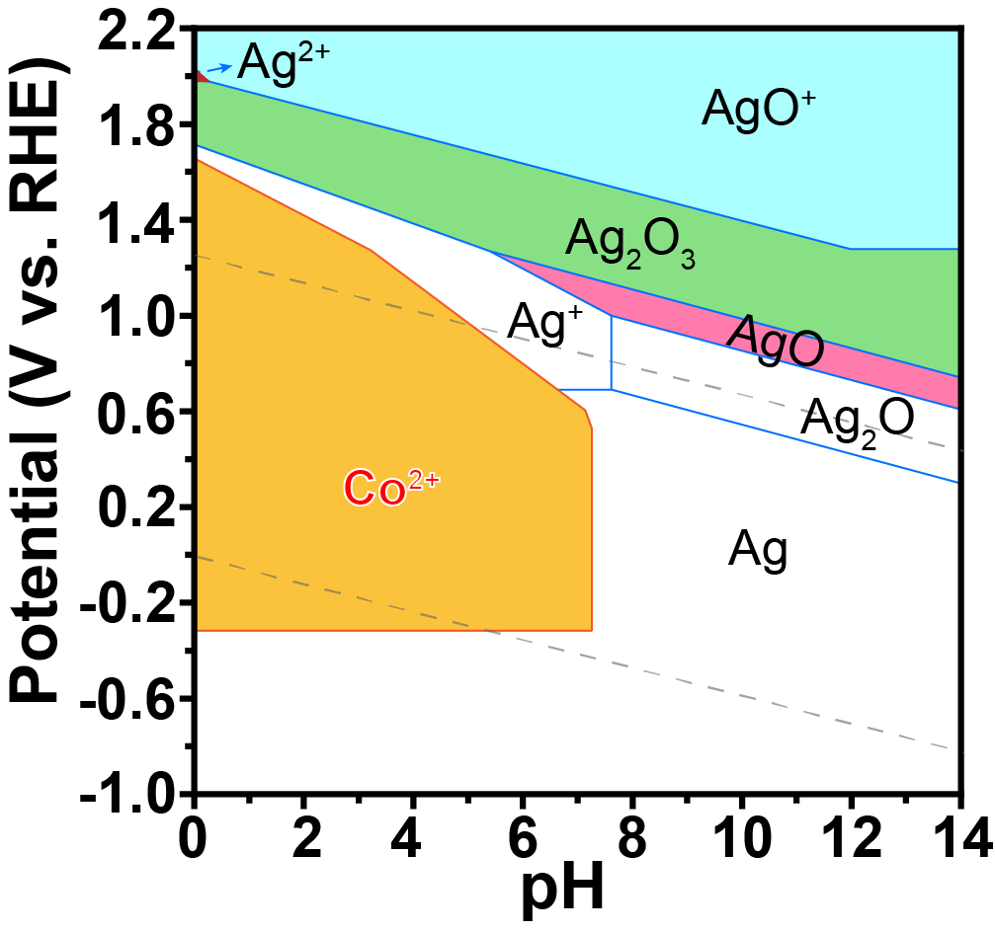
Supplementary Fig. 9 Potential–pH equilibrium diagram for the system silver-water. (T: 25 ℃; Concentration of Ag and Co: 10⁻² M). The pink, green, and cyan regions represent the equilibrium zones of high-valent silver. The orange region represents the equilibrium zone of Co²⁺.

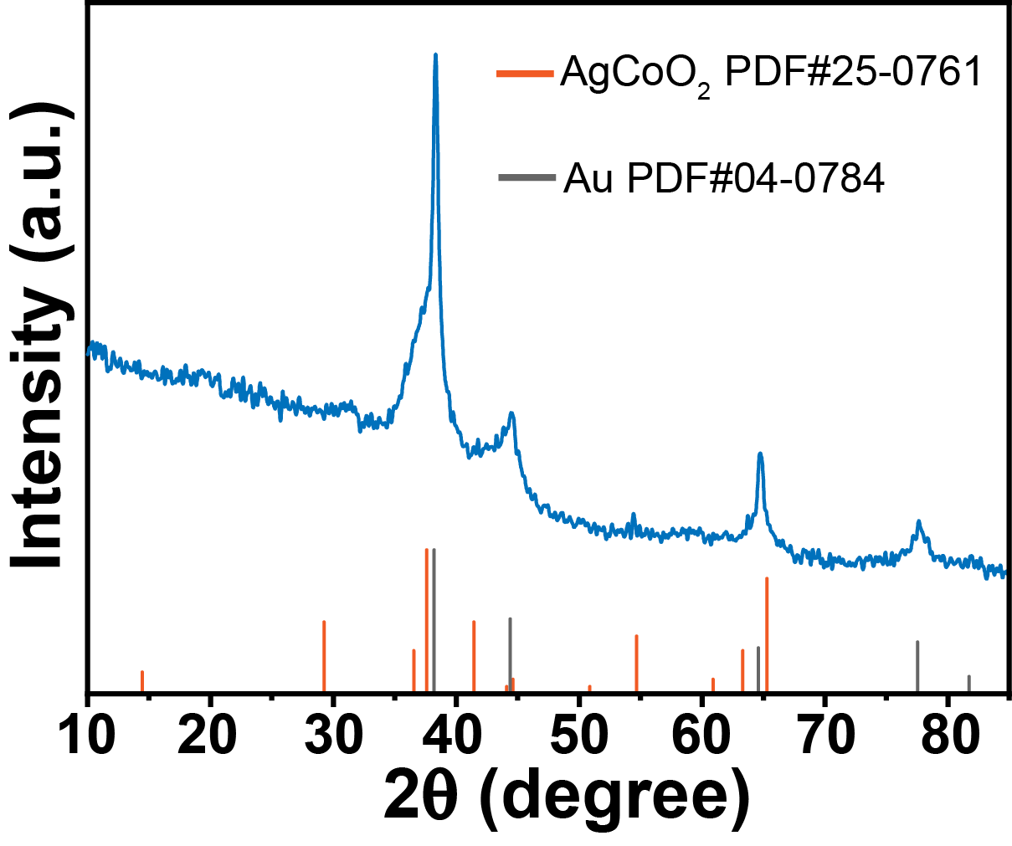
Supplementary Fig. 10 XRD pattern of the AgCoO₂ MBPs on gold substrates.

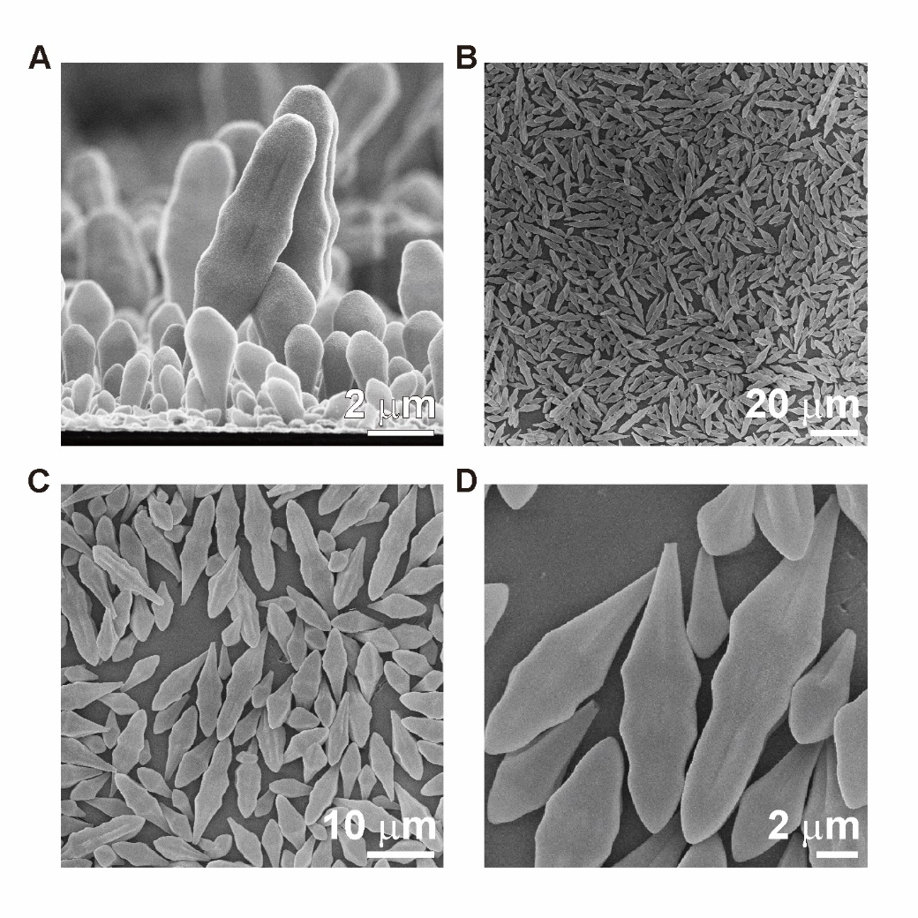
Supplementary Fig. 11 Selectively peeling off AgNiO₂ microtorpedoes from the electrode surface. (A) AgNiO₂ microtorpedoes on the anode electrode surface. (B-D) AgNiO₂ microtorpedoes selectively peeled off from the electrode surface.

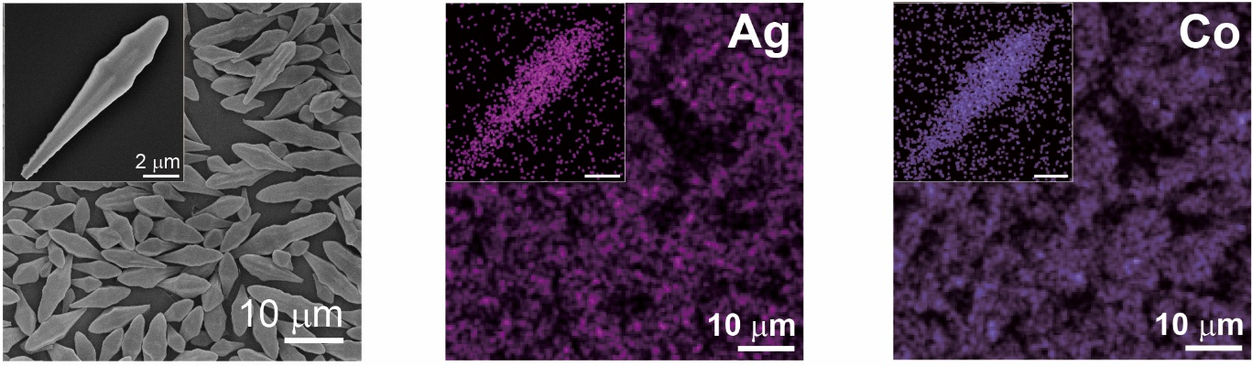
Supplementary Fig. 12 EDX element mapping of the AgCoO₂ BMPs.

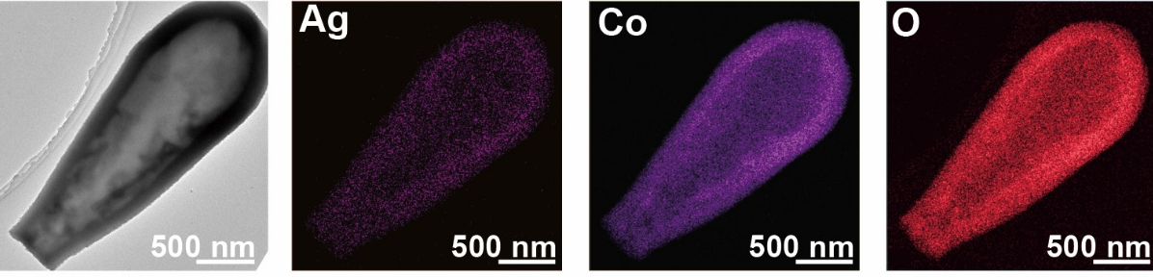
Supplementary Fig. 13 TEM image of the hollow AgCoO₂ microparticle (Left) and and elemental mapping results of the hollow AgCoO₂ microparticle.

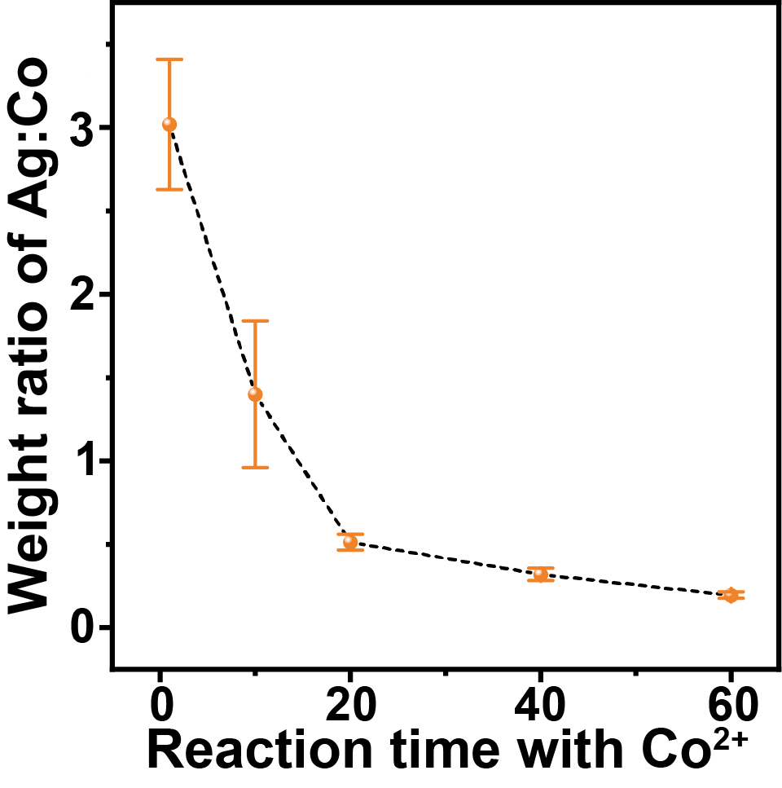
Supplementary Fig. 14 Change of the weight ratio of Ag to Co within the Ag/Co micromotors prepared by varying the reaction time between Ag₇O₈NO₃ MBPs and Co²⁺ ions. Error bars show the mean ± SD (n = 3)

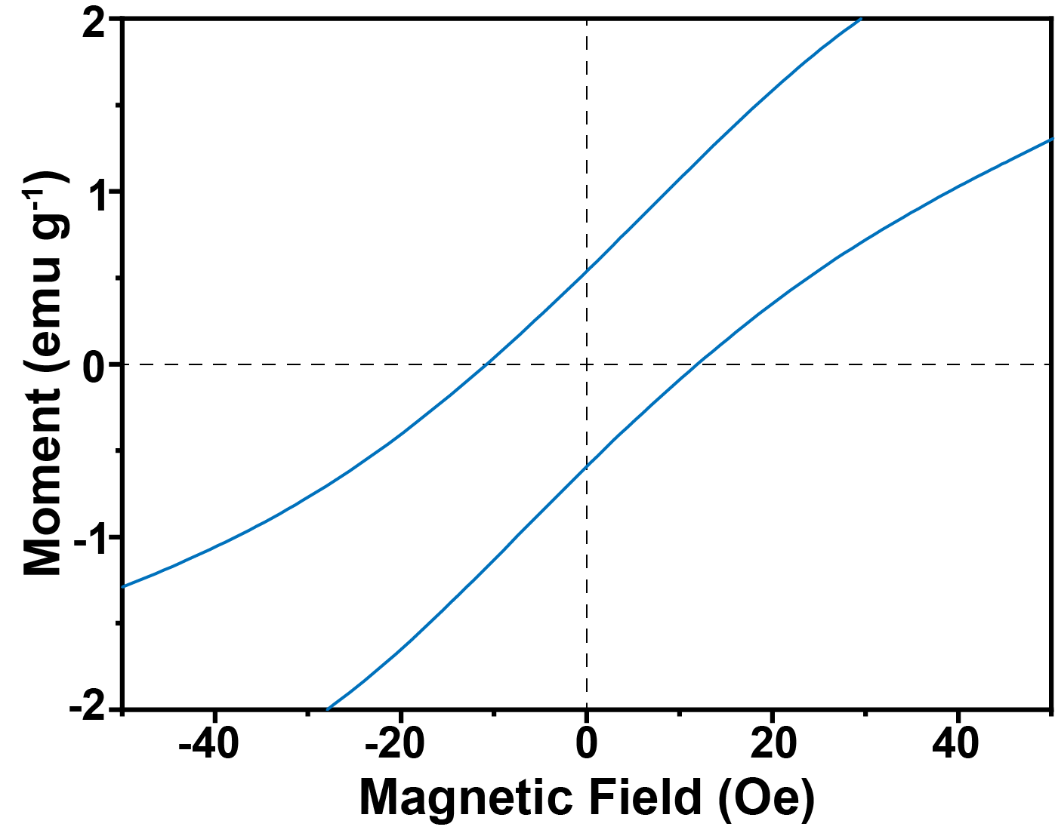
Supplementary Fig. 15 Enlarged magnetic hysteresis loop.

Supplementary Fig. 16 Separation of the Ag/Co micromotors from water with a NdFeB magnet.

Supplementary Fig. 17 Schematics of oxygen bubble formation at site A, B, and C of the Ag/Co micromotors and the moving behavior propelled by the release of oxygen bubbles.

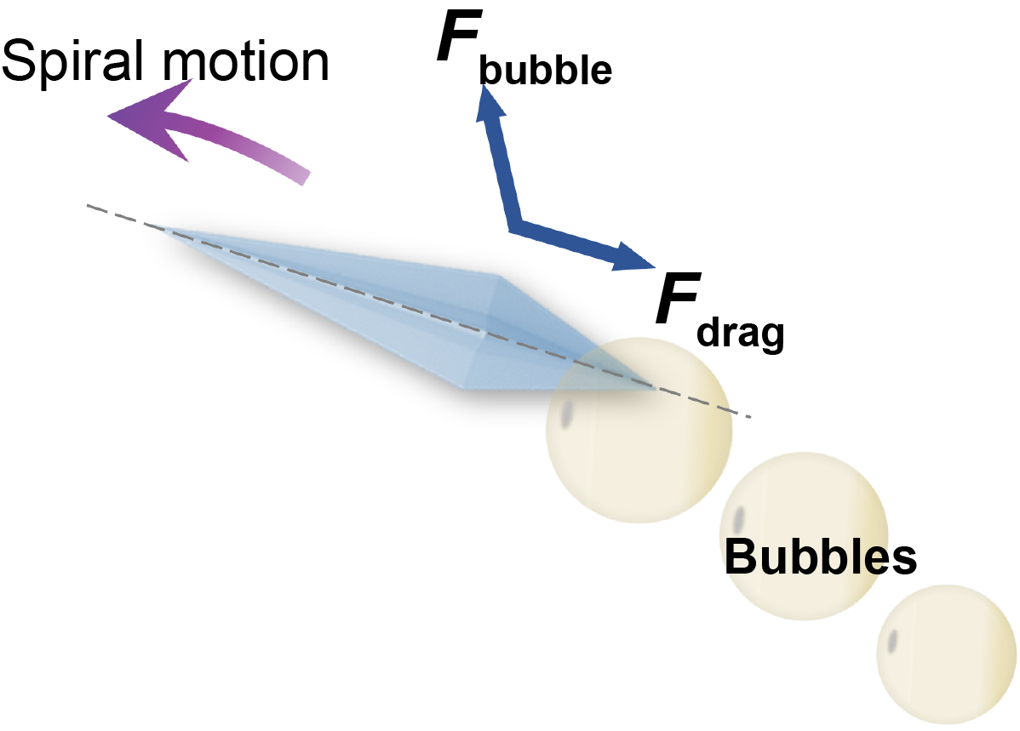
Supplementary Fig. 18 Schematic of the bubble formation and detachment on the bottom tip of a Ag/Co micromotor and the corresponding moving mode. The dashed line indicates the central axis of the micromotor.

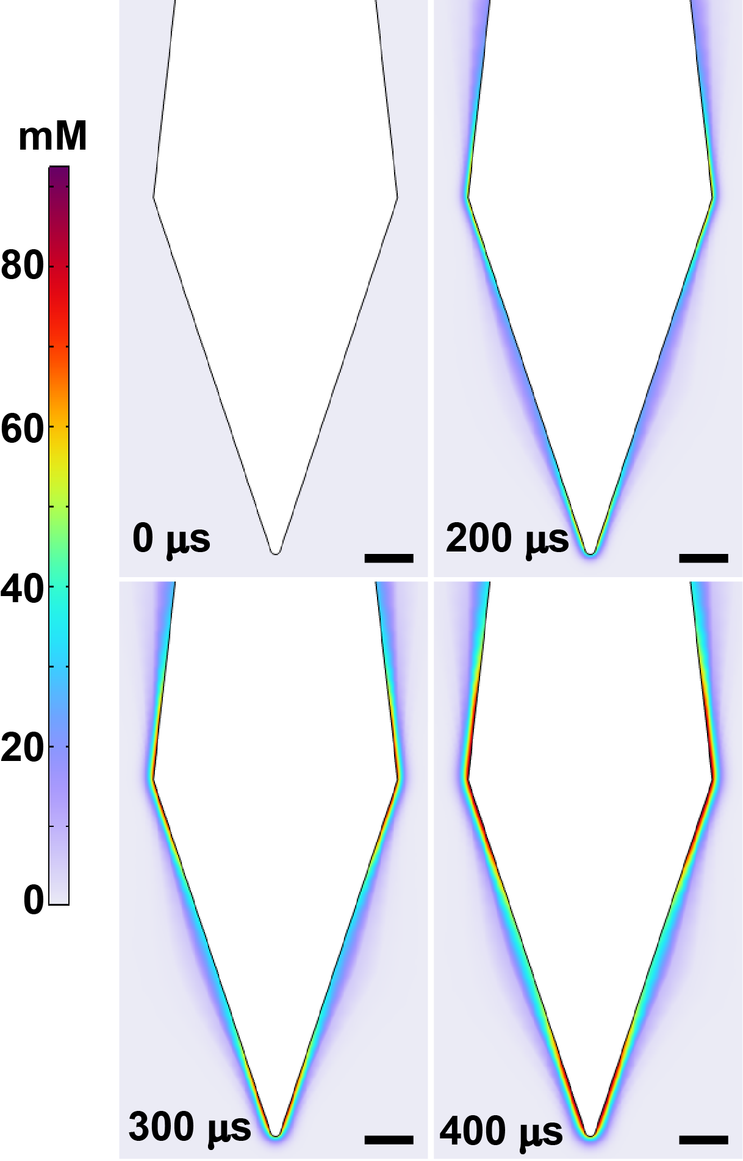
Supplementary Fig. 19 Concentration distribution of oxygen around the Ag/Co micromotors at different catalytic reaction time of 0, 200, 300, and 400 μs. Scale bar: 2 μm.

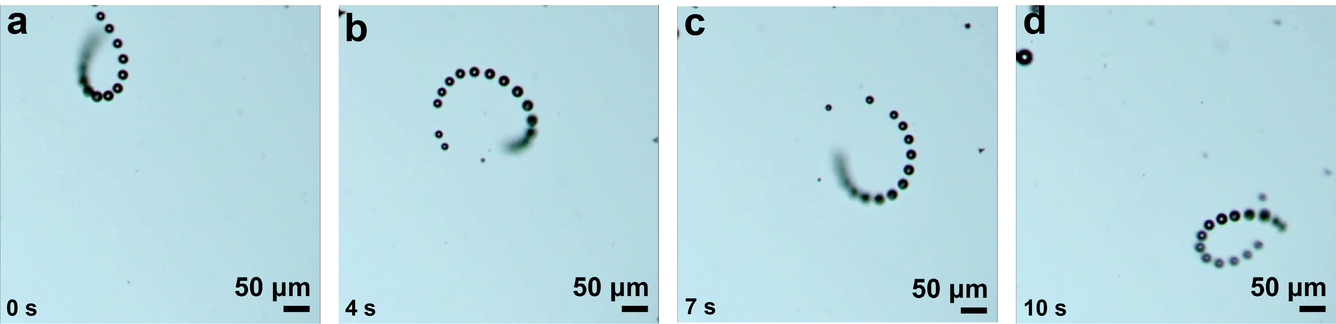
Supplementary Fig. 20 Time-resolved images illustrating the spiral movement of Ag/Co micromotors in the 5.0 wt.% H₂O₂ aqueous solution.

Supplementary Fig. 21 Moving behavior of Ag/Co micromotors in H₂O₂ aqueous solution with different concentrations (the images were captured from the supplementary videos).

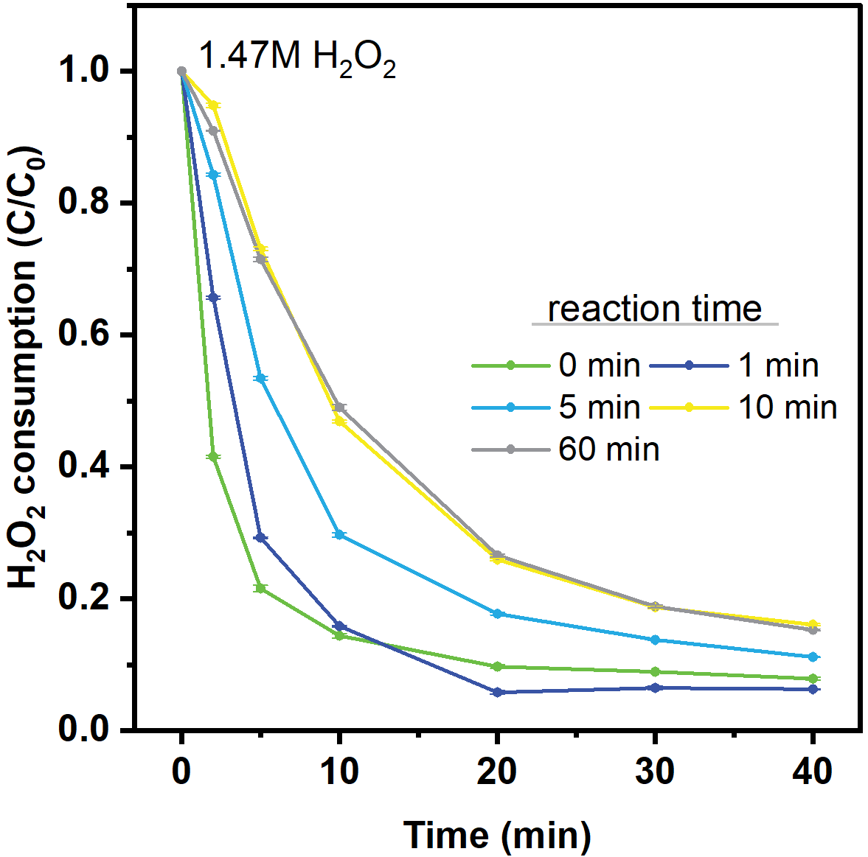

Supplementary Fig. 22 The H₂O₂ concentration decrease after introducing Ag/Co micromotors with different atomic ratios of Ag and Co designed by controlling the reaction time between Ag₇O₈NO₃ and Co²⁺ ions. (Note: the amounts of Ag/Co micromotors were only 0.4 mg/ml in the H₂O₂ solutions)

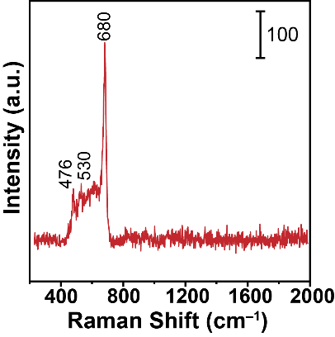
Supplementary Fig. 23 Raman spectrum of Ag/Co micromotors.

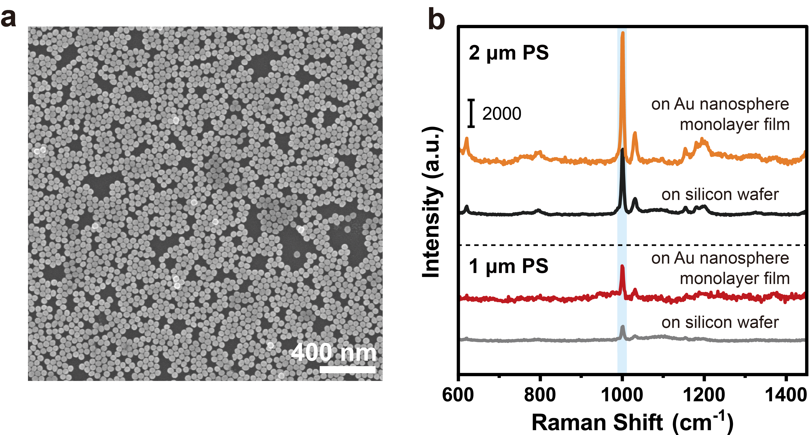
Supplementary Fig. 24 a) Au nanoparticle monoalyer as a representative conventional SERS substrate. b) Raman spectra of isolated 2 μm and 1 μm PS spheres on a piece of silicon wafer and on the Au nanosphere monolayer. Only about two times of Raman enhancement was achieved on the Au nanosphere monolayer because the large PS spheres failed to enter the nanoscale crevices where the hot spots located.

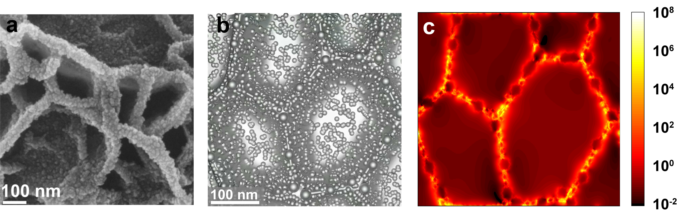
Supplementary Fig. 25 a) SEM image used to simulate the electromagnetic field using the FDTD method. b) Model built used for FDTD simulations. c) Simulated enhancement of the electromagnetic field. Strong electromagnetic fields located at the edges of the nanoplates and within the microcavities that could hold nanoplastics.

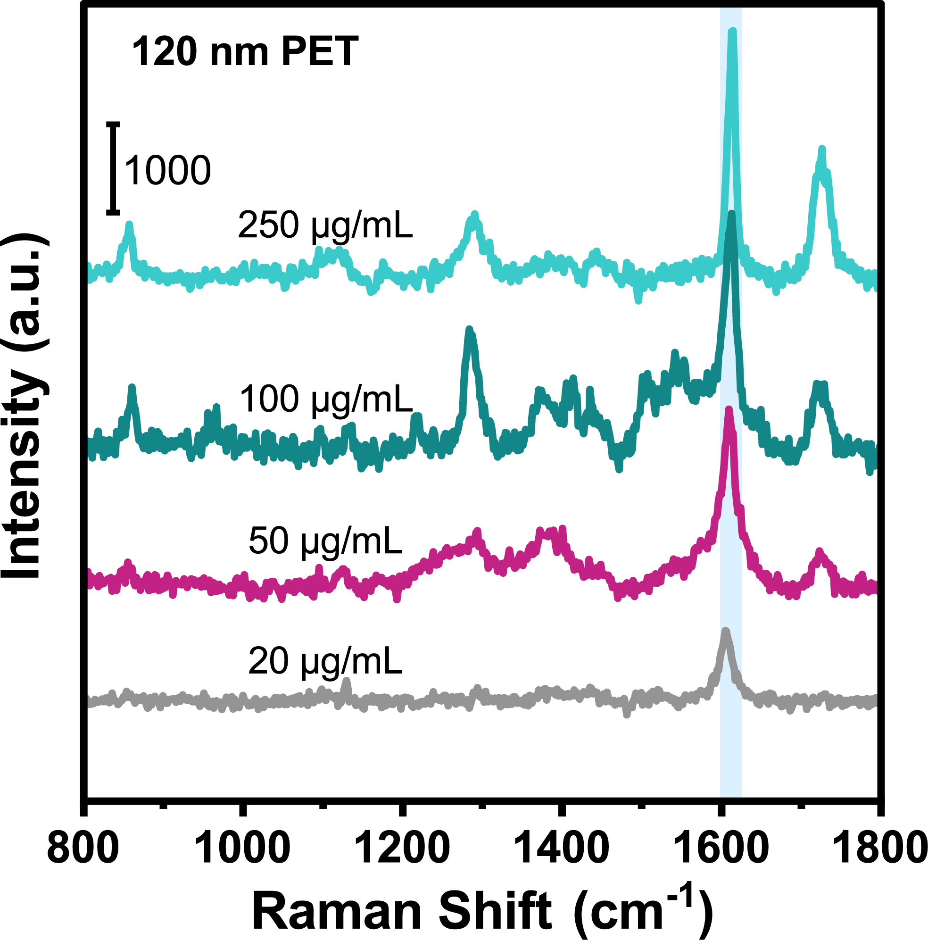
Supplementary Fig. 26 Detection of olyethylene terephthalate nanoparticles with a size of 120 nm using the Ag/Co micromotors.

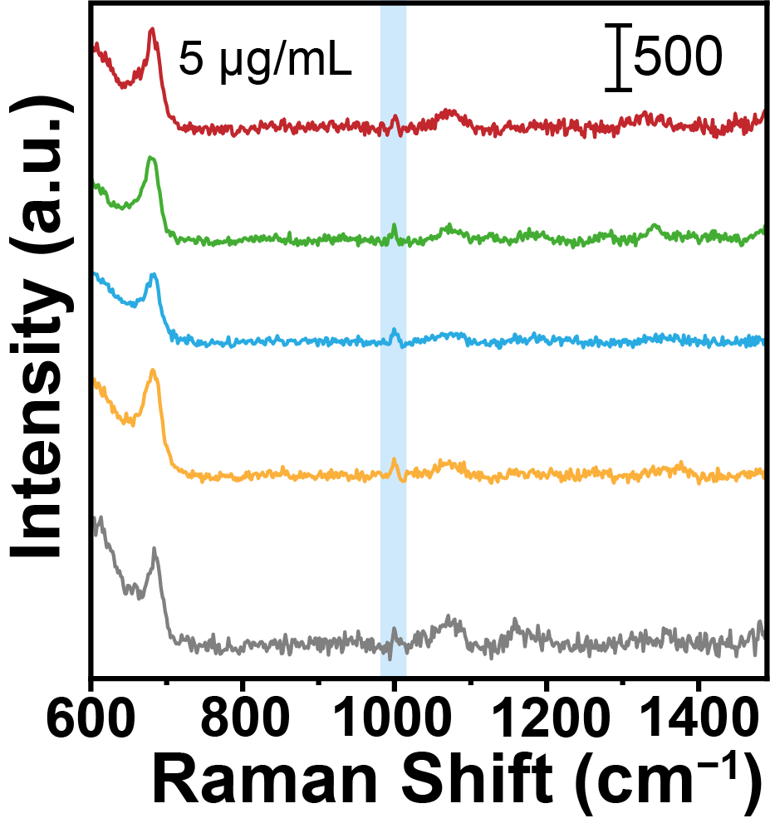
Supplementary Fig. 27 SERS spectra of PS nanoplastics (5 μg/mL) at five random points of Ag/Co micromotors. The SERS peak at 1001 cm⁻¹ is distinguishable.

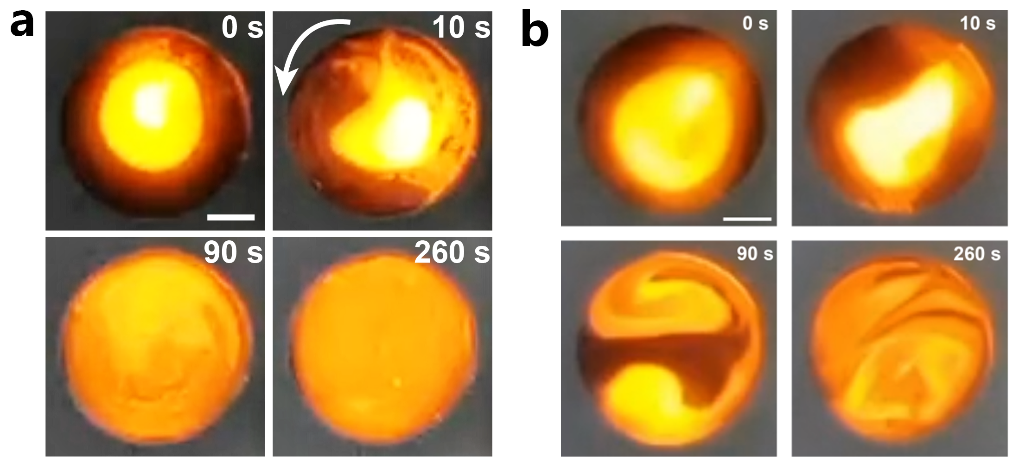
Supplementary Fig. 28 a and b) Photographs showing the dispersion of fluorescent PS nanospheres in a water droplet (10 μL) containing Ag/Co micromotors under the magnetically stirred and non-stirred conditions, respectively. Scale bar: 1 mm.

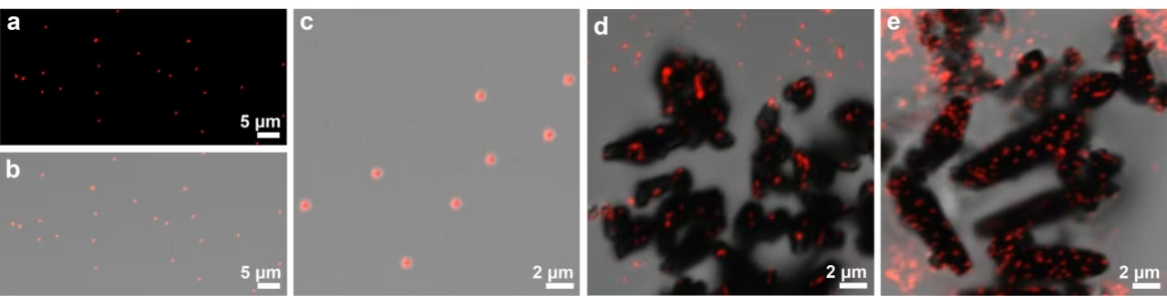
Supplementary Figure R29 a-c) Isolated PS nanospheres formed on a piece of silicon wafer after water evaporated. d) PS nanospheres adhered to the static Ag/Co micromotors after water evaporated. e) PS nanospheres adhered to the magnetically stirring Ag/Co micromotors after water evaporated.

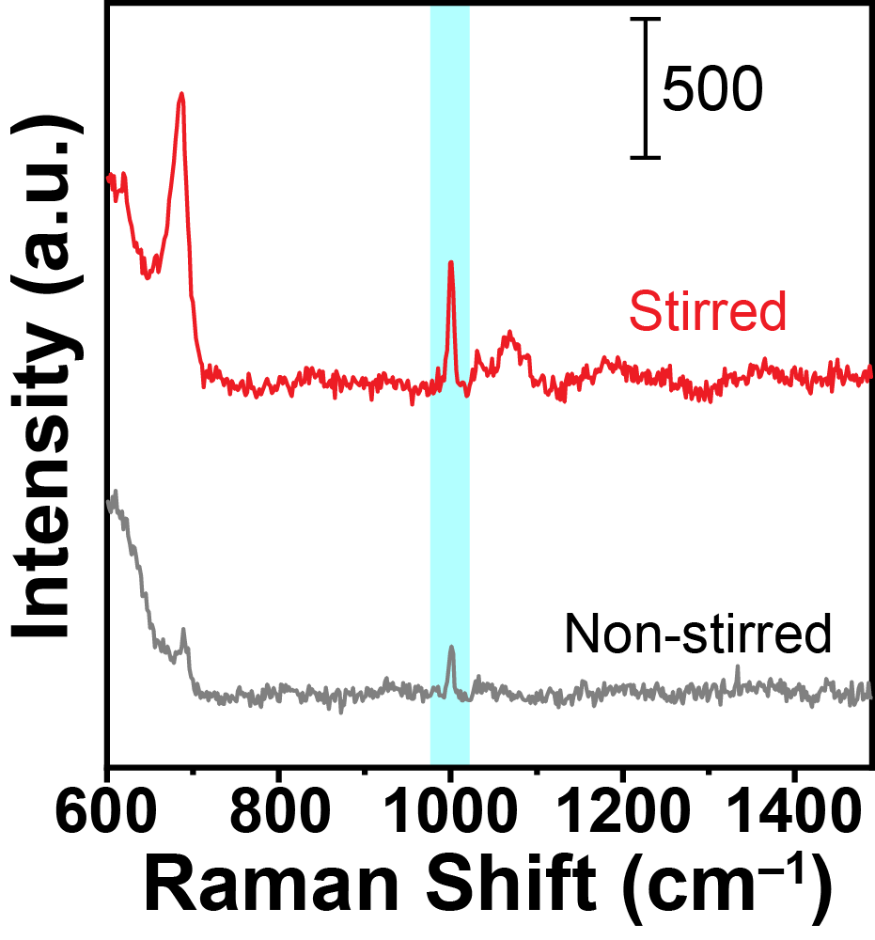
Supplementary Fig. 30 Comparison of SERS spectra of 10 μg/mL PS nanospheres from Ag/Co micromotors in the stirred (1000 rpm) and non-stirred condition.
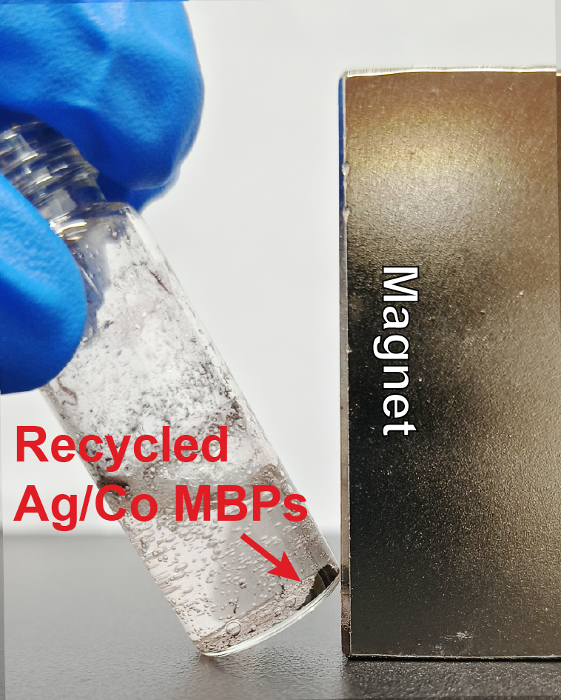
Supplementary Fig. 31 The Ag/Co micromotors were collected by a magnet after the flotation process.

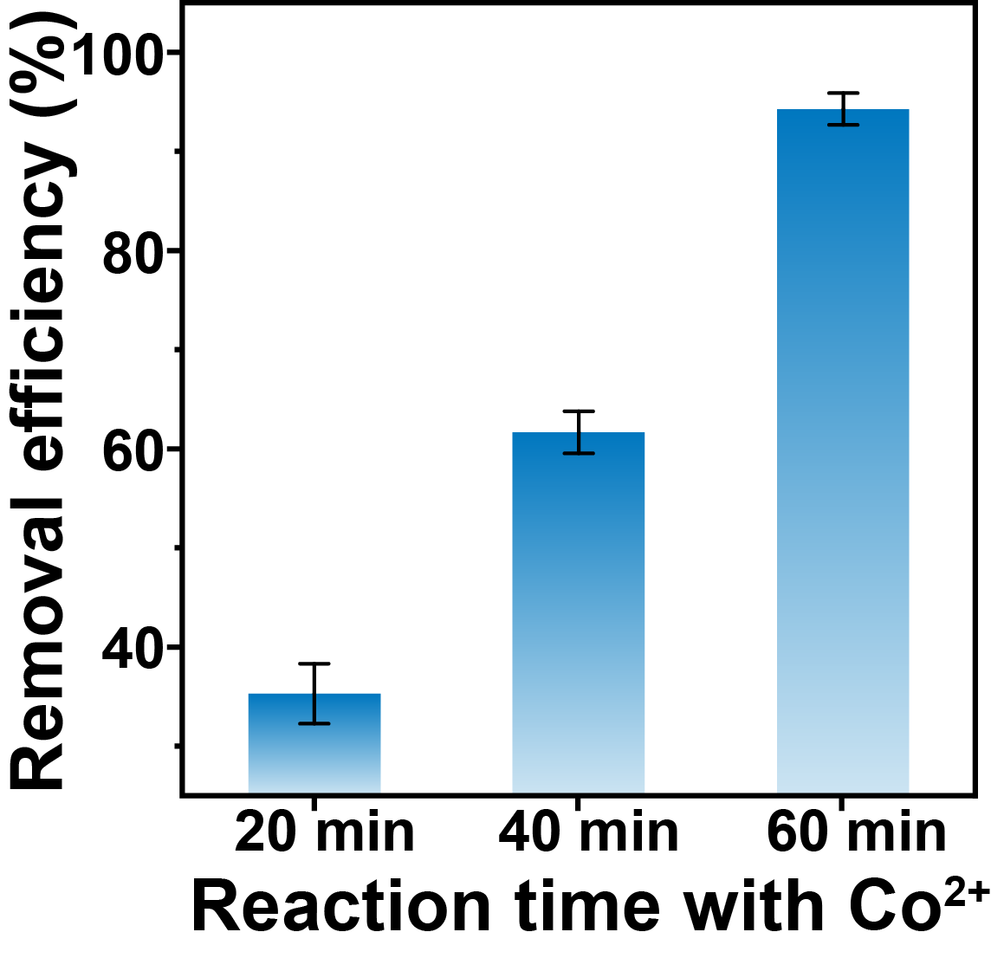
Supplementary Fig. 32 Removal efficiency of PS nanoplastics by Ag/Co micromotors with different conversion time with Co(NO₃)₂ during the galvanic replacement reaction. The error bars show the mean ± SD (n = 3).

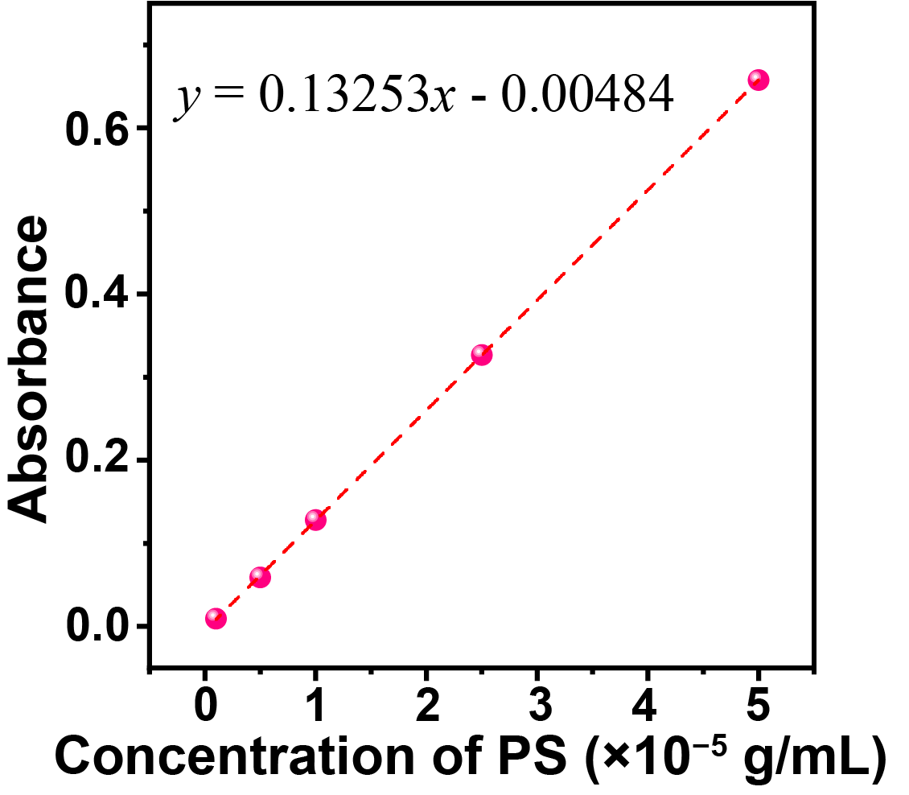
Supplementary Fig. 33 Calibration curve of absorbance for 200 nm red-colored PS nanospheres in water at different concentrations.

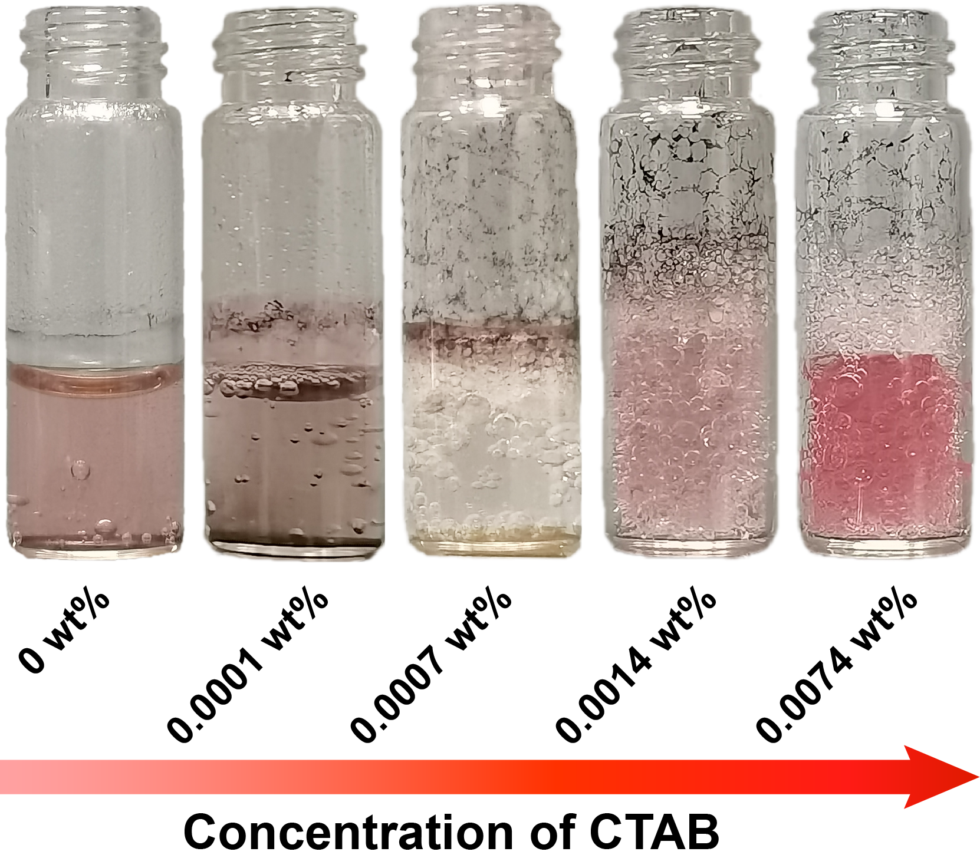
Supplementary Fig. 34 Digital photographs of the PS nanospheres suspensions after the flotation process under different concentration of CTAB.

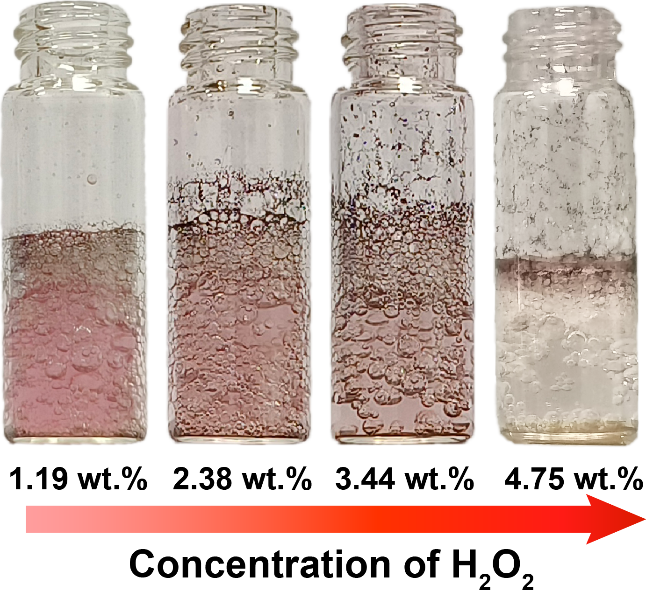
Supplementary Fig. 35 Digital photographs of the PS nanospheres suspensions after the flotation process under different concentrations of H₂O₂.

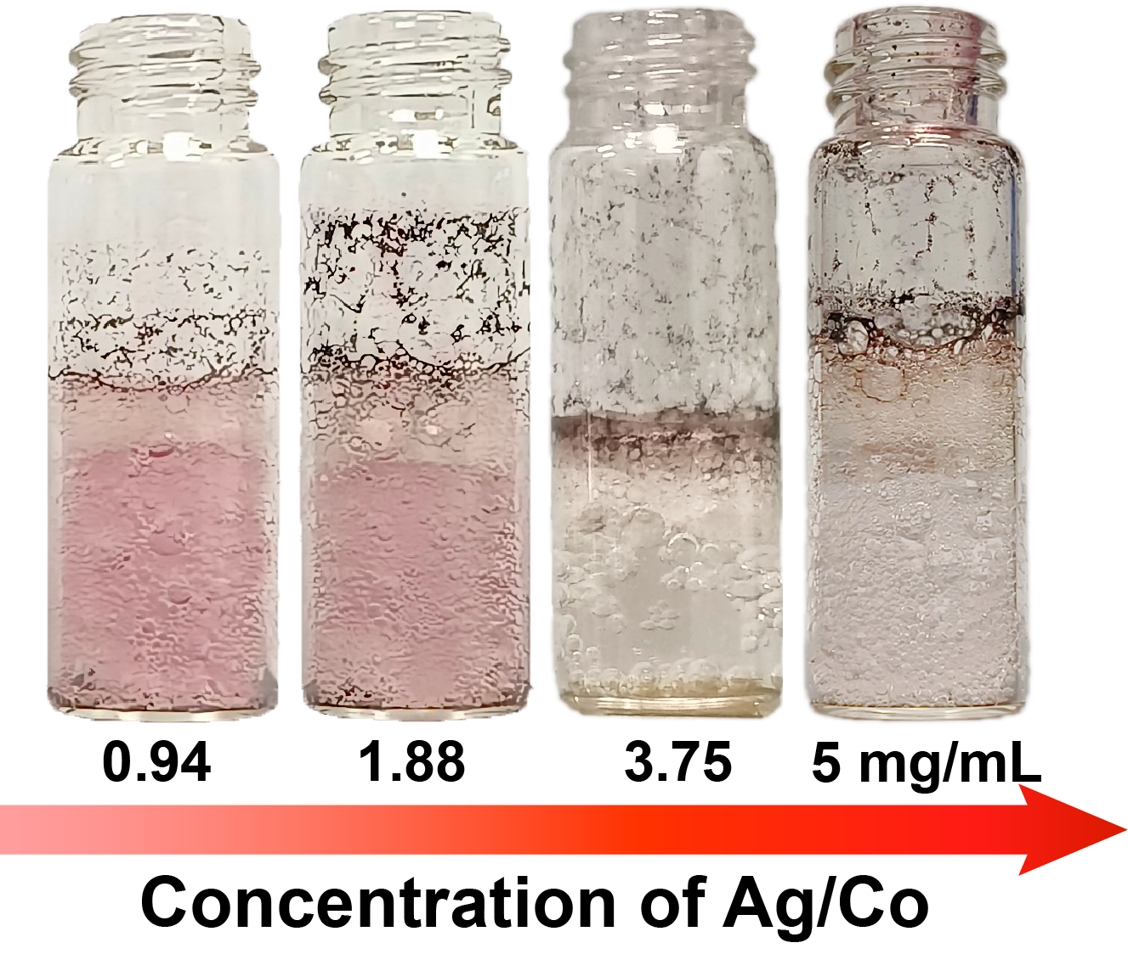
Supplementary Fig. 36 Digital photographs of the PS nanospheres suspensions after the flotation process under different concentrations of Ag/Co micromotors.

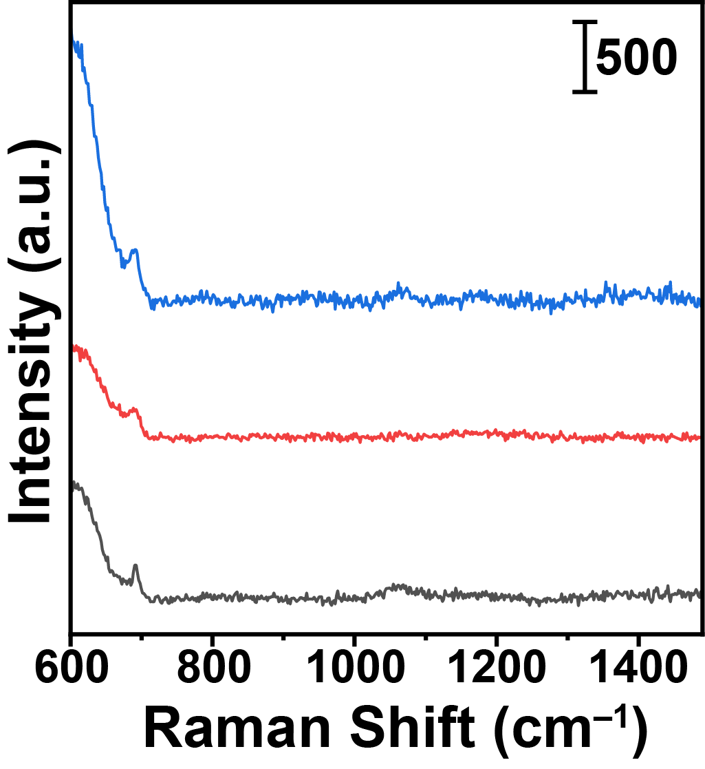
Supplementary Fig. 37 SERS spectra of PS suspensions after the flotation process collected on three random positions of Ag/Co micromotors. The suspension after flotation was mixed with 0.5 mg/mL Ag/Co micromotors, and then 20 μL of the mixture was dropped onto a slippery PDMS-covered silicon surface and then dried at 40 ℃. The SERS spectra were recorded on the Ag/Co micromotors.

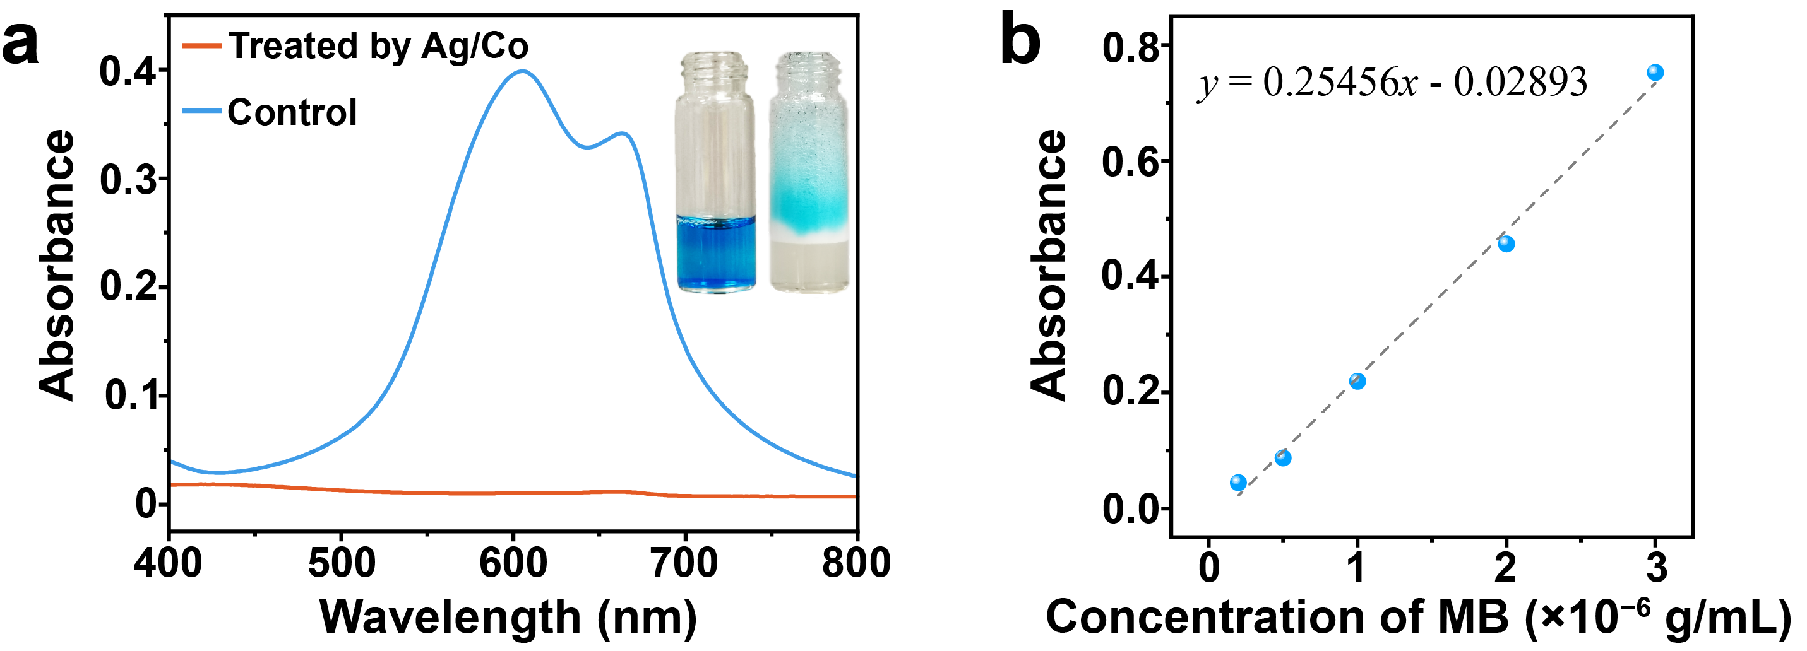
Supplementary Fig. 38 (a) Absorption spectra of the methylene blue (MB) solution treated with Ag/Co micromotors and the control sample without treatment. Inset is the digital photographs of the MB solution without treatment and treated with Ag/Co micromotors. (b) Calibration curve of absorbance for MB solutions at different concentrations.

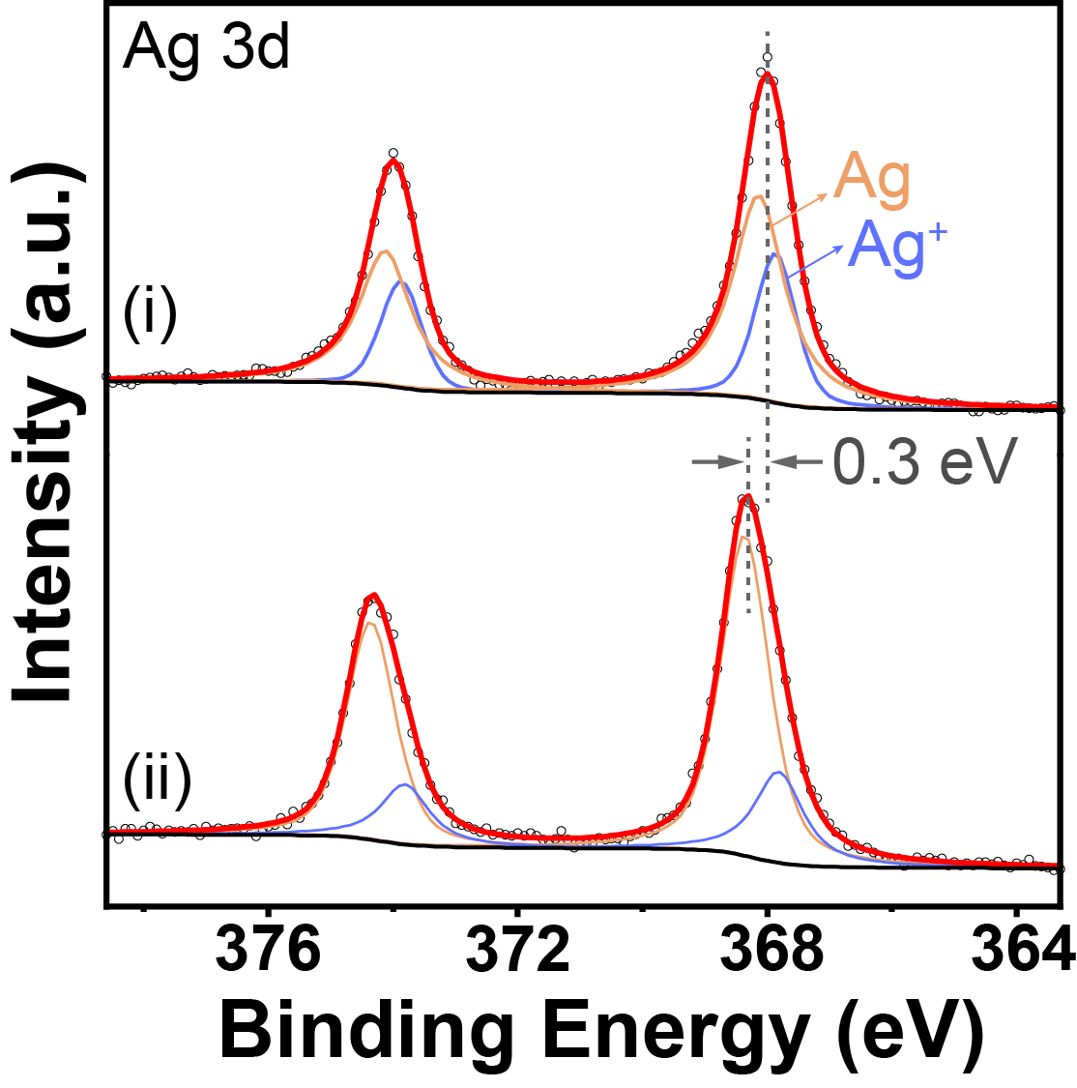
Supplementary Fig. 39 High-resolution XPS spectra of Ag 3d before (i) and after (ii) the restoration process of the Ag/Co micromotors using NaBH₄.

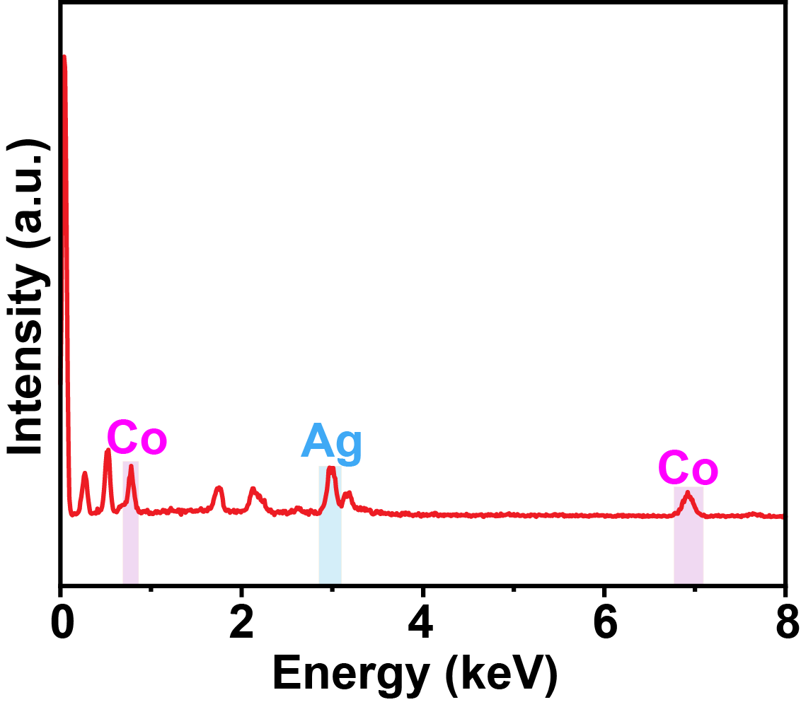
Supplementary Fig. 40 EDX spectrum of Ag/Co micromotors after six times usage.

Supplementary Fig. 41 (a) The absorption spectra of a potassium titanium oxalate solution with different concentrations of H₂O₂. Inset: digital photograph before and after treatment by Ag/Co micromotors. (b) Calibration curve of absorption at 400 nm acquired from the UV-vis absorption spectrum to evaluate the H₂O₂ concentration.

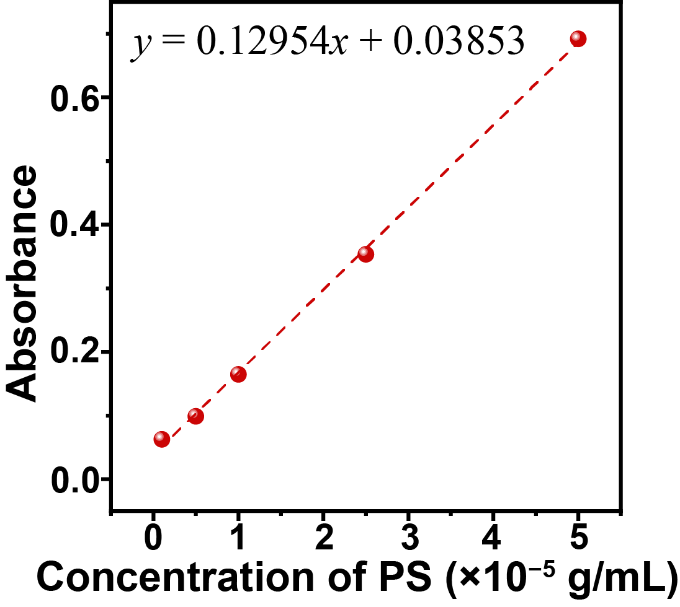
Supplementary Fig. 42 Calibration curve of absorbance for 200 nm red-colored PS nanospheres in real lake water at different concentrations.

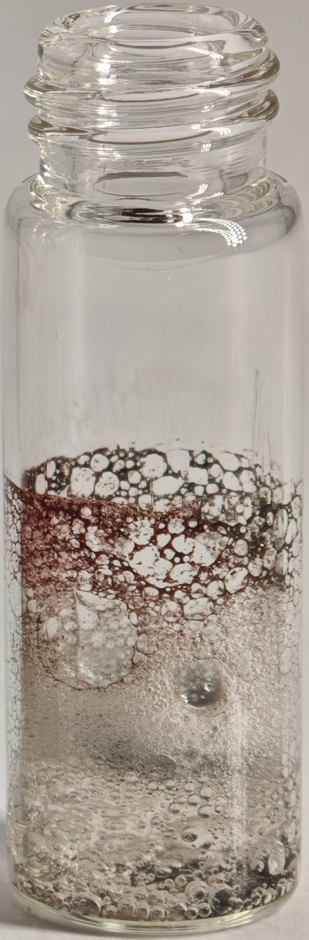
Supplementary Fig. 43 Digital photograph of the PS nanospheres in the tap water after the flotation process.

Supplementary Table 1. Comparison of different SERS substrates for the detection of nanoplastics.
SERS substrates | Nanoplastic size | Limit of detection (μg/mL) | Ref.
Ag nanoparticles | 1 μm | 5 μg/mL | 1
AuNSs@Ag@AAO | 400 nm | 50 μg/mL | 2
Ag nanoparticles | 100 nm | 40 μg/mL | 3
Au nanoparticles | 350 nm | 6.5 μg/mL | 4
Klarite substrates | 360 nm | 26 μg/mL | 5
Ag nanowires arrays on regenerated cellulose film | 84 nm | 100 μg mL | 6
Ag/Co micromotors | 200 nm | 5 μg/mL | This work

Supplementary Table 2. Comparison of different systems for the removal of nanoplastics
Materials | Nanoplastics size | Removal efficiency | Time | Reusability | Ref.
CuNi@carbon | 100 nm | 99.18% | 24 h | 75% in the 4th cycle | 7
Polyacrylonitrile membrane | 50 nm, 100 nm, 500 nm | 89.9%, 99.3%, 99.4% | 1 h | 99.2% in the 2nd cycle | 8
Cellulose/ layered double hydroxides composite beads | 100 nm | 97% | 24 h | 68% in the 5th cycle | 9
Fe₃O₄/carbon | 70 nm | 86.1% | 2 min | 76% in the 4th cycle | 10
Protein amyloid fibrils | 500 nm | 93.4% | 50 min | no | 11
Cloud-point extraction | 44 nm | 90.7% | 3.5 h | no | 12
UiO-66-NH₂/P123 | 26 nm | 100% | 1 week | no | 13
Polyethylenimine coated holocellulose acetoacetate fibers | 100 nm, 500 nm | 99.4%, 99.1% | 1.5 h | no | 14
Polycaprolactone-bound diatomite filter | 100 nm | 69.8% | 1 h | no | 15
Emulsion | 100 nm, 800 nm | 85% | 17 h | no | 16
Ag/Co micromotors | 200 nm | 94.3% | 40 min | 86.1% in the 5th cycle | This work

References
1. Zhou, X. X., Liu, R., Hao, L. T., Liu, J. F. Identification of polystyrene nanoplastics using surface enhanced Raman spectroscopy. Talanta 221, 121552 (2021).
2. Le, Q. T., et al. Nanostructured Raman substrates for the sensitive detection of submicrometer-sized plastic pollutants in water. J. Hazard. Mater. 402, 123499 (2021).
3. Lv, L., et al. In situ surface-enhanced Raman spectroscopy for detecting microplastics and nanoplastics in aquatic environments. Sci. Total Environ. 728, 138449 (2020).
4. Mikac, L., Rigó, I., Himics, L., Tolić, A., Ivanda, M., Veres, M. Surface-enhanced Raman spectroscopy for the detection of microplastics. Appl. Surf. Sci. 608, 155239 (2023).
5. Xu, G., et al. Surface-enhanced Raman spectroscopy facilitates the detection of microplastics <1 μm in the environment. Environ. Sci. Technol. 54, 15594-15603 (2020).
6. Jeon, Y., et al. Detection of nanoplastics based on surface-enhanced Raman scattering with silver nanowire arrays on regenerated cellulose films. Carbohydr. Polym. 272, 118470 (2021).
7. Zhou, G., et al. Removal of polystyrene nanoplastics from water by CuNi carbon material: The role of adsorption. Sci. Total Environ. 820, 153190 (2022).
8. Wang, R., Zhang, L., Chen, B., Zhu, X. Low-pressure driven electrospun membrane with tuned surface charge for efficient removal of polystyrene nanoplastics from water. J. Membr. Sci. 614, 118470 (2020).
9. Sun, J., et al. Effective removal of nanoplastics from water by cellulose/MgAl layered double hydroxides composite beads. Carbohydr. Polym. 298, 120059 (2022).
10. Kouchakipour, S., Hosseinzadeh, M., Qaretapeh, M. Z., Dashtian, K. Sustainable large-scale Fe₃O₄/carbon for enhanced polystyrene nanoplastics removal through magnetic adsorption coagulation. J. Water Process Eng. 58, 104919 (2024).
11. Peydayesh, M., et al. Sustainable removal of microplastics and natural organic matter from water by coagulation–flocculation with protein amyloid fibrils. Environ. Sci. Technol. 55, 8848-8858 (2021).
12. Li, Q., et al. Sequential isolation of microplastics and nanoplastics in environmental waters by membrane filtration, followed by cloud-point extraction. Anal. Chem. 93, 4559-4566 (2021).
13. Pedrero, D., Edo, C., Fernández-Piñas, F., Rosal, R., Aguado, S. Efficient removal of nanoplastics from water using mesoporous metal organic frameworks. Sep. Purif. Technol. 333, 125816 (2024).
14. Chen, Y., Kang, K., Guo, L., Kang, J., Qi, H. S. Facile synthesis of functional holocellulose fibers for removal of micro-/nanoparticles of plastics from waste water. Chem. Eng. J. 457, 141251 (2023).
15. Han, G., Oh, S., Yeo, S. J., Lee, J., Lim, H. Eco-friendly polycaprolactone-bound diatomite filter for the removal of metal ions and micro/nanoplastics from water. Sci. Total Environ. 905, 166956 (2023).
16. Li, Y., et al. A sustainable emulsion for separation and Raman identification of microplastics and nanoplastics. Chem. Eng. J. 469, 143992 (2023).

