1.1 Study Parameters

Table S 1 Overview of Clinical Features
 | Category | Sample Features
 | Anthropometrics & Demographics | Age, Gender, BMI, City Location
 | Oncology | Haematological Malignancy, Solid Tumors, Histology, Cancer Stage, Metastasis
 | Treatment | Chemotherapy, Chemo Cycle, Surgery, Filgrastam, Antibacterial, Antiamoebic, Antiviral, Antifungal, Filgrastam Prophylaxis(In 2 weeks), Antibacterial Prophylaxis (In 2 Weeks), Antiamoebic Prophylaxis (In 2 weeks), Antiviral Prophylaxis (In 2 Weeks), Antifungal Prophylaxis (In 2 weeks)
 | Microbiology | Culture (Blood, Fungal and Microscopy, Sputum, Wound Swab/ Pus/Tissue, Urine, Stool, Throat Swab), Resistance Status, HbsAg, Anti HCV, Anti HIV, HEV IgM, HAV IgM
 | Radiology | X-Ray (Chest, Paranasal Sinuses, Abdominal), CT scan (Abdomen, Chest, Brain), MRI Pelvis
 | Pathology & Hematology | Fever, Neutrophils, WBCs, RBCs, Haemoglobin, Platelets, Lymphocytes, BUN, Creatinine, ALT, AST, GGT, Alkalinee Phosphatase, S Albumin, S Globulin, CRP
BMI: Body Mass Index, WBCs: White Blood Cells, RBCs: Red Blood Cells, ALT: Alanine Aminotransferase,
AST: Aspartate Aminotransferase, GGT: Gamma-glutamyl Transferase, BUN: Blood Urea Nitrogen

1.2 Study Profile

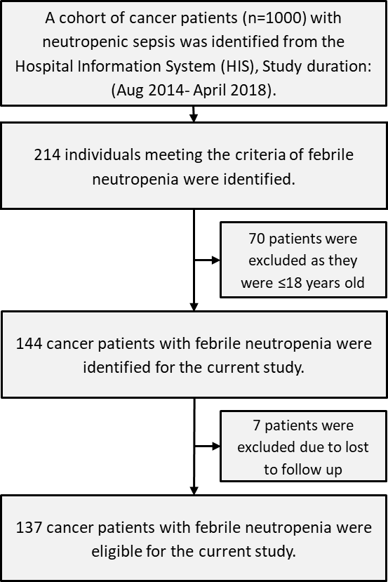
Figure S 1 Flow chart of patient selection

1.3 Patient Characteristics
Table S2- Frequency distribution of hematological malignancies in Neutropenic Cohort.

Haematological Malignancy | Frequency
Acute Myeloid Leukemia | 1
All | 16
Chronic Lymphocytic Leukemia (CLL) | 2
Hairy Cell Leukemia (HCL) | 1
Hodgkins Lymphoma | 5
Multiple Myeloma | 3
Non-Hodgkins Lymphoma | 30
Total | 58

Table S3- Frequency distribution of Solid Tumors in Neutropenic Cohort.
Solid Tumors | Frequency
Bladder Carcinoma | 1
Breast Bladder Dual Primaries | 1
Breast carcinoma | 40
Caecal cancer | 1
Carcinoma Lung | 1
cervical carcinoma | 1
Colon carcinoma | 1
Esophageal carcinoma | 2
Ewing sarcoma | 5
Gastroesophageal junction tumor | 2
Germ Cell Tumor | 3
Langerhan's cell Histiocytosis | 1
Langerhans histiocytosis | 1
Metastatic Germ Cell Tumor | 2
mixed germ cell tumor (right testicle) | 1
Osteosarcoma | 4
Ovarian carcinoma | 3
Prostate Carcinoma | 2
Rectal carcinoma | 1
Seminoma | 1
spindle cell sarcoma | 1
Submandibular Carcinoma | 1
Tongue carcinoma | 2
Yolk sac tumor | 2
Total | 80

Table S 4 - Microbiological profiling from different culture test.
Types of microbials | Type
Escherichia coli | Gram negative  (n=16)
Klebsiella pneumoniae | Gram negative  (n=16)
Klebsiella pneumoniae, Enterococcus species | Gram negative  (n=16)
Micrococcus species | Gram negative  (n=16)
Pseudomonas aeruginosa | Gram negative  (n=16)
Salmonella typhi, Escherichia coli | Gram negative  (n=16)
Streptococcus sanguinis, Escherichia coli | Gram negative  (n=16)
Acinetobacter baumanni, Staphylococcus aureus | Gram negative  (n=16)
Haemophilus parainfluenza | Gram negative  (n=16)
Haemophilus influenzae | Gram negative  (n=16)
Acinetobacter baumanni | Gram negative  (n=16)
Serratia odorifera | Gram negative  (n=16)
Shigella flexneri | Gram negative  (n=16)
Bifidobacterium species | Gram positive  (n=8)
Diphtheroid species | Gram positive  (n=8)
Staph aureus | Gram positive  (n=8)
Staphylococcus aureus | Gram positive  (n=8)
Staphylococcus epidermidis | Gram positive  (n=8)
Streptococcus species, Micrococcus species | Gram positive  (n=8)
Streptococcus (Group A) | Gram positive  (n=8)
Aspergillus flavus | Fungal  (n=2)
Candida albicans | Fungal  (n=2)
Blastocystis hominis | Parasite  (n=3)
Entamoeba histolytica | Parasite  (n=3)
Giardia lamblia | Parasite  (n=3)

Table S5 - Drug Profiling of Intermediate to High-Risk Drugs For Neutropenia Sepsis and Prophylactic Treatment.
S5A. Treatment
 |  | Survival Status
 |  | Alive | Dead
 |  | Count | Count
Carboplatin | No | 107 | 18
Carboplatin | Yes | 5 | 7
Cyclophosphamide | No | 67 | 17
Cyclophosphamide | Yes | 45 | 8
Dacarbazine | No | 110 | 25
Dacarbazine | Yes | 2 | 0
Docetaxel | No | 99 | 25
Docetaxel | Yes | 13 | 0
Doxorubicin | No | 65 | 19
Doxorubicin | Yes | 47 | 6
Etoposide | No | 99 | 19
Etoposide | Yes | 13 | 6
Pertuzumab | No | 112 | 25
Pertuzumab | Yes | 0 | 0
Trastuzumab | No | 111 | 25
Trastuzumab | Yes | 1 | 0
Vinblastine | No | 106 | 24
Vinblastine | Yes | 6 | 1
Vinorelbine | No | 107 | 24
Vinorelbine | Yes | 5 | 1
CP | No | 109 | 25
CP | Yes | 3 | 0
CHOP | No | 104 | 21
CHOP | Yes | 8 | 4
BEP | No | 106 | 24
BEP | Yes | 6 | 1
S5B. Prophylaxis Treatment
Antiamoebic Prophylaxis | No | 86 | 17
Antiamoebic Prophylaxis | Yes | 26 | 8
Antiviral Prophylaxis | No | 92 | 21
Antiviral Prophylaxis | Yes | 20 | 4
Antifungal Prophylaxis | No | 67 | 9
Antifungal Prophylaxis | Yes | 45 | 16
Antibiotics2WP | No | 63 | 12
Antibiotics2WP | Yes | 49 | 13
Antiamoebic 2WP | No | 105 | 24
Antiamoebic 2WP | Yes | 7 | 1
Antiviral 2WP | No | 71 | 13
Antiviral 2WP | Yes | 41 | 12
Antifungal 2WP | No | 83 | 17
Antifungal 2WP | Yes | 29 | 8

S5C. Platelet Profile for The Chemotherapy
 |  | Platelets x10³uL
 |  | Mean | Median | 95.0% Lower CL for Median | 95.0% Upper CL for Median
Carboplatin | No | 115.50 | 85.00 | 70.00 | 115.00
Carboplatin | Yes | 71.33 | 24.00 | 3.00 | 125.00
Doxorubicin | No | 115.20 | 85.00 | 63.00 | 121.00
Doxorubicin | Yes | 105.98 | 76.00 | 37.00 | 119.00
Cisplatin | No | 115.49 | 80.00 | 54.00 | 119.00
Cisplatin | Yes | 91.50 | 84.50 | 39.00 | 115.00
Cyclophosphamide | No | 96.61 | 61.50 | 40.00 | 85.00
Cyclophosphamide | Yes | 135.45 | 119.00 | 84.00 | 155.00
Dacarbazine | No | 107.78 | 80.00 | 56.00 | 109.00
Dacarbazine | Yes | 372.00 | 372.00 | 369.00 | 375.00
Docetaxel | No | 98.35 | 72.00 | 46.00 | 86.00
Docetaxel | Yes | 238.31 | 215.00 | 125.00 | 383.00
Vinblastine | No | 106.98 | 78.50 | 51.00 | 109.00
Vinblastine | Yes | 198.14 | 188.00 | 86.00 | 375.00
Vinorelbine | No | 110.11 | 79.00 | 54.00 | 109.00
Vinorelbine | Yes | 145.00 | 126.50 | 100.00 | 172.00
Etoposide | No | 119.26 | 89.00 | 70.00 | 121.00
Etoposide | Yes | 64.26 | 39.00 | 17.00 | 80.00
CP | No | 111.40 | 81.50 | 56.00 | 109.00
CP | Yes | 122.00 | 125.00 | 33.00 | 208.00
CHOP | No | 114.05 | 83.00 | 60.00 | 114.00
CHOP | Yes | 86.50 | 78.50 | 14.00 | 135.00
BEP | No | 112.82 | 83.50 | 60.00 | 113.00
BEP | Yes | 89.71 | 56.00 | 27.00 | 251.00

Patient’s clinical data
n= 137
Haematological Parameters
Anthropometric Measures & Other Parameters
Chemotherapeutic Agents
Antimicrobials and GCSF prophylactic agents
Data Preprocessing/ Categorization
Literature reported Risk factors for death amongst neutropenic sepsis patients

High and intermediate risk of NS

Model 1
Model 3
Model 2
Final Model
Significant factors
Significant factors

GCSF Prophylaxis
Antiamoebic Prophylaxis
Antiviral Prophylaxis
Antifungal Prophylaxis
Antibiotics 2WP
Antiamoebic 2WP
Antiviral 2WP
Antifungal 2WP
2WP: 2 weeks prophylaxis

Cisplatin
Cyclophosphamide
Docetaxel
Doxorubicin
Etoposide
Vinorelbine
Vinblastine
CP
CHOP
BEP
Trastuzumab
Dacarbazine
Carboplatin
Pertuzumab
Cycle

Age
BMI
Platelet count
Hemoglobin
Shock
Pneumonia
Gender (Male sex)
Length of hospital stay >5 days
Type of Malignancy/Leukemia
ANC<0.1x10^9/L
Gram negative infection

Figure S2 - Schematics for Multivariate Modeling

Primary analysis of available covariates
(n = 144)
Final Predictive model for mortality
Further categorization of the covariates
(N = 144)
Univariate analysis of clinical candidate predictors
(n = 137)
Multivariable analysis of final predictors (set 1, set 2 and set3) for different models
(n =137)
Loss to follow up (n=7)
Figure S3 - Predictor Selection Procedure.

Supplementary material for set 1 and Model 1:

2. Predictor Set 1: Multivariate analysis of factors associated with in-hospital mortality
Predictor Variables: Age_TOA, BMI, Platletsx10E3uL, Hemoglobin g/dL, Shock, Pneumonia, GramNegInfection

2.1 Random Forest Model
AUC: 0.8621
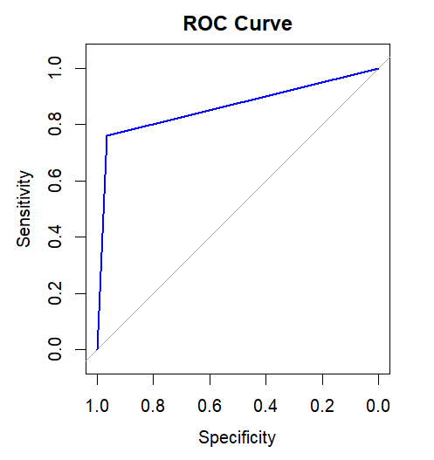
Figure S - 4 ROC curve for Random Forest Model of Set 1 Predictors

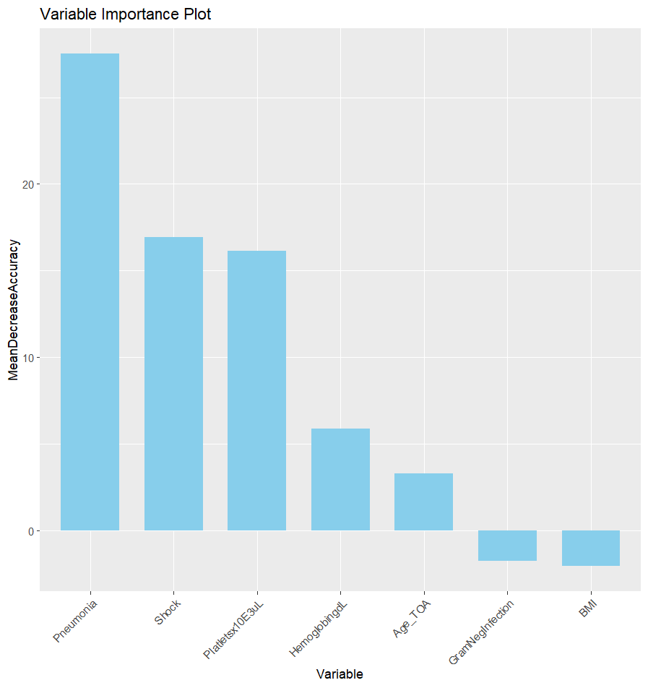
Figure S5 - Variable importance plot an outcome of Random Forest Model of Set 1 Predictors

2.2 Logistic Regression Model

Table S 6 Output in Tabular Format for Logistic Regression Model of Set 1 Predictors
Variables in the Equation
 |  | B | S.E. | Wald | df | Sig. | Exp(B) | 95% C.I.for EXP(B)
 |  |  |  |  |  |  |  | Lower | Upper
1ª | Age_TOA | .020 | .024 | .652 | 1 | .419 | 1.020 | .972 | 1.070
1ª | BMI | .004 | .062 | .004 | 1 | .947 | 1.004 | .889 | 1.135
1ª | Platletsx10E3uL | -.007 | .004 | 2.521 | 1 | .112 | .993 | .985 | 1.002
1ª | HemoglobingdL | -.090 | .161 | .311 | 1 | .577 | .914 | .667 | 1.253
1ª | Shock(1) | 1.44 | .406 | 12.723 | 1 | .000 | 4.255 | 1.920 | 9.428
1ª | Pneumonia(1) | 1.69 | .406 | 17.368 | 1 | .000 | 5.428 | 2.450 | 12.027
1ª | GramNegInfection(1) | -.256 | .377 | .460 | 1 | .498 | .774 | .370 | 1.621
1ª | Constant | .941 | 1.491 | .398 | 1 | .528 | 2.562
a. Variable(s) entered on step 1: Age_TOA, BMI, Platletsx10E3uL, HemoglobingdL, Shock, Pneumonia, GramNegInfection.

Classification Function Coefficients
 | Survival_Reg
 | Alive | Dead
Age_TOA | .073 | .089
BMI | .681 | .688
Platletsx10E3uL | -.007 | -.011
HemoglobingdL | 2.022 | 1.958
Shock | 20.007 | 25.862
Pneumonia | 20.438 | 26.324
GramNegInfection | 5.472 | 4.968
(Constant) | -43.120 | -56.469
Fisher's linear discriminant functions

2.3 Linear Discriminant Analysis

Table S7 - Fisher's Classification Discriminant Functions for Set 1 predictors.

3. Predictor Set 2: Evaluation of Chemotherapeutic related factors in association with mortality amongst febrile neutropenic patients

Predictor Variables:
Cisplatin, Cyclophosphamide, Docetaxel, Doxorubicin, Etoposide, Vinorelbine, Vinblastine, CP, CHOP, BEP, Trastuzumab, Dacarbazine, Carboplatin, Pertuzumab

3.1 Random Forest
AUC: 0.6428
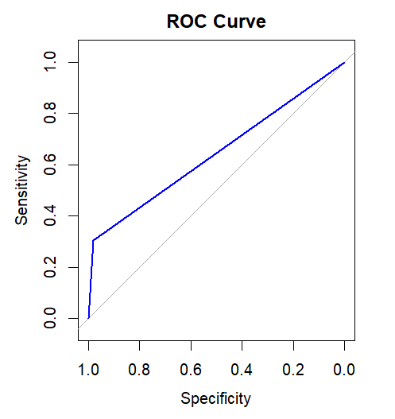
Figure S6 - ROC curve for Random Forest Model of Set 2 Predictors

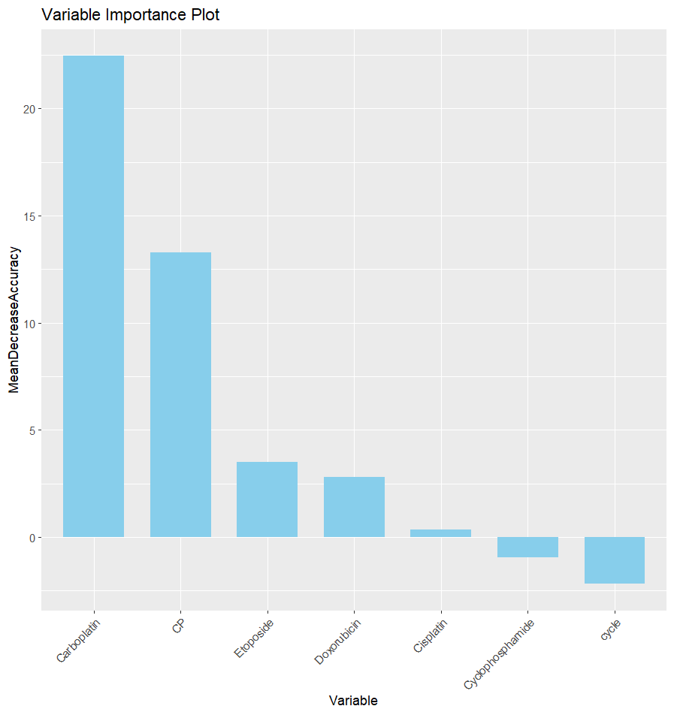
Figure S7 - Variable importance plot an outcome of Random Forest Model of Set 2 Predictors

3.2 Logistic Regression

Table S8 - Output in Tabular Format for Logistic Regression Model of Set 2 Predictors
Variables in the Equation
 |  | B | S.E. | Wald | df | Sig. | Exp(B) | 95% C.I.for EXP(B)
 |  |  |  |  |  |  |  | Lower | Upper
1^{a,b} | Cisplatin(1) | .105 | .416 | .063 | 1 | .802 | 1.110 | .491 | 2.509
1^{a,b} | Carboplatin(1) | 1.638 | .549 | 8.896 | 1 | .003 | 5.146 | 1.754 | 15.100
1^{a,b} | Cyclophosphamide(1) | .460 | .387 | 1.412 | 1 | .235 | 1.584 | .742 | 3.384
1^{a,b} | Doxorubicin(1) | -.419 | .370 | 1.280 | 1 | .258 | .658 | .319 | 1.359
1^{a,b} | Etoposide(1) | -.040 | .449 | .008 | 1 | .930 | .961 | .398 | 2.319
1^{a,b} | CP(1) | -11.256 | 11602.34 | .000 | 1 | .999 | .000 | .000 | .
1^{a,b} | cycle | .012 | .156 | .006 | 1 | .938 | 1.012 | .746 | 1.373
1^{a,b} | Constant | -11.511 | 11602.34 | .000 | 1 | .999 | .000
a. Variable(s) entered on step 1: Cisplatin, Carboplatin, Cyclophosphamide, Doxorubicin, Etoposide, CP, cycle.
b. Variable(s) entered on step 1: Cisplatin, Carboplatin, Cyclophosphamide, Doxorubicin, Etoposide, cycle.

3.3 Linear Discriminant Analysis

Table S9 - Fisher's Classification Discriminant Functions for Set 2 predictors.
Classification Function Coefficients
 | survival_Reg
 | Alive | Dead
Cisplatin | 16.771 | 16.934
Carboplatin | 6.421 | 11.929
Cyclophosphamide | 12.459 | 13.363
Doxorubicin | 4.402 | 3.581
Etoposide | 9.879 | 9.841
CP | 50.406 | 43.819
cycle | 1.515 | 1.528
(Constant) | -59.365 | -59.481
Fisher's linear discriminant functions

4. Predictor Set 3: Impact of antimicrobials and GCSF-Prophylaxis on hospital mortality

4.1 Random Forest
Predictor Variables: "GCSFProphylaxis","AntiamoebicProphylaxis","AntiviralProphylaxis","AntifungalProphylaxis", "Antibiotics2WP","Antiamoebic2WP","Antiviral2WP","Antifungal2WP"
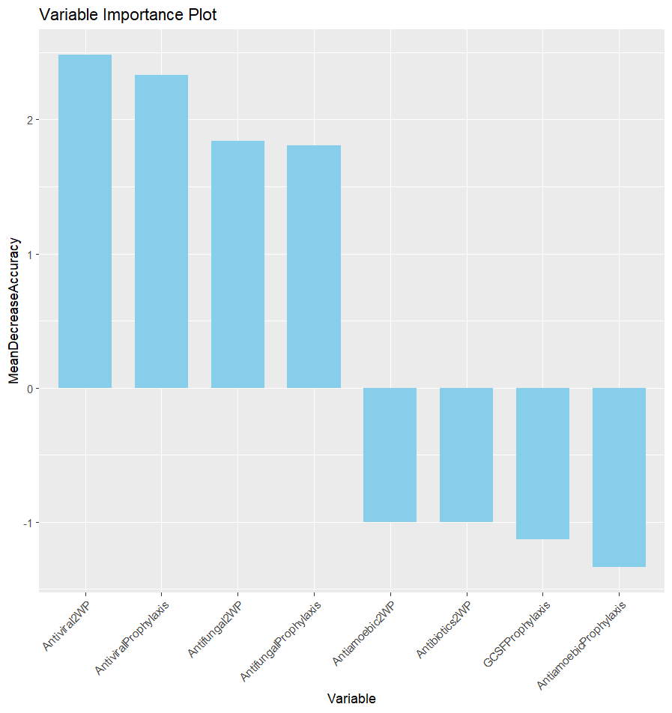
Figure S8 - Variable importance plot an outcome of Random Forest Model of Set 3 Predictor

4.2 Logistic Regression

Table S10 - Output in Tabular Format for Logistic Regression Model of Set 3 Predictors
Variables in the Equation
 |  | B | S.E. | Wald | df | Sig. | Exp(B) | 95% C.I.for EXP(B)
 |  |  |  |  |  |  |  | Lower | Upper
1ª | GCSFProphylaxis(1) | .007 | .859 | .000 | 1 | .993 | 1.007 | .187 | 5.427
1ª | AntiamoebicProphylaxis(1) | .832 | .555 | 2.245 | 1 | .134 | 2.298 | .774 | 6.822
1ª | AntiviralProphylaxis(1) | -1.368 | .821 | 2.776 | 1 | .096 | .255 | .051 | 1.273
1ª | AntifungalProphylaxis(1) | 1.245 | .519 | 5.765 | 1 | .016 | 3.473 | 1.257 | 9.595
1ª | Antibiotics2WP(1) | .168 | .546 | .094 | 1 | .759 | 1.182 | .406 | 3.447
1ª | Antiamoebic2WP(1) | -.266 | 1.173 | .051 | 1 | .821 | .767 | .077 | 7.645
1ª | Antiviral2WP(1) | .526 | .542 | .941 | 1 | .332 | 1.692 | .585 | 4.897
1ª | Antifungal2WP(1) | -.006 | .613 | .000 | 1 | .993 | .994 | .299 | 3.305
1ª | Constant | -2.440 | .882 | 7.663 | 1 | .006 | .087
a. Variable(s) entered on step 1: GCSFProphylaxis, AntiamoebicProphylaxis, AntiviralProphylaxis, AntifungalProphylaxis, Antibiotics2WP, Antiamoebic2WP, Antiviral2WP, Antifungal2WP.

4.3 LDA

Table S11 - Fisher's Classification Discriminant Functions for Set 3 predictors.
Classification Function Coefficients
 | survival_Reg
 | Alive | Dead
GCSFProphylaxis | 23.009 | 23.051
AntiamoebicProphylaxis | 5.624 | 6.436
AntiviralProphylaxis | -3.593 | -4.999
AntifungalProphylaxis | 4.656 | 5.928
Antibiotics2WP | .383 | .521
Antiamoebic2WP | 19.452 | 19.212
Antiviral2WP | 3.671 | 4.229
Antifungal2WP | .324 | .327
(Constant) | -40.606 | -42.763
Fisher's linear discriminant functions

5. Integrative Model

Logistic Regression

Table S 12 - Unadjusted Joint Model Logistic Regression Output in Tabular Format
Variables in the Equation
 |  | B | S.E. | Wald | df | Sig. | Exp(B) | 95% C.I. for EXP(B)
 |  |  |  |  |  |  |  | Lower | Upper
Step 1a | Age_TOA | .003 | .024 | .015 | 1 | .901 | 1.003 | .957 | 1.052
Step 1a | HemoglobingdL | -.192 | .148 | 1.689 | 1 | .194 | .825 | .618 | 1.102
Step 1a | Shock(1) | 1.631 | .400 | 16.639 | 1 | .000 | 5.111 | 2.334 | 11.192
Step 1a | Pneumonia(1) | 1.422 | .408 | 12.144 | 1 | .000 | 4.147 | 1.863 | 9.230
Step 1a | Carboplatin(1) | 1.018 | .436 | 5.447 | 1 | .020 | 2.768 | 1.177 | 6.509
Step 1a | Doxorubicin(1) | -.251 | .369 | .464 | 1 | .496 | .778 | .378 | 1.602
Step 1a | Antifungal2WP(1) | -.480 | .877 | .300 | 1 | .584 | .619 | .111 | 3.449
Step 1a | AntiviralProphylaxis(1) | -.401 | 1.034 | .151 | 1 | .698 | .669 | .088 | 5.078
Step 1a | Constant | 2.854 | 1.575 | 3.286 | 1 | .070 | 17.360
a. Variable(s) entered on step 1: Age_TOA, HemoglobingdL, Shock, Pneumonia, Carboplatin, Doxorubicin, Antifungal2WP, AntiviralProphylaxis.

Table S13 - Components of Adjusted Logistic Regression model
Bootstrap for Variables in the Equation
 |  | B | Bootstrapª
 |  | B | Bias | Std. Error | Sig.  (2-tailed) | 95% Confidence Interval
 |  |  |  |  |  | Lower | Upper
Step 1 | Age_TOA | .003 | -.003 | .029 | .871 | -.057 | .053
Step 1 | HemoglobingdL | -.192 | -.046 | .246 | .172 | -.710 | .135
Step 1 | Shock(1) | 1.631 | .936 | 3.638 | .001 | .806 | 12.143
Step 1 | Pneumonia(1) | 1.422 | .736 | 2.952 | .002 | .332 | 11.764
Step 1 | Carboplatin(1) | 1.018 | .387 | 2.106 | .001 | .279 | 2.805
Step 1 | Doxorubicin(1) | -.251 | -.184 | 2.187 | .503 | -8.738 | .755
Step 1 | Antifungal2WP(1) | -.480 | -.261 | 3.868 | .665 | -4.820 | 2.065
Step 1 | AntiviralProphylaxis(1) | -.401 | -1.277 | 7.599 | .774 | -21.022 | 2.144
Step 1 | Constant | 2.854 | 1.627 | 5.896 | .056 | -.330 | 16.872
a. Unless otherwise noted, bootstrap results are based on 1000 bootstrap samples

LDA

Table S14 - Fisher's Classification Discriminant Functions for Final predictors
Classification Function Coefficients
 | survival_Reg
 | Alive | Dead
Carboplatin | 20.537 | 24.151
Pneumonia | 21.182 | 26.671
Shock | 19.774 | 26.041
Doxorubicin | 12.600 | 12.121
AntiviralProphylaxis | 11.945 | 11.549
Antifungal2WP | 5.844 | 5.368
HemoglobingdL | 2.821 | 2.611
Age_TOA | .328 | .334
(Constant) | -71.309 | -86.472
Fisher's linear discriminant functions
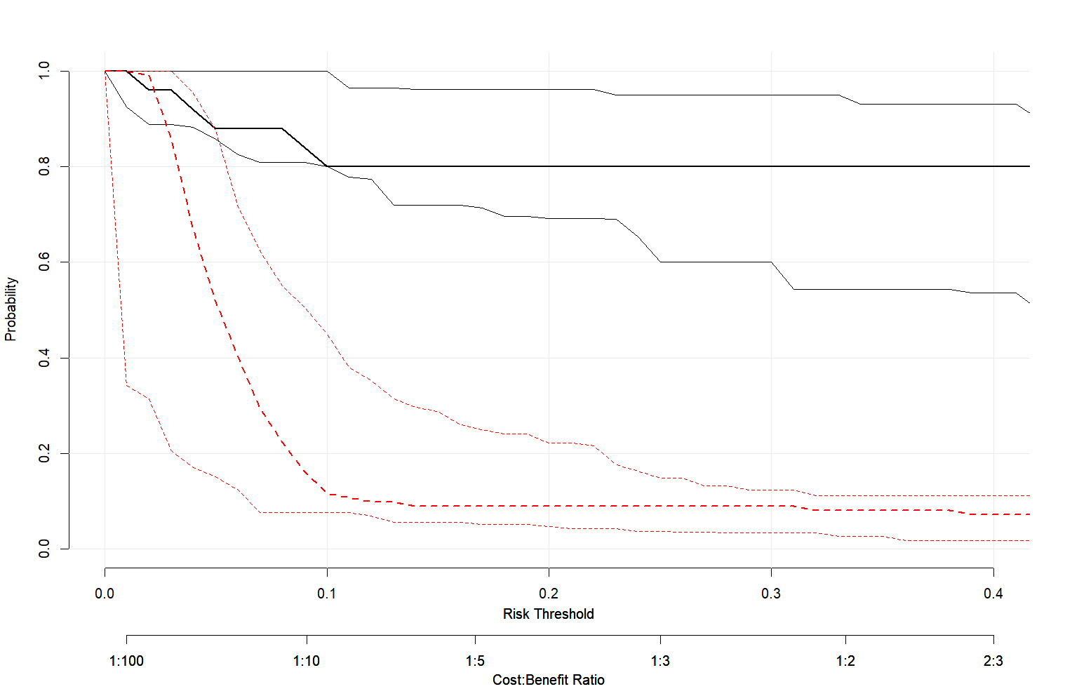
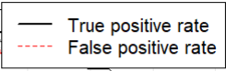
Figure S9. Decision Curve Analysis (DCA) showing probability of true positive and false rate at varying risk thresholds.

Random Forest
Trees:
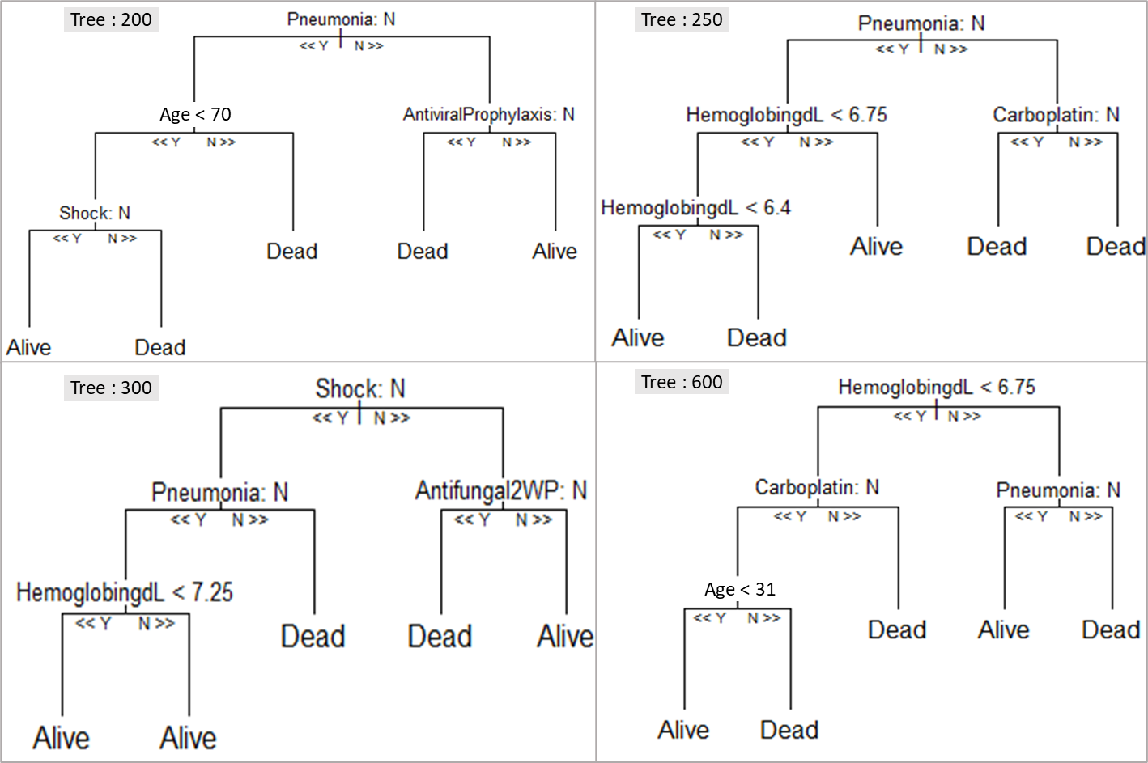
Figure S10. Trees of Random Forest Model

