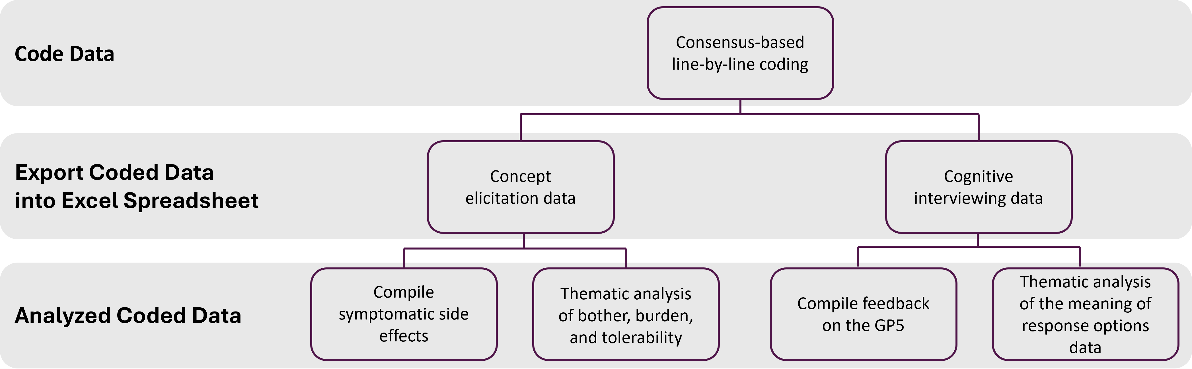
Supplemental Figure 1. Coding and analysis methods

Supplemental Table 1. Demographic and health characteristics
Demographic and health characteristics | N=40
Age (in years)
Mean (SD), Median | 55.5 (13.6), 60.5
Range | 23 - 76
Sex, n (%)
Male | 27 (67.5%)
Female | 13 (32.5%)
Country, n (%)
Australia | 3 (7.5%)
Czech Republic | 6 (15.0%)
Germany | 5 (12.5%)
Italy | 12 (30.0%)
Poland | 8 (20.0%)
Spain | 1 (2.5%)
United Kingdom | 5 (12.5%)
ECOG, n (%)
0 | 29 (72.5%)
1 | 11 (27.5%)
Year of MTC diagnosis, n (%)
1996 - 2000 | 3 (7.5%)
2001 - 2005 | 1 (2.5%)
2006 - 2010 | 3 (7.5%)
2011 - 2015 | 2 (5.0%)
2016 - 2020 | 24 (60.0%)
2021 - 2022 | 7 (17.5%)
Time between first day of treatment in the trial and the interview date (weeks)
10 - 14 weeks | 4 (10.0%)
15 - 24 weeks | 3 (7.5%)
> 24 weeks | 33 (82.5%)
Mean (SD), Median | 62.7 (37.1), 59
Range | 11 - 135

