Supplemental Table 1: Data collection and refinement statistics of JNK3 complexes
Protein (PDB ID) | JNK3:21G (8VO4) | JNK3:21J (8VNX) | JNK3:23GA (8VS0) | JNK3:23M (8VTF)
Data collection
Space group | P 212121 | P 212121 | P 212121 | P 212121
Cell dimensions  a, b, c (Å) | 52.230 71.040 107.540 90.00 90.00 90.00 | 52.220 71.210 107.740 90.00 90.00 90.00 | 53.460 71.330 107.800 90.00 90.00 90.00 | 51.762 71.242 107.769 90.00 90.00 90.00
Resolution (Å)¹ | 71.04-2.07 (2.12-2.07) | 71.21-2.00 (2.05-2.00) | 43.01-2.46 (2.56-2.46) | 53.88-2.02 (2.06-2.02)
Unique reflections¹ | 25234 (1911) | 27927 (2025) | 15534 (1717) | 23488 (1198)
Mean I/I¹ | 11.5 (3.0) | 10.5 (4.3) | 8.9 (3.6) | 19.4 (1.8)
Completeness (%)¹ | 99.9 (100.0) | 99.3 (99.9) | 99.7 (99.5) | 87.5 (90.3)
Multiplicity¹ | 6.3 (6.6) | 6.0 (6.2) | 6.1 (6.3) | 4.3 (3.7)
Rmerge¹ | 0.098 (0.660) | 0.095 (0.324) | 0.110 (0.381) | 0.046 (0.691)
Rpim¹ | 0.043 (0.275) | 0.043 (0.275) | 0.070 (0.240) | 0.034 (0.490)
CC1/2¹ | 0.959 (0.893) | 0.959 (0.893) | 0.900 (0.963) | 0.999 (0.734)
Refinement
Resolution (Å)¹ | 53.77-2.07 (2.15- 2.07) | 37.49-2.00 (2.07-2.00) | 42.78-2.46 (2.56-2.46) | 53.88-2.80 (3.08-2.80)
No. of reflections¹ | 25143 (2758) | 27839 (2566) | 15430 (1542) | 10124 (2504)
No. of reflections in Rfree^{1,2} | 1200 (125) | 1406 (155) | 1199 (130) | 504 (116)
Rwork¹ | 0.2200 (0.2719) | 0.2119 (0.2519) | 0.1932 (0.2504) | 0.154 (0.174)
Rfree¹ | 0.2508 (0.3336) | 0.2557 (0.3119) | 0.2053 (0.2510) | 0.162 (0.179)
R.m.s. Bond length (Å) | 0.010 | 0.004 | 0.003 | 0.002
R.m.s. Bond angle (º) | 1.092 | 0.728 | 0.736 | 0.519
B-factor, protein (Å²) | 40.42 | 42.53 | 60.73 | 49.06
B-factor, Ligand (Å²) | 28.60 | 28.65 | 46.29 | 33.94
B-factor, Water (Å²) | 43.00 | 40.52 | 53.72 | 38.93
Number of atoms
Protein | 2791 | 2804 | 2832 | 2800
Ligand | 32 | 30 | 32 | 31
Water | 178 | 133 | 34 | 48
Model quality (%)
Ramachandran favored | 94.41 | 92.94 | 92.94 | 95.29
Ramachandran allowed | 4.71 | 6.18 | 6.47 | 4.41
Ramachandran outliers | 0.88 | 0.88 | 0.59 | 0.29
Rotamer outliers | 0.32 | 0.00 | 1.61 | 0.32
1 Parentheses refer to statistics for the highest resolution shell.
2 Rfree is calculated with removal of 2 % of the reflections as the test set before the refinement.

Supplemental Table 2: Data collection and refinement statistics of p38α complexes
Protein (PDB ID) | p38α:21G (8VWM) | p38α:21J (8VT6) | p38α:23GA (8VMH) | p38α:23M (8VMM)
Data collection
Space group | P 212121 | P 212121 | P 212121 | P 212121
Cell dimensions  a, b, c (Å) | 66.120 70.780 77.050 90.00 90.00 90.00 | 66.180 70.440 77.000 90.00 90.00 90.00 | 65.640 74.050 77.740 90.00 90.00 90.00 | 66.350 74.330 78.710 90.00 90.00 90.00
Resolution (Å)¹ | 40.80-1.93 (1.98-1.93) | 77.00-2.31(2.40-2.31) | 65.64-2.31 (2.40-2.31) | 41.90-2.40 (2.49-2.40)
Unique reflections¹ | 27450 (1796) | 16246 (1568) | 16921 (1609) | 15805 (1556)
Mean I/I¹ | 19.1 (4.8) | 30.8 (20.0)) | 9.2 (1.9) | 54.4 (6.6)
Completeness (%)¹ | 100.0 (99.7) | 99.8 (99.9) | 99.1 (98.7) | 99.99 (99.94)
Multiplicity¹ | 7.0 (6.5) | 6.2 (6.5) | 6.0 (6.1) | 11.8 (11.5)
Rmerge¹ | 0.072 (0.430) | 0.039 (0.077) | 0.119 (0.948) | 0.675 (1.070)
Rpim¹ | 0.043 (0.181) | 0.017 (0.032) | 0.072 (0.606) | 0.204 (0.327)
CC1/2¹ | 0.990 (0.904) | 0.999 (0.996) | 0.997 (0.691) | 0.769 (0.610)
Refinement
Resolution (Å)¹ | 38.52-1.94 (2.02-1.94 | 40.88-2.31 (2.38-2.31) | 49.12-2.46 (2.65-2.46) | 39.35-2.40(2.55-2.40)
No. of reflections¹ | 27240 (2821) | 16196 (1188) | 14114 (2773) | 15741 (2570)
No. of reflections in Rfree^{1,2} | 1243 (152) | 1624 (134) | 685 (132) | 770 (131)
Rwork¹ | 0.1791 (0.2277) | 0.1608 (0.2158) | 0.2068 (0.2542) | 0.2042 (0.2696)
Rfree¹ | 0.2080 (0.2947) | 0.1629 (0.2442) | 0.2625 (0.3279) | 0.2632 (0.3322)
R.m.s. Bond length (Å) | 0.009 | 0.009 | 0.002 | 0.001
R.m.s. Bond angle (º) | 1.117 | 1.019 | 0.537 | 0.477
B-factor, protein (Å²) | 23.76 | 29.01 | 46.55 | 45.72
B-factor, Ligand (Å²) | 21.13 | 28.14 | 40.10 | 47.21
B-factor, Water (Å²) | 29.66 | 30.08 | 44.71 | 42.71
Number of atoms
Protein | 2811 | 2797 | 2751 | 2751
Ligand | 32 | 30 | 32 | 31
Water | 352 | 188 | 81 | 103
Model quality (%)
Ramachandran favored | 96.22 | 96.22 | 96.44 | 96.44
Ramachandran allowed | 3.79 | 3.78 | 3.56 | 3.56
Ramachandran outliers | 0.3 | 0.00 | 0.00 | 0.00
Rotamer outliers | 1.62 | 1.64 | 1.02 | 0.66
1 Parenthesis refers to statistics for the highest resolution shell.
2 Rfree is calculated with removal of 2 % of the reflections as the test set before the refinement.

Suppl. Figure 1. The stereo view of superposition of JNK3 complexes. The overall view of JNK3 complexes from the side shows that the complex structures superimpose well. JNK3:21J, JNK3:21G, JNK3:23M and JNK3:23GA are colored green, magenta, blue and orange, respectively. The ligands are shown in sticks
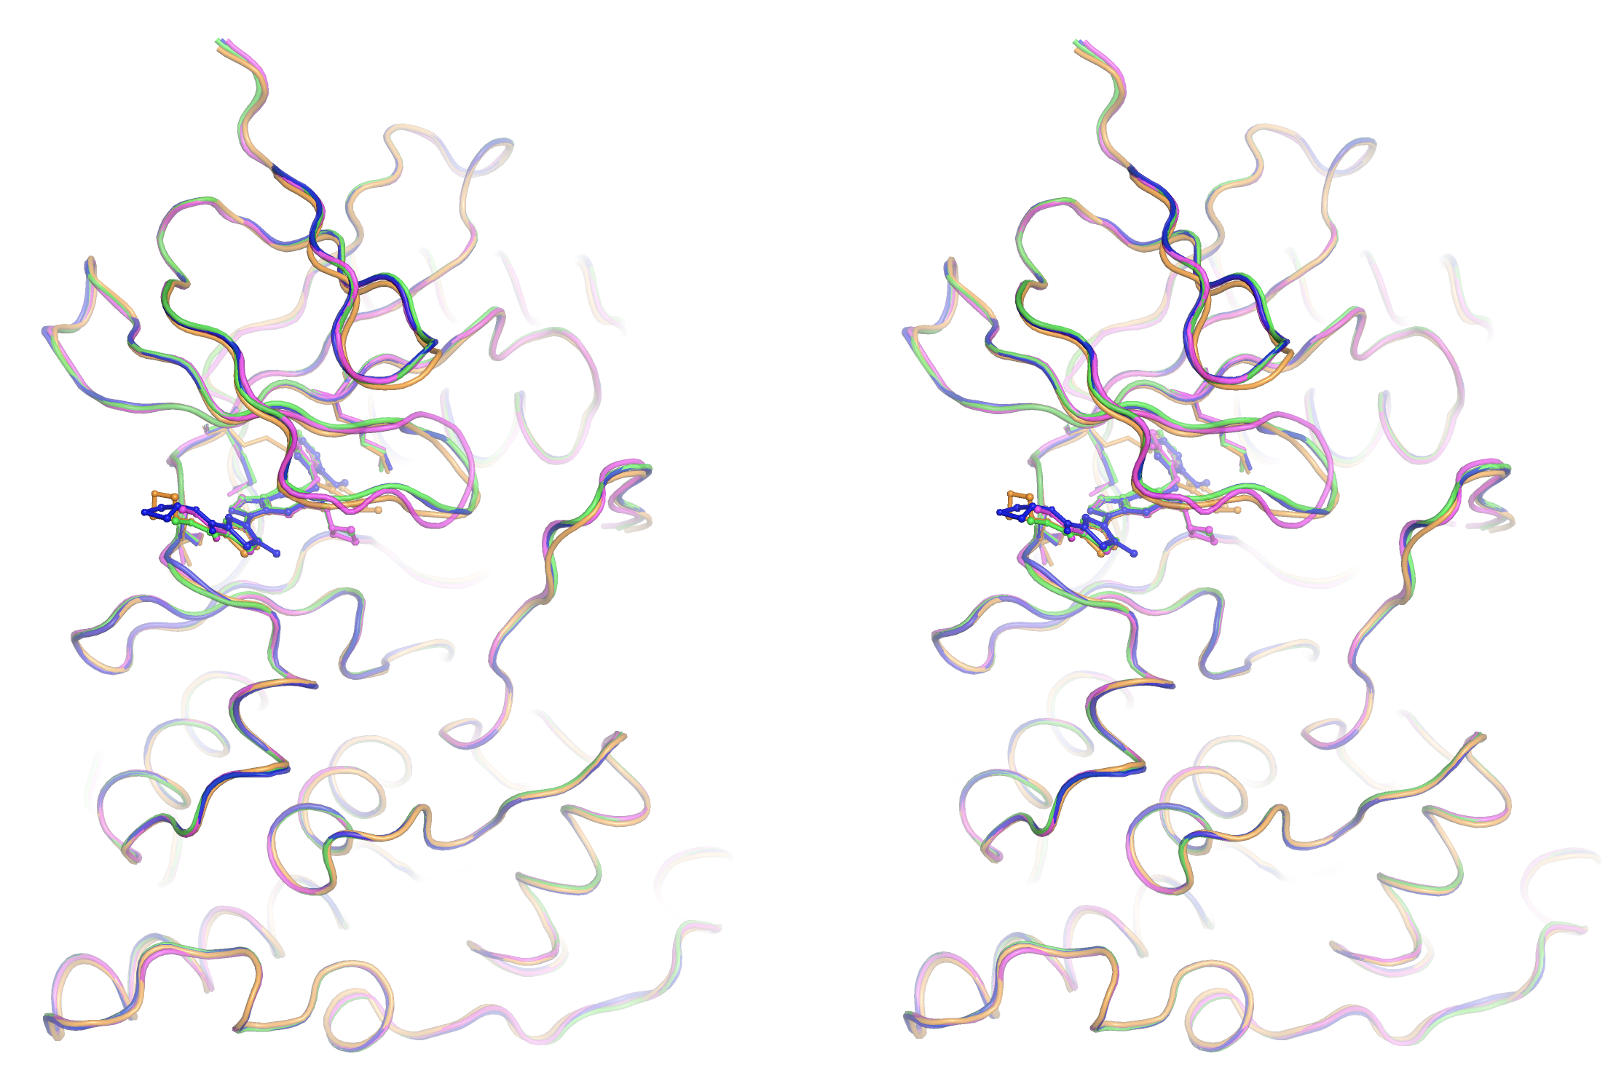

Suppl. Figure 2. The stereo view of superposition of p38α complexes. The overall view of p38α complexes from the side shows that the complex structures superimpose well except for the activation loops. p38α:21J (green) and p38α:21G (magenta) are in DFG-in conformations, while p38α:23M (orange) and p38α:23GA (blue) are in DFG-out conformations. Tyr35 of each structure is shown in sticks to highlight the conformation.

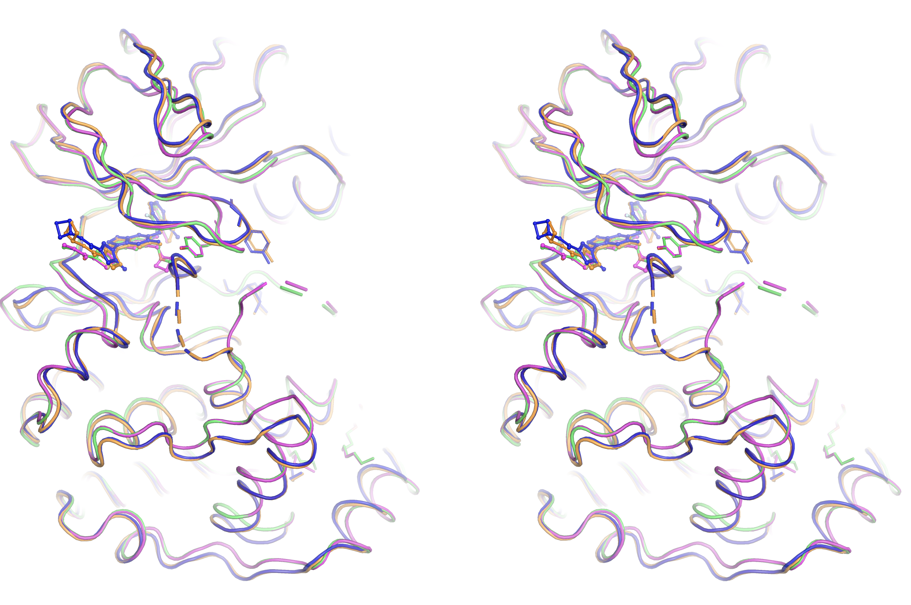
Suppl. Figure 3. Comparison of 21J and 21G interactions with JNK3 during the MD simulations. The observed H-bond interactions between the inhibitors and JNK3 are measured, with percentages representing the observed times during the simulation. Measurements were taken between 101 to 500 ns, with a percentage cut-off set at 30% for clarity. The figure was prepared using Maestro’s simulation analysis tool.

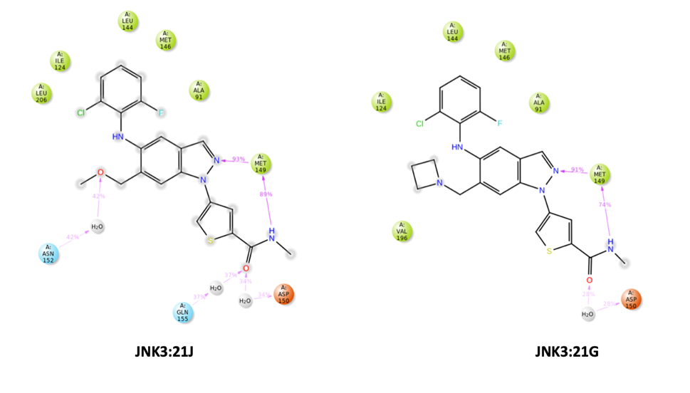
Suppl. Figure 4. Shifting of ligands in the ATP binding pocket was observed. The relative shifting of 23GA compared to 23M was noted for both JNK3 (A) and p38α (B) due to the presence of a methyl substitution at thiophene. The direction of the shifting is indicated by a green arrow. The shifting in p38α introduces a hydrogen bond interaction between 23GA and Arg49, which is shown in cyan. The equivalent residue in JNK3 is Asn89.

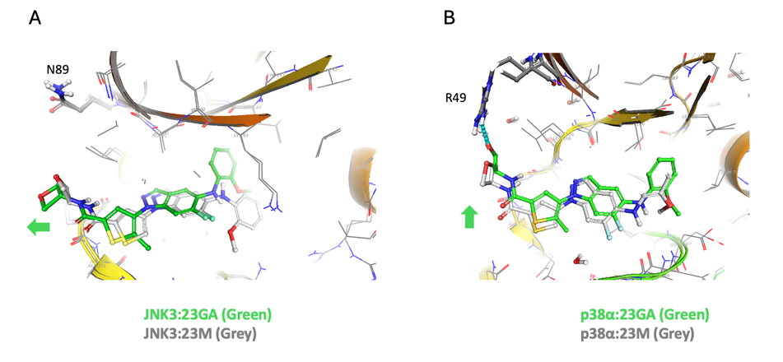
Suppl. Figure 5. The comparison of 23M and 23GA interactions with JNK3 during the MD simulations. The observed hinge binding interactions between the inhibitors and JNK3 are measured. The percentages represent the observed times during the simulation. The measurements were done between 101 to 500 ns and the percentage cut-off was set at 30 % for clear view. The figure was prepared using Maestro’s simulation analysis tool.

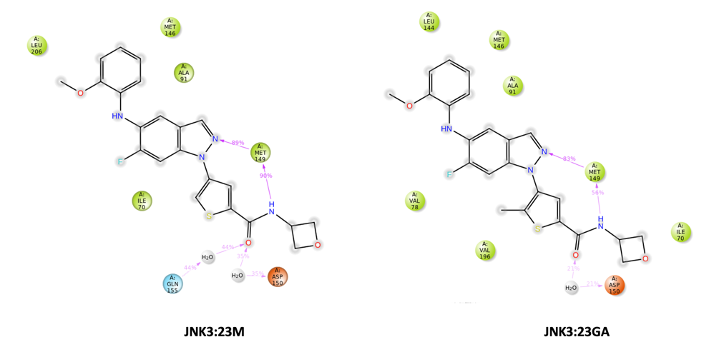
Suppl. Figure 6. Orthogonal comparison of H-bond interactions of 21J and 21G to JNK3 and p38α. Asp168 in p38α is forming direct H-bond interactions with the bound inhibitors. On the other hand, the orthogonal residue Asp207 in JNK3 is unable to make H-bond interactions with the bound inhibitors. Instead, the unmet H-bond potential is fulfilled by water-mediated H-bond interactions through Lys93 in JNK3.

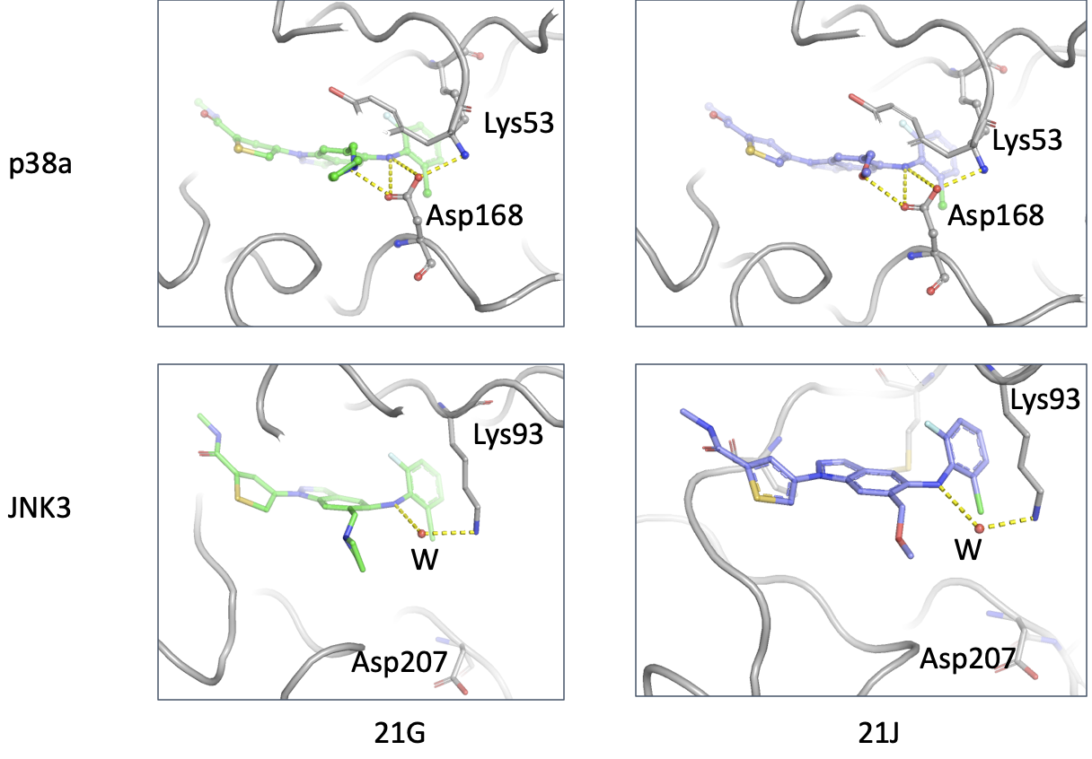
Suppl. Figure 7. Key differences in VdW interactions between JNK3 and p38α. Key residue differences between JNK3 and p38α are represented in sphere models with 21G. The larger side chains in the hydrophobic pocket in JNK3 produce tighter VdW interactions with the bound ligands that p38α.

