SUPPLEMENTARY MATERIALS

Root Morphological Plasticity Exhibits Dehydration Avoidance Strategy of Rapeseed (Brassica napus L.) under PEG-Induced Drought Stress
Jaber Bin Azim¹ and Arif Hasan Khan Robin^{1*}
¹Department of Genetics and Plant Breeding, Bangladesh Agricultural University, Mymensingh, Bangladesh
*Corresponding Author: gpb21bau@bau.edu.bd; ORCID: 0000-0002-6033-3929

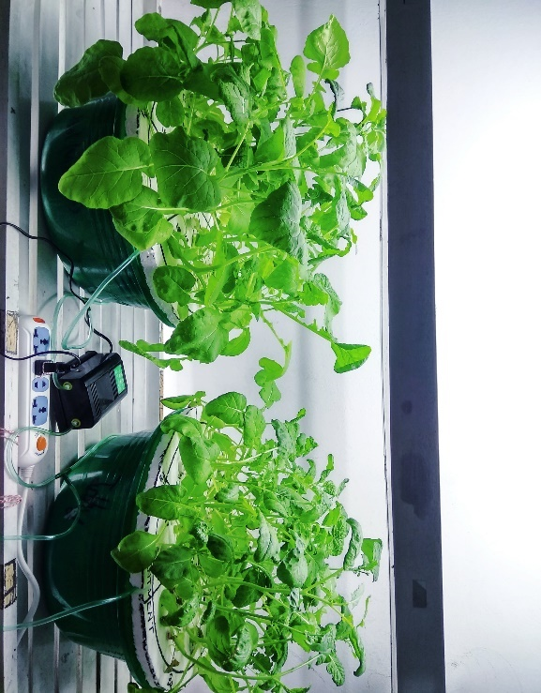
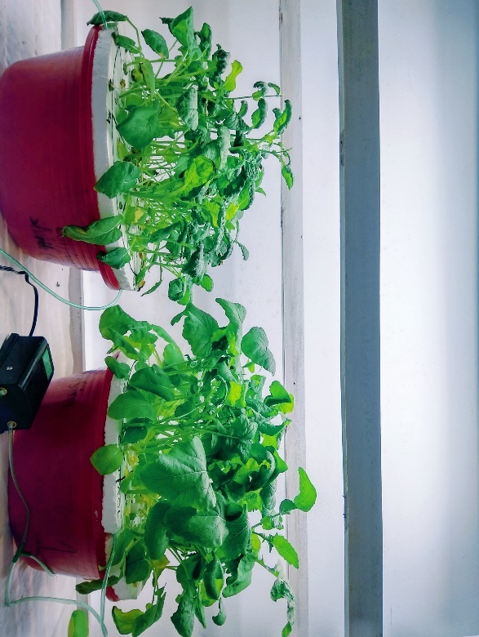
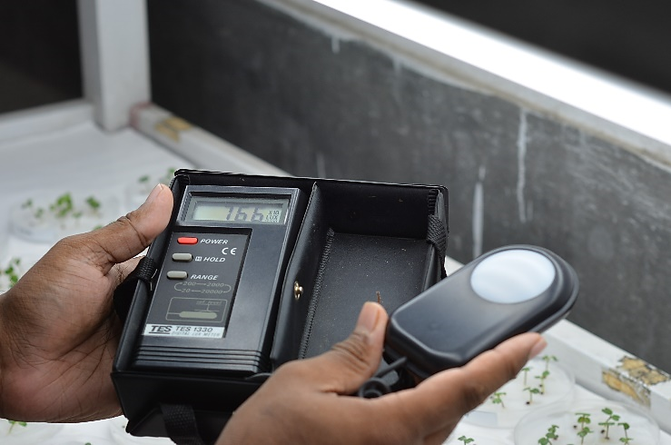
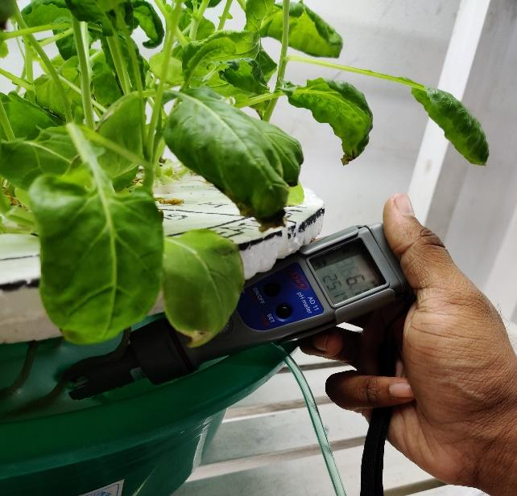
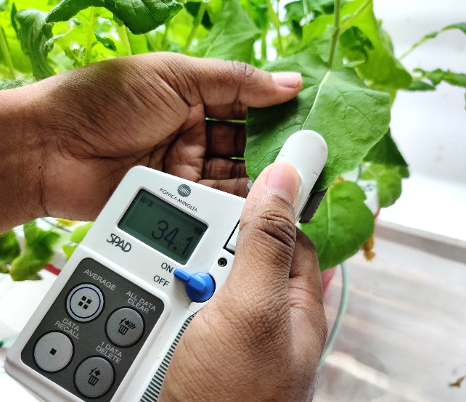
b
a

c
d
e

Figure S1 Culture of rapeseed genotypes in hydroponics. a) and b) experimental setup; measurements of c) light intensity; d) pH of the nutrient solution; e) chlorophyll content

Figure S2 Treatment effect, genotypic variation and treatment × genotype interaction for (A) plant height, (B) chlorophyll content, (C) total no. of live leaves, and (D) leaf injury scoring of ten rapeseed genotypes under control and 5% PEG treatment. Here, G1=NAP-0721-1, G2=BD-7118, G3=BD-6951, G4=NAP-0721-2, G5=BD-10109, G6=NAP-0721-1 x NAP-0724-2, G7=NAP-0721-1 x BD-10109, G8= BD-7118 x BD-10109, G9=BD-6951 x NAP-0724-2 and G10=BD-6951 x BD-10109. Vertical bars indicate standard error of mean; different letters denote significant differences.

Figure S3 Treatment effect, genotypic variation and treatment × genotype interaction for (A) shoot dry weight and (B) root dry weight of ten rapeseed genotypes under 0% (control) and treated (5% PEG) conditions at vegetative stage. In these graphs, G1=NAP-0721-1, G2=BD-7118, G3=BD-6951, G4=NAP-0721-2, G5=BD-10109, G6=NAP-0721-1 x NAP-0724-2, G7=NAP-0721-1 x BD-10109, G8= BD-7118 x BD-10109, G9=BD-6951 x NAP-0724-2 and G10=BD-6951 x BD-10109. Vertical bars indicate standard error of mean; different letters denote significant differences among the treatment × genotype interactions.

Figure S4 Treatment effect, genotypic variation and treatment × genotype interaction for (A) main axis root length, (B) main axis root diameter, (C) primary axis lateral root length and (D) primary axis lateral root diameter of ten rapeseed genotypes under control and 5% PEG treatment. Here, G1=NAP-0721-1, G2=BD-7118, G3=BD-6951, G4=NAP-0721-2, G5=BD-10109, G6=NAP-0721-1 x NAP-0724-2, G7=NAP-0721-1 x BD-10109, G8= BD-7118 x BD-10109, G9=BD-6951 x NAP-0724-2 and G10=BD-6951 x BD-10109. Vertical bars indicate standard error of mean; different letters denote significant differences.

Figure S5 Treatment effect, genotypic variation and treatment × genotype interaction for (A) secondary axis lateral root length, (B) secondary axis lateral root diameter, (C) root hair length of primary lateral roots and (D) root hair length of secondary lateral roots of ten rapeseed genotypes under control and 5% PEG treatment. Here, G1=NAP-0721-1, G2=BD-7118, G3=BD-6951, G4=NAP-0721-2, G5=BD-10109, G6=NAP-0721-1 x NAP-0724-2, G7=NAP-0721-1 x BD-10109, G8= BD-7118 x BD-10109, G9=BD-6951 x NAP-0724-2 and G10=BD-6951 x BD-10109. Vertical bars indicate standard error of mean; different letters denote significant differences.

Figure S6 Treatment effect, genotypic variation and treatment × genotype interaction for leaf biochemical traits (A) POD, (B) APX, (C) MDA and (D) H₂O₂ of ten rapeseed genotypes under control (0%) and treated (5% PEG) conditions. Here, G1=NAP-0721-1, G2=BD-7118, G3=BD-6951, G4=NAP-0721-2, G5=BD-10109, G6=NAP-0721-1 x NAP-0724-2, G7=NAP-0721-1 x BD-10109, G8= BD-7118 x BD-10109, G9=BD-6951 x NAP-0724-2 and G10=BD-6951 x BD-10109. Vertical bars indicate standard error of mean; different letters denote significant differences.

Table S1 Comparison of means between treatments for shoot, root and biochemical traits
 | Traits | Control | 5% PEG
 | TLL | 7.267 | 6.467
 | LIS | 1.401 | 4.467
Shoot | ChlC | 32.673 | 26.562
 | PH (cm) | 29.066 | 22.917
 | SDW (g) | 0.68 | 0.503
 | MAL (cm) | 23.835 | 26.167
 | MAD (mm) | 0.878 | 0.931
 | PAL (cm) | 13.508 | 15.109
 | PAD (mm) | 0.3035 | 0.3831
Root | SAL (cm) | 2.777 | 3.643
 | SAD (mm) | 0.168 | 0.221
 | RHL_{PA} (mm) | 0.276 | 0.336
 | RHL_{SA} (mm) | 0.324 | 0.355
 | RDW (g) | 0.0788 | 0.0891
Biochemical | POD (μmole min-1 g-1 FW) | 3.029 | 3.282
Biochemical | APX (μmole min-1g-1 FW) | 3.579 | 3.343
Biochemical | MDA (nmole g-1 FW) | 0.00525 | 0.00879
Biochemical | H₂O₂ (μmole g-1FW) | 4.0029 | 3.6886

Table S2 Comparison of means among rapeseed genotypes for shoot, root and biochemical traits
 | Traits | G1 | G2 | G3 | G4 | G5 | G6 | G7 | G8 | G9 | G10
Shoot | TLL | 7.165 | 6.67 | 6.5 | 6.665 | 7 | 7.335 | 7 | 7.5 | 6.835 | 6
Shoot | LIS | 3 | 4 | 3 | 3 | 3.33 | 2 | 2 | 2.33 | 3.33 | 3.33
Shoot | ChlC | 27.785 | 25.685 | 27.315 | 29.05 | 29.68 | 32.665 | 33.53 | 32.1 | 29.55 | 28.815
Shoot | PH (cm) | 23.33 | 29.5 | 20.92 | 24.17 | 29 | 28.08 | 27.75 | 28.25 | 27 | 21.915
Shoot | SDW (g) | 0.59 | 0.64 | 0.48 | 0.54 | 0.62 | 0.65 | 0.655 | 0.675 | 0.625 | 0.44
Root | MAL (cm) | 25.5 | 25.335 | 19.67 | 23.335 | 25 | 26.67 | 26.165 | 28.67 | 25.665 | 24
Root | MAD (mm) | 0.92 | 1.015 | 0.76 | 0.885 | 0.87 | 0.975 | 1.01 | 0.99 | 0.84 | 0.78
Root | PAL (cm) | 13.94 | 12.555 | 11.725 | 13.17 | 14.025 | 15.23 | 16.5 | 16.205 | 14.43 | 15.305
Root | PAD (mm) | 0.3445 | 0.3565 | 0.2925 | 0.3465 | 0.328 | 0.3615 | 0.375 | 0.3875 | 0.3285 | 0.3125
Root | SAL (cm) | 2.95 | 3.28 | 2.04 | 2.79 | 3.515 | 2.805 | 4.045 | 4.555 | 2.96 | 3.16
Root | SAD (mm) | 0.18 | 0.215 | 0.17 | 0.18 | 0.18 | 0.21 | 0.21 | 0.23 | 0.19 | 0.18
Root | RHL_{PA} (mm) | 0.445 | 0.33 | 0.25 | 0.37 | 0.165 | 0.255 | 0.28 | 0.335 | 0.375 | 0.255
Root | RHL_{SA} (mm) | 0.27 | 0.2 | 0.35 | 0.26 | 0.335 | 0.345 | 0.41 | 0.42 | 0.455 | 0.35
Root | RDW (g) | 0.0985 | 0.1015 | 0.053 | 0.076 | 0.0835 | 0.104 | 0.1005 | 0.105 | 0.0675 | 0.05
Biochemical | POD | 3.158 | 3.541 | 2.188 | 3.248 | 2.684 | 4.071 | 4.398 | 3.350 | 2.120 | 2.797
Biochemical | APX | 3.643 | 3.857 | 2.893 | 3.321 | 5.786 | 2.786 | 4.821 | 2.893 | 3.000 | 1.607
Biochemical | MDA | 0.0150 | 0.0065 | 0.0043 | 0.0078 | 0.0114 | 0.0069 | 0.0050 | 0.0061 | 0.0031 | 0.0041
Biochemical | H₂O₂ | 4.100 | 2.714 | 3.714 | 4.300 | 4.129 | 3.986 | 3.929 | 4.129 | 3.743 | 3.714

Table S3 Mean performance of rapeseed genotypes for shoot, root and biochemical traits under control and 5% PEG treatment
Genotypes | PH |  | TLL |  | ChlC |  | LIS |  | SDW |  | POD |  | APX |  | MDA |  | H₂O₂
Genotypes | 0% | 5% | 0% | 5% | 0% | 5% | 0% | 5% | 0% | 5% | 0% | 5% | 0% | 5% | 0% | 5% | 0% | 5%
G1 | 27.33 | 19.33 | 8.00 | 6.33 | 29.90 | 25.67 | 1.67 | 4.33 | 0.68 | 0.50 | 2.41 | 3.90 | 4.50 | 2.79 | 0.0114 | 0.0186 | 4.46 | 3.74
G2 | 34.33 | 24.67 | 6.67 | 6.67 | 27.37 | 24.00 | 2.33 | 5.67 | 0.72 | 0.56 | 2.86 | 4.22 | 4.72 | 3.00 | 0.0070 | 0.0060 | 2.03 | 3.40
G3 | 25.17 | 16.67 | 7.00 | 6.00 | 28.90 | 25.73 | 1.67 | 4.33 | 0.56 | 0.40 | 3.45 | 0.93 | 3.22 | 2.57 | 0.0019 | 0.0066 | 3.77 | 3.66
G4 | 26.67 | 21.67 | 7.00 | 6.33 | 30.93 | 27.17 | 1.67 | 4.33 | 0.58 | 0.50 | 3.63 | 2.87 | 4.27 | 2.36 | 0.0070 | 0.0087 | 4.34 | 4.26
G5 | 30.33 | 27.67 | 7.00 | 7.00 | 34.53 | 24.83 | 1.00 | 5.67 | 0.73 | 0.51 | 2.05 | 3.32 | 5.36 | 6.21 | 0.0037 | 0.0192 | 4.23 | 4.03
G6 | 32.33 | 23.83 | 8.00 | 6.67 | 36.33 | 29.00 | 1.00 | 3.00 | 0.78 | 0.52 | 3.34 | 4.80 | 2.57 | 3.00 | 0.0091 | 0.0046 | 4.31 | 3.66
G7 | 33.17 | 22.33 | 7.00 | 7.00 | 37.03 | 30.03 | 1.00 | 3.00 | 0.80 | 0.51 | 4.87 | 3.92 | 4.07 | 5.57 | 0.0041 | 0.0060 | 4.57 | 3.29
G8 | 29.67 | 26.83 | 8.00 | 7.00 | 32.97 | 31.23 | 1.67 | 3.00 | 0.75 | 0.60 | 2.01 | 4.69 | 3.00 | 2.79 | 0.0023 | 0.0099 | 4.23 | 4.03
G9 | 28.33 | 25.67 | 7.67 | 6.00 | 35.07 | 24.03 | 1.00 | 5.67 | 0.74 | 0.51 | 1.49 | 2.75 | 2.36 | 3.64 | 0.0019 | 0.0043 | 3.94 | 3.54
G10 | 23.33 | 20.50 | 6.33 | 5.67 | 33.70 | 23.93 | 1.00 | 5.67 | 0.46 | 0.42 | 4.17 | 1.42 | 1.71 | 1.50 | 0.0041 | 0.0041 | 4.14 | 3.29

Genotype | MAL |  | MAD |  | PAL |  | PAD |  | SAL |  | SAD |  | RHL_{PA} |  | RHL_{SA} |  | RDW
Genotype | 0% | 5% | 0% | 5% | 0% | 5% | 0% | 5% | 0% | 5% | 0% | 5% | 0% | 5% | 0% | 5% | 0% | 5%
G1 | 22.00 | 29.00 | 0.884 | 0.957 | 12.78 | 15.1 | 0.309 | 0.38 | 2.46 | 3.44 | 0.142 | 0.223 | 0.411 | 0.482 | 0.311 | 0.232 | 0.09 | 0.11
G2 | 27.67 | 23.00 | 1.128 | 0.895 | 14.51 | 10.6 | 0.329 | 0.384 | 2.43 | 4.13 | 0.182 | 0.254 | 0.264 | 0.399 | 0.167 | 0.225 | 0.13 | 0.08
G3 | 20.67 | 18.67 | 0.767 | 0.748 | 12.43 | 11.02 | 0.267 | 0.318 | 2.30 | 1.78 | 0.163 | 0.181 | 0.228 | 0.272 | 0.336 | 0.364 | 0.06 | 0.05
G4 | 21.00 | 25.67 | 0.842 | 0.927 | 12.00 | 14.34 | 0.261 | 0.432 | 2.19 | 3.39 | 0.160 | 0.198 | 0.346 | 0.393 | 0.227 | 0.29 | 0.07 | 0.08
G5 | 23.00 | 27.00 | 0.795 | 0.940 | 13.62 | 14.43 | 0.317 | 0.339 | 3.05 | 3.98 | 0.168 | 0.185 | 0.177 | 0.151 | 0.292 | 0.378 | 0.06 | 0.11
G6 | 24.67 | 28.67 | 0.899 | 1.054 | 14.12 | 16.34 | 0.303 | 0.420 | 2.08 | 3.53 | 0.174 | 0.252 | 0.274 | 0.238 | 0.392 | 0.304 | 0.09 | 0.11
G7 | 28.00 | 24.33 | 1.084 | 0.936 | 17.18 | 15.82 | 0.344 | 0.406 | 3.96 | 4.13 | 0.194 | 0.228 | 0.270 | 0.285 | 0.387 | 0.426 | 0.11 | 0.09
G8 | 25.67 | 31.67 | 0.863 | 1.123 | 13.04 | 19.37 | 0.366 | 0.409 | 4.21 | 4.90 | 0.204 | 0.256 | 0.260 | 0.409 | 0.367 | 0.466 | 0.08 | 0.13
G9 | 24.00 | 27.33 | 0.793 | 0.889 | 12.62 | 16.24 | 0.271 | 0.386 | 2.14 | 3.78 | 0.161 | 0.220 | 0.342 | 0.407 | 0.415 | 0.493 | 0.05 | 0.08
G10 | 21.67 | 26.33 | 0.728 | 0.825 | 12.78 | 17.83 | 0.268 | 0.357 | 2.95 | 3.37 | 0.150 | 0.207 | 0.194 | 0.316 | 0.33 | 0.365 | 0.04 | 0.06

