Supplementary Information
Oscillatory mechanoluminescence of SrZnOS: Mn²⁺ in dynamic response to rapid compression
Hao Wang¹, Tingting Zhao¹, Mei Li¹, Junlong Li¹, Ke Liu¹, Shang Peng¹, Xuqiang Liu¹, Bohao Zhao¹, Yanlong Chen¹, Jiao An¹, Xiaohui Chen², Sheng Jiang³, and Chuanlong Lin^{1∗}, Wenge Yang¹

¹Center for High Pressure Science and Technology Advanced Research, Beijing 100093, China
²Institute of Fluid Physics, China Academy of Engineering Physics, Mianyang 621900, China
³Shanghai Institute of Applied Physics, Chinese Academy of Sciences, Shanghai 201203, China
*Email: chuanlong.lin@hpstar.ac.cn

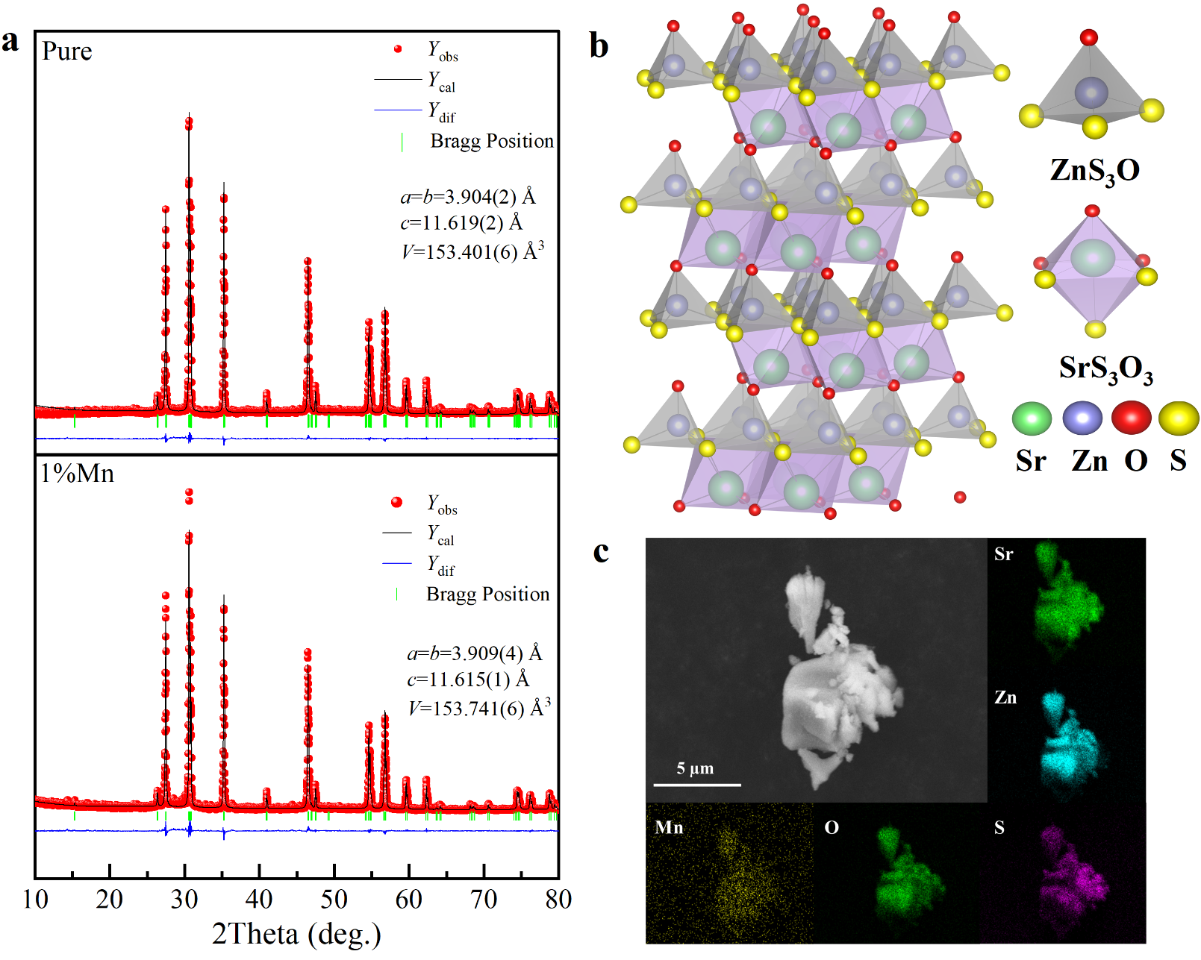

Supplementary Figure 1 | Characterization of the structure, morphology and elements of SrZnOS: Mn²⁺. a, Powder XRD patterns of pure SrZnOS, SrZnOS:1%Mn²⁺ and refinement of the XRD pattern. b, Schematic diagram of the crystal structure of hexagonal SrZnOS. c, The morphology and elemental analysis of the synthesized samples.

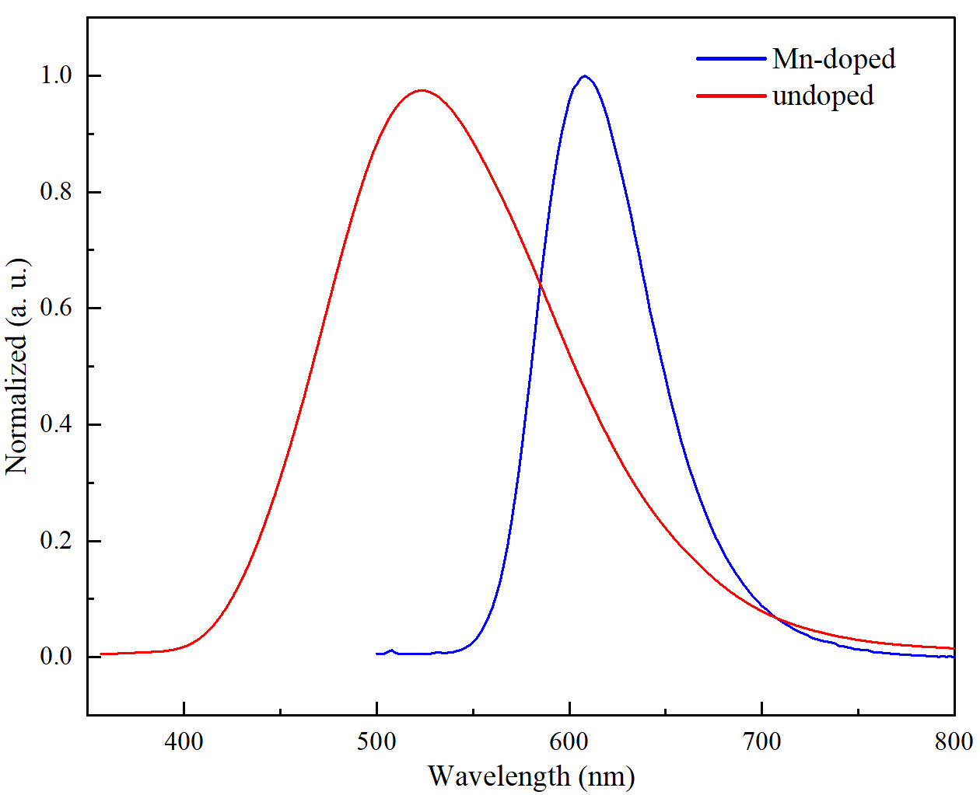
Supplementary Figure 2 | PL spectra of Mn-doped and undoped SrZnOS. The emission peak of the undoped sample lies at 525 nm that comes from the oxygen or Zn vacancies, whereas the emission peak of the Mn-doped sample is located at 608 nm (λ_{ex}=375 nm).

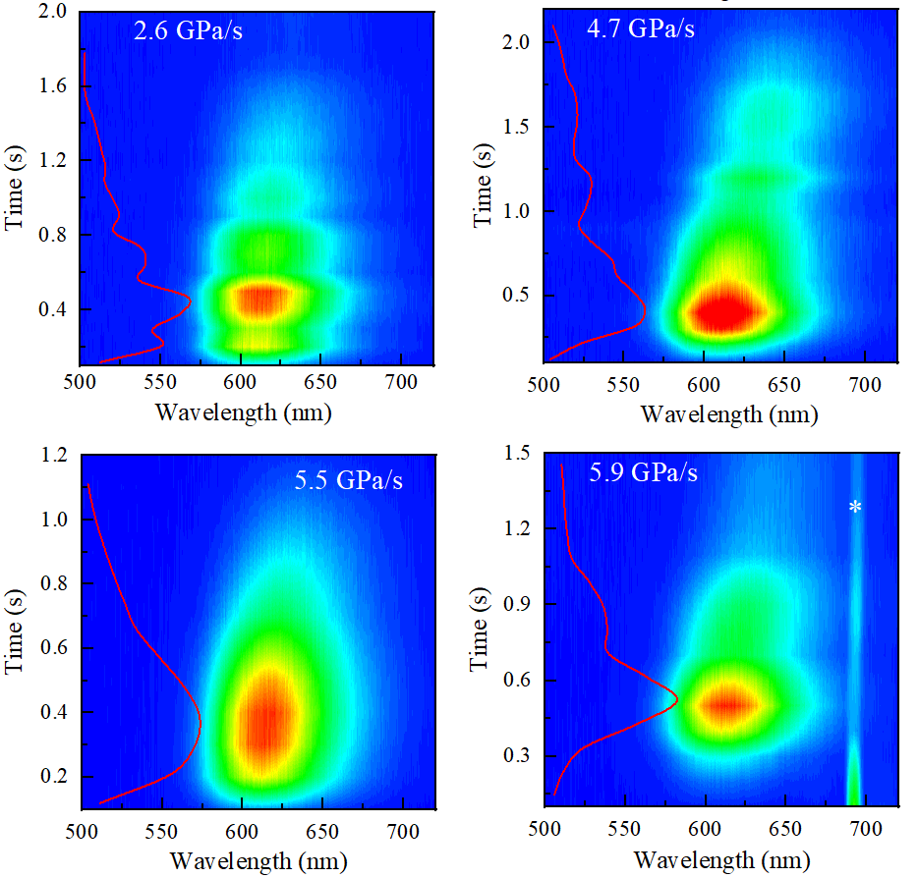
Supplementary Figure 3 | Rate-dependent ML behavior. ML spectra of Mn-doped SrZnOS as a function of pressure (or time) at different compression rates at room temperature, presenting temporal characteristics. The PL peaks around 695 nm (marked by “*”) come from ruby.

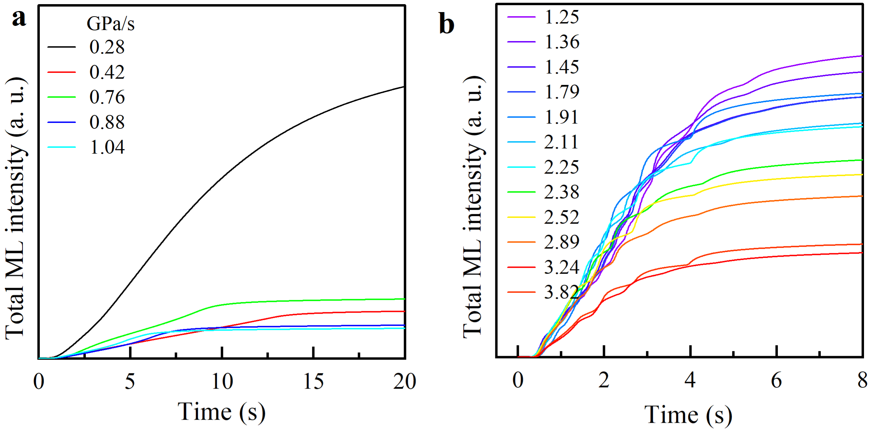
Supplementary Figure 4 | Rate dependent total ML intensity. Total ML intensities at different compression rate. a, 0.28-1.04 GPa/s; b, 1.25-3.82 GPa/s at room temperature.

Supplementary Figure 5 | Temperature dependent ML of SrZnOS: Mn²⁺. ML of SrZnOS: Mn²⁺ during continuous compression process at different compression rates and temperatures.

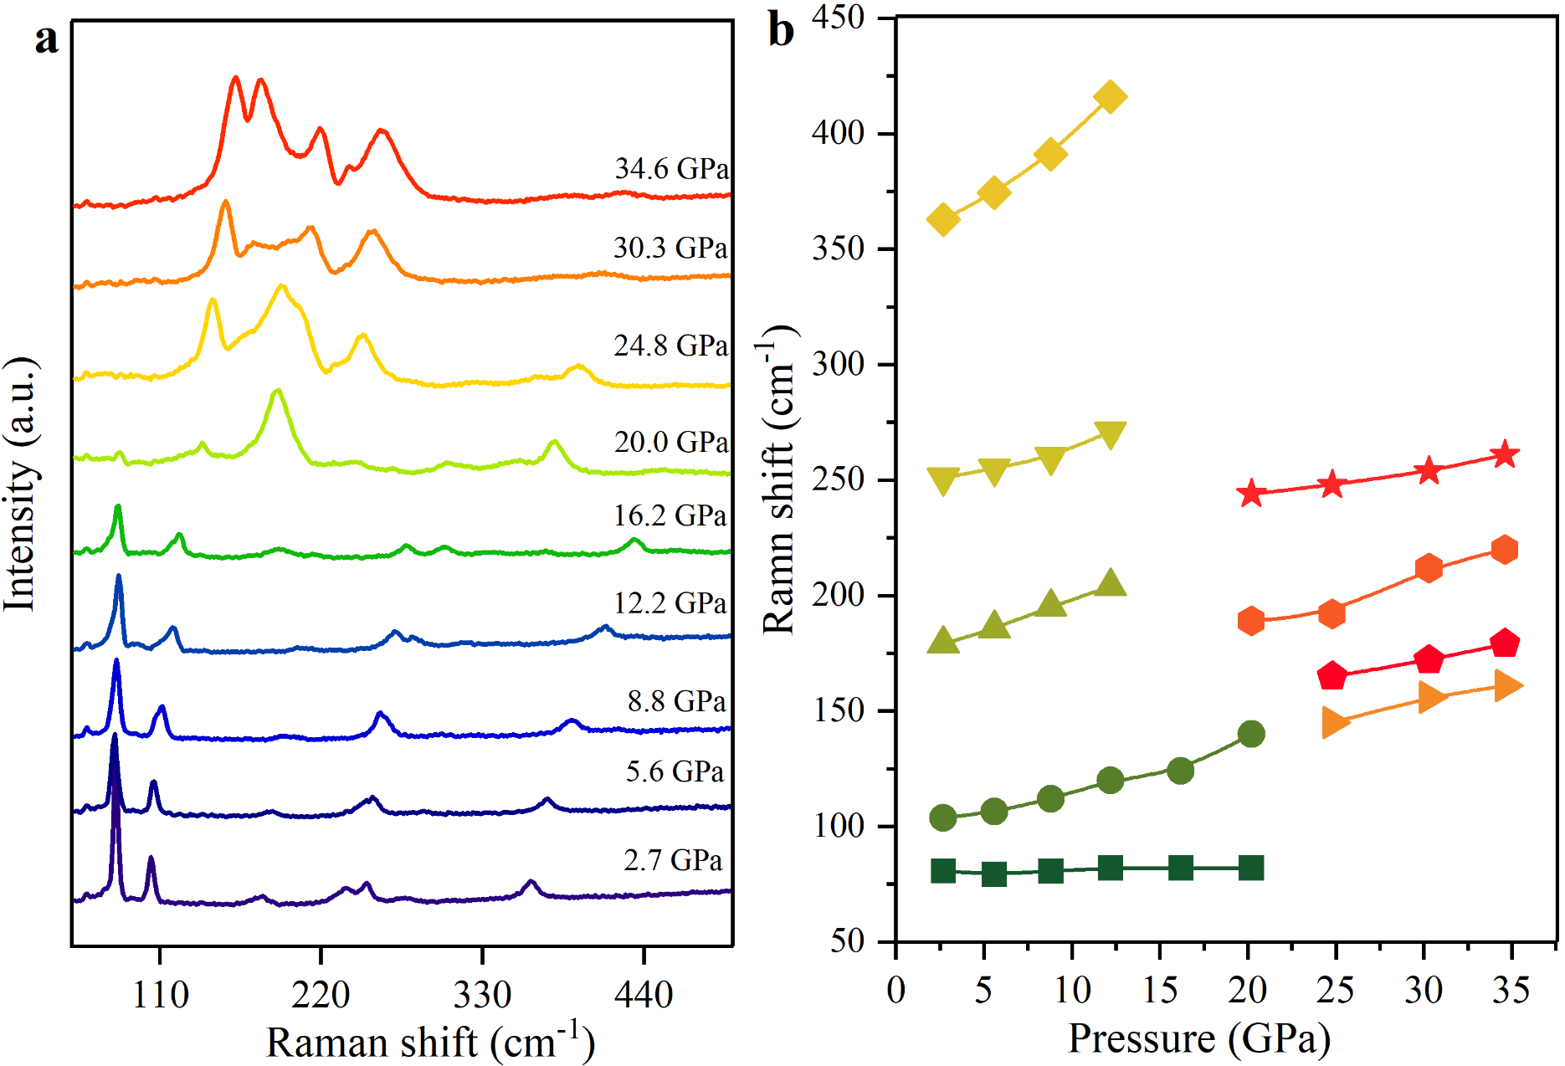
Supplementary Figure 6 | In-situ high-pressure Raman spectra. a, High-pressure Raman spectra of SrZnOS with 532 nm laser. b, The Raman peaks as a function of pressure.

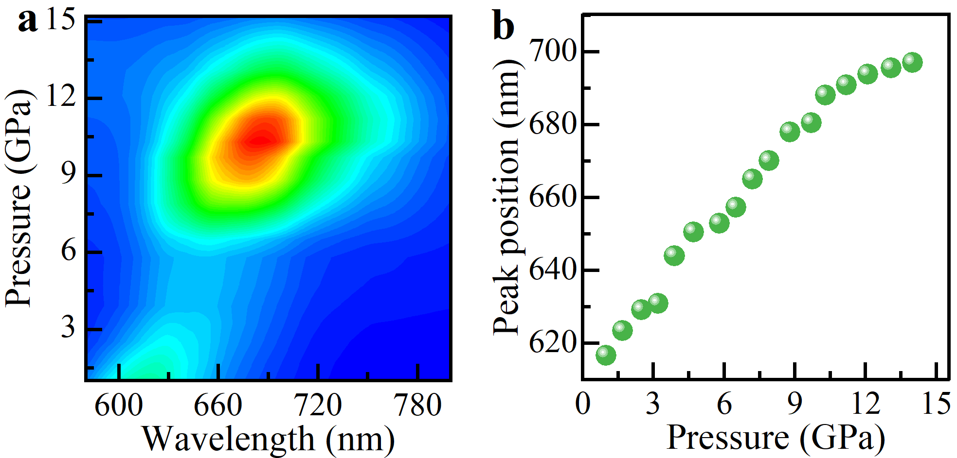
Supplementary Figure 7 | Pressure-induced PL properties of SrZnOS: Mn²⁺. a, PL spectra and b, peak position of Mn-doped SrZnOS as a function of pressure.

Supplementary Table 1 | Structural parameters obtained from the refinementr for SrZnOS.
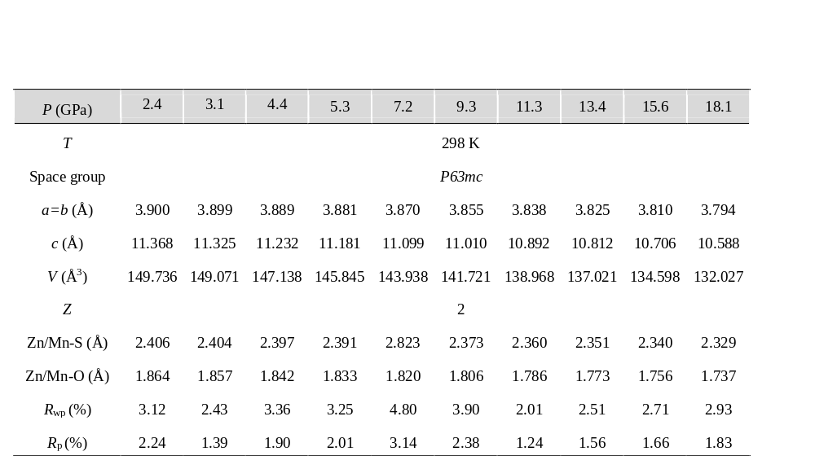

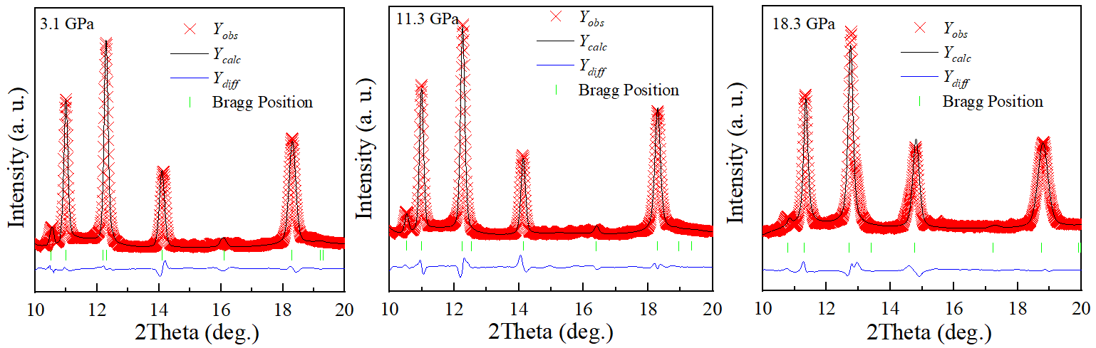
Supplementary Figure 8 | Refinement of the XRD patterns. The refined XRD patterns of SrZnOS at selected pressures of 3.1 GPa, 11.3 GPa and 18.3 GPa.

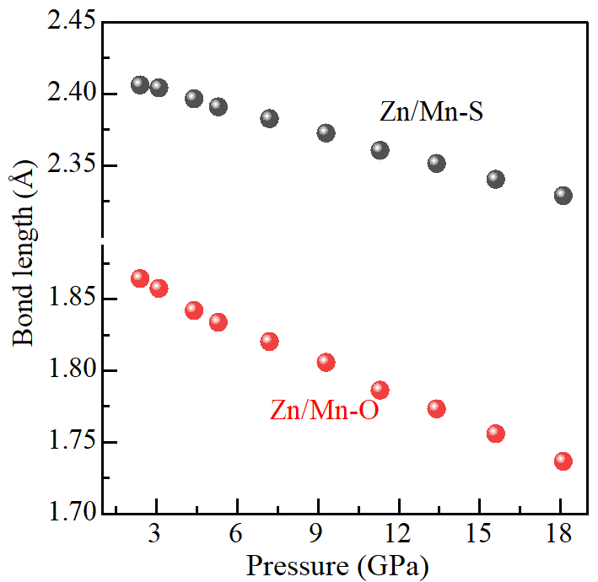
Supplementary Figure 9 | Bond length of Zn (or Mn)-S/O as a function of pressure.
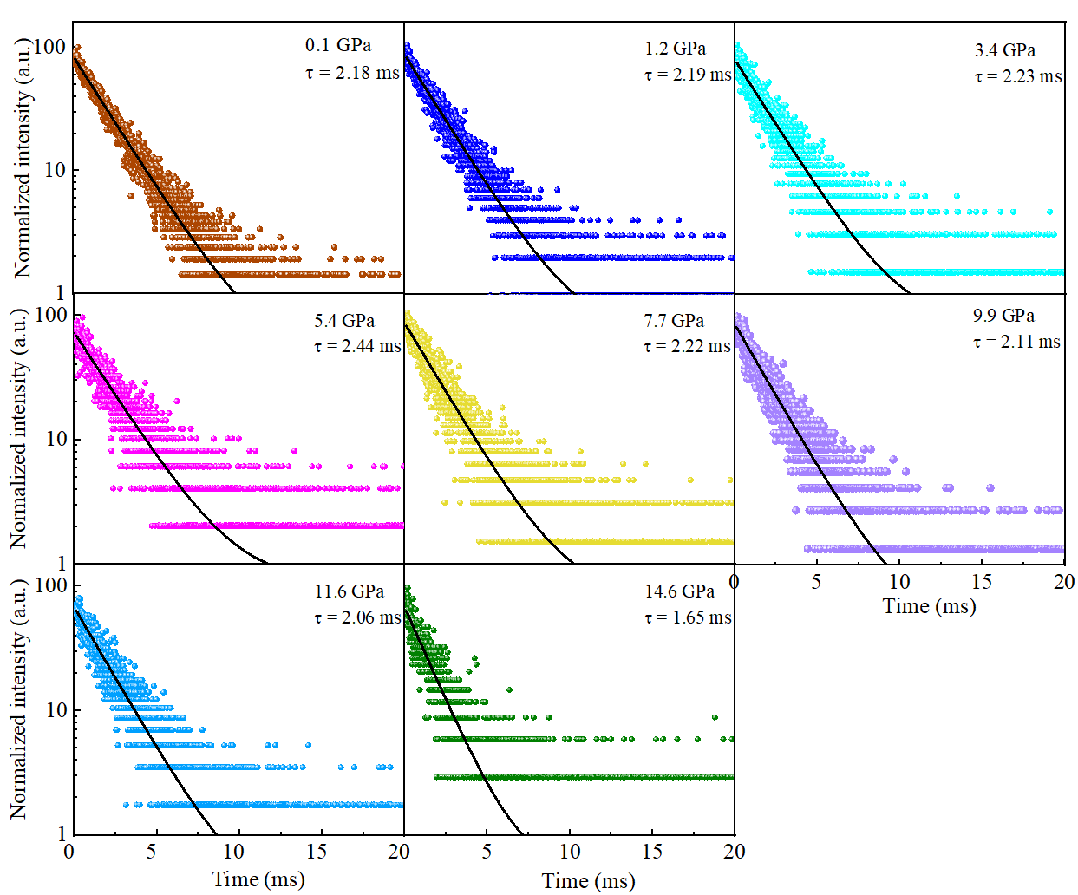
Supplementary Figure 10 | Decay curve and lifetime of PL for SrZnOS: Mn²⁺ excited by a 375 nm laser at various pressures.

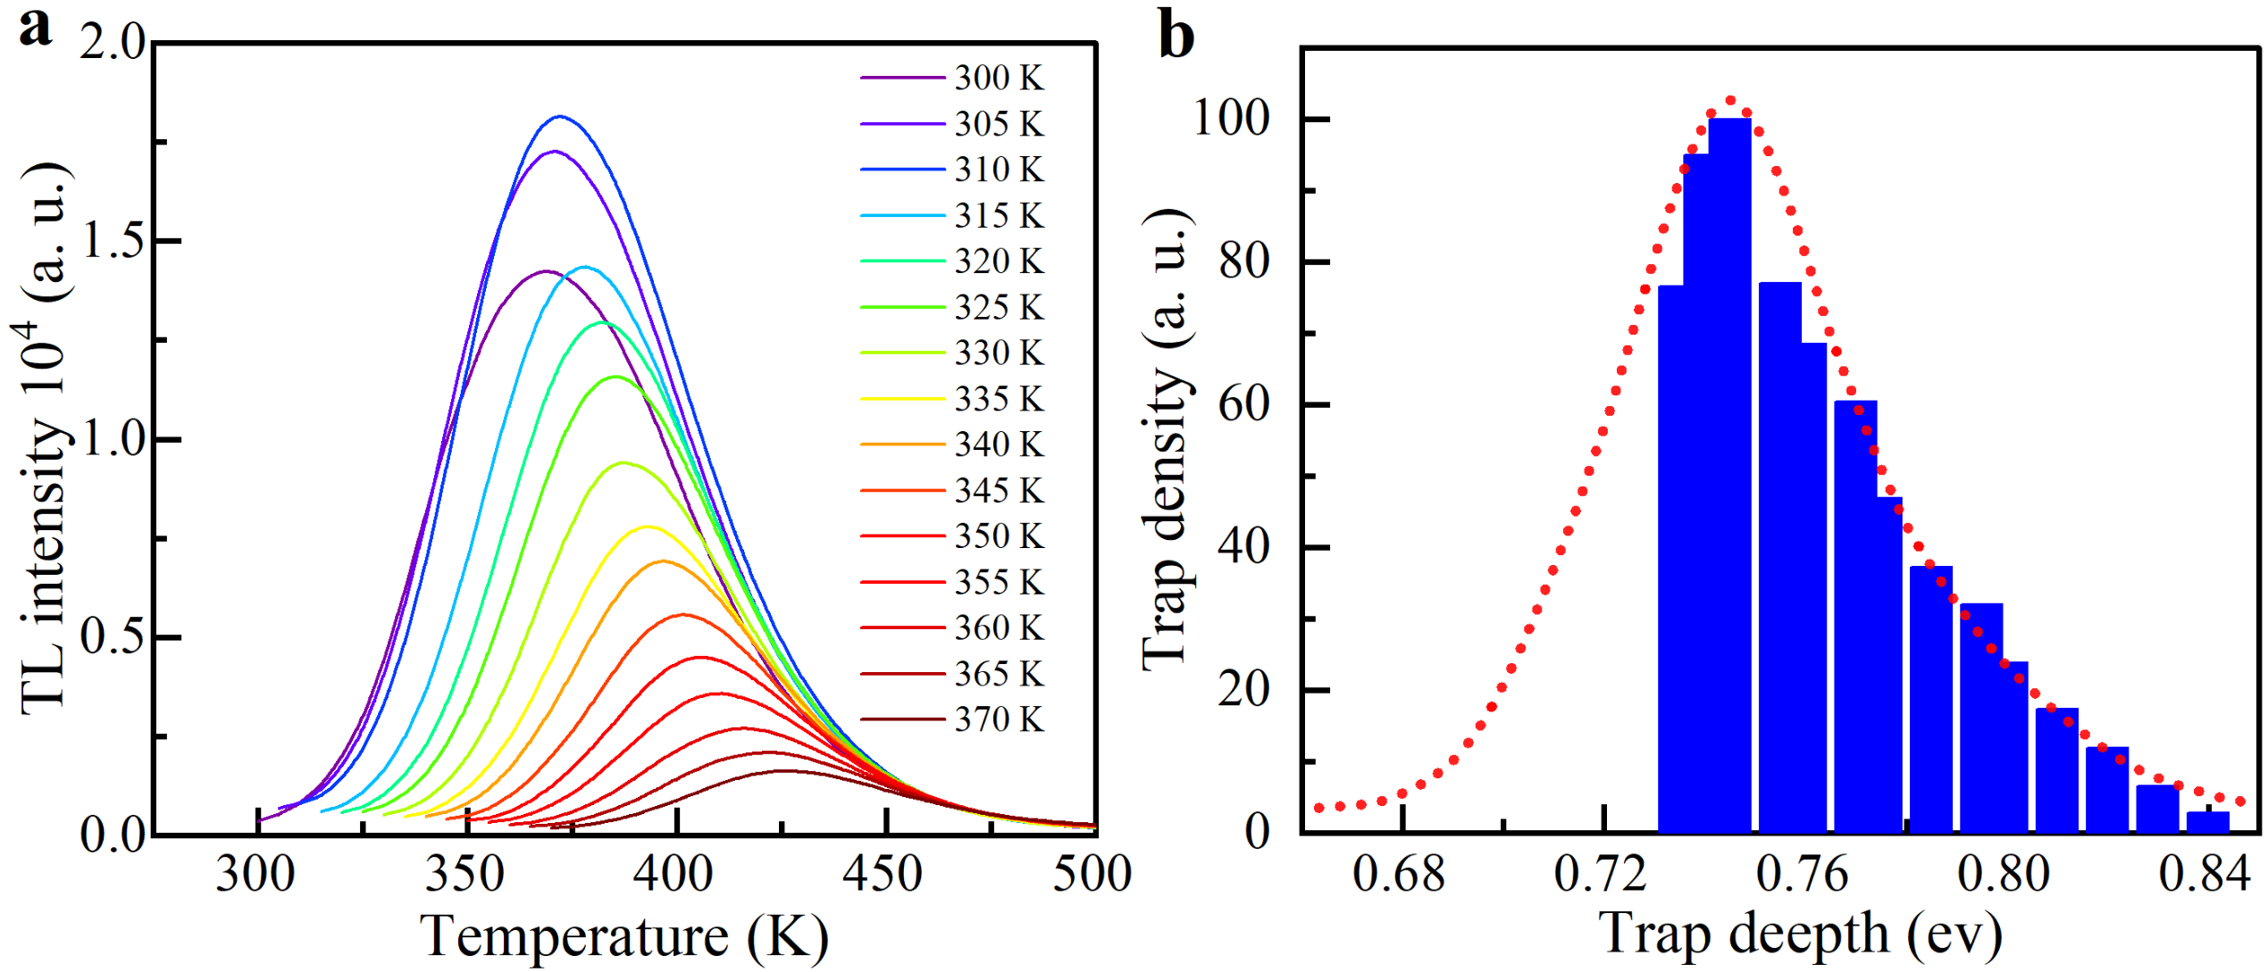
Supplementary Figure 11 | TL properties of SrZnOS: Mn²⁺. a, TL intensity at various excitation temperatures and b, the trap-depth distribution in SrZnOS: Mn²⁺.

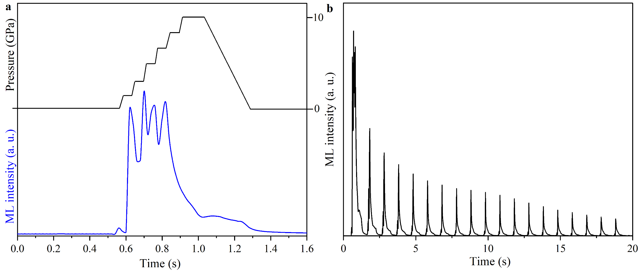
Supplementary Figure 12 | Dynamic ML response. a, ML intensity during stepwise compression process and b, ML emission during multi-cyclic compression-decompression processes.

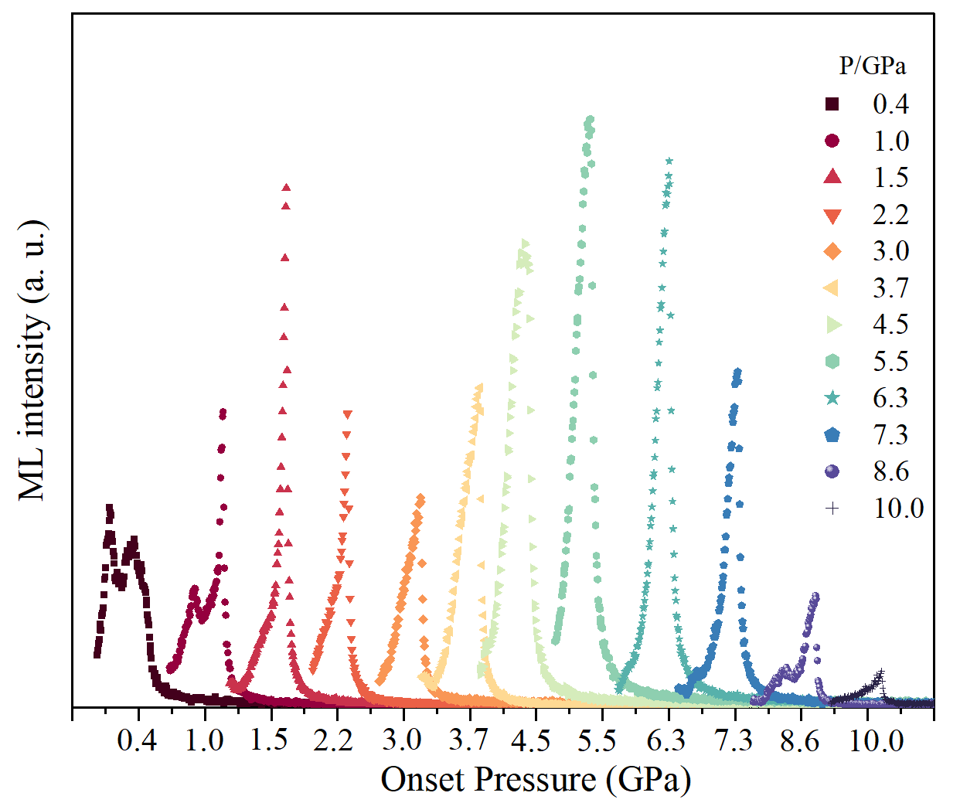
Supplementary Figure 13 | ML emission under compression at different onset pressure.

Supplementary Movies 1−7



Supplementary references

Reference
1. Liu, W. et al. Synthesis and characterization of sulfide oxide SrZnSO with strongly polar crystal structure. J. Solid State Chem. 246, 225-229 (2017).
2. Toby, B. H. EXPGUI, a graphical user interface for GSAS. J. Appl. Crystallogr. 34, 210−213 (2001).
3. Van den Eeckhout, K. et al. Revealing trap depth distributions in persistent phosphors. Phys. Rev. B 87, 045126 (2013).
4. Xiong, P. & Peng, M. Visible to near-infrared persistent luminescence from Tm³⁺- doped two-dimensional layered perovskite Sr₂SnO₄. J. Mater. Chem. C 7, 8303–8309 (2019).

