Supplementary Information for

Direct bonding and debonding of 2D semiconductors

Jieying Liu^{1,2}†, Jiaojiao Zhao^{1,2,3}†, Lu Li^{2,3}, Zheng Wei², Jiawei Li², Qinqin Wang², Hua Yu¹, Lanying Zhou¹, Tong Li¹, Fanfan Wu^{2,3}, Mingtong Zhu², Huacong Sun², Yutong Chen¹, Yun Li¹, Songge Zhang¹, Jinpeng Tian², Xuedong Bai², Nianpeng Lu², Zexian Cao², Shenghuang Lin¹, Shuopei Wang¹, Luojun Du^{2,3}, Wei Yang^{2,3}, Dongxia Shi^{2,3}, Na Li¹ & Guangyu Zhang^{1,2,3}*

¹ Songshan Lake Materials Laboratory; Dongguan, Guangdong 523808, China.
² Beijing National Laboratory for Condensed Matter Physics and Institute of Physics, Chinese Academy of Sciences; Beijing 100190, China.
³ School of Physical Sciences, University of Chinese Academy of Sciences; Beijing 100190, China.
†These authors contributed equally to this work
*Corresponding author. Email: gyzhang@iphy.ac.cn OR gyzhang@sslab.org.cn

Supplementary Note 1. Pick-up of epitaxial MoS₂ assisted by PMMA
The dry transfer method assisted by PMMA¹⁸ requires a lower adhesion between 2D materials and substrate than that between 2D materials and PMMA. When we apply this method on epitaxially grown MoS₂ on sapphire with strong adhesion, the transfer is failed and as-obtained films is fragmented as shown in Fig. S1.
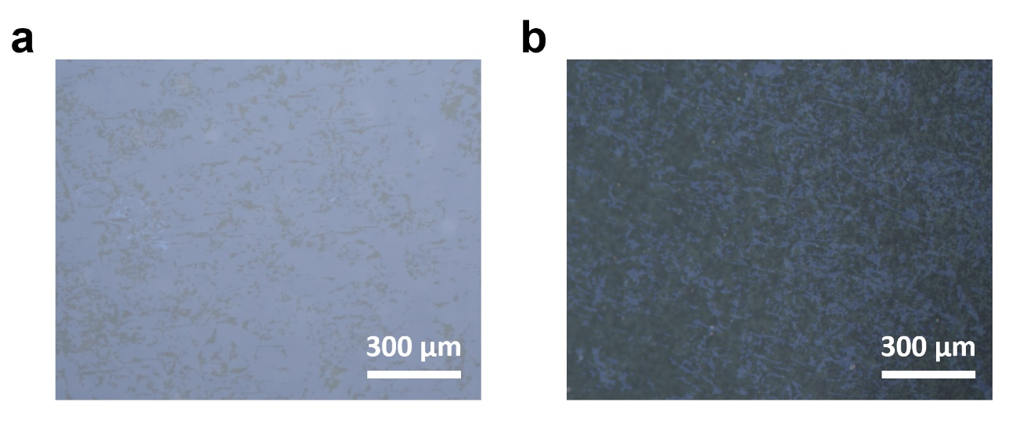
Figure S1 PMMA-assisted pick-up of epitaxial MoS₂ grown on sapphire. a, Optical micrograph of MoS₂/sapphire after PMMA-assisted peeling, vast bright area is MoS₂ films left behind after peeling. b, Optical micrograph of MoS₂/PMMA after PMMA-assisted peeling, bright area is fragmented MoS₂ films transferred onto PMMA.

Supplementary Note 2. Debonding process
During debonding, the stress exerted on films is affected by critical energy release rate (G_{c}) of the cracked interface. In interface fracture mechanics, G_{c} is influenced by mode-mixity, debonding loading rate, and temperature. Mode-mixity phase angle is: ψ =$\tan^{-1}{(\sqrt{\frac{σ_{s}}{σ_{n}}})}$, where σ_{n} (σ_{s}) is the normal (shear) component of traction. ψ = 0° and 90° corresponds to pure mode-I (σ_{s} = 0) and mode-Ⅱ (σ_{n} = 0) fracture, respectively. During crack propagation, G_{c} increases monotonously with the growth of mode-mix phase angle^{28–30}. The double cantilever beam (DCB) mode I fracture applied in our debonding process (Movie S1), which have been used for the large area dry transfer of graphene and bismuth films^{24,25}, can effectively reduce G_{c} and shear stress during delamination.
In DCB fracture, the fracture toughness is influenced by displacement loading rate, low loading rate (~2 μm/s) leads to smaller strain energy release rate G, which ensures a stable crack propagation and a lower level of shear stress^{31,32}. In contrast, the wafer delaminated under rapid exfoliation shows countless cracks caused by unstable crack propagation and high shear stress (Fig. S2). The exfoliating temperature also dramatically influences G_{c}. Debonding under low temperature (room temperature) increases G_{c}, leading to higher G, causing unstable crack propagation. As shown in Fig. S3, bilayer MoS₂ wafer obtained by exfoliating under room temperature shows many cracks (crack kinks occurred during unstable crack propagation), while bilayer MoS₂ wafer obtained by debonding under 90 ℃ doesn’t (Fig. 1e, right). This is probably because higher temperature induces thermal strain and thermal ripple effect^{42–44} which in turn leads to reduction of f_{adhesion}.
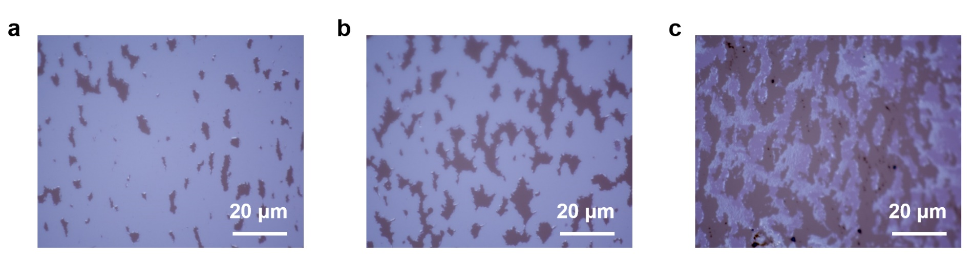
Figure S2 Optical micrographs of bilayer MoS₂ wafer obtained by bonding and debonding, in which debonding is performed under 90 ℃ with high displacement loading rate (~ 50 μm/s).

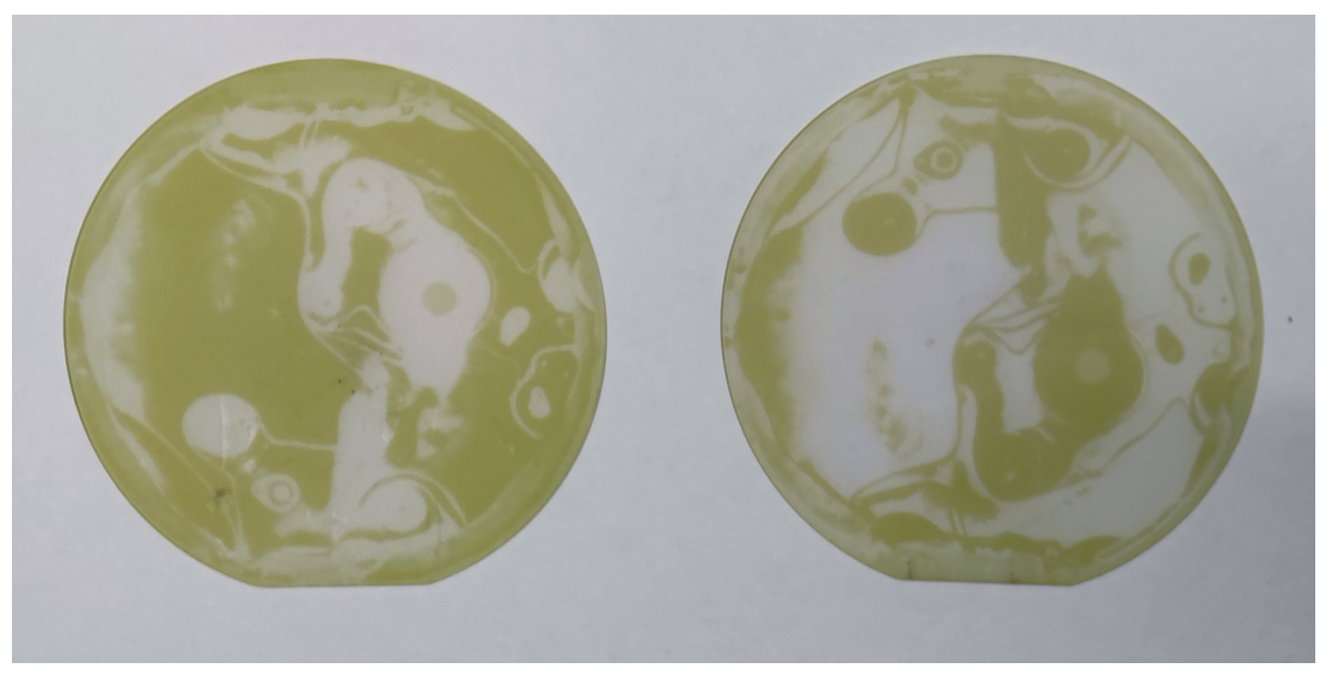
Figure S3 Photograph of bilayer MoS₂ wafer obtained by bonding and debonding, in which debonding is performed with low loading rate but under room temperature.

Supplementary Note 3. Homo-bonding and debonding
For the bonding-debonding of 2D materials with identical adhesion force to their substrates, we add a spherical epoxy gasket between the top pressure plate and graphite gasket (Extended Data Fig. 3a) to form a slightly domed indenter. With the aid of spherical gasket, a warpage is induced in bonded samples (Extended Data Fig. 3b) and sustains until after debonding.
Consider a small fraction of bilayer MoS₂ film between the delaminated area and bonded area, it is subjected to tractions from film in delaminated area (σ_{d}) and bonded area (σ_{b}), and tangential tractions from top sapphire (τ_{top}) and bottom sapphire (τ_{bottom}). During delamination, the MoS₂ in delaminated area (strain released area, ε_{d}) and bonded area (tensile strain area, ε_{b}) have different strain, namely ε_{d}<ε_{b} thus σ_{d}<σ_{b}. Before delamination of this area, balanced force requires τ_{top}>τ_{bottom}, which means the shear stress in the interface between bilayer MoS₂ and top sapphire is larger than that between bilayer MoS₂ and bottom sapphire, hence the top interface is delaminated first. Thus, the employ of a domed top indenter facilitates unidirectional transfer of MoS₂ from top sapphire to bottom MoS₂/sapphire.
The bonding-debonding results of bilayer MoS₂/sapphire with and without spherical epoxy gasket is shown in Extended Data Fig. 3c, which verifies the importance of domed indenter in bonding-debonding transfer of 2D materials with identical adhesion force to their substrates.

Supplementary Note 4. SHG determination of twist angles in tBLMs
Consider a tBLMs film with twisted angle of β and laser electric field polarization direction of α, the generated SH electric field is E₁(2ω) and E₂(2ω) from the first layer and second layer. By superposition, the total SH electric field E_{t}(2ω) can then be obtained: E_{t}(2ω) = E₁(2ω) + E₂(2ω). The SH intensity of first layer (|E₁(2ω)|²) and bilayer |Et(2ω)|² can be calculated
|E₁(2ω)|² = |E₁(2ω)|²cos² (3α)
|Et(2ω)|² = |E₁(2ω)|²(cos² (3α) +cos²(3α+3β) +2cos(3α)cos(3α+3β).
As shown in Fig. S4 the simulated SHG pattern, 30° tBLMs SHG petals rotated 15° compared to monolayer SHG petals.
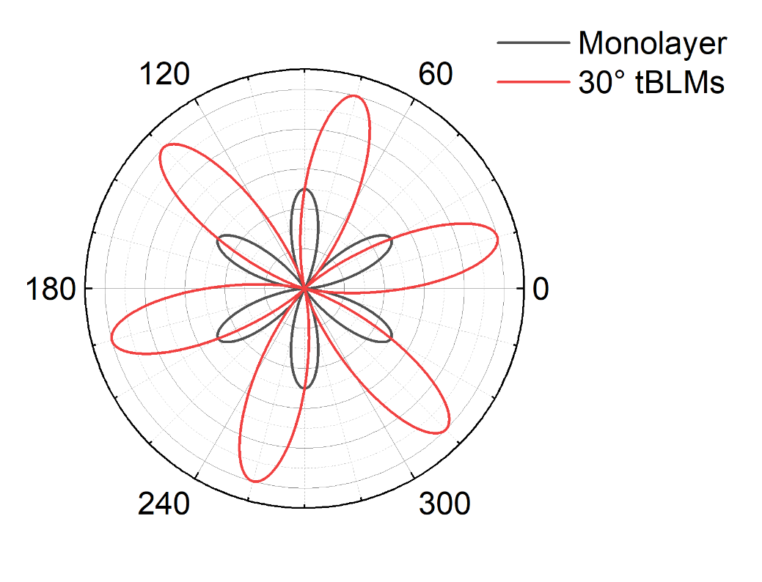
Figure S4 Calculated SHG patterns of monolayer MoS₂ and 30° tBLMs.

References from Supplementary Information

42. Chang, Z., Yang, R. & Wei, Y. The linear-dependence of adhesion strength and adhesion range on temperature in soft membranes. J. Mech. Phys. Solids 132, 103697 (2019).
43. Costamagna, S., Neek-Amal, M., Los, J. H. & Peeters, F. M. Thermal rippling behavior of graphane. Phys. Rev. B 86, 041408 (2012).
44. Meyer, J. C. et al. The structure of suspended graphene sheets. Nature 446, 60–63 (2007).

