Table S1. Components and scoring approach for OBS, NHANES 1999-2018.
 |  | Male |  |  | Female
 | Property | 0 | 1 | 2 | 0 | 1 | 2
Dietary OBS components
Dietary fiber (g/d) | A | <12.56 | 12.56-19.67 | >19.67 | <10.05 | 10.05-16.30 | >16.30
Carotene (RE/d) | A | <103.57 | 103.57-319.07 | >319.07 | <100.03 | 100.03-383.35 | >383.35
Riboflavin (mg/d) | A | <1.79 | 1.79-2.69 | >2.69 | <1.34 | 1.34-2.02 | >2.02
Niacin (mg/d) | A | <20.63 | 20.63-29.71 | >29.71 | <14.52 | 14.52-21.85 | >21.85
Vitamin B6 (mg/d) | A | <1.59 | 1.59-2.40 | >2.40 | <1.13 | 1.13-1.77 | >1.77
Total folate (mcg/d) | A | <307.68 | 307.68-491.50 | >491.50 | <250.00 | 250.00-386.57 | >386.57
Vitamin B12 (mcg/d) | A | <3.35 | 3.35-6.20 | >6.20 | <2.21 | 2.21-4.21 | >4.21
Vitamin C (mg/d) | A | <42.31 | 42.31-113.20 | >113.20 | <38.00 | 38.00-98.30 | >98.30
Vitamin E (ATE) (mg/d) | A | <5.82 | 5.82-9.41 | >9.41 | <4.51 | 4.51-7.51 | >7.51
Calcium (mg/d) | A | <645.90 | 645.90-1068.11 | >1068.11 | <499.45 | 499.45-848.70 | >848.70
Magnesium (mg/d) | A | <257.00 | 257.00-361.00 | >361.00 | <187.00 | 187.00-283.21 | >283.21
Zinc (mg/d) | A | <9.75 | 9.75-15.08 | >15.08 | <6.73 | 6.73-10.74 | >10.74
Copper (mg/d) | A | <1.12 | 1.12-1.57 | >1.57 | <0.85 | 0.85-1.28 | >1.28
Selenium (mcg/d) | A | <94.94 | 94.94-141.70 | >141.70 | <67.83 | 67.83-99.10 | >99.10
Total fat (g/d) | P | >111.46 | 76.90-111.46 | <76.90 | >76.79 | 51.89-76.79 | <51.89
Iron (mg/d) | P | >19.15 | 19.15-12.88 | <12.88 | >14.58 | 9.88-14.58 | <9.88
Lifestyle OBS components
Physical activity (MET-minute/week) | A | <422.23 | 422.23-1134.56 | >1134.56 | <248.07 | 248.07-889.00 | >889.00
Alcohol (drinks/d) | P | >30g/day | 0-30g/day | None | >15g/day | 0-15g/day | None
Body mass index (kg/m2) | P | >33.36 | 29.57-33.36 | <29.57 | >29.78 | 27.45-29.78 | <27.45
Cotinine (ng/mL) | P | >1.06 | 0.04-1.06 | <0.04 | >0.18 | 0.04-0.18 | <0.04
Table S2. Follow-up data for the baseline population with pre-diabetes, NHANES 1999-2018.
 | Median (Q1-Q3) | Weighted
Time, month (median, IQR) | 101 (55-149) | 101 (55-149)
All-cause death | N (%) | N
alive | 7165(90.030) | 32122576
death | 1091(9.970) | 3557441
CVD-cause death
No | 7929(97.154) | 34664710
Yes | 327(2.846) | 1015307
Table S3. Association of OBS with all-cause mortality in people with prediabetes excluding those with CVD at baseline.
 | Crude Model  HR (95%CI) | p | Model 2  HR (95%CI) | p | Model 3  HR (95%CI) | p
OBS | 0.967(0.955,0.978) | <0.0001 | 0.966(0.954,0.978) | <0.0001 | 0.964(0.948,0.980) | <0.0001
OBS quartile
Q1 | ref | ref | ref | ref | ref | ref
Q2 | 0.939(0.755,1.167) | 0.571 | 0.943(0.761,1.168) | 0.591 | 0.937(0.745,1.178) | 0.576
Q3 | 0.706(0.558,0.893) | 0.004 | 0.707(0.557,0.897) | 0.004 | 0.709(0.535,0.941) | 0.017
Q4 | 0.504(0.394,0.644) | <0.0001 | 0.503(0.392,0.645) | <0.0001 | 0.477(0.361,0.630) | <0.0001
P for trend |  | <0.0001 |  | <0.0001 |  | <0.0001
OBS. dietary | 0.970(0.957,0.982) | <0.0001 | 0.969(0.956,0.982) | <0.0001 | 0.967(0.950,0.985) | <0.001
OBS. dietary quartile
Q1 | ref | ref | ref | ref | ref | ref
Q2 | 0.907(0.720,1.142) | 0.406 | 0.903(0.719,1.134) | 0.379 | 0.932(0.731,1.187) | 0.568
Q3 | 0.715(0.565,0.905) | 0.005 | 0.707(0.557,0.897) | 0.004 | 0.736(0.548,0.990) | 0.042
Q4 | 0.579(0.440,0.762) | <0.0001 | 0.580(0.440,0.766) | <0.001 | 0.574(0.410,0.802) | 0.001
P for trend |  | <0.0001 |  | <0.0001 |  | <0.001
OBS. lifestyle | 0.855(0.801,0.913) | <0.0001 | 0.859(0.804,0.918) | <0.0001 | 0.877(0.820,0.937) | <0.0001
OBS. lifestyle quartile
Q1 | ref | ref | ref | ref | ref | ref
Q2 | 0.855(0.685,1.066) | 0.164 | 0.860(0.689,1.073) | 0.182 | 0.879(0.708,1.092) | 0.246
Q3 | 0.668(0.526,0.848) | <0.001 | 0.675(0.530,0.861) | 0.002 | 0.714(0.556,0.917) | 0.008
Q4 | 0.530(0.404,0.696) | <0.0001 | 0.541(0.413,0.708) | <0.0001 | 0.577(0.441,0.755) | <0.0001
P for trend |  | <0.0001 |  | <0.0001 |  | <0.0001
The crude model did not adjust for any covariates; model 1 adjusted for age, sex, and race/ethnicity; and model 2 additionally adjusted for education, PIR, marriage, dietary energy intake, hypertension, and CVD based on model 1.
Table S4. Association of OBS with CVD mortality in people with prediabetes excluding those with CVD at baseline.
 | Crude Model HR (95%CI) | p | Model 2  HR (95%CI) | p | Model 3  HR (95%CI) | p
OBS | 0.957(0.933,0.981) | <0.001 | 0.956(0.931,0.982) | <0.001 | 0.946(0.920,0.974) | <0.001
OBS quartile
Q1 | ref | ref | ref | ref | ref | ref
Q2 | 1.208(0.821,1.777) | 0.337 | 1.254(0.843,1.867) | 0.264 | 1.174(0.823,1.674) | 0.377
Q3 | 0.795(0.467,1.353) | 0.398 | 0.811(0.470,1.400) | 0.452 | 0.731(0.396,1.349) | 0.316
Q4 | 0.303(0.156,0.588) | <0.001 | 0.309(0.156,0.614) | <0.001 | 0.245(0.131,0.458) | <0.0001
P for trend |  | <0.0001 |  | <0.001 |  | <0.0001
OBS. dietary | 0.963(0.938,0.990) | 0.007 | 0.963(0.936,0.991) | 0.01 | 0.954(0.921,0.988) | 0.008
OBS. dietary quartile
Q1 | ref | ref | ref | ref | ref | ref
Q2 | 1.017(0.666,1.554) | 0.938 | 1.026(0.662,1.590) | 0.907 | 0.995(0.669,1.480) | 0.98
Q3 | 0.689(0.431,1.102) | 0.12 | 0.683(0.424,1.100) | 0.117 | 0.639(0.369,1.105) | 0.109
Q4 | 0.422(0.203,0.879) | 0.021 | 0.431(0.203,0.914) | 0.028 | 0.345(0.152,0.784) | 0.011
P for trend |  | 0.003 |  | 0.004 |  | 0.003
OBS. lifestyle | 0.755(0.670,0.851) | <0.0001 | 0.756(0.670,0.854) | <0.0001 | 0.776(0.693,0.868) | <0.0001
OBS. lifestyle quartile
Q1 | ref | ref | ref | ref | ref | ref
Q2 | 0.896(0.579,1.386) | 0.621 | 0.883(0.566,1.377) | 0.583 | 0.909(0.585,1.411) | 0.67
Q3 | 0.361(0.229,0.569) | <0.0001 | 0.362(0.230,0.572) | <0.0001 | 0.391(0.249,0.612) | <0.0001
Q4 | 0.390(0.211,0.723) | 0.003 | 0.390(0.208,0.731) | 0.003 | 0.423(0.228,0.786) | 0.006
P for trend |  | <0.0001 |  | <0.0001 |  | <0.0001
The crude model did not adjust for any covariates; model 1 adjusted for age, sex, and race/ethnicity; and model 2 additionally adjusted for education, PIR, marriage, dietary energy intake, hypertension, and CVD based on model 1.
Table S5. Association of OBS with all-cause mortality in people with prediabetes excluding those with a follow-up time within two years.
 | Crude Model  HR (95%CI) | p | Model 2  HR (95%CI) | p | Model 3  HR (95%CI) | p
OBS | 0.963(0.953,0.974) | <0.0001 | 0.963(0.953,0.973) | <0.0001 | 0.960(0.945,0.975) | <0.0001
OBS quartile
Q1 | ref | ref | ref | ref | ref | ref
Q2 | 0.913(0.758,1.101) | 0.343 | 0.919(0.762,1.107) | 0.374 | 0.900(0.731,1.107) | 0.317
Q3 | 0.724(0.599,0.875) | <0.001 | 0.724(0.595,0.881) | 0.001 | 0.705(0.554,0.898) | 0.005
Q4 | 0.459(0.370,0.569) | <0.0001 | 0.455(0.366,0.567) | <0.0001 | 0.440(0.344,0.564) | <0.0001
P for trend |  | <0.0001 |  | <0.0001 |  | <0.0001
OBS. dietary | 0.968(0.958,0.979) | <0.0001 | 0.967(0.957,0.978) | <0.0001 | 0.966(0.950,0.982) | <0.0001
OBS. dietary quartile
Q1 | ref | ref | ref | ref | ref | ref
Q2 | 0.890(0.729,1.088) | 0.255 | 0.880(0.720,1.075) | 0.211 | 0.888(0.712,1.107) | 0.29
Q3 | 0.722(0.599,0.869) | <0.001 | 0.711(0.588,0.859) | <0.001 | 0.728(0.574,0.925) | 0.009
Q4 | 0.527(0.409,0.680) | <0.0001 | 0.523(0.404,0.678) | <0.0001 | 0.510(0.369,0.704) | <0.0001
P for trend |  | <0.0001 |  | <0.0001 |  | <0.0001
OBS. lifestyle | 0.819(0.771,0.870) | <0.0001 | 0.822(0.773,0.874) | <0.0001 | 0.846(0.795,0.900) | <0.0001
OBS. lifestyle quartile
Q1 | ref | ref | ref | ref | ref | ref
Q2 | 0.703(0.587,0.843) | <0.001 | 0.703(0.588,0.841) | <0.001 | 0.738(0.615,0.887) | 0.001
Q3 | 0.615(0.496,0.763) | <0.0001 | 0.620(0.499,0.770) | <0.0001 | 0.672(0.540,0.836) | <0.001
Q4 | 0.453(0.357,0.575) | <0.0001 | 0.458(0.362,0.579) | <0.0001 | 0.506(0.399,0.642) | <0.0001
P for trend |  | <0.0001 |  | <0.0001 |  | <0.0001
The crude model did not adjust for any covariates; model 1 adjusted for age, sex, and race/ethnicity; and model 2 additionally adjusted for education, PIR, marriage, dietary energy intake, hypertension, and CVD based on model 1.
Table S6. Association of OBS with CVD mortality in people with prediabetes excluding those with a follow-up time within two years.
 | Crude Model  HR (95%CI) | p | Model 2  HR (95%CI) | p | Model 3  HR (95%CI) | p
OBS | 0.949(0.933,0.966) | <0.0001 | 0.948(0.930,0.966) | <0.0001 | 0.937(0.914,0.960) | <0.0001
OBS quartile
Q1 | ref | ref | ref | ref | ref | ref
Q2 | 1.205(0.899,1.614) | 0.212 | 1.239(0.919,1.671) | 0.159 | 1.132(0.827,1.548) | 0.439
Q3 | 0.757(0.516,1.109) | 0.153 | 0.764(0.508,1.150) | 0.197 | 0.669(0.409,1.095) | 0.11
Q4 | 0.246(0.142,0.428) | <0.0001 | 0.247(0.140,0.439) | <0.0001 | 0.211(0.113,0.396) | <0.0001
P for trend |  | <0.0001 |  | <0.0001 |  | <0.0001
OBS. dietary | 0.958(0.940,0.976) | <0.0001 | 0.957(0.937,0.977) | <0.0001 | 0.949(0.920,0.979) | <0.001
OBS. dietary quartile
Q1 | ref | ref | ref | ref | ref | ref
Q2 | 1.070(0.769,1.490) | 0.687 | 1.061(0.760,1.482) | 0.727 | 1.013(0.712,1.440) | 0.944
Q3 | 0.753(0.544,1.043) | 0.088 | 0.741(0.523,1.050) | 0.092 | 0.718(0.466,1.108) | 0.134
Q4 | 0.345(0.179,0.664) | 0.001 | 0.345(0.176,0.676) | 0.002 | 0.294(0.132,0.657) | 0.003
P for trend |  | <0.0001 |  | <0.0001 |  | <0.001
OBS. lifestyle | 0.707(0.636,0.786) | <0.0001 | 0.705(0.632,0.786) | <0.0001 | 0.740(0.669,0.818) | <0.0001
OBS. lifestyle quartile
Q1 | ref | ref | ref | ref | ref | ref
Q2 | 0.653(0.458,0.931) | 0.018 | 0.639(0.445,0.917) | 0.015 | 0.696(0.490,0.989) | 0.043
Q3 | 0.385(0.262,0.566) | <0.0001 | 0.382(0.260,0.563) | <0.0001 | 0.433(0.301,0.624) | <0.0001
Q4 | 0.267(0.164,0.436) | <0.0001 | 0.261(0.159,0.429) | <0.0001 | 0.309(0.187,0.508) | <0.0001
P for trend |  | <0.0001 |  | <0.0001 |  | <0.0001
The crude model did not adjust for any covariates; model 1 adjusted for age, sex, and race/ethnicity; and model 2 additionally adjusted for education, PIR, marriage, dietary energy intake, hypertension, and CVD based on model 1.
Figure S1. Stratified analysis of OBS and all-cause mortality in the prediabetic population.
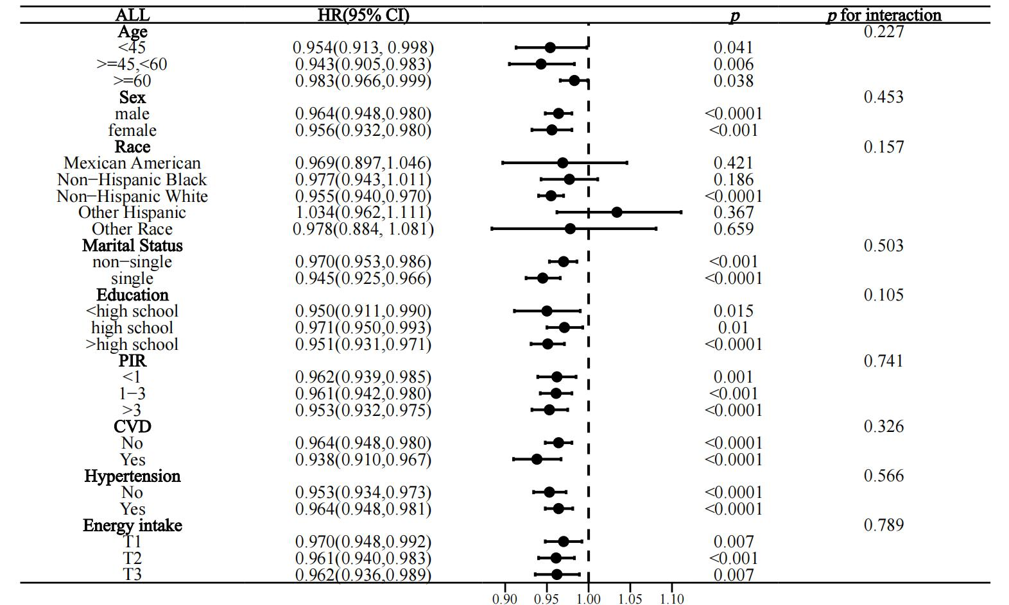
Figure S2. Stratified analysis of OBS and CVD mortality in the prediabetic population.
