Extended Data Fig. 1.
UMAP plots of PBMCs derived from each SSc patients or HDs.
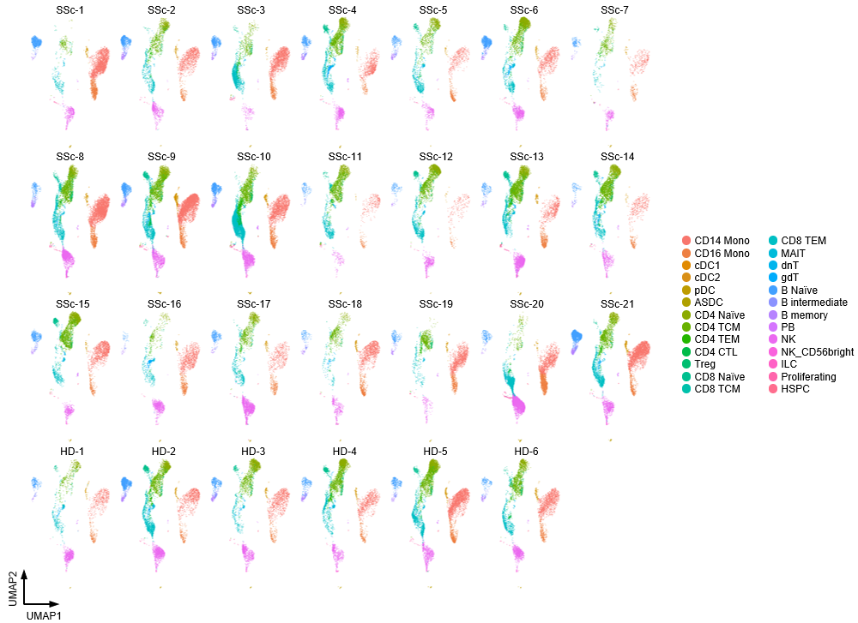
UMAP plots showing PBMCs in each patient with SSc or HD. Each cellular cluster was annotated with reference mapping. UMAP, uniform manifold approximation and projection; PBMC, peripheral blood mononuclear cells; SSc, systemic sclerosis; HD, healthy donor; Mono, monocytes; cDC, conventional dendritic cells; ASDC, AXL⁺ dendric cells; pDC, plasmacytoid dendritic cells; TCM, central memory T cells; TEM, effector memory T cells; CTL, cytotoxic T lymphocytes; Treg, regulatory T cells; MAIT, mucosal associated invariant T cells; dnT, double negative T cells; gdT, gamma-delta T cells; PB, plasmablasts; NK, natural killer cells; ILC, innate lymphoid cells; Proliferating, proliferating cells; HSPC, hematopoietic stem and progenitor cells.
Extended Data Fig. 2.
UMAP plots of Monocytes derived from each SSc patients or HDs.
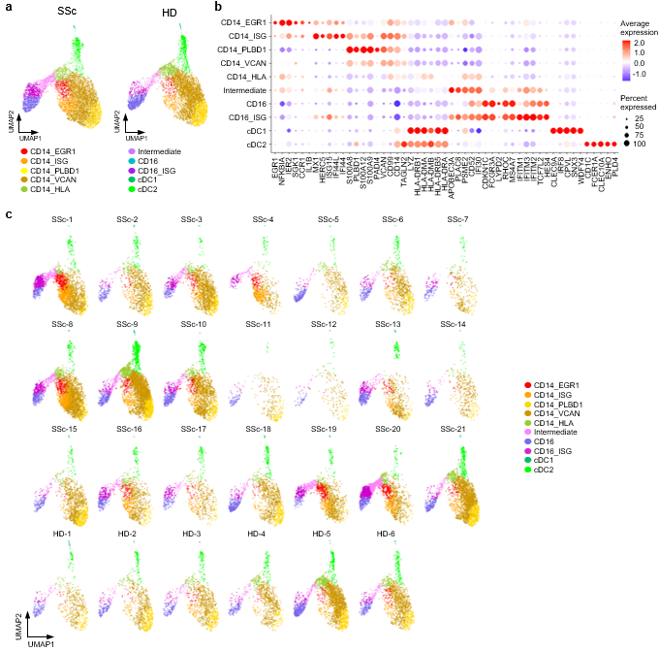
(a) UMAP plots showing the monocyte subpopulations in patients with SSc (SSc; n=21, left) and HDs (HD; n=6, right). Ten cellular clusters were identified; CD14⁺ monocytes with high expression of EGR1 (CD14_EGR1), interferon signature genes (ISGs) (CD14_ISG), PLBD1 (CD14_PLBD1), VCAN (CD14_VCAN), HLA (CD14_HLA), intermediate monocytes (Intermediate), CD16⁺ monocytes characterized by high expression of ISGs (CD16_ISG), other CD16⁺ monocytes (CD16), conventional type 1 dendritic cells (cDC1), and conventional type 2 dendritic cells (cDC2). Each plot shows 8,000 randomly selected cells. (b) Balloon plot showing highly expressed genes in each subpopulation shown in (a). (c) UMAP plots showing monocyte subpopulations in each patient with SSc or HD.
Extended Data Fig. 3.
UMAP plots of CD4⁺ T cells derived from each SSc patients or HDs.
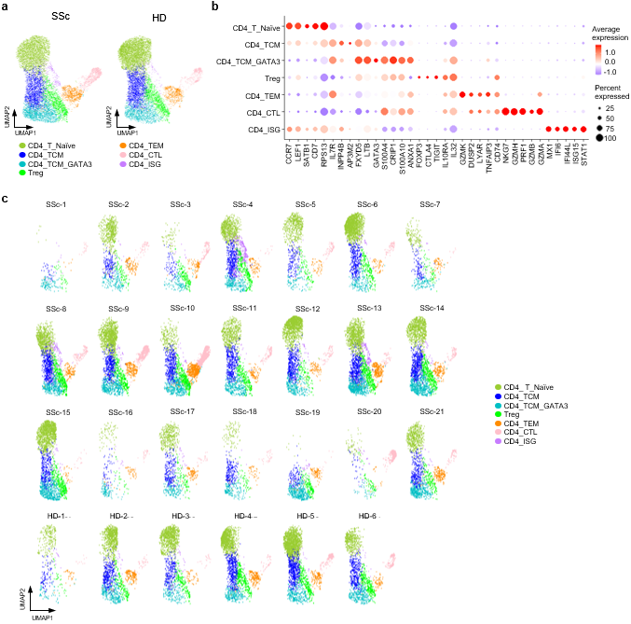
(a) UMAP plots showing the CD4⁺ T cell subpopulations in patients with SSc (SSc; n=21, left) and HDs (HD; n=6, right). Seven cellular clusters were identified: naïve CD4⁺ T cells (CD4_Naïve), central memory CD4⁺ T cells characterized by high expression of GATA3 (CD4_TCM_GATA3), other central memory CD4 ⁺ T cells (CD4_TCM), effector memory CD4⁺ T cells (CD4_TEM), cytotoxically active CD4⁺ T cells (CD4_CTL), and CD4⁺ T cells characterized by high expression of ISGs (CD4_ISG). Each plot shows 10,000 randomly selected cells. (b) Balloon plot showing highly expressed genes in each subpopulation shown in (a). (c) UMAP plots showing CD4⁺ T cell subpopulations in each patient with SSc or HD.
Extended Data Fig. 4.
UMAP plots of CD8⁺ T cells derived from each SSc patients or HDs.
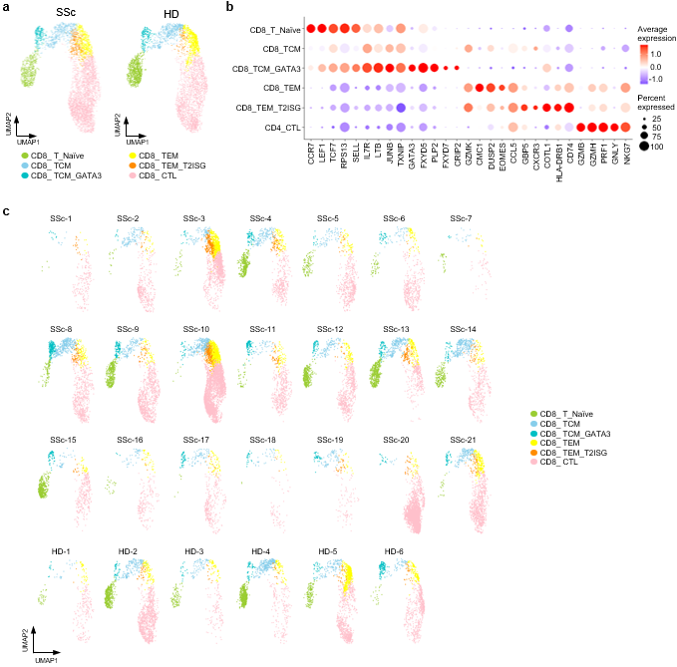
(a) UMAP plots showing the CD8⁺ T cell subpopulations in patients with SSc (SSc; n=21, left) and HDs (HD; n=6, right). Six cellular clusters were identified: naïve CD8⁺ T cells (CD8_T_ Naïve), central memory CD8⁺ T cells characterized by high expression of GATA3 (CD8_TCM_GATA3), other central memory CD8⁺ T cells (CD8_TCM), effector memory CD8⁺ T cells characterized by high expression of type 2 ISGs (CD8_TEM_T2ISG), other effector memory CD8⁺ T cells (CD8_TEM), and cytotoxically active CD8⁺ T cells (CD8_CTL). Each plot shows 5,000 randomly selected cells. (b) Balloon plot showing highly expressed genes in each subpopulation shown in (a). (c) UMAP plots showing CD8⁺ T cell subpopulations in each patient with SSc or HD.

Extended Data Fig. 5.
UMAP plots of B cells derived from each SSc patients or HDs.
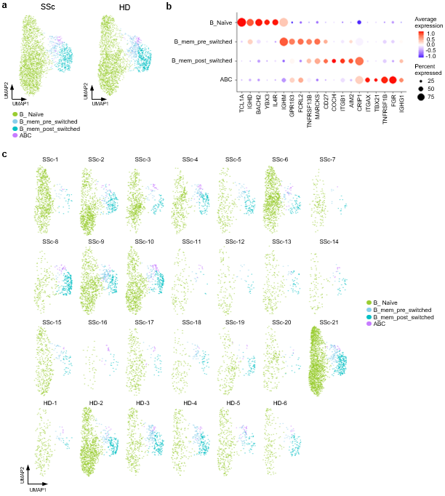
(a) UMAP plots showing the B cell subpopulations in patients with SSc (SSc; n=21, left) and HDs (HD; n=6, right). Four cellular clusters were identified: naïve B cells (B_Naïve), pre-switched memory B cells (B_mem_pre_switched), post-switched memory B cells (B_mem_post_switched), and age-associated B cells (ABC). Each plot shows 3,000 randomly selected cells. (b) Balloon plot showing highly expressed genes in each subpopulation shown in (a). (c) UMAP plots showing B cell subpopulations in each patient with SSc or HD.
Extended Data Fig. 6.
UMAP plots of NK cells derived from each SSc patients or HDs.
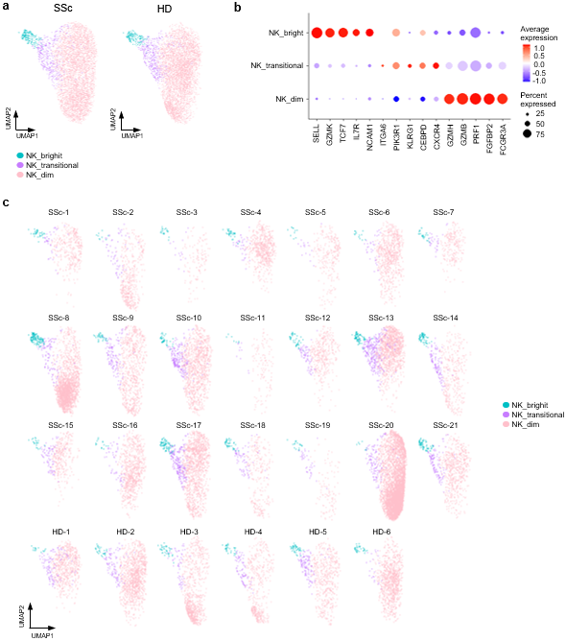
(a) UMAP plots showing NK cell subpopulations in patients with SSc (SSc; n=21, left) and HDs (HD; n=6, right). Three cellular clusters were identified: NK cells characterized by high expression of NCAM1 (NK_bright), NK cells characterized by low expression of NCAM1 and high expression of GZMH (NK_dim), and transitional NK cells (NK_transitional). Each plot shows 5,000 randomly selected cells. (b) Balloon plot showing highly expressed genes in each subpopulation shown in (a). (c) UMAP plots showing NK cell subpopulations in each patient with SSc or HD.

Extended Data Fig. 7.
UMAP plots of pDC derived from each SSc patients or HDs.
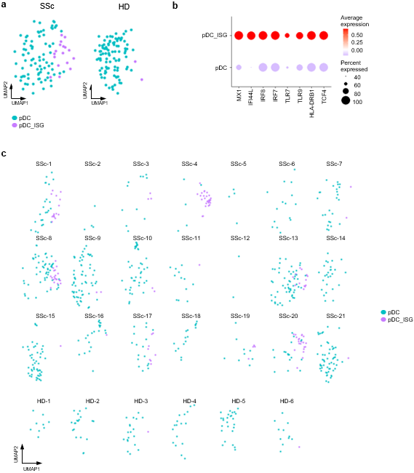
(a) UMAP plots showing pDC subpopulations in patients with SSc (SSc; n=21, left) and HDs (HD; n=6, right). Two cellular clusters were identified: pDC characterized by high expression of ISGs (pDC_ISG) and other pDC (pDC). Each plot shows 100 randomly selected cells. (b) Balloon plot showing highly expressed genes in each subpopulation shown in (a). (c) UMAP plots showing pDC subpopulations in each patient with SSc or HD.

Extended Data Fig. 8.
Differential abundance analysis of Monocytes between patients with SRC and HDs.
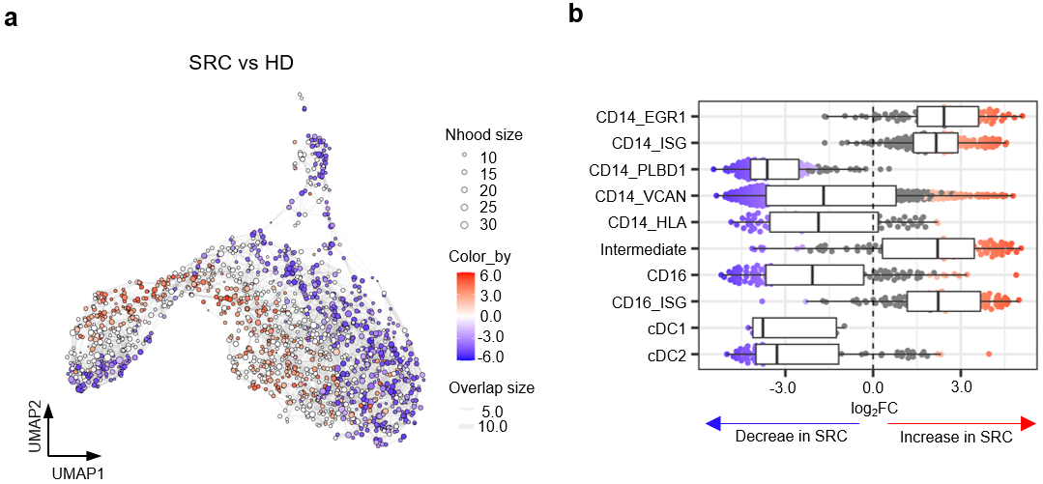
(a) Neighborhood graph of monocytes indicating the log₂-fold differences between SRC patients and HDs. (b) Beeswarm and box plots showing the distribution of log₂-fold differences in neighborhoods in different cell type clusters of monocytes. Colors are shown similar to (a). Box plots are created in a similar fashion as in Fig. 2b.

Extended Data Fig. 9.
UMAP plots of Monocytes derived from each patient with SRC or LN, and HDs.
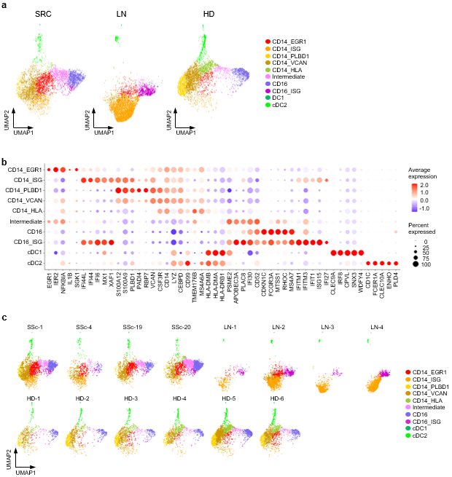
(a) UMAP plots showing the monocyte subpopulations in SSc patients with SRC (SRC; n=4, left), patients with lupus nephritis (LN; n=4, center), and HDs (HD; n=6, right). Each plot shows 5,000 randomly selected cells. (b) Balloon plot showing highly expressed genes in each subpopulation shown in (a). (c) UMAP plots showing monocyte subpopulations in each patient or HD.
Extended Data Fig. 10.
Expression of selected surface antigens in monocyte subsets enriched in SSc patients with SRC.
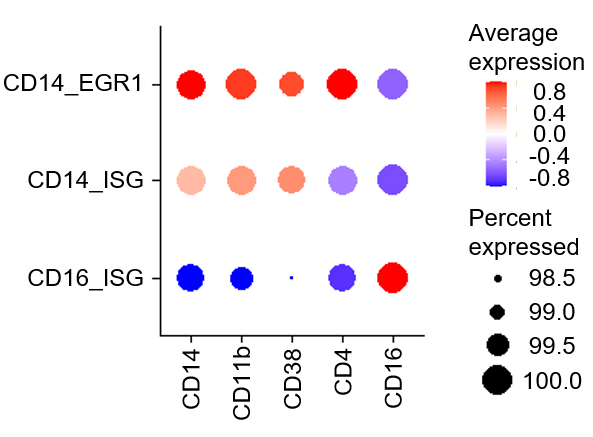
Balloon plot showing the expression levels of CD14, CD11b, CD4, CD38, and CD16 surface antigens in the CD14_EGR1, CD14_ISG, and CD16_ISG monocyte subpopulations.

Extended Data Fig. 11.
Renal biopsy obtained from the SSc patient at the onset of SRC.
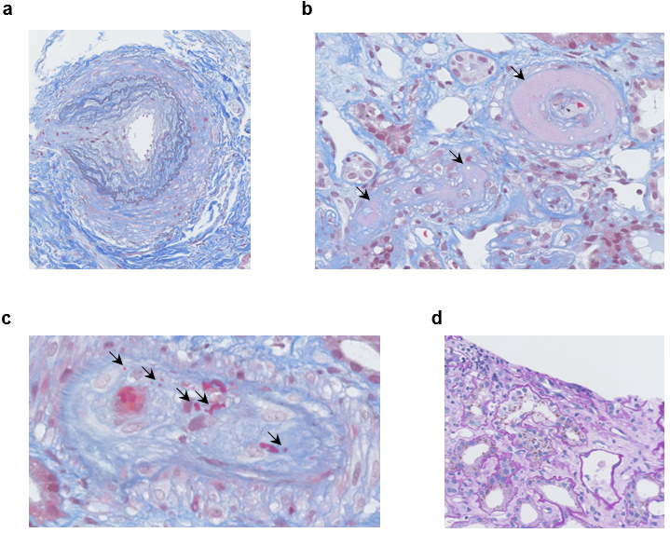
Pathological features of a kidney biopsy sample from the patient at the onset of SRC (Patient ID: SSc-19). (a) Intimal thickening and luminal narrowing within an artery. (b) Fibrinoid necrosis of arterioles (arrows). (c) Red blood cell fragmentations within the vessel (arrows). (d) Focal tubular necrosis and tubulitis. (a)-(c): Masson’s trichrome staining. (d): Hematoxylin and eosin staining.

Extended Data Fig. 12.
UMAP plots of renal tissue and peripheral blood cells derived from a patient at the onset of SRC.
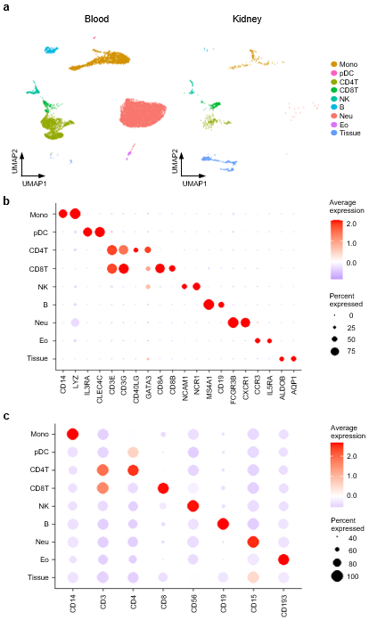
(a) UMAP plots showing Abseq data of all cells from peripheral blood (left) and renal tissue (right) derived from one patient at the onset of SRC (Patient ID: SSc-19). Mono, monocytes, macrophages, and conventional dendritic cells (cDC); pDC, plasmacytoid dendritic cells; CD4T, CD4⁺ T cells; CD8T, CD8⁺ T cells; NK, natural killer cells; B, B cells; Neu, neutrophils; Eo, eosinophils; Tissue, tissue cells. (b) Balloon plot showing highly expressed genes in each population shown in (a). (c) Balloon plot showing highly expressed surface antigens in each population shown in (a).

Extended Data Fig. 13.
Pathway analysis using DEGs of the THBS1_Mac subset.
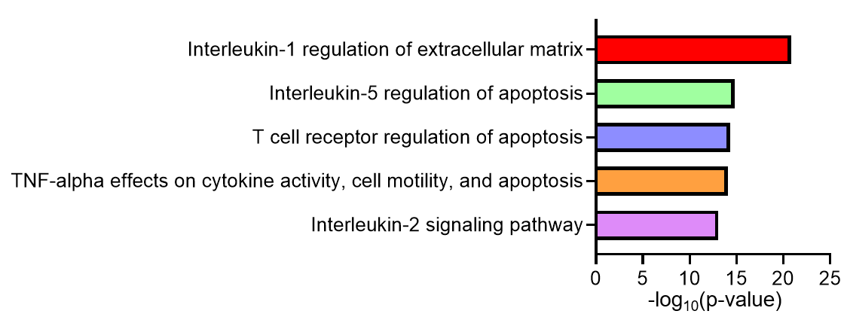
Gene set enrichment analysis of differentially expressed genes (DEGs) in the THBS1_Mac subset was conducted using the BioPlanet 2019. P-values for each pathway were calculated using the Benjamini–Hochberg method.

Extended Data Fig. 14.
Feature plots of immature monocyte marker genes in monocytes, cDC, and macrophages derived from the patient at the onset of SRC.
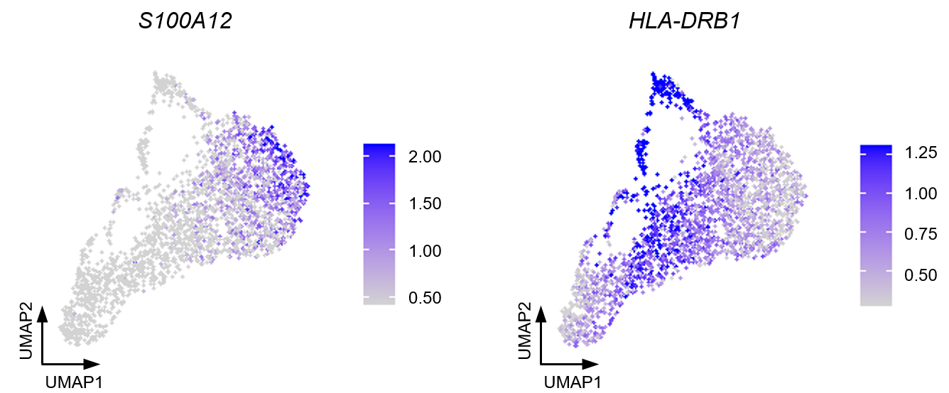
Feature plots showing the gene expression levels of S100A12 (left), and HLA-DRB1 (right) in monocytes, macrophages and cDCs from both peripheral blood and kidney of the patient at the onset of SRC (Patient ID: SSc-19).

Extended Data Fig. 15.
UMAP plots of PBMCs derived from a patient with SSc before the development, at the onset, and after the treatment of SRC.
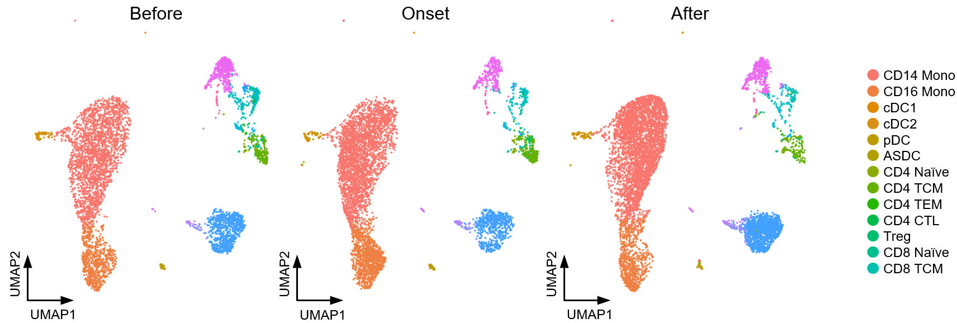
UMAP plots showing the PBMCs derived from one patient with SSc (Patient ID: SSc-1) before the development (Before, left), at its onset (Onset, center), and after the treatment (After, right) of SRC. Each cellular cluster was annotated with reference mapping. Mono, monocytes; cDC, conventional dendritic cells; ASDC, AXL⁺ dendric cells; pDC, plasmacytoid dendritic cells; TCM, central memory T cells; TEM, effector memory T cells; CTL, cytotoxic T lymphocytes; Treg, regulatory T cells; MAIT, mucosal associated invariant T cells; dnT, double negative T cells; gdT, gamma-delta T cells; PB, plasmablasts; NK, natural killer cells; ILC, innate lymphoid cells; Proliferating, proliferating cells; HSPC, hematopoietic stem and progenitor cells.

Extended Data Fig. 16.
Differential abundance analysis of CD4⁺ T cells derived from patients with SSc and HDs.
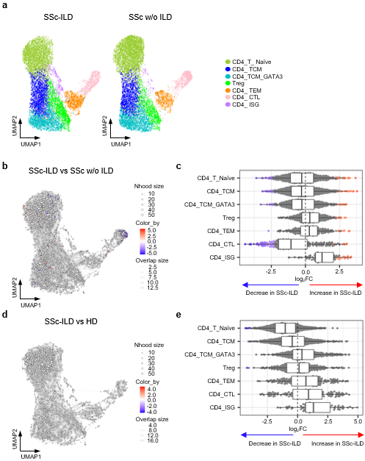
(a) UMAP plots showing the peripheral CD4⁺ T cell subpopulations derived from SSc patients with interstitial lung disease (ILD) (SSc-ILD; n = 12, left) or without ILD (SSc w/o ILD; n = 9, right). Cell annotations were consistent with those described in Extended Data Fig. 3. Each plot shows 10,000 randomly selected cells. (b) Neighborhood graph of CD4⁺ T cells indicating the log₂-fold differences between SSc-ILD and SSc w/o ILD. (c) Beeswarm and box plots showing the distribution of log₂-fold differences between SSc-ILD and SSc w/o ILD in neighborhoods in different cell type clusters of CD4⁺ T cells. Colors are shown similar to (b). Box plots are created in a similar fashion as in Fig. 2b. (d) Neighborhood graph of CD4⁺ T cells indicating the log₂-fold differences between SSc-ILD and HDs. (e) Beeswarm and box plots showing the distribution of log₂-fold differences between SSc-ILD and HDs in neighborhoods in different cell type clusters of CD4⁺ T cells. Colors are shown similar to (d). Box plots are created in a similar fashion as in Fig. 2b.

Extended Data Fig. 17.
Differential abundance analysis of CD8⁺ T cells between patients with SSc-ILD and HDs.
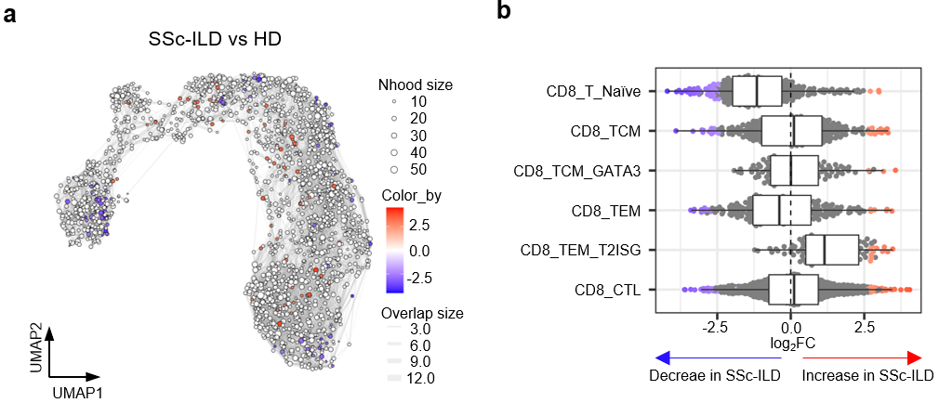
(a) Neighborhood graph of peripheral CD8⁺ T cells indicating the log₂-fold differences between SSc-ILD and HDs. (b) Beeswarm and box plots showing the distribution of log₂-fold differences between SSc-ILD and HDs in neighborhoods in different cell type clusters of CD8⁺ T cells. Colors are shown similar to (a). Box plots are created in a similar fashion as in Fig. 2b.

Extended Data Fig. 18.
UMAP plots of lung CD8⁺ T cells derived from patients with advanced SSc-ILD and HDs.
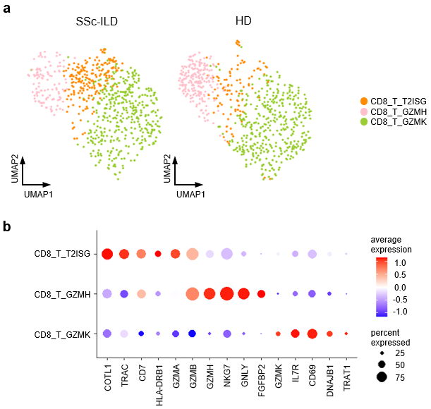
(a) UMAP plots showing the lung CD8⁺ T cell subpopulations derived from SSc patients with advanced SSc-ILD (SSc-ILD; n=8, left) and HDs (HD; n=7, right). Each plot shows 700 randomly selected cells. (b) Balloon plot showing highly expressed genes in each subpopulation shown in (a).

Supplementary Table 1.
Scoring for the classification of each patient with SSc according to 2013 ACR/EULAR criteria.
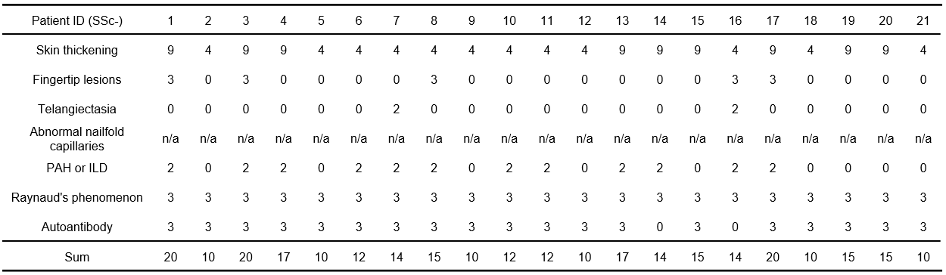
Patients with a total score of ≥9 are classified as systemic sclerosis on the basis of 2013 ACR/EULAR classification criteria.
SSc, systemic sclerosis; PAH, pulmonary artery hypertension; ILD, interstitial lung disease; n/a, not assessed.

Supplementary Table 2.
Individual characteristics of systemic sclerosis patients.
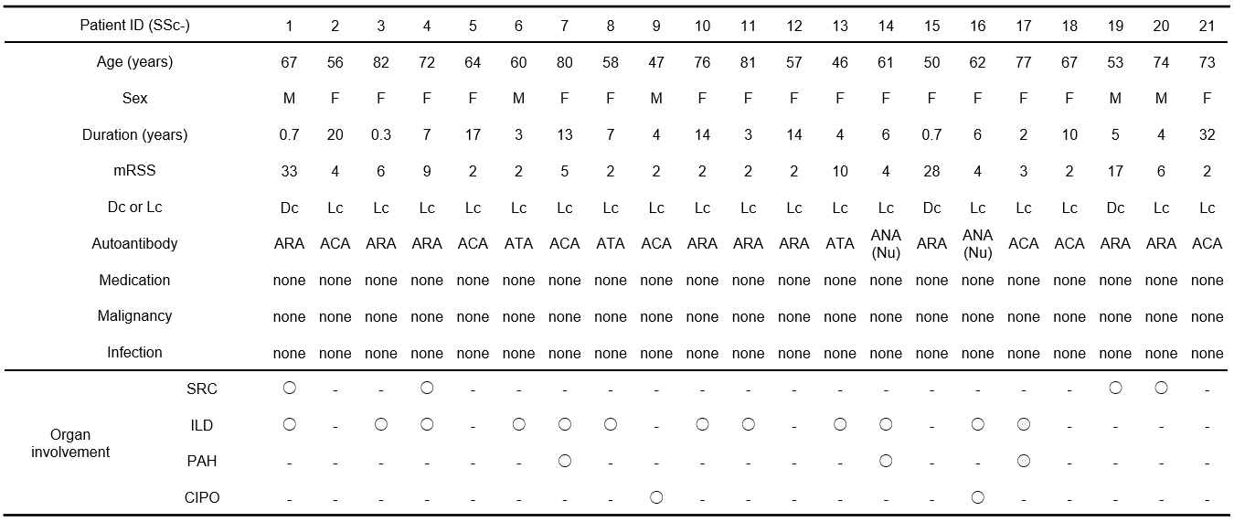
SSc, systemic sclerosis; mRSS, modified Rodnan skin score; Dc, diffuse cutaneous; Lc, limited cutaneous; ARA, anti-RNA polymerase III antibody; ACA, anti-centromere antibody; ATA, anti-topoisomerase I antibody; ANA, anti-nuclear antibody; Nu, nucleolar pattern; SRC, scleroderma renal crisis; ILD, interstitial lung disease; PAH, pulmonary artery hypertension; CIPO, chronic intestinal pseudo-obstruction.

Supplementary Table 3.
Detailed clinical information of individual systemic sclerosis patients.
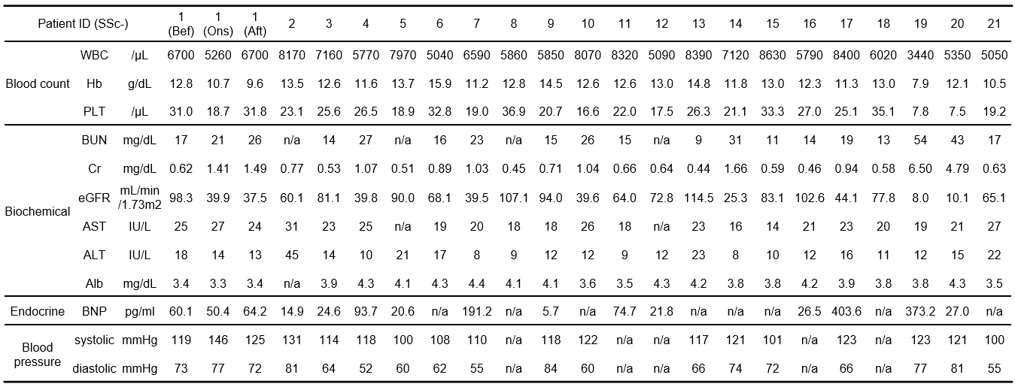
SSc, systemic sclerosis; Bef, before the onset of scleroderma renal crisis (SRC); Ons, at the onset of SRC; Aft, after the improvement of SRC; WBC, white blood cell; Hb, hemoglobin; PLT, platelet; BUN, blood urea nitrogen; Cr, creatinine; eGFR, estimated glomerular filtration rate; AST, aspartate aminotransferase; ALT, alanine aminotransferase; Alb, albumin; BNP, brain natriuretic peptide; n/a, not assessed.

Supplementary Table 4.
Clinical characteristics of lupus nephritis patients.
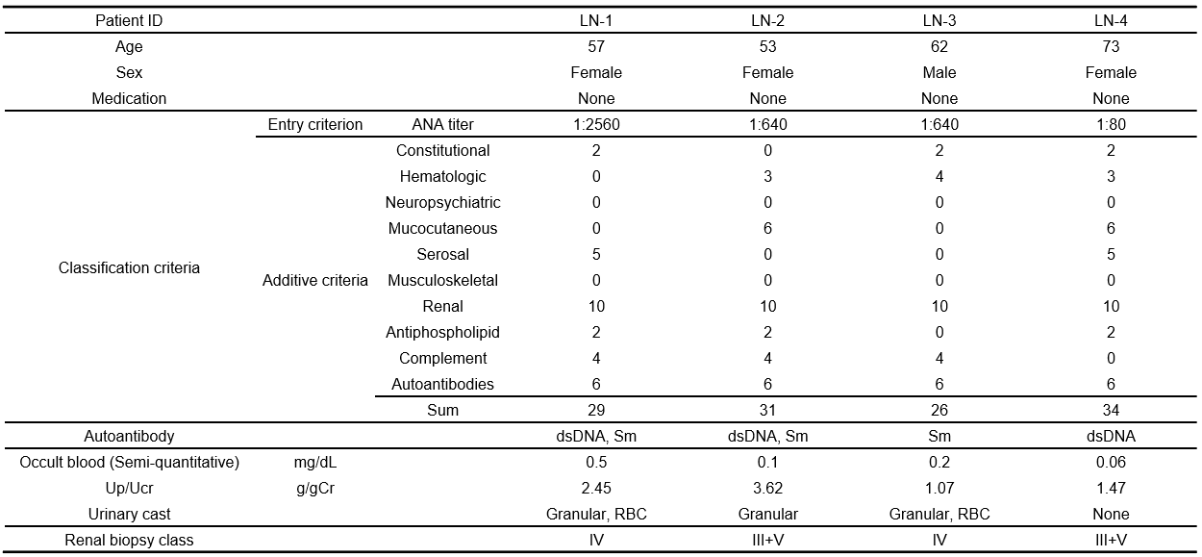
Patients with a total score of ≥10 in additive criteria are classified as systemic lupus erythematosus on the basis of 2019 EULAR/ACR classification criteria.
LN, lupus nephritis; Up/Ucr, urine protein/urine creatinine ratio; ANA, anti-nuclear antibody; dsDNA, anti-double stranded DNA antibody; Sm, anti-Smith antibody; Granular, granular cast; RBC, red blood cell cast; Renal biopsy class, the class of lupus nephritis according to International Society of Nephrology/Renal Pathology Society 2003 classification.

Supplementary Table 5.
Highly expressed genes in the CD14_EGR1 subset.
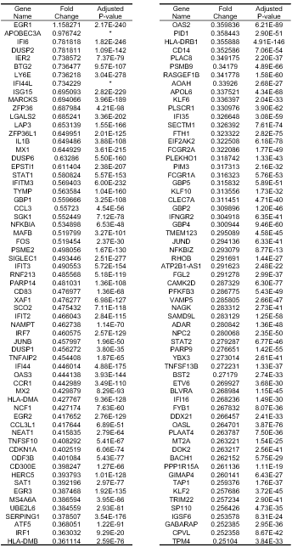
A list of genes highly expressed in CD14_EGR1. The log₂-fold change and the adjusted P-value were calculated. Genes that show 0.25 < fold change were listed. * Adjusted P-values were smaller than 1E-280.

Supplementary Table 6.
Highly expressed genes in the THBS1_Mac subset.
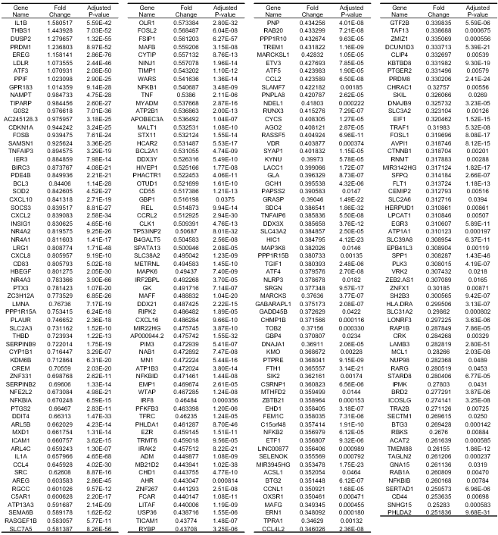
A list of genes highly expressed in THBS1_Mac. The log₂-fold change and the adjusted P-value were calculated. Genes that show 0.25 < fold change were listed.

Supplementary Table 7.
Highly expressed genes in the CD8_TEM_T2ISG subset.
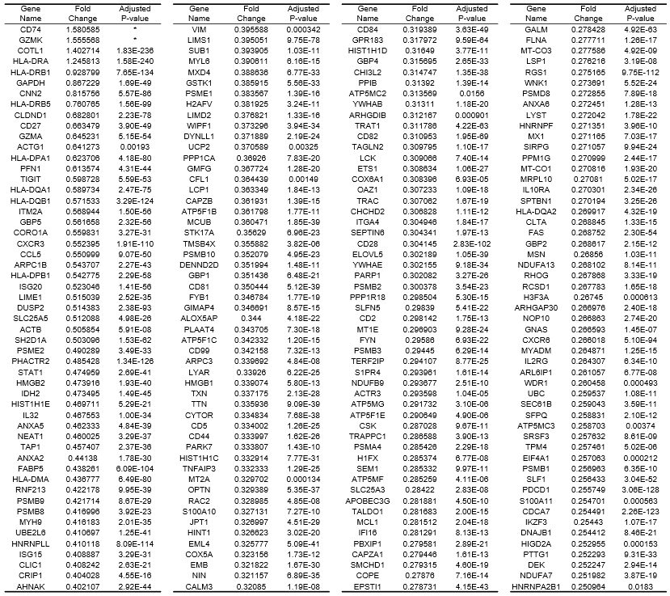
A list of genes highly expressed in CD8_TEM_T2ISG. The log₂-fold change and the adjusted P-value were calculated. Genes that show 0.25 < fold change were listed. *Adjusted P-values were smaller than 1E-240.

Supplementary Table 8.
The Sequence information in CITE-seq experiments conducted on the 10x chromium platform.
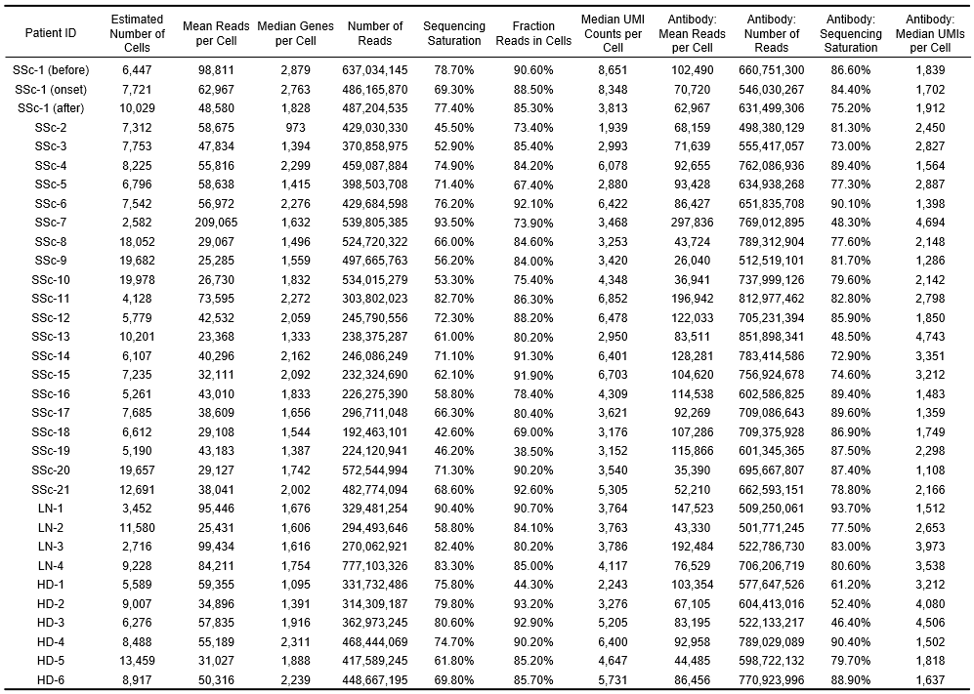
UMI, Unique molecular identifiers; SSc, systemic sclerosis; LN, lupus nephritis; HD, healthy donor; before, before the onset of scleroderma renal crisis (SRC); onset, at the onset of SRC; after, after the improvement of SRC.

Supplementary Table 9.
The Sequence information in Abseq experiments conducted on the BD Rhapsody Express System.
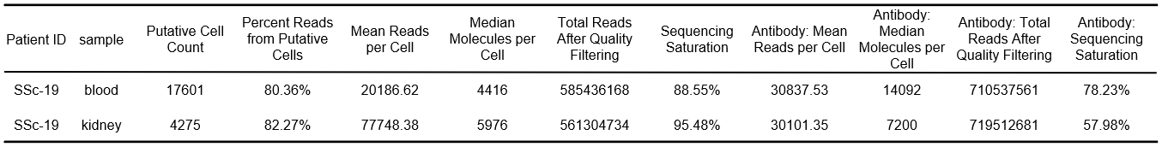

Supplementary Table 10.
The list of DNA-barcoded antibodies used for Abseq experiments conducted on the BD Rhapsody Express System.
