Soil organic matter oxidation by hydroxyl radical: an overlooked route of greenhouse gas production in drylands

Xing Guo^{1,2}, Yongxing Lu¹, Jungang Yang¹, Fan Du¹, Yakov Kuzyakov^{3,4}, Yuanhe Yang⁵, Shen Yu⁶, Shuping Qin⁷, Qinglong Fu⁸, Xiaoying Rong¹, Benfeng Yin¹, Kai Shi¹, Xiangfang Lv⁹, Yuanming Zhang¹, Xiaobing Zhou^{1,*}

- Key Laboratory of Ecological Safety and Sustainable Development in Arid Lands, Xinjiang Institute of Ecology and Geography, Chinese Academy of Sciences, 830011 Urumqi, China.
- University of the Chinese Academy of Sciences, 100049 Beijing, China.
- Department of Soil Science of Temperate Ecosystems, Department of Agricultural Soil Science, University of Goettingen, 37077 Göttingen, Germany.
- Peoples Friendship University of Russia (RUDN University), 117198 Moscow, Russia.
- State Key Laboratory of Vegetation and Environmental Change, Institute of Botany, Chinese Academy of Sciences, 100093 Beijing, China.
- Key Laboratory of Urban Environment and Health, Institute of Urban Environment, Chinese Academy of Sciences, 361021 Xiamen, China.
- Key Laboratory of Soil Ecology, Key Laboratory of Agricultural Water Resources, Center for Agricultural Resources Research, Institute of Genetic and Developmental Biology, Chinese Academy of Sciences, 050021 Hebei, China.
- School of Environmental Studies, China University of Geoscience, 430074 Wuhan, China.
- Urumqi Ecological Environment Monitoring Station, 830011 Urumqi, China.

Corresponding author:
Xiaobing Zhou, zhouxb@ms.xjb.ac.cn.
Supplementary method 1:
To verify that the decrease in CO₂, N₂O release from simulated rainfall under 10% methanol conditions was mainly due to the effect of ·OH rather than changes in microbial community structure, a control experiment was additionally designed. This experiment simulates rainfall scenarios with a control group (Under water) and an experimental group (Under water with ·OH quencher). Notably, at the onset of the simulated rainfall experiment, both the control and experimental groups were incubated with pure water for 12 hours. The purpose was to ensure the microbial community structures of both groups remained consistent. After the 12-hour incubation period, methanol was added to the experimental group to quench ·OH, and after one hour of further incubation, the changes in the accumulated production of CO₂ and N₂O were compared. The short-term addition of methanol does not alter the microbial community structure but can rapidly quench ·OH (Supplementary Fig. 9). After 10% methanol was added for 1 h, CO₂ accumulation decreased 18%, 59% and 54% compared to control in Bare, Cyan/Lich and Moss crusted soil , respectively. Similarly, N₂O accumulation decreased 29%, 52% and 53% in Bare, Cyan/Lich and Moss crusted soil, respectively. Therefore the removal of ·OH by methanol was the reason affecting the decrease of CO₂ and N₂O accumulation (Supplementary Fig. 11).
The specific steps are as follows: 100 g of soil sample was placed into a conical flask equipped with a rubber stopper and a three-way valve, uniformly mixed with 5 mL of pure water solution, and incubated for 12 hours. After this period, an additional 5 mL of pure water was added to the control flask, while a 20% methanol solution (resulting in a final methanol concentration of 10%) was added to the experimental flask, which was then immediately sealed with a rubber stopper. One hour later, a syringe was used to extract 50 mL of gas, which was then injected into a gas collection bag for the detection of accumulated concentrations of CO₂ and N₂O using a gas chromatograph (Agilent 7890B, Agilent, Germany).
Supplementary method 2:
Prior to FT-ICR MS analyses, WEOC extraction was first performed¹. 100 g of soil was placed into a 250 mL conical flask at a soil-to-water ratio of 1:1, to which 100 mL of pure water was added. The mixture was then shaken for 24 hours. The solution collected was centrifuged at 4000 RCF for 10 minutes, followed by filtration through a 0.45 μm filter membrane, and then collected into a pre-acidified bottle. Subsequently, the WEOC solution was divided into two portions: one served as a control, while the other was quantitatively added with Fenton reagent based on the concentration of ·OH produced 24 hours after rainfall events (Fig. 1), to observe changes in the content and component structure of WEOC before and after the reaction.
Specifically, the pH of the WEOC solution was adjusted to 3, and 4 mg of FeSO₄·7H₂O was added to 50 mL of WEOC solution². Based on the soil types of Bare, Cyan/Lich, and Moss crusted soil, 0.4, 1.1, and 1.6 mL of 5 mmol L⁻¹ H₂O₂ were added to the WEOC, respectively, resulting in solution H₂O₂ concentrations of 40, 110, and 160 μmoL L⁻¹, and the final ·OH concentrations generated were approximately 1.7, 4.9, and 7.1 μmol L⁻¹ (Supplementary Fig. 12). After standing for 1 hour, changes in WEOC concentration before and after the Fenton reaction were detected using a carbon-nitrogen analyzer (Multi N/C 2100, Analytik Jena, Germany). The remaining samples were adjusted to pH 2 with hydrochloric acid, stored in the dark at 4°C, and prepared for subsequent FT-ICR MS analysis.

Supplementary Tables
Supplementary Table 1: Main inorganic mineral components of soil
Major minerals | content(%)
Major minerals | Bareland | cyanobacteria/lichen | Moss
SiO₂ | 87.86 | 82.17 | 78.90
Al₂O₃ | 7.47 | 10.28 | 12.56
Fe₂O₃ | 1.82 | 3.77 | 4.13
K₂O | 1.66 | 1.97 | 1.99
TiO₂ | 0.33 | 0.53 | 0.72
P₂O₅ | 0.15 | 0.17 | 0.23
MnO | 0.07 | 0.08 | 0.07
Cr₂O₃ | 0.06 | 0.08 | 0.05

Supplementary Table 2: PCR primers for nitrifying and denitrifying functional genes
Gene | Primer | Sequence 5’- 3’
AOA | AOA-F | GACTACATMTTCTAYACWGAYTGGGC
AOA | AOA-R | GGKGTCATRTATGGWGGYAAYGTTGG
AOB | AOB-F | GGGGTTTCTACTGGTGGT
AOB | AOB-R | CCCCTCKGSAAAGCCTTCTTC
narG | narG-F | TAYGTSGGGCAGGARAAACTG
narG | narG-R | CGTAGAAGAAGCTGGTGCTGTT
nirS | nirS-F | GTSAACGTSAAGGARACSGG
nirS | nirS-R | GASTTCGGRTGSGTCTTGA
nirK | nirK-F | ATCATGGTSCTGCCGCG
nirK | nirK-R | GCCTCGATCAGRTTGTGGTT
nosZ | nosZ-F | CGYTGTTCMTCGACAGCCAG
nosZ | nosZ-R | CGSACCTTSTTGCCSTYGCG

Supplementary Figures

Supplementary Fig. 1 CH₄ accumulation in soil from bareland (a), cyanobacteria/lichen (b), and moss crusted soil (c) rainfall event. Rainfalls were simulated under H₂O and under H₂O with ·OH quencher. ·OH quencher was 10% methanol. Data are presented as the means ± Standard Error. Significant differences between groups are denoted by letters (p < 0.05), and significance within groups is denoted by * (*: P < 0.05).

Supplementary Fig. 2 Relationships between decreased CO₂ and N₂O production and decreased ·OH content under ·OH quencher after rainfall event. Bareland (a, d), cyanobacteria/lichen (b, e), and moss crusted soil (c, f).

Supplementary Fig. 3 ¹⁸O content in CO₂ (a, d), N₂O (b, e) and NO₃⁻ (c) after 24 h rainfall events where d, e represent the gray-black areas in a, b respectively. The isotope labels are light blue: unlabeled, brown: ¹⁸O labeled, dark blue: ¹⁸O + ¹⁵N labeled, and red: ¹⁸O + ¹⁵N + ¹³C labeled. Rainfalls were simulated under H₂O and under H₂O with ·OH quencher. ·OH quencher was 10% methanol. Data are presented as the means ± Standard Error. Significance within groups is denoted by * (*: P < 0.05).

Supplementary Fig. 4 Structure of WEOC before and after the Fenton reaction. N-ConSatCom: Nitrogen-saturated compounds; N-FreeSatCom: Nitrogen-free saturated compounds; ConAroStru: Condensed aromatic structures. Data are presented as the means ± Standard Error. Significance within groups is denoted by * (*: P < 0.05).

Supplementary Fig. 5 NH₄⁺ and NO₃⁻ content in soil from bareland (a, d), cyanobacteria/lichen (b, e), moss crusted soil (c, f) after rainfall event. Rainfalls were simulated under H₂O and under H₂O with ·OH quencher. ·OH quencher was 10% methanol. Data are presented as the means ± Standard Error. Significance within groups is denoted by * (*: P < 0.05).

Supplementary Fig. 6 Relative expression of nitrification and denitrification functional genes of bareland, cyanobacteria/lichen, moss crusted soil 24 h after rainfall events. AOA (a), AOB (b), narG (c), nirK (d), nirS (e), nosZ (f). Rainfalls were simulated under H₂O and under H₂O with ·OH quencher. ·OH quencher was 10% methanol. Data are presented as the means ± Standard Error. Significance within groups is denoted by * (*: P < 0.05).

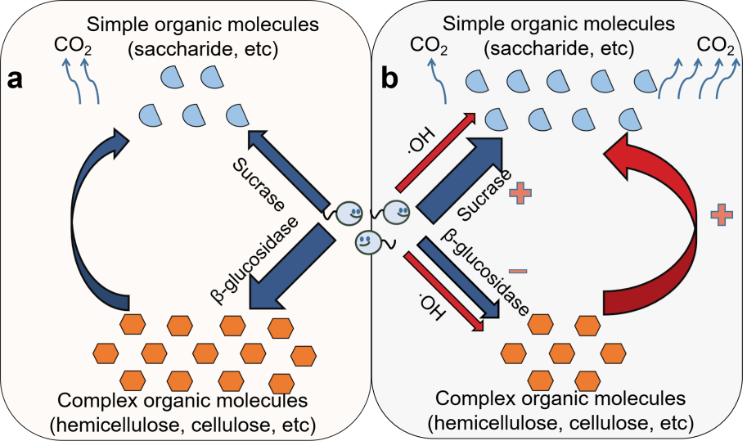
Supplementary Fig. 7 Conceptual diagram reflecting how ·OH facilitate the CO₂ production. a: the traditional view on enzymatic processes of organic matter decomposition, b: illustrates the synergistic effects of ·OH with enzymatic reactions. The symbols "+" and "-" represent the positive and negative impacts of the addition of ·OH on each process, relative to the traditional view, respectively. The production of ·OH not only oxidizes complex organic matter into simpler forms but also allows microorganisms to optimize energy allocation by reducing the synthesis of complex organic matter decomposing enzymes and increasing the synthesis of enzymes that break down simpler organic matter. This, in turn, facilitates the CO₂ production.

Supplementary Fig. 8 The dynamic of accumulation of ·OH under 10% methanol condition after rainfall event. The black, blue and red lines indicate bareland, cyanobacteria/lichen, moss crusted soil, respectively. The solid line indicates no treatment Control, and the dashed line indicates 10% methanol addition treatment. Data are presented as the means ± Standard Error.

Supplementary Fig. 9 Microbial community structure in bareland, cyanobacteria/ lichen, moss crusted soil. Rainfalls were simulated under H₂O and under H₂O with ·OH quencher. In contrast to the original soil, Under H₂O, Under H₂O with ·OH quencher conditions, the structure of the bacterial and fungal microbial communities of all crust types was significantly altered, except for the bareland fungal community, which did not change significantly.

Supplementary Fig. 10 Effect of 10% methanol addition in soil CO₂ (a) and N₂O (b) accumulation. Data are presented as the means ± Standard Error. Significance within groups is denoted by * (*: P < 0.05).

Supplementary Fig. 11 Correlation between added H₂O₂ concentration and ·OH production.

References
- Huang, Z.Q., Xu, Z.H., Chen, C.R. Effect of mulching on labile soil organic matter pools, microbial community functional diversity and nitrogen transformations in two hardwood plantations of subtropical Australia. Appl. Soil Ecol. 40, 229-239(2008).
- Patel, K.F., Tejnecký, V., Ohno, T., Bailey, V.L., Sleighter, R.L., Hatcher, P.G. Reactive oxygen species alter chemical composition and adsorptive fractionation of soil-derived organic matter. Geoderma 384, 114805 (2021).

