Supplementary material

Table S1 Variables, codes, and modalities used in the MCA
Qualitative variable | Modalities | Meaning | Frequencies (%)
Ecological region (ER) | 1 | Arid Sudanian region | 43.6
 | 2 | Semi-arid Sudano-Guinean | 56.4
Ethnicity group (EG) | 1 | Fulani | 53.1
 | 2 | Gando | 27.9
 | 3 | Bariba | 19.0
Main occupation (MO) | 1 | Livestock keeping | 79.5
 | 2 | Crop farming | 19.2
 | 3 | Trade | 1.3
Level of education (LE) | 1 | None | 88.5
 | 2 | Secondary school | 9.0
 | 3 | University | 2.5
Source of labour (SOL) | 1 | Family | 73.0
 | 2 | Hired | 14.1
 | 3 | Both | 12.9
Crop cultivation (CCU) | 1 | Yes | 83.3
 | 2 | No | 16.7
Crop integrated (CIT) | 1 | Maize | 22.1
 | 2 | Maize + Cotton | 21.3
 | 3 | Maize + Sorghum | 56.6
Tree plantation (TP) | 1 | Yes | 79.0
 | 2 | No | 21.0
Trees integrated (TI) | 1 | Fruit trees | 33.3
 | 2 | Fodder | 11.5
 | 3 | Fruit + Fodder trees | 27.0
 | 4 | Shrubs | 17.9
 | 5 | Timber-Fruit-Fodder | 10.3
Reasons of trees integrated (RTI) | 1 | Feed and Animal heath | 67.7
 | 2 | Improved soil fertility | 30.4
 | 3 | Wood and fruits | 1.9
Contribution of trees integrated (CTI) | 1 | Resilience to climate change | 76.5
 | 2 | Food security | 23.5
 | 3 | Household income | 10.0
Possession land tittle (PLT) | 1 | Yes | 82.1
 | 2 | No | 17.9
Feeding mode (FM) | 1 | Grazing (G) | 18.0
 | 2 | G+ supplementation | 82.0
Valorization of manure (VM) | 1 | Yes | 80.1
 | 2 | No | 19.9
Quantitative variable | Unity |  | Mean ± SE
Age of farmer | year | - | 45.0 ± 1.2
Household size | people | - | 12.1 ± 0.6
Farmer size | ha | - | 3.2 ± 0.3
Tree plantation size | ha | - | 1.6 ± 0.2
Tropical Livestock Units | TLU | - | 15.3 ± 0.4

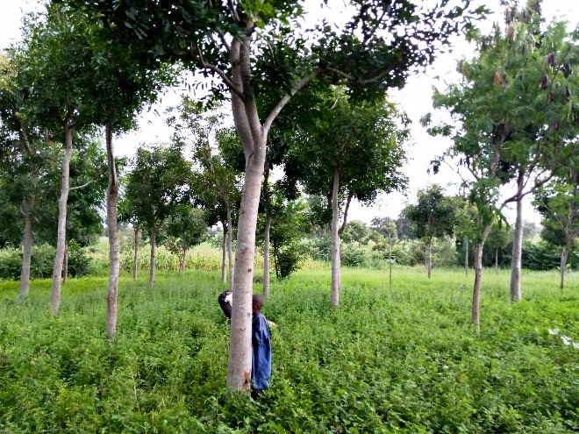
Fig. S1 Khaya senegalensis plantation established in drylands of Benin
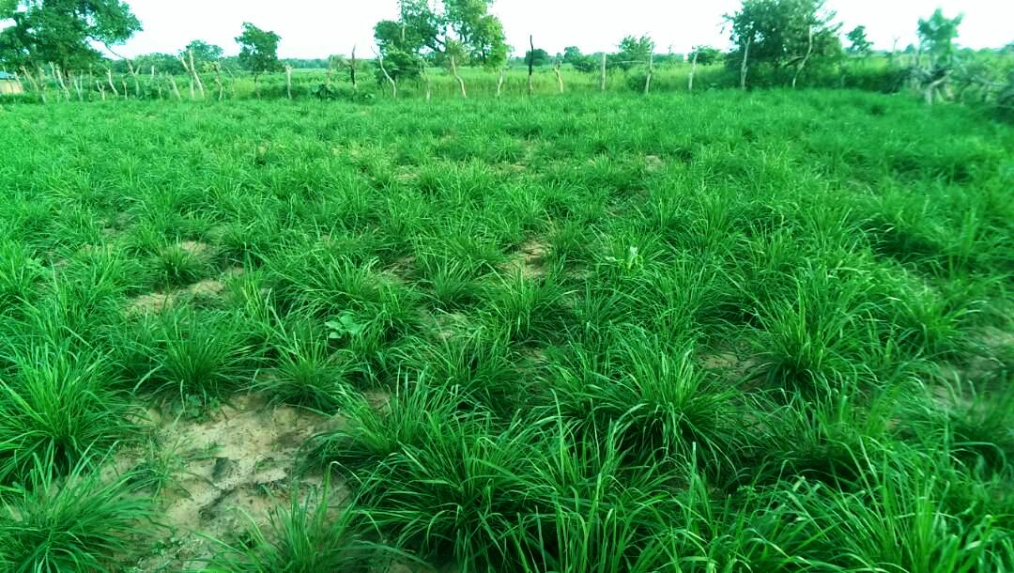
Fig. S2 Panicum maximun plot in drylands of Benin
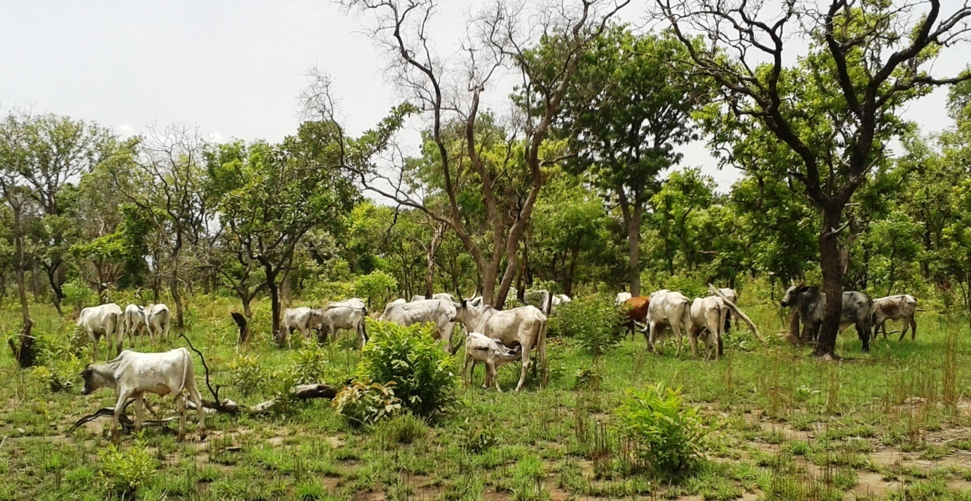
Fig. S3 Presence of domestic animals in Upper Alibori protected areas in drylands of Benin

