Supplementary Method 1
Computed tomography (CT) images were acquired on a 64-detector row CT scanner (Discovery CT750 HD, GE Healthcare, Chicago, USA) or 256-detector row CT scanner (Revolution CT, GE Healthcare, Chicago, USA). The scanning parameters were as follows: tube voltage, 120 kVp; detector collimation, 128×0.625 mm or 32×0.6 mm; and reconstruction image thickness, 5 mm.

Supplementary Method 2
The data splitting was performed by the ‘caret’ package (version 6.0.94). The least absolute shrinkage and selection operator regression was carried out by the ‘glmnet’ package (version 4.1.7). The multivariate logistic regression was conducted by the t ‘rms’ package (version 6.7.0). The receiver operating characteristic curves were generated by the ‘pROC’ package (version 1.18.0).

Supplementary Method 3
- Median: The median gray level intensity within the ROI.
- Dependence Non-Uniformity Normalized (DNN): Measures the similarity of dependence throughout the image, with a lower value indicating more homogeneity among dependencies in the image.
- Dependence Variance (DV): Measures the variance in dependence size in the image.
- Gray Level Nonuniformity Normalized (GLNN): GLNN measures the variability of gray-level intensity values in the image, with a lower value indicating a greater similarity in intensity values.
- Coarseness: Coarseness is a measure of the average difference between the center voxel and its neighborhood and is an indication of the spatial rate of change. A higher value indicates a lower spatial change rate and a locally more uniform texture.

Supplementary Table 1
Logistic regression analysis using UC severity and medication

 | Coefficient | Standard error | Z value | P value
Intercept | -1.4203 | 0.4603 | -3.0860 | 0.0020
Severity | -2.7724 | 0.6068 | -4.5690 | <0.0001
Medication | 0.9855 | 0.2233 | 4.4130 | <0.0001

Null deviance: 154.275 on 125 degrees of freedom
Residual deviance: 98.217 on 123 degrees of freedom
AIC: 104.22

Supplementary Figure 1.
The data recruitment diagram
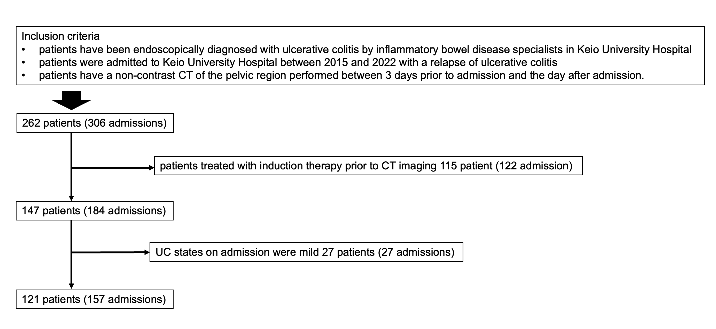

Supplementary Figure 2.
Radiomics feature selection using the LASSO binary regression model
Left, penalty parameter (λ) selection using 10-fold cross-validation; right, coefficient profile plot of the 310 texture features where the optimal parameter (λ) resulted in 5 features with nonzero coefficients
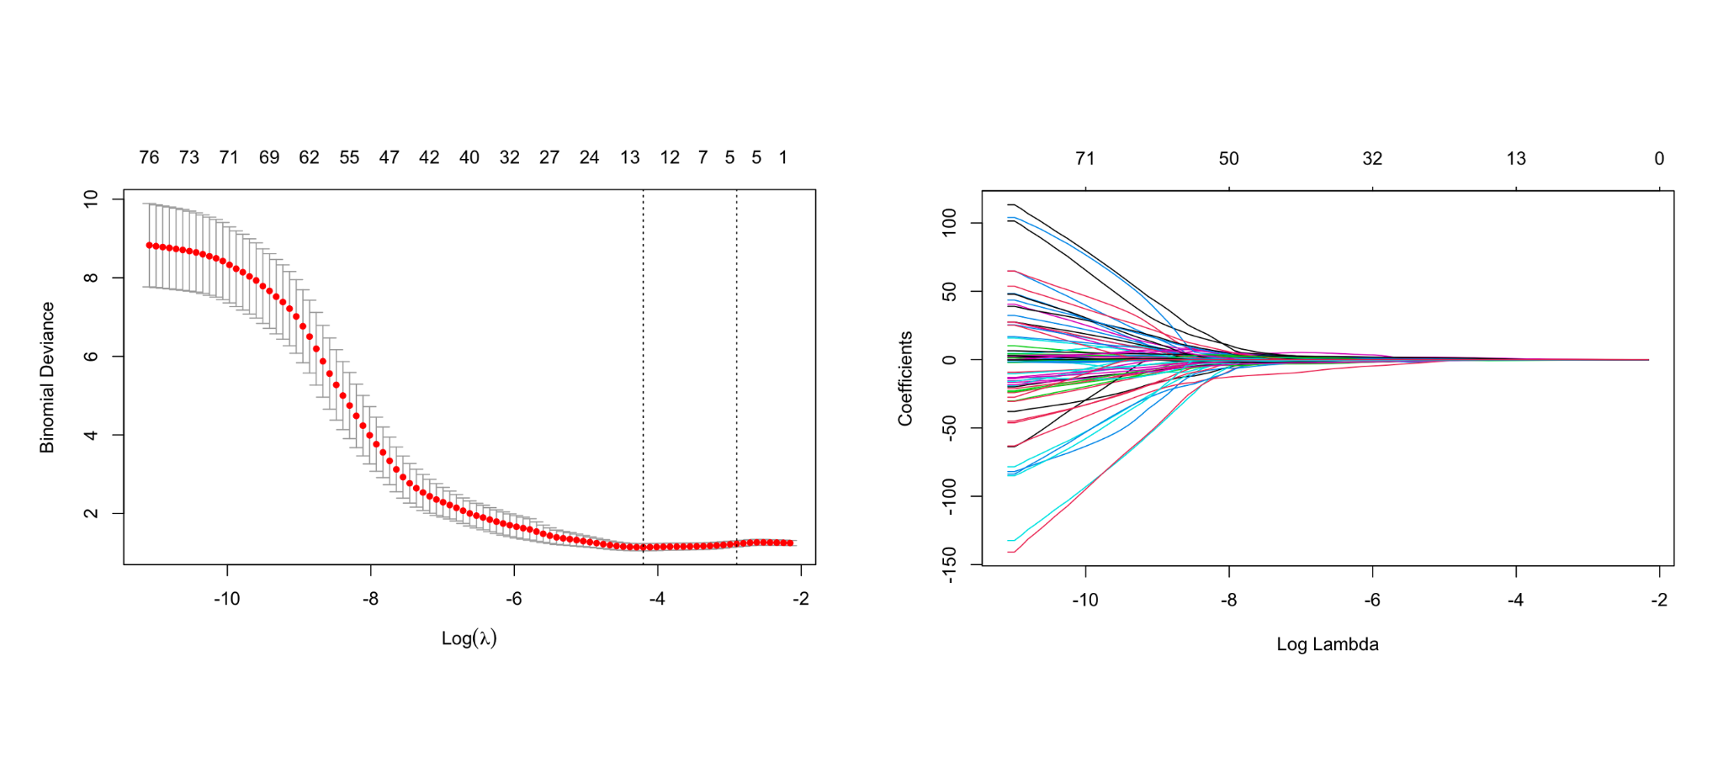

Supplementary Figure 3.
DeLong test results between each two models in the training and b validation cohorts
Red boxes represent p values < 0.05
