Spatial-Confinement in Biomimetic Catalysts: Enhancing Homolytic Sulfur-Chain Reactions and Enzyme-like Activity for High-Performance Lithium-Sulfur Batteries
Tingting Li, Yangyang Dong, Zeyi Guo, Dong Cai*, Meiling Shu, Xuemei Zhou, Hao Tang, Shuo Yang, Haoran Tu*, Jia Guan*, Zhi Yang*

T. Li, Z. Guo, Y. Dong, Dr. D. Cai, M. Shu, Dr. H. Tu, X. Zhou, Prof. H. Tang, Prof. Jia Guan, Prof. S. Yang, Prof. Z. Yang
Key Laboratory of Carbon Materials of Zhejiang Province, Wenzhou University, Wenzhou, 325035, China
- mail: caidong@wzu.edu.cn; guanjia@wzu.edu.cn; yang201079@126.com

Dr. H. Tu
Center for Neutron Scattering and Advanced Light Sources , Dongguan University of Technology, Dongguan, 523808, China
- mail: terrytu@dgut.edu.cn

Keywords: lithium−sulfur battery; iron porphyrin; metal-organic-framework; spatial confinement; enzymatic catalysis; lithium polysulfide homolytic reaction

1. Synthesis and Characterization
Synthesis of Fe-TCPP@Cu-BTC and Cu-BTC: Fe-TCPP@Cu-BTC was synthesized following a previously reported method (ACS Appl. Mater. Interfaces 2021, 13, 25937−25945). The typical synthesis procedure was as follows: 1,3,5-benzenetricarboxylic acid (H₃BTC, 300 mg, 98%, Meryer) and Fe-TCPP (10 mg, 95%, Bide) were dissolved in a 1:1 (v/v) mixture of ethanol and N,N-dimethylformamide (DMF) (5 mL). This solution was then added to 2.5 mL of an aqueous Cu(NO₃)₂·3H₂O solution (400 mg, 99.99%, Aladdin). The resulting mixture was sonicated to ensure thorough dispersion and then sealed in a 15 mL Teflon-lined autoclave. The reaction was carried out at 60 °C for 7 h. The product was collected by centrifugation, washed sequentially with DMF and ethanol, and then dried under vacuum at 60 °C for 12 h. Cu-BTC was synthesized following the same procedure, omitting the addition of Fe-TCPP.

Synthesis of CNTs-S composites: The synthesis of CNTs-S was carried out following a previously reported method. The process began with the preparation of sulfur quantum dots (SQDs). In a 100 mL round-bottom flask, sublimed sulfur powder (1.4 g, >99.99%, Aladdin), ultrapure water (50 mL), PEG-400 (3 mL, Aladdin), and sodium hydroxide (4 g, Aladdin) were combined. This mixture was stirred at 70 °C for 72 h. After the reaction period, the solution was cooled to room temperature and filtered to remove any undissolved particles. The filtrate was then dialyzed against ultrapure water to eliminate residual sodium hydroxide and PEG-400, yielding purified sulfur quantum dots. In the next step, the purified SQDs were mixed with carbon nanotubes (CNTs, >99.9%, Aladdin) in an aqueous solution under vigorous stirring. Dilute hydrochloric acid (0.1 M, analytical grade) was added dropwise to this suspension. The resulting product, CNTs-S, was obtained through subsequent centrifugation, filtration, and drying processes.

Preparation of Fe-TCPP@Cu-BTC, Cu-BTC, Fe-TCPP, and CNTs cathodes:
The cathodes for Li−S batteries were fabricated using a composite mixture of CNTs-S, CNTs, Fe-TCPP@Cu-BTC, and 5 wt% polyvinylidene difluoride (PVDF) in a mass ratio of 70:19:1:10. This mixture was dispersed in N-Methylpyrrolidone (NMP, 99.5%, Aladdin) to form a slurry, which was then stirred for 10 h at room temperature. The resulting slurry was cast onto Al foil and dried at 55 ℃ for an additional 10 h. Subsequently, the dried film was cut into circular disks with a diameter of 14 mm to serve as cathodes. For comparative analysis, cathodes composed of Cu-BTC, Fe-TCPP, and CNTs were prepared following the same methodology. Unless otherwise specified, the sulfur loading on each disk was maintained at ~1.2 mg cm⁻².

Cell assembly and electrochemical measurements: CR2025 coin cells were assembled in an Ar-filled glove box using Li foil as the anode, Celgard 2400 membrane as the separator, and an electrolyte composed of 1 M LiTFSI with 1 wt% LiNO₃ in a 1:1 (v/v) mixture of DOL/DME (Guangdong CanrdNew Energy Technology). The electrolyte-to-sulfur (E/S) ratio was maintained at ~20 µL mg⁻¹. Galvanostatic charge-discharge tests were conducted using a Neware battery test system (Shenzhen Neware, China) at various current densities. Cyclic voltammetry (CV) measurements were performed on a CHI 760E electrochemical workstation (Shanghai Chenhua, China) within a voltage range of 1.6-2.8 V (vs. Li/Li⁺). Additionally, electrochemical impedance spectroscopy (EIS) measurements were carried out over a frequency range from 100 kHz to 0.01 Hz. All electrochemical tests were conducted at a constant temperature of 25 °C.

Material characterization: X-ray diffraction (XRD) patterns were obtained using a D/MAX-2400 diffractometer with Cu Kα radiation (40 kV, 100 mA, λ=1.54056 Å). Nitrogen adsorption/desorption isotherms were recorded at 77 K using a Micromeritics ASAP 2020 M device. Prior to measurement, samples were degassed under vacuum at 50 °C for 12 h. The Barrett–Joyner–Halenda (BJH) model was applied to derive pore size distributions (PSD) from the adsorption branch of the isotherms, while the Brunauer–Emmett–Teller (BET) equation was used to calculate specific surface areas. Scanning electron microscope (SEM) images were captured using a JSM-6700F field-emission scanning electron microscope. Fourier transform infrared (FT-IR) spectra were recorded with a Fourier-transform infrared spectrometer (iS50, Thermo Fisher). X-ray photoelectron spectroscopy (XPS) measurements were conducted using an ultrahigh vacuum setup equipped with a monochromatic Al Kα X-ray source (PHI VersaProbe III 5000). Raman spectra were obtained using a Renishaw inVia Raman microscope with a 532 nm Ar-ion laser excitation source.

Visualized adsorption of LiPSs: A 0.2 M Li₂S₆ solution was prepared by combining high-purity sulfur and Li₂S at a 1:5 molar ratio in a 1:1 (v/v) DOL/DME solvent mixture. The solution was continuously stirred at 60 °C in a glove box until fully dissolved. This stock solution was then diluted to 0.5 mM using the same DOL/DME (1:1, v/v) solvent mixture. For the adsorption tests, 5 mg of each adsorbent material (Fe-TCPP@Cu-BTC, Cu-BTC, Fe-TCPP, or CNTs) was individually immersed in 5 mL of the prepared 0.5 mM Li₂S₆ solution. The mixtures were allowed to rest for 12 h at room temperature. Digital photographs were taken after this resting period to visually assess the adsorption capabilities of each material.

Symmetric cell measurements: Symmetrical CR2025 coin cells were assembled using two identical sulfur-free electrodes, a Celgard 2400 membrane as the separator, and 20 μL of 0.2 M Li₂S₆ electrolyte (prepared in a 1:1 v/v DOL/DME solution) applied to each electrode as the active material, with cyclic voltammetry (CV) tests for these cells conducted at a scan rate of 30 mV s⁻¹ within a potential window of -1.0 to 1.0 V.

PITT measurements: The potentiostatic intermittent titration technique (PITT) was implemented using a Neware battery test system. The procedure involved applying a 0.02 V potential step and recording the current as a function of time. The potential was advanced to the next level when the current decreased below 30 μA or after a maximum duration of 2 h, whichever occurred first. This sequence was repeated across a voltage range of 1.8 to 2.4 V (vs. Li/Li⁺).

Nucleation of Li₂S: A 0.25 M Li₂S₈ solution was prepared by combining high-purity sulfur and Li₂S (7:1 molar ratio) in tetraglyme (TEGDME, AR, >98%) solvent, stirring at 50 °C for 24 h. Electrodes for Li₂S deposition study (Fe-TCPP@Cu-BTC, Cu-BTC, Fe-TCPP, or CNTs) were prepared similarly to those used in symmetric cell experiments. CR2025 coin cells were assembled using these materials as cathodes, Li foil as anodes, and Celgard 2400 membranes as separators. Each cell contained 40 μL of Li₂S₈ solution as the catholyte and 40 μL of TEGDME solution as the anolyte. The assembled cells were initially discharged galvanostatically to 2.06 V at 0.112 mA, then held potentiostatically at 2.04 V using a CHI 760E electrochemical workstation. Current-time (i-t) curves were recorded to monitor the complete transformation of LiPSs into Li₂S, with the process considered complete when the current dropped below 10⁻⁵ A.

In-situ UV–Vis spectroscopy measurements: In-situ UV–vis spectroscopic measurements were conducted using an ultraviolet spectrophotometer (UV-1800, Malvern Panalytical). The experimental setup employed Fe-TCPP@Cu-BTC, Cu-BTC, Fe-TCPP, or CNTs on glassy carbon as the cathode and a platinum wire as the anode. The electrolyte consisted of a 0.25×10⁻³ M Li₂S₈ solution, prepared by combining high-purity sulfur and Li₂S in a 7:1 molar ratio in dimethyl sulfoxide (DMSO, Aladdin) and stirring for 24 h in an Ar-filled glovebox. During measurements, potential control was maintained using an electrochemical workstation (CHI 760E). To facilitate comparison, the UV-vis absorbance data were normalized by setting the absorbance at 2.8 V as the reference value.

In-situ Raman spectroscopic characterization: In-situ Raman spectroscopy was performed using a Renishaw inVia Raman microscope equipped with a 532 nm Ar-ion laser. The in-situ spectro-electrochemical cell was controlled by a CHI 760E electrochemical workstation with a scan rate of 0.15 mV s⁻¹. Cathode preparation followed a method similar to that used in battery performance experiments, with the exception that carbon papers (CPs) were employed as current collectors. The in-situ spectro-electrochemical cell was assembled in an Ar-filled glovebox, comprising the cathode (with the material side facing the optical window), a Celgard 2400 separator, and a Li foil anode.

Shuttle current measurements: The cells underwent three charge-discharge cycles at 0.2 C, followed by charging to 2.7 V and a subsequent 10-min rest period at open circuit. After this preparatory phase, the cells were maintained at the measured open circuit voltage, and the current applied to the cell was monitored for a minimum of 1×10⁴ s, during which the current stabilized to a steady-state value. This final steady-state current was recorded and designated as the shuttle current.

Activation energy determinations: The charge transfer resistance (R_{ct}) at each discharge/charge potential under various temperatures was determined at the assembled cells by electrochemical impedance spectroscopy (EIS, frequency range: 100 kHz to 0.01 Hz, current amplitude: 5 mV). Thermostat was used to control the temperature and electrochemical workstation (CHI 760E, scan rate: 0.1 mV s⁻¹) was used to control the potential during the measurements. By fitting the R_{ct} with the Arrhenius equation (Equation (1)), the activation energy (E_{a}) was evaluated.
R_{Ct} = Aexp($\frac{−Ea}{RT}$) (1)
where A is the apparent rate constant, R is molar gas constant (8.314 J mol⁻¹ K⁻¹), and T is absolute temperature.
This equation can be converted to a linear relationship between $\ln{\frac{1}{R_{Ct}}}$ and $\frac{1}{T}$ by logarithmic processing:
$\ln{\frac{1}{R_{Ct}}}$ = $\frac{E_{a}}{R}$×$\frac{1}{T}−\ln{A}$ (2)
Whereby fitting the slope $\frac{E_{a}}{R}$ of this linear equation, the E_{a} can be obtained.

Computational Methods: All the Density-Functional Theory (DFT) calculations were performed using the CP2K package¹ based on the GPW (hybrid Gaussian and Plane Waves wavefunctions) method,^{2,3} where the Perdew-Burke-Ernzerhof (PBE) functional⁴ and the MOLOPT DZVP-MOLOPT-SR-GTH basis set⁵ along with its relativistic, norm-conserving Godecker-Teter-Hutter (GTH)⁶⁻⁸ pseudopotentials were employed to expand the valence electron density and represent the interaction between atomic nuclei, respectively. A kinetic-energy cutoff of 450 Ry was truncated for the density expansion in an auxiliary plane waves basis, and a 50 Ry cutoff for the Gaussian distribution grid. To minimize the interatomic forces, the quasi-Newton Broyden-Fletcher-Goldfarb-Shanno (BFGS) algorithm for geometric optimization was applied with a convergence criterion of 6*10⁻⁴ Ha bohr⁻¹ in the energy gradients.

2. Supporting Figures

Supplementary Fig.1. SEM images of (a) Cu-BTC and (b) Fe-TCPP@Cu-BTC.

Supplementary Fig.2. EDS mapping of Fe-TCPP@Cu-BTC.

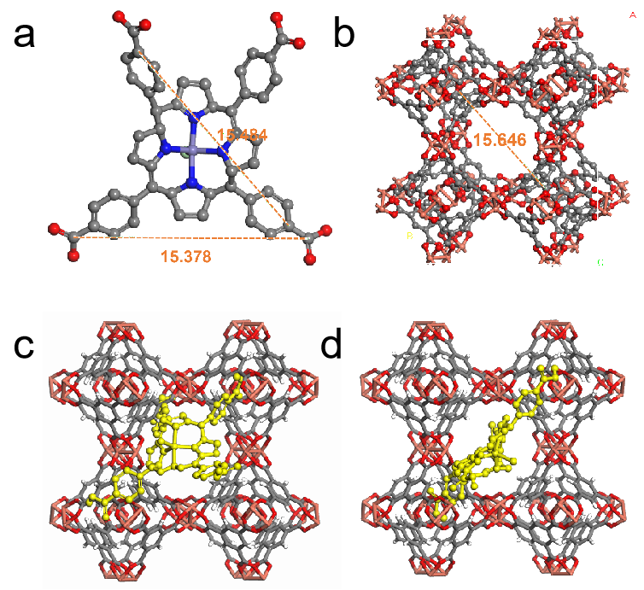
Supplementary Fig.3. The 3-Dimensional tetragonal framework of Fe-TCPP@Cu-BTC, a) Fe-TCPP; b) Cu-BTC; c, d) different angles of Fe-TCPP in Cu-BTC).

Supplementary Fig.4. N₂ adsorption isotherms of Fe-TCPP@Cu-BTC and Cu-BTC.

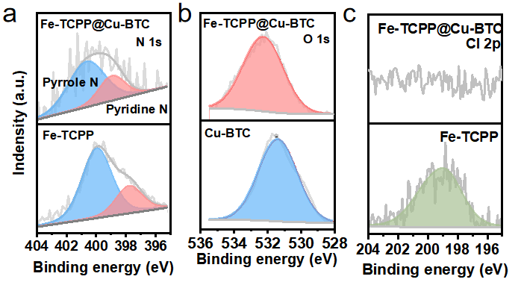
Supplementary Fig.5. a) N 1s, b) O 1s and c) Cl 1sXPS sepctra of Fe-TCPP and Fe-TCPP@Cu-BTC.

Supplementary Fig.6. Solubility test of Fe-TCPP, Cu-BTC and Fe-TCPP@Cu-BTC in electrolyte.

Supplementary Fig.7. Visualized adsorption tests of Li₂S₆. Polysulfide adsorption tests of Fe-TCPP@Cu-BTC, Fe-TCPP, Cu-BTC and CNTs.

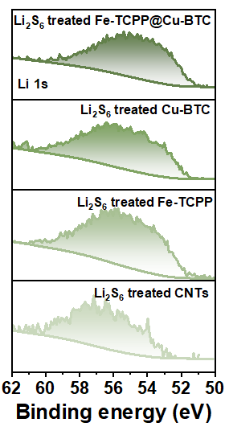
Supplementary Fig.8. Li 1s XPS spectra of Li₂S₆ treated Fe-TCPP@Cu-BTC, Cu-BTC, Fe-TCPP and CNTs.

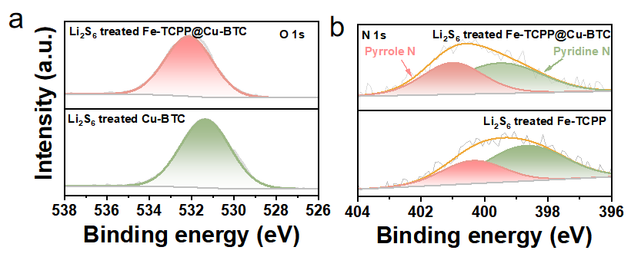
Supplementary Fig.9. a) O 1s XPS spectra of Li₂S₆ treated Fe-TCPP@Cu-BTC and Cu-BTC; b) O 1s XPS spectra of Li₂S₆ treated Fe-TCPP@Cu-BTC and Fe-TCPP.

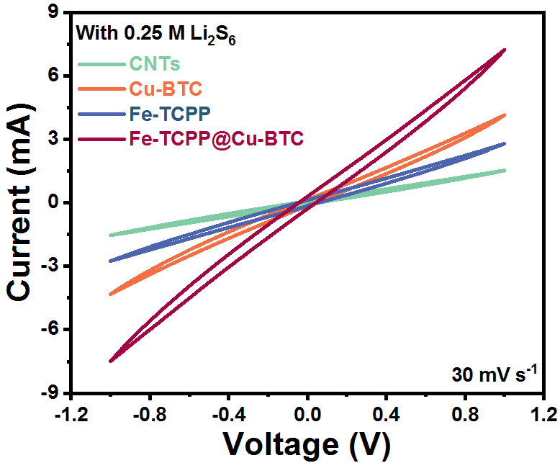
Supplementary Fig.10. CV profiles of the Fe-TCPP@Cu-BTC, Fe-TCPP, Cu-BTC and CNTs electrodes in Li₂S₆ symmetric cells.

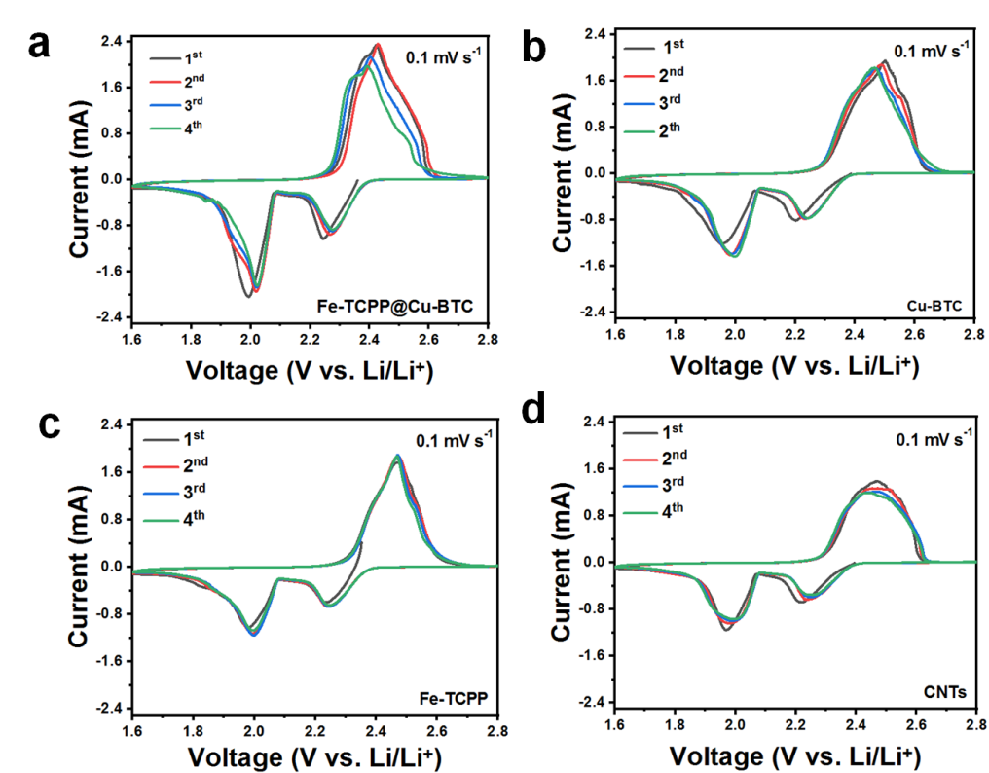
Supplementary Fig.11. CV profiles of (a) Fe-TCPP@Cu-BTC, (b) Cu-BTC, (c) Fe-TCPP, and (d) CNTs cathode between 1.6 and 2.8 V for the first four cycles, recorded at a scan rate of 0.1 mV s⁻¹.

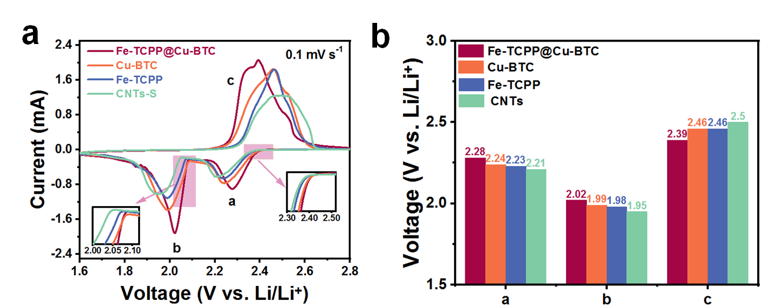
Supplementary Fig.12 (a) CV profiles of Fe-TCPP@Cu-BTC, Cu-BTC, Fe-TCPP, and CNTs cathodes at a scanning rate of 0.1 mV s⁻¹ and a voltage range of 1.6–2.8 V. The insets are magnifications of the corresponding reduction curvesat 2.30–2.45 and 2.00–2.10 V. (b) Peak voltage in the second CV cycle of Fe-TCPP@Cu-BTC, Cu-BTC, Fe-TCPP, and CNTs cathodes.
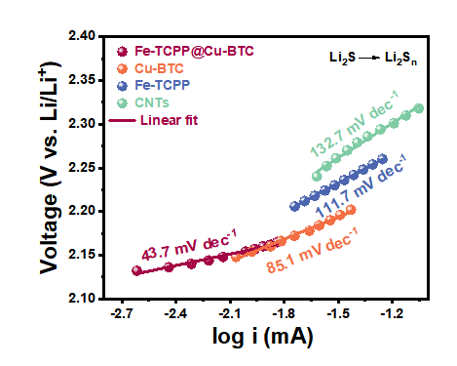
Supplementary Fig.13. Tafel plots corresponding to the reductions of Li₂S to Li₂S_{n} for Fe-TCPP@Cu-BTC, Cu-BTC, Fe-TCPP, and CNTs cathodes.

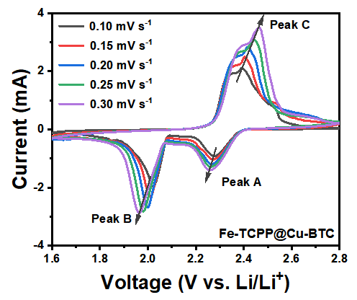
Supplementary Fig.14. CV curves at scanning rates ranging from 0.10 to 0.30 mV s^{–1} of Fe-TCPP@Cu-BTC.

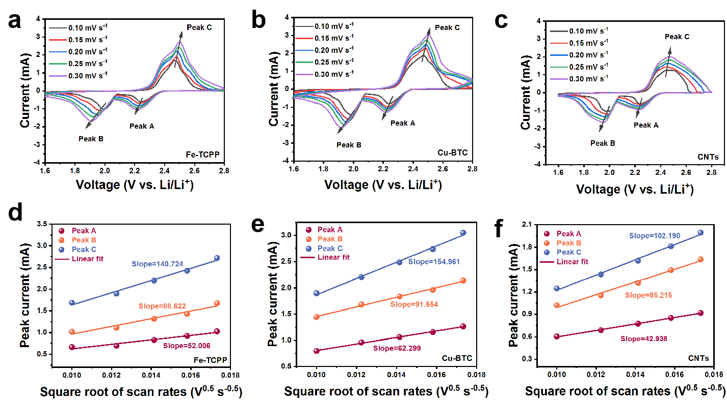
Supplementary Fig.15. CV curves at scanning rates ranging from 0.10 to 0.30 mV s^{–1} (a) Fe-TCPP, (b) Cu-BTC, and (c) CNTs and the scanning rate dependent peak currents at A, B, and C positions (as marked by dashed lines) for the calculation of Li⁺ diffusion coefficients of (d) Fe-TCPP, (e) Cu-BTC, and (f) CNTs.

Supplementary Fig.16. Potentiostatic intermittent titration technique (PITT) measurements of Fe-TCPP@Cu-BTC, Cu-BTC, Fe-TCPP, and CNTs cells.

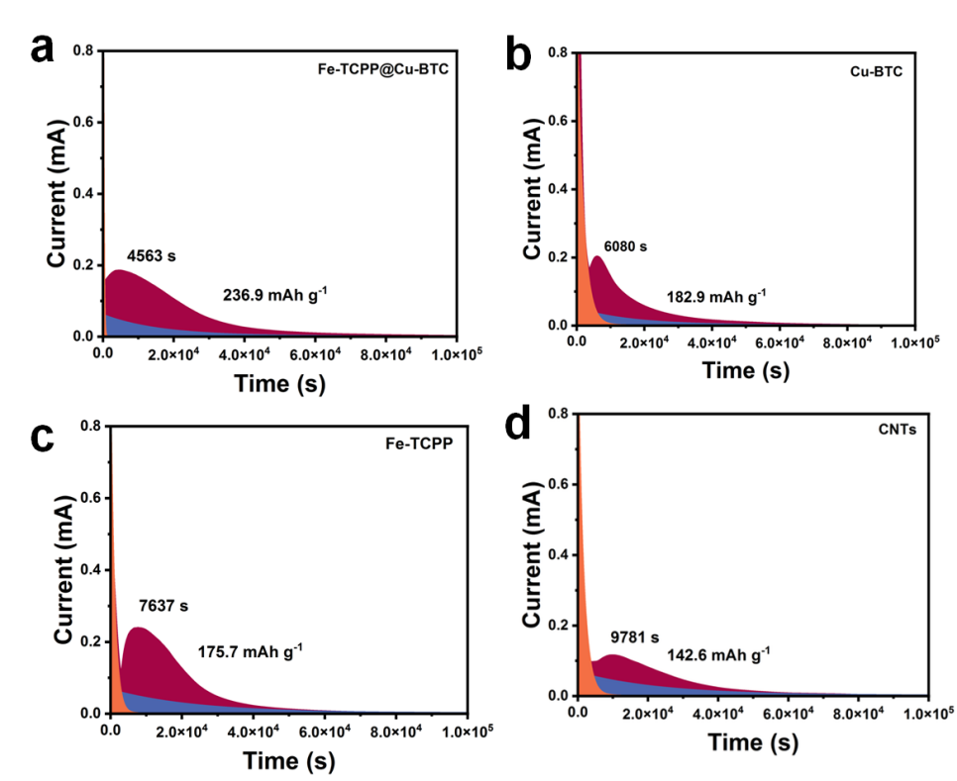
Supplementary Fig.17. Potentiostatic discharge profiles of Li₂S nucleation on Fe-TCPP@Cu-BTC, Cu-BTC, Fe-TCPP, and CNTs cells.

Supplementary Fig.18. In-situ UV-vis spectra of S₈²⁻ and S₃²⁻/S₃^{*-} in Li₂S₈ solution of Cu-BTC, Fe-TCPP, and CNTs.

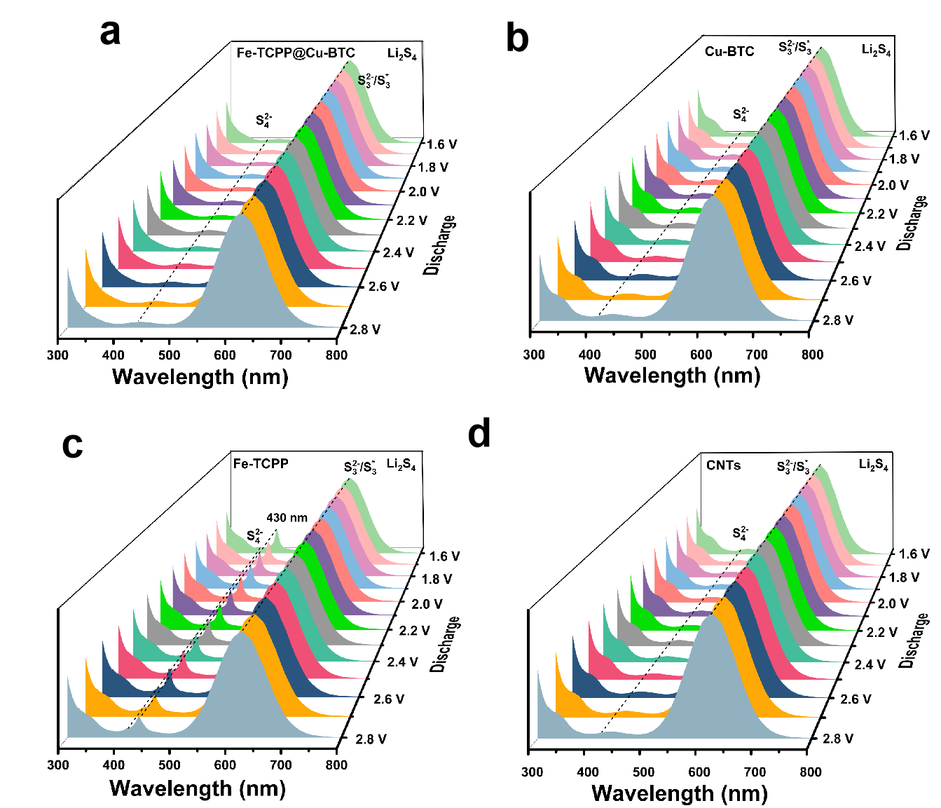
Supplementary Fig.19. In-situ UV-vis spectra of S₄²⁻ and S₃²⁻/S₃^{*-} in Li₂S₄ solution of Fe-TCPP@Cu-BTC, Cu-BTC, Fe-TCPP, and CNTs.
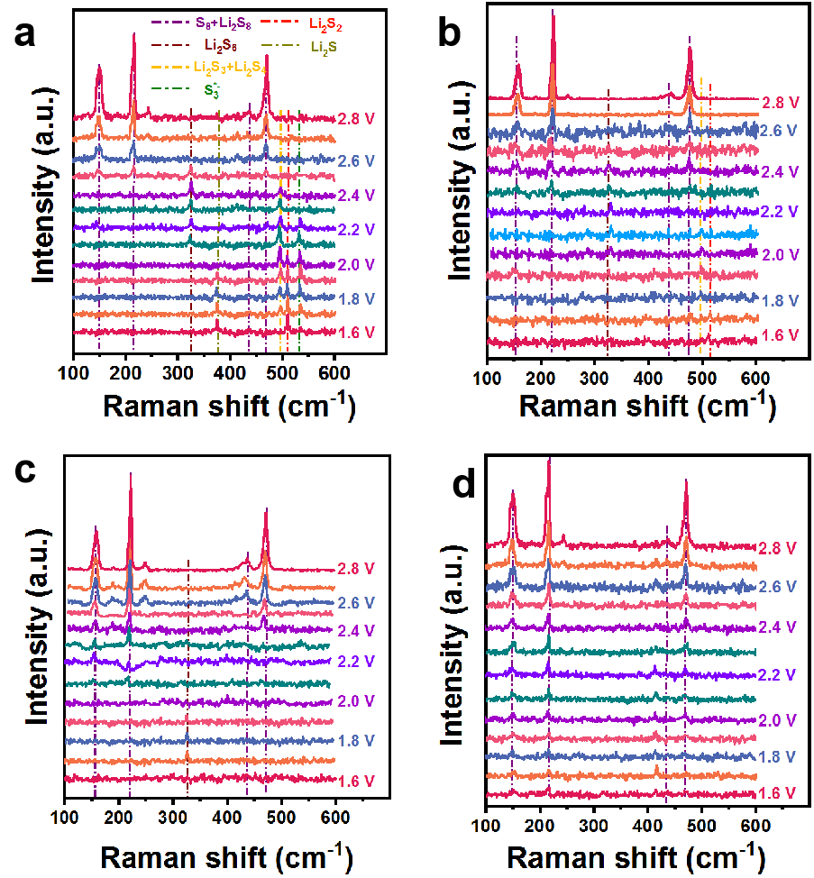
Supplementary Fig.20. In-situ Raman spectra of the (a) Fe-TCPP@Cu-BTC, (b) Cu-BTC, (c) Fe-TCPP, and (d) CNTs electrodes.

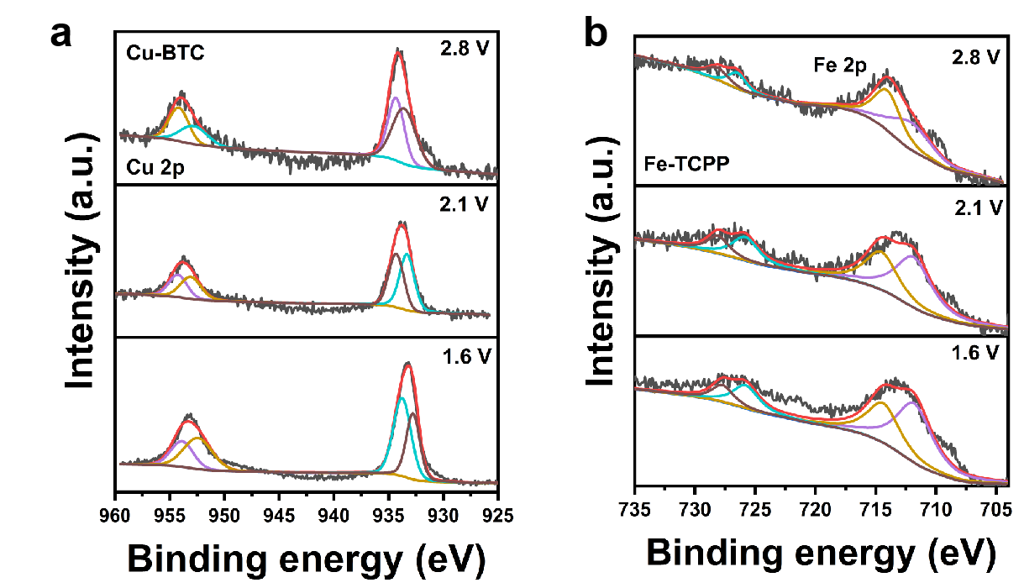
Supplementary Fig.21. Semi-in situ Cu 2p and Fe 2p XPS spectra of the cell with (a) Cu-BTC, (b) Fe-TCPP.

Supplementary Fig.22. Refinement of the fitting of S₃*‒ concentration within a cell containing a, b) Cu-BTC, c, d) Fe-TCPP, and e) CNTs, respectively, by applying Michaelis-Menten kinetics during the discharge.

Supplementary Fig.23. EIS curves of the Fe-TCPP@Cu-BTC cathodes at different temperature and voltages during discharge process. a–i) The Nyquist plots of Fe-TCPP@Cu-BTC cathodes at various temperatures at the charge potential of (a) 2.8, (b) 2.6, (c) 2.4, (d) 2.2, (e) 2.1, (f) 2.0, (g) 1.9, (h) 1.8 V, and (i) 1.6 V.

Supplementary Fig.24. EIS curves of the Cu-BTC cathodes at different temperature and voltages during discharge process. a–h) The Nyquist plots of Fe-TCPP@Cu-BTC cathodes at various temperatures at the charge potential of (a) 2.8, (b) 2.6, (c) 2.4, (d) 2.2, (e) 2.1, (f) 2.0, (g) 1.9, (h) 1.8 V, and (i) 1.6 V.

Supplementary Fig.25. EIS curves of the Fe-TCPP cathodes at different temperature and voltages during discharge process. a–i) The Nyquist plots of Fe-TCPP@Cu-BTC cathodes at various temperatures at the charge potential of (a) 2.8, (b) 2.6, (c) 2.4, (d) 2.2, (e) 2.1, (f) 2.0, (g) 1.9, (h) 1.8 V, and (i) 1.6 V.

Supplementary Fig.26. EIS curves of the CNTs cathodes at different temperature and voltages during discharge process. a–i) The Nyquist plots of Fe-TCPP@Cu-BTC cathodes at various temperatures at the charge potential of (a) 2.8, (b) 2.6, (c) 2.4, (d) 2.2, (e) 2.1, (f) 2.0, (g) 1.9, (h) 1.8 V, and (i) 1.6 V.

Supplementary Fig.27. The corresponding linear fitting based on Arrhenius equation. An Arrhenius plot showing the linear relationship between logarithmic values of the reciprocal of charge transfer resistance in Figure Supplementary Fig.22–25 and the reciprocal of absolute temperatures.

Supplementary Fig.28. Voltage-dependent activation energy plots collected from EIS spectra at various discharge voltages and temperatures for the Fe-TCPP and Cu-BTC cells.

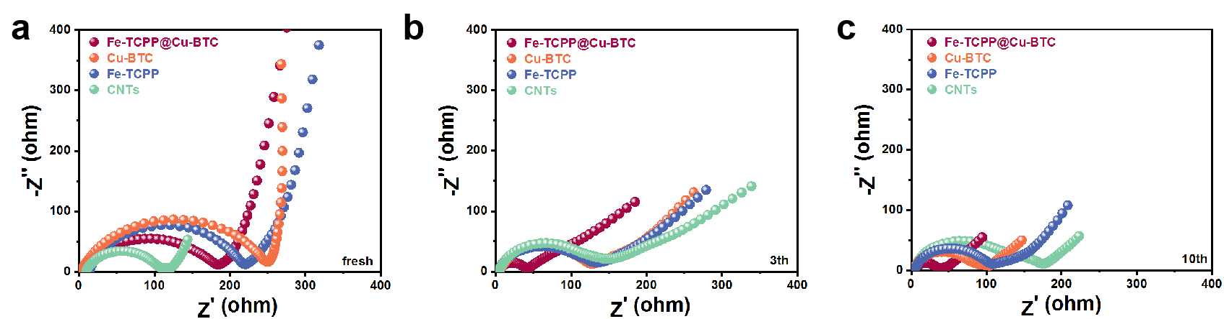
Supplementary Fig.29. EIS spectra of Fe-TCPP@Cu-BTC, Cu-BTC, Fe-TCPP, and CNTs after different cycles (a) fresh, (b) 3th, (c) 10th.

Supplementary Fig.30. Long-term cycling performance of Cu-BTC and Fe-TCPP cells at 0.2 C.

Supplementary Fig.31. Long-term cycling performance of Cu-BTC and Fe-TCPP cells at 1.0 C.

3. Supporting Tables

Supplementary Table 1. The Michaelis‒Menten constants (K_{m}) is fitted by the Michaelis‒Menten equation for Fe-TCPP@Cu-BTC, Fe-TCPP, Cu-BTC and CNTs.
Material | Voltage range (V) | K_{m} (mM)
Fe-TCPP@Cu-BTC | 2.8-2.2 | 5.92×10⁻³
Fe-TCPP@Cu-BTC | 2.1-1.6 | 7.79×10⁻⁴
Cu-BTC | 2.8-2.2 | 1.02×10⁻³
Cu-BTC | 2.1-1.6 | -
Fe-TCPP | 2.8-2.2 | -
Fe-TCPP | 2.1-1.6 | 3.89×10⁻²
CNTs | - | -

Supplementary Table 2. The rate (V_{max}) at each voltage is fitted by the Michaelis‒Menten equation of Fe-TCPP@Cu-BTC, Fe-TCPP, and Cu-BTC.
Voltage  (V vs. Li/Li⁺) | Fe-TCPP@Cu-BTC  mM min⁻¹ | Fe-TCPP  mM min⁻¹ | Cu-BTC  mM min⁻¹
2.8 | 0 | 0 | 0
2.7 | 5.87E-4 | - | -
2.6 | 3.85E-4 | - | -
2.5 | 4.81E-4 | 3.59E-6 | -
2.4 | 4.10E-4 | 3.77E-6 | -
2.3 | 3.12E-4 | 4.62E-6 | -
2.2 | 2.37E-4 | 7.70E-6 | -
2.1 | 1.87E-4 | 8.06E-6 | 1.24E-6
2.0 | 1.54E-4 | 8.47E-6 | 1.24E-6
1.9 | 1.35E-4 | - | 1.20E-6
1.8 | 1.18E-4 | - | 1.49E-6
1.7 | 9.95E-5 | - | 2.26E-6
1.6 | 8.56E-5 | - | 2.14E-6

Supplementary Table 3. EIS of Fe-TCPP@Cu-BTC cells after various cycles.
Cycle number | R_{e} (Ω) | R_{ct} (Ω) | R_{mt} (Ω)
0 | 7.8 | 172.1 | 191.9
3 | 2.2 | 40.5 | 35.6
10 | 4.5 | 31.3 | 36.7

Supplementary Table 4. EIS of Cu-BTC cells after various cycle numbers.
Cycle number | R_{e} (Ω) | R_{ct} (Ω) | R_{mt} (Ω)
0 | 9.5 | 221.8 | 243.6
3 | 4.6 | 122.7 | 120.5
10 | 3.1 | 90.4 | 97.6

Supplementary Table 5. EIS of Fe-TCPP cells after various cycle numbers.
Cycle number | R_{e} (Ω) | R_{ct} (Ω) | R_{mt} (Ω)
0 | 2.9 | 246.6 | 254.1
3 | 2.5 | 126.1 | 158.8
10 | 3.7 | 103.3 | 101.8

Supplementary Table 6. EIS of CNTs cells after various cycle numbers.
Cycle number | R_{e} (Ω) | R_{ct} (Ω) | R_{mt} (Ω)
0 | 9.1 | 99.1 | 32.1
3 | 3.3 | 140.1 | 123.4
10 | 3.5 | 152.7 | 167.6

Reference
1. Kühne, T. D. et al. CP2K: An electronic structure and molecular dynamics software package-Quickstep: Efficient and accurate electronic structure calculations. J. Chem. Phys. 152, 194103 (2020).
2. Lippert, G. & Parrinello, M. A hybrid Gaussian and plane wave density functional scheme. Molecular Physics 92, 477-488 (1997).
3. Lippert, G., Hutter, J. & Parrinello, M. The Gaussian and augmented-plane-wave density functional method for ab initio molecular dynamics simulations. Theor. Chem. Acc. 103, 124-140 (1999).
4. Perdew, J. P., Burke, K. & Ernzerhof, M. Generalized Gradient Approximation Made Simple. Phys. Rev. Lett 77, 3865-3868 (1996).
5. VandeVondele, J. & Hutter, J. Gaussian basis sets for accurate calculations on molecular systems in gas and condensed phases. J. chem. Phys. 127, 114105 (2007).
6. Goedecker, S., Teter, M. & Hutter, J. Separable dual-space Gaussian pseudopotentials. Phys. Rev. B 54, 1703-1710 (1996).
7. Hartwigsen, C., Gœdecker, S. & Hutter, J. Relativistic separable dual-space Gaussian pseudopotentials from H to Rn. Phys. Rev. B 58, 3641-3662 (1998).
8. Krack, M. Pseudopotentials for H to Kr optimized for gradient-corrected exchange-correlation functionals. Theor. Chem. Acc. 114, 145-152 (2005).

