Supplementary Information

Three-Step Thermodynamic vs. Two-Step Kinetic-Limited Sulfur Reactions in All-Solid-State Sodium Batteries
Tongtai Ji¹, Qingsong Tu², Yang Zhao,³ Dominik Wierzbicki⁴, Vincent Plisson⁵, Ying Wang¹, Jiwei Wang¹, Kenneth S. Burch⁵, Yong Yang⁶, Hongli Zhu^{1,} *
¹Department of Mechanical and Industrial Engineering, Northeastern University, 360 Huntington Avenue, Boston, Massachusetts 02115, United States
²Department of Mechanical Engineering, Rochester Institute of Technology, Rochester, NY 14623, USA
³Department of Mechanical and Materials Engineering, University of Western Ontario, London, Ontario N6A 5B9, Canada
⁴National Synchrotron Light Source II, Brookhaven National Laboratory, Upton, NY, 11973 USA
⁵Department of Physics, Boston College, Chestnut Hill, Massachusetts 02467, United States
⁶State Key Laboratory of Physical Chemistry of Solid Surfaces, College of Materials, Xiamen University, Xiamen 361005, China
*: Corresponding author: Hongli Zhu. E-mail: h.zhu@neu.edu

Supplementary Discussion 1
Discussion of the decomposition of the solid electrolyte
In the all-solid-state batteries with sulfide-based SE, it is common that the decomposition of the sulfide-based SE occurs when it intimately contacts with carbon, but the decomposition products are highly reversible during cycling and further protect the unreacted SE.^{1,2} The decomposition became obvious when the cells were operated at a slow rate and high temperature. The slow rate and high temperatures under the high voltage (> 2.5V) provide sufficient time and energy for the SE decomposition reaction to take place, resulting in this additional oxidation peak. Supplementary Fig. 4 shows the CV curve of the Na₃PS₄ SE when it intimately contacts with carbon at 90 °C. We also evaluated the capacity provided by the catholyte by mixing SE with the PPCF (85:15) as the cathode material, and the specific capacity of the catholyte is around 40-60 mAh/g with high reversibility (Supplementary Fig. 5). Although the decomposition cannot be avoided, it can be effectively limited by controlling the interface between SE and carbon.^{2,3} In our work, for the preparation of the composite cathode (S: C: SE= 35: 15: 50), sulfur was first coated on the PPCF by the melting method and further mixed with the SE to minimize the interface between carbon and SE. Based on the capacity ratio from the catholyte, we expect that less than 5% of the total capacity is contributed by the SE decomposition even at 90°C. This number can be even lower at 25°C. Therefore, the decomposition of the solid electrolyte will not alter the electrochemical behavior of the sulfur cathode we are studying.

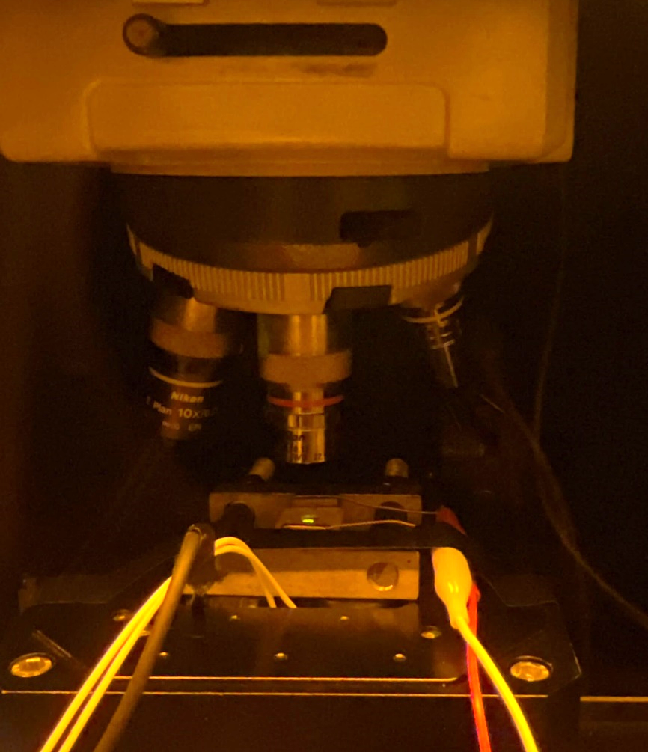
Supplementary Fig. 1. Digital image of the setup for the in-situ Raman test in the glovebox

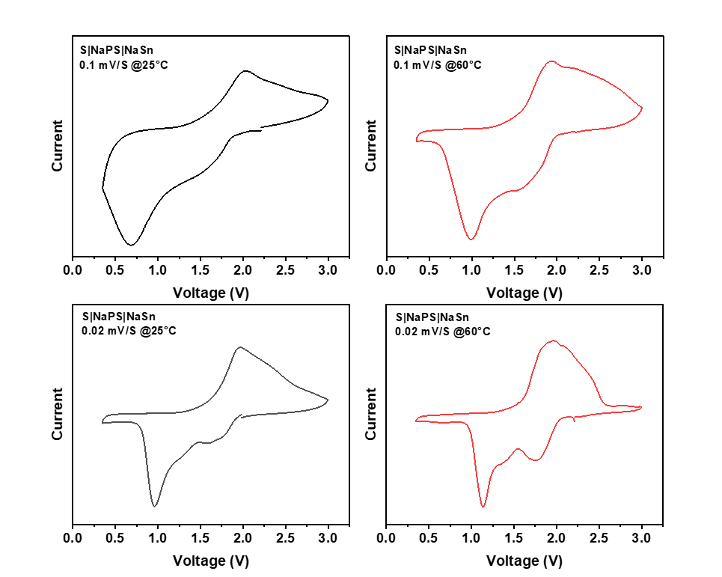
Supplementary Fig. 2. Cyclic voltammetry (CV) curves of the all-solid-state sodium-sulfur batteries operated at 25°C (black), 60°C (red) at 0.1 mV/s (up) and 0.02 mV/s (bottom).

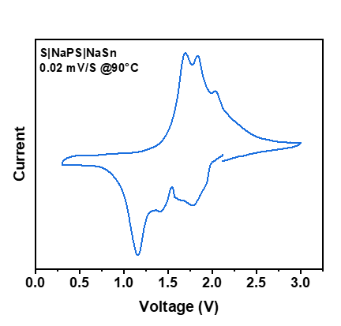
Supplementary Fig. 3. CV curves of the all-solid-state sodium-sulfur batteries operated at 90°C under 0.02 mV/s
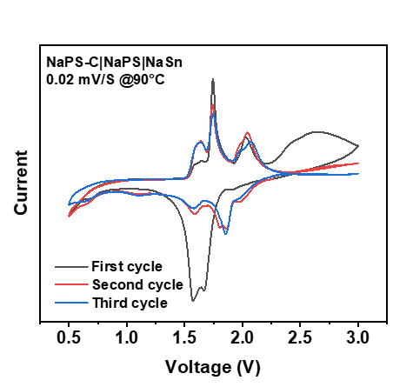
Supplementary Fig. 4. The CV curves of Na₃PS₄ solid electrolyte at 90°C

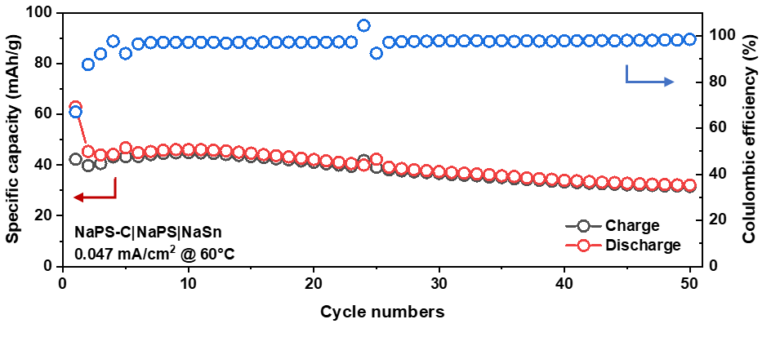
Supplementary Fig. 5. Cycling capacity of the all-solid-state battery with Na₃PS₄ (mixing with PPCF) as the cathode material at 60°C.

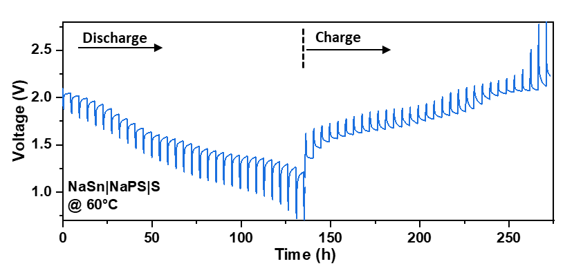
Supplementary Fig. 6. Galvanostatic intermittent titration technique (GITT) test profile of the ASSSBs operated at 60°C.

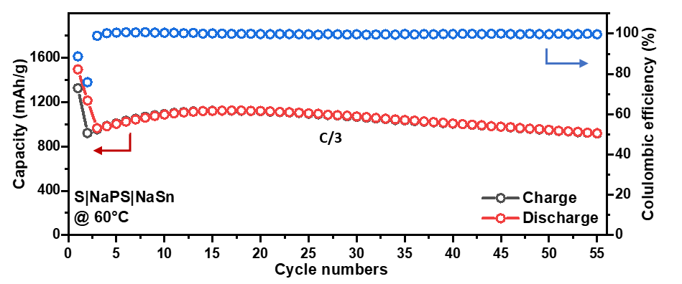
Supplementary Fig. 7. The long cycling performance of the ASSSB operated at 60°C.

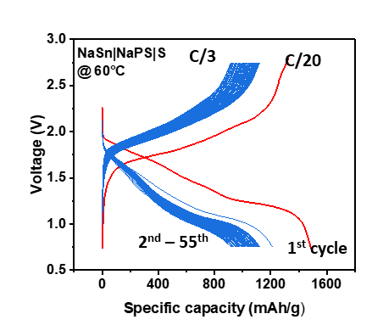
Supplementary Fig. 8. Voltage profiles of the long cycling performance of the ASSSB operated at 60°C.

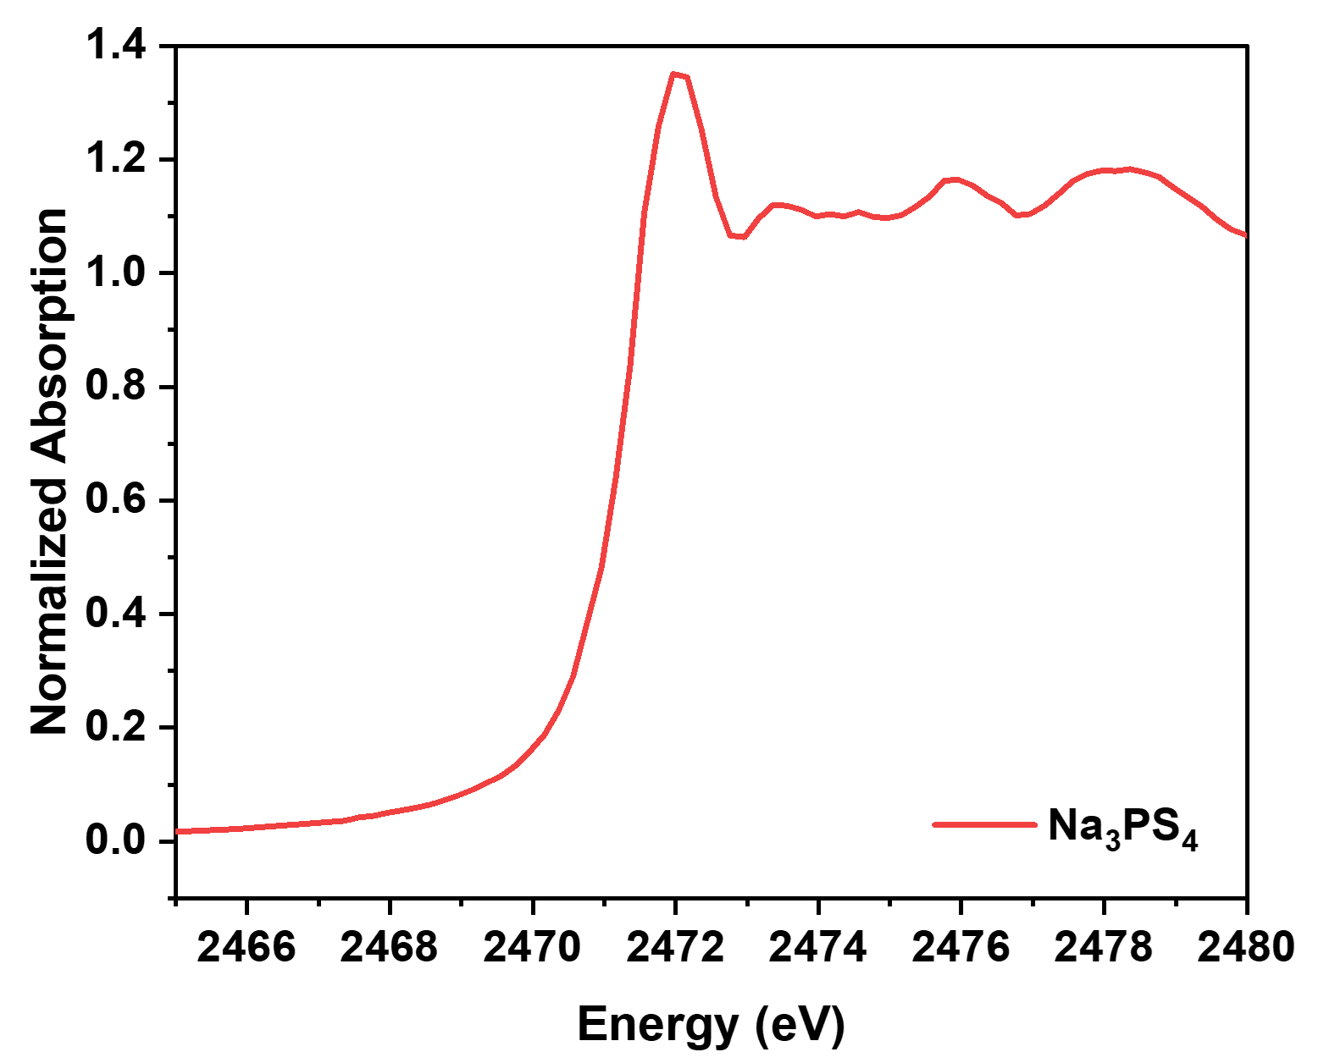
Supplementary Fig. 9. S K-edge XANES spectrum of Na₃PS₄

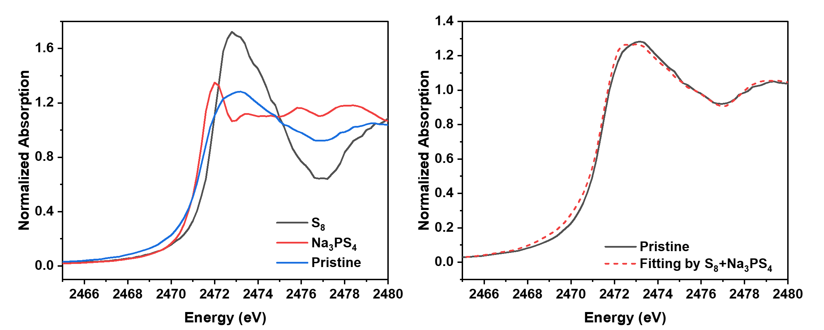
Supplementary Fig. 10. (Left) The comparison of the S K-edge XANES spectra of S₈, Na₃PS₄, and Pristine cathode. (Right) The linear combination fitting result of the pristine cathode by S₈ and Na₃PS₄.

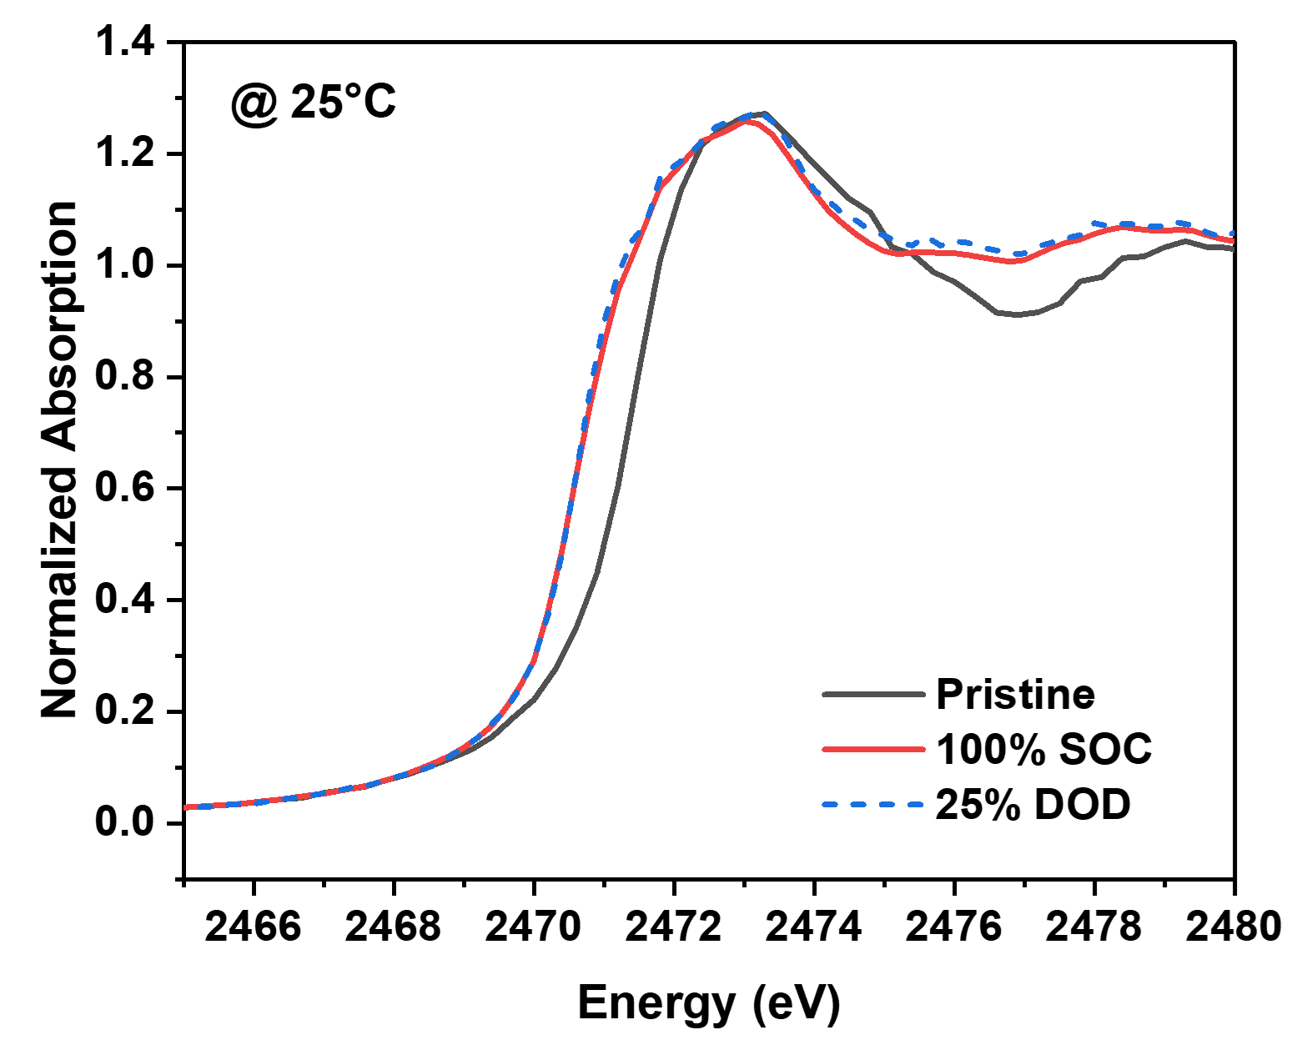
Supplementary Fig. 11. The comparison of the Pristine, 25% DOD, and 100% SOC S K-edge XANES spectra at 25°C.

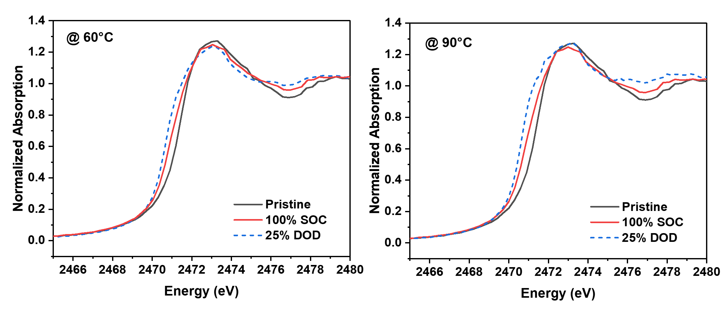
Supplementary Fig. 12. The comparison of the Pristine, 25% DOD, and 100% SOC S K-edge XANES spectra at 60°C (left) and 60°C (right).

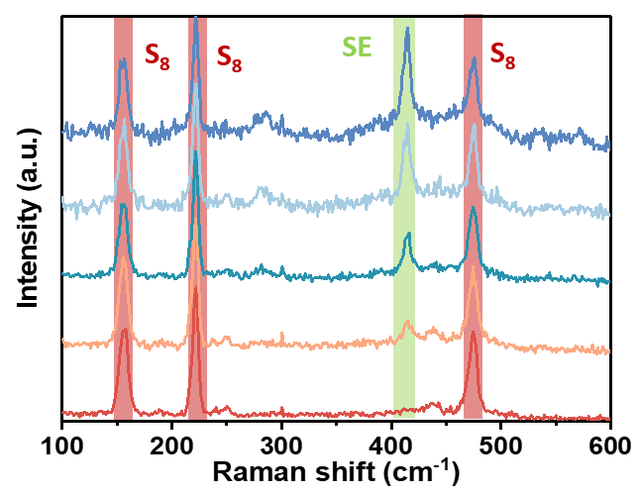
Supplementary Fig. 13. Raman spectrum of the pristine composite cathode at different places.

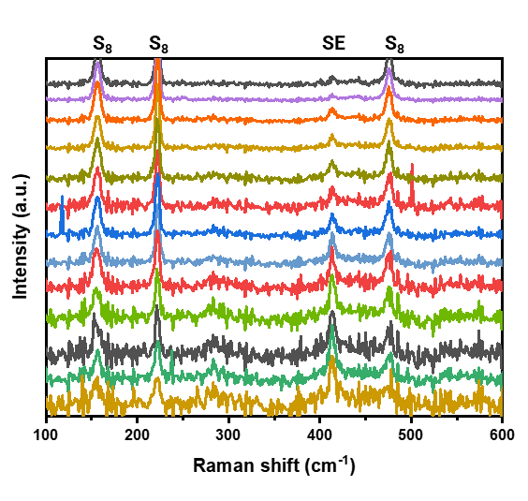
Supplementary Fig. 14. Operando Raman measurement for the most surface layer of the sulfur cathode from 0 to 3h, the change of the sulfide species are hard to detect. The change of the intensity of the peaks from S₈ and SE is due to the slight moving of the position.
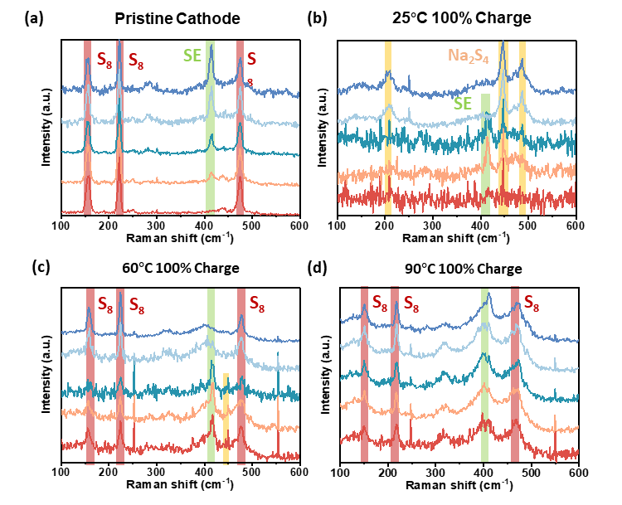
Supplementary Fig. 15. Comparation of the ex-situ Raman spectra of (a) pristine cathode, and the cathode at 100% SoC operated at (b) 25°C, (c) 60°C, and (d) 90°C

Supplementary Table 1. Lattice constants of different phases
Phase | a constant (Å) | b constant (Å) | c constant (Å) | volume (Å³/atom)
4(S8) | 8.507 | 8.507 | 13.551 | 27.560
4(Na₂S₅) | 5.784 | 7.677 | 14.529 | 23.041
4(Na₂S₄) | 8.952 | 8.952 | 8.952 | 22.414
2(Na₂S₂) | 4.443 | 4.443 | 10.205 | 21.810
Na₂S | 4.601 | 4.601 | 4.601 | 22.954
Na₂ | 3.730 | 3.730 | 6.099 | 36.738

Supplementary Equation 1 diffusion coefficient calculated by GITT test⁴
$$D=\frac{4}{πτ}{(\frac{n_{m}V_{m}}{S})}^{2}{(\frac{{∆E}_{s}}{{∆E}_{t}})}^{2}$$
Where, 𝜏 (s) is the duration of the current pulse; n_{m} (mol) is the number of moles; V_{m} (cm³/mol) is the molar volume of the electrode; S (cm²) is the electrode area; ΔE_{s} (V) is the steady-state voltage change, due to the current pulse and ΔE_{t} (V) is the voltage change during the constant current pulse, eliminating the iR drop.

Reference
1 Yue, J. et al. High-performance all-inorganic solid-state sodium–sulfur battery. ACS nano 11, 4885-4891 (2017).
2 Banerjee, A., Wang, X., Fang, C., Wu, E. A. & Meng, Y. S. Interfaces and interphases in all-solid-state batteries with inorganic solid electrolytes. Chemical reviews 120, 6878-6933 (2020).
3 Tan, D. H. et al. Elucidating reversible electrochemical redox of Li6PS5Cl solid electrolyte. ACS Energy Letters 4, 2418-2427 (2019).
4 Jia, M. et al. Re-understanding the galvanostatic intermittent titration technique: Pitfalls in evaluation of diffusion coefficients and rational suggestions. Journal of Power Sources 543, 231843 (2022).

