Supplementary Materials for

Percolative Sulfide Core Formation in Oxidized Asteroid Parent Bodies and Terrestrial Planets

Crossley Samuel* et al.

*Corresponding author. Email: crossley@arizona.edu

This PDF file includes:

Supplementary Text
Figs. S1 to S4
Tables S1 to S7

Supplementary Text
Starting materials: rationale and considerations for LAP 04840
Detailed petrographic and mineralogical analyses of LAP 04840 reported in previous work (McCanta et al., 2008; Crossley et al., 2023) were used as a basis for comparison with our experimental results. Of note, LAP 04840 is anomalous among most RC meteorites due to the presence of hydrated silicates: amphibole and biotite. These phases are thought to have been produced through hydrothermal alteration of precursor silicates, perhaps during impact mixing on the RC parent body. Hydrothermal alteration of the RC precursor was likely also responsible for the oxidation of sulfides to form Cr-magnetite (e.g., Crossley et al., 2023). If hydrothermal alteration occurred as a product of impact mixing, some caveats must be considered for using LAP 04840 as an analogue for oxidized assemblages at the onset of sulfide melting. The alteration of Fe,Ni-sulfides to magnetite would decrease the volume of phases participating in melt percolation, as the melting point of magnetite (~1,400°C) exceeds our experimental temperatures and is well above the silicate eutectic. As such, we expect that the anhydrous precursor of LAP 04840 contained a greater proportion of sulfides that could participate in percolative melt migration. It is possible that the observed alteration of Cr-magnetite to ferrichromite inflated the anion content of FeNiS melt through the incorporation of additional oxygen into the melt, but our EPMA totals from the experimental quenched melts are near 100 wt% (Table S1), showing this to be unlikely. Likewise, the dehydration of amphibole and biotite in our experiments may also not bear relevance to oxidized differentiation if it those phases were products of hydrothermal alteration. However, our experimental melts showed no evidence for incorporation of H₂O into the melt at wt% levels, so dehydration likely had negligible effects on our results.
Dimensional Analysis of SOCs from µXCT
Initial 3D morphology of sulfide-oxide complexes
Three-dimensional renderings from µXCT images of LAP 04840 prior to heating (Fig. 1a) show sulfide-oxide complexes (SOCs) comprising 7 vol% of the bulk sample, which is in agreement with published 2D petrographic analyses of 5.6-8.7 vol% (McCanta et al., 2008; Crossley et al., 2023). Segmentation of SOCs according to contiguous voxel connectivity yielded over 36,000 spatially resolvable objects. Among resolvable SOCs, 8% have maximum feret diameters <10 µm, which is the lower limit of our whole scan resolution (4.85 µm/voxel); 87% are 10-100 µm; 5% are 100-1,000 µm; and 0.01% are >1,000 µm. Convolution indices (CVIs), which quantify morphological complexity relative to that of a perfect sphere of equivalent volume (Hanna et al., 2018), range from 0.9 to 7.5. The three largest assemblages comprise ~12% of the total volume of sulfides and oxides. Each are >1,000 µm maximum feret diameter and >106 µm³. The three largest SOCs also possess the most complex morphologies (i.e., highest CVIs, 5.6-7.6). These large, complex morphologies may have formed during thermal and/or hydrothermal alteration of the RC parent body.
3D morphology of sulfide-oxide complexes at 900°C
After heating to 900°C, many discrete SOCs in LAP 04840 had visibly deformed, although the overall trend of CVIs in the whole rock vs equivalent sphere diameters was largely unchanged. Among the largest SOCs, CVIs are within ~0.4 of their initial values. However, the maximum CVI among the SOC population increased by 70% relative to the unheated maximum CVI. This illustrates how melting among SOCs is not uniform and is dependent upon µm-scale mineralogy. Some assemblages formed small vesicles (<50 µm) in their interiors during partial melting. Vesicles likely formed as incipient FeNiS melts drained into the surrounding silicate matrix, consistent with an overall decrease in resolvable SOCs by 3% relative to their initial volume (Table S1). The smallest melt veins could not be directly imaged in whole rock scans due to limited voxel resolution (4.8 µm/voxel), but interconnectivity of distinct melt sources was likely limited, as melting would have been dominated by pentlandite, which only accounts for ~13 vol% of sulfide-oxide complexes in LAP 04840 (Crossley et al., 2023) and 0.9% of the total sample volume in experiments. The number of discrete SOCs at 900°C decreased by ~8% from initial counts with many of the smallest sulfides no longer resolvable, probably due to more efficient melting of the small sulfide grains relative to the larger SOCs.
3D morphology of sulfide-oxide complexes at 1,020°C
In whole rock scans of the 1,020°C experiment, sulfides had extensively melted, forming vesicles and voids throughout most SOCs, and sometimes completely vacating their original locations. The fragmentation of larger sulfides resulted in a ~14% increase in the number of discrete SOCs over initial counts. The total resolvable volume of SOCs decreased by 7% from their initial values as sulfide melts drained into pore spaces between neighboring silicates. The morphologies of the largest SOCs increased in complexity as evident from increased convolution indices (CVIs) relative to sphere diameters at equivalent volumes (Fig. S3). Linear regression of CVIs and equivalent sphere diameters show that the morphological complexity of the SOC/melt population approximately doubled from 900-1,020°C. While the upper limit of SOC maximum feret diameter did not change significantly, the locations of the largest SOCs did; some pre-existing assemblages were truncated by partial melting, while others were joined by newly formed melt networks (Fig. 1).
Two-dimensional petrographic and mineralogical analysis
Backscattered electron images of a polished section from the interior of 1,020°C experiment confirm the formation of extensive submicrometer melt veins ubiquitously throughout the sample (Fig. 4). Silicates remain unzoned with respect to Fe and Ni and retain sharp grain boundaries in BSE images, indicating that they did not react extensively with sulfide melts. Amphibole and biotite dehydrated to form intergrowths of anhydrous silicates (i.e., pyroxene, olivine, and plagioclase microcrystals). Quenched FeNiS melts across the polished section are homogeneous with wt% Fe = 49.2 (σ = 0.5), Ni = 11.4 (0.3), and S = 37.4 (0.4), which is consistent with near complete melting of sulfides, dominated by the more modally abundant Ni-rich pyrrhotite in LAP 04840. Electron microprobe totals for melts were >99 wt%, indicating that <1 wt% O was incorporated into FeNiS melts, despite dehydration of amphiboles and biotite. No residual monosulfide solid solution grains were identified in the polished section of the 1,020°C experiment, although we cannot conclude that melting of sulfide was complete due to potential nugget effects in 2D petrographic cross-sections.
Residual magnetite is present in many of the SOCs, although its composition has been altered from reported average values (e.g., McCanta et al., 2008). Experimental magnetite molar Fe/Mg was reduced by 40%, while Cr/Al was only reduced by 1.3%. The change in Fe/Mg over Cr/Al occurred as FeO partitioned from magnetite into FeNiS melt, altering Cr-magnetite to ferrichromite (Fig. S4). This mechanism is consistent with metallurgical experiments involving pure magnetite and Fe-S-O liquids (Asaki et al., 1986), which led to dissolution of magnetite via mass transfer of FeO across the liquid-magnetite boundary according to reaction,
FeS(l) + 3Fe₃O₄(s) 10FeO(l) + SO₂ [S1].
Consequently, some fraction of SO₂ may have been volatilized within our evacuated SiO₂ assembly but it did not precipitate visible coatings along the glass walls. Instead, SO₂ likely remained dissolved in the liquid or reacted with other phases, which may have contributed to the slight S-enrichment of FeNiS melts (53 at%) over calculations for initial sulfide assemblages in LAP 04840 (50 at%; Crossley et al., 2023).

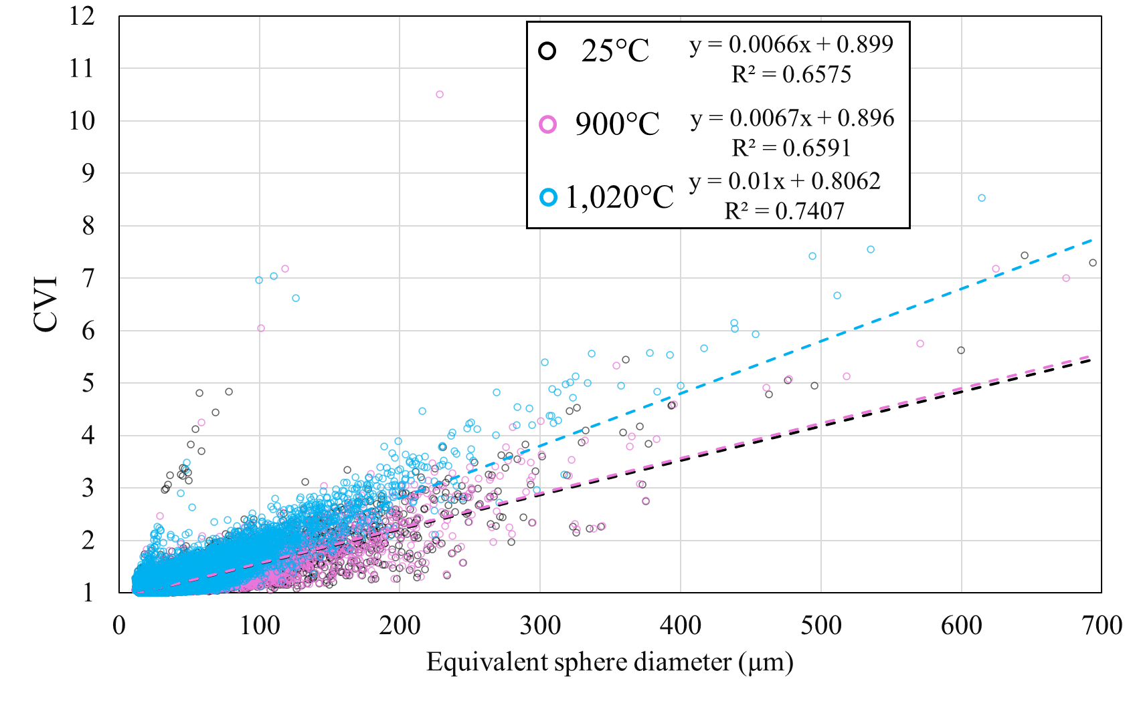
Supplementary Figures
Fig. S1. Morphological complexity of sulfides melts in percolation experiments. The 3D topographical morphologies of sulfides in LAP 0480 increased in complexity during partial melting experiments. The convolution index (CVI), a ratio of an object’s surface area relative to the surface area for a sphere of equivalent volume, increases as morphologies become more complex. The increasing slopes for linear regressions (dashed lines) through CVI and equivalent sphere diameters represent increasing morphological complexity of the SOC/melt population. Changes in morphological complexity of the SOC population up to 900°C are not resolvable in our whole rock scans but are evident at 1,020°C from the ~2x increase in the slope of CVI/diameter regression.

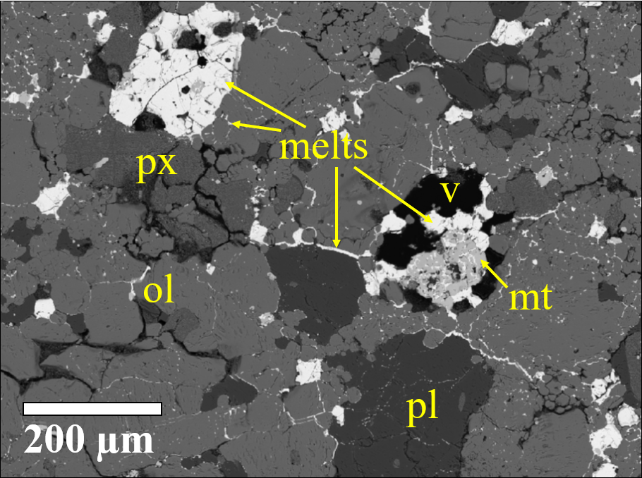

Fig. S2. Backscattered electron images of a polished section from the 1,020°C experiment. Sulfide melts (white) are capable of percolating between silicate grains. Percolation of sulfide melts causes vesicles and voids to form in melt sources as liquids drain out. The efficiency of percolation over the 48-hour duration of experiments appears to be correlated with grain size of surrounding silicates, as smaller silicate grains have greater surface areas per unit of volume, which better facilitates grain wetting via the high interfacial energy between sulfide melts and silicate grains (px =pyroxene, ol = olivine, pl = plagioclase, mt = magnetite, and v = void).

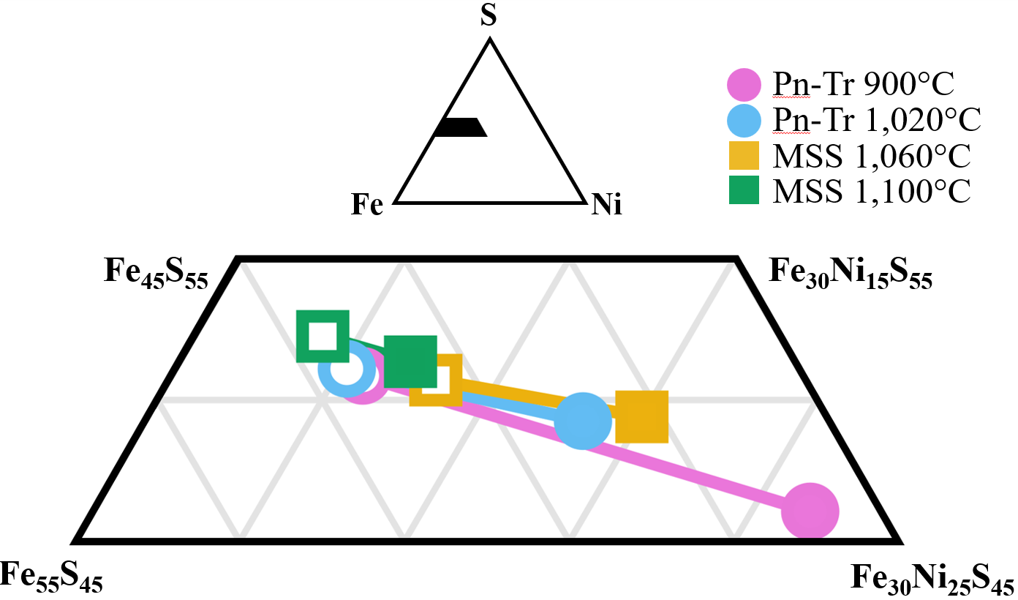

Fig. S3. Inset of the Fe-Ni-S ternary diagram (mole%) for sulfide trace element partitioning experiments. For each experiment, composition of quenched melt is shown with filled symbols, and peritectic or residual MSS is shown with open symbols.

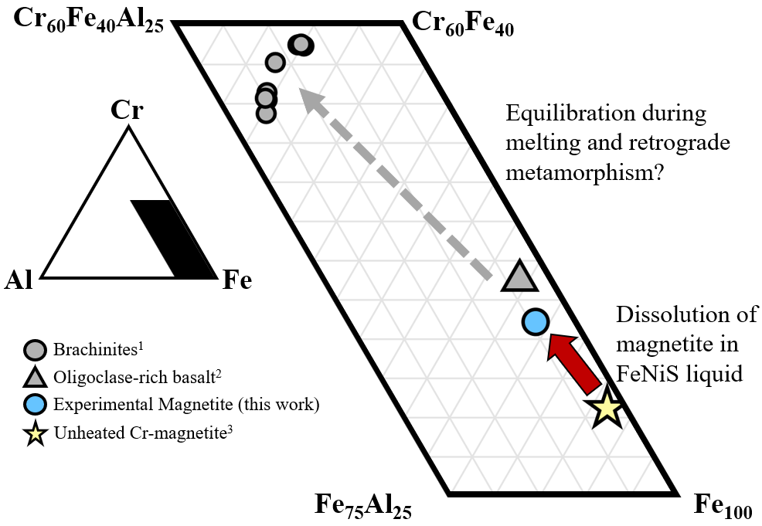

Fig. S4. LAP 04840 spinel Cr-Al-Fe ternary diagram normalized to 3 cations (mole%). Cr-magnetite in LAP 04840 was altered during partial melting of sulfides due to reaction of Cr-magnetite with FeNiS melts. This led to partial dissolution of Cr-magnetite as FeO was lost to the FeNiS melt (red arrow). In Cr-Al-Fe space, spinels in the experimental product approach the composition of those reported in oligoclase-rich basalts GRA 06128/9, although the spinels in those basalts are significantly more Ti-rich (Day et al., 2012). Potentially, Ti-rich chromites could form from partial melt fractions of Cr-magnetite (grey dashed arrow), leaving Ti-depleted Fe-chromite in the residue (e.g., Andronikov et al., 2022) similar to spinels observed in brachinites. Data for ternary points are from ¹Crossley et al. (2020), ²Day et al. (2012), and ³McCanta et al. (2008).

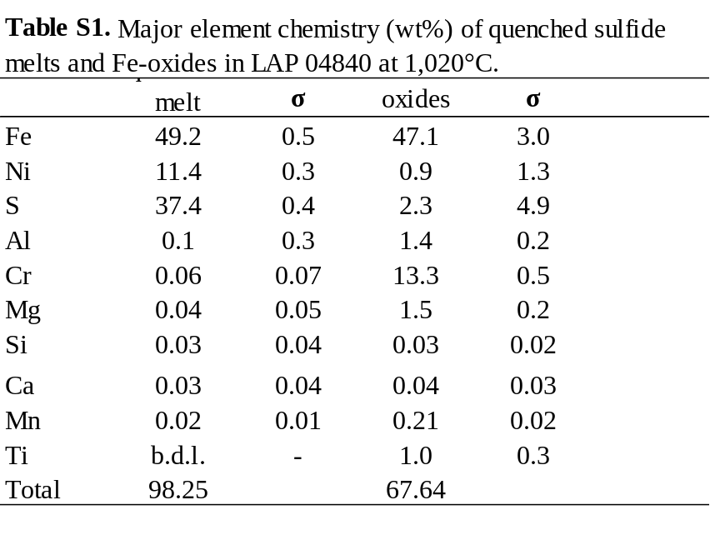
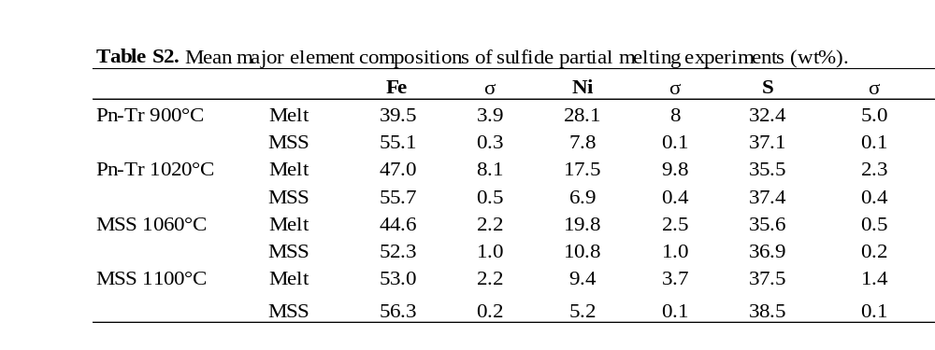
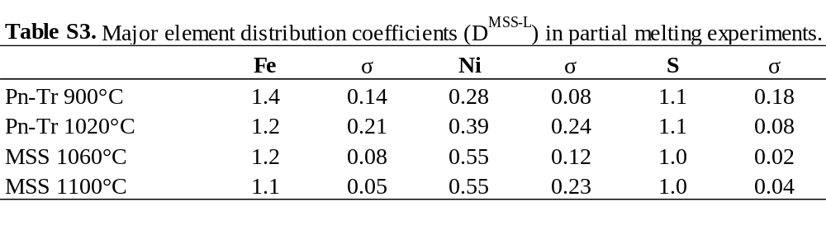

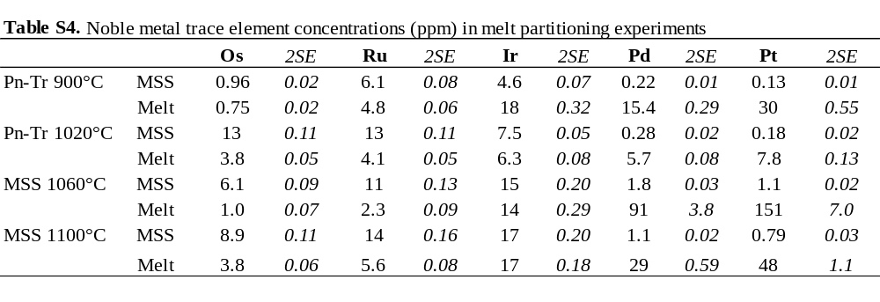
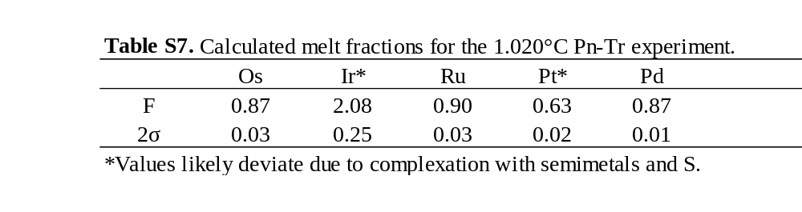
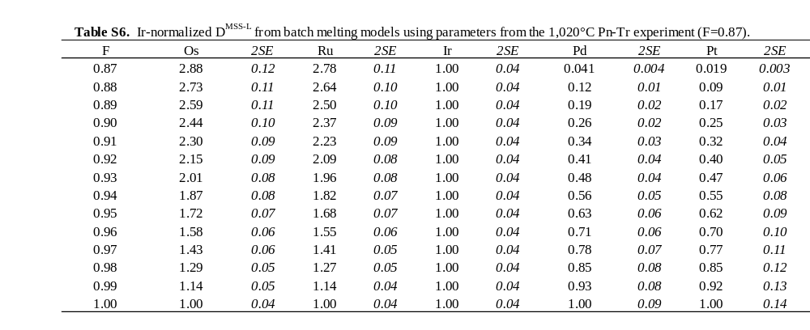
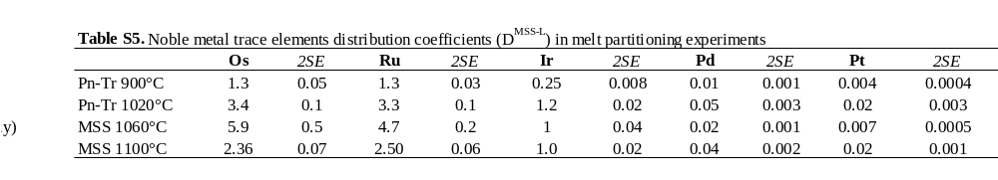

Supplementary References:
Z. Asaki, M. Shiiki, H. Kusuno, H. Kato, H. Doi, Y. Kondo, Dissolution of solid magnetite in Fe-S-O melt. MTB 17, 639–645 (1986).

1.
A. V. Andronikov, I. E. Andronikova, O. Pour, Major and Trace-Element Chemistry of Cr-Spinel in Upper Mantle Xenoliths from East Antarctica. Minerals 12, 720 (2022).

