Supplementary Tables and Figures

Table S1: Distribution Across TMAs: FFPE Blocks, Patients, Sites, and Timepoints.
Counts | TMA-1 | TMA-2 |  |  |  | TMA-3 |  |  |  |  |  | TMA-Recurrence
Blocks | 3 | 3 | 4 | 5 | 6 | 3 | 5 | 6 | 7 | 8 | 10 | 2 | 3
Patients | 21 | 23 | 18 | 15 | 3 | 1 | 1 | 1 | 4 | 5 | 2 | 4 | 10
Specimens | 63 | 69 | 72 | 75 | 18 | 3 | 5 | 6 | 28 | 40 | 20 | 8 | 30
Primary
Adnexa | 63 | 43 | 34 | 55 | 10 | 0 | 2 | 5 | 11 | 18 | 6 | 4 | 10
Omentum | 0 | 17 | 16 | 11 | 3 | 1 | 1 | 0 | 4 | 5 | 2 | 0 | 10
Other peritoneal | 0 | 7 | 19 | 9 | 5 | 0 | 0 | 0 | 3 | 2 | 2 | 0 | 0
Lymph nodes and other | 0 | 2 | 3 | 0 | 0 | 0 | 0 | 1 | 1 | 0 | 0 | 0 | 0
Recurrence
Adnexa | 0 | 0 | 0 | 0 | 0 | 2 | 0 | 0 | 4 | 1 | 3 | 4 | 10
Omentum | 0 | 0 | 0 | 0 | 0 | 0 | 0 | 0 | 2 | 4 | 3 | 0 | 0
Other peritoneal | 0 | 0 | 0 | 0 | 0 | 0 | 2 | 0 | 2 | 4 | 4 | 0 | 0
Lymph nodes and other | 0 | 0 | 0 | 0 | 0 | 0 | 0 | 0 | 1 | 6 | 0 | 0 | 0

Table S2: IHC Protocols
antibody | supplier | clone | mouse/rabbit monoclonal | dilution 1/ | HIER/ protocol | Detection | Platform
CD8 | DAKO | 123C3 | MM | RTU | H30-X-30 | HRP based using 3,3’-diaminobenzidine (DAB) | DAKO Omnis
Ki67 | DAKO | MIB-1 | MM | RTU | L20-X-20 | HRP based using 3,3’-diaminobenzidine (DAB) | DAKO Omnis
p16 | CINtec | E6H4 | MM | 24 | 30-10M-30 | HRP based using 3,3’-diaminobenzidine (DAB) | DAKO Omnis
p53 | DAKO | DO-7 | MM | RTU | 30-10M-30 | HRP based using 3,3’-diaminobenzidine (DAB) | DAKO Omnis
PR | DAKO | PGR1294 | MM | 200 | H20-X-20 | HRP based using 3,3’-diaminobenzidine (DAB) | DAKO Omnis
WT1 | Leica | WT49 | MM | 25 | 30-10M-30 | HRP based using 3,3’-diaminobenzidine (DAB) | DAKO Omnis

Table S3: Power-Based A priori Sample Size Calculation. This calculation assumes a binary marker. The null hypothesis is that there is no heterogeneity in the
Null hypothesis | Alternate hypothesis | Prevalence of biomarker | Number of raters
kappa0 | kappa1 | props | 2 | 3 | 4 | 5 | 6
0.95 | 0.6 | 0.05 | 33 | 23 | 17 | 14 | 12
0.95 | 0.6 | 0.10 | 18 | 12 | 10 | 8 | 7
0.95 | 0.6 | 0.15 | 13 | 9 | 7 | 6 | 5
0.95 | 0.6 | 0.20 | 10 | 7 | 6 | 5 | 5
0.95 | 0.6 | 0.25 | 9 | 6 | 5 | 5 | 4
0.95 | 0.6 | 0.30 | 8 | 5 | 5 | 4 | 4
0.95 | 0.6 | 0.35 | 7 | 5 | 4 | 4 | 4
0.95 | 0.6 | 0.40 | 7 | 5 | 4 | 4 | 4
0.95 | 0.6 | 0.45 | 7 | 5 | 4 | 4 | 4
0.95 | 0.6 | 0.50 | 7 | 5 | 4 | 4 | 4
0.95 | 0.7 | 0.05 | 65 | 44 | 34 | 28 | 24
0.95 | 0.7 | 0.10 | 34 | 23 | 18 | 15 | 14
0.95 | 0.7 | 0.15 | 25 | 16 | 13 | 11 | 10
0.95 | 0.7 | 0.20 | 20 | 13 | 11 | 10 | 9
0.95 | 0.7 | 0.25 | 17 | 11 | 9 | 8 | 8
0.95 | 0.7 | 0.30 | 15 | 10 | 9 | 8 | 7
0.95 | 0.7 | 0.35 | 14 | 9 | 8 | 7 | 7
0.95 | 0.7 | 0.40 | 13 | 9 | 8 | 7 | 7
0.95 | 0.7 | 0.45 | 13 | 9 | 7 | 7 | 7
0.95 | 0.7 | 0.50 | 13 | 9 | 7 | 7 | 7
0.95 | 0.8 | 0.05 | 179 | 120 | 93 | 76 | 65
0.95 | 0.8 | 0.10 | 95 | 64 | 50 | 42 | 37
0.95 | 0.8 | 0.15 | 67 | 45 | 36 | 31 | 28
0.95 | 0.8 | 0.20 | 54 | 36 | 29 | 26 | 23
0.95 | 0.8 | 0.25 | 46 | 31 | 25 | 22 | 21
0.95 | 0.8 | 0.30 | 41 | 27 | 23 | 21 | 19
0.95 | 0.8 | 0.35 | 38 | 25 | 21 | 19 | 19
0.95 | 0.8 | 0.40 | 36 | 24 | 20 | 19 | 18
0.95 | 0.8 | 0.45 | 35 | 23 | 20 | 18 | 18
0.95 | 0.8 | 0.50 | 35 | 23 | 20 | 18 | 18

Table S4: ICC using Nested Mixed Models
Biomarker | ITH Type | # patients | Estimate (95% CI) | Interpretation
WT1 | In-situ | 48 | 0.94 (0.92, 0.95) | Almost Perfect
WT1 | Adnexa vs. Omentum | 61 | 0.97 (0.96, 0.98) | Almost Perfect
WT1 | Adnexa vs. Other peritoneal | 33 | 0.89 (0.85, 0.92) | Almost Perfect
WT1 | Primary vs. Recurrence | 27 | 0.85 (0.76, 0.89) | Almost Perfect
WT1 (categorical) | In-situ | 48 | 0.98 (0.99, 1) | Almost Perfect
WT1 (categorical) | Adnexa vs. Omentum | 61 | 0.99 (0.99, 1) | Almost Perfect
WT1 (categorical) | Primary vs. Recurrence | 27 | 0.99 (0.97, 1) | Almost Perfect
p53 | In-situ | 48 | 1 (1, 1) | Almost Perfect
p16 | In-situ | 48 | 0.99 (0.99, 1) | Almost Perfect
p16 | Adnexa vs. Omentum | 56 | 0.98 (0.98, 1) | Almost Perfect
p16 | Adnexa vs. Other peritoneal | 29 | 0.98 (0.96, 1) | Almost Perfect
p16 | Primary vs. Recurrence | 27 | 0.99 (0.98, 1) | Almost Perfect
PR | In-situ | 48 | 0.83 (0.78, 0.87) | Almost Perfect
PR | Adnexa vs. Omentum | 62 | 0.74 (0.7, 0.79) | Substantial
PR | Adnexa vs. Other peritoneal | 33 | 0.86 (0.81, 0.89) | Almost Perfect
PR | Primary vs. Recurrence | 27 | 0.34 (0.18, 0.44) | Fair
PR (categorical) | In-situ | 48 | 0.83 (0.7, 0.89) | Almost Perfect
PR (categorical) | Adnexa vs. Omentum | 62 | 0.9 (0.82, 0.99) | Almost Perfect
PR (categorical) | Adnexa vs. Other peritoneal | 33 | 0.97 (0.97, 1) | Almost Perfect
PR (categorical) | Primary vs. Recurrence | 27 | 0.81 (0.64, 0.94) | Almost Perfect
CD8 | In-situ | 48 | 0.79 (0.73, 0.83) | Substantial
CD8 | Adnexa vs. Omentum | 56 | 0.74 (0.66, 0.79) | Substantial
CD8 | Adnexa vs. Other peritoneal | 29 | 0.69 (0.56, 0.76) | Substantial
CD8 | Primary vs. Recurrence | 27 | 0.72 (0.61, 0.8) | Substantial
CD8 (categorical) | In-situ | 48 | 0.73 (0.56, 0.82) | Substantial
CD8 (categorical) | Adnexa vs. Omentum | 56 | 0.66 (0.41, 0.74) | Substantial
CD8 (categorical) | Adnexa vs. Other peritoneal | 29 | 0.72 (0.5, 0.81) | Substantial
CD8 (categorical) | Primary vs. Recurrence | 27 | 0.68 (0.47, 0.84) | Substantial
Ki67 | In-situ | 48 | 0.79 (0.72, 0.85) | Substantial
Ki67 | Adnexa vs. Omentum | 56 | 0.8 (0.73, 0.85) | Substantial
Ki67 | Adnexa vs. Other peritoneal | 29 | 0.78 (0.69, 0.84) | Substantial
Ki67 | Primary vs. Recurrence | 27 | 0.75 (0.66, 0.83) | Substantial
Ki67 (categorical) | In-situ | 48 | 0.7 (0.46, 0.8) | Substantial
Ki67 (categorical) | Adnexa vs. Omentum | 56 | 0.76 (0.58, 0.83) | Substantial
Ki67 (categorical) | Adnexa vs. Other peritoneal | 29 | 0.71 (0.48, 0.78) | Substantial
Ki67 (categorical) | Primary vs. Recurrence | 27 | 0.71 (0.53, 0.8) | Substantial
Note: Some comparisons could not be assessed due to model singularity or constant levels in the biomarker.

Table S5: Fleiss’ Kappa Summary
Biomarker | ITH Type | # patients Complete/Assessed | Estimate (95% CI) | Interpretation
Minimal Diagnostic Biomarker
WT1 (categorical) | In-situ | 47/48 | 0.25 (0.019,0.478) | Fair
WT1 (categorical) | Adnexa vs. Omentum | 60/62 | 0.37 (-0.201,0.949) | Fair
WT1 (categorical) | Adnexa vs. Other peritoneal | 31/33 | 1 (1,1) | Almost Perfect
WT1 (categorical) | Primary vs. Recurrence | 27/27 | 1 (1,1) | Almost Perfect
p53 | In-situ | 45/48 | 1 (1,1) | Almost Perfect
p53 | Adnexa vs. Omentum | 55/62 | 1 (1,1) | Almost Perfect
p53 | Adnexa vs. Other peritoneal | 29/33 | 1 (1,1) | Almost Perfect
p53 | Primary vs. Recurrence | 27/27 | 1 (1,1) | Almost Perfect
Second Line Diagnostic Biomarker
p16 | In-situ | 46/48 | 0.7 (0.528,0.881) | Substantial
p16 | Adnexa vs. Omentum | 56/62 | 0.81 (0.648,0.967) | Almost Perfect
p16 | Adnexa vs. Other peritoneal | 28/33 | 0.45 (0.118,0.785) | Moderate
p16 | Primary vs. Recurrence | 27/27 | 0.84 (0.605,1) | Almost Perfect
Second Line Diagnostic/Prognostic Biomarker
PR (categorical) | In-situ | 43/48 | 0.5 (0.291,0.699) | Moderate
PR (categorical) | Adnexa vs. Omentum | 61/62 | 0.4 (0.139,0.659) | Moderate
PR (categorical) | Adnexa vs. Other peritoneal | 32/33 | 0.56 (0.206,0.923) | Moderate
PR (categorical) | Primary vs. Recurrence | 27/27 | 0.17 (-0.244,0.577) | Slight
Potentially Prognostic Biomarker
CD8 (categorical) | In-situ | 47/48 | 0.48 (0.29,0.68) | Moderate
CD8 (categorical) | Adnexa vs. Omentum | 56/62 | 0.46 (0.225,0.704) | Moderate
CD8 (categorical) | Adnexa vs. Other peritoneal | 29/33 | 0.65 (0.36,0.947) | Substantial
CD8 (categorical) | Primary vs. Recurrence | 27/27 | 0.26 (-0.131,0.648) | Fair
Ki67 (categorical) | In-situ | 46/48 | 0.35 (0.151,0.552) | Fair
Ki67 (categorical) | Adnexa vs. Omentum | 54/62 | 0.4 (0.146,0.654) | Moderate
Ki67 (categorical) | Adnexa vs. Other peritoneal | 29/33 | 0.3 (-0.093,0.684) | Fair
Ki67 (categorical) | Primary vs. Recurrence | 26/27 | 0.23 (-0.176,0.628) | Fair

Figure S1: In-situ Heterogeneity Aggregated Scores
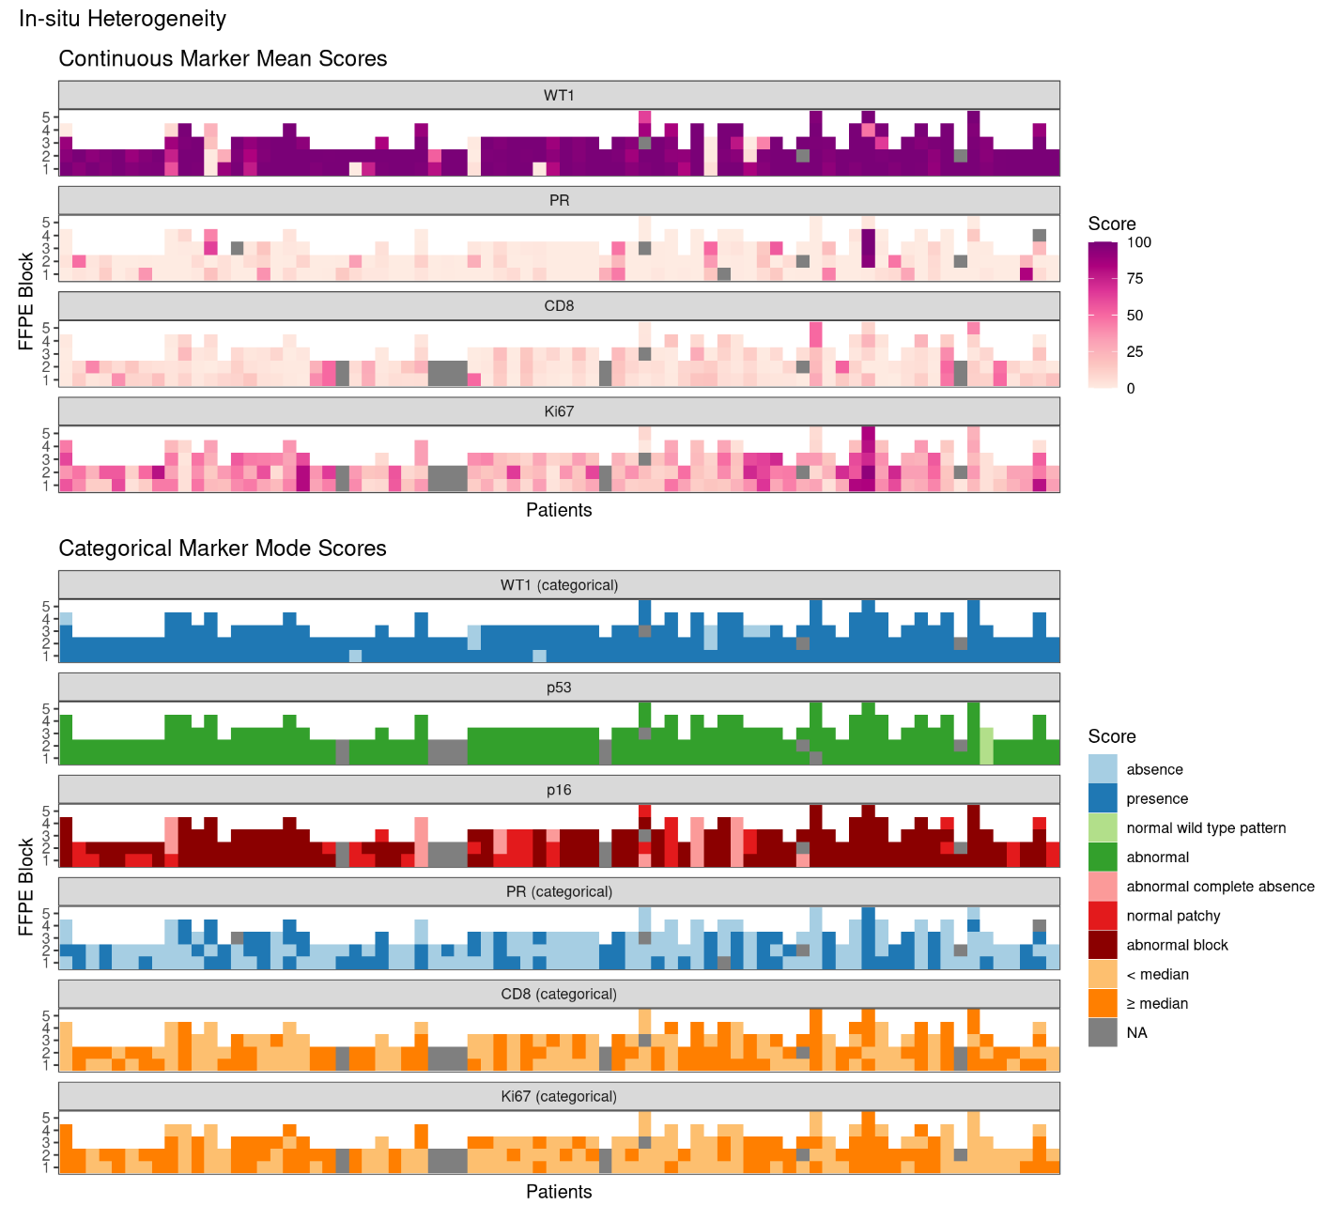

Figure S2: Adnexa vs. Other peritoneal Heterogeneity Aggregated Scores 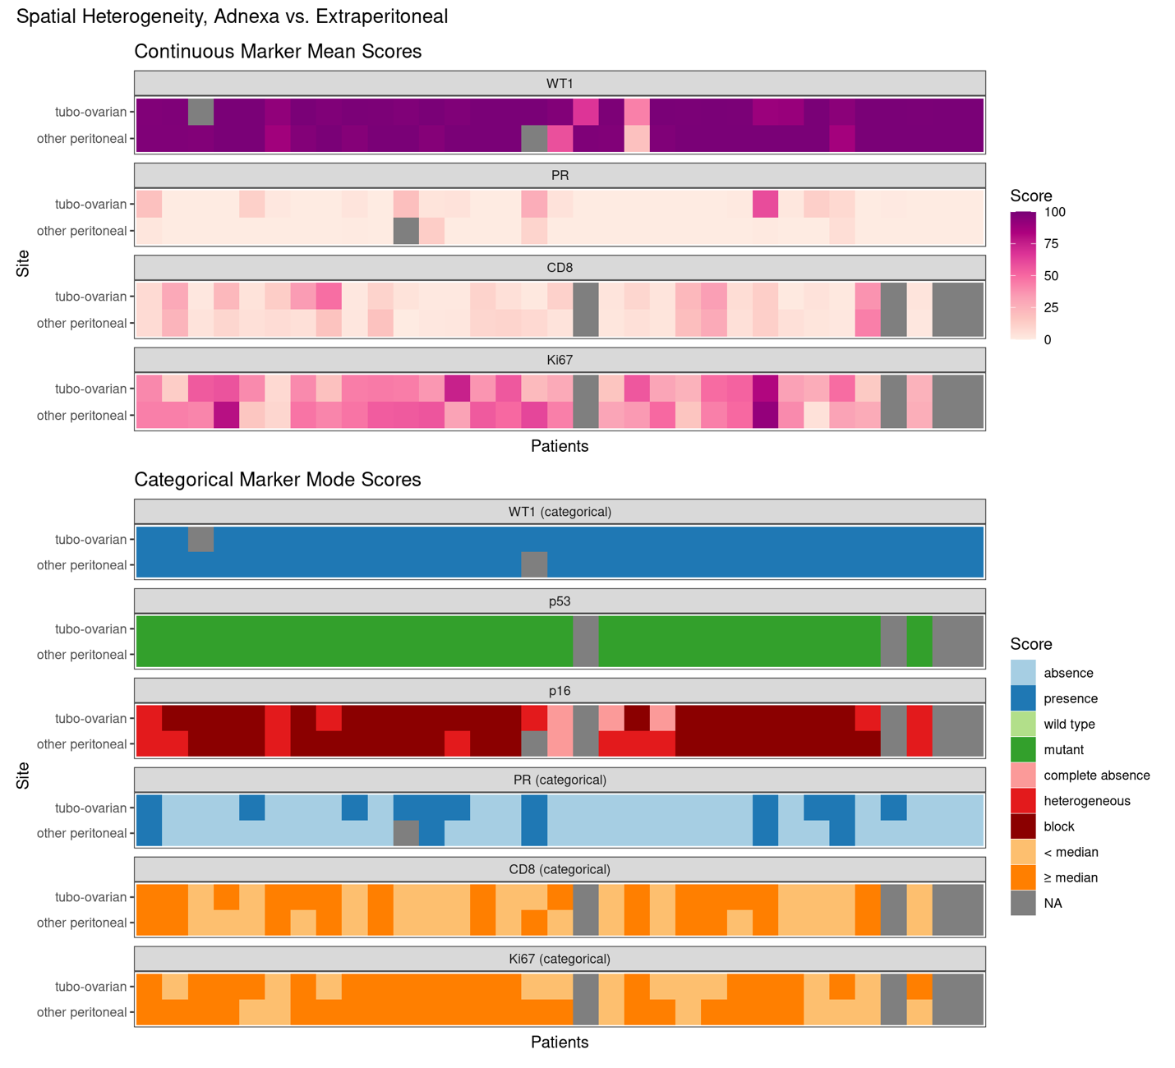

Figure S3: Primary vs. Recurrence Heterogeneity Aggregated Scores
