Supplementary Information for Role of tropical cyclones and salinity stratification in the expansion of a coastal marine heatwave

Devanarayana R.M. Rao ^{1,2}, Brian Dzwonkowski ^{1,2}, Severine Fournier ³, and Grant Lockridge ^{2,4}
¹ Stokes School of Marine and Environmental Sciences, University of South Alabama, Mobile,
AL, United States 36688
² Dauphin Island Sea Lab, Dauphin Island, AL, United States 36528
³ Jet Propulsion Laboratory, California Institute of Technology, Pasadena, CA, United States,91109
⁴ U.S. Naval Research Laboratory, Stennis Space Center, Mississippi,39529
Figures:
Supplementary Figure 1. Number of marine heatwave events in the Gulf of Mexico in 2019 during study period (August 15 – November 15). The green dashed line indicates 300m isobath and the region in white indicates absence of any marine heatwave events.

Supplementary Figure 2. Two-day evolution of thermal structure across the continental shelf along 88.21°W in September from GLORYS. White dots overlaid represent daily area affected by marine heatwaves, with white shades indicating positive deviation from 90th percentile. Respective dates are shown on top of each panel and vertical dashed lines in each panel indicate (left to right) locations of FOCAL, 50m and 300m depths.

Supplementary Figure 3. Two-day evolution of thermal structure across the continental shelf along 88.21°W in October from GLORYS. White dots overlaid represent daily area affected by marine heatwaves, with white shades indicating positive deviation from 90th percentile. Respective dates are shown on top of each panel and vertical dashed lines in each panel indicate (left to right) locations of FOCAL, 50m and 300m depths.

Supplementary Figure 4. Time series from Orange Beach Buoy (ORB) of (a) air temperature at 2m above sea surface with daily average (red), climatology (blue) and 90th percentile (dashed black), (b)relative humidity (c) sensible heat flux (Wm⁻²) and (d) latent heat flux (Wm⁻²). In (b), (c) and (d), red lines and green lines indicate hourly and daily average values from ORB, while blue lines indicate 3-hourly values from NARR. Shading in (a) indicates periods of atmospheric heatwaves.

Supplementary Figure 5. Time series of vertical structures of east-west (a) velocity, (b) temperature gradient and (c) advective transport, and (d) total advective transport at 29.4°N from GLORYS. Shaded regions in red in (a) indicate eastward flow, (b) represent warmer western side, (c) indicate eastward heat transport, and (d) net heat transport towards the location.

Supplementary Figure 6. Timeseries at FOCAL site of along-shelf (U, left column) and cross-shelf (V, right column) components of currents (m s⁻¹) from FOCAL and GLORYS for the depth averaged currents (a) and (b) as well as at near surface depths of 4m for FOCAL and 0.5m for GLORYS (c) and (d), and bottom ~19.5m for both (e) and (f) . Red dashed lines indicate 40-hour low pass filtered observations from FOCAL and blue lines indicate GLORYS. Positive values of along-shelf and cross-shelf currents indicate eastward and northward flows respectively and vice versa.

Supplementary Figure 7. Maps of (a) mean wind speed (m s⁻¹), (b)mean air-sea temperature difference and (c) mean total heat flux (Wm⁻²) during non-atmospheric heatwave days in October from NARR.

Supplementary Figure 8. Timeseries of (a) surface (~0.5m, red) and bottom (~19.5m, blue) salinities from GLORYS at the FOCAL location, and surface minus bottom (b) salinities and (c) temperatures of FOCAL (green) and GLORYS (solid black).

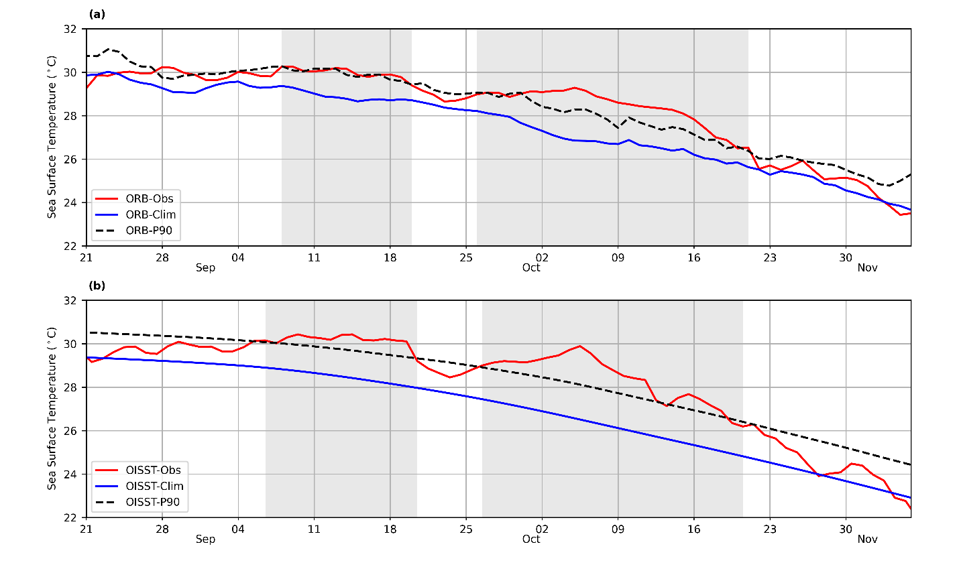
Supplementary Figure 9. Time series of daily average sea surface temperatures (SST, red) from (a) Orange Beach Buoy (ORB) and (b) Optimum Interpolation SST (OISST) from the closest pixel to ORB with climatology (blue) and 90th percentile (dashed black). Shading indicates periods of surface marine heatwaves.

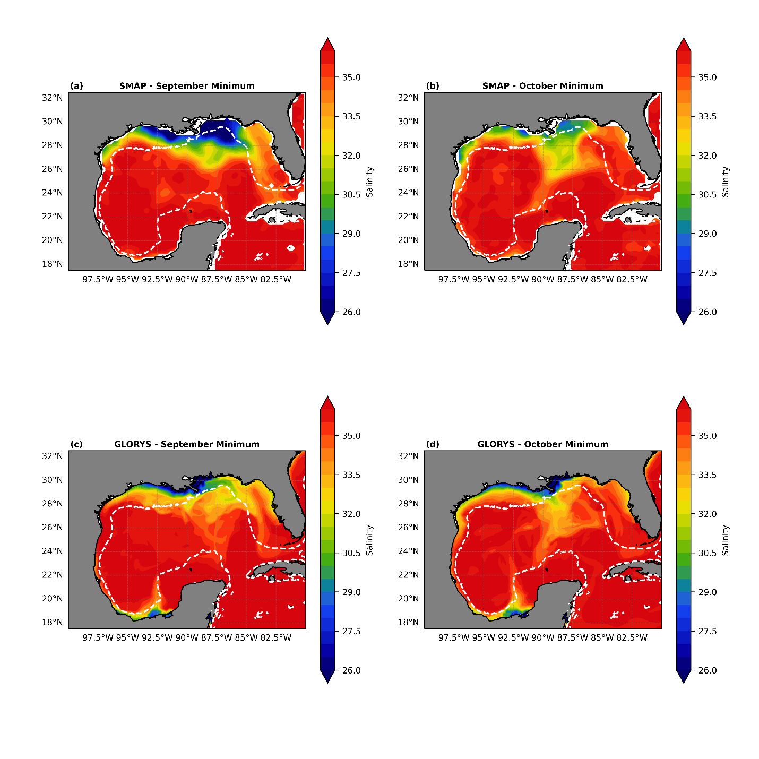
Supplementary Figure 10. Map of monthly minimum sea surface salinity (SSS) from Soil Moisture Active Passive (SMAP) observatory (top panel) and Global Ocean Physics Reanalysis (GLORYS) dataset (bottom panel) during the month of September ((a) and (c)) and October ((b) and (d)). White contour lines indicate shelf break at 300m isobath.

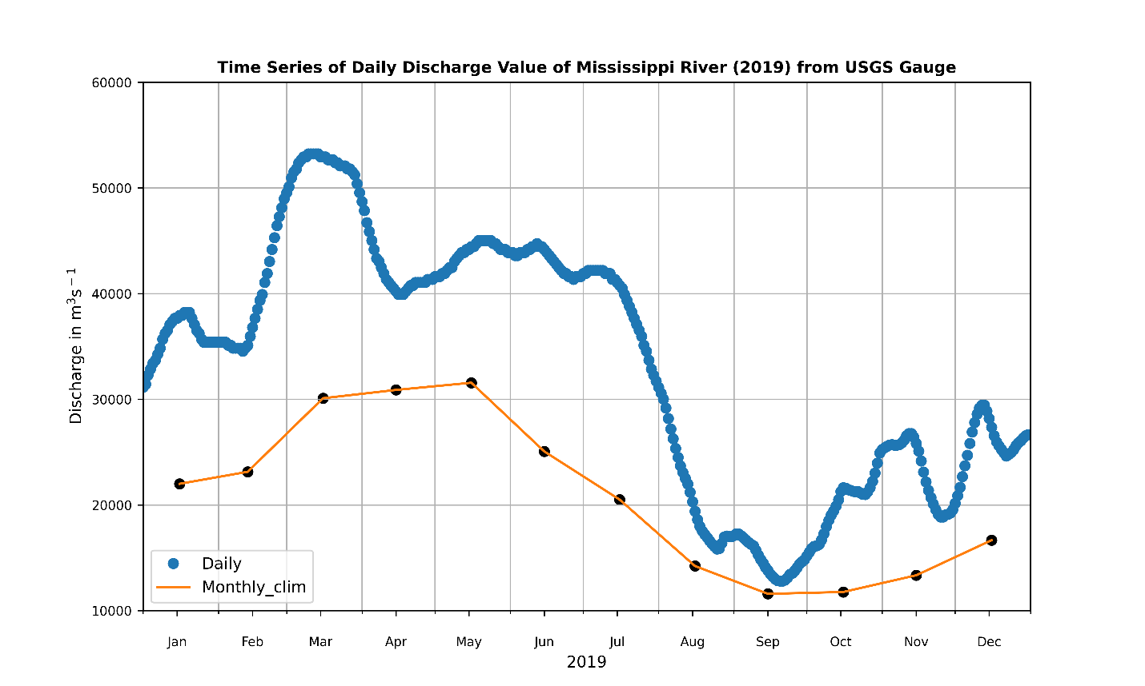
Supplementary Figure 11. Timeseries of discharge values (m³ s⁻¹) of Mississippi river in 2019 with daily values (blue) and monthly climatology (orange) from USGS station at Vicksburg, MS (#07289000).

