Reply to Respected AE Comments:
Ref: Submission ID aeff5a0a-0eb1-43ed-a543-bc80eec19eec

AE recommendation:
Although the study can be potentially of interest to the readership of the Journal, (1) the methods are poorly described and thus, the reader cannot follow what is done and why, (2) the implications of the findings for other locations/sites etc and for a broader readership are not discussed, and (3) the limitation of the study/methodology/assumptions are also not at all discussed. Below I list also few more specific comments that the authors could take into consideration when revising the manuscript. I invite them to address in detail the comment raised, strengthen their work and resubmit it.
Dear respected editor, it is important that the title of our article is revised into following for noticing the broader case study analyses and best citations:
A Novel Fuzzy Forest Health Index (FFHI) for Standardizing Stochastic Forest-Smart Mining, Case Study of 30 All-Around the World Mining-Engaged Forests
L29-31: What is the physical meaning/interpretation of these values of the index ? The text, as is right now, does not convey the key results of the study and the broader implications for the wide readership of the Journal.
The fuzzy forest health index falls in range of [-100, +100] from which negative values represent destructive forest health index i.e. forest health has disgusting conditions requiring essential attentions; while, positive values represent constructive forest health index i.e. forest health has proper conditions.
FFHI (Fuzzy Forest Health Index) is defined as difference of Constructive and Destructive FFHIs. Finally the net FFHI is categorized/defuzzified in 6 membership functions of 1-Low Constructive FFHI (from 0 to 35), 2-Average Constructive FFHI (from 15 to 85), 3-High Constructive FFHI (from 65 to 100), 4-Low Destructive FFHI (from -35 to 0), 5-Average Destructive FFHI (from -65 to -35) and 6-High Destructive FFHI (from -100 to -65).
Hence FFHI of 2.1 for Sungun indicates a low constructive/positive fuzzy forest health index, FFHI of 37.92 for Merian indicates an average constructive/positive fuzzy forest health index and FFHI of -25.7 indicates a low Destructive/negative fuzzy forest health index. For better understanding please pay attention to following figures as outputs of FFHIs.
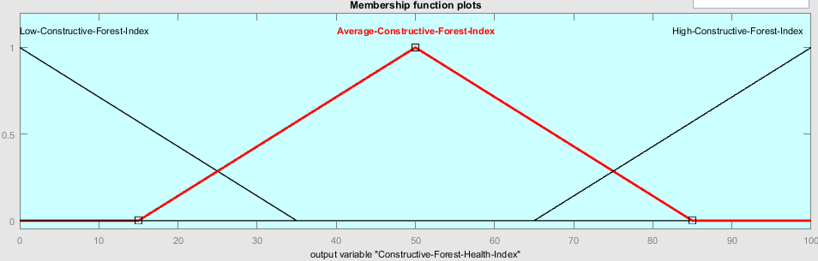
Figure 6: Membership Functions for Output Parameter Fuzzy Constructive Forest Health Index in FCFHI
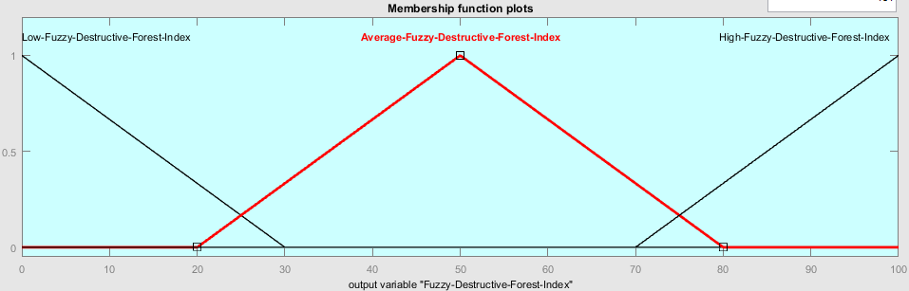
Figure 12: Membership Functions for distribution of Output Parameter Fuzzy Destructive Forest Health Index in FDFHI

As a result the naming lines are modified as following:
Results indicate that the Forest Health Index (FFHI) for Sungun is 2.1 (interpreting as rather low constructive fuzzy forest health index). For broader case studies, maximum and minimum FFHIs (Fuzzy Forest Health Index) were observed in Merian (37.92 interpreting as rather average constructive fuzzy forest health index) and Nimba Range Mineral Province (NRMP) (-25.7 interpreting as rather low/average destructive fuzzy forest health index), respectively.
As well a subsection added to methods section as following:

4.2. Fuzzy Forest Health Index (FFHI)
Generally fuzzy forest health index parameters are divided into two major groups naming 1-Constructive Parameters and 2-Destructive Parameters. The former represents the positive impacts of climate-smart mining on forest health while the latter indicates the negative impacts of mining activities on forest health. Eventually the fuzzy forest health index is calculated by simply subtracting destructive fuzzy forest health index from constructive fuzzy forest health index as a net value. Constructive parameters are 1-Intact Forestry, 2-Core Forestry, 3-Ecologically Viable Forestry, 4-Secondary Forest and 5-Forest Connectivity. While destructive parameters are 1-Total Deforestation, 2-Forest Fragmentation, 3-Population Change, 4-Total Population and 5-Road Density. The fuzzy indices are developed in following sections.

L31-33: again, this outcome is not clear from the results/analysis. Also, the implications of the obtained results to the broader scientific community is needed.

It is important to note that 28 forests engaged with mining projects from all around the world have been put under thorough analyses by our novel fuzzy study and we do believe that this is an enterprise in standardizing stochastic forest health index. As you do know such a substantial and comprehensive case by case assessment is rare in literature or better saying unfound so far. And this is the best representative for a broader scientific community and a worldwide case study. The present study will become of course a great global standard in forest health index and climate-smart mining projects.
As a result we revised the title to exhibit better our vast case study to receive more worldwide attentions as well as best citations. The revised Title is:
A Novel Fuzzy Forest Health Index (FFHI) for Standardizing Stochastic Forest-Smart Mining, Case Study of 30 All-Around the World Mining-Engaged Forests

Following lines added:
The outcomes emphasize the importance of implementing forest-smart mining practices to mitigate the adverse effects of mining activities on the Arasbaran forest and promote conditions conducive to forest health. It is better to diminish high road density, forest fragmentation and total deforestation along with improve forest core, forest connectivity and secondary forestry.
L59-61: more explanations and literature on the FHI is needed in the introduction.
Following lines added:
World Bank first time introduced this index by using several key issues that mining activities positively or negatively affect were analyzed using expert opinions on 29 mining regions. In this article, we utilize remote sensing to examine environmental indices in some of these regions, verify their differences, and propose an index with higher accuracy and efficiency.

In this paper, we apply remote sensing to examine some of these regions' environmental indices, validate their discrepancies, and suggest an improved more reliable index.

L73: ‘development approach’: reads unclear
The term: sustainable development program scheme was substituted in text.

L99: ‘vegetations’ no need for plural
‘Vegetation’ was substituted.
L97-110: this section reads overly simplistic with no clear scientific jargon (‘take pictures’, ‘photographs’, etc.), terminology and ‘methods description’ on how remote sensing techniques have been used in this specific work.
By using remote sensing, it is possible to estimate the extent of deforestation resulting from mining operations over a variety years and calculate vegetation indicators to assess mining activities impact on nearby environment (Figure 1).

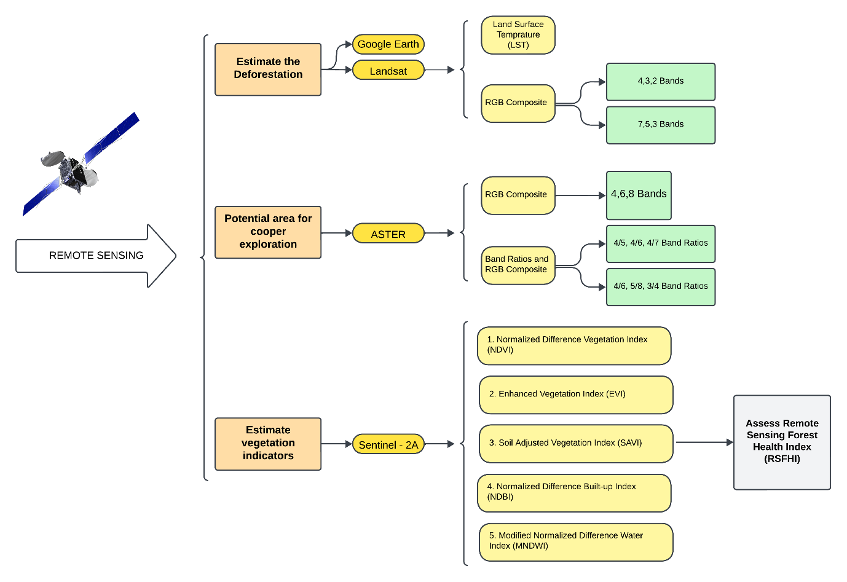
Figure 1: Remote sensing flowchart for deforestation and vegetation assessment using satellite data and indices.
Table 3. How sensitive are the obtained results to the assigned weights reported on Table 3? Apart from the cited report of WB is there any additional literature pointing towards these numbers?

Thank you for your insightful comment regarding Table 3. The weights assigned to the variables, as reported in Table 3, are primarily based on expert opinion, as the cited World Bank report does not specify a detailed methodology for determining these weights. One of the motivations for authoring this article is to address the ambiguity and lack of systematic tools for determining these weights. To enhance the reliability and understanding of the weighting process, we suggest using fuzzy logic and remote sensing techniques to improve the weighting process's comprehension and dependability. These tools offer a more structured and data-driven approach, which could significantly improve the accuracy and justification of the weights assigned to the variables.
Although lines 348 to 353 of our manuscript describe the cited article's approach to variable weighting
L343-346: ‘It is helped from following references (Sarkheil et al., 2018; Sarkheil et al., 2019; Sarkheil and Rahbari, 2016; Sarkheil et al., 2018a; Sarkheil et al., 2018b; Sarkheil et al., 2020; Sarkheil et al., 2021; Sarkheil et al., 2023a; Sarkheil et al., 2023b) in methodology of present study.’
-The sentence above reads weird because of (1) wrong grammar/syntax and (2) the too many self-citations. The authors should cite relevant literature also from other groups applying these methods.
The naming sentence was omitted and following parts added to introduction and reference sections.
Fuzzy environmental quality indices have been constructed by following references (Dunea, et al., 2011; Enea & Salemi, 2001; Sarkheil, et al., 2023a; Sarkheil, et al., 2021). A novel fuzzy soil quality index using resistivity and induced polarization was constructed by Sarkheil, et al., 2023b. Some air quality indices were developed via fuzzy mathematics both Mamdani and Sugeno systems by Sowlat, et al., 2011; Sarkheil & Rahbari 2016; Sarkheil, et al., 2018a. Fuzzy wastewater quality indices have successfully been proposed and applied for industrial case studies by Sarkheil, et al., 2018b; Sarkheil, et al., 2019. Hosseini, et al., 2015 proposed a ground water quality index via fuzzy inference system.
In continue of environmental and sustainability indices, in this study it is provided a novel metric to assess the condition of forest ecosystems: the Fuzzy Forest Health Index (FFHI).

Sowlat M, Gharibi H, Yunesian M, Mahmoudi T, Lotfi S (2011) A novel, fuzzy-based air quality index (FAQI) for air quality assessment. Atmos Environ 45:2050–2059.
Dunea D, Pohoat AA, Langu E (2011) Fuzzy inference systems for estimation of air quality index. ROMAI J 7(2):63–70
Enea M, Salemi G (2001) Fuzzy approach to the environmental impact evaluation. Ecol Model 135:131–147
Hosseini-Moghari SM, Ebrahimi K, Azarnivand A, “Groundwater quality assessment with respect to fuzzy water quality index (FWQI): an application of expert systems in environmental monitoring”, Environmental Earth Sciences, 2015, 74, 7229.
Zadeh LA . Fuzzy sets. Inf Control 1965;8(3):338–53 Jun 1 .
Zadeh LA . The concept of a linguistic variable and its application to approxi- mate reasoning—I. Inf Sci (Ny) 1975;8(3):199–249 .
Ross TJ . Fuzzy logic with engineering applications, New York: Wiley; 2004. Jun .
L345-347: such sentences are not at all informative and do not help a reader understand/reproduce the methodology.
The sentences deleted and a subsection added for addressing fuzzy inference system.
L347: what is a ‘membership function’? As is, a reader cannot follow the methods.
For better understanding of fuzzy inference system terms a subsection added as following:

4.1. Fuzzy Sets and Fuzzy Inference System FIS
A fuzzy set A as introduced first by Zadeh in 1965 is defined as following:
$Fuzzy Set A≡\{X, μ_{A}\left(x\right); Where:x∈X\}$
Where $μ_{A}$ is called membership function which is defined as a function or a curve for assigning a membership degree or a presence percentage to definite point/element x of set A. For example the amount of membership function $μ_{A}$ for set “young in word class of age” $for$a thirty-year old man would be 70% or 0.70. This is because fuzzy logic is relative and can receive values between 0 (pure absence) and 1 (pure presence) in contrast to Aristotle binary logic. And this is served as a great advantage to overcome many actual physical problems.
Following equations represent some applicable operations on fuzzy sets for mathematical computations and proceeding to fuzzy inference system.
$μ_{A∪B}\left(x\right)≈μ_{A}\left(x\right) Or μ_{B}\left(x\right)≡Max\{μ_{A}\left(x\right), μ_{B}\left(x\right)\}$ $μ_{A∩B}\left(x\right)≈μ_{A}\left(x\right) AND μ_{B}\left(x\right)≡Min\{μ_{A}\left(x\right), μ_{B}\left(x\right)\}$
$$Complementary of$$
$A≈ Other than μ_{A}\left(x\right)≈NOT μ_{A}\left(x\right)≡1-μ_{A}\left(x\right)$
Fuzzy inference system is a process in which a scheme or a proper relation is formulated from given sets of input variables into a projected set of output variable(s) by relative fuzzy logic. Figure 1 illustrates a sketch for fuzzy inference process. As observed, there exist four parts of 1. Knowledge Base, 2. Fuzzification, 3. Inference Unit and 4. Defuzzification in an FIS process unit. The relations between input/output parameters are constructed via fuzzy rules. These rules are lingual clauses including If/Then sub-clauses like What-if processes.
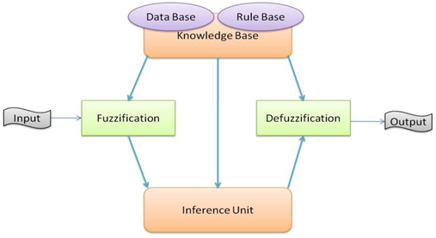
Figure 1: The sketch of fuzzy inference system FIS process
The knowledge-base includes all necessary information about MFs and fuzzy rules for classification of sets in word classes and relationships. Fuzzification Unit transduces input numeric variables into lingual variables by a definite MF. In Inference Unit, the input linguistic variables are linked or better saying connected into lingual output variables by If-Then word clauses. Applicable operations of AND, OR or NOT are used for connecting If sub clauses. Eventually Defuzzification Unit transduces output lingual variable into output numeric variable.
L396: what is the meaning of ‘destructive parameters’ ?
Generally fuzzy forest health index parameters are divided to two major groups naming 1-Constructive Parameters and 2-Destructive Parameters. The former represents the positive impacts of climate-smart mining on forest health while the latter indicates the negative impacts of mining activities on forest health. Eventually the fuzzy forest health index is calculated by simply subtracting destructive fuzzy forest health index from constructive fuzzy forest health index as a net value. Constructive parameters are 1-Intact Forestry, 2-Core Forestry, 3-Ecologically Viable Forestry, 4-Secondary Forest and 5-Forest Connectivity. While destructive parameters are 1-Total Deforestation, 2-Forest Fragmentation, 3-Population Change, 4-Total Population and 5-Road Density.
What is the basis/rational of the ‘rules’ reported in the methods (e.g., L377- 393, L424-439)?
We do believe that fuzzy logic can help simplify and actually visualize the phenomena taking place in standardizing fuzzy forest health index from beginning input parameters to output parameters through the innovatively developed process. All naming rules can simply be extracted within word by word relation of constructive and destructive parameters. All parameters as well as indices are categorized in three membership function of 1)Low, 2)Average and 3)High. The fuzzy rules simply connect Low MFs of parameters to Low FFHI, Average MFs of parameters to Average FFHI and correspondingly High MFs of parameters to High MF of FFHI. On the other hand researchers’ intuitions can firmly defend the development of fuzzy rules. As an example for following rule we can state that uneven and repeated break-ups in forests coming from cutting trees, unwanted fires, or diseases (resulting in drying) can cause high levels of forest fragmentations and this is served as a high level of destructive conditions called here as Fuzzy Destructive Forest Health Index.

- “If Forest Fragmentation is High then FDFHI is High (0.5)”
We are certain that all fuzzy rules are developed correctly and again we assert that this methodology is purely novel based on our intuitions, attitudes, experiences and knowledge. Our scientific experience in this field is highlighted in introduction section. The novelty and as well simplicity of fuzzy rules by lingual analyses here is an important advantage which certainly overcomes problems of classic indexing methods like Pi or Sigma accumulative models or maximizing linear fitting attitudes like US-EPA-AQI.
L442: unclear what you mean by ‘analyzing Raster images with Remote Sensing (RS) methods from 2008, 2012, 2016, 2018, and 2023’. Such analysis is not presented in the methods.
The following line replaced:

By comparing satellite images from Google Earth in 2008 and 2023 (Fig. 15) and comparing the bare soil false color composites (band 4,3 and 2) from 2008, 2013, 2016, 2018, and 2023, it was observed that approximately 12 square kilometers of forest in this area were lost during the same months. The mine and urban area appear white, while the shades of white to blue represent exposed rocks by water and snow (Fig. 17).
Fig 14. You should correct the strips in landsat LST in year 2012.
Strips Fixed
Fig15. Unclear how the ‘contaminated mining zone’ is defined. Only visually/qualitative from the false colour images? So what is not green/vegetation means it is contaminated? All this need detailed description in the methods and quantification/numbers/statistics apart from the qualitative figures.
For “contaminated mining zone” we just chose the wrong name for this area because the rocks from the copper mine are very toxic for the environment and the light blue false color composite of bands 4, 3, and 2 represents the sediment-laden water. So when the water reacts with minerals such as chalcopyrite, which are products of copper mining, it leads to the creation of acid mine drainage (AMD), making the area contaminated.
following line added:
Band 2 (Green, 0.52-0.60 µm) captures the green reflectance of healthy vegetation and is useful for assessing plant vigor. Bare soils also reflect more in this band compared to vegetation.”
“In False Color Composite images using Landsat 7 bands 4, 3, and 2, solid white or very bright areas typically represent the Bare Soil or Exposed Rock, these areas with high reflectance across all three bands (NIR, Red, and Green) appear bright or white. This is often indicative of bare soil, sand, or exposed rock surfaces.also built-up areas, concrete structures, and some types of roofing materials can appear very bright or white due to their high reflectance in all three bands.
When areas appear in shades of white to blue in this FCC, they often represent snow and ice which have high reflectance in all visible and near-infrared bands but slightly higher in the blue wavelengths, causing them to appear white with a bluish tint.also shallow water or sediment-laden water can appear in light blue to white shades.

composition of Band 4,3 and 2 are useful to identify bare soil, highlighting the contrast between the mine area and other land uses, excluding forests and vegetation. Because in the 7-5-3 RGB composite, the other soil area around the mine site does not have visually noticeable differences. While this combination can highlight certain features such as vegetation and water bodies, it may not always reveal subtle differences in soil types, especially in areas surrounding a mine site where the mineral content can be uniform. For more detailed soil analysis, other band combinations might be considered to enhance the contrast between different soil areas.
the"contaminate mining area" change to Exposed Rocks and water or sediment-laden water.
solid white represent Exposed Rocks and light blue represent water and sediment-laden water.

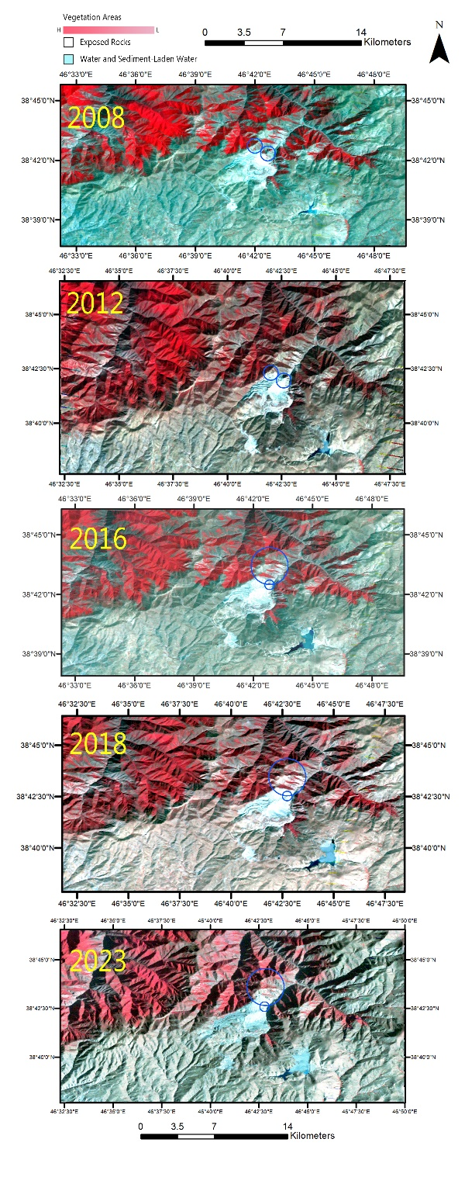
Figure 17: According to the RGB Composite 4, 3, 2 (2008-2023), the red area represents the vegetation area, while the white area indicates the exposed rocks or mine operation area. This observation suggests that deforestation is ongoing on the north side of the mine area.

L520, check citation
The citation was checked and corrected.
L530. All these are part of the methods not the results section
The desired section was moved to the method section.

