Supplementary Material
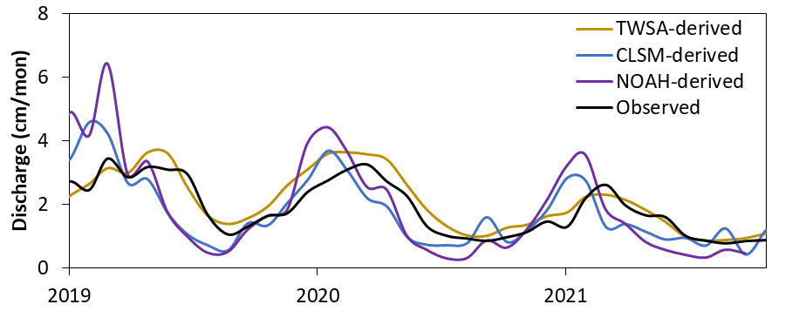
Figure S1Monthly streamflow at Mississippi River, Baton Rouge
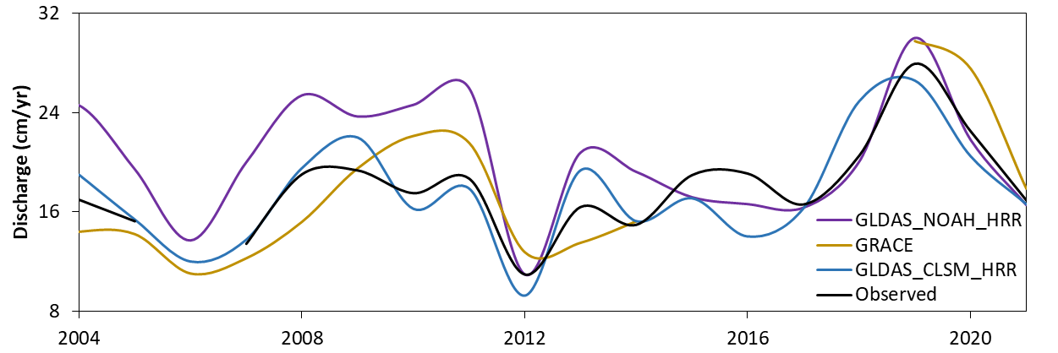
Figure S2 Annual streamflow at Mississippi River, Baton Rouge

