Supporting Information

A preprogrammed force field generated in a confined space enables external-module-free anisotropic
vat-photopolymerization 3D printing

Satoshi Honda*
Department of Basic Science, Graduate School of Arts and Sciences, The University of Tokyo, 3-8-1 Komaba, Meguro-ku, Tokyo 153–8902, Japan.

Table 1. Size characteristics of mica flakes.
Mica | Size (μm)ª | Aspect ratio^{b} | d (g mL⁻¹)^{c}
A-11 | 3 | N/A | 0.11
A-21S | 23 | 70 | 0.13
AB-25S | 24 | 80 | 0.17
J-31M | 35 | 75 | 0.20
Y-1800 | 10 | 70 | 0.15
Y-2300X | 19 | 60 | 0.16
Y-3000 | 23 | 80 | 0.25
ªAveraged particle size, determined based on laser diffraction particle size analysis, provided from the manufacturer. ^{b}Aspect ratio, provided from the manufacturer. ^{c}Bulk density, provided from the manufacturer.

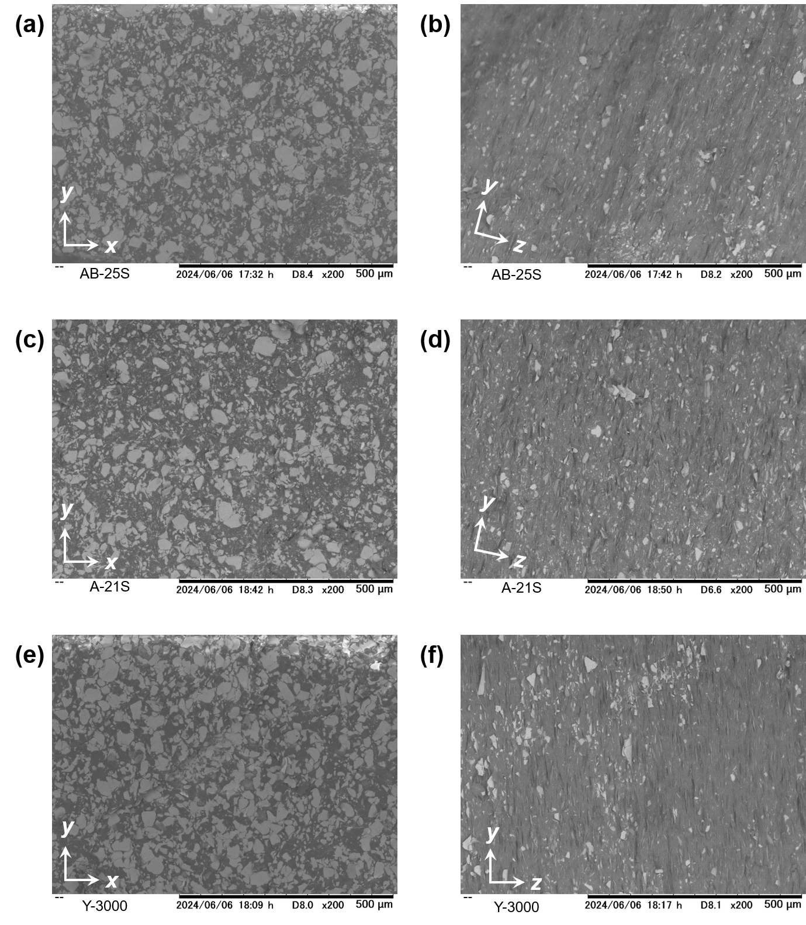
Figure S1. SEM image of (a, b) CPMC_{AB-25S}, (c, d) CPMC_{A-21S}, and (e, f) CPMC_{Y-3000} fabricated with the thickness of each layer to be cured during 3DP as 25 μm. The images were taken to observe the distribution of mica flakes in the (a, c, e) xy-plane and (b, d, f) yz-plane.

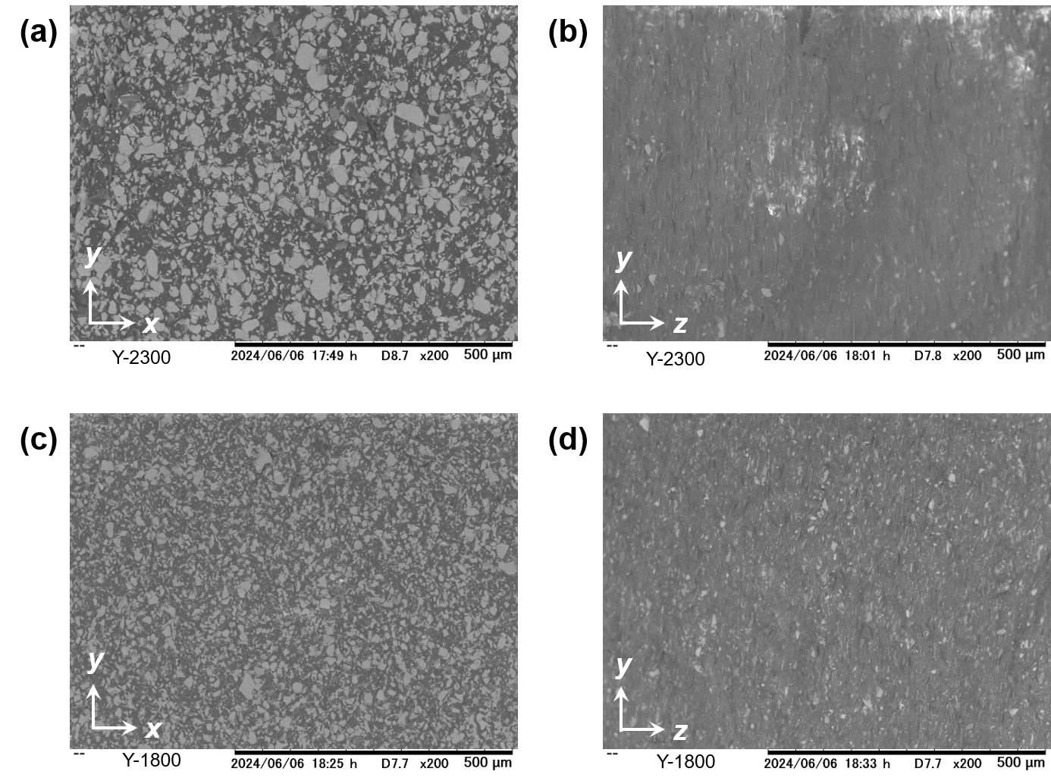
Figure S2. SEM image of (a, b) CPMC_{Y-2300}, (c, d) CPMC_{Y-1800} fabricated with the thickness of each layer to be cured during 3DP as 25 μm. The images were taken to observe the distribution of mica flakes in the (a, c) xy-plane and (b, d) yz-plane.

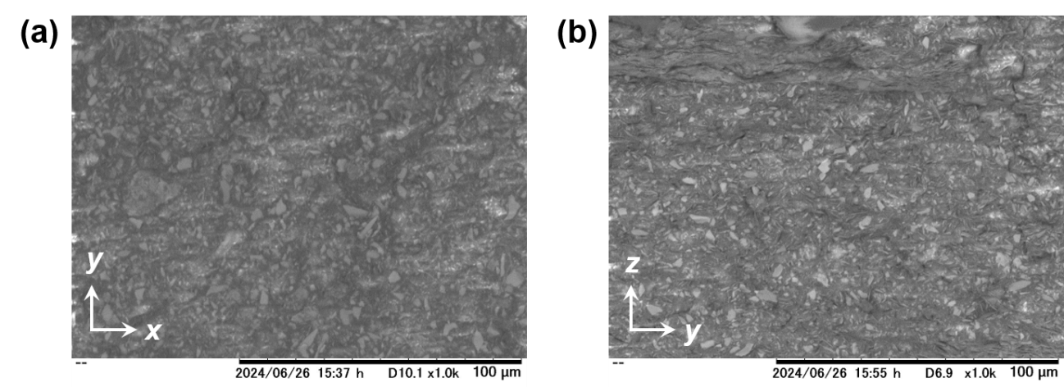
Figure S3. SEM image of CPMC_{A-11} fabricated with the thickness of each layer to be cured during 3DP as 10 μm. The images were taken to observe the distribution of mica flakes in the (a) xy-plane and (b) yz-plane.

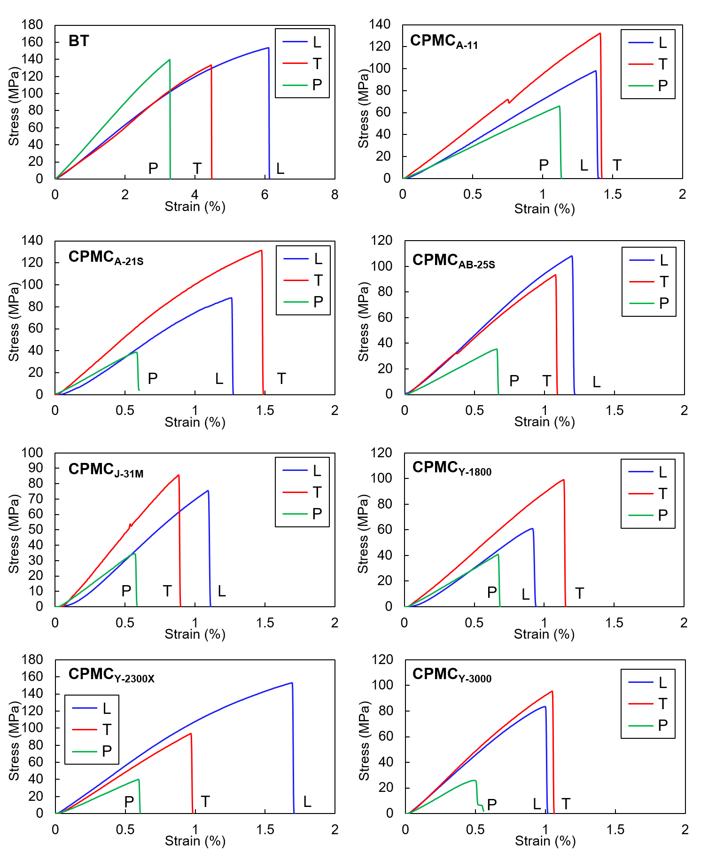
Figure S4. Stress–strain curves of (a) BT, (b) CPMC_{A-11}, (c) CPMC_{A-21S}, (d) CPMC_{AB-25S}, (e) CPMC_{J-31M}, (f) CPMC_{Y-1800}, (g) CPMC_{Y-2300X}, (h) CPMC_{Y-3000} measured in three different (L, T, and P) directions.

