Table 1: The ACCORD (ACcurate COnsensus Reporting Document) Checklist for Reporting Delphi Studies

﻿Manuscript section | ﻿Item wording | Page no.
﻿Title | ﻿Identify the article as reporting a consensus exercise and state the consensus methods used in the title. | 1
﻿Introduction | ﻿Explain why a consensus  s exercise was chosen over other approaches. | 4
﻿Introduction | ﻿State the aim of the consensus exercise, including its intended audience and geographical scope (national, regional, global). | 4
﻿Introduction | ﻿If the consensus exercise is an update of an existing document, state why an update is needed, and provide the citation for the original document. | 4
﻿Methods > Registration | ﻿If the study or study protocol was prospectively registered, state the registration platform and provide a link. If the exercise was not registered; this should be stated. | 4
﻿Methods > Selection of SC and/or panelists | ﻿Describe the role(s) and areas of expertise or experience of those directing the consensus exercise. | 4
﻿Methods > Selection of SC and/or panelists | ﻿Explain the criteria for panelist inclusion and the rationale for panelist numbers. State who was responsible for panelist selection. | 5
﻿Methods > Selection of SC  and/or panelists | ﻿Describe the recruitment process (how panelists were invited to participate) | 5
﻿Methods > Selection of SC and/or panelists | ﻿Describe the role of any members of the public, patients, or carers in the different steps of the study. | 5
﻿Methods > Preparatory  research | ﻿Describe how information was obtained prior to generating items or other materials used during the consensus exercise | 5
﻿Methods > Preparatory  research | ﻿Describe any systematic literature search in detail, including the search strategy and dates of search or the citation if published already. | Appendix 1,Page 3 & 4
﻿Methods > Preparatory  research | ﻿Describe how any existing scientific evidence was summarized and if this evidence was provided to the panelists. | 5
﻿Methods > Assessing  consensus | ﻿Describe the methods used and steps taken to gather panelist input and reach consensus (for example, Delphi, RAND/ UCLA, nominal group technique). | 5
﻿Methods > Assessing  consensus | ﻿Describe how each question or statement was presented and the response options. State whether panelists were able to or required to explain their responses, and whether they could propose new items | 5
﻿Methods > Assessing  consensus | ﻿State the objective of each consensus step. | 5
﻿Methods > Assessing  consensus | ﻿State the definition of consensus (for example, number, percentage, or categorical rating, such as “agree” or “strongly agree”) and explain the rationale for that definition. | 5
﻿Methods > Assessing  consensus | ﻿State whether items that met the prespecified definition of consensus were included in any subsequent voting rounds. | 5
﻿Methods > Assessing  consensus | ﻿For each step, describe how responses were collected, and whether responses were collected in a group setting or individually. | 5
﻿Methods > Assessing  consensus | ﻿Describe how responses were processed and/or synthesized. | 5
﻿Methods > Assessing consensus | ﻿Describe any piloting of the study materials and/or survey instruments | 5
﻿Methods > Assessing  consensus | ﻿If applicable, describe how feedback was provided to panelists at the end of each consensus step or meeting. | 5
﻿Methods > Assessing  consensus | ﻿State whether anonymity was planned in the study design. Explain where and to whom it was applied and what methods were used to guarantee anonymity. | 5
﻿Methods > Assessing  consensus | ﻿State if the steering committee was involved in the decisions made by the consensus panel. | 5
﻿Methods > Participation | ﻿Describe any incentives used to encourage responses or participation in the consensus process. | 5
﻿Methods > Participation | ﻿Describe any adaptations to make the surveys/meetings more accessible. | 5
﻿﻿Results | ﻿State when the consensus exercise was conducted. List the date of initiation and the time taken to complete each consensus step, analysis, and any extensions or delays in the  analysis.
﻿Results | ﻿Explain any deviations from the study protocol, and why these were necessary | 6
﻿Results | ﻿For each step, report quantitative (number of panelists, response rate) and qualitative (relevant sociodemographic) data to describe the participating panelists. | Appendix 1, Figure 2, Page 5
﻿Results | ﻿Report the final outcome of the consensus process as qualitative (for example, aggregated themes from comments) and/or quantitative (for example, summary statistics, score means, medians, and/or ranges) data. | Table 2 and Table 3
﻿Results | ﻿List any items or topics that were modified or removed during the consensus process. Include why and when in the process they were modified or removed. | Appendix 1, Figure 2, Page 5
﻿Discussion | ﻿Discuss the methodological strengths and limitations of the consensus exercise. | 12
﻿Discussion | ﻿Discuss whether the recommendations are consistent with any preexisting literature and, if not, propose reasons why this process may have arrived at alternative conclusions. | 6-13
﻿Other information | ﻿List any endorsing organizations involved and their role. | 5
﻿Other information | ﻿State any potential conflicts of interests, including among those directing the consensus study and panelists. Describe how conflicts of interest were managed. | 14
﻿Other information | ﻿State any funding received and the role of the funder | 14

UCLA, University of California, Los Angeles, not applicable; PRISMA, Preferred Reporting Items for Systematic Reviews and Meta-Analyses;
SC, Steering Committee.

Search Strategy Used for Drafting the Round One Clinical Statements

A focused search was performed for this report through Medline and Embase databases using keywords "Sepsis" OR “Shock, Septic" AND "Resource-Limited Settings" OR "Developing Countries" between January 1, 2000 and March 1, 2023. Only original studies, excluding narrative reviews, scoping reviews, case series, and case reports were included. Further, the literature was filtered for English language and adult (>18 years) humans. The search result and final included studies are presented in the flow diagram. Besides the focused search, the references included in the recent edition of surviving sepsis campaign guidelines [14] for the management of sepsis and septic shock was also included for drafting the clinical statements of Round 1.

Figure 1: PRISMA Flowchart of Studies Included for Qualitative Evidence Synthesis

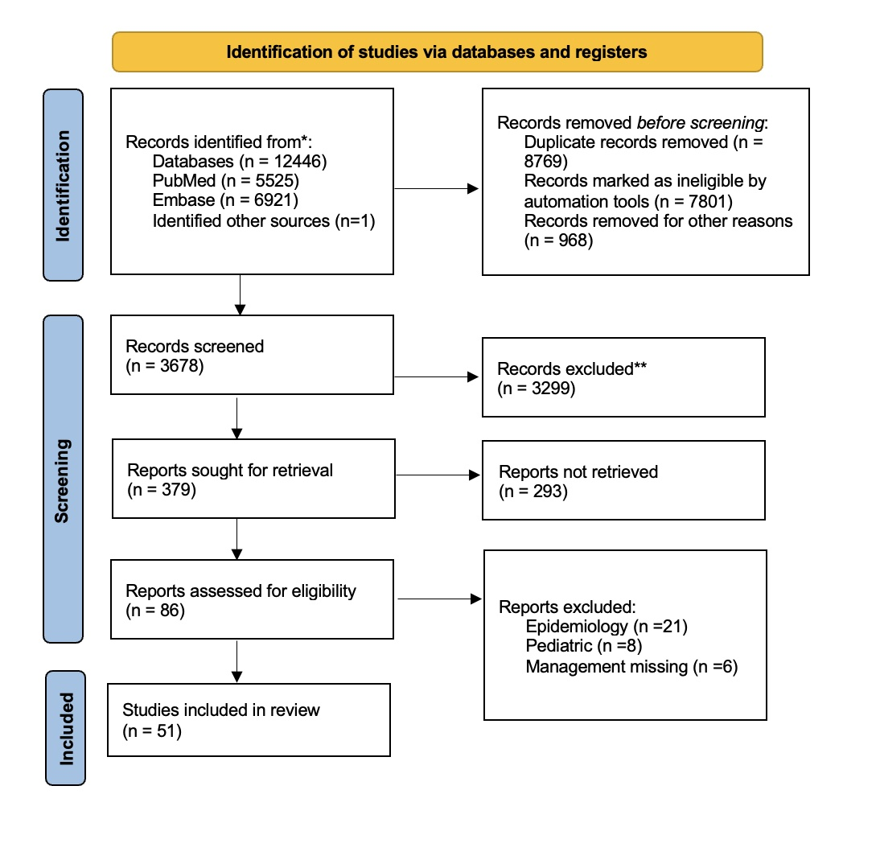
From: Page MJ, et al. The PRISMA 2020 statement: an updated guideline for reporting systematic reviews. BMJ 2021;372: n71.

Figure 2: Delphi Process and Involvement of the Experts

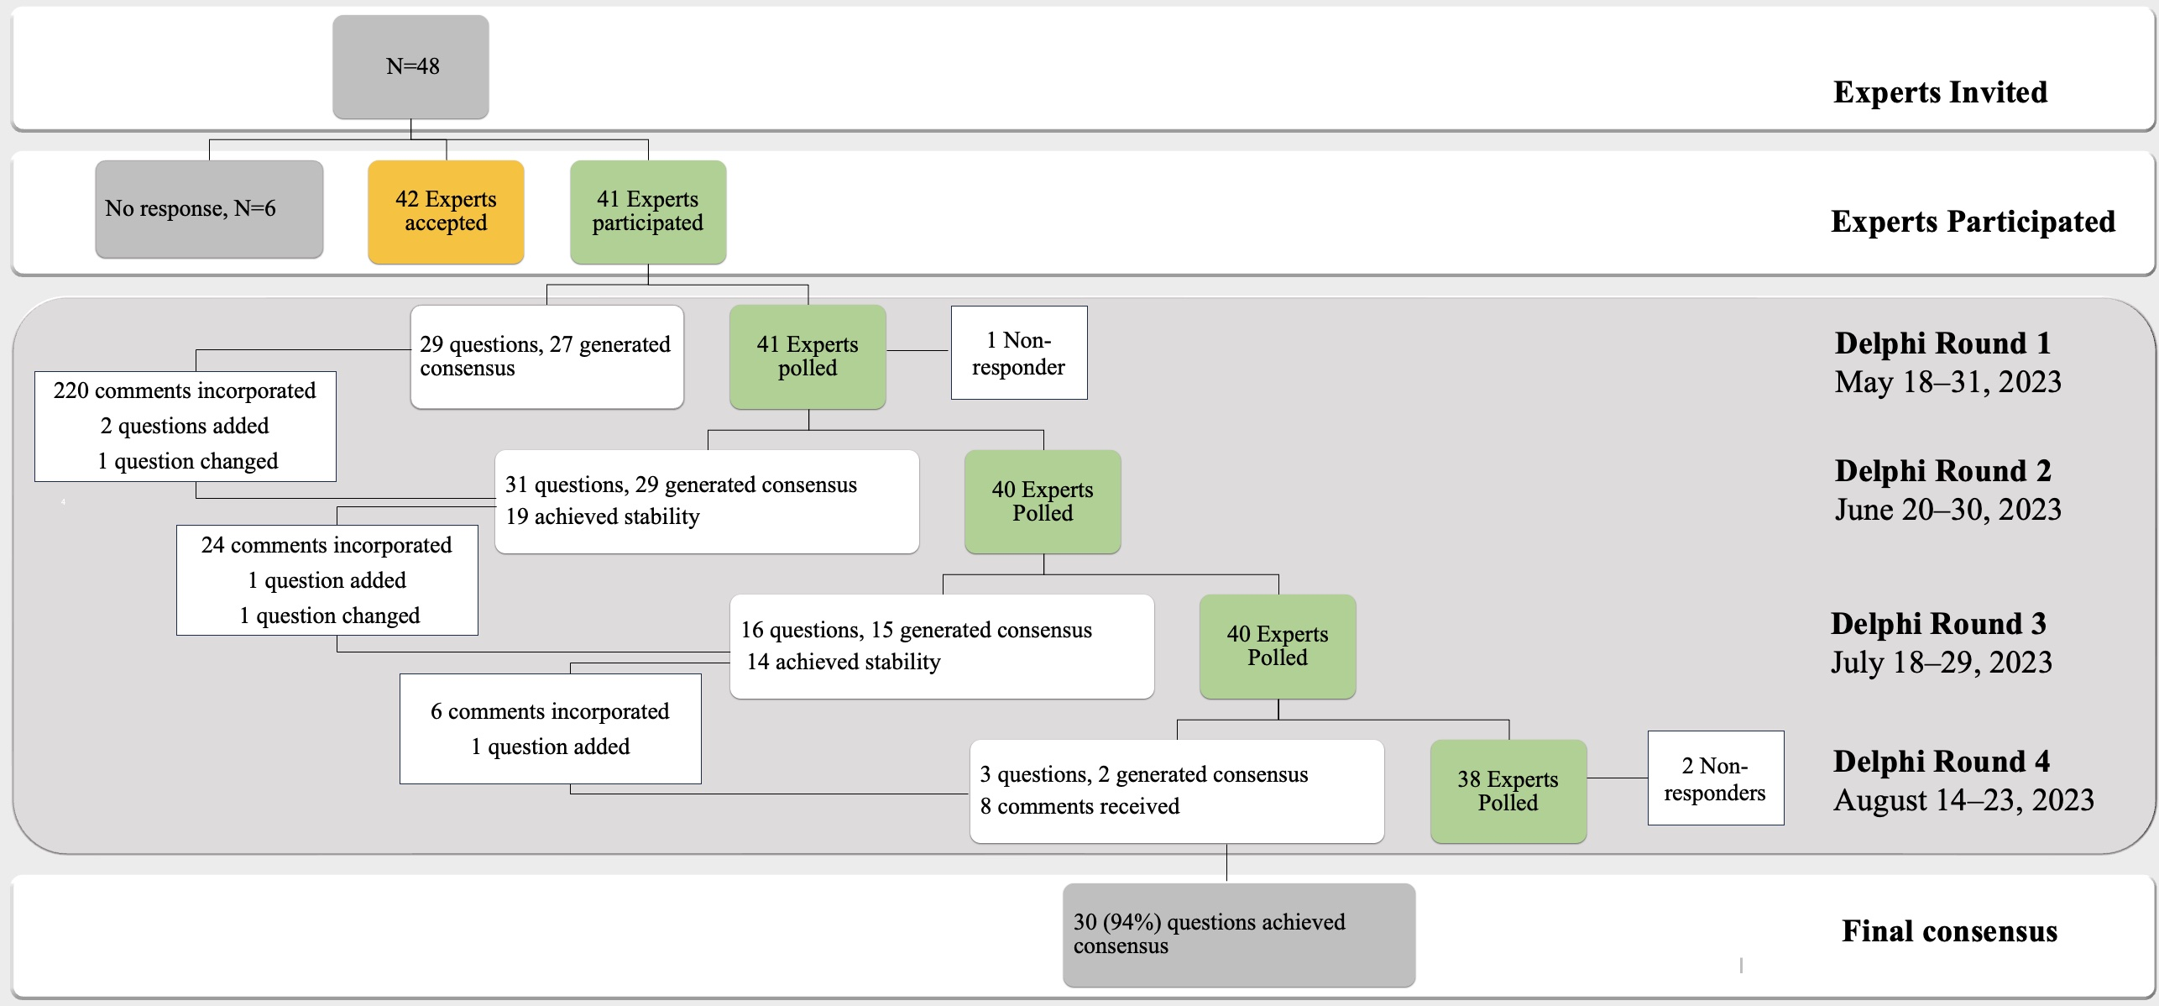

Table 2: Demographic Data of the Expert Panellists

No. | Name | Gender | Country | Country Income Status*
1 | Dita Aditianingsih | Female | Indonesia | L/MIC
2 | Massimo Antonelli | Male | Italy | HIC
3 | Yaseen M Arabi | Male | Saudi Arabia | HIC
4 | Andrew Argent | Male | South Africa | L/MIC
5 | Luciano Azevedo | Male | Brazil | L/MIC
6 | Elizabeth Bennett | Female | Fiji | L/MIC
7 | Arunaloke Chakrabarti | Male | India | L/MIC
8 | Kevin De Asis | Male | Philippines | L/MIC
9 | Jan De Waele | Male | Belgium | HIC
10 | Jigeeshu Vasishtha Divatia | Male | India | L/MIC
11 | Elisa Estenssoro | Female | Argentina | L/MIC
12 | Laura Evans | Female | United States of America | HIC
13 | Abul Faiz | Male | Bangladesh | L/MIC
14 | Naomi E Hammond | Female | Australia | HIC
15 | Madiha Hashmi | Female | Pakistan | L/MIC
16 | Margaret S Herridge | Female | Canada | HIC
17 | Shevin T Jacob | Male | Uganda | L/MIC
18 | Jimba Jatsho | Male | Bhutan | L/MIC
19 | Yash Javeri | Male | India | L/MIC
20 | Karima Khalid | Female | Tanzania | L/MIC
21 | Lie Khie Chen | Male | Indonesia | L/MIC
22 | Mitchell Levy | Male | United States of America | HIC
23 | Ganbold Lundeg | Male | Mongolia | L/MIC
24 | Flavia R Machado | Female | Brazil | L/MIC
25 | Yatin Mehta | Male | India | L/MIC
26 | Mervyn Mer | Male | South Africa | L/MIC
27 | Do Ngoc Son | Male | Vietnam | L/MIC
28 | Gustavo A. Ospina-Tascón | Male | Columbia | L/MIC
29 | Marlies Ostermann | Female | United Kingdom | HIC
30 | Chairat Permpikul | Male | Thailand | L/MIC
31 | Hallie C Prescott | Female | United States of America | HIC
32 | Konrad Reinhart | Male | Germany | HIC
33 | Gloria Rodriguez Vega | Female | Puerto Rico | L/MIC
34 | Halima S-Kabara | Female | Nigeria | L/MIC
35 | Gentle S Shreshta | Male | Nepal | L/MIC
36 | Wangari Siika | Female | Kenya | L/MIC
37 | Toh Leong Tan | Male | Malaysia | L/MIC
38 | Subhash Todi | Male | India | L/MIC
39 | Swagata Tripathy | Female | India | L/MIC
40 | Bala Venkatesh | Male | Australia | HIC
41 | Jean-Louis Vincent | Male | Belgium | HIC

*According to World Bank Classification
HIC – High Income Country
L/MIC – Low OR Middle-Income Country

