Supplementary Material 1

To explore how the probability evolves in time, and if there are visible differences in rest and task, we have made animations of the probability distribution. These animations illustrate the probability as defined by our model at each electrode. The probability is encoded in both the size and color of the electrode. Figure 1 is Taken, Figure 2 is Taken Scrambled, and Figure 3 is the rest acquisition prior to Taken.

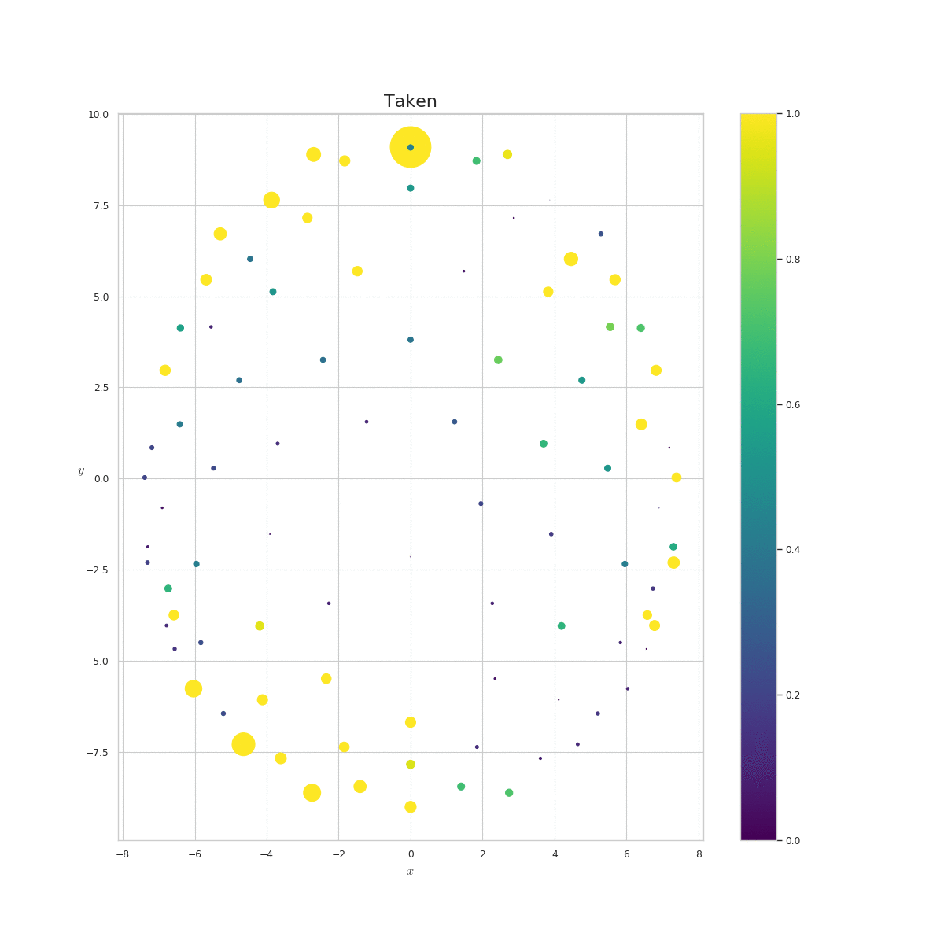
Figure 1 Animation of probability at each electrode for the Taken acquisition.

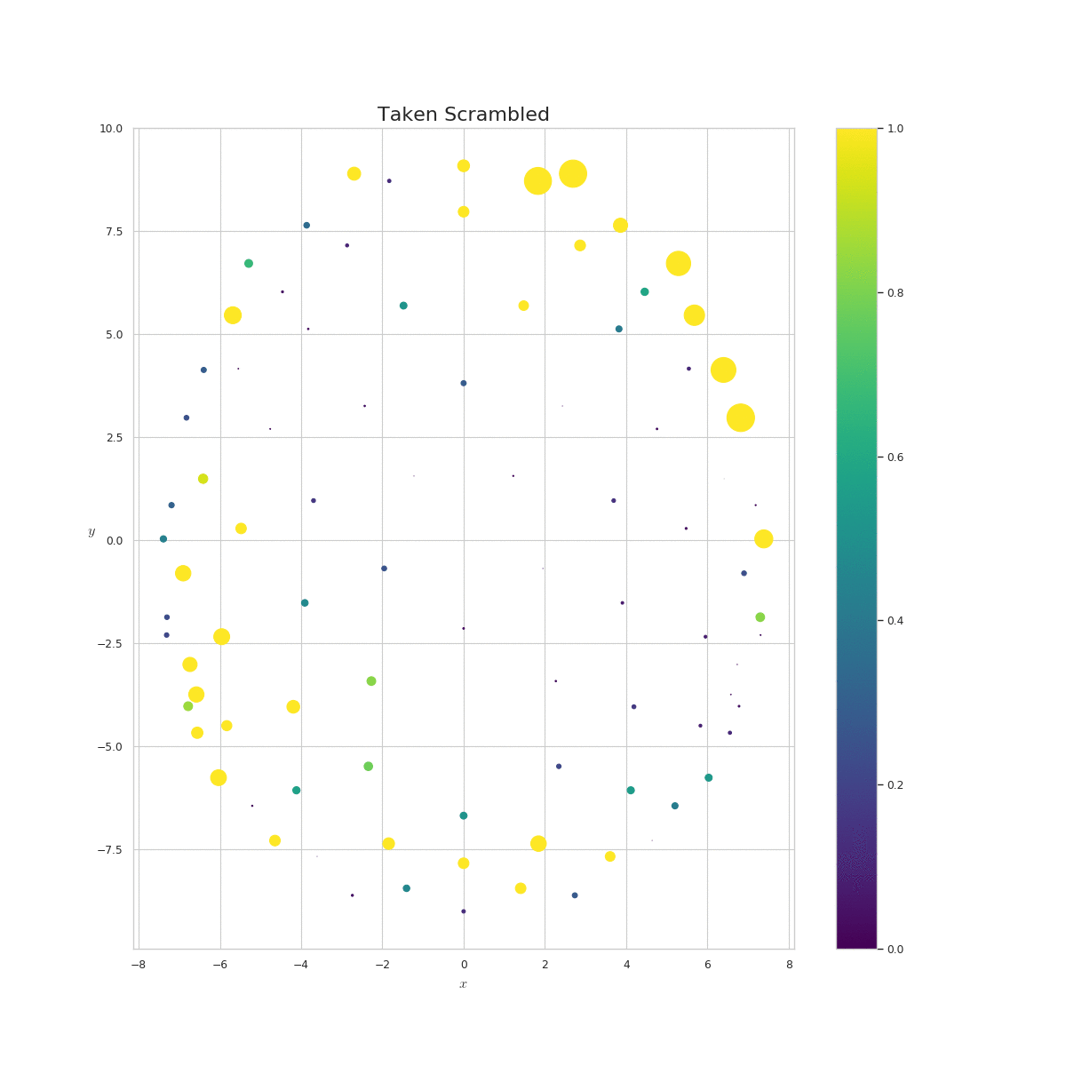
Figure 2 Animation of probability at each electrode for the Scrambled Taken acquisition.

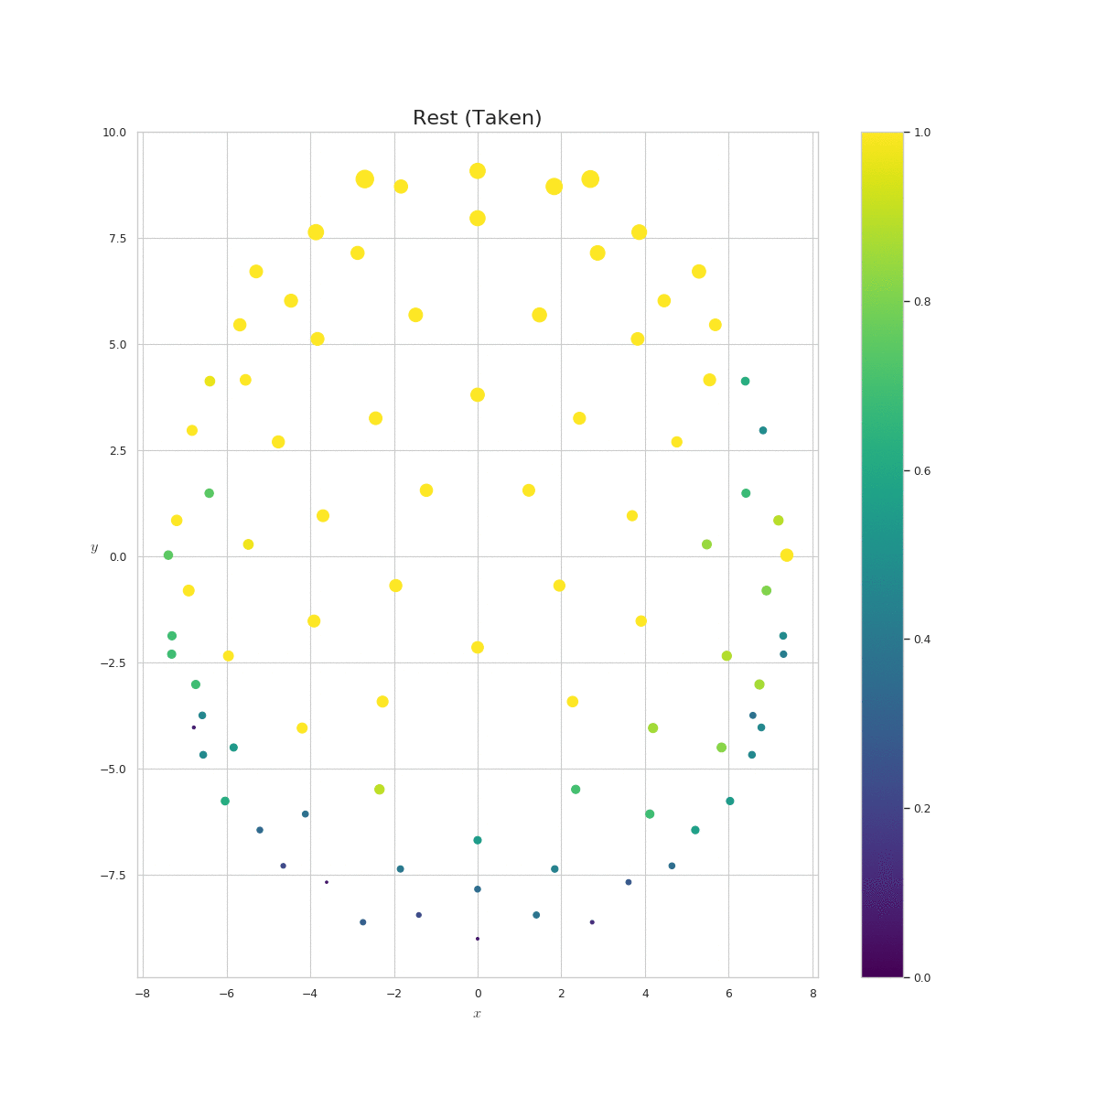
Figure 3 Animation of probability at each electrode for the rest prior to Taken.

Similarly, Figure 4 is Bang! You’re Dead, Figure 5 is the scrambled version of Bang! You’re Dead, and Figure 6 is the rest acquisition prior to Bang! You’re Dead.

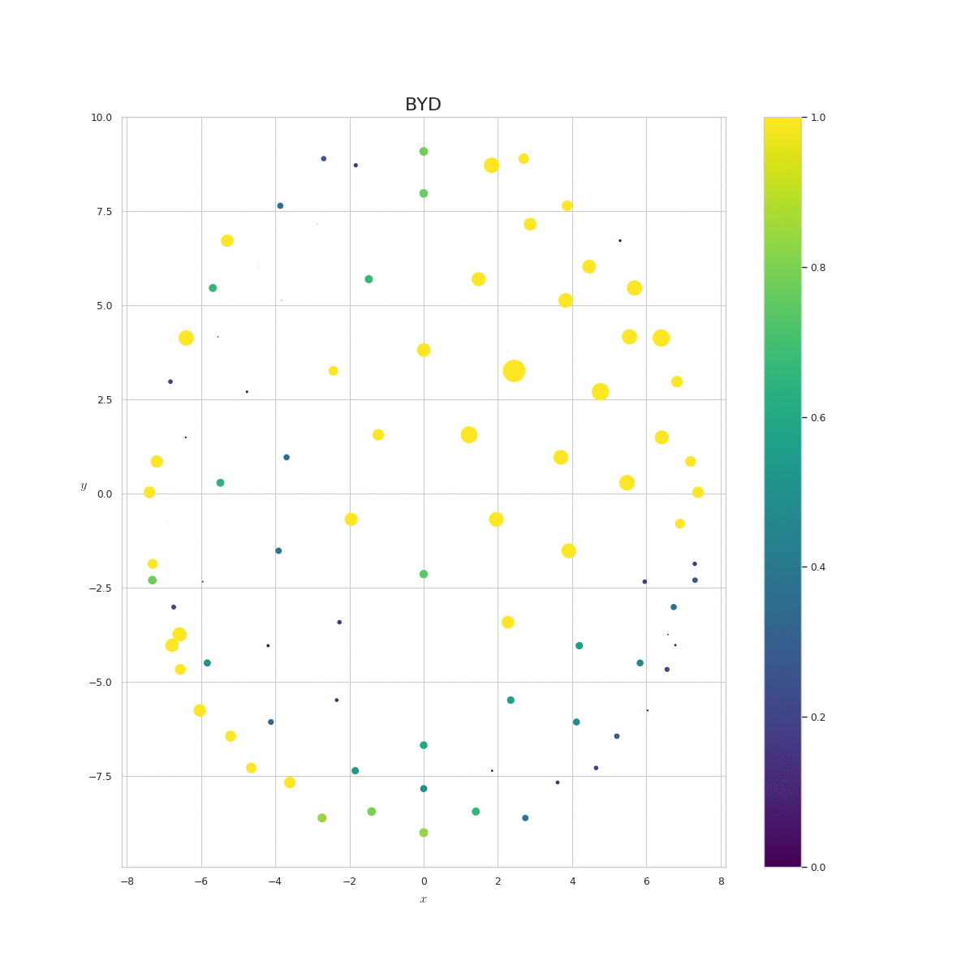
Figure 4 Animation of probability at each electrode for the Bang! You’re Dead acquisition.

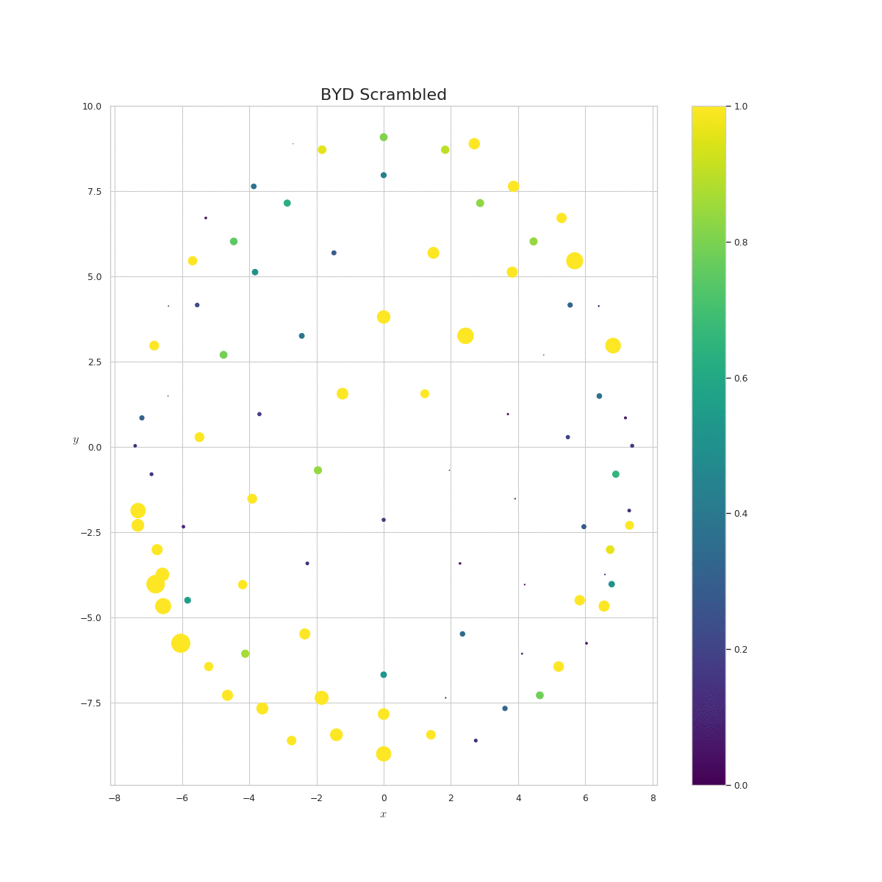
Figure 5 Animation of probability at each electrode for the Scrambled Bang! You’re Dead acquisition.

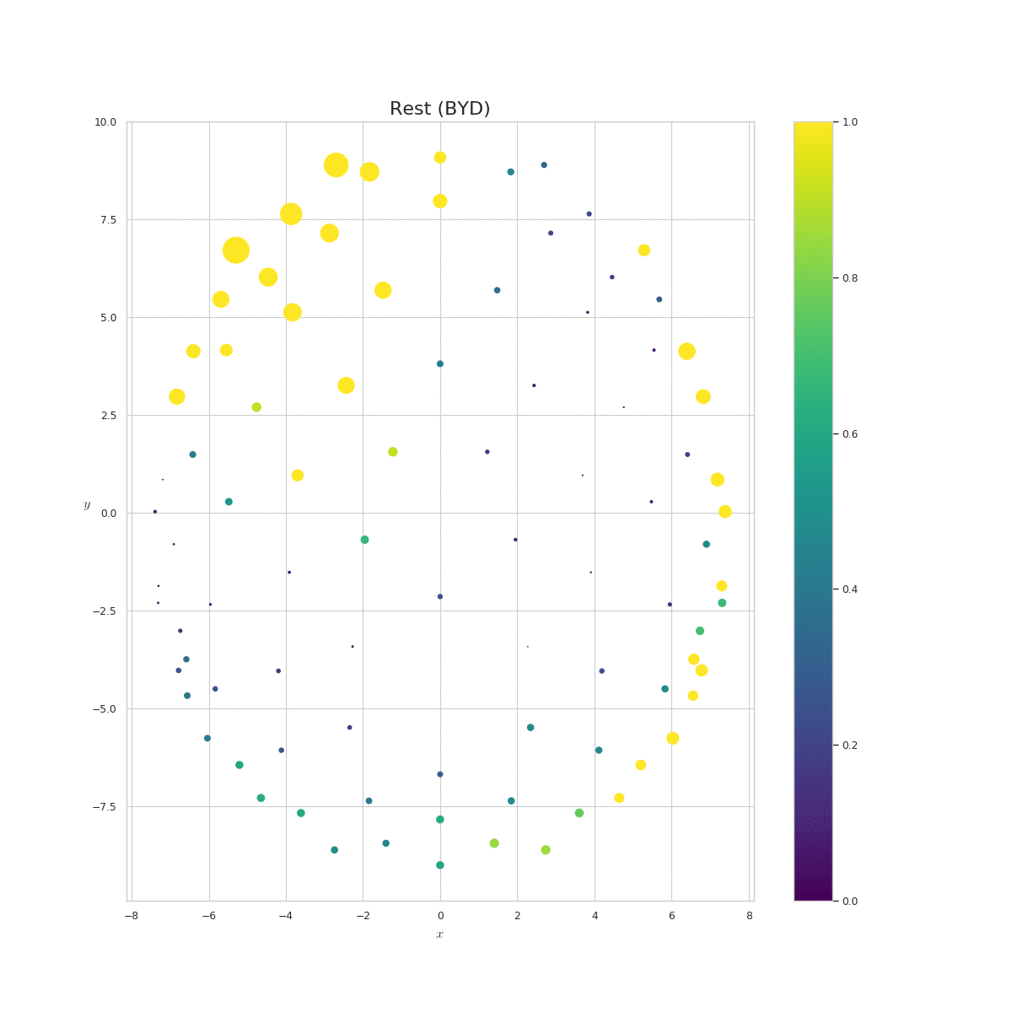
Figure 6 Animation of probability at each electrode for the rest prior to Bang! You’re Dead.

