Supplementary Information
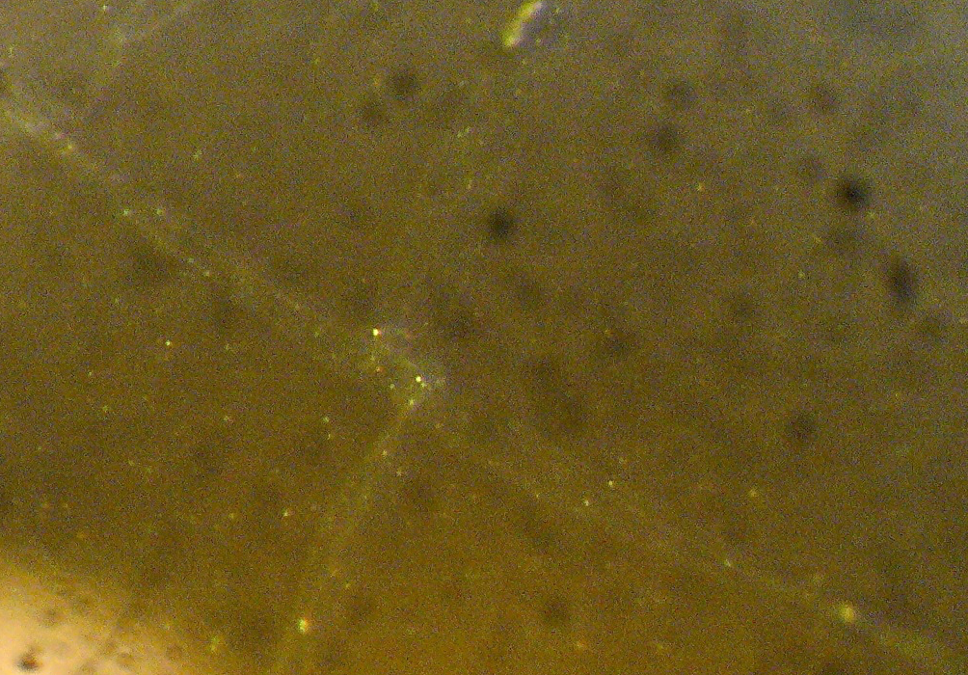
Supplementary Figure 1 Lipid Bilayer on Buffer
Stereomicroscopic image of a nanoelectrospray generated lipid bilayer on a buffer solution after overnight incubation at room temperature. Some folds of the viscous surface are visible.

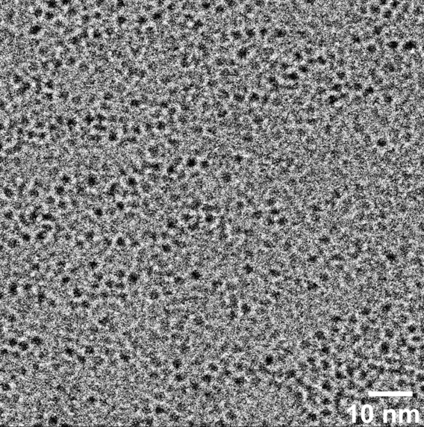
Supplementary Video 1 Overlay of the Crystal Structure of OmpG and an OmpG Containing Membrane
Overlay of an OmpG crystal structure derived image (from Behlau, M., D. J. Mills, H. Quader, W. Kühlbrandt & J. Vonck. 2001. "Projection structure of the monomeric porin OmpG at 6 A resolution." Journal of molecular biology 305:71-77) with the platinum shadowed transmission electron image of the membrane containing OmpG (figure 4). The scales of both images have been matched. The size and shape of the crystal structure derived image fits precisely to the structures seen in the electrospray prepared layers visualized in the transmission electron microscope. OmpG-Simulation.mp4 (figshare: https://doi.org/10.6084/m9.figshare.25908022)

