Supporting information

Rethinking water resources: Harnessing The Gambia River with pressure-driven membrane processes for sustainable supply
Youssef-Amine Boussouga ¹*, Zhi-Fu Lin ¹, Matthias Schmidt ², Andrea I. Schäfer ¹
¹ Institute for Advanced Membrane Technology (IAMT), Karlsruhe Institute of Technology (KIT), Hermann-von-Helmholtz-Platz 1, 76344 Eggenstein-Leopoldshafen, Germany
² Department of Technical Biogeochemistry, Helmholtz Center for Environmental Research (UFZ), Leipzig, Germany
*Corresponding author: youssef-amine.boussouga@kit.edu (Y.-A. Boussouga), +49 721 608 24364
- Tide information during sampling
Tide variations are of great importance to salinity variations over the day. For this, the tide chart for the 10 sampling locations, using Tide Table Chart V1.6.1 (Canada), is presented in Table S1. This is particularly relevant for water samples taken from the tidal/saline regions where different salinities can be observed from different periods of day ¹.
Table S1. Tide information of the locations of water sampling in The Gambia River
Site name | Distance to Mouth (Km) | 1st High (time) | 1st Low (time) | 2nd High (time) | 2nd Low (time)
James Island | 35 | 12:00:00 | 5:56:00 | 23:56:00 | 18:16:00
Tendaba | 100 | 2:09:03 | 8:44:36 | 14:25:03 | 21:04:36
Midriver | 108 | 2:24:45 | 9:02:43 | 14:40:45 | 21:22:43
Jasobo | 116 | 2:40:27 | 9:20:50 | 14:56:27 | 21:40:50
Balingho | 124 | 2:56:09 | 9:38:57 | 15:12:09 | 21:58:57
Farafenni | 132 | 3:19:52 | 10:02:12 | 15:36:08 | 22:20:56
Bambali | 163 | 5:22:53 | 11:52:19 | 17:41:07 | 00:01:10
Kaur | 198 | 7:41:46 | 13:56:38 | 20:02:14 | 1:54:20
Kudang | 228 | 9:40:48 | 15:43:12 | 22:03:12 | 3:31:20

The water quality of the samples is specific to the particular time when collected (status of the tide) and the location (mostly from edge and the surface of the river) and do not represent the distribution of water quality along the surface and the depth of the river. This is particularly relevant to salinity and turbidity distirbuion in the river.
- Filtration systems and membrane material
  - Membrane characteristics
The polyethersulfone (PES) UF membranes with different pore radii (3-31 nm) were selected to investigate the treatment of the freshwater region in The Gambia River, in particular turbidity and OM removal. Characteristics of the UF membranes are summarised in Table S2.
Table S2. Characteristics of the PES UF membranes
Membrane MWCO (kDa) ª | Pore radius (nm) ^{b} | Zeta potential pH 7 (mV) ^{c} | Water permeability (L_{p}; L/m² h bar) _ENREF_2 | Humic acid removal ^{e} (%)
10 | 2.7 | N.A | 390 | 85
50 | 6.3 | -6.3 | 630 | 80
100 | 9.1 | -15.1 | 930 | 20
300 | 16.3 | N.A | 1330 | -
500 | 21.4 | N.A | 1620 | -
1000 | 30.8 | N.A | 4025 ^{d} | -
ª Data from the supplier. ^{b} Calculated from the MWCO using the equation $r_{P}=2 . 037∙{10}^{-11}∙{MWCO }^{0.53}$, where r_{P} (nm) is the membrane pore radius ².
^{c} Zeta potential was calculated from streaming potential measurement using 10 mM KCl solution ³. The Biomax membranes have no IEP and exhibit a negative charge over the pH range 2-12.
^{e} This work. ^{d} The filtration was performed at 10 mgC/L HA ⁴.

The selected NF/RO membranes, which were used to investigate desalination and water reuse, have a wide range of water permeability and salt retention. The characteristics of the NF/RO are summarised in Table S3.
Table S3. Characteristics of the NF/RO membranes.
NF/RO membrane | NF90 | NF270 | BW30
Isoelectric point ª (IEP) | 4.5 – 5.5 ⁵ | 3.0 – 4.0 ⁵ | 3.5 – 4.0 ^{6, 7}
Roughness ^{b} (nm) | 65 – 228 ^{6, 8, 9} | 3 –13 ^{8, 9} | 65 – 125 ^{6, 9}
Water permeability (L_{p}, L/m² h bar) | 6.0 – 11.0 ⁵ | 14.0 – 19.0 ⁵ | 2.0 – 3.5 ^{9, 10}
Average pore radius ^{c} (nm) | 0.29±0.02 | 0.34±0.04 | -
NaCl retention ^{d} (%) | 85 – 95 ^{d(1)} | 80 ^{d(2)} | 99.5 ^{d(3)}
MgSO₄ retention ^{d} (%) | 98.7 ^{d(1)} | >97.0 ^{d(2)} | 99.7 ^{d(3)}
ª IEP was measured by streaming current using 1mM KCl.
^{b} Roughness measurements were performed by atomic force microscope (AFM).
^{c} Average pore radius of NF270 and NF90 was estimated by applying SHP model on organic solutes retention ⁵;
^{d} Test conditions ¹¹: (1) 4.8 bar, 15% recovery (NF90); (2) 3.5 bar, 10% recovery (NF270); 10 bar, 10% recovery (BW30). All conditions were at 2000 mg/L salt concentration, pH 7-8, and 25°C.
- Filtration protocol for ultrafiltration experiments
The filtration protocol used for the UF experiments with the dead-end stainless steel stirred cell was adapted from previous work ¹², where the operational permeate flow rate was controlled (constant flux operation) (Table S4).
Table S4. Filtration protocol ¹² for using stainless steel stirred cell system used for UF membranes
Step | Conditions | Justification
Membrane pre-conditioning | The UF membrane is soaked in Milli-Q water for 30 min. | To remove the glycerine coating
Compaction/wetting | Filtration of 900 mL of MilliQ water 1 L/h flow rate and 400 rpm stir speed for 1 hour. | Wet the membrane before pure water flux is measured.
Pure water flux measurement | Run Milli-Q water for 30 min, and plot the mass collected in the permeate beaker as a function of time. | Measure the permeability of the membrane
UF experiments | 700 mL of feed solution will be filtered at 1 L/h flow rate and 400 rpm. 9 permeate samples of 40 mL were collected (total 600 mL, recovery 86%). At the end, 100 mL of concentrate will be collected. | Experiments will be performed under operating conditions.
Pure water flux (after experiment) | MilliQ water at 1 L/h flow rate and stir speed 400 rpm for 30 min. | To check whether the permeability has changed after the experiment.
- Filtration protocol for nanofiltration/reverse osmosis experiments
The filtration protocol used for the NF/RO experiments was adapted from Imbrogno and Schäfer ⁵. This present protocol (see Table S5), was operated at a controlled permeate flow rate (Q_{p}) using a proportional integral derivative (PID) controller. The PID controller regulates the solenoidal valve, adjusting its opening and closing to achieve the pressure necessary to maintain the desired Q_{p}.
Table S5. Filtration protocol of the cross-flow system used for NF/RO membranes.
No. | Step | Conditions | Justification
1. | Membrane conditioning | Membrane coupons were completely soaked in 10 mM NaCl solution for an hour. | To enhance the swelling of the active layer of the NF/RO membrane ¹³.
2. | Membrane compaction | Preconditioned membranes were compacted for 1 hour using MilliQ water following the highest expected pressure used in the experiment (10-20bars). | Compaction at steady conditions ensures the constant permeability of the membrane during the filtration experiments.
3. | Measure pure water flux before filtration | The pure water flux was measured at steady-state for 30 min before the filtration experiments. | The measurement enables the calculation of the pure water permeability.
4. | Filtration | Filtration experiments were carried out on feed water collected from The Gambia River and Kotu wastewater (Q_{F} = 0.45 L/min, Q_{p} = 1 – 6 mL/min) | Q_{p} was selected based on the water salinity as shown in Table S6.
5. | Measure pure water flux after filtration | At the end of the experiment, the system was cleaned with MilliQ and pure water flux was measured for 30 min. | To observe any change in the membrane or fouling action after the filtration test.
The permeate flow rates were fixed according to the different osmotic pressure (π) conditions, such that the feed pressure would not exceed 20 bars (maximum allowable working pressure of the system). Therefore, different settings were required due to the different membrane permeability and rejection characteristics, as well as feed water salinity. For this, the value of Q_{p} in the experiments was set based on 3 water salinity categories (Table S6).
Table S6. Operating conditions based on the feed water salinity
Water category | TDS range (g/L) | Permeate flow rate (Q_{p}; mL/min) | Flux (J_{v}; L/m².h)
Freshwater | 0.1 - 0.8 | 6 | 77
Low saline brackish water | 1.7 - 4 | 3 | 38
high saline brackish water | 10 - 21 | 1.5 | 19
- Dilution in the cross-flow filtration system
Due to the limited water volume collected (5 L each sample) for desalination experiments with the NF/RO membranes, associated with the transport of samples from The Gambia, the same samples were reused to complete all the membrane experiments. To assess the impact of consecutive dilutions from the Milli-Q water used for membrane compaction and present in the dead volume of the cross-flow system prior to filtration, the dilution factor of three consecutive filtrations of 3 L feed solution containing 1 g/L NaCl with NF270 was investigated. Results are presented in Table S7.
Table S7. Electrical conductivity (EC), and dilution factor for 3 consecutive filtration experiments
Parameter | 1g/L NaCl feed solution | In feed tank for filtration 1 | In feed tank for filtration 2 | In feed tank for filtration 3
EC (mS/cm) | 2.06 | 1.91 | 1.76 | 1.63
Dilution factor | - | 0.93 | 0.92 | 0.93
A constant dilution factor was observed in the three filtration experiments of about 0.93. This corresponds to a dead volume in the cross-flow system of 210 mL (based on the 3L solution. Such dilution was considered when reusing the feed water samples, particularly for high TDS samples where the EC was adjusted using 100 mM NaCl.
- Data analysis and error calculations
  - Performance parameters for UF and NF/RO membranes
The parameters used to evaluate the performance of UF membranes for the freshwater treatment and NF/RO membranes for desalination and water reuse are listed in Table S8.

Table S8. Main parameters involved in evaluating the performance of UF and NF/RO membranes.
Parameter | Unit | Formula | Eq.
UF performance parameters
Flux (J_{v}) | L/m².h | $$J_{v}= \frac{m_{p}}{t∙ρ_{w}∙A}$$  where m_{p} is the mass of permeate (g), t is the filtration time (s), ρ_{w} is the density of water (1 g/cm³), and A is the active area of the UF membrane (38.5 cm²) | (S1)
TMP | bar | $$TMP= P_{f}-P_{p}$$  where P is the pressure (bar) in feed (f) and permeate (p) | (S2)
L_{p} | L/m².h.bar | $$L_{p}= \frac{J_{v}}{TMP}$$ | (S3)
Mass loss (mg) | mg | $$m_{loss } = V_{f}∙c_{f}- \sum_{1}^{n}{V_{p,i}∙c_{p,i}} - V_{c}∙c_{c}$$  where c_{f}, c_{p,1} and c_{c} (µg/L) are the concentration in the initial feed, permeate, and in the concentrate (or final feed), respectively. V_{f}, V_{p,1} and V_{c} (L) are the initial feed, permeate and retentate volumes, respectively. | (S4)
Removal (R) | % | $$R= \left(1-\frac{c_{p,end}}{c_{c}}\right)∙100$$  where $c_{p,end}$ is concentration in the last permeate sample collected at 600 mL. | (S5)
NF/RO performance parameters
Removal (R) | % | $$R= \left(1-\frac{c_{p}}{c_{f}}\right)·100$$  where c_{p} and c_{f} are the permeate and initial feed concentration of (mg/L, µg/L), respectively. | (S6)
TMP | bar | $$TMP= \frac{P_{f}+P_{c}}{2}$$  where P is the pressure (bar) in feed (f), concentrate (c), and permeate (p). | (S7)
L_{p} | L/m².h.bar | $$L_{p}= \frac{J_{v}}{TMP}$$ | (S8)
Specific energy consumption (SEC) ^{14, 15} | Wh/L | $$SEC=\frac{{EC}_{pump}}{η{∙Q}_{p}}≈\frac{R∙TMP∙Q_{f}}{3600∙η{∙Q}_{p}}$$  where Q is the controlled flow rate for feed (f) and permeate (p), η the pump efficiency (assumed to be 0.8).  Fundamentally, the pressure in this case (TMP; bar or 10⁵ Pa, and 1 Pa = 1 J/m³) is the rate of work of the pump ($\dot{W}$; J) per volume (m³), which corresponds to the energy consumption of the pump (EC_{pump} ) (1 (J/m³) = 1/3600 (kWh)). | (S9)
Minimum SEC (SEC_{min}) ¹⁶ | Wh/L | $${SEC}_{min}=10∙R_{g}∙T∙\left[\frac{{TDS}_{f}}{WR}∙ln\left(\frac{{TDS}_{c}}{{TDS}_{f}}\right)-c_{P}∙ln\left(\frac{{TDS}_{c}}{{TDS}_{p}}\right)\right]$$  where R_{g} is the universal gas constant (8.314 J/K⋅mol), T is the absolute temperature (K), WR is the water recovery , TDS (mol/L) is the total dissolved solides considering considering only majors ions (Ca²⁺, Mg²⁺, Sr²⁺, K⁺, Na⁺, NO₃⁻, Br⁻, Cl⁻, HCO₃⁻, SO₄²⁻) in feed (f), permeate (p) and concentrate (c), and 10 is the number of the major ions. The calculation of SEC_{min} assumes an ideal process such as a 100% pump effiencency ¹⁶. | (S10)

  - Error analysis
Error analysis was performed to determine the experimental error on TOC, LC-OCD, turbidity calibration, and the different performance parameters for UF and NF/RO experiments. Two types of error sources are identified:
- During UF and NF/RO experiments, this can be mainly caused by variability in the setting operating parameters (temperature, feed flow rate, permeate flow rate). This is known as a random error.
- Dilution of the reused water samples in the desalination experiments. This can be considered in the random error category.
- An analytical error can occur when preparing the standard calibration for water analysis. This is known as systematic error.
Since no feed solution was prepared and only real water was used, the operator error is minimized and only considered when setting the operating parameters. The analytical error from the analytical methods is also contributing to the reported data on the removal. For this, an error propagation was adopted following the method of Imbrogno et al. ¹⁷. Table S9 illustrates the error sources and parameters contributing to the calculations.
Table S9. Type of error sources and parameters contributing to the error calculations
Error sources/parameter | Equation
Removal error ($ΔR$) | $$ΔR=100∙\frac{c_{p}}{c_{f}} \sqrt{{\left(\frac{Δc_{f, ana}}{c_{f}}\right)}^{2}+ {\left(\frac{Δc_{f, pre}}{c_{f}}\right)}^{2}+{\left(\frac{Δc_{p, ana}}{c_{p}}\right)}^{2}+{\left(\frac{ΔJ_{v}}{J_{v}}\right)}^{2}}$$ | (S11)
flux ($ΔJ_{v}$) | $$ΔJ_{v}(L/m^{2}.h)=\frac{1}{A}\sqrt{{\left(\frac{ΔQ_{p}}{Q_{p}}\right)}^{2}+{\left(\frac{ΔT}{T}\right)}^{2}+{\left(\frac{ΔP}{P}\right)}^{2} }$$ | (S12)
Permeability ($ΔL_{p}$) | $$\frac{ΔL_{p}}{L_{p}}= \sqrt{{\left(\frac{ΔJ_{v}}{J_{v}}\right)}^{2}+ {\left(\frac{ΔP_{f}}{P_{f}}\right)}^{2}}$$ | (S13)
Mass loss ($Δm_{loss}$) | $$∆m_{ads}=\sqrt{{∆m_{f,abs}}^{2}+{∆m_{c,abs}}^{2}+\sum_{i=1}^{n}{{∆m_{p,i,abs}}^{2}}}$$  $${=\left(m_{f}∙\left[{\left({∆c}_{f,rel}\right)}^{2}+({\frac{{∆V}_{f,abs}}{V_{f}})}^{2}\right]\right)}^{2}+{\left(m_{p}∙\left[{\left({∆c}_{p,rel}\right)}^{2}+({\frac{{∆V}_{p,i,abs}}{V_{p,i}})}^{2}\right]\right)}^{2}$$ | (S14)

The analytical error of TOC (1-5%) and turbidity (5-10%) was quantified with the max-min method ¹⁷, from 10 repeated measurements of the same standard sample at different concentrations.
- Water analysis
  - Correlation between total dissolved solids and electrical conductivity
The correlation between the measured EC and the calculated TDS from the sum of the analysed major ions, excluding organic matter and solids, found in The Gambia River is presented in Figure S1.
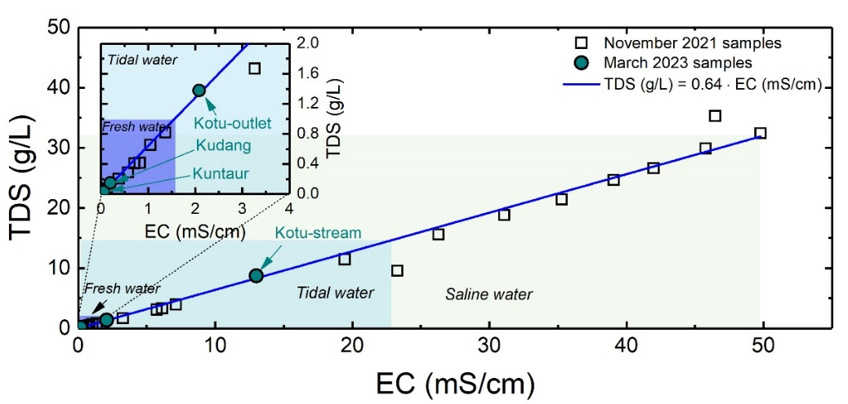
Figure S1. Correlation between EC and TDS of the samples collected in November 2021 and March 2023 from The Gambia River. Data from the 2021 samples are taken from Boussouga et al. ¹
- The TDS of The Gambia River increases linearly with the measured EC with a correlation of 0.64. This is within the correlation range of natural water 0.55 – 0.75 ¹⁸.
- The deviation of the correlation in the saline water region may have been caused by the high salinity.
- The TDS of the samples collected in March 2023 is within the EC correlation with the TDS of the samples collected in November 2021.
  - Calibration curve of turbidity
Calibration of the turbidity meter (Aqualytic, model AL450T-IR, Germany) was performed using the T-CAL standards (Aqualytic, Germany) <0.1, 20, 200, and 800 NTU (see Figure S2).
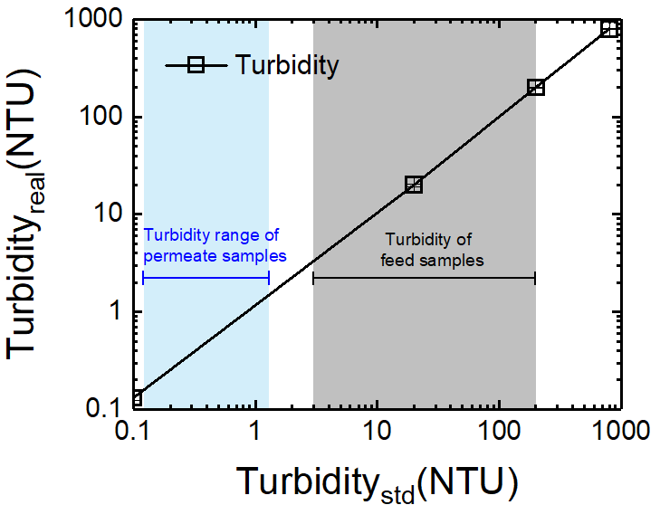
Figure S2. The turbidity measured by the turbidity meter (real turbidity) as a function of the reported turbidity in the standards calibration.
- The calibration of the turbidity meter was limited to 4 calibration standards that showed a linear correlation between the turbidity values of standards values and the measured turbidity values.
- The limit of detection (LOD) is likely below 0.1 NTU. Further calibration standards below 0.1 NTU are necessary to determine the LOD.
  - Total organic carbon analysis: Calibration and limit of detection
Total organic carbon (TOC) was determined using a TOC analyser (TOC-LCPH FA E200, Shimadzu, Japan) using blank and 8 calibration standards with concentrations from 0.2 to 10 mCg/L (Figure S3). For this, potassium hydrogen phthalate (KHP, C₈H₅KO₄, dissolved in Milli-Q water from 99.5% powder, EMSURE®, Merck Millipore, Germany) was used. The LOD was determined following the same method described elsewhere ¹⁷.
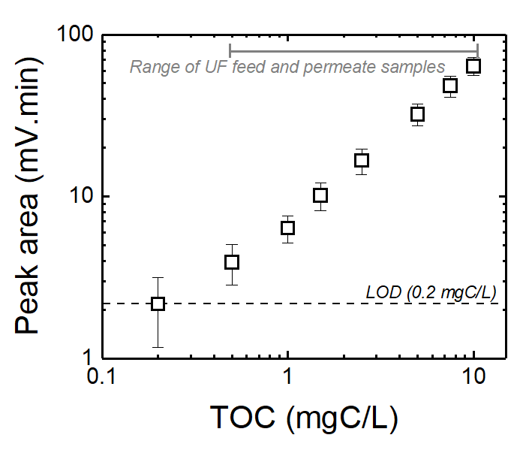
Figure S3. Peak area as a function of TOC concentration of the calibration standards.
- The measured TOC of the feed, concentrate, and permeate samples are within the calibration range.
The limit of detection (LoD) was calculated from the linear regression using Eq. S1 ¹⁹:
 | $$LOD=\frac{s_{blank}+3 σ_{blank} }{b}$$ | (S1)
where $s_{blank}$ is the blank measured signal, $σ$ is the blank standard deviation, and $b$ is the calibration slope. Based on the peak area of the 3 blank samples, the LoD of 0.2 mgC/L was obtained, which is within the range reported by Imbrogno et al. ¹⁷.
  - Calibration and validation of liquid chromatography–organic carbon detection
The LC-OCD was calibrated and the limit of detection (LOD), was distinguished from background noise ²⁰, and the limit of quantification (LOQ), the lowest concentration measured with acceptable precision and accuracy ²⁰, were determined (Figure S4).
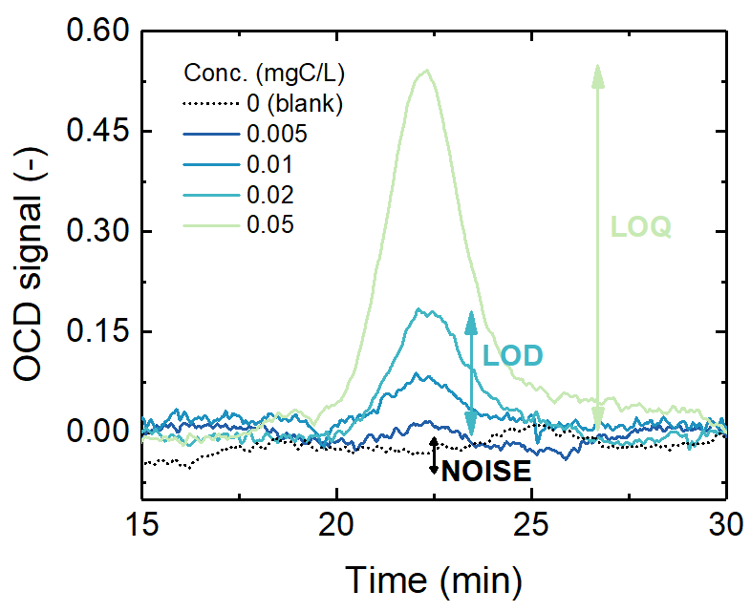
Figure S4. OCD signal as a function of elution time in LC-OCD at concentrations in the range of 0 (mobile phase blank) to 0.05 mgC/L. These data were published earlier in Imbrogno et al. ¹⁷.
- At a lower concentration of 0.005 mgC/L, the signal is not distinguishable from the noise, hence the LOD can be estimated to be 0.01 mgC/L.
- LOQ is defined as the signal that is 10 times higher than the noise, which corresponds to 0.05 mgC/L.
To validate the calibration, 5 samples prepared from potassium hydrogen phthalate with known concentrations (0.1, 1, 2.5, 3.5, 5 mgC/L) were measured, and the results were compared with the expected values. Results are shown in Figure S5.
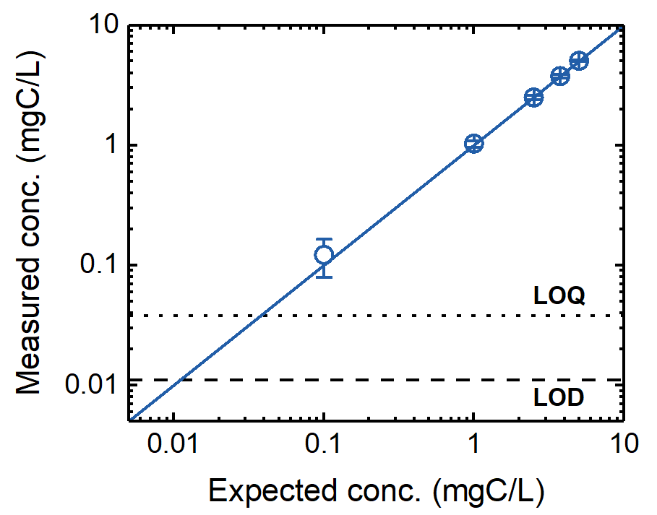
Figure S5. Measured concentration by the LC-OCD as a function of the expected concentrations from 5 samples of known DOC concentration (0.1, 1, 2.5, 3.5, 5 mgC/L). LoD and LoQ data are taken from the signal noise of the blank sample, as shown above.
- Results showed that the measured values were linear with the expected concentrations of the samples, which validated the above OCD calibration.
  - Methods used for micropollutants analysis
Similarly to the previous work with this water/river system ¹, eight different analytical methods were performed by TZW (Hagsfeld Germany) for the full screening of 103 micropollutants in feed and permeate samples during NF/RO filtration of Kotu–outlet and Kotu-stream. The list of micropollutants, with their category and LOQ are described in Table S10.
Table S10. List of pesticides, hormones, pharmaceuticals, and PFAS analyzed in The Gambia River with their analytical method, analytical tool, and LOQ for a water sample volume of 0.8-1 L.
Category | Analytical method | Analytical tool | Compound | LOQ (µg/L)
Pesticides | Method 1 ²¹ | HPLC/MS-MS | Benzotriazole, 4-Methylbenzotriazole, 5-methylbenzotriazole | 0.05
Pesticides | Method 6 ²² | GC/MS | 2,4,5-T; 2,4,5-TP (Fenoprop); 2,4-D; 2,4-DB;  2,4-DP (Fichlorprop); Bentazone; Bromoxynil; Dinoterb; Fluroxypyr; Ioxynil; MCPA; MCPB; MCPP (mecoprop); triclopyr | 0.05
Pesticides | Method 7 ²³ | HPLC/MS-MS | Dichlorobenzamide (Metabolite); Alachlor  Ametryn; Atrazine; Desethylatrazine (Metabolite); Bromacil; Chloridazon; Chlortoluron; DEET; Diuron; Ethidimuron; Hexazinone; Isoproturon; Linuron; Metalaxyl; Metamitron; Metazachlor; Methabenzthiazuron; Metobromuron; Monolinuron; Pendimethalin; Phenmedipham  Sebuthylazine; Simazine; Desethylsimazine (Metabolite); Metolachlor; Terbuthylazine; Desethylterbuthylazine (Metabolite); Terbutryn | 0.05
Pesticides | Method 4 ²⁴ | GC/MS-MS | o,p-DDT; p,p-DDD; p,p-DDE; p,p-DDT; alpha-Endosulfan; beta-Endosulfan; alpha-HCH; beta-HCH; gamma-HCH (Lindane); Hexachlorobenzene (HCB); Pentachloronitrobenzene | 0.05
Pesticides | Method 5 ²⁵ | HPLC/MS-MS | Glyphosate; AMPA | 0.01
Pharmaceutical, hormones and EDC | Method 3 ²⁶ | HPLC/MS-MS | Amoxicillin | 0.25
Pharmaceutical, hormones and EDC | Method 3 ²⁶ | HPLC/MS-MS | Candesartan; Carbamazepine; Diclofenac  Hydrochlorothiazide; Ibuprofen  Irbesartan; Metoprolol; Paracetamol; Sulfamethoxazole | 0.05
Pharmaceutical, hormones and EDC | Method 2 ²¹ | GC/MS-MS | 17-beta-estradiol; 17-alpha-ethinylestradiol, Estrone | 0.0005
Pharmaceutical, hormones and EDC | Method 2 ²¹ | GC/MS-MS | Estriol, Mestranol, Norethisterone | 0.005
Pharmaceutical, hormones and EDC | Method 2 ²¹ | GC/MS-MS | 4-tert-octylphenol, Bisphenol A | 0.005
Pharmaceutical, hormones and EDC | Method 2 ²¹ | GC/MS-MS | 4-iso-nonylphenol | 0.125
Per- and polyfluoroalkyl substances (PFAS) | Method 8 ²⁷ | HPLC/MS-MS | Perfluorobutanoate; Perfluoropentanoate; Perfluorohexanoate; Perfluoroheptanoate; Perfluorooctanoate; Perfluoronanoate  Perfluorodecanoate; Perfluorundecanoate  Perfluorododecanoate; Perfluorotridecanoate  Perfluorobutanesulfonate; Perfluoropentanesulfonate  Perfluorohexanesulfonate; Perfluoroheptanesulfonate  Perfluorooctanesulfonate; Perfluorononanesulfonate  Perfluorodecanesulfonate; Perfluorundecanesulfonate  Perfluorododecanesulfonate; Perfluorotridecanesulfonate  Perfluorooctane sulfonic acid amide; 7H-dodecafluoroheptanoate  2H,2H-perfluorodecanoate; 2H,2H,3H,3H-perfluorundecanoate; 1H,1H,2H,2H-perfluorooctanesulfonate | 0.005

- Ultrafiltration experiments on Kuntaur and Kudang
  - Filtration data
Flow rate, which was controlled at 1 L/h (equivalent to flux 260 L/m².h), and temperature over the filtration time, were monitored when treating Kudang and Kuntaur waters with biomax UF membranes to ensure that experiments were stable. Results are shown in Figure S6.
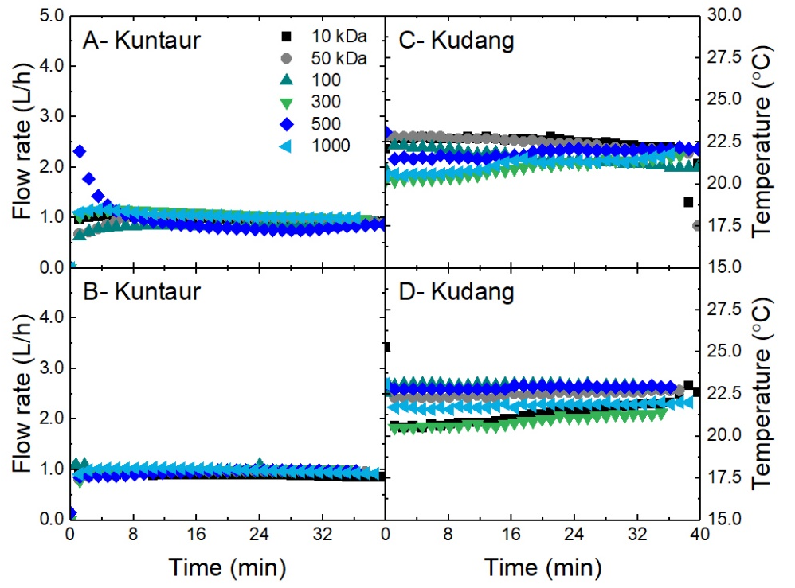
Figure S6. Flow rate and temperature during treatment of (A, B) Kuntaur and (C, D) Kudang samples using UF membranes of different MWCO as a function of filtration time (pH 7.5±0.2, flow rate 1 L/h, flux 260 L/m².h, 400 rpm, 22.0±0.5°C).
- Overall flow rate was stable during the experiments at a value of around 1 L/h.
- Temperature, which was controlled by a chiller, revealed an average variation of ±0.5 during the experiment.
  - Mass loss of organic matter due to UF fouling
The increase in transmembrane pressure (TMP) during UF experiments on Kudang and Kuntaur samples was caused by the deposition of particles, organic matter (OM), and potentially microorganisms that constitute water turbidity. A mass balance from the TOC values of feed permeate and concentration samples was carried out to elucidate the OM loss during filtration that is due to depositions (Figure S7).
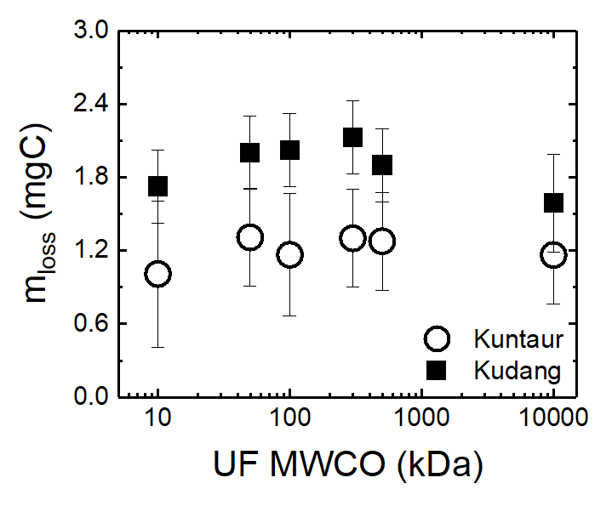
Figure S7. Mass loss of total organic matter as a function of UF MWCO (pH 7.5±0.2, flow rate 1 L/h, flux 260 L/m².h, 400 rpm, 22.0±0.5°C).
- Mass loss of OM was higher for Kudang than Kuntaur. This explains the higher TOC values in the concentrate after treating Kuntaur.
- Mass loss was independent of membrane MWCO.
- NF/RO experiments at different salinities along The Gambia River
  - Fouling in NF/RO membranes along the salinity gradient
To explore the fouling of the NF/RO membranes used for salinity experiments, water permeability calculated from the pure water flux was investigated before and after experiments (Figure S8).
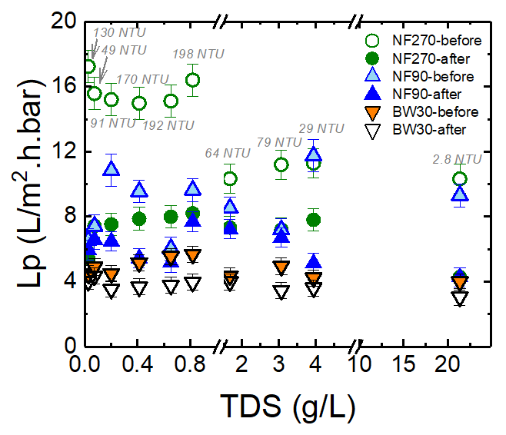
Figure S8. Pure water permeability before and after the filtration experiments with NF/RO membranes as a function of TDS of The Gambia River (pH 7.0±0.5; Q_{F} 0.45 L/min, Q_{P} 1 – 6 mL/min, 22.0±0.5°C).
- NF270 exhibited a significant reduction in water permeability compared to NF90 and BW30, particularly when treating the high turbidity waters located a the low TDS range.
- A previous study revealed higher fouling with NF270 when treating surface water directly compared to NF90, resulting from the difference in membrane pore size and properties ²⁸.

  - Driving force in NF/RO over the salinity gradient
At controlled flow rate conditions, different TDS values and concentration polarization (CP) result in different osmotic pressure gradients. This results in variations in the effective driving force (pressure difference across the membrane) and the separation performance of NF/RO. Variations in TMP and osmotic pressure at the membrane surface (π_{m}) with other affected parameters such as permeability (L_{p}) and concentration polarization modulus (CP) are plotted versus TDS of The Gambia River (Figure S9). CP and π_{m} were calculated following the method published in previous work for the same filtration system ²⁹. It should be noted that the turbidity of the samples may contribute to the parameters mentioned above.
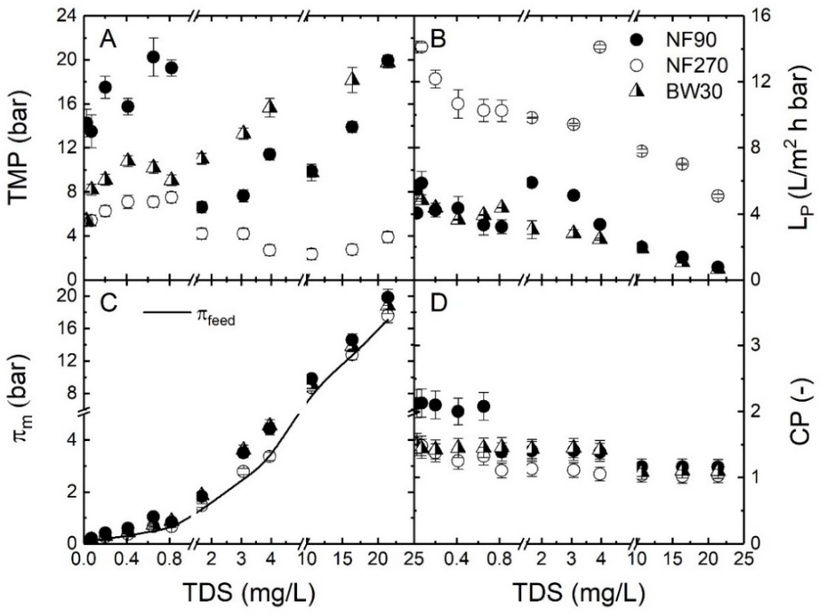
Figure S9. (A) transmembrane pressure (TMP), (B) water permeability (L_{p}), (C) osmotic pressure at the membrane surface (π_{m}), and (D) CP modulus as a function of TDS in The Gambia River during filtration with NF270, NF90, and BW30. (pH 7.0±0.5; Q_{F} 0.45 L/min, Q_{P} 1 – 6 mL/min, 22.0±0.5°C).
- Permeability of the three membranes decreased with TDS which induces resistance to water permeation through the membrane.
- Osmotic pressure at the NF90 surface (π_{m}), which increased with TDS, was comparable to the π_{m} of BW30 and higher than the π_{m} of NF270. Such an increase in π_{m} resulted in the water permeability decrease.

  - Filtration data for low TDS range: 0.1-0.8 g/L (120 km from the river mouth)
To ensure that the experiments were stable, temperature, flux, TMP, water permeability, and EC, over the filtration time were investigated for low TDS range (0.1-0.8 g/L) as described for NF270 (Figure S10), NF90 (Figure S11), and BW30 (Figure S12).
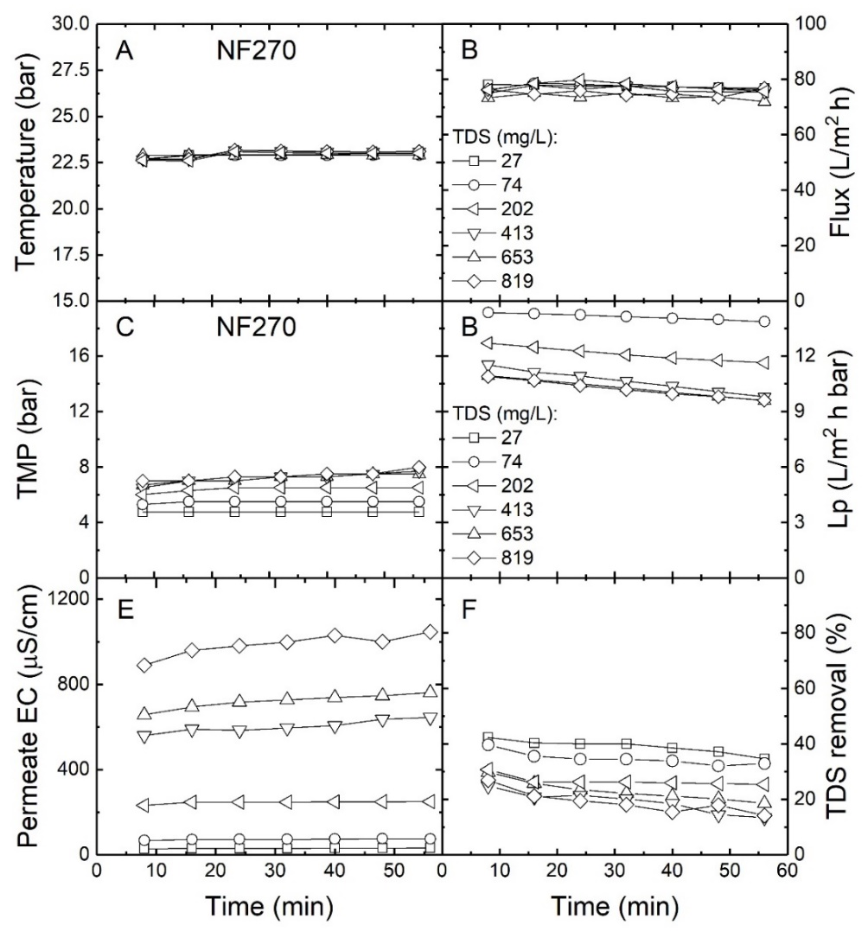
Figure S10. (A) temperature, (B) flux, (C) TMP, (D) L_{p}, (E) permeate EC and (F) TDS removal as a function of the filtration time (NF270; TDS 0.1-0.8 g/L; Q_{F} 0.45 L/min; Q_{P} 6 mL/min).
- The controlled temperature and flux during the experiments were constant.
- TMP and water permeability, which were dependent on the water TDS, were more or less stable at TDS < 0.4 g/L, with a slight increase in the case of TMP and a decrease for water permeability in the TDS range 0.4-0.8 g/, which could be to opposition.
- EC in permeate and TDS removal, which were dependent on feed TDS, were stable over the filtration experiments.
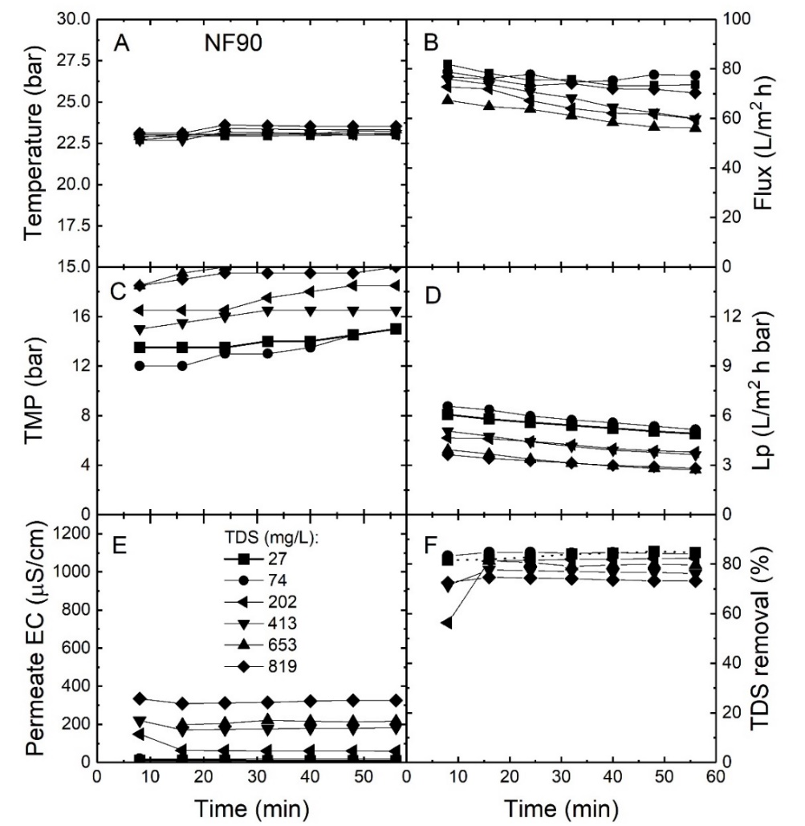
Figure S11. (A) temperature, (B) flux, (C) TMP, (D) L_{p}, (E) permeate EC and (F) TDS removal as a function of the filtration time (NF90; TDS 0.1-0.8 g/L; Q_{F} 0.45 L/min; Q_{P} 6 mL/min).
- The controlled temperature was stable over the different experiments
- The flux that was meant to be constant was varying within the range of 60-80 L/m².h in the different experiments. This could be caused by the continuous increase in TMP caused by fouling, while the proportional integral derivative (PID) controller was trying to keep a constant flux.
- TMP increased while water permeability decreased with the filtration time. This could be due to the high turbidity in low-range TDS feed waters.
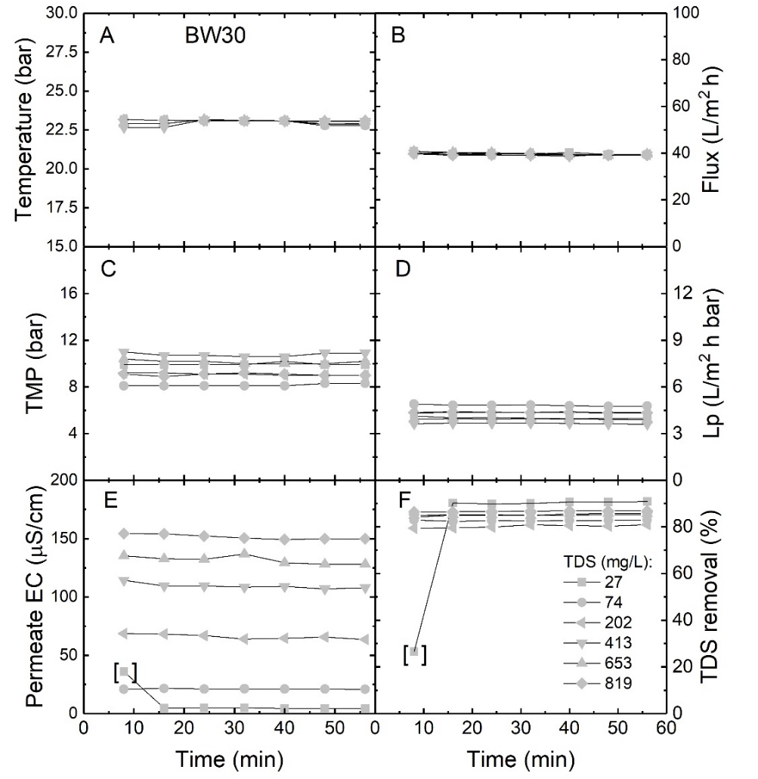
Figure S12. (A) temperature, (B) flux, (C) TMP, (D) L_{p}, (E) permeate EC and (F) TDS removal as a function of the filtration time (BW30; TDS 0.1-0.8 g/L; Q_{F} 0.45 L/min; Q_{P} 3 mL/min).
- The controlled temperature was stable over the filtration.
- EC in permeate, and ultimately TDS removal was constant over the filtration time, except for 27 mg/L which may be due to high EC water in the permeate tube when collecting the first sample.
- Overall, the TMP, permeability and EC permeate were stable over the filtration time with TDS.
  - Filtration data for moderate TDS range: 1.7-4.0 g/L (100 - 108 km from the river mouth)
To ensure that the NF/RO experiments were stable, temperature, flux, TMP, permeability, permeate EC, and TDS removal over the filtration time were investigated for moderate TDS range (1.7-4 g/L). Results are shown in Figure S13.
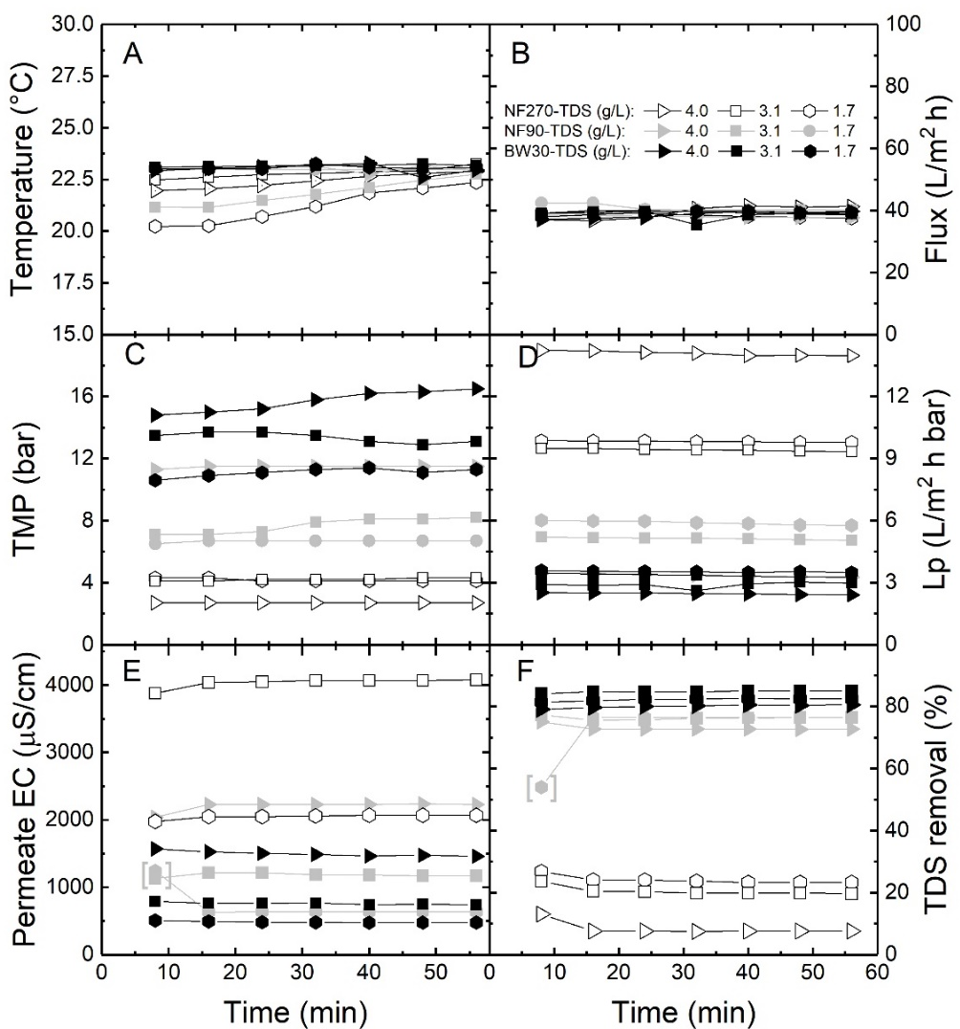
Figure S13. (A) temperature, (B) flux, (C) TMP, (D) L_{p}, (E) permeate EC and (F) TDS removal as a function of the filtration time (TDS 1.7-4.0 g/L; Q_{F} 0.45 L/min; Q_{P} 3 mL/min).
- While fixed flux could be achieved, a temperature variation was noticed at the start of the experiment for NF270 (at 1.7 g/L TDS) and NF90 (at 3.1 g/L TDS). This may explain the increase in TMP for NF90 at 3.1 g/L TDS, while NF270 TMP was not affected nor the water permeability.
- The performance of all membranes, in terms of water permeability, permeate EC and TDS removal was stable over the filtration time but depended on the feed TDS.
  - Filtration data for high TDS: 11-21 g/L (<35 km from the river mouth)
To ensure that the NF/RO experiments were stable, temperature, TMP, water permeability, permeate EC, and TDS removal over the filtration time was investigated for the high TDS range (11 - 21 g/L). Results are shown in Figure S14.
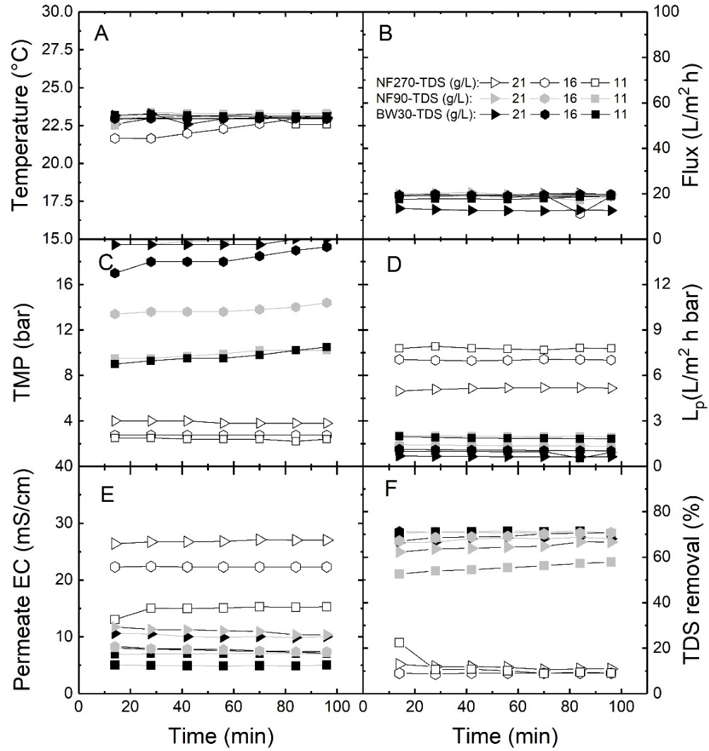
Figure S14. (A) temperature, (B) flux, (C) TMP, (D) L_{p}, (E) permeate EC and (F) TDS removal as a function of the filtration time (TDS 11 - 21 g/L; Q_{F} 0.45 L/min; Q_{P} 1.5 mL/min).
- The performance of the membrane, in terms of temperature, flux, TMP, permeability, and EC, was overall stable over the filtration time.
- Feed TDS dependency for permeability and TMP was observed as expected.
- NF/RO experiments for Kotu wastewater samples
  - Filtration data for Kotu wastewater samples
To ensure that the NF/RO experiments on Kotu-outlet and Kotu-stream were stable, temperature, flux, TMP, water permeability, permeate EC, and TDS removal were investigated over the filtration time (Figure S15).

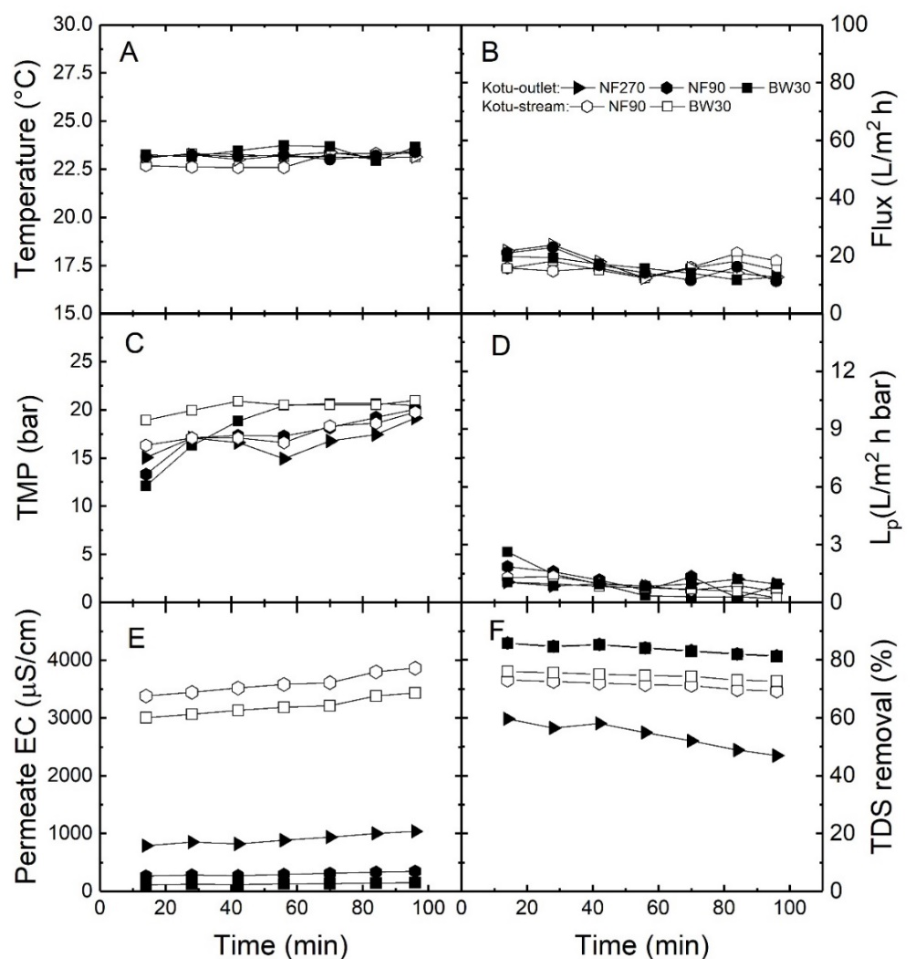
Figure S15. (A) temperature, (B) flux, (C) TMP, (D) L_{p}, (E) permeate EC, and (F) TDS removal as a function of the filtration time (TDS 11 - 21 g/L; Q_{F} 0.45 L/min; Q_{P} 1.5 mL/min).
- The controlled temperature was stable, while slight variations were observed for the flux.
- TMP increased with time, while water permeability decreased due to potential fouling that occurred during the experiments on the Kotu wastewater samples.
- Permeate EC slightly increased with time, which explains the decrease in TDS removal by the NF/RO membranes.
  - Fouling in NF/RO membranes used to treat Kotu wastewater samples
To evaluate the fouling of the NF/RO membranes used to treat Kotu-outlet and Kotu-stream, the pure water permeability of the membrane was investigated before and after experiments (Figure S16).
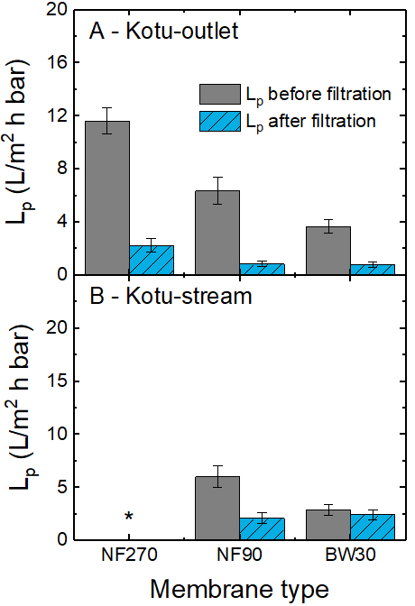
Figure S16. Pure water permeability before and after the filtration experiments with NF/RO membranes as a function of membrane type for (A) Kotu-outlet and (B) Kotu-stream (pH 7.3±0.1; Q_{F} 0.45 L/min, Q_{P} 1.5 mL/min, 22±0.5°C). *NF270 was not used for Kotu-stream of high salinity.
- A significant reduction in permeability for all NF/RO membranes was observed after the treatment of Kotu-outlet, which is a treated wastewater effluent.
- For Kotu-stream, BW30 did not exhibit a reduction in permeability after the experiment, while the permeability in NF90 was reduced.
  - Organic matter removal by NF/RO from Kotu wastewater samples
To investigate OM removal with NF/RO from Kotu-outlet and Kotu-stream, TOC analysis was performed for feed, permeate, and concentrate samples (Figure S17).
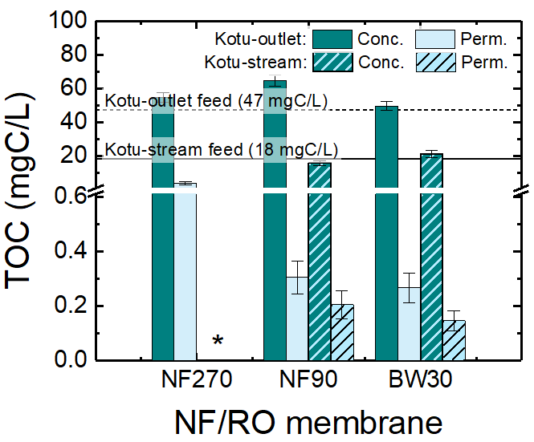
Figure S17. TOC in feed, permeate, and concentration when treating Kotu-outlet and Kotu-stream samples using the NF/RO membranes (pH 7.3±0.1; Q_{F} 0.45 L/min, Q_{P} 1.5 mL/min, 22.0±0.5°C). *NF270 was not used for Kotu-stream of high salinity.
- As expected, TOC in Kotu-outlet, the treated wastewater effluent was higher than in Kotu-stream.
- NF90 and BW30 were able to reduce the TOC to below 0.4 mgC/L from both Kotu wastewater samples.
- In Kotu-outlet, TOC was reduced from 47 mgC/L in feed to 4 mgC/L in permeate by NF270, which corresponds to a removal of 91%. This is typically low, which could be due to the presence of low molecular weight organic matter formed during the wastewater treatment process.
  - SEM-EDX images of NF/RO membranes used to treat Kotu samples
The NF/RO experiments on Kotu samples were carried out without pretreatment, and hence, deposition of solids and fouling was observed as previously shown in Figure S16. This was attributed to the turbidity that may contain microorganisms, sediments, and OM are in the Kotu samples. To identify the nature and characteristics of the deposits on the NF/RO membranes, SEM-EDX analysis of NF90 surface was performed (Figure S18).
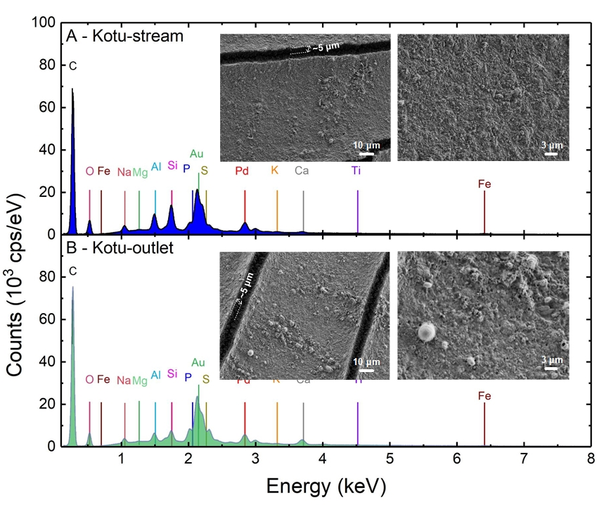
Figure S18. SEM images and EDX spectra of the surface of NF90 following filtration of (A) Kotu-stream (8.7 g/L TDS) and (B) Kotu-outlet (1.3 g/L TDS). Au and Pd signals result from sputter-coating of the surface.
- NF90 used to filtrate Kotu-outlet (Figure S18B) showed microorganisms (about 3 µm) of oval structures, likely attached to the membrane surface. With Kotu-stream, microorganisms (bacteria) with rod-shaped structures (below 3 µm) were observed. In these cases, biofouling is expected, and a pretreatment step prior NF/RO is advisable.
- A fouling layer thickness of about 5µm could be observed with the SEM images on NF90.
- Regarding the elemental surface characterization, the surface of NF90 showed similar elements with similar signal intensities, when treating Kotu-outlet and Kotu-stream. This was expected since Kotu-outlet is discharged in Kotu-stream.
- Experimental specific energy consumption of desalination and water reuse
To evaluate the experimental specific energy consumption (SEC) of desalination and water reuse at the actual operating parameters, the calculated SEC using Eq. (S9) was investigated as a function of TDS (Figure S19).
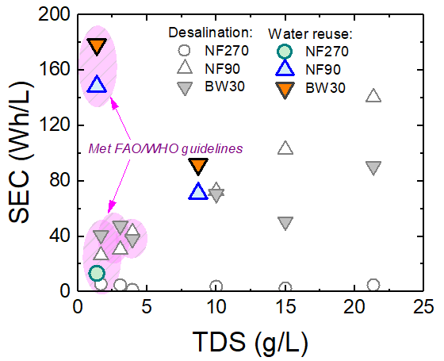
Figure S19. Experimental SEC as a function of TDS along The Gambia River (Q_{F} 0.45 L/min; Q_{P} 1.5 mL/min (19 L/m².h) for Kotu-outlet and Kotu-stream and the samples with TDS 10-21 g/L, Q_{P} 3 mL/min (38 L/m².h) for samples with TDS 1.7-4.0 g/L; 22.0±0.5°C).
- The SEC for desalination with NF90 and BW30 increased with TDS but was significantly higher than what is reported for desalination with RO (0.4-4 Wh/L ³⁰).
- The calculated SEC revealed that the treatment of Kotu-outlet with NF/RO was particularly energy intensive and was far from what was reported for municipal water reuse with RO (0.3-2.4 Wh/L ³¹).
- In the case of the lab cross-flow system, with an oversized pump, the experimental SEC is not reliable to the actual energy requirement for NF/RO. Instead theoretical SEC_{min} was used.
- References
1. Boussouga Y.-A., Sacher F., Schäfer A.I., Water quality of The Gambia River: A prospective drinking water supply, Science of the Total Environment, 162794 (2023).
2. Worch E., Eine neue Gleichung zur Berechnung von Diffusionskoeffizienten gelöster Stoffe, Vom Wasser 81, 289-297 (1993).
3. Burns D.B., Zydney A.L., Buffer effects on the zeta potential of ultrafiltration membranes, Journal of Membrane Science 172, 39-48 (2000).
4. Jermann D., Pronk W., Boller M., Schäfer A.I., The role of NOM fouling for the retention of estradiol and ibuprofen during ultrafiltration, Journal of Membrane Science 329, 75-84 (2009).
5. Imbrogno A., Schäfer A.I., Comparative study of nanofiltration membrane characterization devices of different dimension and configuration (cross flow and dead end), Journal of Membrane Science 585, 67-80 (2019).
6. Hayatbakhsh M., Sadrzadeh M., Pernitsky D., Bhattacharjee S., Hajinasiri J., Treatment of an in situ oil sands produced water by polymeric membranes, Desalination and Water Treatment 57, 14869-14887 (2016).
7. Fargues C., Sagne C., Szymczyk A., Fievet P., Lameloise M.L., Adsorption of small organic solutes from beet distillery condensates on reverse-osmosis membranes: Consequences on the process performances, Journal of Membrane Science 446, 132-144 (2013).
8. Boussu K., Zhang Y., Cocquyt J., Van der Meeren P., Volodin A., Van Haesendonck C., Martens J.A., Van der Bruggen B., Characterization of polymeric nanofiltration membranes for systematic analysis of membrane performance, Journal of Membrane Science 278, 418-427 (2006).
9. Pontie M., Dach H., Leparc J., Hafsi M., Lhassani A., Novel approach combining physico-chemical characterizations and mass transfer modelling of nanofiltration and low pressure reverse osmosis membranes for brackish water desalination intensification, Desalination 221, 174-191 (2008).
10. Yuksel S., Kabay N., Yuksel M., Removal of bisphenol A (BPA) from water by various nanofiltration (NF) and reverse osmosis (RO) membranes, Journal of Hazardous Materials 263, 307-310 (2013).
11. DuPont, FILMTEC™ Reverse osmosis membranes, technical manual https://www.dupont.com/content/dam/dupont/amer/us/en/water-solutions/public/documents/en/RO-NF-FilmTec-Manual-45-D01504-en.pdf accessed date 28/04/2021, Version 7, (2021).
12. Wolters J., Tagliavini M., Schäfer A.I., Removal of steroid hormone micropollutants by UF-PBSAC composite in presence of organic matter, Journal of Membrane Science 592, 117315 (2019).
13. Nilsson M., Trägårdh G., Östergren K., The influence of sodium chloride on mass transfer in a polyamide nanofiltration membrane at elevated temperatures, Journal of Membrane Science 280, 928-936 (2006).
14. Zhu A., Christofides P.D., Cohen Y., Minimization of energy consumption for a two-pass membrane desalination: Effect of energy recovery, membrane rejection and retentate recycling, Journal of Membrane Science 339, 126-137 (2009).
15. Patel S.K., Biesheuvel P.M., Elimelech M., Energy consumption of brackish water desalination: Identifying the sweet spots for electrodialysis and reverse osmosis, ACS ES&T Engineering 1, 851-864 (2021).
16. Wang L., Violet C., DuChanois R.M., Elimelech M., Derivation of the theoretical minimum energy of separation of desalination processes, Journal of Chemical Education 97, 4361-4369 (2020).
17. Imbrogno A., Nguyen M.N., Schäfer A.I., Tutorial review of error evaluation in experimental water research at the example of membrane filtration, Chemosphere, 141833 (2024).
18. Rusydi A.F., Correlation between conductivity and total dissolved solid in various type of water: A review, IOP Conference Series: Earth and Environmental Science 118, 012019 (2018).
19. Miller J., Miller J.C., Statistics and chemometrics for analytical chemistry, in, Pearson education, 5-19-142 (2018).
20. EPA U., Definition and procedure for the determination of the method detection limit, Revision 2, Environmental Protection Agency (EPA), 1-6 (2016).
21. Valls-Cantenys C., Scheurer M., Iglesias M., Sacher F., Brauch H.-J., Salvadó V., A sensitive multi-residue method for the determination of 35 micropollutants including pharmaceuticals, iodinated contrast media and pesticides in water, Analytical and Bioanalytical Chemistry 408, 6189-6200 (2016).
22. ISO 18913:2021-12, Imaging materials - Permanence - Vocabulary, (2021).
23. German National Standard, DIN 38407-36: Determination of selected active substances of plant protection products and other organic substances in water - Method using high performance liquid chromatography and mass spectrometric detection (HPLC-MS/MS or -HRMS) after direct injection (F 36), (2014).
24. German National Standard, DIN 38407-39: Determination of selected polycyclic aromatic hydrocarbons (PAH) - Method using gas chromatography with mass spectrometric detection (GC-MS) (F 39), (2011).
25. 16308:2017-09 D.I., Water quality - Determination of glyphosate and AMPA - Method using high performance liquid chromatography (HPLC) with tandem mass spectrometric detection (ISO 16308:2014), (2017).
26. German National Standard, DIN 38407-47: Determination of selected active pharmaceutical ingredients and other organic substances in water and waste water - Method using high performance liquid chromatography and mass spectrometric detection (HPLC-MS/MS or -HRMS) after direct injection (F 47), (2017).
27. German National Standard, DIN 38407-42: Determination of selected polyfluorinated compounds (PFC) in water - Method using high performance liquid chromatography and mass spectrometric detection (HPLC/MS-MS) after solid-liquid extraction (F 42), (2011).
28. Boivin S., Fujioka T., Membrane fouling control and contaminant removal during direct nanofiltration of surface water, Desalination 581, 117607 (2024).
29. Boussouga Y.-A., Frey H., Schäfer A.I., Removal of arsenic(V) by nanofiltration: Impact of water salinity, pH and organic matter, Journal of Membrane Science 618, 118631 (2021).
30. Voutchkov N., Energy use for membrane seawater desalination – current status and trends, Desalination 431, 2-14 (2018).
31. Giammar D.E., Greene D.M., Mishrra A., Rao N., Sperling J.B., Talmadge M., Miara A., Sitterley K.A., Wilson A., Akar S., Kurup P., Stokes-Draut J.R., Coughlin K., Cost and energy metrics for municipal water reuse, ACS ES&T Engineering 2, 489-507 (2022).

