Supporting Information

Exploiting a Lattice-Driven Gating in a Cu-Based Zeolitic Imidazolate Framework for Efficient High-Temperature Hydrogen Isotope Separation
Minji Jung^{a†}, Jaewoo Park^{a†}, Raeesh Muhammad^{, a†} Taeung Park^{b}, Jungwon Yiª, Cheolwon Jung^{c}, Jacques Ollivier^{d}, Anibal J. Ramirez-Cuesta^{e}, Jitae T. Park ^{f}, Jaheon Kim^{c}*, Margarita Russina^{g}* and Hyunchul Oh^{a, b}*

ª Department of Chemistry, Ulsan National Institute of Science and Technology (UNIST), Ulsan 44919, Republic of Korea
^{b} Graduate School of Carbon Neutrality, Ulsan National Institute of Science and Technology (UNIST), Ulsan 44919, Republic of Korea
^{c} Department of Chemistry, Soongsil University, Seoul 06978, Republic of Korea
^{d} Institute Laue-Langevin, 71 avenue des Martyrs CS 20156, 38042 Grenboble Cedex 9, France
^{e} Neutron Scattering Division, Oak Ridge National Laboratory, Oak Ridge, Tennessee
^{f} Heinz Maier-Leibnitz Zentrum (MLZ), Technische Universität München, Garching D-85747, Germany
^{g} Helmholtz Zentrum Berlin fur Materialien und Energie Hahn-Meitner-Platz 1, Berlin 14109, Germany

*email; hcoh@unist.ac.kr; margarita.russina@helmholtz-berlin.de; jaheon@ssu.ac.kr
† equally contributed

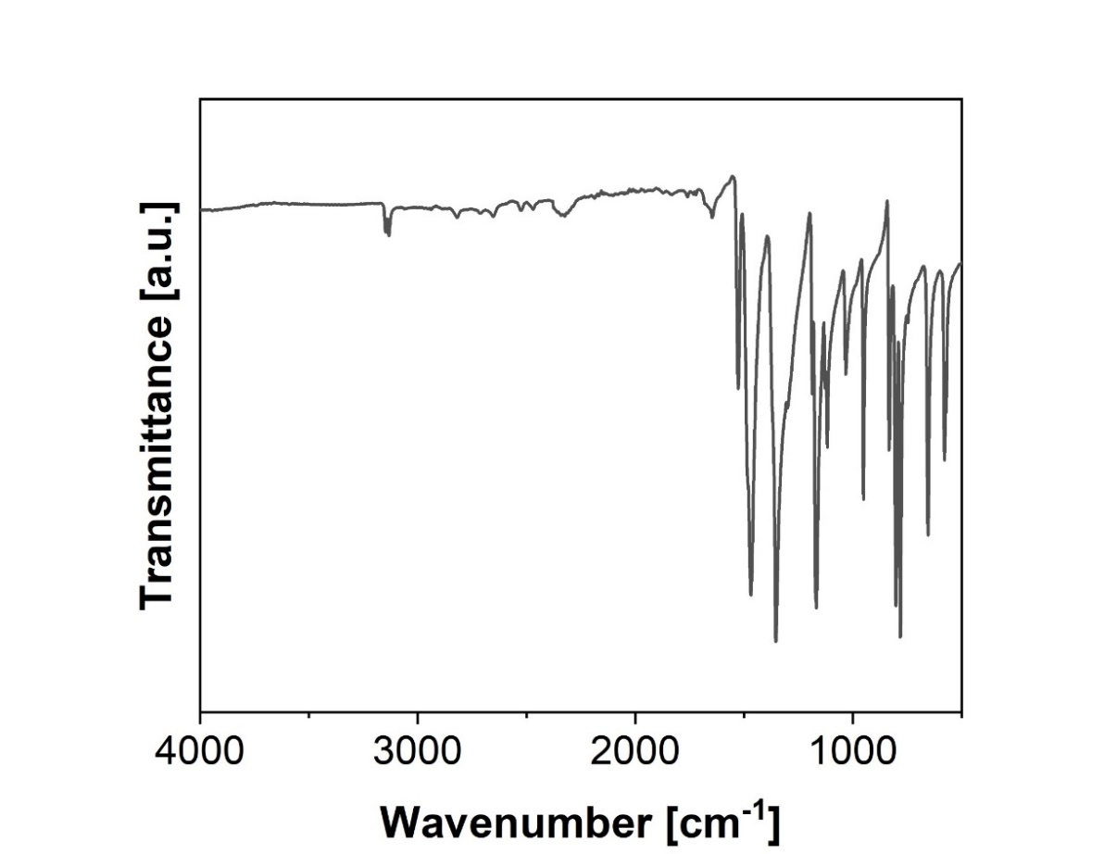
Fig. S1. FT-IR spectrum of Cu-ZIF-gis.
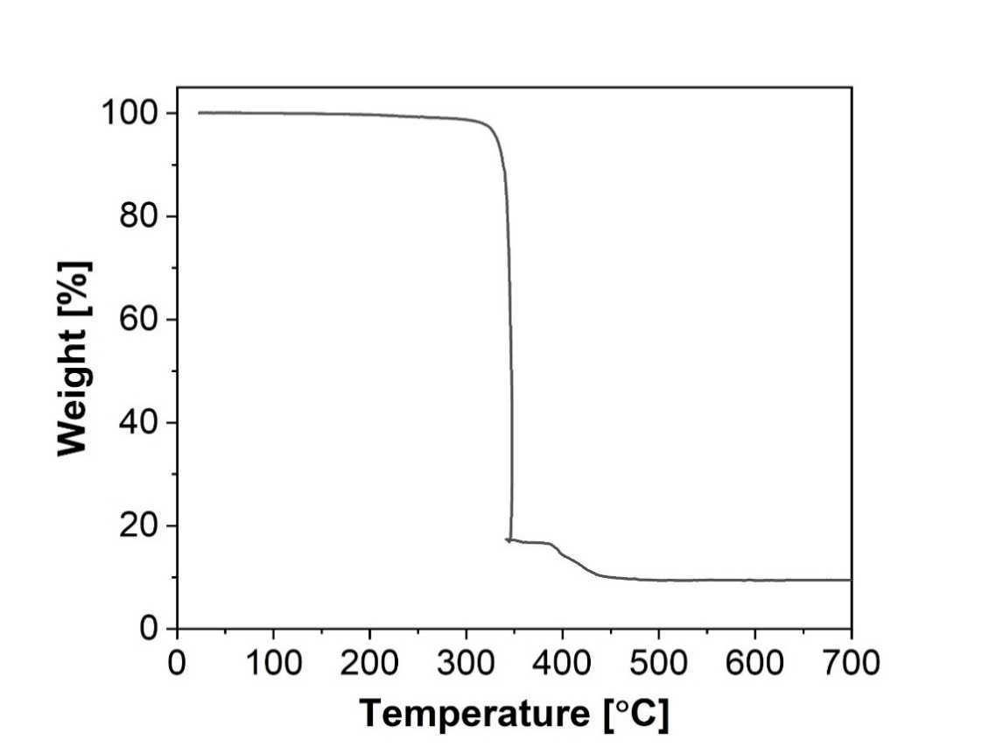
Fig. S2. TGA curve of Cu-ZIF-gis.

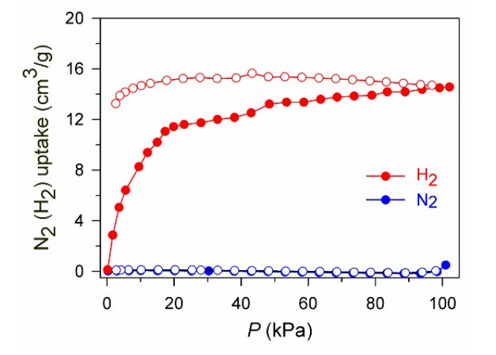
Fig. S3. The sorption isotherm of H₂ and N₂ at 77 K in Cu-ZIF-gis. Reproduced from Ref.¹

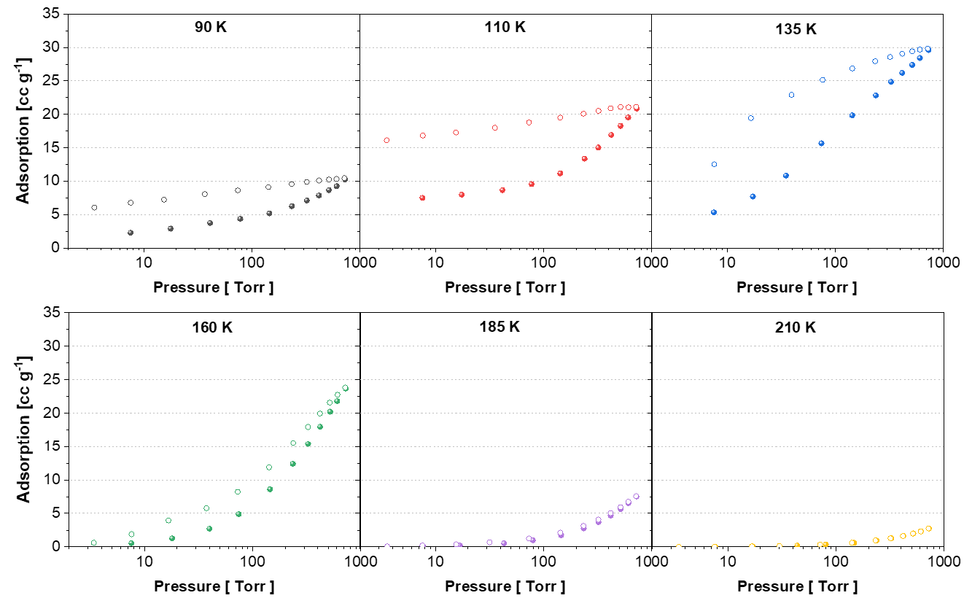
Fig. S4. O₂ sorption isotherms measured at various temperatures (90 - 210 K) in Cu-ZIF-gis.

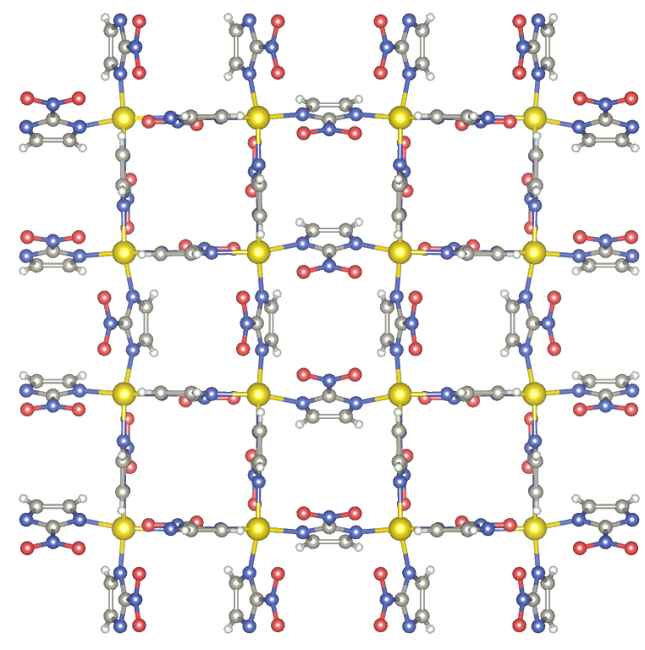
Fig. S5. The structure of Cu-ZIF-gis at 100 K.

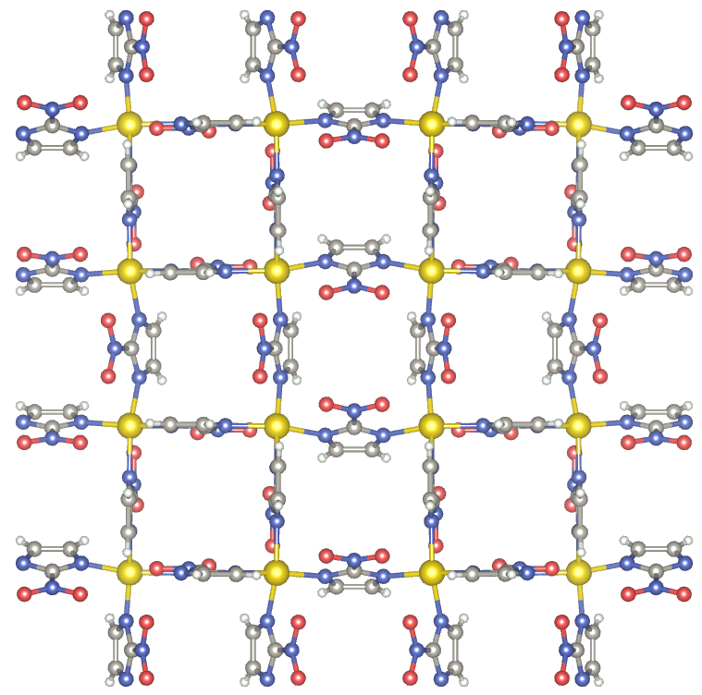
Fig. S6. The structure of Cu-ZIF-gis at 233 K.
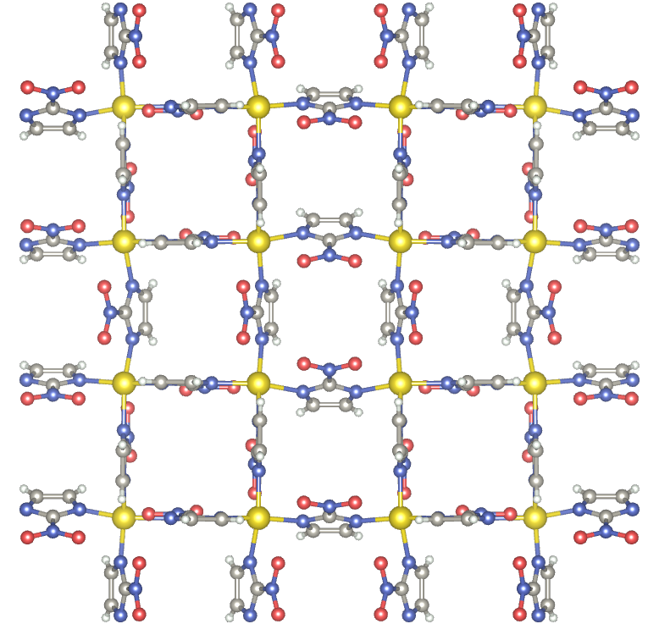
Fig. S7. The structure of Cu-ZIF-gis at 298 K.

Table S1. The cell parameters of Cu-ZIF-gis at various temperatures. Reproduced from Ref.¹ with permission from the Royal Society of Chemistry.
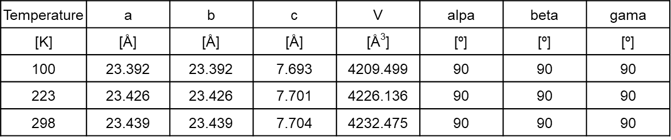

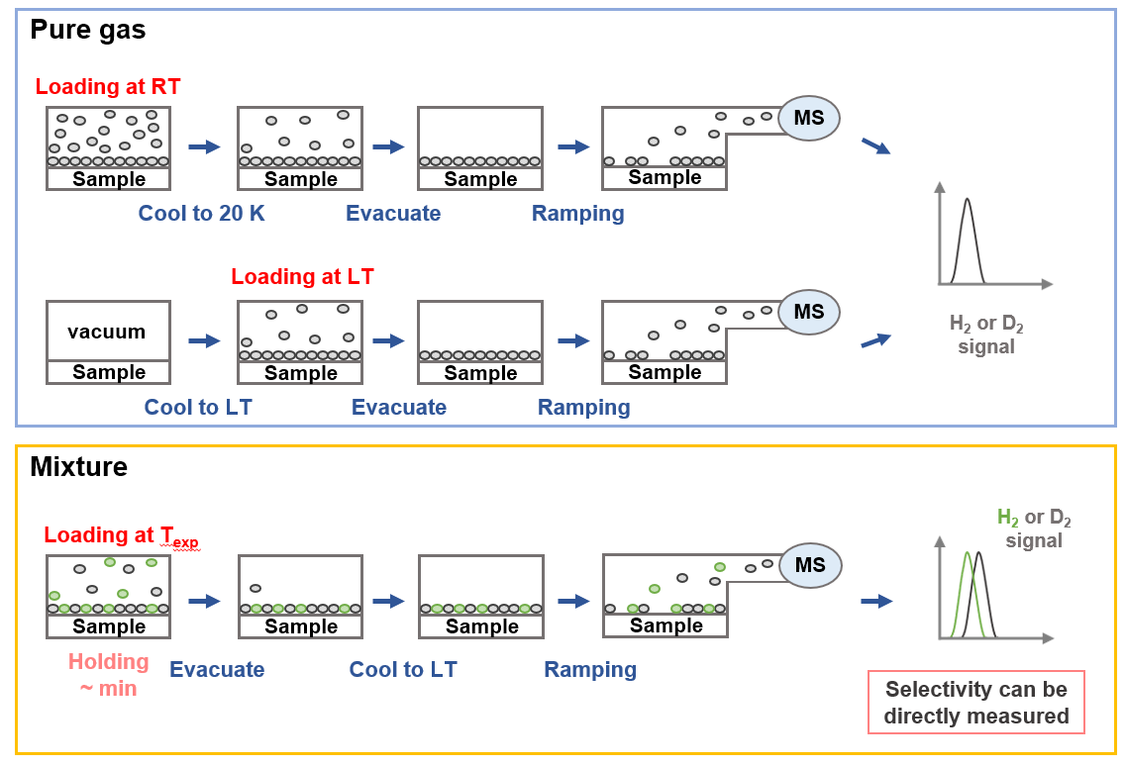
Fig. S8. TDS measurement procedure of pure gas and H₂/D₂ 1:1 mixture.

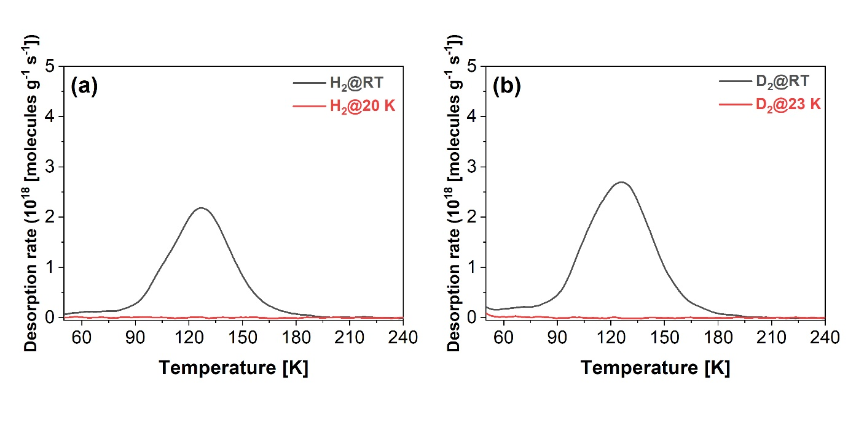
Fig. S9. TDS spectrum of pure gas (a) H₂ and (b) D₂ at room temperature (RT) and liquefaction temperature.

Desorption energy
The activation energy of desorption can be determined by the equation proposed by Falconer using TDS spectra with different heating rates. TDS measurements for desorption energy were performed at different heating rates of 3, 4.5, 6 K min⁻¹ at 100 K and 500 mbar. Falconer proposed that each peak maximum corresponds to the desorption rate at peak temperature and it can be described by the following equation (1). The method assumes the fractional surface coverage at desorption peak maximum is not a function of heating rate.
$\left[\ln\left(N_{P}\right)\right]=\ln\left[vg\left(θ_{p}\right)\right]-\frac{E_{d}}{R}\left[\frac{1}{T_{p}}\right]$ (1)
Where N_{p} is the maximum desorption rate at peak temperature, ν is the pre-exponential factor, g(θ_{p}) is a general form of desorption dependence on coverage, E_{d} is desorption energy, R is gas constant, T_{p} is temperature corresponding to maximum desorption rate. This method can be used to obtain desorption rates without assumptions about pre-exponential factors and reaction order. The plot of the logarithm of maximum desorption rate versus reciprocal temperature yields a straight line and desorption energies can be calculated using the slope.
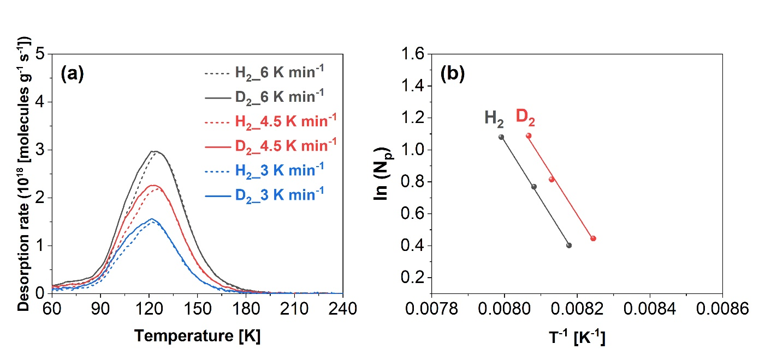
Fig. S10. (a) H₂ and D₂ TDS spectrum measured at room temperature, and (b) calculated desorption energy of H₂ and D₂.
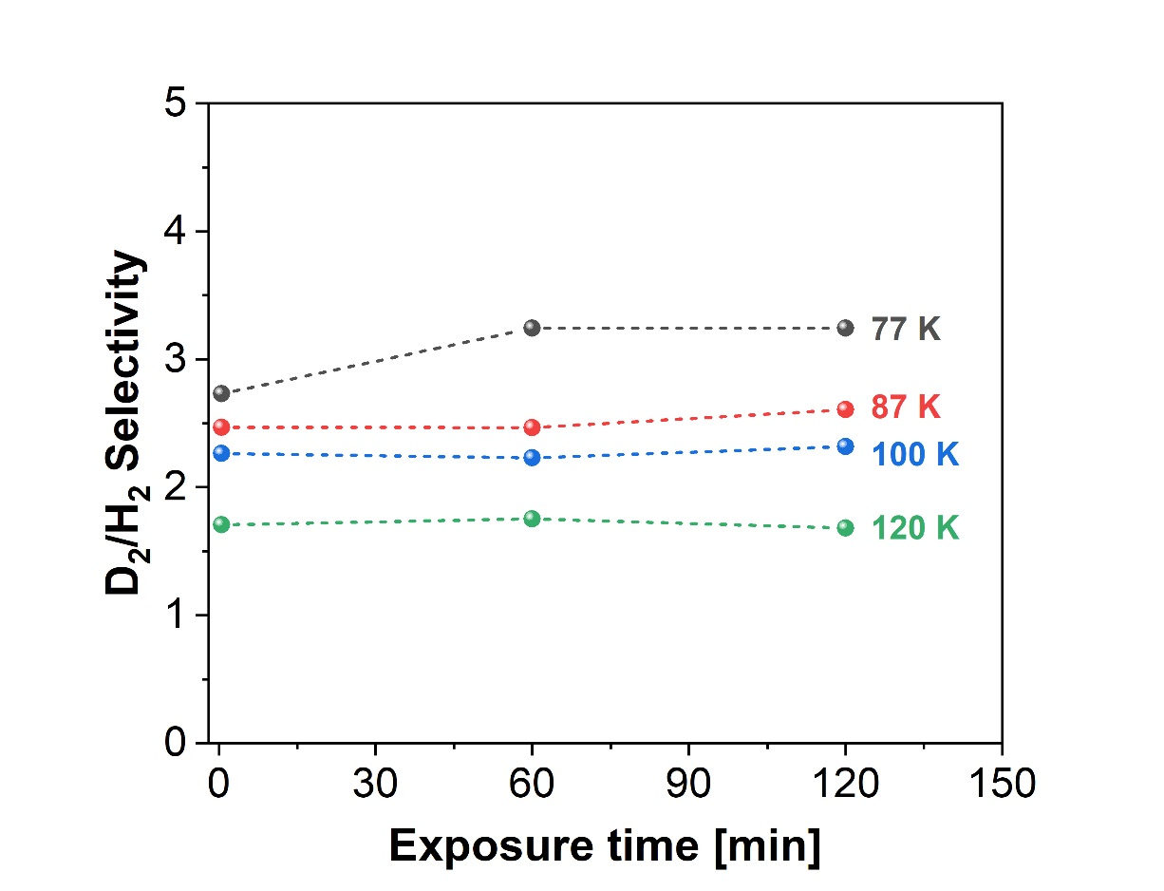
Fig. S11. The D₂/H₂ selectivity at loading pressure of 1000 mbar and various temperatures (77, 87, 100 and 120 K) and exposure times (0.5, 60 and 120 min) in Cu-ZIF-gis.
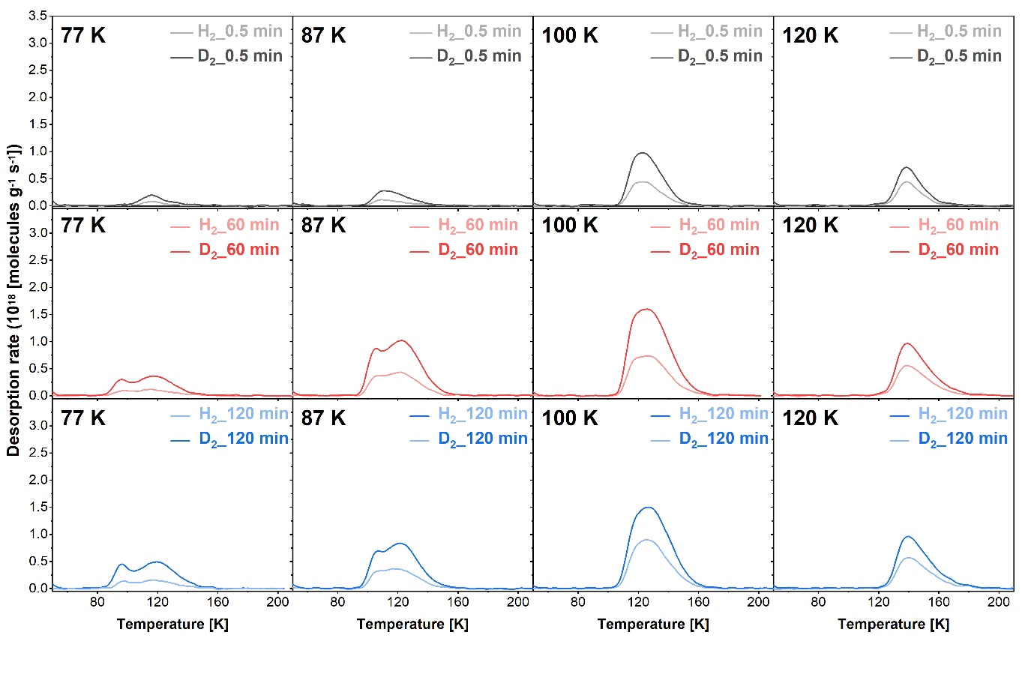
Fig. S12. TDS spectrum of D₂/H₂ mixture measured at loading pressure of 1000 mbar and exposure times of 0.5, 60, 120 min and 77, 87, 100 and 120 K.
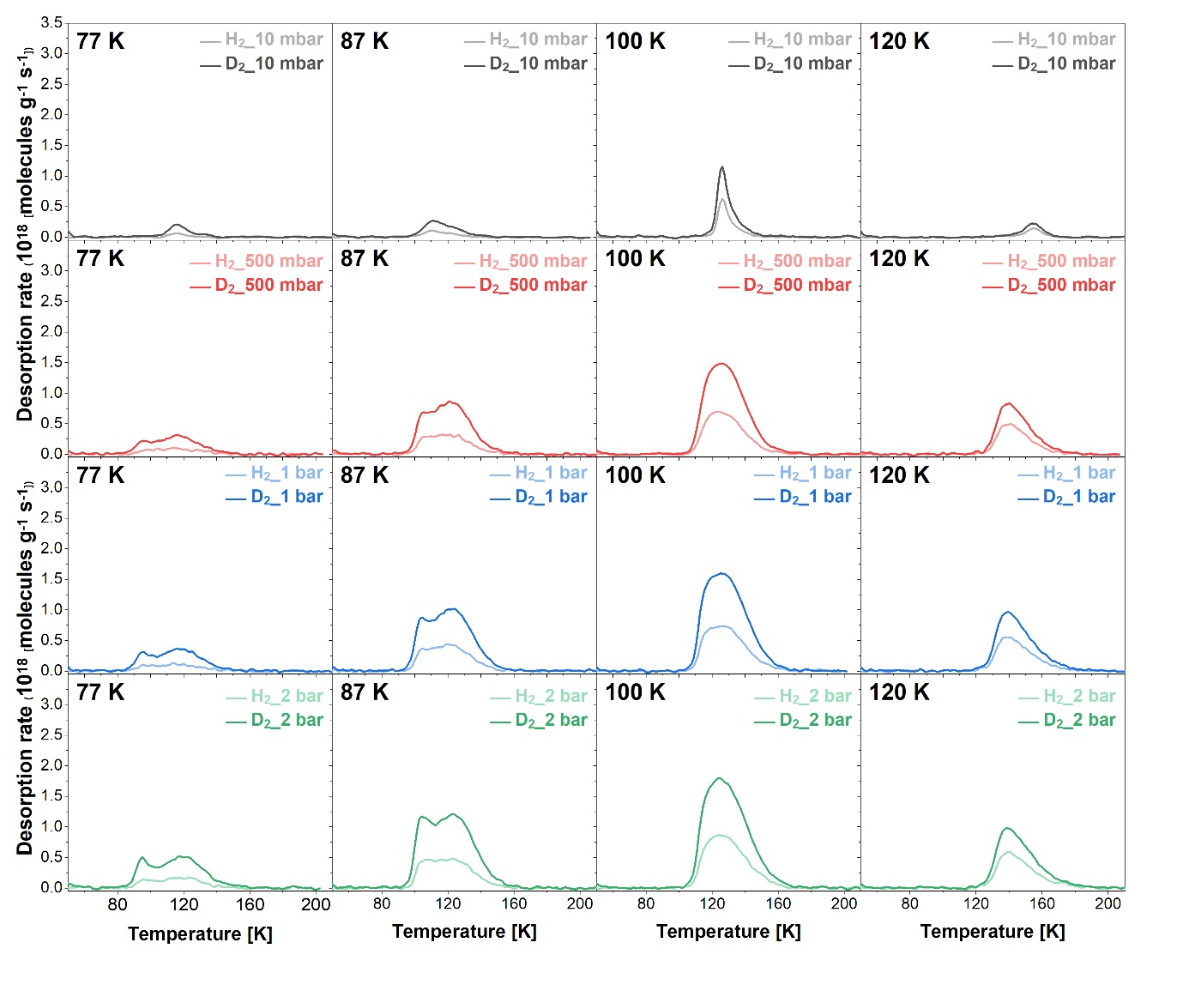
Fig. S13. TDS spectrum of D₂/H₂ mixture measured at loading pressure of 10, 500, 1000, 2000 mbar and 77, 87, 100 and 120 K.
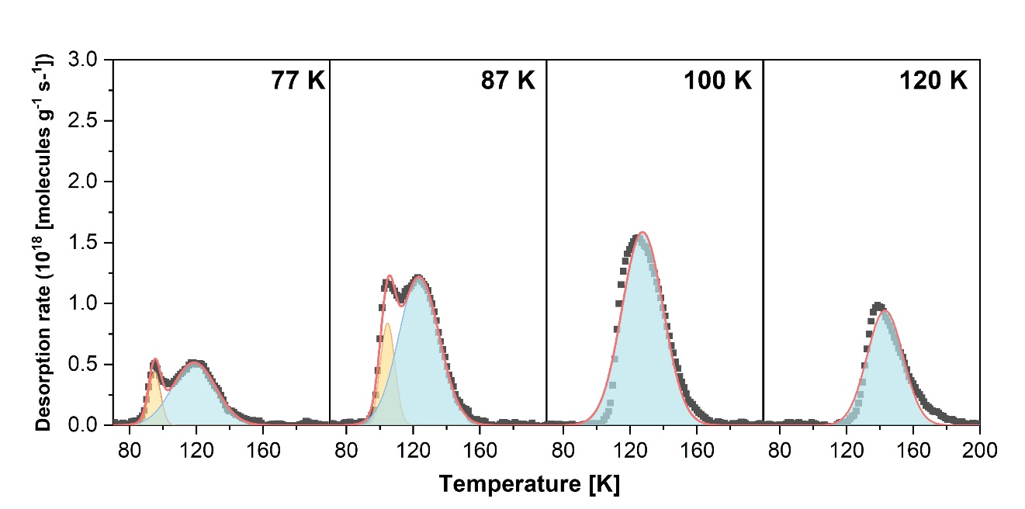
Fig. S14. TDS spectrum of D₂ in Cu-ZIF-gis at various temperatures (77, 87, 100 and 120 K).

Table S2. D₂/H₂ selectivity via KQS effect above 77 K with various porous materials without open metal site
Sample | Temperature | Pressure | D₂/H₂ selectivity | Measurement method | Ref
Sample | [K] | [mbar] | D₂/H₂ selectivity | Measurement method | Ref
1.5GN-H | 77 | 100 | 5.83 | Pure isotherm | 2
3KT-172 | 77 | 20 | 1.86 | Pure isotherm | 2
K1.6Na10.4A | 77 | 650 | 4.5 | co-adsorption | 3
Zeolite NaA | 77 | 650 | 2.9 | co-adsorption | 3
IFP-4 | 77 | 60 | 2.2 | TDS | 4
IFP-7 | 77 | 60 | 2.2 | TDS | 4
zeolite Y | 77 | 4000 | 1.52 | Breakthrough | 5
Zeolite 10X | 77 | 4000 | 1.33 | Breakthrough | 5
SBA-15 | 77 | 93 | 1.26 | Breakthrough | 5
2α | 77 | 200 | 2.8 | TDS | 6
2α | 100 | 200 | 2 | TDS | 6
2β | 77 | 200 | 2.2 | TDS | 6
2β | 100 | 200 | 1.7 | TDS | 6
FJI-Y11 | 77 | - | 1.76 | Breakthrough | 7
zeolite 5A | 77 | 150 | 2.48 | Pure gas isotherm | 8
Zeolite 4A | 77 | 150 | 2.09 | Pure gas isotherm | 8
CMK-3 | 77 | 93 | 1.01 | Pure gas isotherm | 8
SWCNT-SG | 77 | - | 1.7 | Breakthrough | 9
SWCNT-LA | 77 | - | 1.6 | Breakthrough | 9
ACF15 | 77 | - | 1.66 | Breakthrough | 9
ACF7 | 77 | - | 1.61 | Breakthrough | 9
FMOFCu | 77 | 50 | 3.8 | TDS | 10
FMOFCu | 87 | 50 | 3.2 | TDS | 10
MIL-53(Al) | 77 | 10 | 2.05 | TDS | 11
F373ACFs | 77 | 930 | 1.6 | IAST | 12
CMS | 77 | 4000 | 1.52 | Breakthrough | 13
CuBOTf | 77 | 50-1000 | 1.13 | Pure gas isotherms | 14
M'MOF-1 | 77 | 5-1000 | 1.09 | Pure gas isotherms | 14
M'MOF-1 | 87 | 5-1000 | 1.11 | Pure gas isotherms | 14
12-Connected | 77 | 1000 | 1.1 | Pure gas isotherm | 15
Cu2L2 | 78 | 100 | 1.2 | Pure gas isotherm | 16
Cu-ZIF-gis | 77 | 2000 | 4.0 | TDS | This work
Cu-ZIF-gis | 120 | 2000 | 1.8 | TDS | This work

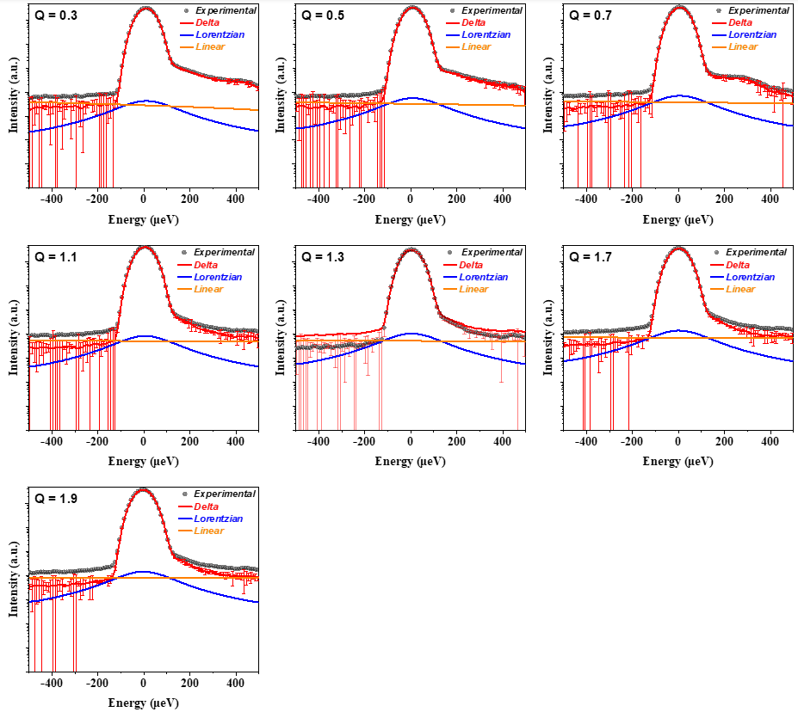
Fig. S15. QENS spectra for D₂ at various momentum transfer measured at 77 K and 0.7 mmol g⁻¹ of pressure in Cu-ZIF-gis.
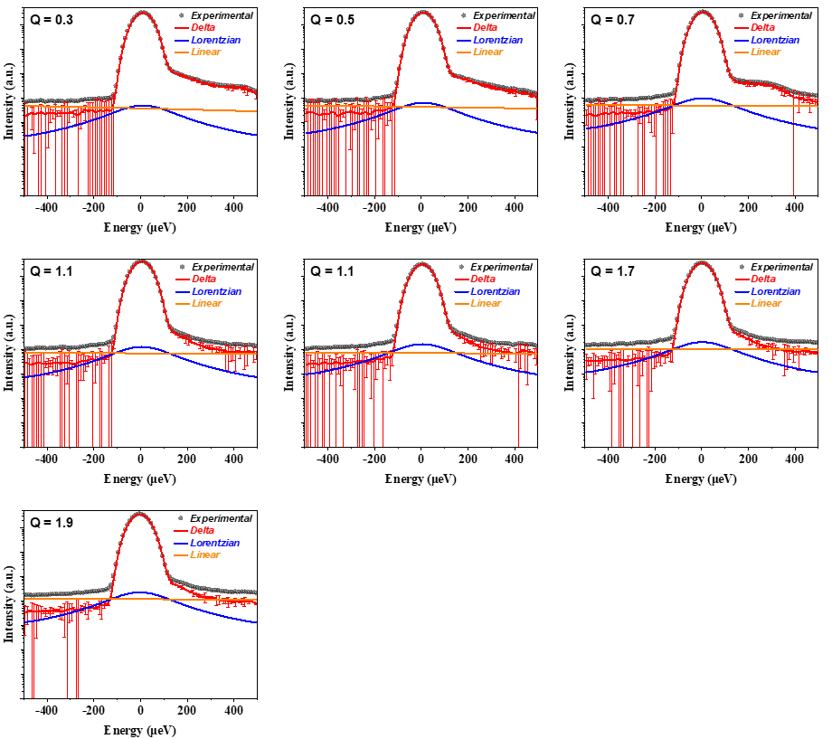
Fig. S16. QENS spectra for D₂ at various momentum transfer measured at 100 K and 0.7 mmol/g of pressure in Cu-ZIF-gis.

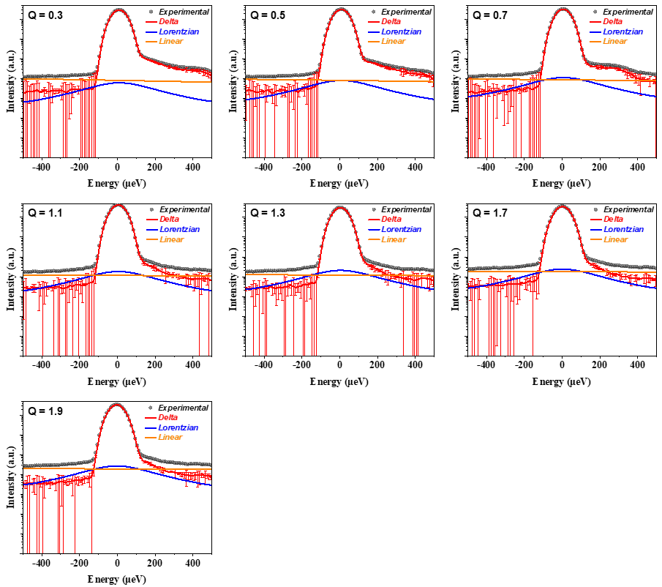
Fig. S17. QENS spectra for D₂ at various momentum transfer measured at 150 K and 0.7 mmol g⁻¹of pressure in Cu-ZIF-gis.
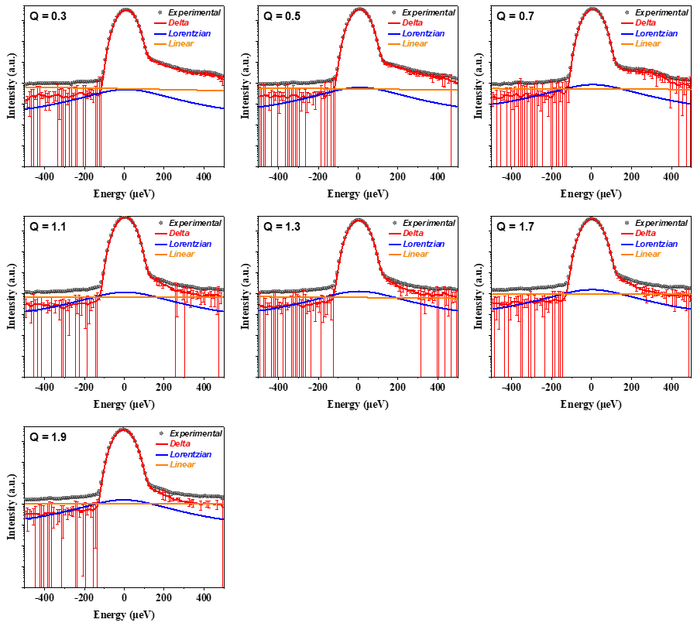
Fig. S89. QENS spectra for H₂ at various momentum transfer measured at 77 K and 0.7 mmol g⁻¹ of pressure in Cu-ZIF-gis.
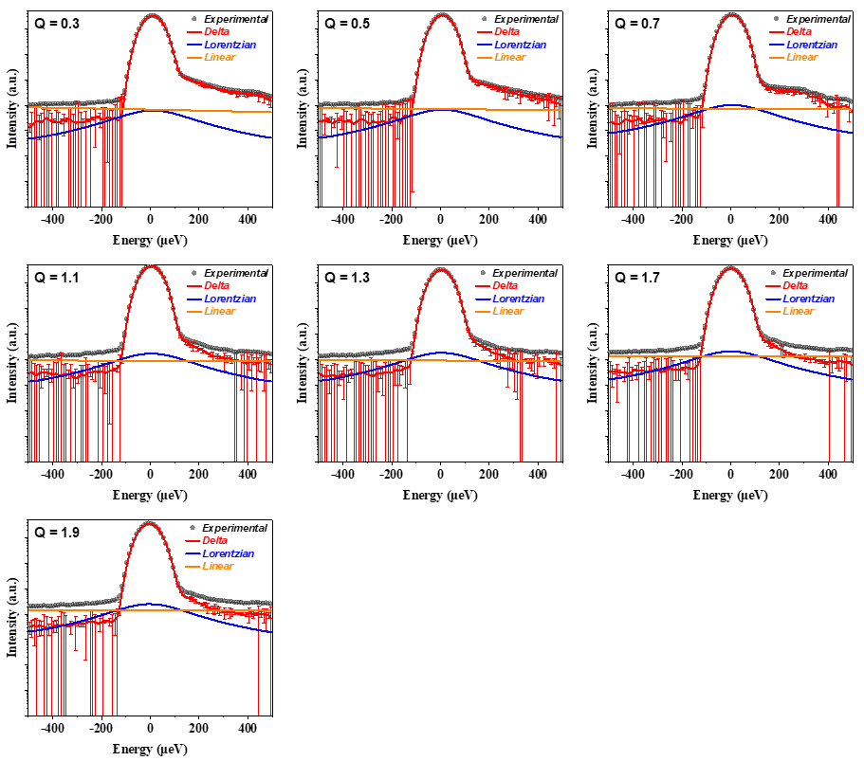
Fig. S19. QENS spectra for H₂ at various momentum transfer measured at 100 K and 0.7 mmol g⁻¹of pressure in Cu-ZIF-gis.
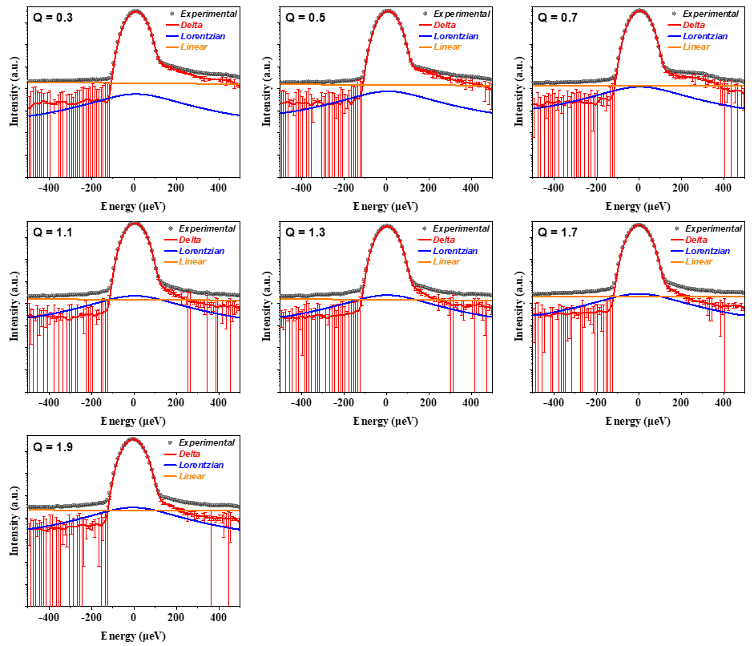
Fig. S20. QENS spectra for H₂ at various momentum transfer measured at 150 K and 0.7 mmol g⁻¹of pressure in Cu-ZIF-gis.

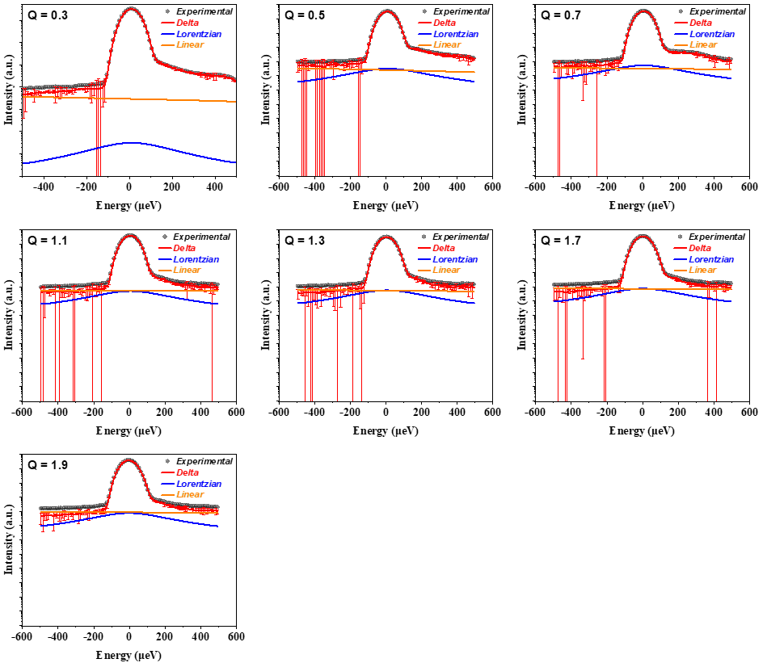
Fig. S21. QENS spectra for D₂ at various momentum transfer measured at 77 K and 2.0 mmol g⁻¹ of pressure in Cu-ZIF-gis.

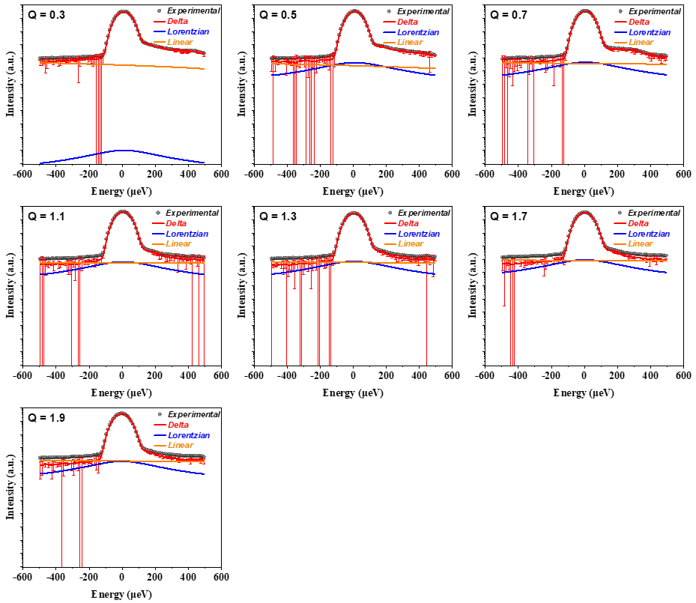
Fig. S22. QENS spectra for D₂ at various momentum transfer measured at 87 K and 2.0 mmol g⁻¹ of pressure in Cu-ZIF-gis.

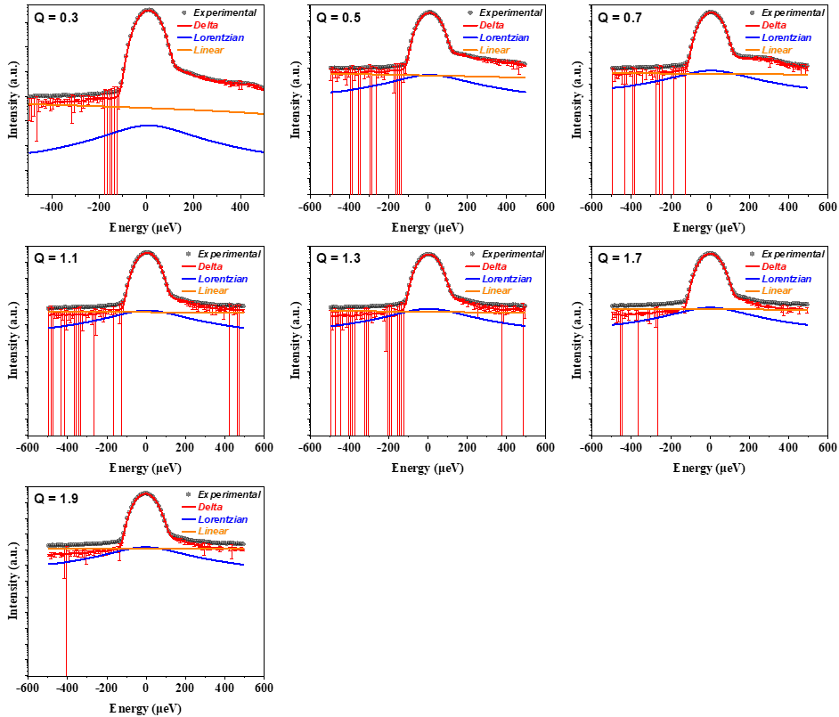
Fig. S23. QENS spectra for D₂ at various momentum transfer measured at 100 K and 2.0 mmol g⁻¹ of pressure in Cu-ZIF-gis.

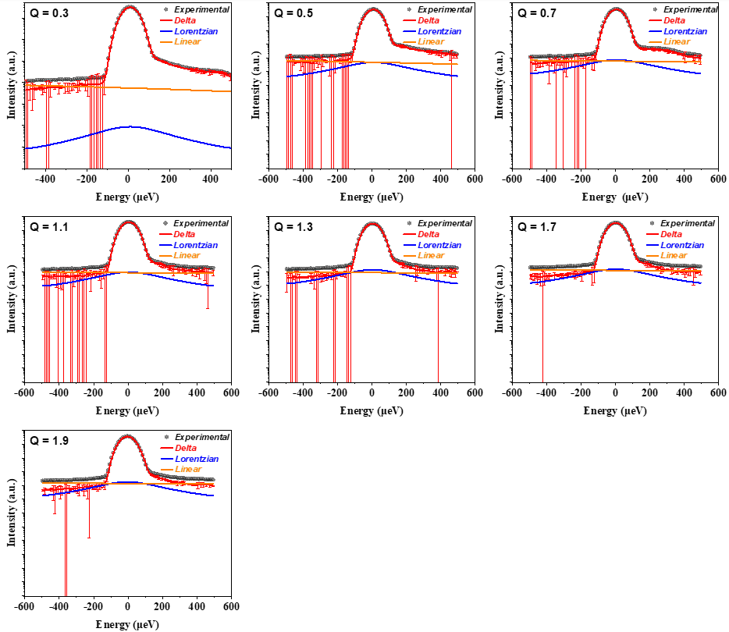
Fig. S24. QENS spectra for D₂ at various momentum transfer measured at 120 K and 2.0 mmol g⁻¹ of pressure in Cu-ZIF-gis.

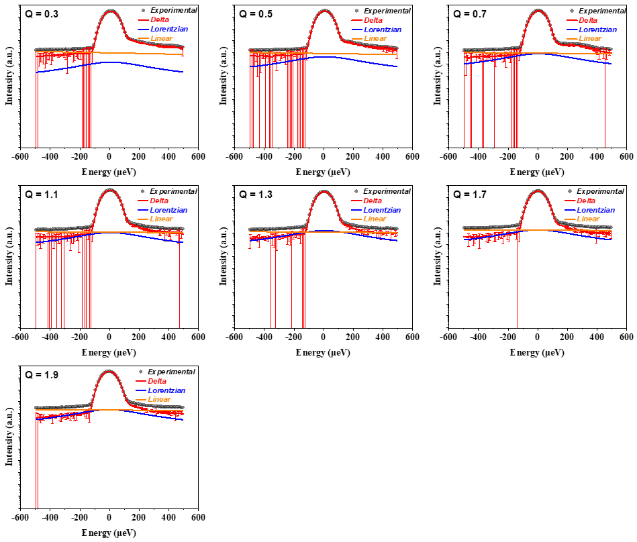
Fig. S25. QENS spectra for D₂ at various momentum transfer measured at 150 K and 2.0 mmol g⁻¹ of pressure in Cu-ZIF-gis.

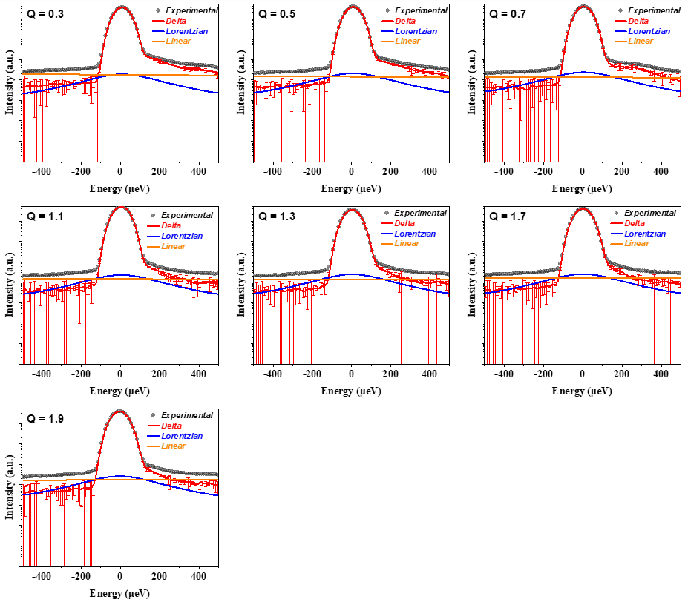
Fig. S26. QENS spectra for H₂ at various momentum transfer measured at 77 K and 2.0 mmol g⁻¹ of pressure in Cu-ZIF-gis.

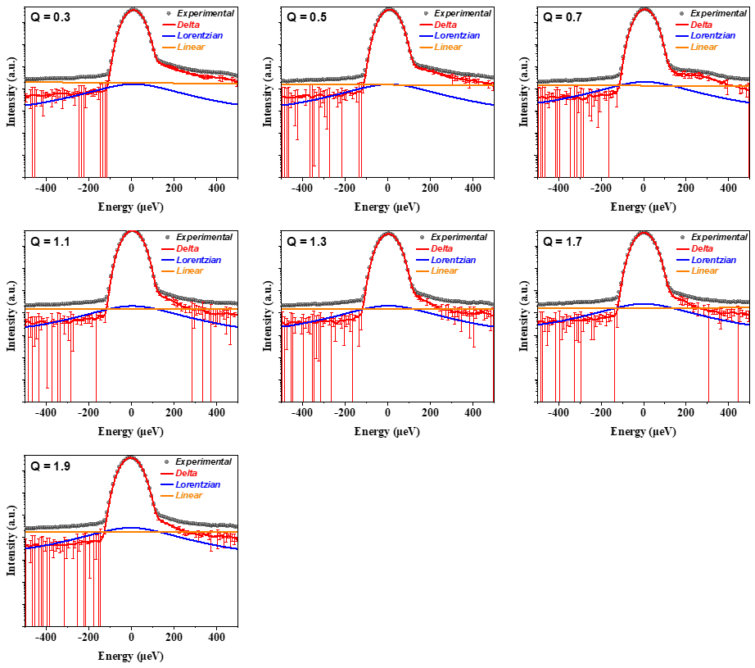
Fig. S27. QENS spectra for H₂ at various momentum transfer measured at 87 K and 2.0 mmol g⁻¹ of pressure in Cu-ZIF-gis.

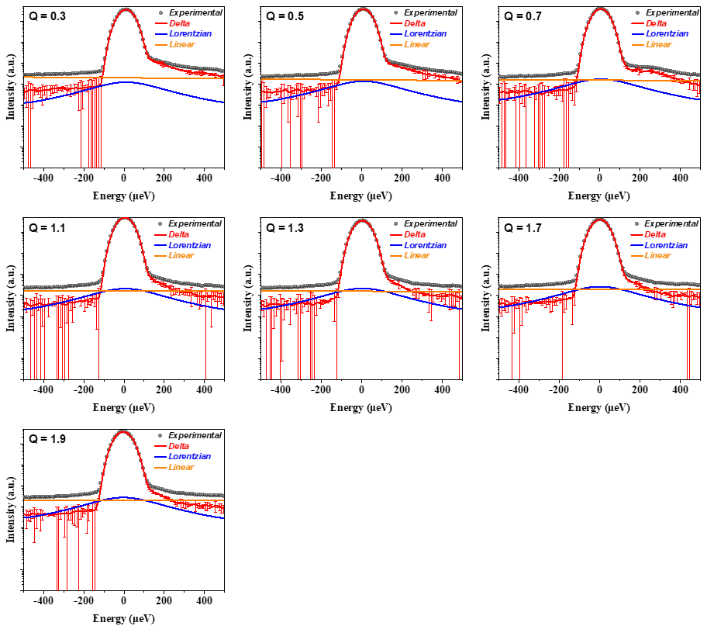
Fig. S28. QENS spectra for H₂ at various momentum transfer measured at 100 K and 2.0 mmol g⁻¹ of pressure in Cu-ZIF-gis.

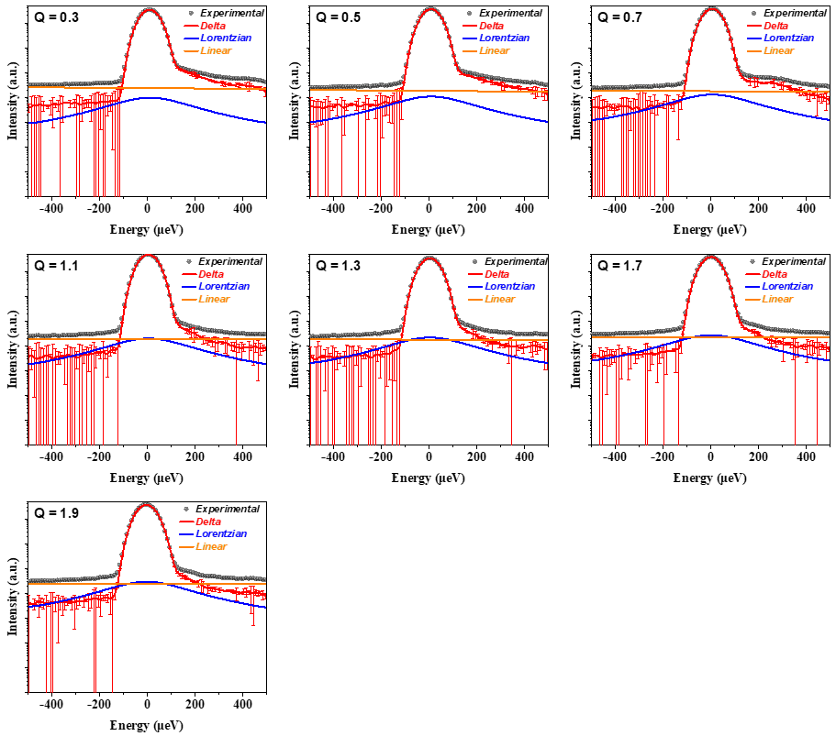
Fig. S29. QENS spectra for H₂ at various momentum transfer measured at 120 K and 2.0 mmol g⁻¹ of pressure in Cu-ZIF-gis.

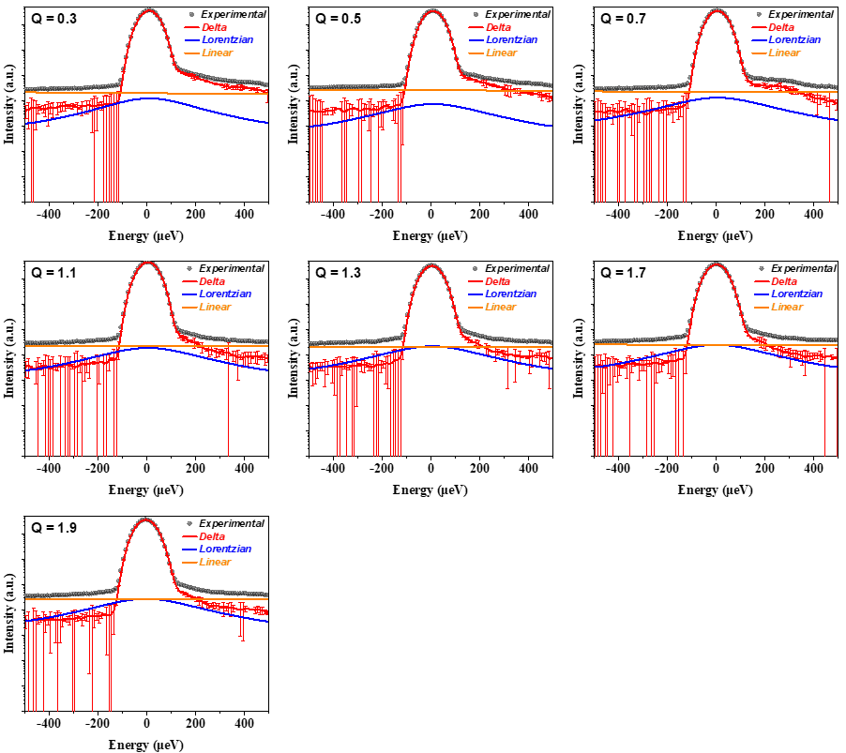
Fig. S30. QENS spectra for H₂ at various momentum transfer measured at 150 K and 2.0 mmol g⁻¹ of pressure in Cu-ZIF-gis.

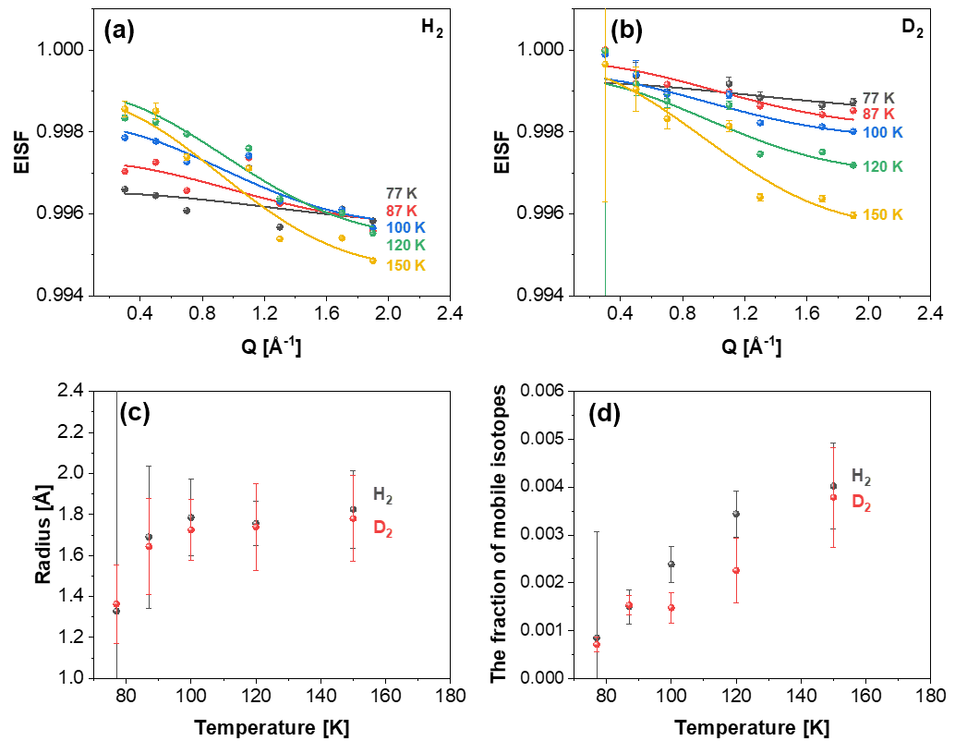
Fig. S31. Q-dependence of the EISF of (a) H₂ and (b) D₂ at various temperatures and 2.0 mmol g⁻¹ of pressure loading in Cu-ZIF-gis. The solid lines represent the fitting data of EISF obtained using the diffusion in a sphere model proposed by Volino and Dianoux.¹⁷ The fraction of mobile H₂ (black) and D₂ (red) in the confined pore of Cu-ZIF-gis, was obtained from the EISF fitting parameter.

Reference
1 Jung, C. et al. Porous zeolitic imidazolate frameworks assembled with highly-flattened tetrahedral copper (ii) centres and 2-nitroimidazolates. ChemComm. 59, 4040-4043 (2023).
2 Xing, Y., Cai, J., Li, L., Yang, M. & Zhao, X. An exceptional kinetic quantum sieving separation effect of hydrogen isotopes on commercially available carbon molecular sieves. Phys. Chem. Chem. Phys. 16, 15800-15805 (2014).
3 Bezverkhyy, I., Giraudet, M., Dirand, C., Macaud, M. & Bellat, J.-P. Enhancement of D2/H2 selectivity in zeolite A through partial Na–K exchange: single-gas and coadsorption studies at 45–77 K. J. Phys. Chem. C 124, 24756-24764 (2020).
4 Mondal, S. S. et al. Systematic Experimental Study on Quantum Sieving of Hydrogen Isotopes in Metal‐Amide‐Imidazolate Frameworks with narrow 1‐D Channels. ChemPhysChem 20, 1311-1315 (2019).
5 Chu, X.-Z. et al. Separation dynamics of hydrogen isotope gas in mesoporous and microporous adsorbent beds at 77 K: SBA-15 and zeolites 5A, Y, 10X. Int. J. hydrogen energy. 39, 4437-4446 (2014).
6 He, D. et al. Hydrogen isotope separation using a metal-organic cage built from macrocycles. Angew. Chem. Int. Ed. 61, e202202450 (2022).
7 Si, Y. et al. Highly effective H ₂/D₂ separation in a stable Cu-based metal-organic framework. Nano Res. 14, 518-525 (2021).
8 Chu, X.-Z. et al. Adsorption of hydrogen isotopes on micro-and mesoporous adsorbents with orderly structure. J. Phys. Chem. B 110, 22596-22600 (2006).
9 Niimura, S. et al. Dynamic quantum molecular sieving separation of D₂ from H₂–D₂ mixture with nanoporous materials. J. Am. Chem. Soc. 134, 18483-18486 (2012).
10 Zhang, L. et al. Exploiting dynamic opening of apertures in a partially fluorinated MOF for enhancing H₂ desorption temperature and isotope separation. J. Am. Chem. Soc. 141, 19850-19858 (2019).
11 Kim, J. Y. et al. Selective hydrogen isotope separation via breathing transition in MIL-53 (Al). J. Am. Chem. Soc. 139, 17743-17746 (2017).
12 Sugiyama, H. & Hattori, Y. Quantum-molecular Sieving of Hydrogen Isotopes in Fluorinated Carbon Nanopores. Chem. Lett. 50, 1460-1463 (2021).
13 Chu, X.-Z. et al. Adsorption dynamics of hydrogen and deuterium in a carbon molecular sieve bed at 77 K. Sep. Purif. Technol. 146, 168-175 (2015).
14 Noguchi, D. et al. Quantum sieving effect of three-dimensional Cu-based organic framework for H₂ and D₂. J. Am. Chem. Soc. 130, 6367-6372 (2008).
15 Jia, J. et al. Twelve-connected porous metal-organic frameworks with high H 2 adsorption. ChemCommun 8, 840-842 (2007).
16 Lin, X. et al. High H₂ adsorption by coordination-framework materials. Angew. Chem. Int. Engl. 45, 7358 (2006).
17 Volino, F. & Dianoux, A. Neutron incoherent scattering law for diffusion in a potential of spherical symmetry: general formalism and application to diffusion inside a sphere. Mol. Phys. 41, 271-279 (1980).

