Supplementary Information

The cortical changes in the brain caused by substance addiction

Zidong Zhang¹, Zhen Wang¹, Jing Zou², Le Zhang¹, Jinghua Ning¹, Xin Zhang¹, Liu Heng³, Chenggui Zhang³, Yi Liang⁴, Yuzhe Zhang¹(Correspondence)

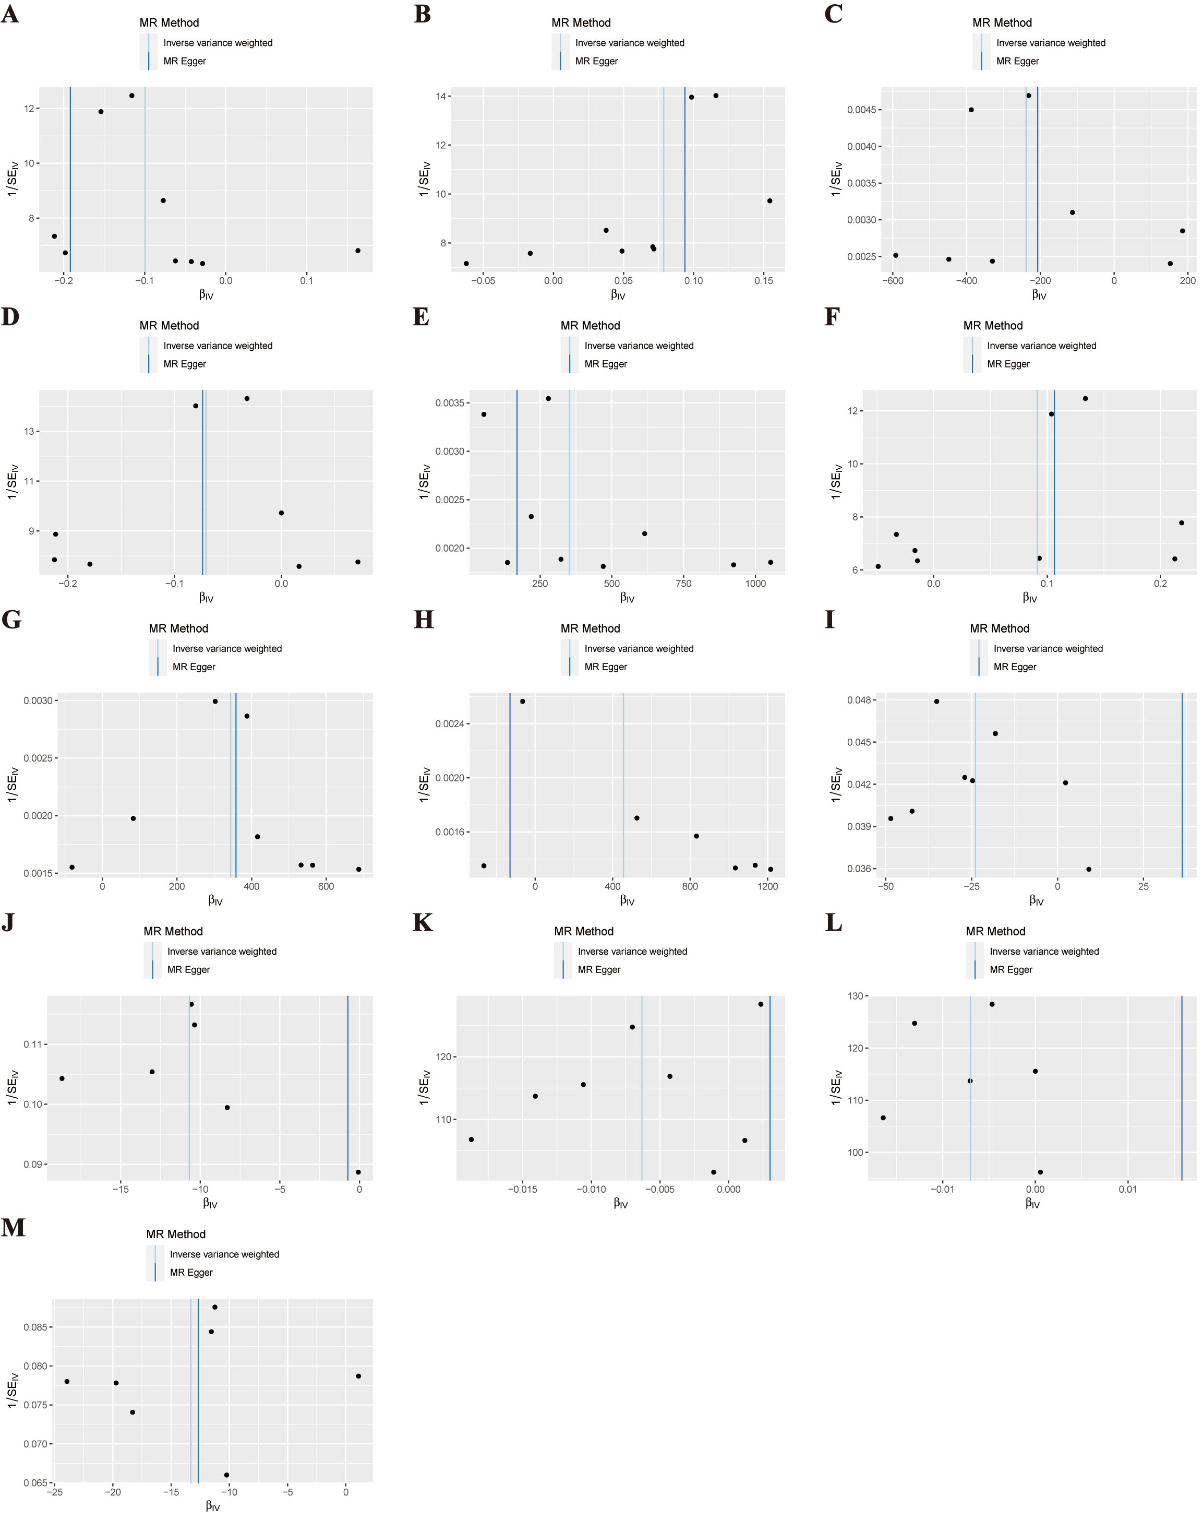
Figure S1. (A) genetically predicted "Alcohol use/AUDIT" on the TH of the bankssts with global weighted; (B) genetically predicted "Alcohol use/AUDIT" on the TH of the cuneus with global weighted; (C) genetically predicted "Alcohol use/AUDIT" on the SA of the precentral with global weighted; (D) genetically predicted "Alcohol use/AUDIT" on the TH of the superior temporal with global weighted; (E) genetically predicted "Alcohol use/AUDIT" on the SA of the postcentral without global weighted; (F) genetically predicted "Alcohol use/AUDIT" on the TH of the cuneus without global weighted; (G) genetically predicted "Alcohol use/AUDIT" on the SA of the lateral occipital without global weighted; (H) genetically predicted "Alcohol use/AUDIT" on the SA of the inferior parietal with globalout weighted; (I) genetically predicted "Cannabis use disorder" on the SA of the inferior temporal with global weighted; (J) genetically predicted "Cannabis use disorder" on the SA of the posterior cingulate with global weighted; (K) genetically predicted "Cannabis use disorder" on the TH of the pars triangularis with global weighted; (L) genetically predicted "Cannabis use disorder" on the TH of the middle temporal with global weighted; (M) genetically predicted "Cannabis use disorder" on the SA of the posterior cingulate without global weighted.
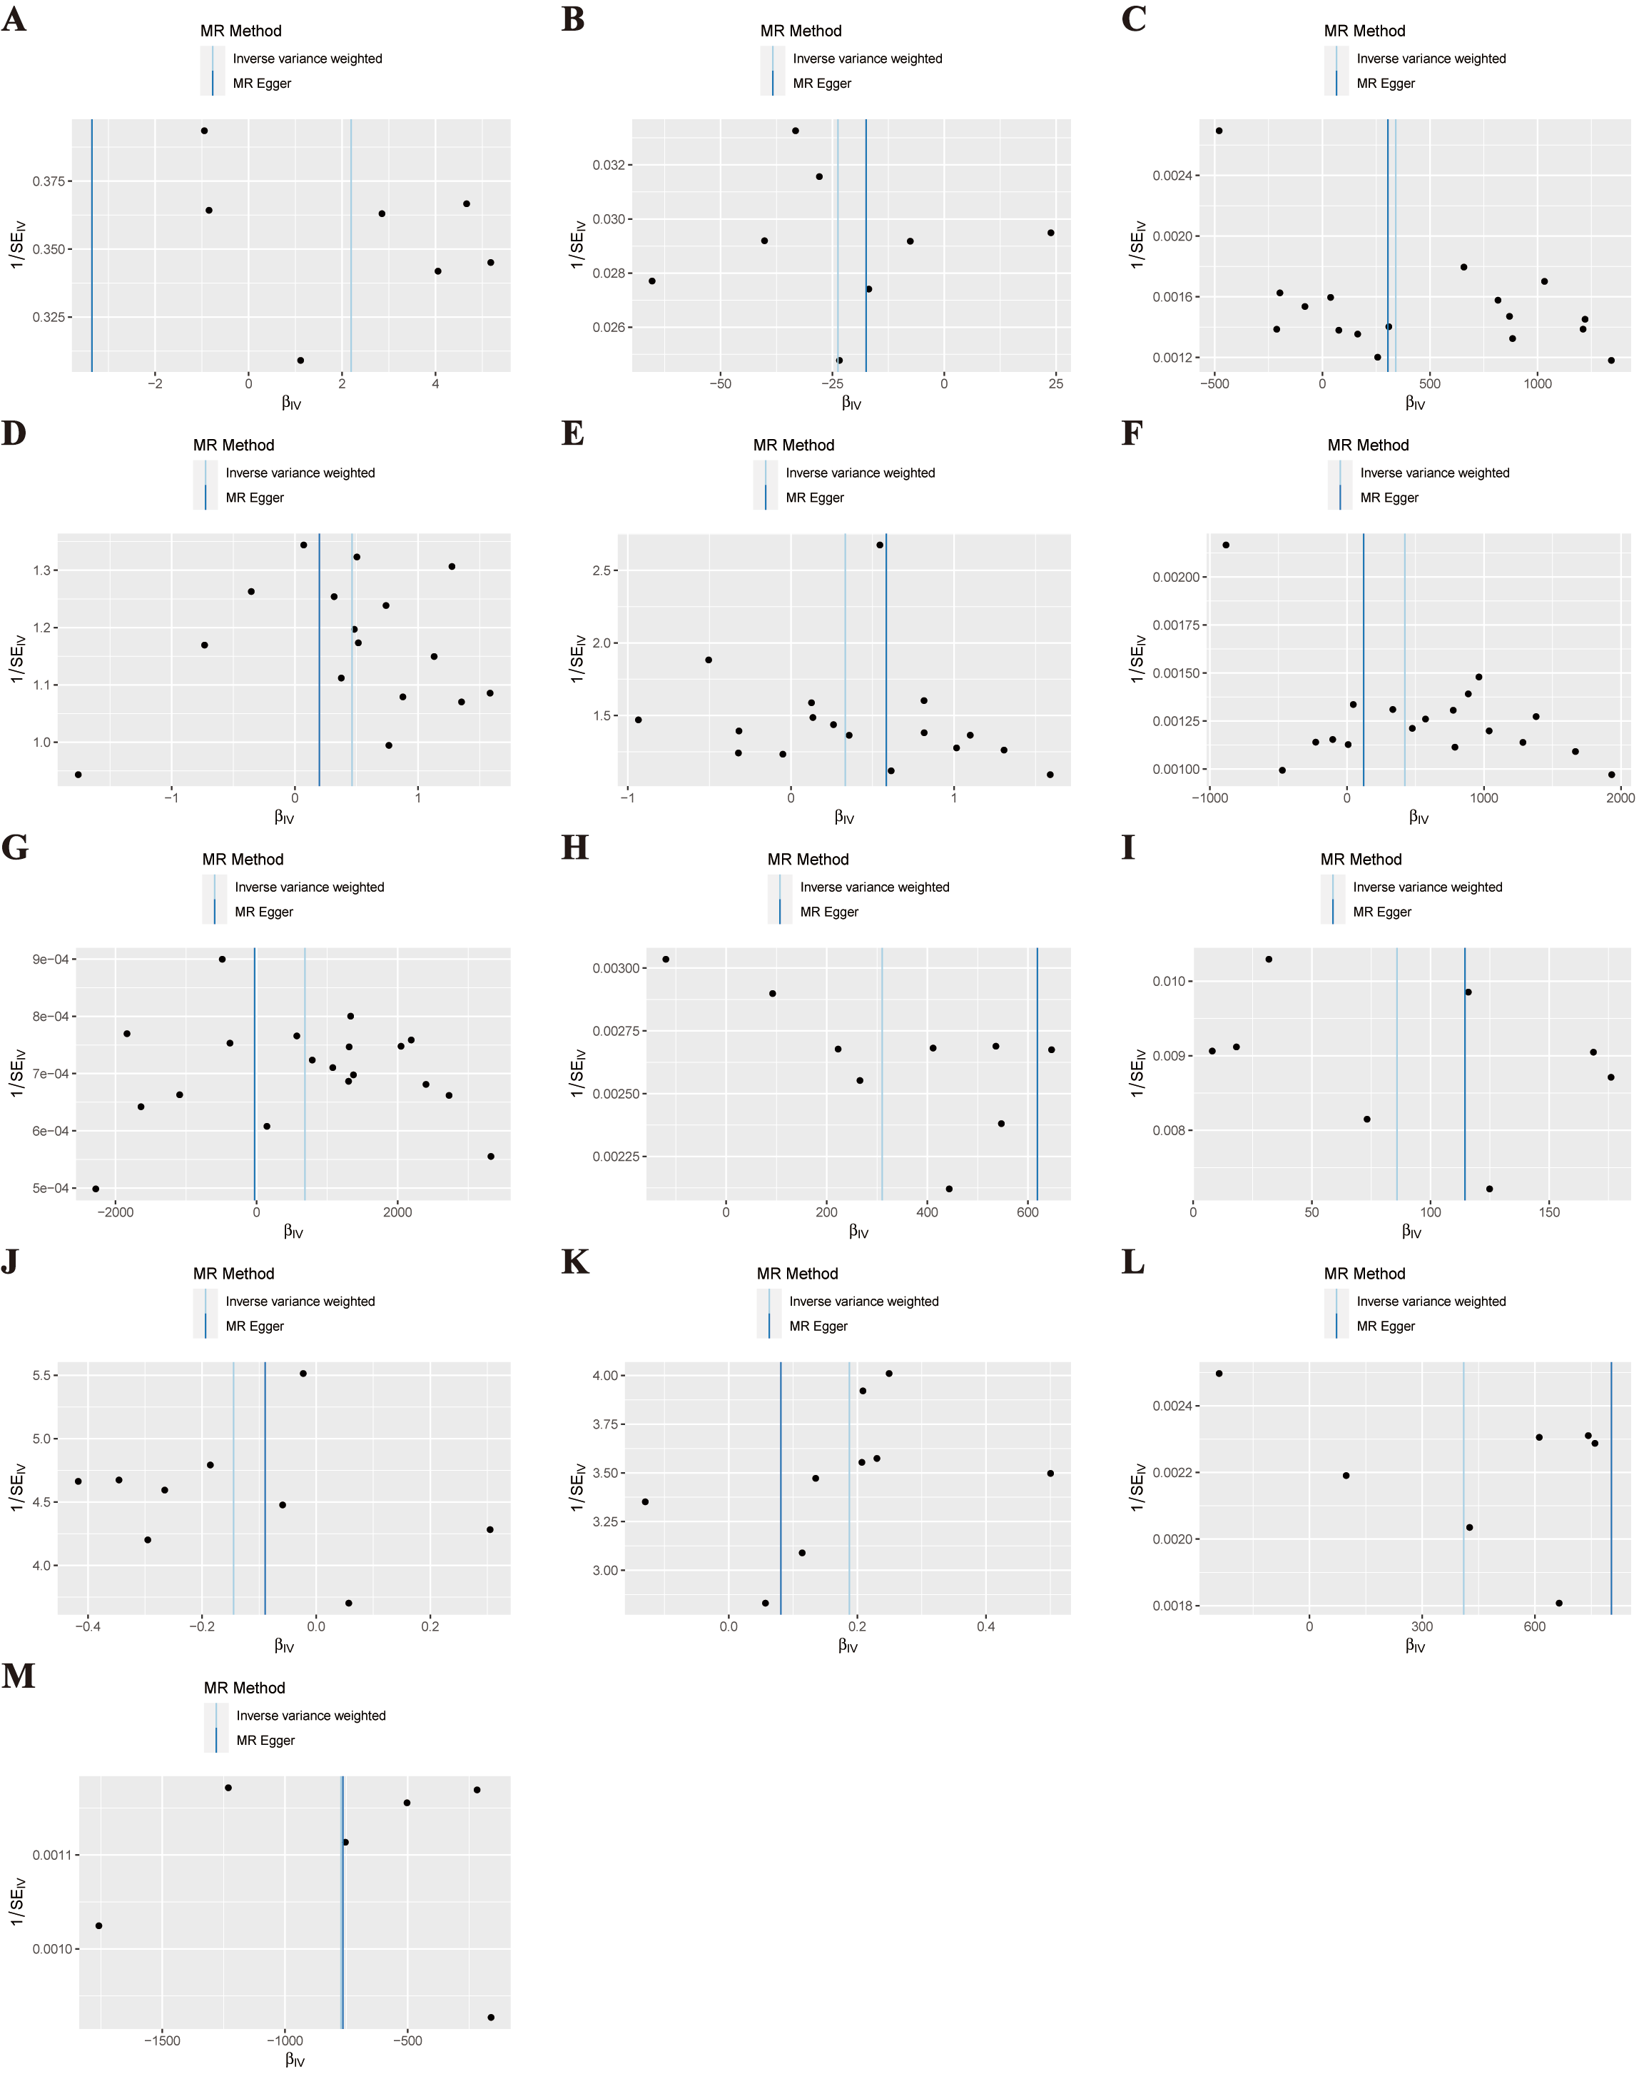 Figure S2. (A) genetically predicted "Cannabis use disorder" on the SA of the frontal pole without global weighted; (B) genetically predicted "Cannabis use disorder" on the SA of the inferior temporal without global weighted; (C) genetically predicted "Substance of prescription or over-the-counter medication addiction: A painkiller" on the SA of the caudal anterior cingulate with global weighted; (D) genetically predicted "Substance of prescription or over-the-counter medication addiction: A painkiller" on the TH of the insula with global weighted; (E) genetically predicted "Substance of prescription or over-the-counter medication addiction: A painkiller" on the TH of the fusiform with global weighted; (F) genetically predicted "Substance of prescription or over-the-counter medication addiction: A painkiller" on the SA of the caudal anterior cingulate without global weighted; (G) genetically predicted "Substance of prescription or over-the-counter medication addiction: A sedative, benzodiazepine or sleeping tablet" on the SA of the pericalcarine without global weighted; (H) genetically predicted "Tobacco smoking: Smokes on most or all days" on the SA of the pars triangularis with global weighted; (I) genetically predicted "Tobacco smoking: Smokes on most or all days" on the SA of the temporal pole with global weighted; (J) genetically predicted "Tobacco smoking: Smokes on most or all days" on the TH of the lingual with global weighted; (K) genetically predicted "Tobacco smoking: Smokes on most or all days" on the TH of the insula with global weighted; (L) genetically predicted "Tobacco smoking: Smokes on most or all days" on the SA of the pars triangularis without global weighted; (M) genetically predicted "Tobacco smoking: Smokes on most or all days" on the SA of the lingual without global weighted.
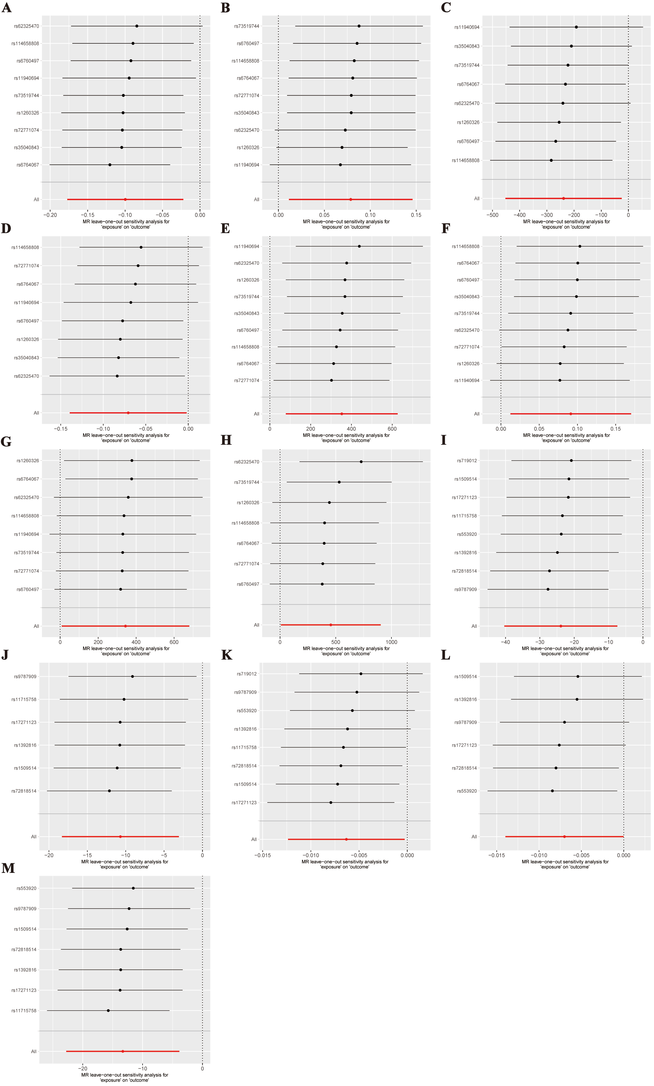
Figure S3. (A) genetically predicted "Alcohol use/AUDIT" on the TH of the bankssts with global weighted; (B) genetically predicted "Alcohol use/AUDIT" on the TH of the cuneus with global weighted; (C) genetically predicted "Alcohol use/AUDIT" on the SA of the precentral with global weighted; (D) genetically predicted "Alcohol use/AUDIT" on the TH of the superior temporal with global weighted; (E) genetically predicted "Alcohol use/AUDIT" on the SA of the postcentral without global weighted; (F) genetically predicted "Alcohol use/AUDIT" on the TH of the cuneus without global weighted; (G) genetically predicted "Alcohol use/AUDIT" on the SA of the lateral occipital without global weighted; (H) genetically predicted "Alcohol use/AUDIT" on the SA of the inferior parietal without global weighted; (I) genetically predicted "Cannabis use disorder" on the SA of the inferior temporal with global weighted; (J) genetically predicted "Cannabis use disorder" on the SA of the posterior cingulate with global weighted; (K) genetically predicted "Cannabis use disorder" on the TH of the pars triangularis with global weighted; (L) genetically predicted "Cannabis use disorder" on the TH of the middle temporal with global weighted; (M) genetically predicted "Cannabis use disorder" on the SA of the posterior cingulate without global weighted
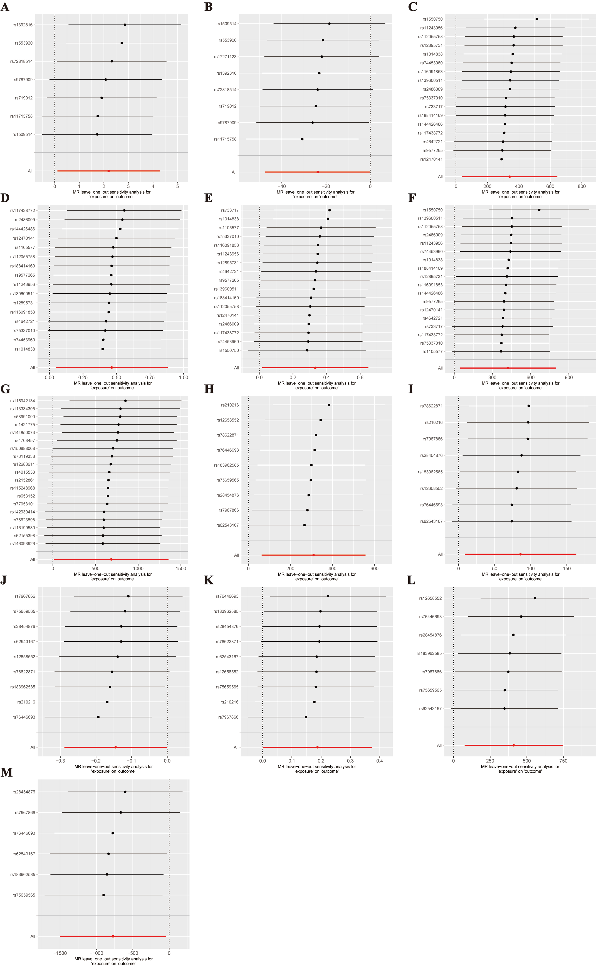
Figure S4. (A) genetically predicted "Cannabis use disorder" on the SA of the frontal pole without global weighted; (B) genetically predicted "Cannabis use disorder" on the SA of the inferior temporal without global weighted; (C) genetically predicted "Substance of prescription or over-the-counter medication addiction: A painkiller" on the SA of the caudal anterior cingulate with global weighted; (D) genetically predicted "Substance of prescription or over-the-counter medication addiction: A painkiller" on the TH of the insula with global weighted; (E) genetically predicted "Substance of prescription or over-the-counter medication addiction: A painkiller" on the TH of the fusiform with global weighted; (F) genetically predicted "Substance of prescription or over-the-counter medication addiction: A painkiller" on the SA of the caudal anterior cingulate without global weighted; (G) genetically predicted "Substance of prescription or over-the-counter medication addiction: A sedative, benzodiazepine or sleeping tablet" on the SA of the pericalcarine without global weighted; (H) genetically predicted "Tobacco smoking: Smokes on most or all days" on the SA of the pars triangularis with global weighted; (I) genetically predicted "Tobacco smoking: Smokes on most or all days" on the SA of the temporal pole with global weighted; (J) genetically predicted "Tobacco smoking: Smokes on most or all days" on the TH of the lingual with global weighted; (K) genetically predicted "Tobacco smoking: Smokes on most or all days" on the TH of the insula with global weighted; (L) genetically predicted "Tobacco smoking: Smokes on most or all days" on the SA of the pars triangularis without global weighted; (M) genetically predicted "Tobacco smoking: Smokes on most or all days" on the SA of the lingual without global weighted.
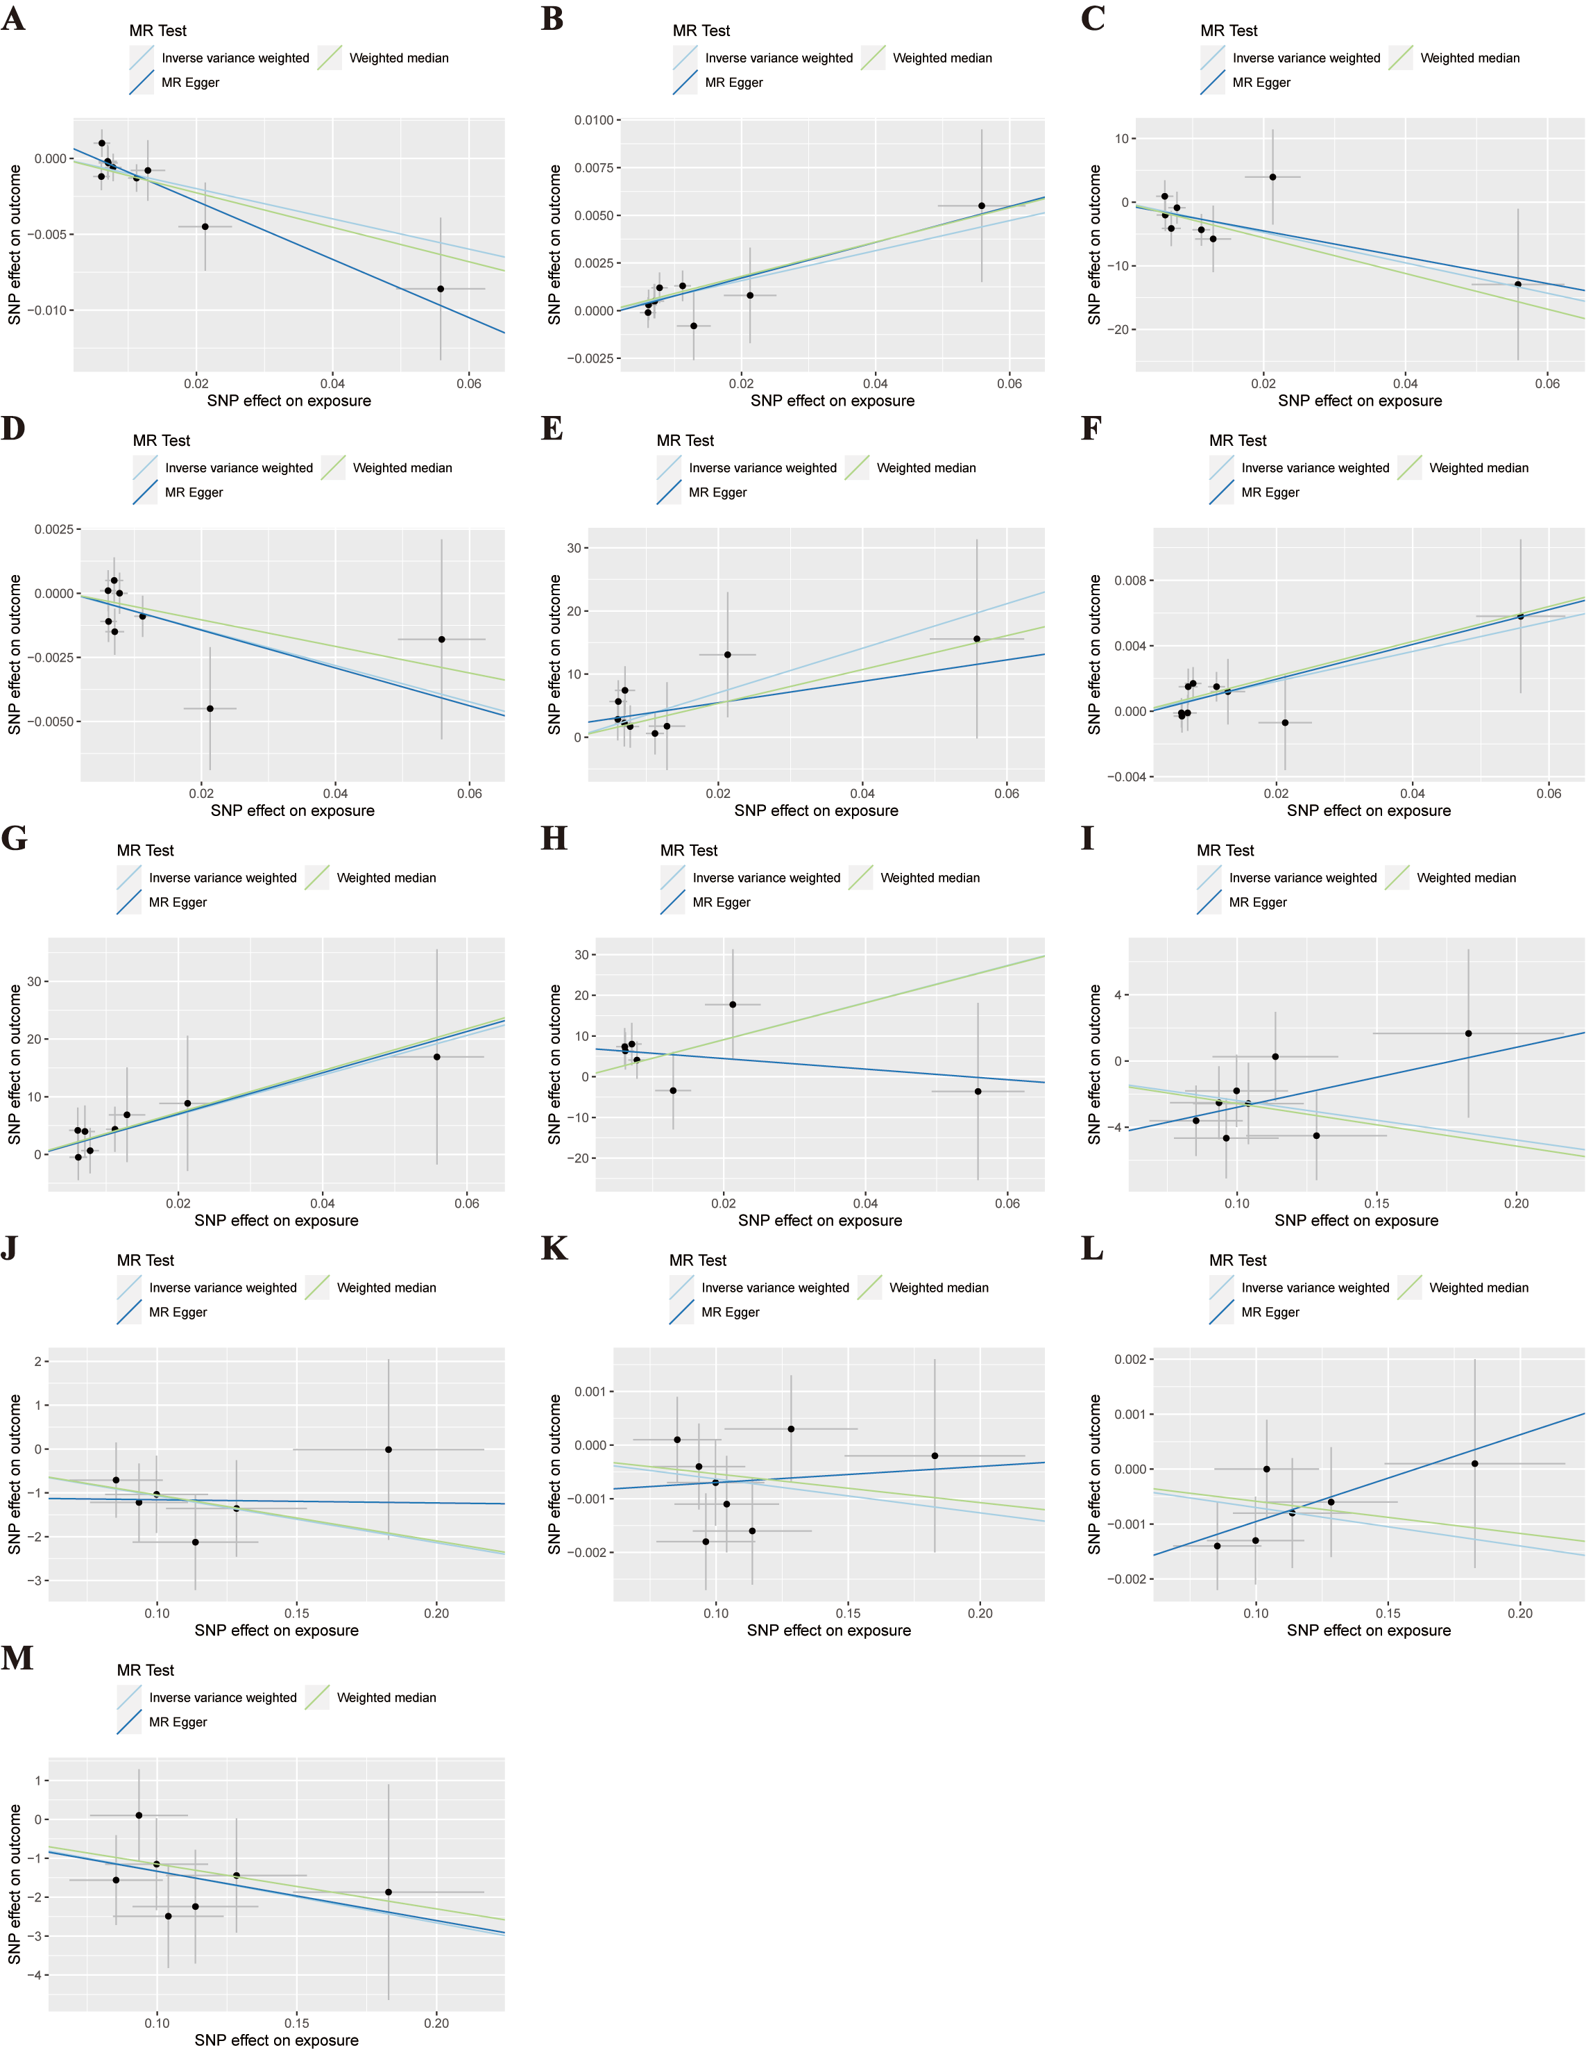
Figure S5. (A) genetically predicted "Alcohol use/AUDIT" on the TH of the bankssts with global weighted; (B) genetically predicted "Alcohol use/AUDIT" on the TH of the cuneus with global weighted; (C) genetically predicted "Alcohol use/AUDIT" on the SA of the precentral with global weighted; (D) genetically predicted "Alcohol use/AUDIT" on the TH of the superior temporal with global weighted; (E) genetically predicted "Alcohol use/AUDIT" on the SA of the postcentral without global weighted; (F) genetically predicted "Alcohol use/AUDIT" on the TH of the cuneus without global weighted; (G) genetically predicted "Alcohol use/AUDIT" on the SA of the lateral occipital without global weighted; (H) genetically predicted "Alcohol use/AUDIT" on the SA of the inferior parietal without global weighted; (I) genetically predicted "Cannabis use disorder" on the SA of the inferior temporal with global weighted; (J) genetically predicted "Cannabis use disorder" on the SA of the posterior cingulate with global weighted; (K) genetically predicted "Cannabis use disorder" on the TH of the pars triangularis with global weighted; (L) genetically predicted "Cannabis use disorder" on the TH of the middle temporal with global weighted; (M) genetically predicted "Cannabis use disorder" on the SA of the posterior cingulate without global weighted.
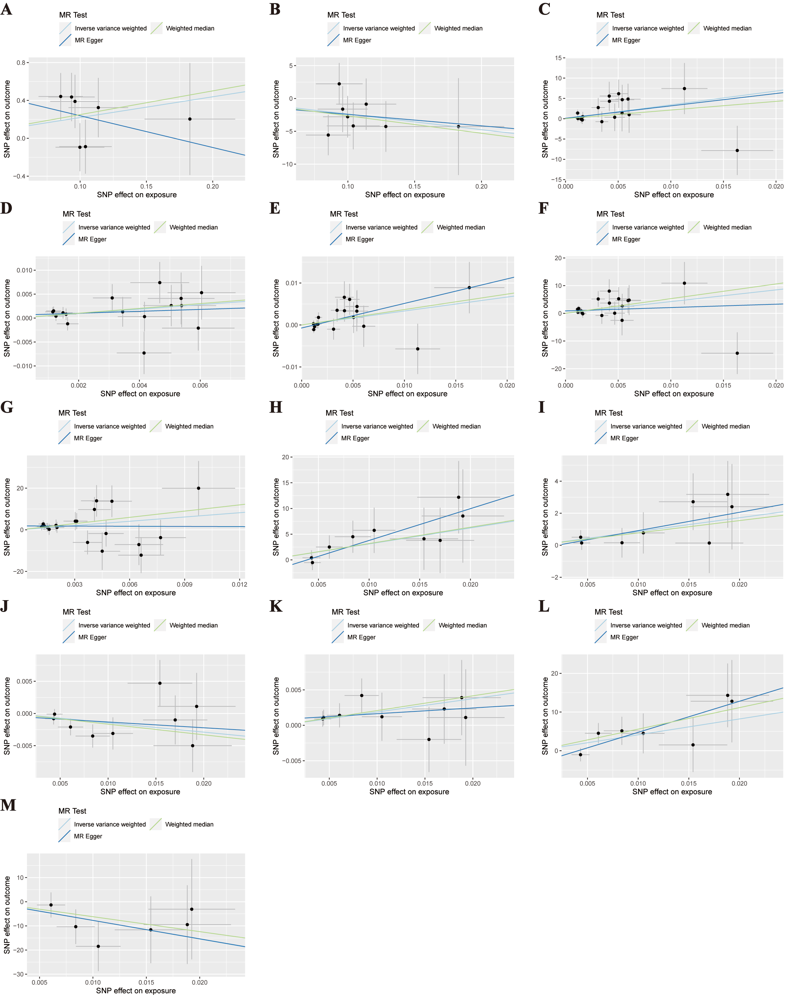
Figure S6. (A) genetically predicted "Cannabis use disorder" on the SA of the frontal pole without global weighted; (B) genetically predicted "Cannabis use disorder" on the SA of the inferior temporal without global weighted; (C) genetically predicted "Substance of prescription or over-the-counter medication addiction: A painkiller" on the SA of the caudal anterior cingulate with global weighted; (D) genetically predicted "Substance of prescription or over-the-counter medication addiction: A painkiller" on the TH of the insula with global weighted; (E) genetically predicted "Substance of prescription or over-the-counter medication addiction: A painkiller" on the TH of the fusiform with global weighted; (F) genetically predicted "Substance of prescription or over-the-counter medication addiction: A painkiller" on the SA of the caudal anterior cingulate without global weighted; (G) genetically predicted "Substance of prescription or over-the-counter medication addiction: A sedative, benzodiazepine or sleeping tablet" on the SA of the pericalcarine without global weighted; (H) genetically predicted "Tobacco smoking: Smokes on most or all days" on the SA of the pars triangularis with global weighted; (I) genetically predicted "Tobacco smoking: Smokes on most or all days" on the SA of the temporal pole with global weighted; (J) genetically predicted "Tobacco smoking: Smokes on most or all days" on the TH of the lingual with global weighted; (K) genetically predicted "Tobacco smoking: Smokes on most or all days" on the TH of the insula with global weighted; (L) genetically predicted "Tobacco smoking: Smokes on most or all days" on the SA of the pars triangularis without global weighted; (M) genetically predicted "Tobacco smoking: Smokes on most or all days" on the SA of the lingual without global weighted

