Supplementary materials: Forecasting COVID-19 Inpatient Mortality using Fundamental Parameters in Resource-Constrained Settings: a Countrywide Multi-Center Cohort Study

Authors:
Ibrahem Hanafi^{1*}, Marah Alsalkini², Alaa Almouhammad³, Ghaya Salhab⁴, Qamar Khoder⁵, Taj Azzam⁶, Bayan Hanafi⁷, Sondos Sallam⁸, Majd Abu Khamis⁹, Ola Alnabelsi¹⁰, Lyana Alzamel¹⁰, Zen Afif¹¹, Manaf Jassem¹², Rahaf Alsoudi¹³, Samaher Almousa⁵

1 Division of Neurology, Department of Internal Medicine, Faculty of Medicine, Damascus University, Damascus, Syrian Arab Republic
2 Faculty of Medicine, Al-Baath University, Homs, Syrian Arab Republic
3 Division of Neurosurgery, Department of Surgery, Faculty of Medicine, Aleppo University, Aleppo, Syrian Arab Republic
4 Division of Pulmonology, Department of Internal Medicine, Faculty of Medicine, Tishreen University, Lattakia, Syrian Arab Republic
5 Division of Rheumatology, Department of Internal Medicine, Tishreen Military Hospital, Damascus, Syrian Arab Republic
6 Division of Endocrinology and Diabetes, Department of Internal Medicine, Tishreen Military Hospital, Damascus, Syrian Arab Republic
7 Department of Radiology, Faculty of Medicine, Damascus University, Damascus, Syrian Arab Republic
8 Division of Pulmonology, Department of Internal Medicine, Damascus Hospital, Damascus, Syrian Arab Republic
9 Faculty of Pharmacy, Al-Rasheed International Private University for Science and Technology, Damascus, Syrian Arab Republic
10 Division of Pulmonology, Department of Internal Medicine, Faculty of Medicine, Damascus University, Damascus, Syrian Arab Republic
11 Division of Plastic and Reconstructive Surgery, Department of Surgery, Faculty of Medicine, Tishreen University, Latakia, Syrian Arab Republic
12 Department of Internal Medicine, Damascus Hospital, Ministry of Health, Damascus, Syrian Arab Republic
13 Department of Oncology, Faculty of Medicine, Damascus University, Damascus, Syrian Arab Republic

* Correspondence to Ibrahem Hanafi, MD, MSc, Division of Neurology, Department of Internal Medicine, Faculty of Medicine, Damascus University, Midan Area 9, Zahira Neighborhood 1, Muhiddin Kattab Ave, Lane 1021, Building 2, Damascus, Syria. Ibrahem.W.Hanafi@gmail.com; 00491781417588; https://orcid.org/0000-0001-5306-0128
Supplementary figure 1: Symptoms at presentation and comorbidities reported by the recruited patients.
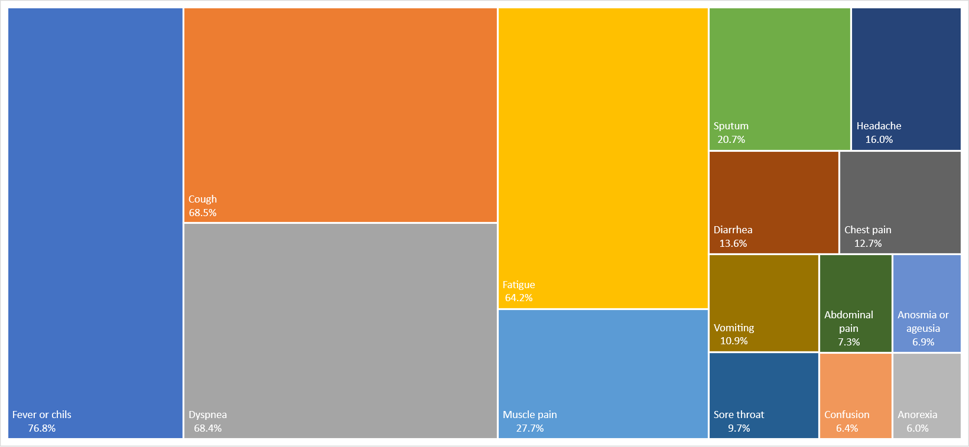
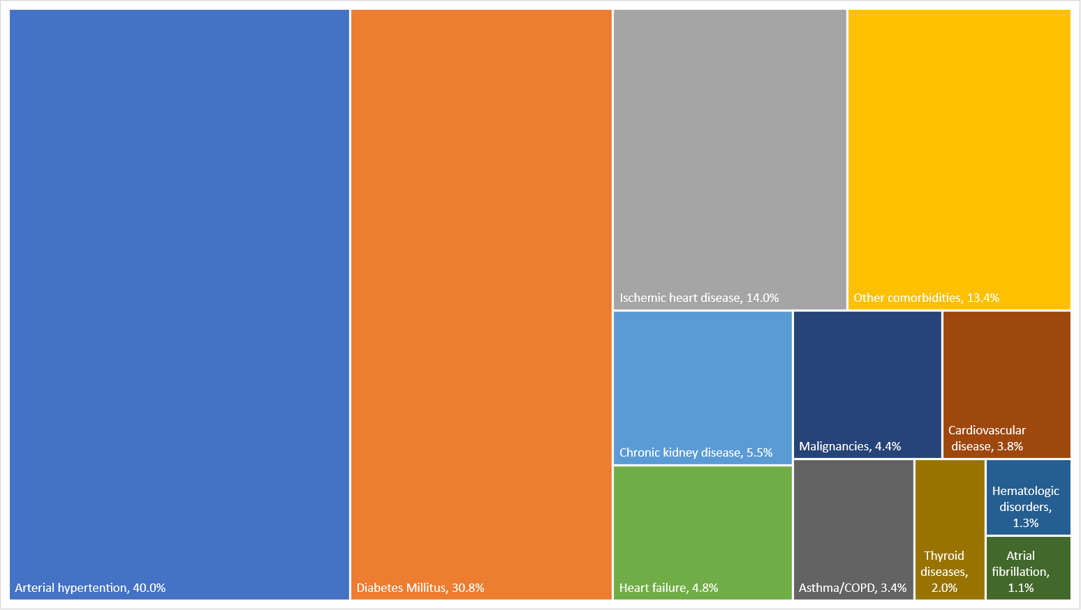
a)
b)

Supplementary figure 1 legend: The percentages represent the proportion of patients with these symptoms (a) or comorbidities (b) at presentation.

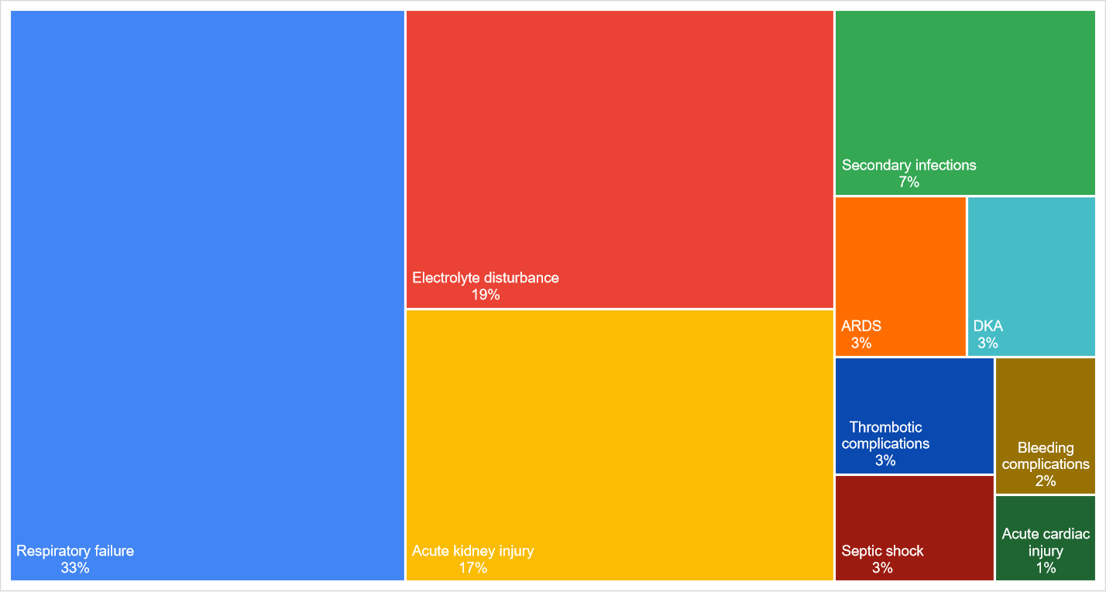
Supplementary figure 2: Complications developed during admission.

Supplementary figure 2 legend: Dialysis was needed in 50 patients; Secondary infections comprised renal, intestinal, and sepsis-related complications; Major bleeding included upper or lower gastro-intestinal hemorrhage as well as pulmonary hemorrhage; Thrombotic complications included ischemic strokes, deep venous thrombosis, and pulmonary embolism; Electrolyte disturbances included hyponatremia, hypokalemia, hyperkalemia, hypernatremia, hypocalcemia, hypochloremia, and hyperchloremia.

Supplementary table 1: Patients’ characteristics and the variables selected from the univariate analysis to predict mortality during hospitalization though the multivariate analysis.

Variables* | Total  (n=3199) | Univariate analysis |  | Multivariate analysis
Variables* | Total  (n=3199) | Mortality (all patients)†  (n=2733) | Mortality (PCR+ patients)†  (n=1409) | Mortality during hospitalization (LR-COMPACK)‡ | Mortality during ICU admission (LR-ALBO-ICU)‡
Characteristics
Gender |  | P=0.421 | - | - | -
Males | 2174 (68.0) | 718 (38.6)
Females | 1025 (32.0) | 323 (37.0)
Age groups |  | P<0.001 | P<0.001 | Included | Included
<55 | 1082 (33.8) | 169 (17.2) | 70 (13.5)
[55-59] | 312 (9.8) | 78 (30.0) | 34 (24.5)
[60-69] | 831 (26.0) | 322 (46.8) | 142 (39.4)
[70-89] | 932 (29.1) | 452 (58.7) | 208 (55.6)
>89 | 42 (1.3) | 20 (60.6) | 8 (47.1)
Smoking |  | P=0.006 | - | - | -
Yes | 763 (23.9) | 231 (35.8)
No | 1806 (56.5) | 570 (37.0)
Missing information | 630 (19.7) | 240 (44.0)
Referral from another center |  | P<0.001 | P=0.006 | - | -
Yes | 302 (9.4) | 129 (47.6) | 80 (41.5)
No | 2897 (90.6) | 912 (37.0) | 382 (31.4)
Previous outpatient management |  | P=0.672 | - | - | -
Yes | 981 (30.7) | 304 (37.5)
No | 2218 (69.3) | 737 (38.3)
Comorbidities
Diabetes Miletus |  | P<0.001 | P<0.001 | Not significant | Not significant
Yes | 986 (30.8) | 379 (46.1) | 173 (41.4)
No | 2213 (69.2) | 662 (34.7) | 289 (29.2)
Hypertension |  | P<0.001 | P<0.001 | Not significant | Not significant
Yes | 1281 (40.0) | 501 (46.8) | 211 (40.0)
No | 1918 (60.0) | 540 (32.5) | 251 (28.5)
Ischemic heart disease |  | P<0.001 | P=0.007 | - | -
Yes | 449 (14.0) | 183 (48.4) | 72 (41.9)
No | 2750 (86.0) | 858 (36.4) | 391 (31.5)
Heart Failure |  | P<0.001 | P<0.001 | Not significant | Not significant
Yes | 154 (4.8) | 69 (50.7) | 37 (55.2)
No | 3045 (95.2) | 972 (37.4) | 425 (31.7)
Atrial fibrillation |  | P=0.090 | - | - | -
Yes | 34 (1.1) | 15 (53.6)
No | 3165 (98.9) | 1026 (37.9)
Chronic lung diseases |  | P=0.615 | - | - | -
Yes | 110 (3.4) | 32 (35.6)
No | 3089 (96.6) | 1009 (38.2)
Chronic kidney disease |  | P<0.001 | P<0.001 | Included | Not significant
Yes | 176 (5.5) | 88 (59.1) | 36 (55.4)
No | 3023 (94.5) | 953 (36.9) | 426 (31.7)
Cardiovascular accident |  | P<0.001 | P=0.002 | Not significant | Not significant
Yes | 122 (3.8) | 59 (56.7) | 24 (54.5)
No | 3077 (96.2) | 982 (37.4) | 438 (32.1)
Malignancies |  | P<0.001 | P<0.001 | Included | Not significant
Yes | 140 (4.4) | 75 (63.0) | 27 (58.7)
No | 3059 (95.6) | 966 (37.0) | 435 (31.9)
Hematologic disorders |  | P=0.757 | - | - | -
Yes | 42 (1.3) | 15 (40.5)
No | 3157 (98.7) | 1026 (38.1)
Hyper- and hypothyroid |  | P=0.094 | - | - | -
Yes | 65 (2.0) | 14 (26.9)
No | 3134 (98.0) | 1027 (38.3)
Other comorbidities |  | P=0.039 | - | - | -
Yes | 430 (13.4) | 154 (43.0)
No | 2769 (86.6) | 887 (37.3)
Vital signs
Mean arterial pressure |  | P=0.287 | - | - | -
 | 90.5 ± 14.2 | -0.6 ± 0.6
Respiration rate |  | P<0.001 | Available in <50% | Excluded | -
 | 27.1 ± 8.2 | 6.4 ± 0.5
O2_sat_room_groups |  | P<0.001 | P<0.001 | Included | Included
 | 83.8 ± 13.2 | -15.4 ± 0.5 | -14.3 ± 0.7
Pulse rate |  | P<0.001 | P=0.013 | Included | Not significant
 | 93.6 ± 17.7 | 3.3 ± 0.8 | 2.7 ± 1.1
Temp* |  | P=0.050 | - | - | -
 | 37.9 ± 1.0 | -0.1 ± 0.0
Consciousness |  | P<0.001 | P<0.001 | Included | Not significant
Disturbed | 244 (7.6) | 178 (80.2) | 77 (78.6)
Full | 2955 (92.4) | 863 (34.4) | 385 (29.4)
Laboratory findings
WBCs c/ul |  | P<0.001 | P<0.001 | Not significant | Not significant
 | 9681.2 ± 5303.9 | 2941.3 ± 211.5 | 3119.0 ± 284.2
Lymphocytes % |  | P<0.001 | P<0.001 | Included | Included
 | 13.7 ± 11.2 | -5.0 ± 0.5 | -5.7 ± 0.7
Plt p/ul |  | P=0.543 | - | - | -
 | 234.3 ± 108.4 | -2.8 ± 4.6
Alt u/l |  | P=0.554 | - | - | -
 | 49.1 ± 92.4 | 2.9 ± 4.9
Ast u/l |  | P=0.005 | - | - | -
 | 49.8 ± 51.4 | 8.3 ± 3.0
LDH u/l |  | P<0.001 | P<0.001 | Included | Included
 | 732.0 ± 665.5 | 397.8 ± 35.2 | 286.9 ± 41.6
CK u/l |  | P=0.143 | - | - | -
 | 246.4 ± 455.6 | 37.3 ± 25.4
Ur mg/dl |  | P<0.001 | P<0.001 | Not significant | Not significant
 | 63.7 ± 50.6 | 33.3 ± 2.3 | 31.8 ± 2.9
Cr mg/dl |  | P=0.694 | - | - | -
 | 5.5 ± 21.5 | 0.4 ± 1.0
CRP mg/dl |  | P<0.001 | P<0.001 | Included | Not significant
 | 76.2 ± 73.7 | 28.1 ± 3.3 | 37.9 ± 4.8
Na mEq/l |  | P=0.774 | - | - | -
 | 136.1 ± 6.2 | 0.1 ± 0.3
K mEq/l |  | P<0.001 | P=0.037 | Not significant | Not significant
 | 4.0 ± 0.8 | 0.2 ± 0.0 | 0.1 ± 0.0
Ph |  | P<0.001 | P=0.005 | Included | Not significant
 | 7.4 ± 0.1 | -0.037 ± 0.008 | -0.031 ± 0.012
PaCo2 mmHg |  | P=0.791 | P=0.530 | - | -
 | 30.9 ± 11.1 | 0.2 ± 0.7 | 0.8 ± 1.3
Hco3 mEq/l |  | P<0.001 | P=0.036 | Included | Included
 | 19.8 ± 5.7 | -1.5 ± 0.4 | -1.1 ± 0.6
Imaging findings
Right infiltration |  | P<0.001 | P<0.001 | Included | Not significant
<25% | 468 (27.4) | 57 (14.2) | 28 (14.7)
25-50% | 636 (37.3) | 188 (37.2) | 64 (30.5)
50-75% | 404 (23.7) | 192 (57.7) | 96 (54.5)
>75% | 197 (11.6) | 136 (80.0) | 71 (80.7)
Left infiltration |  | P<0.001 | P<0.001 | Included | Not significant
<25% | 497 (29.1) | 55 (13.3) | 23 (11.8)
25-50% | 654 (38.4) | 212 (40.1) | 81 (35.5)
50-75% | 371 (21.8) | 179 (59.1) | 95 (57.6)
>75% | 183 (10.7) | 127 (78.9) | 60 (77.9)
Distribution |  | P<0.001 | P<0.001 | Not significant | Not significant
Central | 532 (22.1) | 230 (56.0) | 121 (57.3)
Peripheral | 1878 (77.9) | 571 (35.3) | 200 (28.6)
Alveolar infiltrates |  | P<0.001 | P<0.001 | Not significant | Not significant
Yes | 1441 (77.3) | 202 (57.9) | 99 (57.2)
No | 423 (22.7) | 388 (32.4) | 179 (30.1)
Interstitial infiltrates |  | P<0.001 | P<0.001 | Not significant | Not significant
Yes | 618 (33.2) | 189 (44.6) | 108 (51.7)
No | 1246 (66.8) | 401 (35.7) | 170 (30.5)
Pleural effusion |  | P=0.015 | - | - | -
Yes | 143 (5.9) | 56 (50.5)
No | 2267 (94.1) | 745 (38.9)
Ground glass opacity (on CT) |  | P=0.475 | - | - | -
Yes | 1090 (71.0) | 320 (38.1)
No | 446 (29.0) | 242 (59.8)
Consolidation (on CT) |  | P<0.001 | P<0.001 | Not significant | Not significant
Yes | 277 (18.0) | 89 (48.6) | 48 (49.5)
No | 1259 (82.0) | 389 (36.7) | 149 (30.5)
Interlobular septal thickening (on CT) |  | P=0.099 | - | - | -
Yes | 114 (7.4) | 35 (47.9)
No | 1422 (92.6) | 448 (38.3)
* The statistical tests were Chi-square for categorical variables and Student t test for continuous variables; † These columns include n (%) for categorical variables and mean ± SD or mean difference ± standard error difference for continuous variables with a sample size of 2733 for the whole sample and 1409 for PCR+ cases; ‡ Variables which reached the significance level of 0.001 for the overall sample and 0.005 or 0.05 for categorical and continuous variables, respectively, when focusing on PCR positive patients, entered these multivariate binary logistic regression analyses.

Supplementary table 2: Diagnostic modalities utilized to confirm the COVID-19 diagnosis.
Modality | Frequency |  | Percentage
CT |  | 702 |  | 21.9
CXR |  | 548 |  | 17.1
Positive PCR* |  | 1725 |  | 53.9
Rapid positive lgM test |  | 14 |  | 0.4
Only clinical suspicion |  | 210 |  | 6.6
* 1868 patients performed PCR tests in total and 143 of them received negative or inconclusive results.

Supplementary table 3: First step binary logistic regression analysis to predict mortality (n=1982; R²=52.3; P<0.001).

 |  | Regression findings |  |  |  |  | Bootstrap findings
Predictors |  | B | P value | Exp(B) | 95% CI |  | P value | 95% CI
 | DM | .148 | .294 | 1.160 | .880 | 1.529 | .301 | -.156 | .427
 | HTN | -.139 | .329 | .871 | .659 | 1.150 | .358 | -.444 | .135
 | Heart failure | .109 | .689 | 1.115 | .653 | 1.903 | .690 | -.438 | .661
 | CKD | .523 | .041 | 1.687 | 1.021 | 2.787 | .044 | -.026 | 1.033
 | CVA | .200 | .502 | 1.222 | .680 | 2.195 | .488 | -.457 | .850
 | Malignancies | 1.430 | <.001 | 4.181 | 2.448 | 7.140 | <.001 | .872 | 2.112
 | Age <55 |  | <.001 |  |  |  | .013 | .101 | 1.122
 | [55,59] | .595 | .013 | 1.814 | 1.133 | 2.904 | <.001 | .782 | 1.483
 | [60-69] | 1.111 | <.001 | 3.036 | 2.135 | 4.318 | <.001 | 1.089 | 1.811
 | [70-89] | 1.408 | <.001 | 4.086 | 2.887 | 5.784 | <.001 | .719 | 2.891
 | >89 | 1.666 | .002 | 5.291 | 1.861 | 15.048 | .015 | .234 | 1.759
 | O₂ blood saturation ≥97 |  | <.001 |  |  |  | <.001 | 1.041 | 2.565
 | [92-96] | .884 | .016 | 2.422 | 1.180 | 4.971 | <.001 | 1.808 | 3.408
 | [87-91] | 1.672 | <.001 | 5.322 | 2.648 | 10.697 | <.001 | 2.034 | 3.619
 | [82-86] | 2.464 | <.001 | 11.754 | 5.848 | 23.628 | <.001 | 3.054 | 4.687
 | [77-81] | 2.671 | <.001 | 14.458 | 6.981 | 29.940 | <.001 | 3.509 | 5.186
 | [72-76] | 3.726 | <.001 | 41.500 | 19.312 | 89.179 | <.001 | 3.619 | 5.390
 | [62-71] | 4.164 | <.001 | 64.358 | 30.146 | 137.394 | .003 | .197 | .905
 | ≤61 | 4.325 | <.001 | 75.556 | 34.723 | 164.407 | .009 | .334 | 2.015
 | HR ≤110 |  | <.001 |  |  |  | <.001 | 1.482 | 2.632
 | [111-125] | .538 | .002 | 1.713 | 1.209 | 2.428 | <.001 | -4.911 | -3.568
 | >125 | 1.103 | .003 | 3.014 | 1.471 | 6.175 | .301 | -.156 | .427
 | Disturbed consciousness | 1.984 | <.001 | 7.270 | 4.322 | 12.230 | .358 | -.444 | .135
 | Constant | -4.074 | <.001 | .017 |  |  | .690 | -.438 | .661

Supplementary table 4: Binary logistic regression analysis that predicts mortality using a model of eight blood tests isolated from the univariate analysis (n=507; R²=10.5%; P<0.001).

 |  | B | P value | Adj. OR | 95% CI
 | CRP | .704 | .002 | 2.022 | 1.294 | 3.159
 | Ur | .799 | .069 | 2.223 | .941 | 5.252
 | LDH | .782 | .025 | 2.185 | 1.102 | 4.334
 | WBC | .261 | .171 | 1.298 | .893 | 1.886
 | Lymphocytes | .653 | .020 | 1.922 | 1.108 | 3.335
 | K | .159 | .617 | 1.172 | .628 | 2.188
 | Ph | .587 | .036 | 1.799 | 1.038 | 3.118
 | HCO3 | .503 | .014 | 1.654 | 1.108 | 2.469
 | Constant | -2.996 | <.001 | .050

Supplementary table 5: Binary logistic regression analysis to predict mortality using six radiological findings eligible for multivariate analysis (n=656; R²=40.5%; P<0.001).
 |  | B | Sig. | Exp(B) | 95% CI
 | Alveolar infiltrates | .475 | .054 | 1.607 | .992 | 2.604
 | Interstitial infiltrates | .441 | .060 | 1.554 | .981 | 2.461
 | Consolidation on CT | -.110 | .686 | .896 | .526 | 1.527
 | Central distribution of infiltration | -.165 | .529 | .848 | .507 | 1.417
 | Right lung infiltration <25% |  | <.001
 | 25-50% | .718 | .028 | 2.050 | 1.079 | 3.898
 | 50-75% | 1.574 | <.001 | 4.826 | 2.279 | 10.217
 | >75% | 2.502 | <.001 | 12.202 | 4.530 | 32.864
 | Left lung infiltration <25% |  | <.001
 | 25-50% | 1.260 | <.001 | 3.526 | 1.896 | 6.559
 | 50-75% | 1.418 | <.001 | 4.127 | 1.864 | 9.136
 | >75% | 1.650 | .001 | 5.204 | 1.919 | 14.111
 | Constant | -2.796 | <.001 | .061

Supplementary table 6: A binary logistic regression analysis to predict mortality based on demographics, vital signs, blood tests, and imaging (n=667; P<0.001)
 |  | B | P value | Adj. OR | 95% CI
Block 1:  Demographics and vital signs  Block 2:  Blood tests  Block 3: Imaging | CKD | .447 | .383 | 1.564 | .572 | 4.279
 | Malignancies | 1.429 | .003 | 4.173 | 1.602 | 10.875
 | Age <55 |  | <.001
 | [55.59] | .627 | .159 | 1.873 | .783 | 4.481
 | [60-69] | 1.685 | <.001 | 5.391 | 2.825 | 10.289
 | [70-89] | 1.282 | <.001 | 3.604 | 1.946 | 6.675
 | >89 | 21.647 | .999 | - | - | -
 | O₂ saturation ≥97 |  | <.001
 | [92-96] | .568 | .370 | 1.765 | .509 | 6.114
 | [87-91] | .689 | .260 | 1.993 | .601 | 6.607
 | [82-86] | 1.374 | .026 | 3.951 | 1.181 | 13.214
 | [77-81] | 1.693 | .012 | 5.435 | 1.453 | 20.327
 | [72-76] | 2.753 | <.001 | 15.689 | 3.809 | 64.623
 | [62-71] | 2.512 | <.001 | 12.327 | 3.271 | 46.451
 | ≤61 | 2.788 | <.001 | 16.242 | 4.110 | 64.192
 | Disturbed consciousness | 2.190 | <.001 | 8.934 | 2.694 | 29.628
 | HR ≤110 |  | .006
 | [111-125] | .739 | .024 | 2.093 | 1.101 | 3.978
 | >125 | 1.951 | .017 | 7.033 | 1.416 | 34.938
 | CRP | 1.477 | <.001 | 4.378 | 1.976 | 9.701
 | LDH | .762 | .050 | 2.143 | .999 | 4.598
 | Right lung infiltration <25% |  | .080
 | 25-50% | .489 | .265 | 1.631 | .690 | 3.854
 | 50-75% | 1.053 | .050 | 2.866 | 1.002 | 8.196
 | >75% | 1.719 | .014 | 5.580 | 1.424 | 21.857
 | Left lung infiltration <25% |  | .036
 | 25-50% | 1.228 | .005 | 3.415 | 1.438 | 8.109
 | 50-75% | 1.339 | .015 | 3.814 | 1.297 | 11.213
 | >75% | 1.549 | .029 | 4.708 | 1.168 | 18.968
 | Constant | -7.067 | <.001 | .001

Supplementary table 7: LR-COMPAK and LR-ALBO-ICU comparison among cities and their association with mortality and ICU admission.
Geographical variable | LR-COMPAK | LR-ALBO-ICU | Mortality during hospitalization  (n=2733) | ICU admission  (n=3199) | Mortality in the ICU  (n=756)
City | P<0.001* | P<0.001* | P<0.001° | P<0.001° | P<0.001°
Damascus | 30 (15,46) | 34 (25,45) | 608 (40.5) | 559 (33.9) | 432 (82.1)
Aleppo | 34 (20,42) | 34 (25,39) | 110 (26.2) | 105 (22.1) | 35 (36.5)
Latakia | 33 (20,44) | 25 (19,34) | 158 (46.3) | 73 (12.7) | 59 (92.2)
Homs | 23 (14,39) | - | 165 (35.1) | 70 (13.9) | 60 (85.7)
Hospital | P<0.001* | P<0.001* | P<0.001° | P<0.001° | P<0.001°
Al-Assad hospital | 38 (25,48) | 35 (25,45) | 178 (51.0) | 124 (32.2) | 107 (90.7)
Al-Mowasat hospital | 43 (36,56) | 25 (34,45) | 139 (64.7) | 118 (47.0) | 79 (73.1)
Damascus hospital | 36 (25,51) | 26 (24,35) | 179 (48.8) | 200 (46.4) | 152 (81.7)
Tishreen military hospital | 17 (9,31) | 34 (24,38) | 110 (22.5) | 112 (22.5) | 92 (84.4)
Qatana military hospital | 0 (0,9) | - | 2 (2.4) | 5 (6.1) | 2 (40.0)
Aleppo University hospital | 34 (20,42) | 34 (25,39) | 110 (26.2) | 105 (22.1) | 35 (36.5)
Tishreen University hospital | 33 (20,44) | 25 (19,34) | 158 (46.3) | 73 (12.7) | 59 (92.2)
Al-Waleed hospital | 26 (15,39) | - | 98 (37.4) | 3 (1.1) | 3 (100.0)
Homs military hospital | 23 (9,39) | - | 67 (32.2) | 67 (30.6) | 57 (85.1)
* Wilcoxon signed-rank test; ° Chi-square test.

Supplementary table 8: The association between LR-COMPAK, LR-ALBO-ICU, mortality, and major clinical interventions.

 | LR-COMPAK | Mortality during hospitalization | P value and OR | LR-ALBO-ICU | Mortality during ICU admission | P value and OR
O₂ support
No | 9 (0,20) | 38 (5.4) | <0.001 | - | - | -
Yes | 38 (27,51)* | 1003 (49.3) | 16.9 [12.1-23.7] | - | - | -
ICU admission
No | 25 (11,39) | 455 (23.0) | <0.001 | 34 (24,36) | - | -
Yes | 46 (36,56)* | 586 (77.5) | 11.5 [9.4-14.1] | 34 (25,45) | - | -
MV
No | 28 (14,41) | 690 (29.3) | <0.001 | 34 (25,36) | 235 (62.8) | <0.001
Yes | 48 (36,57)* | 351 (91.9) | 27.3 [18.7-39.8] | 35 (25,45) | 351 (91.9) | 6.7 [4.4-10.2]
NIV
No | 28 (15,42) | 800 (34.0) | <0.001 | 34 (25,37) | 453 (80.7) | <0.001
Yes | 48 (36,56)* | 241 (63.4) | 3.4 [2.7-4.2] | 34 (25,45) | 133 (68.2) | 0.5 [0.4-0.7]
Diagnostic Modalities
PCR/Rapid | 28 (15,41) | 464 (32.7) | <0.001 | 30 (24,35) | 227 (72.8) | <0.001
CT | 31 (17,48)* | 291 (44.8) |  | 34 (25,45)° | 175 (87.1)
CXR | 36 (17,51)* | 206 (42.6) |  |  | 156 (78.8)
Clinical presentation | 41 (28,51)* | 80 (44.7) |  |  | 28 (62.2)
* Marks statistically significant difference between the LR-COMPAK values of each category; ° Due to the limited number of cases we grouped all patients without a PCR positive test in one category.

Supplementary table 9: Binary logistic regression analysis utilizing the same items in LR-COMPAK to predict ICU admission (n=2358; R²=27.5%; P<0.001)
 |  |  |  |  |  |  | Bootstrap findings
 |  | B | P value | Adj. OR | 95% CI |  | P value | 95% CI
 | CKD | .041 | .854 | 1.042 | .671 | 1.620 | .874 | -.470 | .496
 | Malignancies | .346 | .145 | 1.413 | .887 | 2.251 | .155 | -.136 | .820
 | Age <55 |  | .301
 | [55.59] | .230 | .263 | 1.259 | .841 | 1.886 | .273 | -.186 | .645
 | [60-69] | .309 | .039 | 1.362 | 1.016 | 1.826 | .045 | -.005 | .602
 | [70-89] | .261 | .077 | 1.298 | .972 | 1.734 | .098 | -.042 | .575
 | >89 | .114 | .806 | 1.121 | .451 | 2.786 | .805 | -1.062 | 1.078
 | O₂ saturation ≥97 |  | <.001
 | [92-96] | .536 | .065 | 1.708 | .968 | 3.015 | .055 | .003 | 1.173
 | [87-91] | .992 | <.001 | 2.698 | 1.548 | 4.702 | <.001 | .473 | 1.607
 | [82-86] | 1.607 | <.001 | 4.987 | 2.872 | 8.659 | <.001 | 1.114 | 2.274
 | [77-81] | 1.933 | <.001 | 6.912 | 3.872 | 12.339 | <.001 | 1.376 | 2.643
 | [72-76] | 2.469 | <.001 | 11.815 | 6.523 | 21.401 | <.001 | 1.924 | 3.161
 | [62-71] | 2.708 | <.001 | 14.999 | 8.426 | 26.700 | <.001 | 2.168 | 3.324
 | ≤61 | 2.988 | <.001 | 19.845 | 11.074 | 35.565 | <.001 | 2.460 | 3.732
 | HR ≤110 |  | <.001
 | [111-125] | .360 | .014 | 1.434 | 1.074 | 1.913 | .017 | .042 | .664
 | >125 | .919 | <.001 | 2.508 | 1.461 | 4.305 | <.001 | .360 | 1.520
 | Disturbed consciousness | 1.419 | <.001 | 4.134 | 2.831 | 6.038 | <.001 | .982 | 1.866
 | Constant | -3.112 | <.001 | .045 |  |  | <.001 | -3.686 | -2.726

Supplementary table 10: Binary logistic regression analysis utilizing the items in LR-COMPAK to predict mortality for patients admitted to the ICU (n=530; R²=15.8%; P<0.001).

 |  | B | P value | Adj. OR | 95% CI
 | CKD | .110 | .833 | 1.116 | .401 | 3.108
 | Malignancies | .984 | .126 | 2.675 | .759 | 9.437
 | Age <55 |  | <.001
 | [55.59] | .176 | .650 | 1.192 | .558 | 2.547
 | [60-69] | 1.060 | .001 | 2.885 | 1.532 | 5.432
 | [70-89] | 1.121 | <.001 | 3.067 | 1.668 | 5.639
 | >89 | -.120 | .906 | .887 | .121 | 6.504
 | O₂ saturation ≥97 |  | .002
 | [92-96] | .507 | .426 | 1.660 | .476 | 5.789
 | [87-91] | .845 | .177 | 2.328 | .683 | 7.935
 | [82-86] | 1.201 | .051 | 3.322 | .994 | 11.105
 | [77-81] | 1.368 | .033 | 3.926 | 1.120 | 13.757
 | [72-76] | 1.431 | .027 | 4.184 | 1.172 | 14.940
 | [62-71] | 2.183 | <.001 | 8.876 | 2.454 | 32.108
 | ≤61 | 1.831 | .004 | 6.242 | 1.823 | 21.376
 | Disturbed consciousness | .677 | .068 | 1.968 | .951 | 4.072
 | HR ≤110 |  | .298
 | [111-125] | .475 | .167 | 1.608 | .820 | 3.152
 | >125 | -.247 | .597 | .781 | .313 | 1.951
 | Constant | -.733 | .214 | .480

Supplementary table 11: Binary logistic regression analyses predicting mortality in the ICU by patients’ characteristics and vital signs (n=520); blood tests (n=228); and imaging findings (n=156; P<0.001 for all).

 |  | B | P value | Adj. OR | 95% CI
 | Patients’ characteristics and vital signs
 | DM | -.117 | .660 | .889 | .528 | 1.499
 | HTN | .226 | .405 | 1.253 | .736 | 2.134
 | Heart failure | -.830 | .059 | .436 | .184 | 1.030
 | CKD | .206 | .694 | 1.229 | .439 | 3.438
 | CVA | -.464 | .352 | .629 | .237 | 1.669
 | Malignancies | .928 | .146 | 2.529 | .725 | 8.821
 | Age >59 | .519 | <.001 | 1.680 | 1.309 | 2.158
 | HR ≤110 |  | .236
 | [111-125] | .509 | .131 | 1.663 | .859 | 3.220
 | >125 | -.259 | .567 | .772 | .318 | 1.873
 | O₂ blood saturation <82 | .224 | <.001 | 1.251 | 1.115 | 1.405
 | Disturbed consciousness | .554 | .129 | 1.739 | .851 | 3.554
 | Constant | -.498 | .156 | .608
 | Blood tests
 | LDH | 1.341 | .018 | 3.824 | 1.255 | 11.654
 | CRP | .210 | .652 | 1.234 | .494 | 3.081
 | Ur | 1.135 | .120 | 3.113 | .743 | 13.042
 | Lymphocytes | .975 | .049 | 2.651 | 1.004 | 7.002
 | Hco3 | .931 | .010 | 2.538 | 1.253 | 5.139
 | WBC | .002 | .994 | 1.002 | .496 | 2.028
 | K | 1.102 | .173 | 3.011 | .618 | 14.672
 | Ph | -.178 | .721 | .837 | .316 | 2.219
 | Constant | -2.554 | .023 | .078
 | Imaging findings
 | Right lung infiltration <25% |  | .457
 | 25-50% | -.716 | .475 | .489 | .069 | 3.481
 | 50-75% | .023 | .983 | 1.024 | .125 | 8.361
 | >75% | .926 | .466 | 2.524 | .210 | 30.377
 | Left lung infiltration <25% |  | .123
 | 25-50% | .757 | .454 | 2.131 | .293 | 15.478
 | 50-75% | -.773 | .482 | .462 | .053 | 3.989
 | >75% | .977 | .511 | 2.657 | .145 | 48.806
 | Central distribution of infiltration | 2.119 | .080 | 8.323 | .775 | 89.339
 | Alveolar infiltrates | .955 | .206 | 2.598 | .591 | 11.422
 | Interstitial infiltrates | .079 | .924 | 1.082 | .216 | 5.405
 | Consolidation on CT | .830 | .480 | 2.294 | .229 | 23.010
 | Constant | 1.121 | .128 | 3.069

Supplementary table 12: Binary logistic regression analysis predicting mortality in the ICU by a combination of variables isolated from supplementary table 11 (n=200, r²=24.2, P<0.001).

 |  | B | P value | Adj. OR | 95% CI
 | Hco3 <22 | 1.027 | .009 | 2.792 | 1.296 | 6.012
 | LDH <350 |  | .013
 | [350-1250] | 1.578 | .006 | 4.844 | 1.561 | 15.028
 | >1250 | 1.942 | .008 | 6.971 | 1.654 | 29.381
 | Lymphocites <20% | .386 | .471 | 1.471 | .515 | 4.202
 | O2 blood saturation <82 | 1.078 | .006 | 2.938 | 1.362 | 6.336
 | Age >59 | .951 | .016 | 2.588 | 1.197 | 5.597
 | Constant | -2.220 | .005 | .109

