Phytochemical screening, UPLC analysis, evaluation of synergistic antioxidant and antibacterial efficacy of three medicinal plants used in Kinshasa, D.R. Congo

Supplementary information

A.
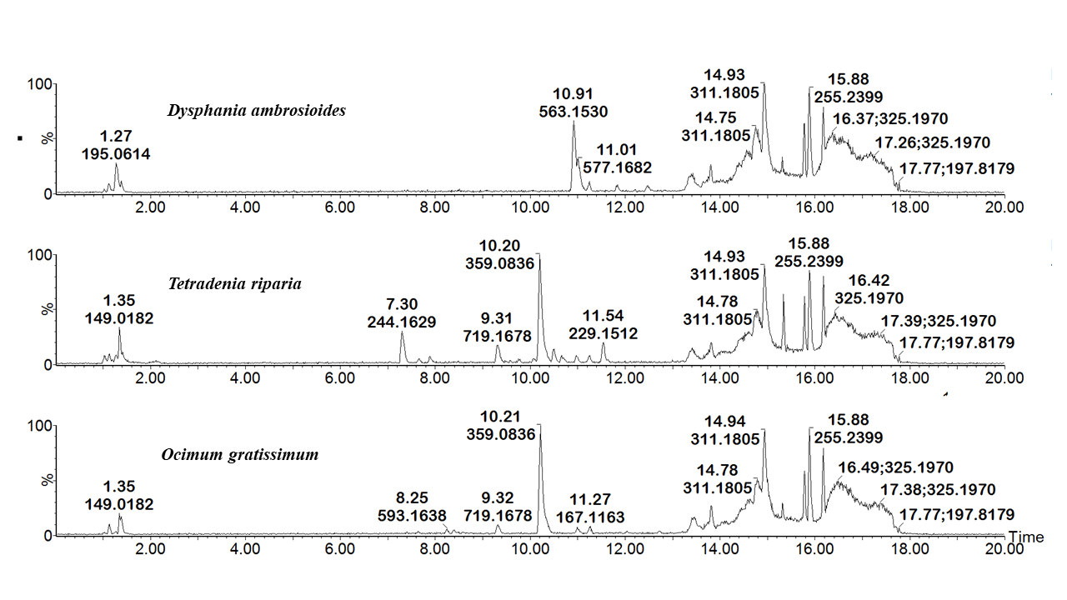
B.
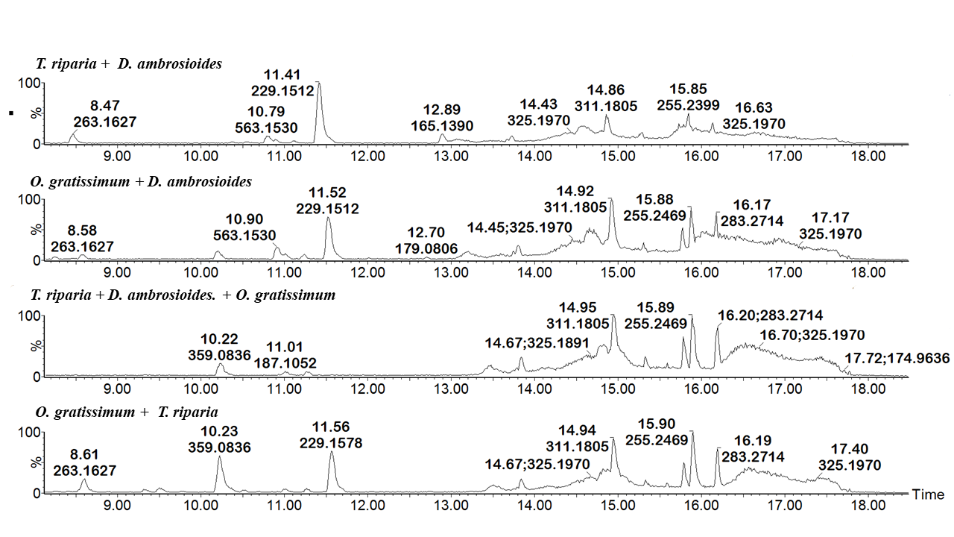
Figure S1. ESI negative mode BPI chromatograms of decocted extracts of the tested plant species (A) and their combinations (B). The tentatively identified compounds are shown in Table S1.

Table S1. Tentative identification of the major compounds in the decocted plant extracts.
Medicinal plants | RT min | Acquired [M-H]⁻  m/z | Theoretical  [M-H]⁻  m/z | Molecular Formula | Tentative Identification
O. gratissimum | 9.32 | 719.1678 | 719.1612 | C₃₆H₃₂O₁₆ | Kaempferol3-[2-O,3-O,4-O-triacetyl-6-O-[(E)-p-coumaroyl]-beta-D-glucopyranoside]
O. gratissimum | 10.21 | 359.0836 | 359.0767 | C₁₈H₁₆O₈ | Rosmarinic acid
O. gratissimum | 13.82 | 343.0911 | 343.0818 | C₁₈H₁₆O₇ | Xanthomicrol
T. riparia | 9.31 | 719.1678 | 719.1612 | C₃₆H₃₂O₁₆ | Kaempferol3-[2-O,3-O,4-O-triacetyl-6-O-[(E)-p-coumaroyl]-beta-D-glucopyranoside]
T. riparia | 10.20 | 359.0836 | 359.0767 | C₁₈H₁₆O₈ | Rosmarinic acid
D. ambrosioides | 10.91 | 563.1530 | 563.1401 | C₂₆H₂₈O₁₄ | Apigenin 7-glycosides
D. ambrosioides | 11.01 | 577.1682 | 577.1557 | C₂₇H₃₀O₁₄ | Kaempferitrin
O. gratissimum + T. riparia | 10.23 | 359.0836 | 359.0767 | C₁₈H₁₆O₈ | Rosmarinic acid
O. gratissimum + T. riparia | 11.56 | 481.2818 | 481.2801 | C₂₆H₄₂O₈ | Xerophinoid C
O. gratissimum + D. ambrosioides | 7.28 | 309.1100 | 309.1127 | C₁₉H₁₈O₄ | 7-Hydroxy-3-(4-methoxyphenyl)-4-propylcoumarin
O. gratissimum + D. ambrosioides | 8.24 | 593.1563 | 593.1506 | C₂₇H₃₀O₁₅ | Kaempferol 3-O-rutinoside
O. gratissimum + D. ambrosioides | 10.20 | 359.0836 | 359.0767 | C₁₈H₁₆O₈ | Rosmarinic acid
O. gratissimum + D. ambrosioides | 10.90 | 563.1530 | 563.1401 | C₂₆H₂₈O₁₄ | Apigenin 7-glycosides
O. gratissimum + D. ambrosioides | 11.52 | 481.2818 | 481.2801 | C₂₆H₄₂O₈ | Xerophinoid C
T. riparia + D. ambrosioides | 10.79 | 563.1530 | 563.1401 | C₂₆H₂₈O₁₄ | Apigenin 7-glycosides
T. riparia + D. ambrosioides | 11.41 | 481.2818 | 481.2801 | C₂₆H₄₂O₈ | Xerophinoid C
T. riparia + D. ambrosioides | 12.89 | 441.2305 | 441.0880 | C₂₂H₁₈O₁₀ | 3-Galloylcatechin  Epicatechin 5-gallate
T. riparia + D. ambrosioides +  O. gratissimum | 10.22 | 359.0836 | 359.0767 | C₁₈H₁₆O₈ | Rosmarinic acid
T. riparia + D. ambrosioides +  O. gratissimum | 13.82 | 343.0911 | 343.0818 | C₁₈H₁₆O₇ | Xanthomicrol

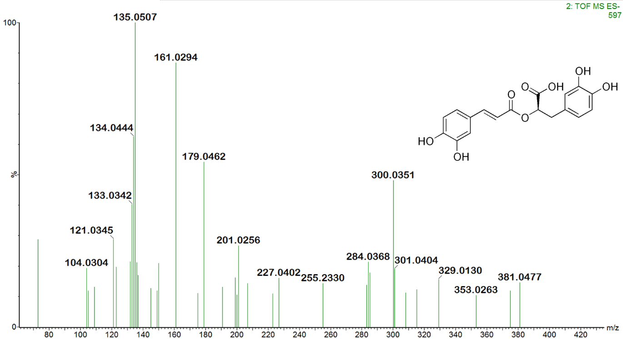
Figure S2: MS/MS spectrum of rosmaniric acid and its chemical structure

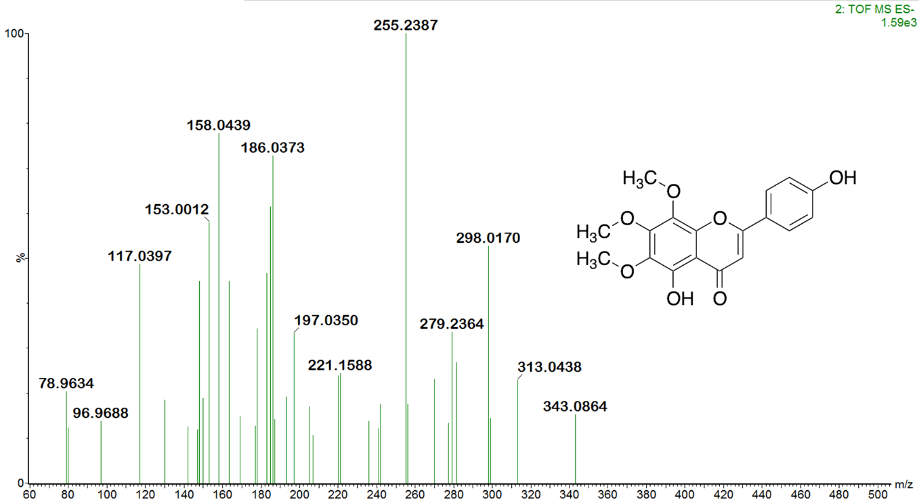
Figure S3: MS/MS spectrum of xanthomicrol and its chemical structure

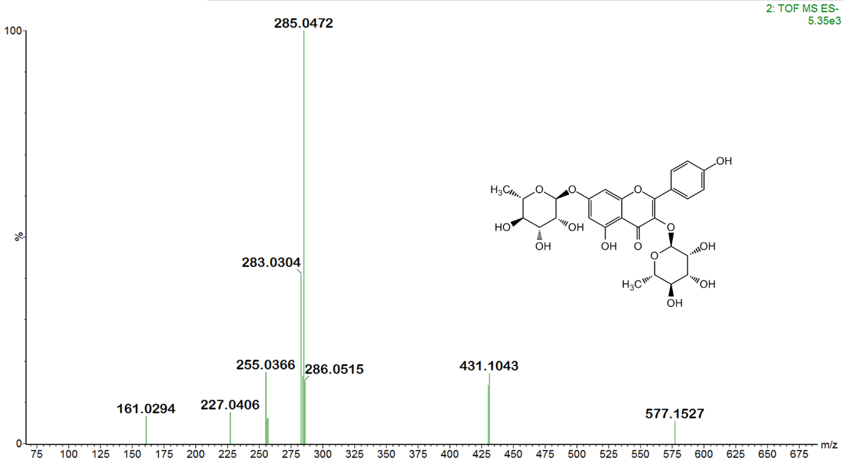
Figure S4: MS/MS spectrum of kaempferitrin and its chemical structure

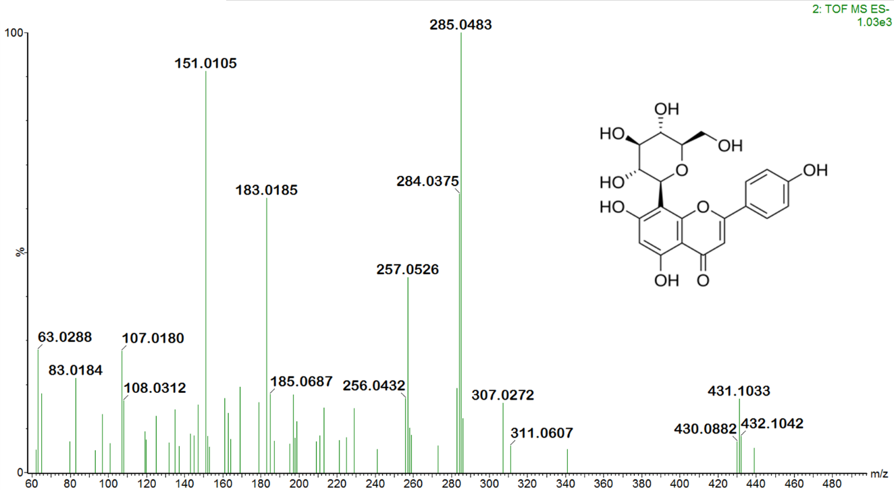
Figure S5: MS/MS spectrum of vitexin and its chemical structure
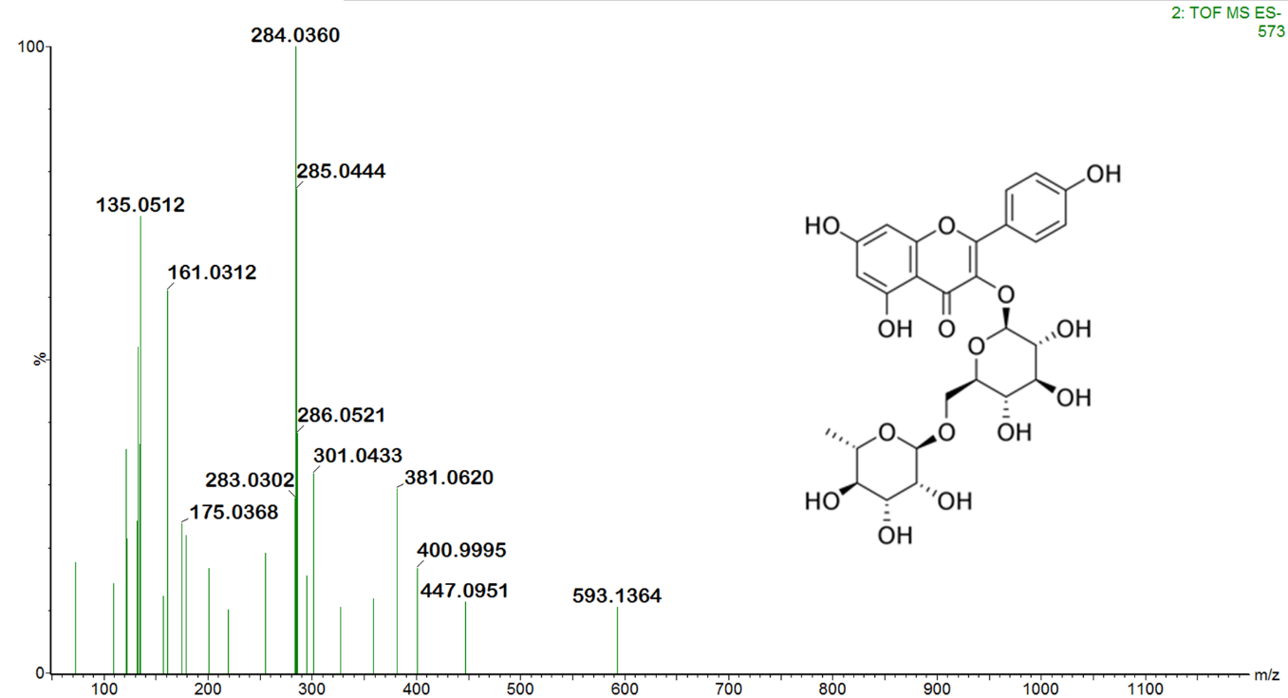
Figure S6: MS/MS spectrum of kaempferol 3-O-rutinoside and its chemical structure

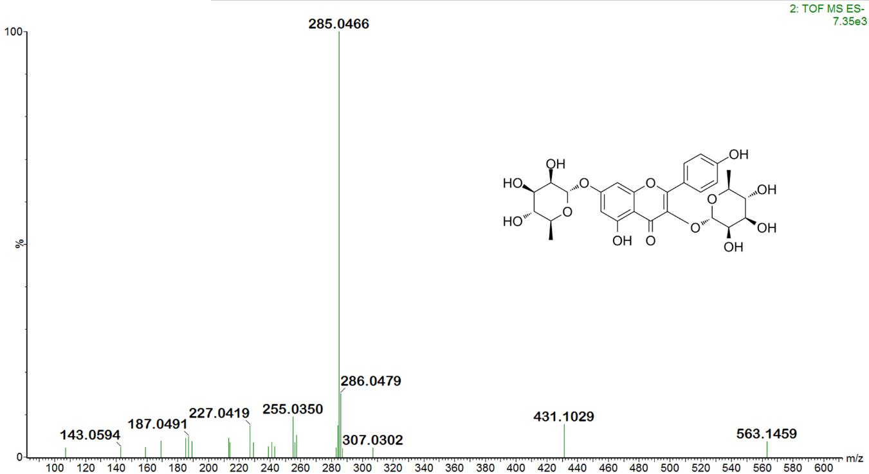
Figure S7: MS/MS spectrum of apigenin 7-glycosides and its chemical structure

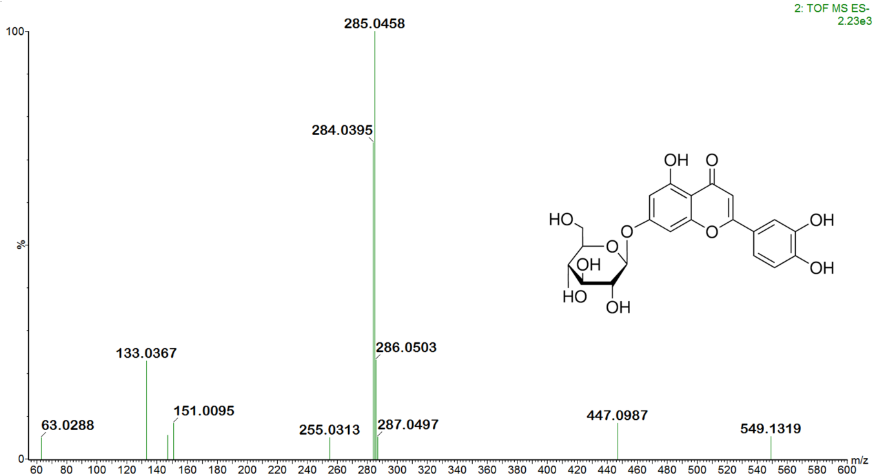
Figure S8: MS/MS spectrum of luteolin 7-O-glucoside and its chemical structure

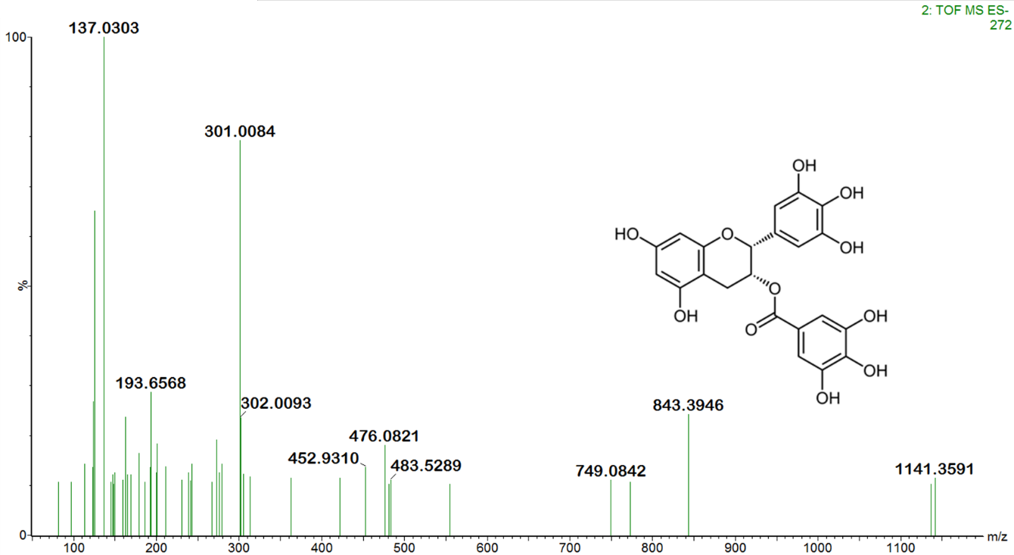
Figure S9: MS/MS spectrum of epigallocatechin 3-gallate and its chemical structure
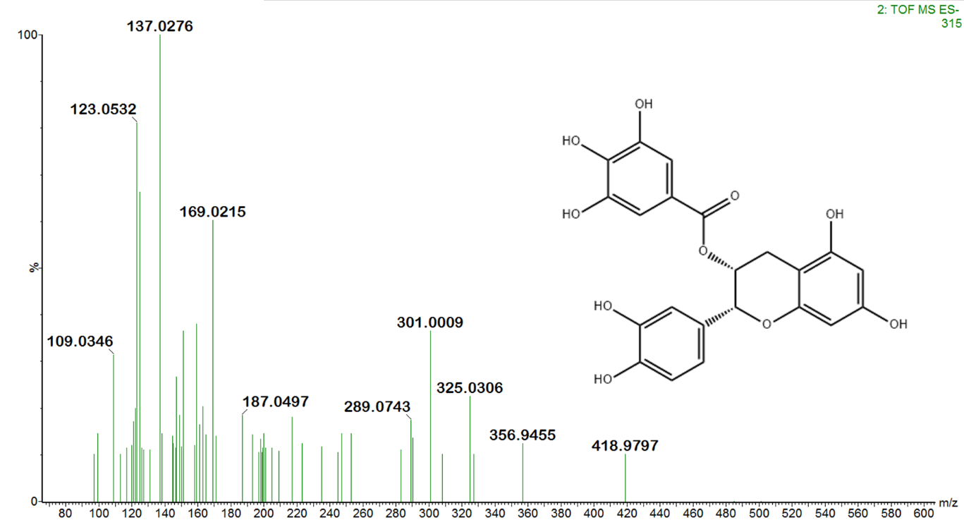
Figure S10: MS/MS spectrum of 3-galloylcatechin epicatechin 5-gallate and its chemical structure

Table S2. Minimum inhibitory concentration (MIC) values of decocted extracts from selected medicinal plants and control antibiotic against tested bacterial strains.

Decocted extracts | MIC (µg/mL)
Decocted extracts | Bacterial strains
Decocted extracts | Staphylococcus aureus | Escherichia coli | Pseudomonas aerogenes
T. riparia | 2000 | 2000 | >2000
O. gratissimum | 2000 | >2000 | 2000
D. ambrosioides | >2000 | >2000 | >2000
Control (Ciproflaxine) | 0.125 | 0.03 | 0.25

