A B
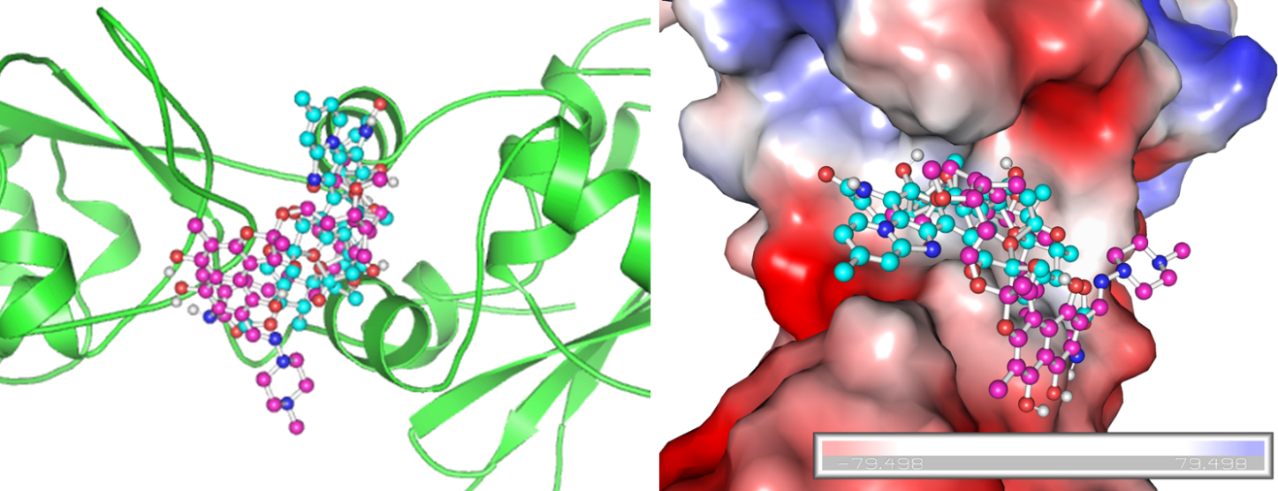

Supplementary Figure S1: Interactions of Rifaximin and Rifampicin with DNA-dependent RNA polymerase (A) Interactions of Rifaximin and Rifampicin with binding pockets of RNA polymerase. (B) Surface representation of substrate-binding pocket of RNA polymerase in complex with Rifaximin and Rifampicin.

