Brevibacterium litoralis sp. nov., a cellulose-degrading strain isolated from marine surface sediment.
Quan Yang¹, Aolin Zhao¹, Haifei Liu¹, Jiawei Li¹, Shujing Wu¹, Ying Huang¹, Jie Weng², Mingguo Jiang^{1, *} and Yi Jiang^{3, *}
¹School of Marine Science and Biotechnology, Guangxi Key Laboratory for Polysaccharide Materials and Modifications, Guangxi Minzu University, Nanning 530008, PR China;
²School of Chemistry and Chemical Engineering, Guangxi Key Laboratory of Chemistry and Engineering of Forest Products, Guangxi Minzu University. Nanning 530008, PR China.
³Yunnan Institute of Microbiology, Yunnan University, Kunming 650091, PR China.
*Authors for correspondence
Mingguo Jiang
Tel & Fax: +86-771-3267023
- mail: mzxyjiang@163.com ORCID:0000-0003-2279-5740
Yi Jiang
Tel & Fax: 86-871-65034073
E-mail: jiangyi@ynu.edu.cn

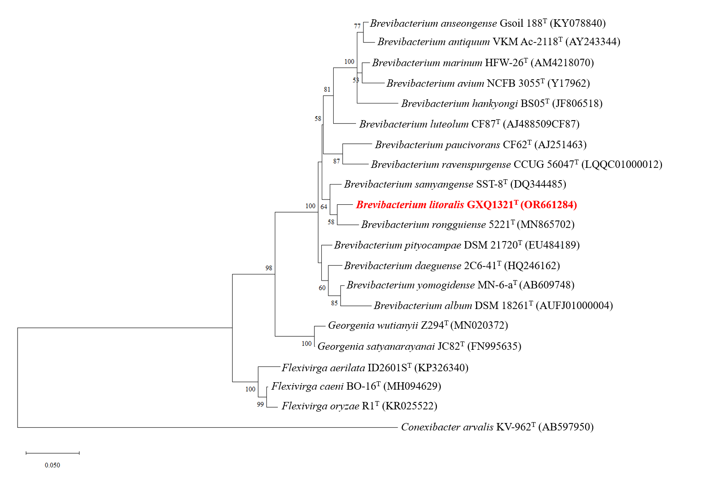
Fig. S1 The maximum-likelihood tree based on the 16S rRNA gene sequences showing the phylogenetic relationship of GXQ1321^{T} with related taxa. The sequence of Conexibacter arvalis KV-962^{T} (AB597950) was used as an outgroup. Bootstrap support values were calculated from 1000 replicates.

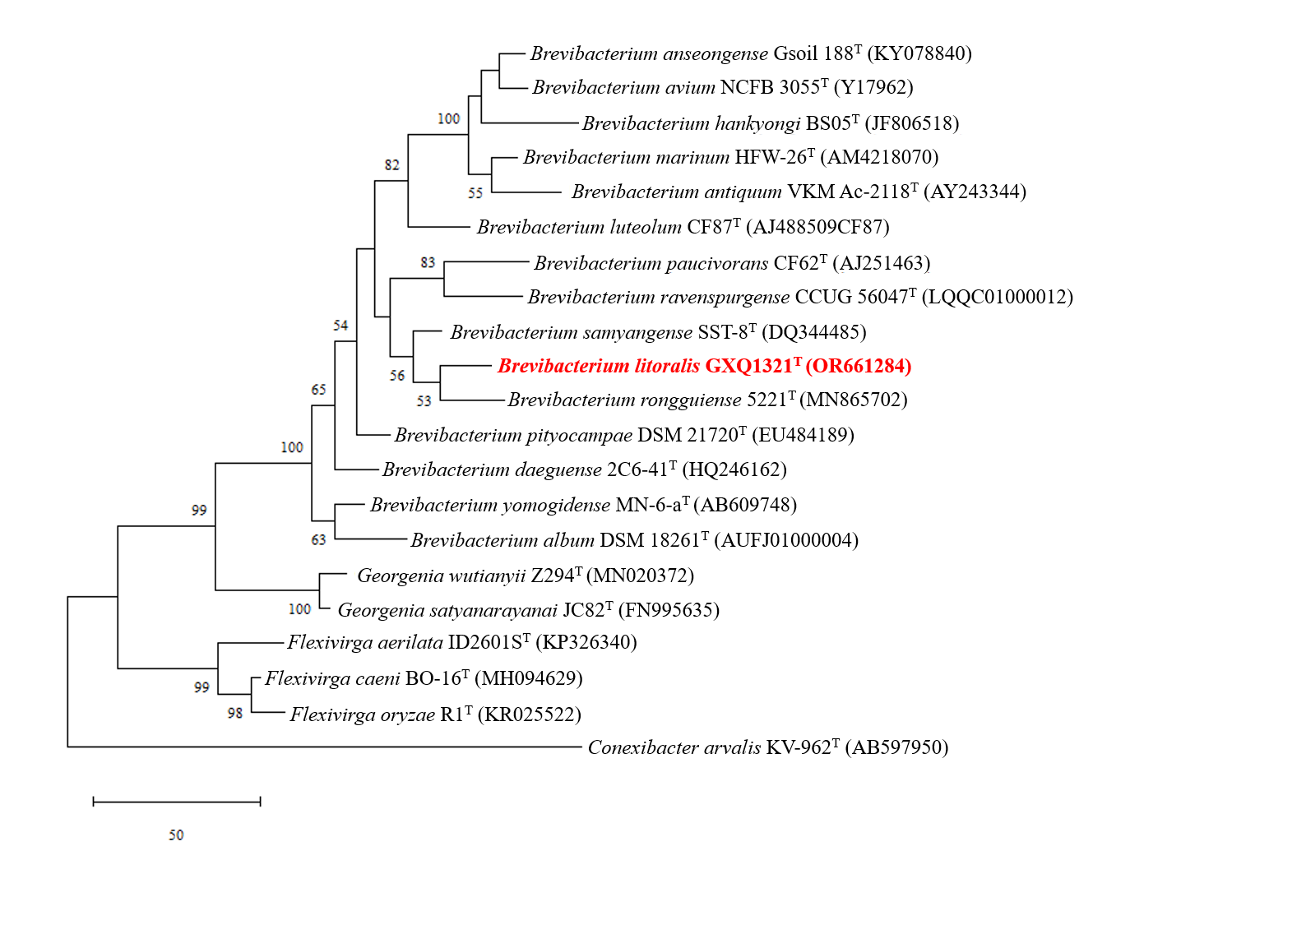
Fig. S2 The maximum-parsimony tree based on the 16S rRNA gene sequences showing the phylogenetic relationship of GXQ1321^{T} with related taxa. The sequence of Conexibacter arvalis KV-962^{T} (AB597950) was used as an outgroup. Bootstrap support values were calculated from 1000 replicates.

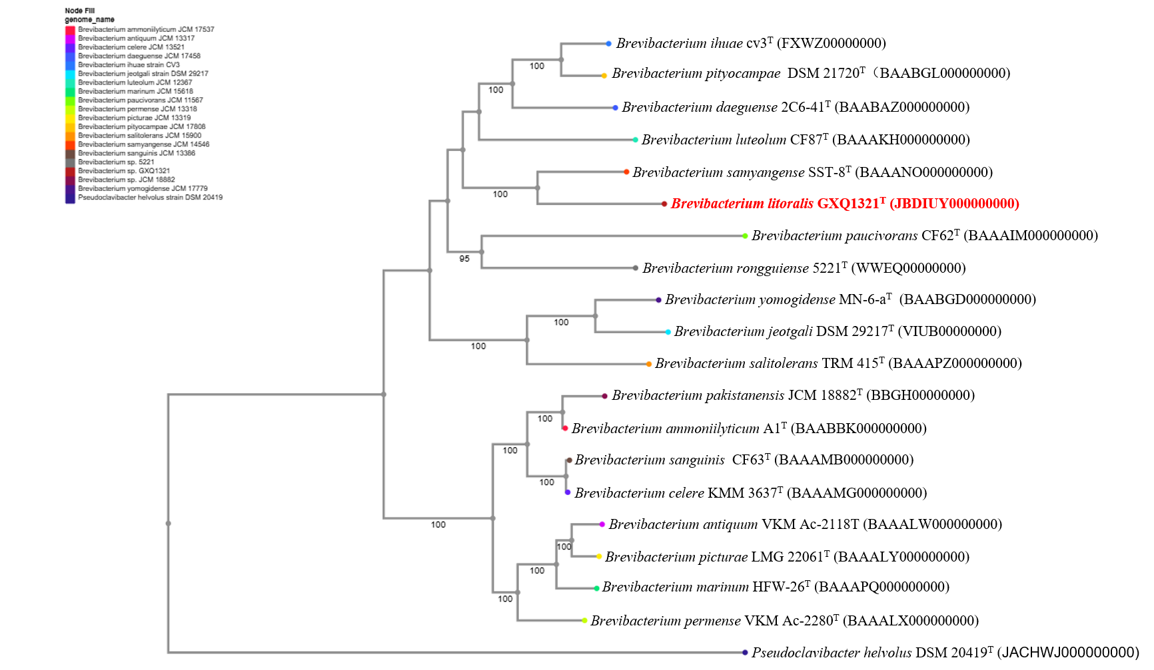
Fig. 2 Phylogenetic tree based on the whole-genome information. In the picture, strains GXQ1321^{T} and Brevibacterium samyangense SST-8^{T} form a robust branch.

Table S1 Subsystem characterisation counts for GXQ1321^{T} and related members of the genus Brevibacterium.
Subsystem feature counts | GXQ1321^{T} | B. samyangense SST-8^{T} | B. rongguiense 5221^{T}
Stress Response | 16 | 21 | 13
Respiration | 33 | 32 | 27
Dormancy and Sporulation | 1 | 1 | 1
Miscellaneous | 23 | 30 | 23
Protein Metabolism | 162 | 161 | 160
Cell Division and Cell Cycle | 0 | 0 | 0
Fatty Acids, Lipids, and Isoprenoids | 90 | 96 | 68
Membrane Transport | 41 | 53 | 22
Secondary Metabolism | 4 | 6 | 4
Motility and Chemotaxis | 0 | 0 | 0
RNA Metabolism | 31 | 25 | 27
Iron acquisition and metabolism | 4 | 4 | 7
Nitrogen Metabolism | 19 | 8 | 9
Nucleosides and Nucleotides | 65 | 70 | 80
Metabolism of Aromatic Compounds | 12 | 12 | 23
Carbohydrates | 134 | 139 | 171
Cofactors, Vitamins, Prosthetic Groups, Pigments | 108 | 87 | 99
Photosynthesis | 0 | 0 | 0
Virulence, Disease and Defense | 23 | 30 | 23
Phosphorus Metabolism | 25 | 23 | 22
DNA Metabolism | 46 | 51 | 48
Phages, Prophages, Transposable elements, Plasmids | 0 | 0 | 0
Potassium metabolism | 3 | 2 | 7
Amino Acids and Derivatives | 209 | 207 | 219
Sulfur Metabolism | 5 | 11 | 4
Cell Wall and Capsule | 21 | 24 | 12
Regulation and Cell signaling | 12 | 12 | 8

Table S2 antiSMASH of GXQ1321^{T} and related members of the genus Brevibacterium.
antiSMASH v.6.0.1 | GXQ1321^{T} | B. samyangense SST-8^{T} | B. rongguiense 5221^{T}
Terpene | + | + | +
NAPPA | + | + | +
Ectoine | + | - | -
NAPAA*：Non-alpha poly-amino acids like e-Polylysin

Table S3 The results of conduct the COG category analysis of coding proteins about GXQ1321^{T} and reference strains of the genus Brevibacterium.
Functional-Categories | GXQ1321^{T} | B. samyangense SST-8^{T} | B. rongguiense 5221^{T}
RNA processing and modification | 1 | 0 | 0
Chromatin structure and dynamics | 0 | 2 | 0
Energy production and conversion | 136 | 168 | 0
Cell cycle control, cell division, chromosome partitioning | 30 | 34 | 33
Amino acid transport and metabolism | 277 | 332 | 253
Nucleotide transport and metabolism | 94 | 80 | 80
Carbohydrate transport and metabolism | 163 | 165 | 207
Coenzyme transport and metabolism | 166 | 107 | 111
Lipid transport and metabolism | 199 | 156 | 119
Translation, ribosomal structure and biogenesis | 201 | 157 | 163
Transcription | 194 | 206 | 219
Replication, recombination and repair | 111 | 191 | 185
Cell wall/membrane/envelope biogenesis | 129 | 123 | 118
Cell motility | 14 | 7 | 6
Posttranslational modification, protein turnover, chaperones | 122 | 84 | 69
Inorganic ion transport and metabolism | 170 | 208 | 199
Secondary metabolites biosynthesis, transport and catabolism | 40 | 99 | 64
General function prediction only | 222 | 0 | 0
Function unknown | 72 | 517 | 520
Signal transduction mechanisms | 108 | 86 | 77
Intracellular trafficking, secretion, and vesicular transport | 31 | 44 | 37
Defense mechanisms | 75 | 35 | 31
Extracellular structures | 11 | 0 | 0
Mobilome: prophages, transposons | 18 | 0 | 1
Cytoskeleton | 0 | 0 | 1

Fig. S3 AAI values of strain GXQ1321^{T} and reference strains B. samyangense SST-8^{T} and B. rongguiense 5221^{T}.

Table S4 Genes related to phosphorus metabolism of strain GXQ1321^{T} and its closely related species. S=subsystem; a=Thioredoxin-disulfide reductase; b=Utilization of glutathione as a sulphur source; c=Ammonia assimilation; d=Cyanate hydrolysis; e=Nitrate and nitrite ammonification .
S | Role | GXQ1321^{T} | B. samyangense SST-8^{T} | B. rongguiense 5221^{T}
a | Thioredoxin reductase (EC 1.8.1.9) | + | + | +
 | Alkyl hydroperoxide reductase protein F (EC 1.6.4.-) | + | + | +
 | Alkylhydroperoxidase protein D | + | + | +
 | Hydrogen peroxide-inducible genes activator | + | + | +
 | Thiol peroxidase, Tpx-type (EC 1.11.1.15) | + | + | +
 | Alkyl hydroperoxide reductase subunit C-like protein | + | + | +
b | Gamma-glutamyltranspeptidase (EC 2.3.2.2) | - | + | -
 | Putative gluthatione transporter, solute-binding component | - | + | -
 | Putative glutathione transporter, permease component | - | + | -
 | Putative glutathione transporter, ATP-binding component | - | + | -
 | Putative glutathione transporter,solute-binding component | - | + | -
c | Glutamine synthetase type I (EC 6.3.1.2) | + | - | -
 | Glutamate-ammonia-ligase adenylyltransferase (EC 2.7.7.42) | + | - | -
 | Glutamate synthase [NADPH] large chain (EC 1.4.1.13) | + | - | -
 | Glutamate synthase, alpha subunit domain protein | + | - | -
 | Ammonium transporter family | + | - | -
 | Global nitrogen regulatory protein, CRP family of transcriptional regulators | + | - | -
 | Glutamine synthetase inactivating factor IF17 | + | - | -
 | Nitrogen regulation protein NR(II) (EC 2.7.3.-) | + | - | -

Fig. S5 Transmission electron micrographs of the cells of strain GXQ1321^{T} Cells are cultured on 2216E medium at 30 °C for 24-36 h. Bar, 1μm.

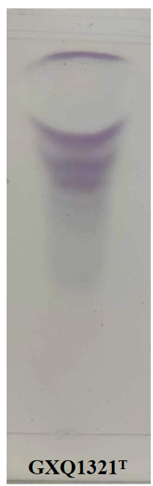

Fig. S6 TLC chromatogram of GXQ1321^{T} peptidoglycan structure.

Fig. S7 Polar lipids of GXQ1321^{T}. Polar lipids of strain separated by two-dimensional TLC and detected with molybdophosphoric acid reagent; (A), α-naphthol reagent; (B), anisaldehyde reagents; (C). All data presented are from this study. DPG, diphosphatidylglycerol; PG, phosphatidylglycerol; PGL1-PGL3, phosphoglycolipid; UG, unknown glycolipids.

Table S4 Cellular fatty acid composition of GXQ1321^{T} and related strains. Compounds occurring at percentages of 1 or higher are given. All presented data were obtained in the same laboratory under standardized conditions.
Fatty acids (%) | GXQ1321^{T} | B. samyangense SST-8^{T} | B. rongguiense 5221^{T}
anteiso-C_{19:0} | 27.28 | – | -
anteiso-C_{17:0} | 15.95 | 35.3 | 39.3
anteiso-C_{15:0} | 18.97 | 29.9 | 46.2
iso-C_{16:0} | 12.21 | 2.5 | -
iso-C_{12:0} | 2.08 | - | -
iso-C_{14:0} | 1.75 | - | 0.3
iso-C_{15:0} | 1.56 | 15.5 | 2.2
iso-C_{17:0} | - | 4.2 | -
C_{18:1} | - | 1.9 | -
C_{16:0} | 13.8 | 4.2 | 11.9
C_{18:0} | - | 4.0 | -
anteiso-C17:1 ω9c | 5.35 | - | -

