Supplementary Information

Tracking the global reduction of marine traffic during the COVID-19 pandemic
David March*, Kristian Metcalfe, Joaquin Tintoré, Brendan J Godley

*Corresponding author: David March, email: D.March@exeter.ac.uk. Present address: Centre for Ecology and Conservation, University of Exeter, Cornwall Campus, Penryn TR10 9EZ, United Kingdom.

Contents

Supplementary Tables (Table S1-S2)
Supplementary Figures (Figures S1-S11)

Supplementary Tables

Table S1. Global changes in marine traffic density and occupancy in the oceans during COVID-19. Estimated changes correspond to the difference between April 2020, where more stringent lockdown measures took place globally, and April 2019, as a reference period. Percentage of the ocean with positive and negative changes in traffic density. Average change excluded grid cells without presence of marine traffic in any of the two reference periods. Occupancy estimates reflect gains and reduction of the extent used by marine traffic. All estimates are based on a global grid of 0.25 degrees resolution.

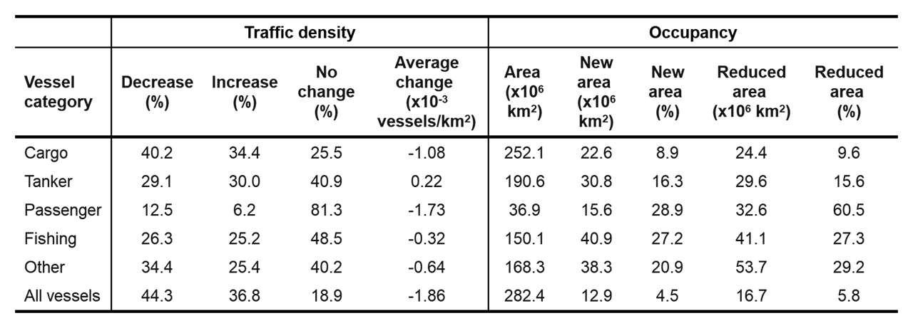

Table S2. Maximal and most recent daily change in active vessels per sector in the Western Mediterranean during COVID-19. Maximal and most recent change in number vessels underway in relation to 2019 since the WHO pandemic declaration on the 11th March 2020. Data are daily numbers of vessels underway within the coastal zone (44.4 km) of EU countries present in the study area (i.e., Spain, France, Italy). Relative change estimated using the log percentage change (L%).

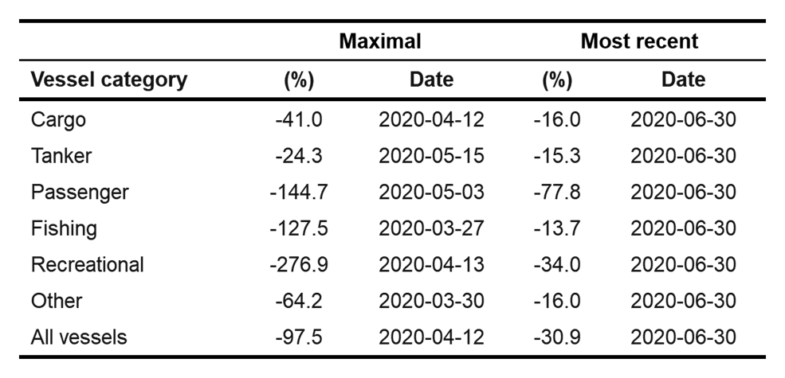

Supplementary Figures

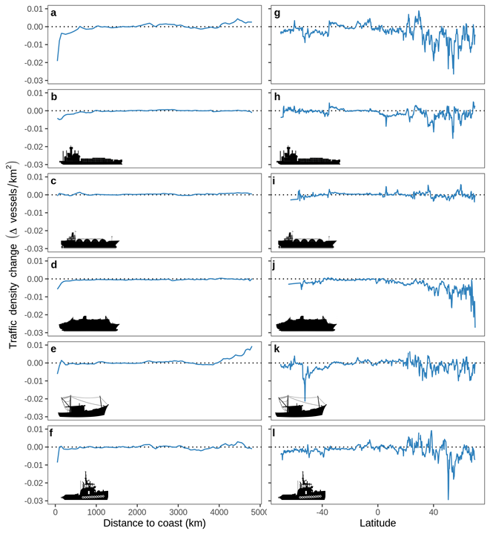

Figure S1. Change in traffic density in relation to the distance to the coast (a-f) and the latitudinal gradient (g-l). Changes estimated by calculating the absolute difference in traffic density between April 2020 and April 2019. Vessel categories: all vessels (a, g), cargo (b, h), tanker (c, i), passenger (d, j), fishing (e, k), and other vessels (f, l).

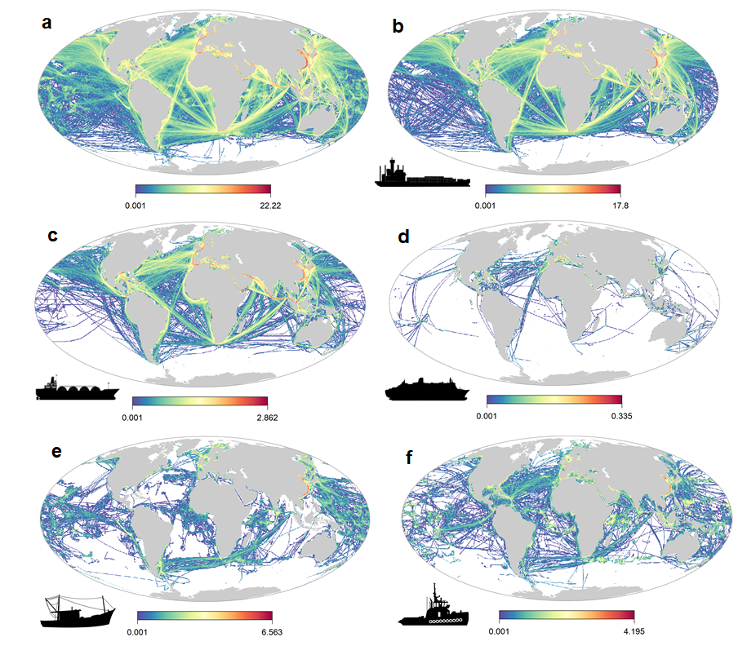
Fig S2. Monthly vessel traffic density in April 2019. Vessel categories: (a) all vessels, (b) cargo, (c) tanker, (d) passenger, (e) fishing, (f) other vessels.

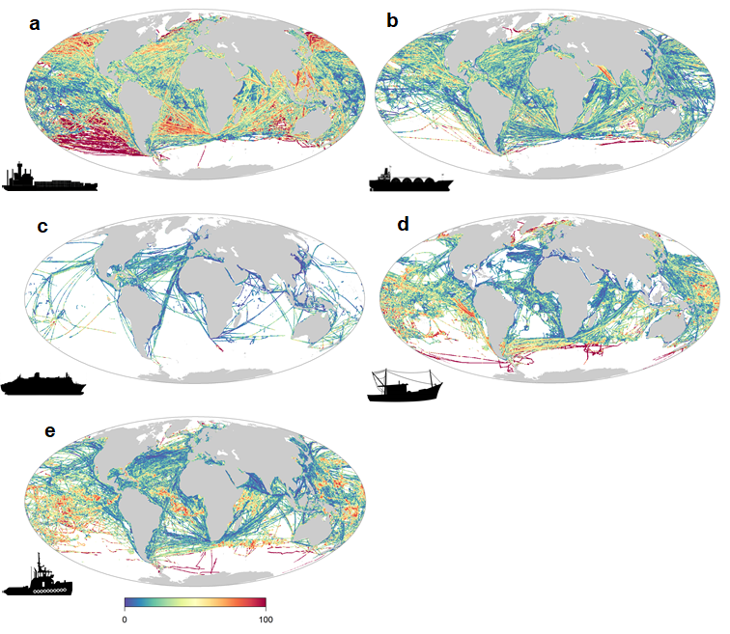
Figure S3. Global maps of the percentage of contribution of each vessel category to the overall change in traffic density. Changes estimated by calculating the absolute difference in traffic density between April 2020 and April 2019. Vessel categories: (a) cargo, (b) tanker, (c) passenger, (d) fishing, (e) other vessels.
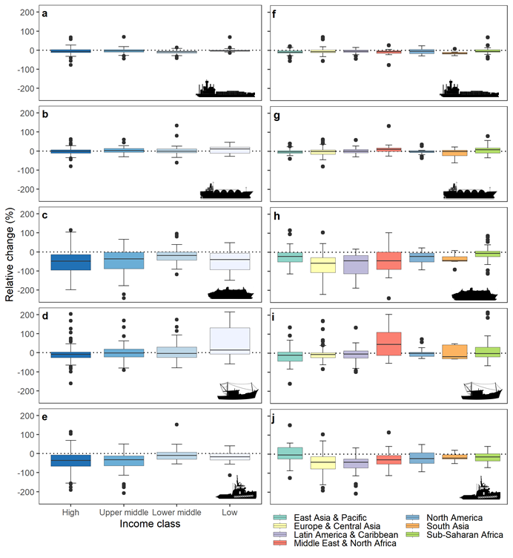
Figure S4. Relative change within Exclusive Economic Zones (EEZ) per ship category. (a-e) EEZ grouped by income class from the World Bank, (f-j) EEZ grouped by region. Vessels classified as follows: (a, f) cargo, (b, g) tanker, (c, h) passenger, (d, i) fishing, and (e, j) other vessels. Relative change estimated using the log percentage change (L%). Box plot shows the median, the interquartile range (IQR), and Tukey whiskers (±1.5 times IQR).

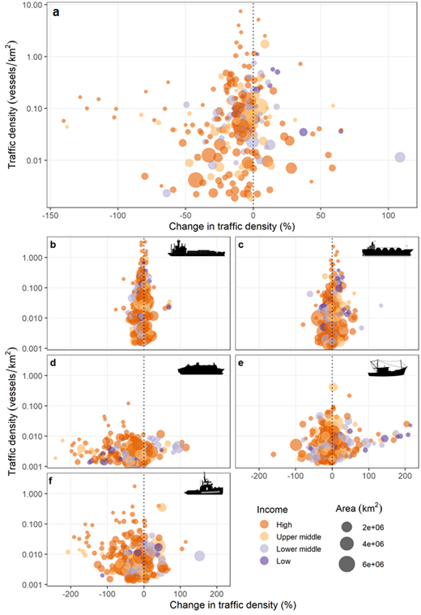
Figure S5. Traffic density versus its relative change for each country’s EEZ. Bubbles are scaled to the area of each country’s EEZ and color-coded by their income. Vessel categories: (a) all vessels, (b) cargo, (c) tanker, (d) passenger, (e) fishing, (f) other vessels. Relative change estimated using the log percentage change (L%).
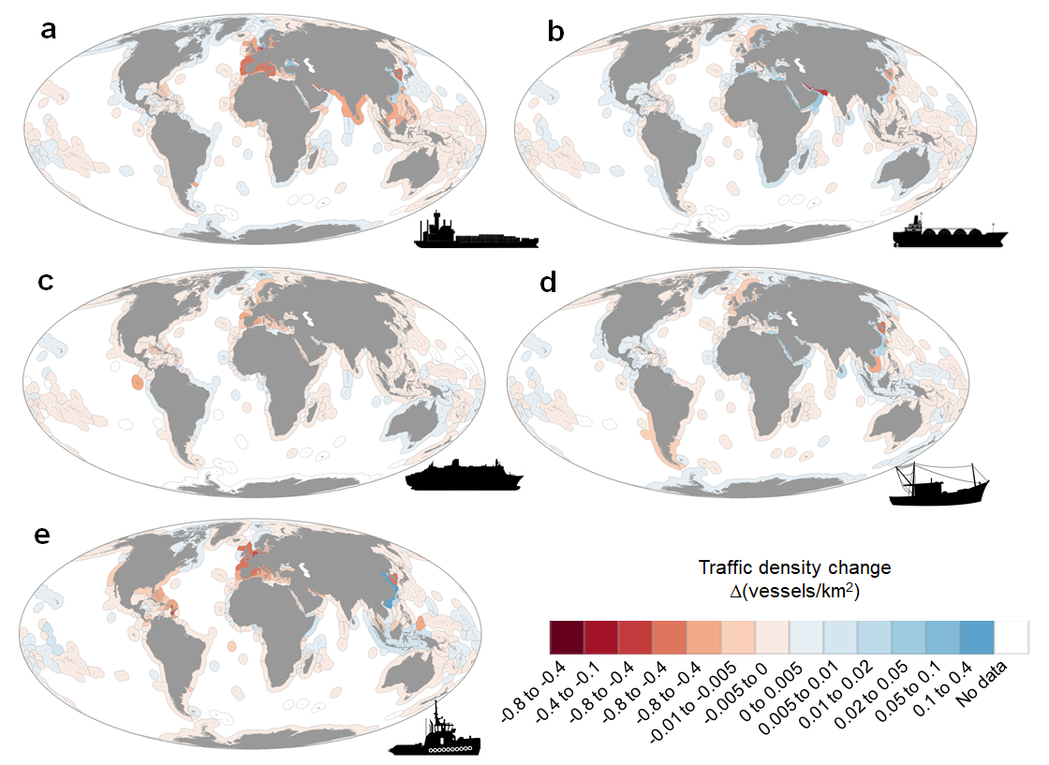

Figure S6. Average change in traffic density in Economic Exclusive Zones (EEZs) per vessel categories. Changes estimated by calculating the absolute difference in traffic density between April 2020 and April 2019 in EEZs (n = 255). Vessel categories: (a) cargo, (b) tanker, (c) passenger, (d) fishing, (e) other vessels.
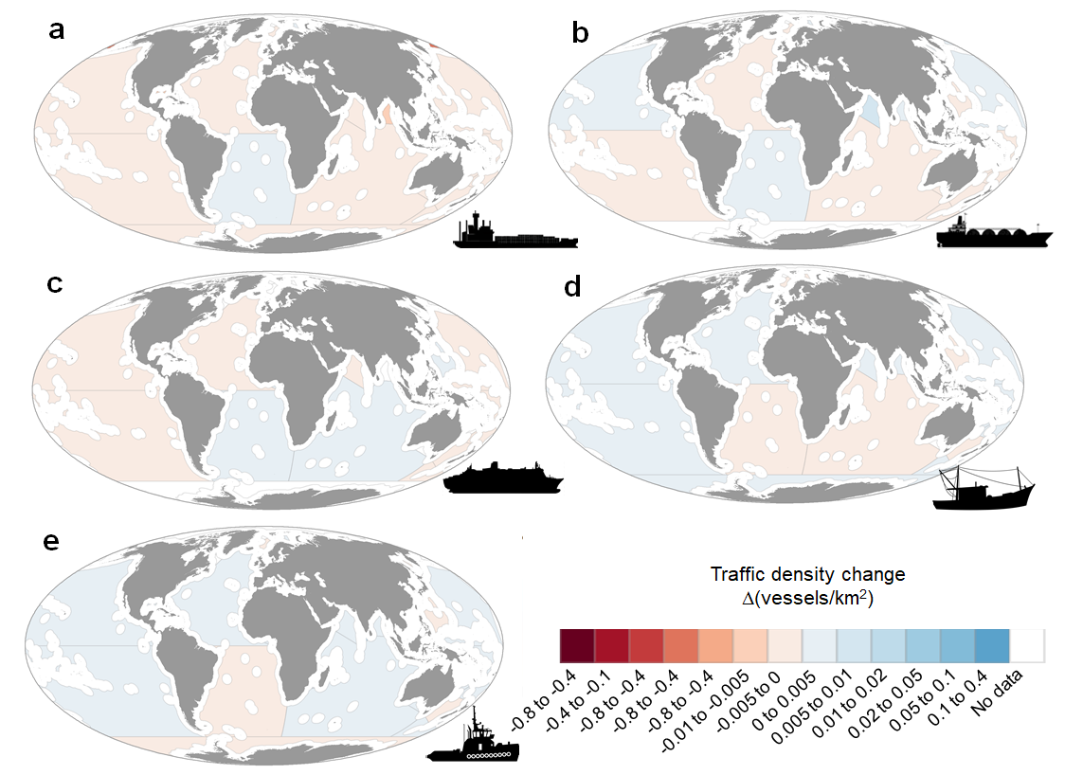

Figure S7. Average change in traffic density in Areas Beyond National Jurisdiction (ABJN). Changes estimated by calculating the absolute difference in traffic density between April 2020 and April 2019 in ABJN (n = 26). Vessel categories: (a) cargo, (b) tanker, (c) passenger, (d) fishing, (e) other vessels.
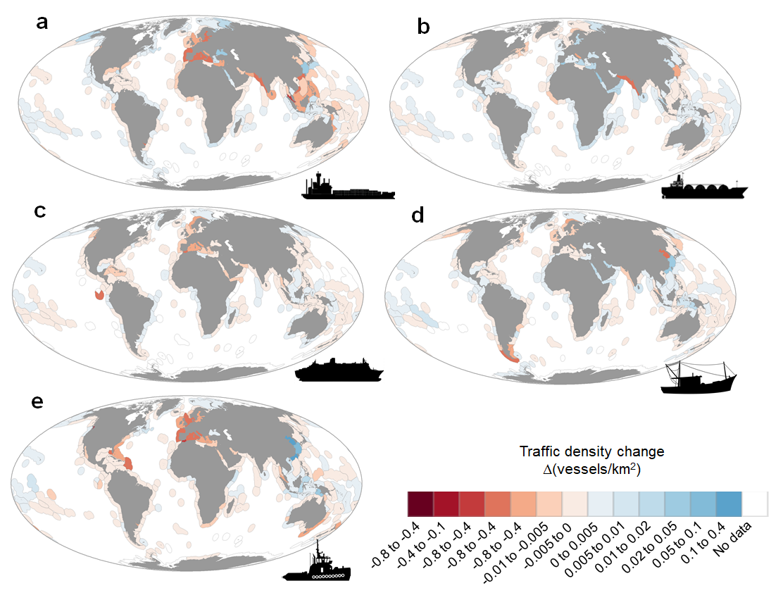

Figure S8. Average change in traffic density per marine ecoregion. Changes estimated by calculating the absolute difference in traffic density between April 2020 and April 2019 in marine ecoregions. Vessel categories: (a) cargo, (b) tanker, (c) passenger, (d) fishing, (e) other vessels.
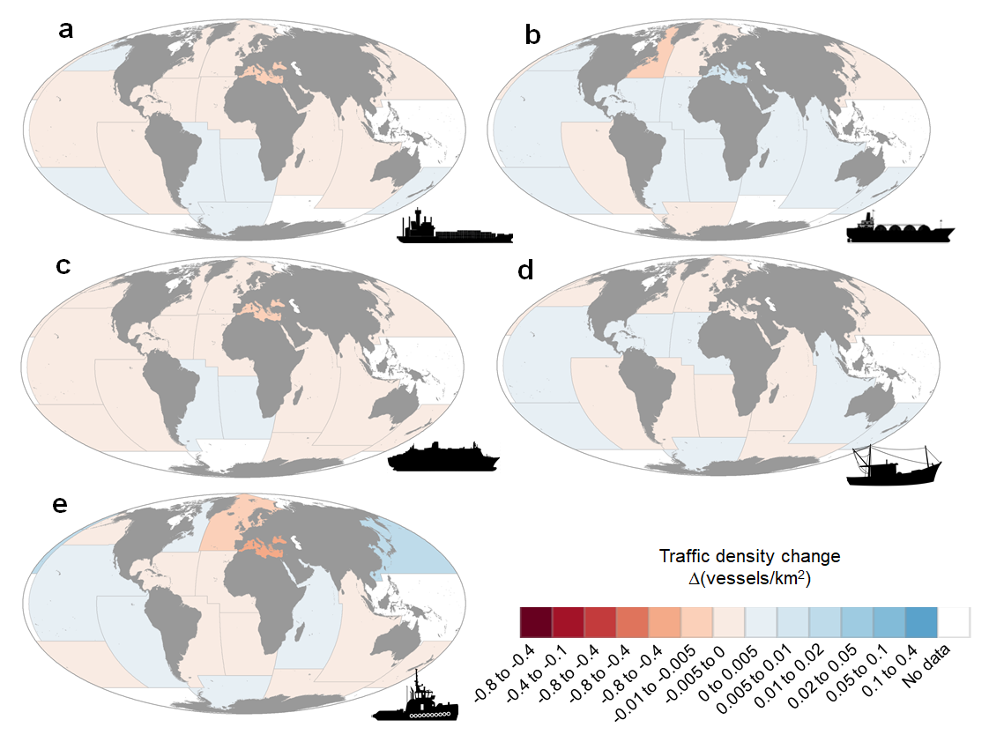
Figure S9. Average change in traffic density per Food and Agriculture Organization (FAO) major fishing area. Changes estimated by calculating the absolute difference in traffic density between April 2020 and April 2019. Vessel categories: (a) cargo, (b) tanker, (c) passenger, (d) fishing, (e) other vessels.
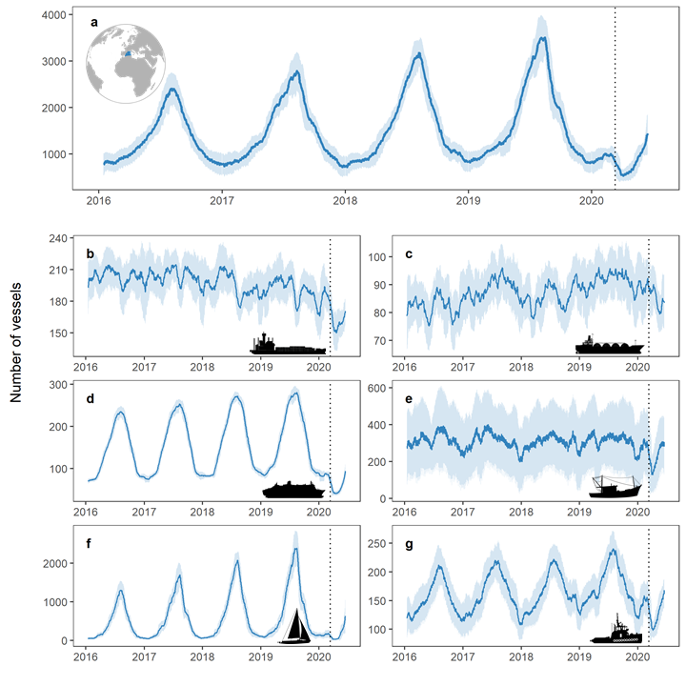
Fig S10. Number of unique vessels equipped with AIS in the Western Mediterranean between 2016 and 2020. (a) All vessel types, (b) cargo, (c) tanker, (d) passenger, (e) fishing, (f) recreational, and (g) others. Daily data using a monthly moving average and standard deviation. Vertical dotted line represents the WHO pandemic declaration on the 11th March 2020.

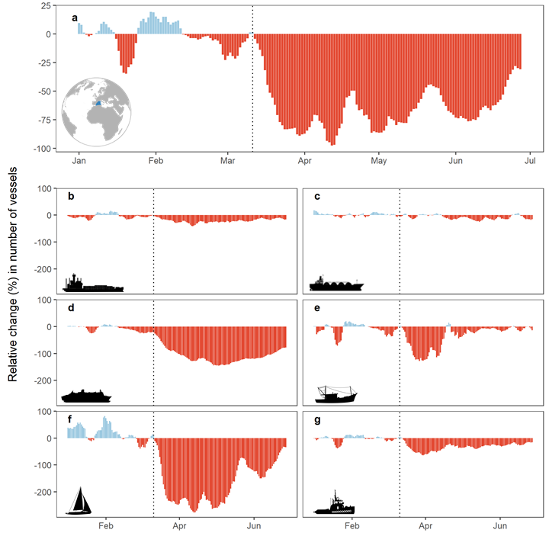
Fig S11. Daily relative change in number of vessels equipped with AIS between 2020 and 2019 in the Western Mediterranean. (a) All vessel types, (b) cargo, (c) tanker, (d) passenger, (e) fishing, (f) recreational, and (g) others. Relative change estimated using the log percentage change (L%). Vertical dotted line represents the WHO pandemic declaration on the 11th March 2020. Blue area in the map inset represents the spatial extent of the AIS dataset.

