Highly active Fenton-like catalyst derived from solid waste-iron tailings using wheat straw pyrolysis
Lihui Gao¹; Lizhang Wang¹; Shulei Li^{2*}; Yijun Cao^{2,3*}
- School of Environment and Spatial Informatics, China University of Mining and Technology, Xuzhou 221116, China
- National Engineering Research Center of Coal Preparation and Purification, China University of Mining and Technology, Xuzhou 221116, China
- School of Chemical Engineering and Technology, Zhengzhou University, Zhengzhou 450001, China

Table S1 Characteristics of wheat straw and iron tailings
Proximate analysis | Wheat straw (Raw biomass)  Average wt%
Volatile matter | 86.09
Fixed carbon | 9.27
Ash | 4.64
XRF analysis | Wheat straw （Raw biomass） | Iron tailings
XRF analysis | Average wt%
SiO₂ | 4.35 | 41.21
Fe₂O₃ | 0.264 | 29.25
Al₂O₃ | 0.337 | 9.47
CaO | 0.443 | 7.105
MgO | 0.235 | 5.31
Ba | - | 3.62
K₂O | 2.369 | 1.73
Cl | 0.905 | -
S | 0.181 | 1.23
Mn | 0.0502 | 0.41
TiO₂ | 0.024 | 0.35
Na₂O | 0.072 | 0.15
Sr | - | 0.0762
P | 0.0721 | 0.057

Table S2 The metal ion concentration in leaching test
Metals | Concentration (ppb)
Metals | 1st | 2nd | 3rd
Li | 7.07 | 1.77 | 3.67
Na | 1051.94 | 468.46 | 1592.07
Mg | 393.97 | 257.27 | 474.06
Al | 84.62 | 34.04 | 86.94
K | 1131.30 | 569.80 | 2299.87
Ca | 4706.97 | 2423.60 | 2993.95
V | 2.07 | 1.13 | 1.29
Cr | 1.10 | 0.40 | 0.82
Mn | 25.50 | 19.29 | 29.91
Fe | 88.78 | 85.07 | 92.67
Ni | 0.82 | 0.24 | 2.05
Cu | 3.27 | 1.29 | 4.17
Zn | 1.27 | 0.28 | 3.47
Ga | 0.08 | 0.10 | 0.15
As | 0.59 | 0.32 | 0.33
Rb | 3.99 | 1.39 | 2.87
Sr | 60.76 | 49.57 | 86.80
Ag | 0.02 | 0.03 | 0.03
Cd | 0.04 | 0.14 | 0.14
Cs | 1.93 | 0.88 | 1.04
Ba | 331.78 | 239.93 | 422.94
Pb | 0.23 | 0.57 | 1.00

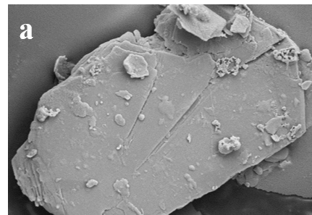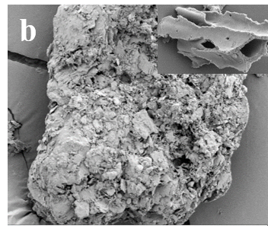
Figure S1 The SEM image of synthesized RT-900-60, scale bar=10 μm (a) and I/W(3:1)-900-60, scale bar=10 um, insert image scale bar=3 um (b)

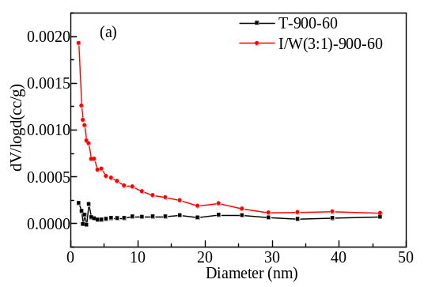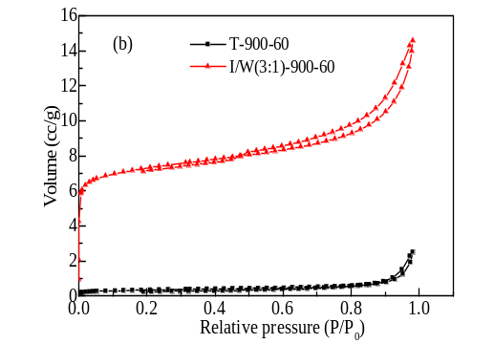
Figure S2 Characterization of the prepared catalysts by N₂ adsorption-desorption: (a) Pore size distribution; (b) adsorption-desorption isotherm
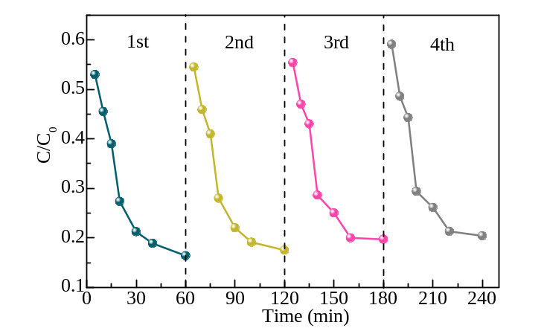
Figure S3 Stability and reusability of I/W(3:1)-900-60 for the degradation of MB
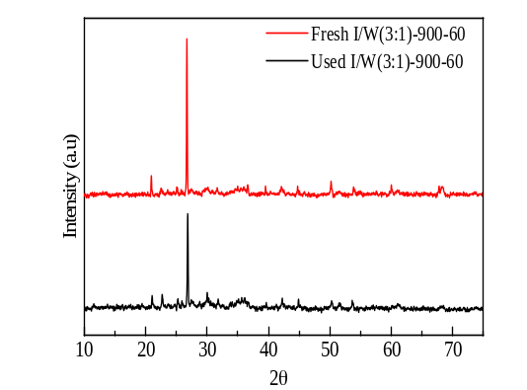Figure S4 (a) XRD patterns of fresh and used I/W(3:1)-900-60; (b) SEM image of used I/W(3:1)-900-60 ([MB]=60 mg/L, [catalyst]=0.3 g/L, [H₂O₂]=16 mmol/L)

