Supplementary Material

Manuscript title:
Signals of memory building-blocks: Pupil-linked arousal predicts event segmentation and episodic memory

Authors:
Pajkossy P. ¹, Szőllősi, Á.^{2,}, Racsmány M. ^{2,3}

1: Department of Cognitive Science, Budapest University of Technology and Economics, Budapest, Hungary
2: Institute of Psychology, University of Szeged, Hungary
3: Institute of Cognitive Neuroscience and Psychology, Research Centre for Natural Sciences, Hungary

Section 1 - Results of the pilot study used to select the four stories used in Exp 1-3
Before starting the experiments, we conducted a pilot study, in which we tested segmentation behavior in all eight stories, to identify those texts, where the spatial and narrative shifts are most effective in triggering event segmentation behavior. The sample size of this pilot study was N = 32 (24 women; M_{age}= 22.53 years, SD_{age} = 2.48, range: 19 - 30). Participants had to indicate with a single key press if they identified an event boundary (the instruction was the same as in Exp 1). To avoid the confounding effects of fatigue and motivation loss, each participant listened to only four stories which were pseudorandomly selected from all eight stories. The randomisation was done so that each story was presented to a similar number of participants (either 16 or 17 times). Overall, 16 different combinations of story-presentation sequences were used. Furthermore, the average position was also counterbalanced, i.e., the average serial position of each story ranged between 2.29-2.71. Regarding all other methodological aspects, the pilot study was identical to Exp 1.
The aim of our analysis was to identify those stories, where the predefined spatial and character shift sentences most consistently triggered such segmentation behavior. To this aim, for each participant, we calculated for each story and for each type of content-based alignment point (spatial/character shifts and control sentence, see methods), the percentage of how many times that particular participant pressed the segmentation key at a specific alignment point or in the following five seconds (e.g. if a participant pressed the segmentation key after two of the four spatial shift sentences of the aquarium story, then the calculated percentage was 0.5). The means of this percentage values are presented in Fig 1SA, and Table S1 and Table S2. These tables also contain the number of participants listening to a particular story – slight differences in these numbers are due to data loss for the data from some of the stories, for some of the participants.
Significance of the differences between shift sentences and control sentences were tested using a nonparametric Wilcoxon Signed Rank test. The results of these significance tests are presented in Fig S1A and detailed statistics is provided in Table S1 and Table S2. As can be seen in Figure S1A, in half of the stories, spatial and character shift sentences elicited more key-presses than the control sentences, with spatial shift sentences being slightly better indicator of event segmentation behavior than character shifts. Because all stories were completed by a different but overlapping set of participants (see methods), segmentation behavior of different stories could not be compared. Nevertheless, based on the difference between control v. spatial/character-shift sentences, the four best performing texts were selected (castle, aquarium, camping, hospital).
To further validate the content-driven alignment points in the chosen texts, the above analyses were also conducted using the data from Experiment 1. Here, the same instruction and methodology was used, as in the pilot study – with the only exception, that this time, all participants listened to all four texts. The results are presented in Fig 1A in the manuscript and in Table S3 – again, the slight variation in the number of participants listening to the different texts are due to data loss. Description and interpretation of the results can be found in the results section of the manuscript.

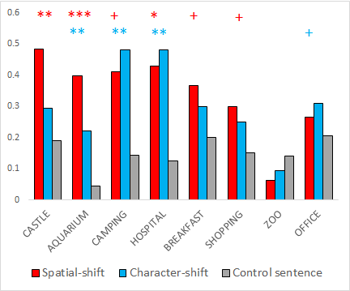
S1. Segmentation behavior in the pilot story. The mean frequency of keypresses after the different alignment points for the eight stories. Asterisks indicate significantly higher values for spatial-shifts (red) or character-shifts (blue), as compared to control sentences.
+:p<.1, *: p<.05, **: p<.01, ***: p<.001
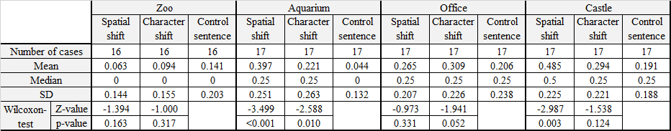
Table S1- Segmentation behavior in the pilot study - descriptive statistics. Descriptive statistics and statistical tests associated with event segmentation behavior after the different alignment points, separately for each task, in the stories zoo, aquarium, office and castle, respectively.
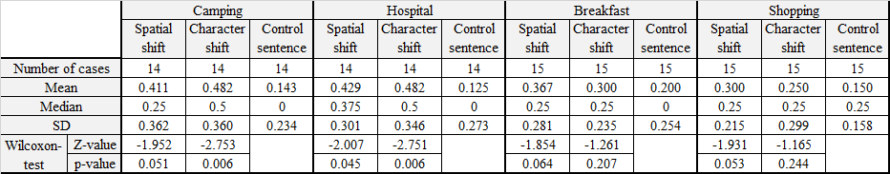
Table S2- Segmentation behavior in the pilot study - descriptive statistics. Descriptive statistics and statistical tests associated with event segmentation behavior after the different alignment points, separately for each task, in the stories camping, hospital, breakfast and shopping, respectively.

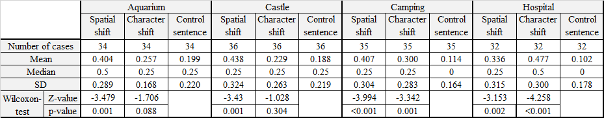
Table S2- Segmentation behavior in Exp 1 - descriptive statistics. Descriptive statistics and statistical tests associated with event segmentation behavior after the different alignment points, separately for each task, in the four stories used in Exp 1.

Section 2. Statistical tests of key-press frequency changes after content-based alignment points in Exp 1
As described in the results section of the manuscript, we investigated on a second-by-second basis how keypress frequency changes around content-based alignment points (spatial/character shifts and control sentences, see method for description). To achieve this aim, we calculated key-press frequency separately for each second in the period of the preceding four and subsequent ten seconds surrounding each alignment point. Then, we aggregated this value for the different alignment points, separately for each participant. This way, we created a data table, which contained for each participant his/her key press frequency change before and after the three alignment point types. The mean values of these data series are presented in Fig 1B in the manuscript, which shows that compared to the last second before the alignment point, keypress frequencies increase at and after alignment points, whereas no such increase is present for the control sentences. To test the significance of these differences we conducted a series of Wilcoxon Signed Rank Tests to investigate whether key-press percentage values during and after alignment points are significantly different than in the second preceding the alignment point. Significant differences are indicated by markers on the lines in Fig 1B, and the results of the Wilcoxon Signed Rank Tests are presented in Table S3.
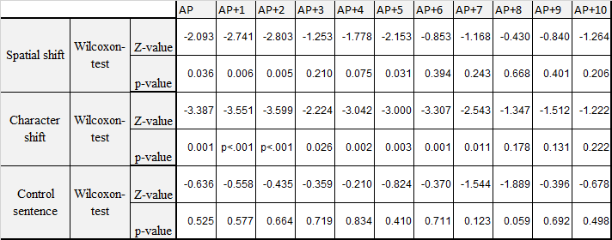
Table S3. Statistical test of key-press frequency changes after alignment points. Wilcoxon Paired Signed Rank test were conducted to compare the key press frequency value of the last second before the alignment point to the key press frequency value at and after alignment points, on a second-by-second basis. AP: Alignment point, AP+1, AP+2 (…), AP+10: The first, second, (…), tenth second after the alignment points.

Section 3 – Analysis of key-press frequency data for the different stories, in both Exp 1 and Exp 5.
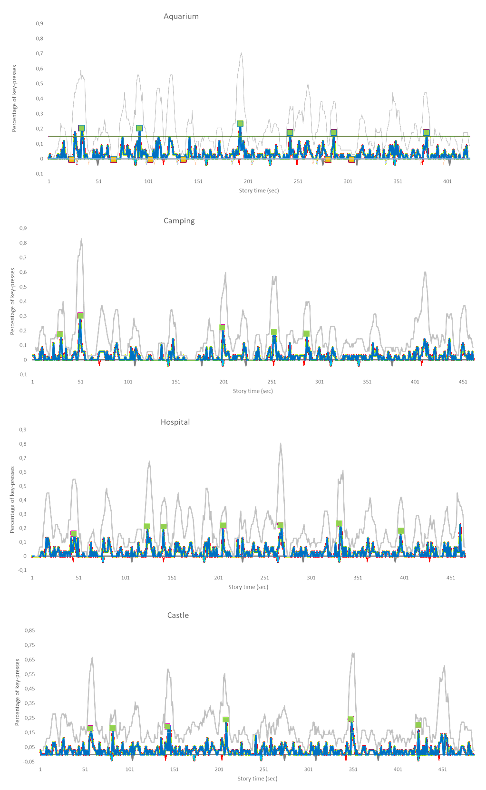
Figure S2. Key-press percentage values for each second of each story in Exp 1. Blue line indicates key-press frequency values computed for each second separately, whereas grey line indicates key-press frequency aggregated separately for each sentence. Red/blue vertical lines indicate spatial/character shift sentences, grey vertical lines indicate control sentences. Green squares indicate event-segmentation hotspots, yellow squares indicate no segmentation hotspots.

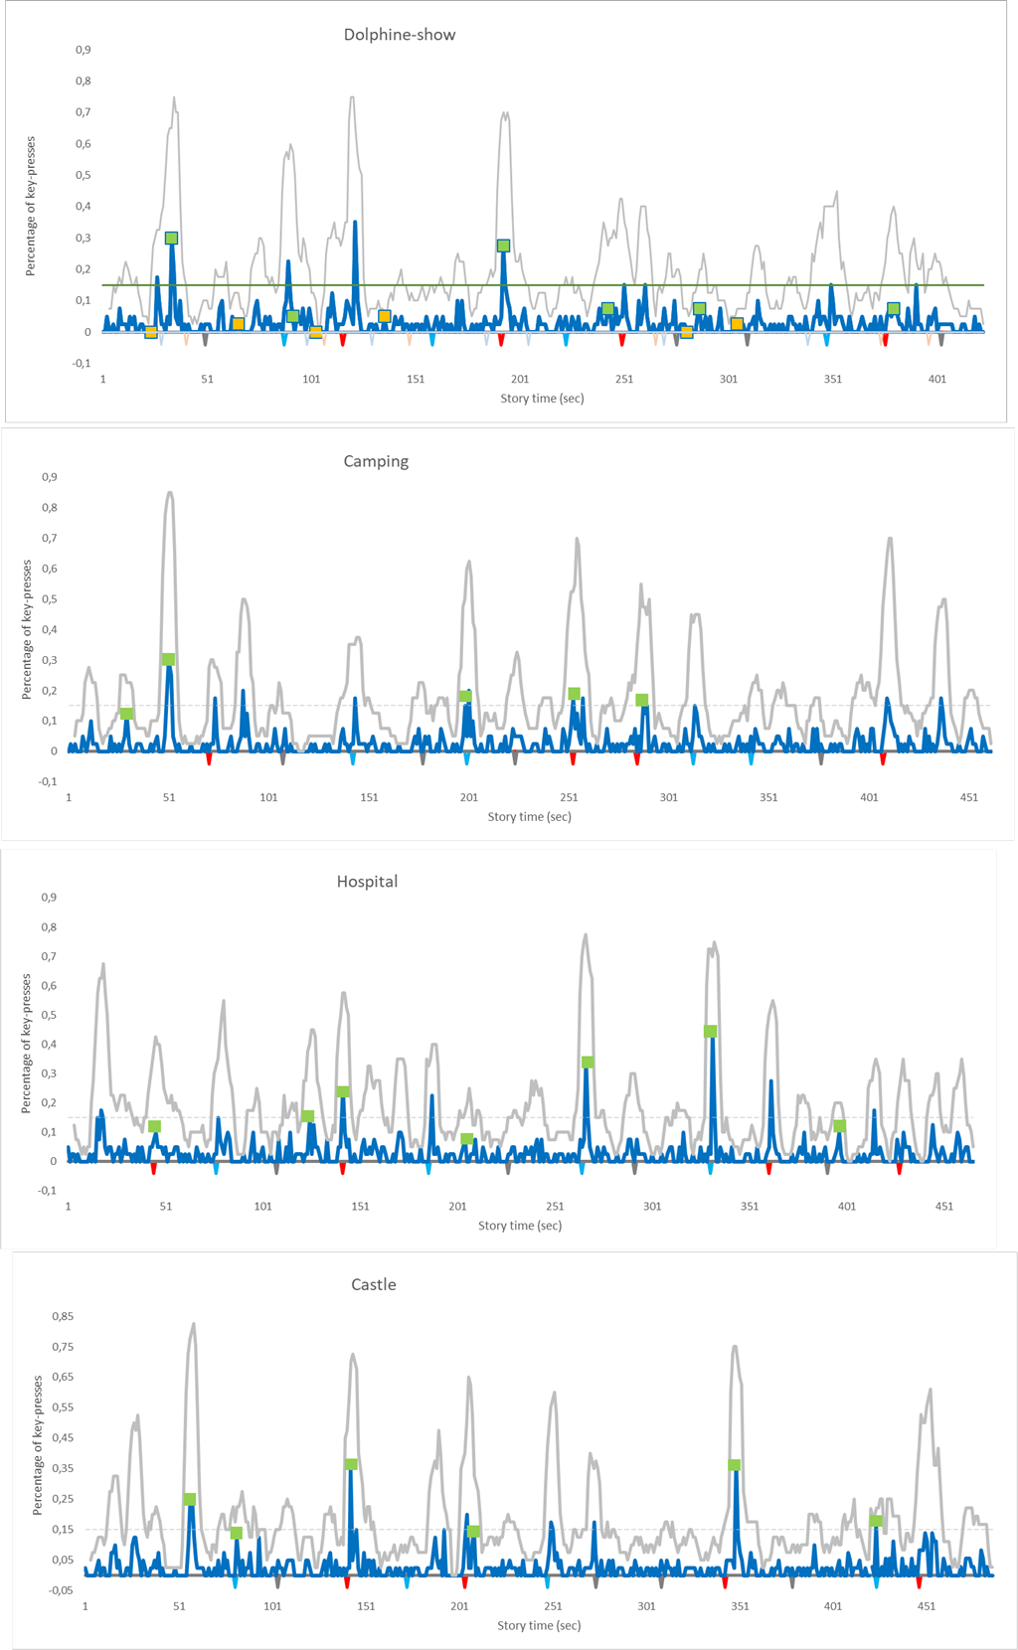
Figure S3. Key-press percentage values for each second of each story in Exp 5. Blue line indicates key-press frequency values computed for each second separately, whereas grey line indicates key-press frequency aggregated separately for each sentence. Red/blue vertical lines indicate spatial/character shift sentences, grey vertical lines indicate control sentences. Green squares indicate event-segmentation hotspots, as detected in Experiment 1.

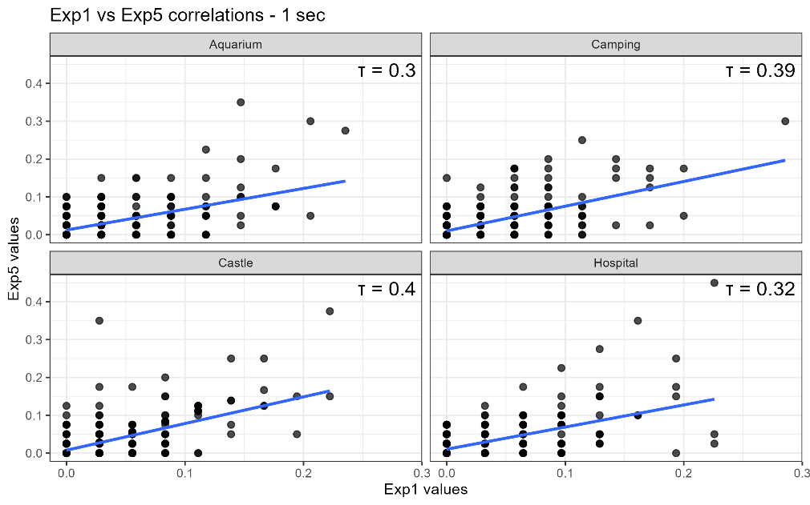
Figure S4. Correlation of segmentation behaviour measured in Exp 1 and Exp 5 – key-press frequencies computed for each second. Key-press frequency values are computed for each second of each story separately (corresponding to blue lines in Figure S2-S3). Due to the large amounts of similar values, all points in the scatterplots correspond to multiple cases.
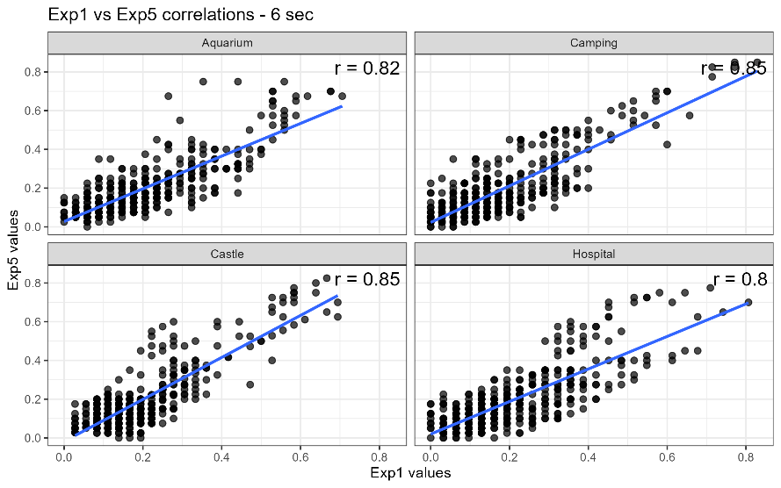

Figure S5. Correlation of segmentation behaviour measured in Exp 1 and Exp 5 – key-press frequency values summed for six seconds. Key-press frequency values are computed for each second by summing key-presses for the given and for the preceeding and subsequent three seconds (corresponding to grey lines in Figure S2-S3).

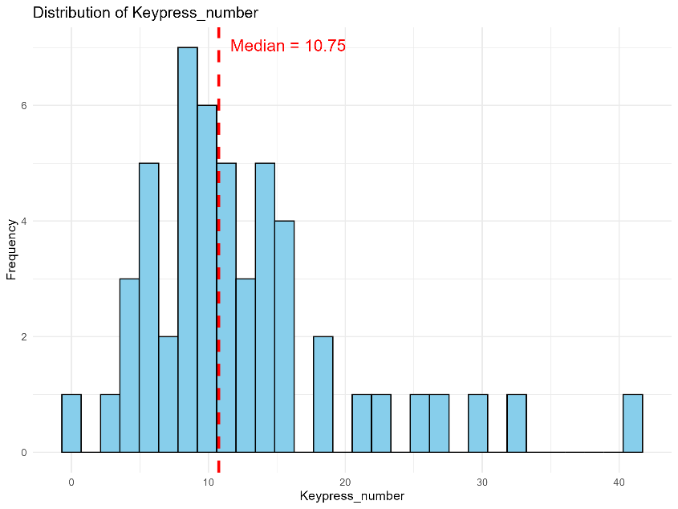

Figure S6. Distribution of the sum of keypresses during segmentation in Exp 5. The histograms represent that on average, how many times the participants pressed the segmentation-key during listening to a story.

Section 4 – Hungarian and English versions of the four stories used in Exp 1-3, with marked alignment points.

Different background font colors denote different alignment points
XXX: spatial shift sentence
XXX: non-boundary spatial location
XXX: character shift sentence
XXX: non-boundary character mention
XXX: control sentence
XXX: event segmentation hotspot
XXX: no segmentation spot
For the content-based alignment points, that specific word is underlined, which was taken as exact alignment point in the pupillometric analysis.

The aquarium story (original story in English, used in Bailey et al, 2017)
One Saturday morning, Linda took her son Jimmy to the local aquarium. Linda was eager to encourage her son’s newfound interest in the ocean.Since Jimmy first saw the great white shark on a nature show last month, he’d started reading shark books and drawing crayon pictures of the ocean instead of playing violent videogames. Linda dreamed of her red-haired little boy as a future marine biologist.They entered the lobby, which had a life-size model of a whale hanging from the ceiling. Jimmy was impressed by the size of the lobby and the whale, with its ribcage the size of a school bus. The high ceiling was painted to resemble the surface of the ocean. He looked around in awe at the colorful coral reefs. Jimmy gaped up at the whale’s belly and smiled. He pointed out to his mom the painted schools of fish on the ceiling. He saw striped angelfish, graceful manta rays, and clownfish like Nemo from the Disney movie. Crabs, too, like the ones they’d seen at seafood restaurants, with their tool-like pinchers. He finally looked down from the ceiling and rubbed his stiffening neck. Jimmy noticed a picture of a shark on the wall, and his eyes widened. He loved sharks. In fact, he was wearing his favorite shark t-shirt. Linda got her money out, and checked the prices above the ticket window. A surgeon at the local hospital, Linda was glad she had found time between shifts to bring Jimmy to the aquarium. Linda's baby-blue eyes widened when she saw how expensive the tickets were. She hadn’t been to the aquarium in years and was surprised at how the prices had gone up. She was a single mom, so money could have been tight. She was glad she had such a great job. Linda paid for the tickets, and they walked down the hall and turned left into the jellyfish room. Purple jellyfish were painted on either side of the doorway to mark the cool, cave-like room. Linda remembered how peaceful jellyfish look, like jello aliens drifting in outer space. She thought Jimmy would like this, and looked forward to see his reaction. Linda looked around at the tanks of all sizes lining the walls in the dimly lit room. Some were lit from beneath by colored lights. Linda liked how this made the jellyfish glow eerily. Linda walked up to the largest tank and gazed through the glass. Jimmy came up to the tank and tapped the glass. He tried to get the attention of one jellyfish in particular, which was the same orange color as his favorite videogame monster. He put his palm against the glass, imagining what it would feel like to touch the squishy creature. Then he looked up and saw a sign above the tank that read: “Do not touch the glass.” Jimmy turned red and shuffled over to a tank near the exit. He had had enough of the jellyfish room. He wanted to move on. He slipped through the exit and found himself in the penguin room. Penguins in their black and white tuxedos were waddling across the ice, chasing fish. The room was chilly, and goosebumps appeared on Jimmy’s freckled forearms. The room was crowded, but Jimmy was small and managed to push his way to the front of the crowd. It was the penguins’ feeding time, and they were all energetically diving for the fish being thrown into the water by an aquarium employee. Jimmy watched wide-eyed until feeding time was over. Linda stepped up closer to get a better view of the feeding. She felt a surge of childlike excitement. She noticed one penguin as it dove into the water behind the glass, its rubbery body moving fast as a bullet. She looked again at the map she held, which also had times for the dolphin shows. There was a show starting in ten minutes. “There’s a dolphin show starting soon; we should head over if we want to get good seats,” she said. The pair left the penguin room and followed the signs pointing them to the right and out a set of double doors to the large outdoor pool where the dolphin shows were held. It was warm outside, but there was a nice breeze. They climbed the bleachers until they found a pair of empty seats near the center. Linda had loved watching dolphin shows since she was little. She was almost as excited as her son. The show started right on time. Linda clapped and cheered with the rest of the audience. It was easy to forget the stress of the hospital here, surrounded by excited children. The operating room seemed far away. Linda pulled her sunglasses out of the pocket of her mint-green scrubs, and put them on to shield some of the glare from the sun reflecting off the water. She watched as the dolphins started their tricks, being rewarded every time by fish tossed to them by their trainer. They jumped through hoops and did back flips. Linda’s favorite was when they balanced on their tails and scooted across the top of the water. Linda began to take pictures. The breeze blew Linda’s curly red hair into her face, and she brushed it out of the way so she could see to take pictures. It was hard to take pictures of the dolphins because they were constantly moving. She finally managed to get a picture of one dolphin balancing a ball on its nose. She also took a photo of the children’s delighted faces as they got splashed in the front row. As one dolphin hit the water, Linda felt droplets splash up on her arms. She laughed out loud. The show only lasted about twenty minutes, but it was very entertaining and the audience cheered again when it was over. Jimmy took out the kids’ map he had been given and saw the picture of the shark. The shark’s jaws looked bigger than Jimmy’s head. He loved how scary the dorsal fins looked, sticking out above the water. Jimmy turned to his mom with pleading eyes. “Mom, can we please go see the sharks now?” he asked. He was so excited he could barely stay in his seat on the bleachers. He was finally going to get to see what he had been waiting for. They entered the building through the same doors they had come out, and Jimmy led the way straight down the hallway to the shark tunnel. Jimmy thought of the scuba divers on the nature show as he walked into the dark glass tube. He imagined he was walking on the ocean floor, side by side with real wild sharks. Jimmy ran to the middle of the glass tunnel and grinned widely, showing his missing front tooth. He tipped his head back to see the sharks swimming over his head. Some kids might have been scared, but he wasn’t. He thought sharks were awesome, especially the scary ones. He grinned as a hammerhead shark swam by—that was the shark on his t-shirt.

A delfin-show (Hungarian adaptation of the aquarium story, used in this study)
Egy szombat délután Linda elvitte a fiát, Andrist a helyi állatkert akváriumába, ahol tengeri halakat lehetett látni. Lelkesen támogatta a fia óceán iránti újdonsült érdeklődését. Andris a múlt hónapban látott először nagy fehér cápát egy természetfilmben, és azóta erőszakos videójátékok helyett elkezdett cápás könyveket olvasni és az óceánt rajzolta zsírkrétával. Linda arról álmodott, hogy a vörös hajú kicsi fia egyszer tengerbiológus lesz. Beléptek az előtérbe, ahol egy bálna életnagyságú modellje lógott a mennyezetről. Andrist lenyűgözte az előtér és a bálna nagysága. A bálna törzse akkora volt, mint egy iskolabusz. A mennyezet olyanra volt festve, mint az óceán felszíne. A kisfiú elképedve nézte a színes korallszirteket. Tátott szájjal nézett fel a bálna hasára és mosolygott. Anyjának mutogatta a mennyezetre festett halrajokat. Csíkos angyalhalakat és kecses rájákat látott, meg bohóchalakat, mint amilyen Nemo a Disney filmből. És rákokat is, mint amiket a halételeket kínáló vendéglőkben lehet látni, hatalmas ollókkal. Nagy sokára levette a tekintetét a mennyezetről és megdörzsölte megfájdult nyakát. Észrevett egy cápát ábrázoló képet a falon és elkerekedett a szeme. Ami azt illeti, most is a kedvenc cápás pólójában volt. Linda elővette a pénztárcáját és megnézte a belépők árát a jegypénztár felett. Sebész volt a helyi kórházban, örült, hogy két műszak között el tudta hozni Andrist az akváriumba. Égszinkék szeme elkerekedett, amikor meglátta, milyen drágák a belépők. Évek óta nem volt az akváriumban és meglepte, hogy mennyire felmentek az árak. Egyedülálló anya volt, könnyen lehettek volna anyagi gondjai, ezért örült, hogy jó munkája van. Kifizette a belépőket, majd végigsétáltak az előtéren és balra fordultak, a medúza terembe. A hideg, barlangszerű terem bejáratának mindkét oldalára lila medúzák voltak festve jelzésképpen. Linda emlékezett, milyen békésnek tűntek itt a medúzák, mintha kocsonyaszerű űrlények lebegnének az űrben. Biztosra vette, hogy Andrisnak tetszeni fognak, és alig várta, hogy lássa, mit szól hozzájuk. Körbenézett, a fal mentén mindenféle méretű akváriumok álltak a gyengén megvilágított teremben. Némelyik alulról volt megvilágítva, színes fényekkel. Lindának tetszett, hogy a medúzák sejtelmesen világítanak tőle. Odament a legnagyobb akváriumhoz és átbámult az üvegen. Andris is odament az akváriumhoz és megkopogtatta az üveget. Az egyik medúza figyelmét próbálta magára vonni, ami pont olyan narancssárga volt, mint a kedvenc szörnye az egyik videojátékban. A tenyerét az üvegre tapasztotta és elképzelte, milyen érzés lenne megérinteni a puha lényt. Aztán felnézett és meglátta a feliratot az akvárium felett: „Az üveghez nyúlni tilos”. Andris elpirult és elcsoszogott egy másik akváriuhmhoz a kijárat közelében. Elunta a medúza termet. Tovább akartenni. Kilépett a kijáraton és a pingvin teremben találta magát. A pingvinek fekete-fehér szmokingjaikban csámpáztak a jégen, és halakra vadásztak. A terem hideg volt, Andris szeplős karja libabőrös lett. Sokan voltak bent, de Andris kicsi volt és sikerült a tömeg elejére furakodnia. Éppen etetés volt a pingvineknél, lendületből csobbantak a halak után, amiket az akvárium alkalmazottja dobált a vízbe. Andris tágra nyílt szemmel figyelte őket, amíg véget nem ért az etetés. Linda közelebb lépett, hogy jobban lássa az etetést. Gyerekes izgatottság töltötte el. Figyelte, ahogy az egyik pingvin épp beleugrik a vízbe az üveg túloldalán, ruganyos teste úgy szelte a vizet, mint egy puskagolyó. Újra a kezében lévő térképre nézett, amin rajta voltak a delfin show-k időpontjai is. A következő show tíz perc múlva kezdődött.-Mindjárt kezdődik egy delfin show, induljunk, ha jó helyről akarjuk nézni- mondta Linda. Elhagyták a pingvin termet és követték a jelzést, amely jobbra, majd egy dupla ajtón át egy hatalmas kinti medencéhez vezetett, itt tartották a delfin show-t. Meleg volt odakint, de kellemes szellő fújt. Addig mentek felfelé a lelátón, amíg két szabad ülőhelyet nem találtak középtájon. Linda kiskora óta imádott delfin show-kat nézni. Majdnem olyan izgatott volt, mint a fia. A show pontosan időben kezdődött. Linda a közönséggel együtt tapsolt és ujjongott. Itt, az izgatott gyerekek között könnyű volt elfelejteni a stresszt, amit a kórházban érzett. A műtőszoba nagyon messzinek tűnt. Elővette a napszemüvegét a mentazöld kórházi köpeny zsebéből, és feltette, hogy védje a szemét a vízről visszaverődő napfénytől. Figyelte, ahogy a delfinek belekezdenek a trükkökbe, és a gondozójuk minden alkalommal jutalom halat dob nekik. Karikákon ugrottak át és hátraszaltóztak. Linda kedvence az volt, amikor a farkukon egyensúlyozva szelték át a vizet. Elkezdte őket fotózni. A szellő Linda arcába fújta a göndör, vörös haját. Félresöpörte a haját az arca elől, hogy jól lásson a fotózáshoz. Nehéz volt a delfineket fotózni, mert folyamatosan mozogtak. Végül sikerült lekapni egy delfint, ahogy egy labdát egyensúlyoz az orrán. Az első sorban ülő gyerekek vidám arcát is lefotózta, miközben a delfinek végig fröcskölték őket vízzel. Ahogy az egyik a vízbe ért, Linda érezte a karján a vízcseppeket. Felnevetett. A show nagyjából húsz percig tartott, de nagyon szórakoztató volt, és a közönség a végén is ujjongott. Andris elővette a gyereknek szánt prospektust, amit kapott, és meglátta benne egy cápa képét. A cápa állkapcsa nagyobbnak tűnt, mint Andris feje. Nagyon tetszett neki, hogy milyen ijesztő, amikor csak a hátúszójuk látszik ki a vízből. Andris könyörgő szemekkel az anyjához fordult.- Anya, légyszi, mehetünk most már a cápákhoz? – kérdezte. Olyan izgatott volt, hogy alig bírt az ülőhelyén maradni a lelátón. Végre megláthatja, amire várt. Visszamentek az épületbe ugyanazon az ajtón, ahol kijöttek, Andris ment elöl, végig a folyosón a cápák medencéjéhez. Andris a természetfilmben látott búvárokra gondolt, ahogy besétált a sötét üvegalagútba. Képzeletben az óceán fenekén sétált, valódi, vad cápák között. Az üvegalagút közepére futott és szélesen vigyorgott, látszott, hogy középen hiányzik egy foga. Hátrahajtott fejjel nézte a fölötte úszó cápákat. Némelyik gyerek talán félt volna, de ő nem. Szerinte a cápák szuperek, főleg az ijesztőek. Vigyorgott, amikor egy pörölycápa úszott el mellette –a pólóján is ilyen cápa volt.

The castle story (original story in English, used in Bailey et al, 2017)
Haley and John, college friends, were on a trip to Germany over spring break. They had met in a French class their freshman year and, although they were incredibly different, had become good friends. John was a nerdy History major and didn’t care much about his appearance, which drove Haley, an artsy budding fashion designer, crazy. The two had been planning this trip for months. It had been difficult because they wanted to see such different things. Haley tended to be solitary and therefore hated tour groups, while John loved being in groups. John was eager to please and keep the peace, whereas Haley always spoke her mind, especially when it involved being annoyed with something, which was often. Mostly thanks to John’s gentle diplomacy, they had negotiated a compromise on the places they would go on their trip. Today they were visiting a medieval castle, which had been John’s idea. John pushed his thick glasses up on his nose and grinned widely as they walked through the castle armory. He was soaking up the history of this place like a sponge. The castle was filled with authentic furnishings, and John took a picture of everything they passed. He was so happy he and Haley had decided to visit the castle that day. Haley, on the other hand, was incredibly bored and cold. Haley pulled her sweater tighter around herself and shivered. She huffed her annoyance, a scowl marring her pretty features. The castle was freezing, and she hadn’t wanted to come in the first place. She had really wanted to visit some of the shops in the town where their hotel was. She thought castles were musty and boring. So far, she was only being proven right. Haley was especially tired of the armory, where they had been standing for nearly fifteen minutes. However, she did have to admit that the sheer number of weapons on display in the room was impressive. The wall they were standing next to had various weapons hanging all along its length. Haley thought the swords looked really intimidating, and hoped they were securely fastened to the wall. She was sure the tour guide was explaining all the historical details, but she had stopped listening to him. She hoped he wasn’t going to talk continuously during the entire tour. The group walked out of the armory and into the castle’s outdoor courtyard. Haley was glad to be outside, where it was much warmer than inside. It was an unusually day for Germany in the middle of March. Just as they walked outside, a cloud moved away from in front of the sun. Haley squinted her hazel eyes against the suddenly bright sunlight. Her annoyance softened a little at seeing the beautiful courtyard. The spring flowers were just beginning to sprout. There was a beautiful fountain in the middle of it all. John pulled his camera out again. John was eagerly documenting the entire trip with pictures.He wanted to remember absolutely everything, so that he could write a full narrative once they returned. He was the editor of the school paper and thought the story would make a good article. “Go stand by the fountain,” he said, motioning to Haley. He waited as she went over and sat down on the edge, and snapped the picture. “That’s good,” he said, and smiled. The two quickly caught up with the tour group and went back into the castle, entering the small chapel with its arched roof. John felt bad taking pictures in here, as the atmosphere was so quiet and respectful. There were numerous people scattered among the pews, sitting in quiet reverence. John reluctantly put his camera down and took a moment to look around. The best part of the chapel was the huge, intricate stained-glass window high on the wall near the ceiling. John listened to the tour guide explain that the chapel had been very humble when the castle was built, but more intricate decoration had been added as it became fashionable. John nodded, fascinated. These were the kinds of minute historical details that he loved. Now that art was involved, Haley was also completely in her element. Stained-glass windows reminded Haley of the kaleidoscopes she had loved as a kid, and these were particularly artistically inspiring. Haley slid into a pew to give another group room to pass in the aisle.“I’d really like to sketch the window,” she said to John. “You go ahead with the group, and I’ll catch up when I’m done.” She took off her backpack and sat down on the wooden pew. She looked for her sketchpad and pencils. Haley’s bag was always filled with everything she could possibly need, so it was constantly a mess. She always had to dig for several minutes just to find what she wanted.Haley tucked her wavy hair behind her ears like she always did when she was drawing. Resting her sketchpad on her knees, she began to draw. She drew quickly and lightly but exactly, outlining the intricate design of the large window. When she finished, she examined her work—the design on her page was beautiful and true to life, but without color it just wasn’t the same. She decided to get out her box of colored pencils. As Haley dug through her bag again, she quickly checked to make sure her wallet was still there. They had been in some very crowded places, and Haley was constantly afraid of being pickpocketed. Fortunately, she found her wallet as well as the box of colored pencils. As Haley opened the box, the pencils all spilled out on the stone floor. Haley laughed at herself and knelt down to pick them up. When she had collected them all, she began to color. It took her slightly longer to fill in all the color, but when she was done she was very pleased with her work. Packing up her things, Haley left the chapel and went down the hall to go in search of the tour group. The hallways within the castle were narrow and winding, and Haley could barely find her way around. She found the group in the master bedroom on the second floor. She was annoyed again at having to search so long to find the group. She was also annoyed that the tour guide was showing no signs of stopping soon. This enormous room was filled with ridiculous decorations, and Haley rolled her eyes to hear the tour guide talk rapturously about all of them. Her favorite was the random suit of armor standing next to the wardrobe. The bed was the best part of the room, though – it was enormous, and the four tall posts were topped with a luxurious-looking canopy. As a child, Haley had always wanted a canopy bed, and so she thought this would be a great place to spend the night. Unfortunately, Haley needed her bedroom very warm at night. Although the sun shone in through the window, the room, like the rest of the castle, was freezing. The giant fireplace in the corner would have taken care of the cold, though. Haley, mind wandering, thought about how scared she would be to light a fire in this room, for the sake of the beautiful tapestries that covered the walls. Her attention was jolted back by a bright flash in her peripheral vision. John laughed aloud when Haley noticeably jumped at his camera flashing in her face. Even John was beginning to get bored. The tour guide was incredibly long-winded, and they had been in the castle for over an hour and a half. He put his camera back into the pocket of his wrinkled pants. His stomach rumbled. He couldn’t believe they had stayed for so long. “I’m starving, want to leave and find some lunch?” he asked. Slipping away from the group, the two easily found their way outside and started down the stone path toward town. There was no shade on the road, and despite the early spring time, it was uncomfortably warm to walk. In addition, the wind that had suddenly picked up blew dust into their faces several times. Fortunately, a grey cloud soon covered the sun, so at least the temperature was no longer disturbing. The road offered a wonderful view of the surrounding mountains, and so they made the journey into town in more or less good spirits.

Kastélyban (Hungarian adaptation of the castle story, used in this study)
Zsófi és István a főiskolán barátkoztak össze, és most Németországba utaztak a tavaszi szünetben. Francia nyelvórán ismerkedtek meg elsőéves korukban, és bár nagyon különbözőek voltak, jó barátok lettek. István stréber történelemszakos hallgató volt és nem érdekelték a külsőségek, ezzel viszont az őrületbe kergette Zsófit, aki divattervezőnek készülő művészlélek volt. Hónapok óta tervezték ezt az utat. Nehéz volt, mert mindketten nagyon más dolgokat akartak megnézni. Zsófi sokat volt egyedül, utálta is a csoportos utazásokat, míg István szeretett csoportban lenni. István igyekezett jóban lenni másokkal és megőrizni velük a jó viszonyt, míg Zsófi mindig kimondta, amit gondolt, főleg ha idegesítette valami - ami gyakori volt. Főleg István diplomatikusságának köszönhetően sikerült egyáltalán kompromisszumot kötniük arról, hogy az utazás alatt majd hová menjenek. Aznap egy középkori várat látogattak meg, ami István ötlete volt. István feltolta az orrán a vastag szemüveget és teli-szájjal vigyorgott, ahogy átsétáltak a kastély fegyvertárán. Úgy szívta magába a hely történelmét, mint egy szivacs. A kastély eredeti korabeli tárgyakkal volt berendezve és István mindent lefotózott, amit csak látott. Nagyon örült, hogy Zsófival úgy döntöttek, hogy aznap a kastélyt nézik meg. Zsófit azonban elképesztően untatta a hely és fázott is. Összehúzta magán a kardigánját és vacogott. Bosszúsan fújtatott, csinos arcán mogorva kifejezés ült. A kastélyban dermesztő hideg volt, és Zsófi egyébként sem akart ide jönni. A boltokban akart nézelődni a városban, ahol a hoteljük is volt. A kastélyok neki dohosak és unalmasak voltak. Ez alól egyelőre ez a kastély sem volt kivétel. Zsófi főleg a fegyvertárat unta, már majdnem tizenöt perce ácsorogtak ott. De azt azért el kellett ismernie, hogy a teremben kiállított fegyverek puszta mennyisége lenyűgöző volt. A mellettük lévő falon teljes hosszában végig különböző fegyverek voltak kiállítva. Zsófi félelmetesnek találta a kardokat, remélte, hogy biztonságosan oda vannak rögzítve a falhoz. Az idegenvezető biztosan elmagyarázta az összes történelmi érdekességet, de ő már nem figyelt oda rá. Remélte, hogy az idegenvezető nem fogja megállás nélkül végigbeszélni a látogatást. A csoport kiért a fegyvertárból és megérkezett a kastély külső udvarára. Zsófi örült, hogy kint lehet, ott sokkal melegebb volt, mint odabent. Március közepéhez képest Németországban ez egy szokatlanul meleg nap volt. Éppen ahogy kiléptek, elvonult egy felhő a nap elől. Zsófi összehúzta zöldesbarna szemét, ahogy hirtelen belesütött az erős napfény. A bosszússága kicsit alább hagyott, ahogy végignézett a gyönyörű udvaron. A tavaszi virágok épp most kezdtek kihajtani. A kert közepén egy gyönyörű szökőkút állt. István újra elővette a fényképezőgépét. Lelkesen fotózta végig az egész utazást. Mindenre tökéletesen akart emlékezni, hogy aztán meg tudja írni az út teljes történetét, amikor hazaértek. Az iskolai újság szerkesztője volt, és úgy gondolta, a történetből jó cikk lehetne. - Állj oda a szökőkút mellé - , mondta Zsófinak, és mutatta, hova. Várt, amíg Zsófi odaért, és leült a szökőkút szélére, aztán készített egy képet. - Ez jó lesz -, mondta, és mosolygott. Gyorsan utolérték a csoportot, és visszamentek a kastélyba, be egy kis, ívelt tetejű kápolnába. István itt kényelmetlenül érezte magát fotózás közben, olyan meghitt és csendes hangulat volt odabent. Sok ember ült szétszórva a padokban, tiszteletteljes csendben. István vonakodva leeresztette a fényképezőgépét és egy percre körbenézett. A kápolna legjobb része a hatalmas, aprólékosan kidolgozott ólomüveg ablak volt magasan, a mennyezet közelében. István odafigyelt az idegenvezetőre, aki elmesélte, hogy a kápolna szerény hely volt, amikor megépült a kastély, de később egyre több díszítést kapott, ahogy népszerűbb lett. István érdeklődve bólogatott. Rajongott az ilyen apró történelmi részletekért. Most, hogy művészetről is szó esett, Zsófi is elemében volt. Művészi ihletet adtak neki az ólomüveg ablakok. Kaleidoszkópokra emlékeztették, amiket gyerekkorában imádott. Zsófi belépett az egyik padsorba, hogy helyet adjon egy másik csoportnak, akik a padok közötti folyosón mentek végig. - Le akarom rajzolni azt az ablakot -, mondta Istvánnak. - Maradj csak a csoporttal, majd ha végeztem, utolérlek titeket. Levette a hátizsákját és leült a fapadra. A vázlatfüzetét és a ceruzáit kereste. Zsófi hátizsákjában mindig volt minden, ami csak kellhetett, úgyhogy folyamatosan rendetlenség volt benne. Mindig percekig kellett kotorásznia benne, mire megtalált valamit. A füle mögé tette hullámos haját, ahogy mindig szokta rajzolás közben. A vázlatfüzetet a térdére támasztotta és rajzolni kezdett. Gyorsan és könnyen, de pontosan rajzolt, felvázolta a hatalmas ablak aprólékos mintáját. Amikor végzett, megvizsgálta a munkáját, - a minta a papíron gyönyörű és élethű volt, de színek nélkül nem volt az igazi. Úgy döntött, előveszi a színes ceruzáit. Ahogy újra a táskájában keresgélt, gyorsan megnézte, hogy megvan-e még a pénztárcája. Jártak pár nagyon zsúfolt helyen, és Zsófi mindig tartott attól, hogy kizsebelik. Szerencsére megtalálta a pénztárcáját és a színes ceruzák dobozát is. Ahogy Zsófi kinyitotta a dobozt, a ceruzák kihullottak és szétszóródtak a kőpadlón. Nevetett saját magán és letérdelt, hogy felszedje őket. Amikor mindet összeszedte, nekiállt színezni. Kicsit tovább tartott, mire mindent kiszínezett, de mikor elkészült, nagyon elégedett volt a munkájával. Összepakolt, kiment a kápolnából, és az előcsarnokba ment, hogy megkeresse a csoportot. A kastély folyosói szűkek és kanyargósak voltak, Zsófi alig tudott bennük eligazodni. A csoportot a második emeleten, hálószobában találta meg. Már megint bosszús volt, mert sokáig kellett keresnie őket. Az is bosszantotta, hogy az idegenvezető semmi jelét nem adta, hogy közeledne a látogatás vége. A hatalmas szoba nevetséges díszítőelemekkel volt tele, Zsófi forgatta a szemét, hallva, hogy az idegenvezető milyen elragadtatottan beszél róluk. A kedvence egy találomra a ruhásszekrény mellé állított páncélzat volt. A szoba legjobb része az ágy volt – hatalmas volt, és a négy sarkában álló magas oszlopokra pazar baldachint tettek. Gyerekként Zsófi mindig is szeretett volna baldachint az ágya fölé, most is arra gondolt, milyen jó lehet ilyen helyen tölteni egy éjszakát. De sajnos Zsófi azt is szerette, ha a hálószoba jól be van fűtve éjszaka. Bár a nap besütött az ablakon keresztül, a szoba, ahogy a kastély többi része is, dermesztően hideg volt. A sarokban álló óriási kandalló azért el tudott volna bánni a hideggel. Zsófi arra gondolt, hogy félne tüzet gyújtani ebben a szobában a falakon lógó gyönyörű falikárpitok miatt. A figyelmét visszazökkentette egy erős villanás a látótere szélén. István felnevetett, mert Zsófi ugrott egyet ahogy az arcába villant a vaku. Ekkor már István is kezdett unatkozni. Az idegenvezető elképesztően terjengősen beszélt, és már vagy másfél órája voltak a kastélyban. A fényképezőgépet visszatette a gyűrött nadrágja zsebébe. A gyomra korgott. El sem hitte, mióta vannak már itt. - Éhen halok, nem indulunk el ebédelni? – kérdezte. Otthagyták a csoportot, könnyen kitaláltak az épületből, és elindultak a városba vezető úton. Az úton nem volt árnyék, és a kora tavaszi időpont ellenére kényelmetlenül meleg volt gyaloglás koban. A hírtelen feltámadt szél ráadásul többször is az arcukba fújta az út porát. Szerencsére hamarosan egy szürke felhő jótékonyan eltakarta a napot, így legalább a hőmérséklet nem volt már zavaró. Az útról csodaszép kilátás nyílt a környező hegyekre, és így azért több-kevésbé jó hangulatban tették meg a városba vezető utat.

The camping story (original story in English, used in Bailey et al, 2017)
Jim and Kathy were preparing to take their kids on their first camping trip, and they were a little nervous. They had waited longer than their friends to have children. Most of the time they were very happy with this decision; they relished the thought of being retired by the kids' late adolescence and having the time to take long trips with them. They felt they were wiser, more patient parents than they would have been twenty years ago. Both had been workaholics in their joint law practice, and it had paid off in a level of financial security. They could afford to slow down, to take time to really enjoy the kids. But they felt a distance from the other parents, and they were at times self-conscious about being perhaps a little less active. Camping was important. Jim picked up his keys from the basket by the front door and paused. The basket was supposed to be a place for just keys, but his were always buried under everything else in there. Jim hated how it became a place to keep junk. From now on he would keep it clean, he vowed. He found his keys and walked into the garage. “I don’t like the look of those clouds,” Jim thought. He remembered that the forecast said it would be in the upper seventies and sunny the rest of the weekend, so he felt the weather would improve. As soon as he entered the garage Jim spotted the tent he had stored in the rafters. He loved getting out into nature and was excited about getting everything ready for the trip. He knew he wasn’t very organized about this, but he figured he would find everything if he just looked around. Unfortunately he already had a nagging feeling that he’d probably forget something. He looked around for other things one would need for a camping trip. “Ah ha! There it is,” he exclaimed. On the top shelf in the corner, Jim saw the box that his wife had conveniently labeled “Camping Gear”. As he pulled it down, the sleeping bags that had been piled on top fell down around him. “At least I won’t forget those,” he muttered as the last one bounced off his shoulder. Opening the tote, he found matches, fire starter, flashlights, camping dishes, and some random pieces of rope. Walking into the garage, Kathy laughed at the pile of stuff surrounding her husband. He was sitting on the floor, digging through the tote. “Jackpot,” he thought to himself. Kathy looked up at the rafters. Pulling back her short black hair, she asked, “Need some help?” Taking a step stool, she pulled the tent down from the rafters and handed it to her husband to load into the car. Putting the stool back, she walked over to the shelves in the corner. She pulled out the other box of camping gear that she herself had packed and labeled. Inside the box, on top of everything else, was a packing list for camping trips that she had made. The list was nicely organized by category. Kathy was glad she was so much more organized than her husband. She pulled out the list and passed the box to her husband to put in the car. She quickly scanned the list and, satisfied, put it into her pocket. “That’s everything from out here—I’ll go get the kids,” Kathy said. Jim leaned against his workbench to wait. Kathy thought the boys were probably downstairs playing. Jim heard her call to them as the screen door closed behind her. Jim scratched his graying beard as he waited. He was excited about taking the kids on this trip. They were going to the same place he had gone camping as a kid. It was halfway up the mountain that their town was named for. The drive would take them about two hours today because it was Memorial Day weekend and Jim knew traffic would be bad. He wondered what time it was. Jim drummed his fingers on the workbench as he began to become impatient. They still had to stop for gas, groceries, and breakfast at McDonald’s before they could even leave town! He was glad when his family came out, and he began loading their camping supplies into the car. ”Let’s go!” he said. They pulled out of the driveway and, five minutes later, pulled up to a gas pump. Jim ran his credit card at the pump and took the nozzle to start filling the car. As the gas pumped, Jim watched the numbers whizzing higher. He was a little worried about sleeping on the ground tonight. He had been standing for five minutes and already his achy back was bothering him. He mentally added aspirin to the grocery list. The list was getting longer, and he hoped it wouldn’t take too long at the store. Fortunately, the gas had just finished pumping. Jim took his receipt and they drove to the grocery store. Jim grabbed a cart as he and Kathy walked into the store. He followed behind with it as they walked through the store. He paused to clean his bifocals. He was embarrassed that his eyesight was so bad already. Looking at the groceries on the shelf, he sometimes had to squint to read the brand names. ”I hope the kids don’t inherit my terrible eyesight,” he thought as he grabbed the aspirin for his back. Kathy expertly led the way through the store, taking the things they needed from the shelves. She had her list organized by type of food and section of the store. It helped that it was summer and all the standard camping food items were at the front of the store. Kathy was very proud of what an efficient shopper she was. In addition to the hot dogs and hamburgers, Kathy picked up a bunch of snacks. She chose granola bars and trail mix, because she tried hard to keep her family healthy. Jim didn’t like that there wasn’t any candy going into the cart. Jim appreciated Kathy’s attempts to make them eat well, but he was on vacation now and really just wanted some sugar. He knew the kids would agree. He liked to spoil them. They passed the candy aisle, and Jim took advantage of the opportunity. He grabbed a giant bag of M&Ms, plus a few other treats. He buried them in the cart beneath Kathy’s bag of carrots. “We’re getting stuff for s’mores, right?” he asked. Jim knew you couldn’t have a camping trip without s’mores. “I guess we can,” Kathy conceded. Jim grinned and threw the ingredients into the cart: marshmallows, chocolate bars, and graham crackers. He considered himself a devoted father, and was determined to give his kids the full childhood camping experience. He checked the cart; it seemed that they had everything they needed. “Let’s check out and get out of here,” Jim said. He paid for the groceries in the self-checkout to save time. He grabbed the bags, took them out and loaded them in the car, and they drove away. The drive up the mountainside towards the campgrounds was beautiful. The kids really seemed to enjoy the idea of camping on the mountain. They pulled up to their camp spot and began to unpack. Jim told the boys that if they helped him put the tent up that he would take them to check out the nearby stream. The tent went up easier than Jim and Kathy thought it would. “Just in time,” they thought, because they were getting hungry again. Kathy set up the grill and started getting some burgers ready. She told Jim to take the kids to the stream and that the food would probably ready in half an hour or so. As she watched them walk off, she happily thought to herself that this was going to be a rewarding trip. She got to cooking and soaked in every second of being outside and on vacation.

Kempingezés (Hungarian adaptation of the camping story, used in this study)
János és Kata életük első kempingezésére készültek a gyerekeikkel, és kicsit idegesek voltak. Tovább vártak a gyerekvállalással, mint a barátaik. Többnyire elégedettek voltak ezzel a döntéssel; örültek a gondolatnak, hogy nyugdíjasok lesznek, mire a gyerekek felnőnek, és lesz majd idejük hosszú kirándulásokra menni együtt. Úgy érezték, bölcsebb, türelmesebb szülők, mint amilyenek 20 évvel korábban lettek volna. Mindketten munkamániásak voltak, a közös ügyvédi irodájukban dolgoztak, és ennek biztonságos anyagi háttér lett a gyümölcse. Megengedhették maguknak, hogy lelassítsanak, hogy kiélvezhessék a gyerekeikkel töltött időt. De érezték, hogy mások, mint a legtöbb szülő, és néha feszengtek amiatt, hogy talán kicsit lehetnének aktívabbak. A kempingezés fontos volt. János kivette a kosárból a kulcsát a bejárati ajtó mellett és megállt. A kosárban csak a kulcsnak kellett volna lennie, de azt most egy rakás más kacat alatt találta meg. Jánost nagyon zavarta, hogy a kosárban már mindenféle vicek-vacak összegyűlt. Megfogadta, hogy mostantól kezdve tisztán fogja tartani. Megtalálta a kulcsát és a garázsba ment.- Nem tetszenek nekem azok a felhők – gondolta János. Emlékezett, hogy az időjárásjelentésben 25 fok feletti hőmérsékletet mondtak és napsütést, így úgy volt vele, hogy majd javul az idő. Ahogy belépett a garázsba, János meglátta a sátrat: fel volt akasztva az egyik tetőgerendára. Imádott a természetben lenni, izgatottan készített elő mindent a kiránduláshoz. Tudta, hogy a rendszeretet nem az erőssége, de úgy gondolta, megtalál mindent, ha jól körülnéz. Sajnos máris volt egy olyan rossz érzése, hogy valószínűleg ki fog felejteni valamit. Körbenézett, hogy mi kellhet még a kempingezéshez. - Aha! Ott van! – kiáltott fel. A felső polcon a sarokban János meglátta a dobozt, amire a felesége gyakorlatiasan felírta, hogy “Kempingfelszerelések”. Ahogy levette, a hálózsákok, amik a tetejére lettek pakolva, lepotyogtak körülötte. - Legalább ezeket biztos nem felejtem el - , morogta, miközben az utolsó is leesett a földre a vállát érintve. Kinyitotta a dobozt, és gyufát, tűzrakó szettet, elemlámpákat, kemping edényeket, és különböző kötéldarabokat talált benne. Kata jött be a garázsba, és elnevette magát a férjét körülvevő halom láttán. A férfi a földön ült és a csomagban kotorászott. Kata felnézett a tetőgerendákra -Kell egy kis segítség? – kérdezte, és hátrasimította rövid, fekete haját. Felállt egy sámlira, lehúzta a sátrat a gerendáról és átadta a férjének, hogy tegye be az autóba. Átment a sarokba a polcokhoz, hogy visszategye a helyére a sámlit. Kihúzta a másik doboznyi kemping felszerelést, amit ő maga pakolt el és cimkézett fel. A dobozban legfelül egy általa összeírt lista volt arról, hogy miket kell elcsomagolni kempingezéshez. A lista szépen, kategóriák szerint volt rendezve. Kata örült, hogy sokkal rendszeretőbb és összeszedettebb, mint a férje. Kivette a listát és a dobozt odaadta a férjének, hogy tegye be azt is a kocsiba. Gyorsan átolvasta a listát és elégedetten betette a zsebébe.- Innen kintről nem kell más. Megyek a gyerekekért – mondta Kata. János a munkaasztalának támaszkodva várt. Kata úgy tippelte, hogy a fiúk a földszinten játszanak. János hallotta, hogy hívja őket, ahogy bezáródott mögötte a szúnyoghálós ajtó. János őszülő szakállát vakarászta, amíg várt. Izgatott volt, hogy kirándulni viszik a gyerekeket. Ugyanoda mentek, ahová ő járt kempingezni gyerekkorában. A kemping a hegyen volt, amiről a városuk kapta a nevét. Az autóút ma nagyjából kétórás lehet majd, mert hosszú hétvége volt, így János tudta, hogy forgalmas lehet az út. Azon gondolkozott, hogy mennyi lehet az idő. Jánosnak fogyóban volt a türelme és elkezdett a munkaasztalon dobolni az ujjaival. Még meg kell állni tankolni, bevásárolni, és megreggelizni a McDonald’s-ban mielőtt egyáltalán kiérnek a városból! Örült, amikor a családja megjelent, és elkezdte bepakolni a kempingező felszerelésüket a kocsiba.- Indulás! – mondta. Kiálltak a felhajtóról, és öt perc múlva megálltak egy benzinkútnál. János levette a töltőpisztolyt, hogy elkezdje feltölteni a tartályt. Amíg jött a benzin, János figyelte, ahogy a kijelzőn növekszenek a számok. Kicsit aggódott, amiért este a földön kell aludniuk. Még csak öt perce állt, és a fájós háta máris kínozta. Fejben felírta az aszpirint a bevásárlólistára. A lista egyre csak nőtt, és remélte, hogy nem tart majd túl sokáig a bevásárlás. Szerencsére a tankolással megvoltak. János fizetett, eltette a nyugtát és tovább hajtottak a bolthoz. János megragadott egy bevásárlókocsit, és Katával bementek a boltba. János ment hátul, ahogy végighaladtak a bolton. Megállt, hogy megtörölje a szemüvegét. Szégyellte, hogy a látása máris ilyen rossz. Amikor a termékeket nézte a polcon, néha hunyorítania kellett, hogy el tudja olvasni, hogy mi van rájuk írva. Remélem, a gyerekek nem örökölik a rossz látásomat, gondolta, ahogy levette a polcról az aszpirint a fájós hátára. Kata szakszerűen haladt végig a bolton, közben összeszedte, amire szükségük volt. A bevásárlólistája az ételtípusok és a bolt elrendezése szerint volt rendszerezve. Jól jött, hogy nyár volt, és a szokásos kempingezős ételek a bolt első részében voltak. Kata nagyon büszke volt rá, hogy milyen hatékonyan vásárol. A virsli és a hamburgerhús mellé Kata összeszedett egy halom rágcsálnivalót is. Müzliszeleteket és diákcsemegét vett, mert törekedett rá, hogy a családja egészséges legyen. János nem örült, hogy semmilyen édesség nem került a kocsiba. Értékelte, hogy Kata azon van, hogy egészséges ételeket egyenek, de János most szabadságon volt, és nagyon hiányzott neki egy kis édesség. Tudta, hogy a gyerekek is egyetértenének vele. Szerette elkényeztetni őket. Az édességes sor mellett elhaladva János kihasználta a lehetőséget. Magához vett egy óriási csomag M&M-t és még néhány édességet. Elrejtette őket a bevásárlókocsiban egy zacskó répa alá, amit Kata rakott be. Veszünk hozzávalókat a pillecukor sütéshez is, ugye? – kérdezte. János tudta, hogy nincs kempingezés pillecukor sütés nélkül. - Hát, jó -, egyezett bele Kata. János vigyorgott és bedobálta a hozzávalókat a kocsiba: pillecukrot, csokoládét, és kekszet. Odaadó apának tartotta magát, és eltökélte, hogy tökéletes gyerekkori kemping élményt ad a gyerekeinek.
Végignézett a bevásárlókocsi tartalmán; úgy tűnt, megvan minden, ami kell. - Fizessünk és menjünk -, mondta János. Az önkiszolgáló kasszánál fizetett, hogy időt spóroljanak. Fogta a szatyrokat, kivitte a kocsihoz, berakodta őket, és elindultak. A kempingező helyre a hegyek között vezető út gyönyörű volt. Úgy tűnt, a gyereknek tényleg van kedvük a hegyen kempingezni. Leparkoltak a táborhelyükön és elkezdtek kipakolni. János mondta a fiúknak, hogy ha segítenek felállítani a sátrat, akkor elviszi őket megnézni a közeli patakot. A sátor felállítása könnyebben ment, mint János és Kata gondolták. Éppen időben, gondolták, mert már kezdtek újra megéhezni. Kata felállította a grillt és nekiállt hamburgereket készíteni. Mondta Jánosnak, hogy vigye el a gyerekeket a patakhoz és hogy az étel nagyjából fél óra múlva kész lesz. Nézte, ahogy elsétálnak, és boldogan gondolta, hogy ez egy remek kirándulás lesz. Elkezdte sütni a húst és közben kiélvezte a kirándulás és a természetben töltött idő minden pillanatát.

The hospital story (original story in English, used in Bailey et al, 2017)
Holly and her boyfriend, Brian, had been dating for six months. Because it was a new relationship, Brian had only met Holly’s family one time. Today, though, they were going to visit Holly’s Grandma Rita in the hospital. Rita had just had surgery on her right hip and was going to be in the hospital recovering for a few more days. Holly sat in the quiet lobby worrying about her grandmother. She had a really close relationship with her Grandma Rita. Holly’s favorite childhood memory was of sitting on her grandmother’s porch eating fresh-baked cookies. She knew her grandmother was old, but she wasn’t ready for anything to happen to her. She was still worrying as they got onto the elevator and pressed the button for the fourth floor. To add to Holly’s anxiety about her grandma’s health, she was anxious about getting on the elevator. Holly felt a little relief when she saw her reflection in the mirrors that made up the elevator’s walls and made it seem a little bigger. She always felt slightly claustrophobic on elevators. She had an irrational fear that she would somehow get trapped inside one. She tried to think of her grandmother and not the size of the elevator. At the same time, Brian was thinking about how much he hated hospitals. Brian knew about Holly’s claustrophobia, but he couldn’t help feeling overwhelmed by his own phobia. He rubbed his hands over his close-shaven hair as he thought about all of his experiences in hospitals. Brian only had visited hospitals when somebody was sick. He had friends and family members who had surgeries. He also was in a hospital when he found out that his father had cancer. To make matters worse, Brian thought hospitals always had an unpleasant smell. They just smelled like illness. “Why can’t they just use some lemon-scented cleaning products or something?”, Brian thought to himself. The numbers on the display lit up indicating that they were moving from the 2nd floor to the 3rd floor. This was the slowest elevator that Brian had ever been on. It seemed as if a lifetime passed between each floor. He wondered if they would ever reach their destination. When the doors opened, Brian stepped off the elevator and turned left towards Rita’s room, room number 4136. Brian had only met Rita at their family Christmas dinner, but thought that she was a nice woman. Right now, Rita was taking a nap and they weren’t sure whether they should wake her up. So they pulled up two chairs near the bed. When Brian saw the clock on the nightstand, his green eyes widened because he realized he was missing the big game. His favorite football team was playing in the first round of the NFL playoffs this afternoon. Brian knew if they stayed at the hospital for too long he would miss the first half of the game. If he said that he was not feeling well, then maybe they could leave early. Holly saw the look on his face and was frustrated because she only wanted to spend an hour with her grandmother. Holly really enjoyed Brian’s company, but had noticed that he could be self-absorbed at times. But she knew this wasn’t the appropriate time to get into an argument. Instead, Holly wanted to focus on her grandma. She hated this room with its dreary gray walls and the chill in the air. Even the fact that there was a window didn’t help, because the view was of the brick building next door. It was hard for Holly to see her grandmother in such a sad room. It was also difficult to see her grandmother so feeble. For as long as Holly could remember, her grandmother had been a strong and vivacious woman. Unlike many women of her generation, Rita had worked outside the home, spending nearly thirty years as a schoolteacher. People always said that Holly took after her hardworking Grandma Rita. Holly was proud to be so much like her grandma—they were both tall, and Holly also had her grandmother’s button-shaped nose. She realized how lucky she was to have spent so much time with her grandma. They had spent many summer afternoons baking cookies and weeding the garden. Some of Holly’s friends had never even met their grandparents. Rita opened her eyes and smiled brightly, delighted to have visitors. Rita found that the older she got, the more she appreciated spending time with her family. She felt groggy and was alarmed by the IV that was taped to her slender forearm. It took her a few moments to remember where she was. Then she recalled that she was in the hospital for hip surgery. She had tripped while walking down the stairs, breaking her right hip. She was embarrassed because she thought only old people broke their hips, and Rita did not feel old. Luckily, Rita always carried her cell phone and was able to call 911. Even though she had only hurt her hip, she did not want to be a burden to her family. Rita was usually unshakable, but this incident had unsettled her because she lived by herself. Rita told her granddaughter, “I’m worried your mother thinks that I can’t take care of myself anymore.” “I’m too young to be put in a nursing home and lose my independence,” she continued. Rita rationalized that she had just tripped, and it could have happened to anyone. Brian felt uncomfortable because this conversation seemed like a private family matter. Brian would have no part in the family’s decision to let Rita go home or to move her into a nursing home. He was a compassionate person, but he didn’t know Holly’s family very well. He had just met them over the recent holidays. Brian had felt comfortable immediately with Holly’s family and hoped to get to know them better. But at this point, he did not think this nursing home discussion was any of his business. Brian left the room and went back down to the hallway towards the elevators to look for the vending machines. Brian wondered whether his football game had started yet. He and his father were huge Green Bay Packer fans. Brian got very excited because the visitors’ lounge had televisions, and no one was watching them. He found the remote and took a seat at the nearest table. He flipped through the channels to find the football game. It turned out that Brian had only missed the first four minutes of the game. Even better was the fact that his Packers were already up by seven points. Brian was surprised that they had scored the first touchdown. The Packers were the underdogs in this first-round game. He just hoped that they could hold onto the lead. Brian smiled, put his Converse-clad feet up onto a chair, and put his hands behind his head. This was the only thing that he had wanted to do all day. However, he couldn’t shake a nagging feeling of guilt. Brian knew that Holly was really close to her grandma and understood why she wanted to visit the hospital .He decided he could suck it up for an hour and walked back to Rita’s room. As Brian headed back to Rita’s hospital room, he realized that one of his friends probably recorded the game. He smiled because now he could be the dependable boyfriend and still watch his Packers play later. To make up for his rude exit earlier, Brian bought Holly a coffee and her favorite candy bar. Certainly she would appreciate this thoughtful gesture and forgive him for leaving. Brian knew a few tricks to keeping a girlfriend happy.

A kórházban (Hungarian adaptation of the hospital story, used in this study)
Dóra és a barátja, Barnabás hat hónapja voltak együtt. Mivel új volt a kapcsolat, Barnabás még csak egyszer találkozott Dóra szüleivel. Aznap azonban Dóra nagymamáját, Erzsit készültek meglátogatni a kórházban. Erzsi jobb csípőjét frissen műtötték, és pár napig még a kórházban kellett lábadoznia. Dóra a csendes előtérben ült és aggódott a nagymamájáért. Nagyon szoros kapcsolata volt a nagymamájával. A kedvenc gyerekkori emléke az volt, amikor a nagymamájánál ült a teraszon, és frissen sült süteményt evett. Tudta, hogy idős már, de nem volt felkészülve rá, hogy bármi történjen vele. Még akkor is ezen aggodalmaskodott, amikor beszálltak a liftbe és megnyomták a negyedik emelet gombját. A nagymamája miatt érzett aggodalmat tetézte az is, hogy szorongott, ha liftbe kellett szállnia. Kicsit megkönnyebbült, amikor meglátta a tükörképét a tükörben a lift falán, amitől kicsit nagyobbnak tűnt a hely. Mindig enyhe klausztrofóbiás érzés tört rá a liftekben. Irracionális félelme volt, hogy valahogyan egyszer beszorul egy liftbe. Próbált a lift mérete helyett a nagymamájára gondolni. Eközben Barnabás arra gondolt, mennyire utálja a kórházakat. Barnabás tudott Dóra klausztrofóbiájáról, de nem tudott nem a saját fóbiájával foglalkozni. Tenyerével a rövidre borotvált haját dörzsölte, és eszébe jutott minden kórházzal kapcsolatos tapasztalata. Csak akkor járt kórházban, ha valaki más beteg volt. Családtagjai és barátai is voltak, akik műtéteken estek át. Akkor is kórházban volt, amikor megtudta, hogy az apjának rákja van. Tovább rontott a helyzeten, hogy Barnabást mindig is zavarta az a szag, ami a kórházakban van. Egyszerűen betegségszag volt.- „Miért nem tudnak citrom illatú tisztítószereket használni vagy valami?” - Gondolta Barnabás. A kijelzőn felvillanó számok szerint épp a másodikról a harmadik emeletre értek. Ez volt a leglassabb lift, amit Barnabás valaha látott. Úgy tűnt, egy örökkévalóság telik el minden emelet között. Már azon gondolkozott, felérnek-e egyáltalán valaha. Amikor kinyílt az ajtó, kilépett a liftből, és balra indult Erzsi kórterme, a 4136-os szoba felé. Barnabás csak a család karácsonyi vacsoráján találkozott Erzsivel, de kedves nőnek találta. Erzsi most épp aludt, és nem tudták, hogy felébresszék-e vagy ne. Így hát odahúztak két széket az ágyához. Amikor Barnabás meglátta az éjjeliszekrényen lévő órát, zöld szeme elkerekedett, mert eszébe jutott, hogy lemarad a meccsről. A kedvenc focicsapata játszott a Bajnokok Ligája selejtezőjének első körében aznap délután. Tudta, hogy ha túl sokáig maradnak a kórházban, lemarad a meccs első félidejéről. Ha azt mondja, hogy nem érzi jól magát, talán elmehetnének korábban. Dóra látta az arckifejezését és frusztrált volt. Ő csak a nagymamájával akart tölteni egy órát. Nagyon élvezte Barnabás társaságát, de észrevette, hogy a férfi néha önző tud lenni. De tudta, hogy most nem állhatnak neki erről vitázni. Dóra ehelyett a nagymamájára akart figyelni. Utálta a kórtermet, a falak sivárak és szürkék voltak, és levertség volt a levegőben. Az sem segített, hogy volt ablak, mert a kilátás a szemben lévő téglafalra nézett. Nehéz volt ilyen komor kórteremben látnia a nagymamáját. Azt is nehéz volt látnia, hogy a nagymamája milyen gyenge. Mióta az eszét tudta, a nagymamája erős és életteli nő volt. A saját generációjának sok nőtagjával ellentétben Erzsi nem maradt otthon, hanem elment dolgozni, közel harminc évig volt tanítónő. Dórának mindig mondták, hogy olyan szorgalmas, mint a nagymamája. Büszke volt, hogy olyan, mint a nagymamája – mindketten magasak voltak, és Dóra a nagymamája pisze orrát is örökölte. Tudta, milyen szerencsés, hogy sok időt tölthetett vele. Nyaranta sok délutánt töltöttek azzal, hogy süteményt sütöttek és gyomláltak a kertben. Dórának sok barátja volt, akik nem is ismerték a nagyszüleiket. Erzsi kinyitotta a szemét és boldogan mosolygott, örült, hogy látogatói vannak. Észrevette, hogy ahogy idősödik, egyre inkább értékeli a családjával töltött időt. Most kába volt és megijesztette a vékony alkarjába vezetett infúzió. Pár másodpercig nem is tudta, hogy hol van. Aztán eszébe jutott, hogy a kórházban van a csípőműtéte miatt. Megbotlott a lépcsőn lefelé menet, és eltörte a jobb csípőjét. Szégyellte magát. Az öregek szokták eltörni a csípőjüket, és Erzsi nem érezte magát öregnek. Szerencsére Erzsinél mindig ott volt a mobilja, és ki tudta hívni a mentőket. Csak csípőtörés volt, nem akart a családja terhére lenni. Általában rendíthetetlen volt, de ez az eset úfelkavarta, mert egyedül élt. Azt mondta az unokájának:- Félek, hogy az anyád azt fogja hinni, hogy nem tudom ellátni magam.- Túl fiatal vagyok ahhoz, hogy idősek otthonába tegyenek és elveszítsem az önállóságom -, folytatta. Hiszen ő csak megbotlott, ez bárkivel megeshet. Barnabás feszengett, mert úgy érezte, ez téma csak a családra tartozik. Neki nincs része abban a döntésben, hogy a család Erzsit az idősek otthonába költözteti, vagy engedi hazamenni. Együttérző volt, de Dóra családját nem ismerte jól. Csak nemrég, az ünnepek alatt találkozott velük. Azonnal jól érezte magát Dóra családtagjai között és remélte, hogy jobban is megismerheti majd őket. De jelen pillanatban úgy gondolta, hogy ez az idősek otthona ügy nem tartozik rá. Barnabás kiment a szobából és visszament a folyosóra a lift felé. Az ital automatákat kereste. Azon mélázott, hogy vajon megy-e már a meccs. Az apjával együtt nagy Real Madrid rajongók voltak. Barnabás izgatott lett, mert a váróban volt tévé, és senki nem nézte. Megtalálta a távirányítót és leült a legközelebbi asztalhoz. Váltogatta a csatornákat, amíg meg nem találta a meccs közvetítését. Kiderült, hogy csak a meccs első négy percéről maradt le. És ami még jobb, a Real Madrid máris vezetett egy góllal. Barnabást meglepte, hogy máris született egy gól. Reménykedett, hogy még további gólokat is szerez a csapata. Mosolygott, elegáns cipőbe bujtatott lábát feltette egy székre, és összekulcsolta a kezét a tarkóján. Nem is akart mással foglalkozni aznap. De a bűntudat kényelmetlen érzését így sem tudta lerázni magáról. Barnabás tudta, hogy Dóra és a nagymamája nagyon közel állnak egymáshoz, és értette, miért akarta a lány, hogy eljöjjenek a kórházba. Úgy döntött, kibír egy órát, és visszament Dóra kórtermébe. Miközben visszaindult, eszébe jutott, hogy az egyik barátja biztosan felveszi a meccset. Mosolygott, mert tudta, hogy így egyszerre lehet rendes, megbízható férfi és később majd megnézheti a Real Madrid meccsét is. Hogy jóvá tegye a korábbi udvariatlan távozást, vitt Dórának kávét és a kedvenc csokiját. Biztos értékeli majd a figyelmes gesztust és megbocsát amiért otthagyta őket. Barnabásnak volt pár ilyen trükkje, amik segítettek a barátnőjét boldoggá tenni.

Section 5- Memory tests
Experiment 2, questions after the stories:
Castle story-original questions used in the study (in Hungarian):
Hogyan ismerkedett meg Zsófi és István?
Hova utazott el Zsófi és István?
Mikben különbözik Zsófi és István?
Hova mentek a fegyvertárból?
Melyik részét élvezte Zsófi a körbevezetésnek?
Hol csinált István fotót Zsófiról?
A kápolna után mit néztek meg a csoporttal?

Castle story-English translations of the questions:
How did Haley and John meet?
Where did Haley and John travel?
How are Haley and John different?
Where did they go from the armoury?
What part of the tour did Haley enjoy?
Where did John take a photo of Haley?
After the chapel, what did they see?

Aquarium story-original questions used in the study (in Hungarian):
Mi volt Andris kedvenc pólóján?
Hol látták az életnagyságú bálnamodellt?
Mi Linda foglalkozása?
Hova mentek a medúzaterem után?
Tetszettek Andrisnak a medúzák?
Hol ültek a gyerekek, akiket Linda lefotózott?
Honnan nézte Andris a cápákat?

Aquarium story-English translations of the questions:
What was on Jimmy's favourite T-shirt?
Where was the life-sized whale model?
What does Linda do for a living?
Where did they go after the jellyfish room?
Did Jimmy like the jellyfish?
Where did the children Linda photographed sit?
From where did Jimmy watch the sharks?

Camping story-original questions used in the study (in Hungarian):
Miért vállalt János és Kata csak később gyereket?
Mit látott meg János először a garázsban?
Miért nevetett Kata, amikor bement a garázsba?
Hol volt Kata listája, amin a kempingezéshez szükséges dolgok szerepeltek?
Mit akart János venni a boltból?
Hol álltak meg először az autóval?
A bolt után hova mentek?

Camping story-English translations of the questions:
Why did Jim and Kathy only have children at a later stage in their lives?
What did Jim first see in the garage?
Why did Kathy laugh when she went into the garage?
Where was Kathy's list of things she needed for camping?
What did Jim want to buy from the shop?
Where did they first stop the car?
Where did they go after the shop?

Hospital story-original questions used in the study (in Hungarian):
Milyen fóbiája van Dórának?
Mitől érezte magát picit jobban Dóra a liftben?
Mit nem szeret Barnabás a kórházakban?
Merre fordult Dóra és Barnabás, amikor kiszálltak a liftből?
Hogy jellemezné Erzsit?
Hányas szobában feküdt Erzsi?
Hol nézte Barnabás a meccset?

Hospital story-English translations of the questions:
What is Holly’s phobia?
What made Holly feel a little better in the lift?
What does Brian not like about hospitals?
Which way did Holly and Brian turn when they got out of the lift?
How would you describe Rita?
What room was Rita in?
Where did Brian watch the match?

Experiment 3- sentences – Hungarian version

Story | Sentence 1 | Sentence 2 | Correct sentence | Boundary type
Aquarium | Linda elővette a pénztárcáját és megnézte a belépők árát a jegypénztár felett | Linda elővette a pénztárcáját és alaposan szemügyre vette a belépők árát a jegypénztár felett | 1 | H -C
Aquarium | Andris is odament az akváriumhoz és megkopogtatta az üveget. | Andris is odament az akváriumhoz és átbámult az üvegen. | 1 | C
Aquarium | Linda közelebb lépett, hogy jobban lássa a trükköket. | Linda közelebb lépett, hogy jobban lássa az etetést. | 2 | C
Aquarium | Andris elővette a gyereknek szánt prospektust, amit kapott, és meglátta benne egy cápa képét. | Andris elővette a gyereknek szánt prospektust, amit kapott, és meglátta benne egy bálna képét. | 1 | C
Aquarium | Kifizette a belépőket, majd a folyosón végigsétálva balra fordultak, a medúza terembe. | Kifizette a belépőket, majd végigsétáltak az előtéren és balra fordultak, a medúza terembe. | 2 | S
Aquarium | Belépett egy ajtón, és a pingvin teremben találta magát. | Kilépett a kijáraton és a pingvin teremben találta magát. | 2 | H-S
Aquarium | Elhagyták a pingvin termet és követték a jelzést, amely jobbra, majd egy dupla ajtón át egy hatalmas kinti medencéhez vezetett, itt tartották a delfin show-t. | Elhagyták a pingvin termet és követték a jelzést, amely jobbra, majd egy szűk kijáraton keresztül egy hatalmas kinti medencéhez vezetett, itt tartották a delfin show-t. | 1 | S
Aquarium | Visszamentek az épületbe ugyanazon az ajtón, ahol kijöttek, Andris ment elöl, végig a folyosón a cápák medencéjéhez. | Visszamentek az épületbe a bejáraton keresztül, Andris ment elöl, végig a folyosón a cápák medencéjéhez. | 1 | H-S
Aquarium | Beléptek az előtérbe, ahol egy bálna hatalmas modellje lógott a mennyezetről. | Beléptek az előtérbe, ahol egy bálna életnagyságú modellje lógott a mennyezetről. | 2 | H
Aquarium | A következő show tíz perc múlva kezdődött. | A következő show harminc perc múlva kezdődött. | 1 | H
Aquarium | A műtőszoba nagyon távolinak tűnt. | A műtőszoba nagyon messzinek tűnt. | 2 | H
Camping | Kata jött be a garázsba, és elnevette magát a férjét körülvevő halom láttán. | Kata jött be a garázsba, és meglepődött a férjét körülvevő halom láttán. | 1 | C
Camping | János a munkaasztalának támaszkodva felnézett. | János a munkaasztalának támaszkodva várt. | 2 | H-C
Camping | Kata sietve haladt végig a bolton, közben összeszedte, amire szükségük volt. | Kata szakszerűen haladt végig a bolton, közben összeszedte, amire szükségük volt. | 2 | C
Camping | János nem örült, hogy semmilyen édesség nem került a kocsiba. | János nem örült, hogy semmilyen rágcsálnivaló nem került a kocsiba. | 1 | C
Camping | Megtalálta a zseblámpát és a garázsba ment. | Megtalálta a kulcsát és a garázsba ment. | 2 | S
Camping | Kiálltak a felhajtóról, és öt perc múlva megálltak egy benzinkútnál. | Kiálltak a garázsból, és öt perc múlva megálltak egy benzinkútnál. | 1 | H-S
Camping | János fizetett, eltette a nyugtát és tovább hajtottak a bolthoz. | János fizetett, eltette a pénztárcáját és tovább hajtottak a bolthoz. | 1 | H-S
Camping | Fogta a bőröndöt, kivitte a kocsihoz, berakodta őket, és elindultak. | Fogta a szatyrokat, kivitte a kocsihoz, berakodta őket, és elindultak. | 2 | S
Camping | Mindketten munkamániásak voltak, a közös ügyvédi irodájukban dolgoztak, és ennek biztonságos anyagi háttér lett a gyümölcse. | Mindketten nagyon szorgalmasak voltak, a közös ügyvédi irodájukban dolgoztak, és ennek biztonságos anyagi háttér lett a gyümölcse. | 1 | H
Camping | A kempingezés fontos volt. | A kempingezés hagyomány volt. | 1 | H
Castle | Zsófit azonban elképesztően untatta a hely és fázott is. | Zsófit azonban hidegen hagyta a hely és fázott is. | 1 | H-C
Castle | István újra kezébe vette a fényképezőgépét. | István újra elővette a fényképezőgépét. | 2 | C
Castle | Most, hogy művészetről is szó esett, Zsófi is elkezdett érdeklődni. | Most, hogy művészetről is szó esett, Zsófi is elemében volt. | 2 | C
Castle | István felnevetett, mert Zsófi ugrott egyet ahogy az arcába villant a vaku. | István felnevetett, mert Zsófi halkan felkiáltott ahogy az arcába villant a vaku. | 1 | H-C
Castle | A csoport kiért a fegyvertárból és megérkezett a kastély belső kertjébe. | A csoport kiért a fegyvertárból és megérkezett a kastély külső udvarára. | 2 | H-S
Castle | Gyorsan utolérték a csoportot, és visszamentek a kastélyba, be egy kis, díszes bejáratú kápolnába. | Gyorsan utolérték a csoportot, és visszamentek a kastélyba, be egy kis, ívelt tetejű kápolnába. | 2 | H-S
Castle | Órájára nézett, kiment a kápolnából, és az előcsarnokba ment, hogy megkeresse a csoportot. | Összepakolt, kiment a kápolnából, és az előcsarnokba ment, hogy megkeresse a csoportot. | 2 | H-S
Castle | Otthagyták a csoportot, könnyen kitaláltak az épületből, és elindultak a városba vezető úton. | Otthagyták a csoportot, könnyen kitaláltak az épületből, és elindultak a kastély kertjén átvezető úton. | 1 | S
Castle | Aznap egy középkori várat látogattak meg, ami István ötlete volt. | Aznap egy romos várat látogattak meg, ami István ötlete volt. | 1 | H
Hospital | Eközben Barnabás arra gondolt, mennyire utálja a kórházakat. | Eközben Barnabás arra gondolt, hogy ki nem állhatja a kórházakat. | 1 | C
Hospital | Dóra látta az arckifejezését és szomorú volt. | Dóra látta az arckifejezését és frusztrált volt. | 2 | C
Hospital | Erzsi kinyitotta a szemét és boldogan mosolygott, örült, hogy látogatói vannak | Erzsi kinyitotta a szemét és elégedetten felnézett, örült, hogy látogatói vannak | 1 | H-C
Hospital | Barnabás feszengett, mert úgy érezte, ez téma csak a családra tartozik. | Barnabás feszengett, mert úgy érezte, ez téma nem tartozik rá. | 1 | H-C
Hospital | Még akkor is erről beszéltek, amikor beszálltak a liftbe és megnyomták a negyedik emelet gombját. | Még akkor is ezen aggodalmaskodott, amikor beszálltak a liftbe és megnyomták a negyedik emelet gombját. | 2 | H-S
Hospital | Amikor kinyílt az ajtó, kilépett a liftből, és balra indult Erzsi kórterme, a 4521-es szoba felé. | Amikor kinyílt az ajtó, kilépett a liftből, és balra indult Erzsi kórterme, a 4136-os szoba felé. | 2 | H-S
Hospital | Barnabás kiment a szobából és visszament a folyosóra a lift felé. | Barnabás kiment a szobából és visszament a folyosóra az italautomatákhoz. | 1 | S
Hospital | Úgy döntött, kibír egy órát, és visszament Dóra kórtermébe. | Úgy döntött, kibír még egy kis időt, és visszament Dóra kórtermébe. | 1 | S
Hospital | A kijelzőn felvillanó számok szerint épp most hagyták el a negyedik emeletet. | A kijelzőn felvillanó számok szerint épp a másodikról a harmadik emeletre értek. | 2 | H
Hospital | Dóra ehelyett a nagymamájára akart figyelni. | Barnabás helyett Dóra a nagymamájára akart figyelni. | 1 | H
Hospital | Barnabást meglepte, hogy máris született egy gól. | Barnabást meglepte, hogy még nem született gól. | 1 | H

Table S4. Sentences in the forced choice recognition task. Participants had to choose which version of the sentences they heard. The correct sentence is indicated in the third column (1: Sentence 1, 2: Sentence 2 was originally heard). The fourth column indicates the type of boundary (H: event segmentation hotspot, S: spatial shift, C: character shift). Note that some sentences might contain multiple boundary types, due to the overlap of the different boundary types (see Fig 1C).
Experiment 3- sentences – English translations of the original Hungarian sentences

Story | Sentence 1 | Sentence 2 | Correct sentence
Aquarium | Linda got her money out, and checked the prices above the ticket window | Linda got her money out, and looked carefully at the the prices above the ticket window | 1
Aquarium | Jimmy came up to the tank and tapped the glass. | Jimmy came up to the tank and looked through the glass. | 1
Aquarium | Linda stepped up closer to get a better view of the tricks. | Linda stepped up closer to get a better view of the feeding. | 2
Aquarium | Jimmy took out the kids’ map he had been given and saw the picture of the shark | Jimmy took out the kids’ map he had been given and saw the picture of the whale | 1
Aquarium | Linda paid for the tickets, and they walked down the corridor and turned left into the jellyfish room | . Linda paid for the tickets, and they walked down the hall and turned left into the jellyfish room | 2
Aquarium | He entered a door and found himself in the penguin room. | He slipped through the exit and found himself in the penguin room. | 2
Aquarium | The pair left the penguin room and followed the signs pointing them to the right and out a set of double doors to the large outdoor pool where the dolphin shows were held. | The pair left the penguin room and followed the signs pointing them to the right and out a narrow door to the large outdoor pool where the dolphin shows were held. | 1
Aquarium | They entered the building through the same doors they had come out, and Jimmy led the way straight down the hallway to the shark tunnel | They entered the building through the entrance, and Jimmy led the way straight down the hallway to the shark tunnel | 1
Aquarium | They entered the lobby, which had a huge model of a whale hanging from the ceiling | They entered the lobby, which had a life-size model of a whale hanging from the ceiling | 2
Aquarium | There was a show starting in ten minutes. | There was a show starting in thirty minutes. | 1
Aquarium | The operating room seemed very distant. | The operating room seemed far away. | 2
Camping | Walking into the garage, Kathy laughed at the pile of stuff surrounding her husband. | Walking into the garage, Kathy was surprised about the pile of stuff surrounding her husband. | 1
Camping | Jim leaned against his workbench and looked up. | Jim leaned against his workbench to wait | 2
Camping | Kathy led the way through the store in a hurry, taking the things they needed from the shelves. | Kathy expertly led the way through the store, taking the things they needed from the shelves. | 2
Camping | Jim didn’t like that there wasn’t any candy going into the cart | Jim didn’t like that there wasn’t any snack going into the cart | 1
Camping | He found his torch and walked into the garage. | He found his keys and walked into the garage. | 2
Camping | They pulled out of the driveway and, five minutes later, pulled up to a gas pump. | They pulled out of the garage and, five minutes later, pulled up to a gas pump. | 1
Camping | Jim took his receipt and they drove to the grocery store. | Jim took his wallet and they drove to the grocery store. | 1
Camping | He grabbed the luggage, took them out and loaded them in the car, and they drove away.. | He grabbed the bags, took them out and loaded them in the car, and they drove away. | 2
Camping | Both had been workaholics in their joint law practice, and it had paid off in a level of financial security. | Both had been hard-working in their joint law practice, and it had paid off in a level of financial security. | 1
Camping | Camping was important. | Camping was a tradition. | 1
Castle | Haley, on the other hand, was incredibly bored and cold. | Haley, on the other hand, was not interested and cold. | 1
Castle | John picked up his camera out again. | John pulled his camera out again | 2
Castle | Now that art was involved, Haley was also interested. | Now that art was involved, Haley was also completely in her element. | 2
Castle | John laughed aloud when Haley noticeably jumped at his camera flashing in her face. | John laughed aloud when Haley cried out softly at his camera flashing in her face. | 1
Castle | The group walked out of the armory and into the castle’s inner courtyard | The group walked out of the armory and into the castle’s outdoor courtyard | 2
Castle | The two quickly caught up with the tour group and went back into the castle, entering the small chapel with its fancy roof. | The two quickly caught up with the tour group and went back into the castle, entering the small chapel with its arched roof. | 2
Castle | Looking at her watch, Haley left the chapel and went down the hall to go in search of the tour group. | Packing up her things, Haley left the chapel and went down the hall to go in search of the tour group. | 2
Castle | Slipping away from the group, the two easily found their way outside and started down the stone path toward town. | Slipping away from the group, the two easily found their way outside and started down the stone path through the castle gardens. | 1
Castle | Today they were visiting a medieval castle, which had been John’s idea. | Today they were visiting a ruined castle, which had been John’s idea. | 1
Hospital | At the same time, Brian was thinking about how much he hated hospitals | At the same time, Brian was thinking about how much he can’t stand hospitals | 1
Hospital | Holly saw the look on his face and was sad. | Holly saw the look on his face and was frustrated. | 2
Hospital | Rita opened her eyes and smiled brightly, delighted to have visitors. | Rita opened her eyes and looked up, delighted to have visitors. | 1
Hospital | Brian felt uncomfortable because this conversation seemed like a private family matter. | Brian felt uncomfortable because this conversation seemed like none of his business. | 1
Hospital | They were still speaking about this as they got onto the elevator and pressed the button for the fourth floor. | She was still worrying as they got onto the elevator and pressed the button for the fourth floor. | 2
Hospital | When the doors opened, Brian stepped off the elevator and turned left towards Rita’s room, room number 4521. | When the doors opened, Brian stepped off the elevator and turned left towards Rita’s room, room number 4136. | 2
Hospital | Brian left the room and went back down to the hallway towards the elevators to look for the vending machines. | Brian left the room and went back down to the hallway towards the vending machines | 1
Hospital | He decided he could suck it up for an hour and walked back to Rita’s room | He decided to hang on a little longer and walked back to Rita’s room | 1
Hospital | The numbers on the display lit up indicating that they have just left the fourth floor. | The numbers on the display lit up indicating that they were moving from the 2nd floor to the 3rd floor | 2
Hospital | Instead, Holly wanted to focus on her grandma. | Instead of Brien, Holly wanted to focus on her grandma. | 1
Hospital | Brian was surprised that they had scored the first touchdown. | Brian was surprised that they had not scored a touchdown yet. | 1

Table S5. Sentences in the forced choice recognition task. Participants had to choose which version of the sentences they heard. The correct sentence is indicated in the rightmost column (1: Sentence 1, 2: Sentence 2 was heard).

Section 6.- Instructions used in the experiments

Exp 1 & pilot study- Original, Hungarian instruction (example for the castle story):
Ön a következőkben egy pár perces, rövid történetet fog hallani. A történet egy kastélyban tett látogatásról fog szólni.
A szöveg hallgatása közben Önnek két feladata lesz:
1: Hallgassa figyelmesen végig a szöveget, mert a végén a szereplőkkel és a helyszínekkel kapcsolatban kell majd kérdésekre válaszolnia.
2: Minden történet több, kisebb, a jelentés szempontjából önálló egységként kezelhető részre szabdalható szét. Ezeket akár tekinthetjük úgy is, mint rövid „fejezeteket”, melyek a történések egy elkülöníthető egységét tartalmazzák. Másképp megfogalmazva, ezek olyan tartalmi egységek, amelyeket egy írott szövegben külön bekezdésekbe tagolnánk. Az Ön feladata az lesz, hogy a hallgatás közben a szöveget ilyen, a jelentés szempontjából elkülönülő egységre tagolja. Ezt úgy teheti meg, ha mindig megnyomja a SPACE-t, ha úgy gondolja, hogy a történet egy, a jelentés szempontjából különálló egysége véget ért, és egy új egység kezdődik. Nincsenek jó vagy rossz válaszok – arra vagyunk kíváncsiak, hogy Ön hogyan bontaná fel a szöveget jelentésteli egységekre.
Exp 1 & pilot study- English translation of the instruction:
You are about to hear a short story lasting a few minutes. The story is about a visit to a castle.
While listening to the text, you will have two tasks:
1: Listen carefully to the text, because at the end you will have to answer questions about the characters and the locations.
2: Each story can be broken down into several smaller parts that can be treated as separate meaningful units. These can be seen as short "chapters" containing a discrete set of happenings. In other words, they are units of content that would be broken down into separate paragraphs in a written text. Your task, as you listen, will be to divide the text into such distinct meaningful units. You can do this by pressing SPACE each time you think that one unit of the story, separate in meaning, has ended and a new unit is beginning. There are no right or wrong answers - we want to know how you would break the text into meaningful units.

Exp 2- Original, Hungarian instruction (example, for the castle story):
Ön a következőkben egy pár perces, rövid történetet fog hallani. A történet egy kastélyban tett látogatásról fog szólni.
Hallgassa figyelmesen végig a szöveget, mert a végén a szereplőkkel és a helyszínekkel kapcsolatban kell majd kérdésekre válaszolnia.

Exp 2- English translation of the instruction:
You are about to hear a short story lasting a few minutes. The story is about a visit to a castle.
Listen carefully to the text, because at the end you will have to answer questions about the characters and the locations.
Exp 3- Original, Hungarian instruction (example, for the castle story):
Ön a következőkben egy pár perces, rövid történetet fog hallani. A történet egy kastélyban tett látogatásról fog szólni.
Hallgassa figyelmesen végig a szöveget, mert a szövegek meghallgatása után a történetekkel kapcsolatos feladatokat kell majd megoldania.
Exp 3- English translation of the instruction:
You are about to hear a short story lasting a few minutes. The story is about a visit to a castle.
Listen carefully to the text, because after listening to the texts, you will be asked to solve tasks associated with the stories.

