Supplementary Meterials
Supplementary Table 1 The PCR sequences of SPRY2
Name | 5’-3’ sequences
SPRY2 F | CCGTGTAAAGATCCGGTACCTGGTCCATGTGCCATTTTAA
SPRY2 R | CCGGCCGAGATCGAAGCTTCTTCAAATAAATATTCTTTAC

Supplementary Table 2 The PCR sequences of miR-122-5p mimic/NC
Name | Sequences
hsa-miR-122-5p mimic | 5’- CUGGAGUGUGACAAUGGUGUUUG -3’
hsa-miR-122-5p mimic | 3’- GACCUCACACUGUUACCACAAAC -5’
mimic NC | 5’-UUUGUACUACACAAAAGUACUG-3’
mimic NC | 3’-AAACAUGAUGUGUUUUCAUGAC-5’

Supplementary Figure 1 Exosomes identification. (A) quantitative standard curve of exosomes. (B) nanoparticle tracking analysis. (C) observation of exosomes by transmission electron microscope.

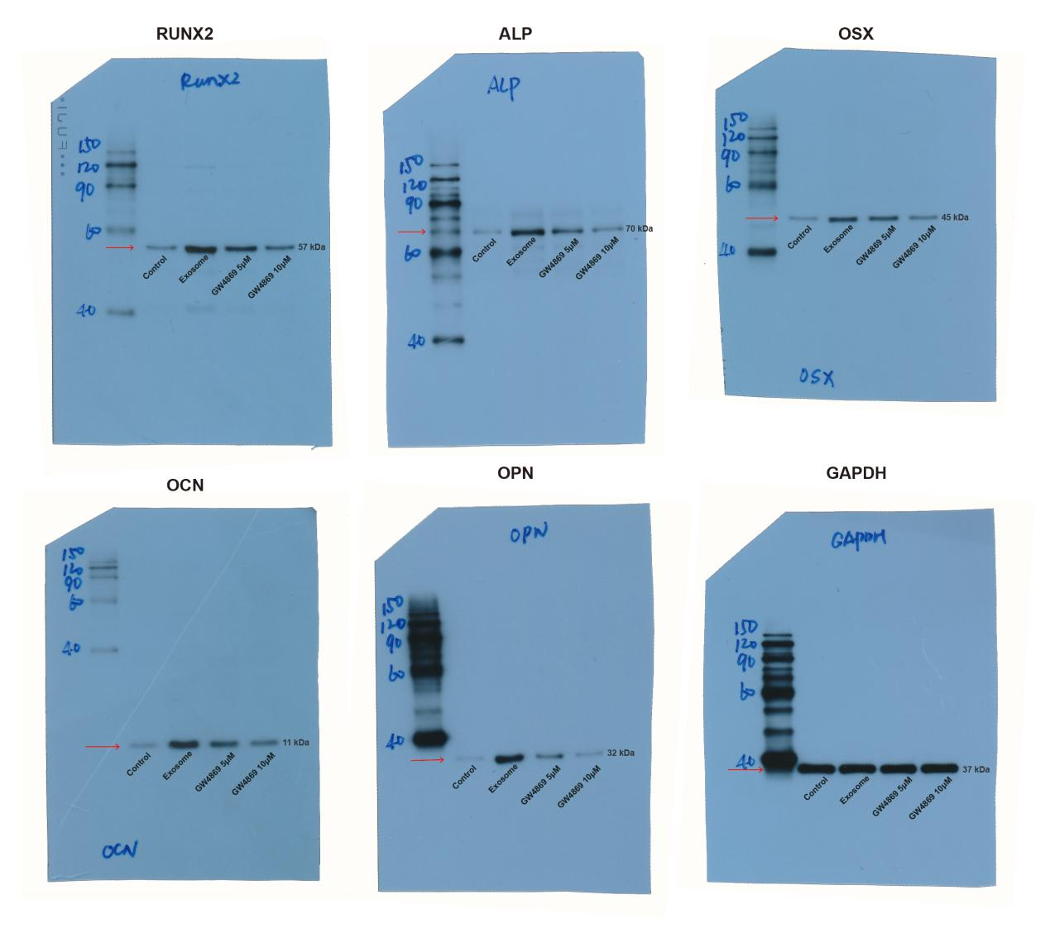
Supplementary Figure 2 Full-length blots of western blotting analysis for RUNX2, ALP, OSX, OCN, and OPN in control, exosome, GW4869 5μM, and GW4869 10μM groups. The protein expression of GAPDH was regarded as an endogenous control for homogenization. The red arrow represents the location of the crop.

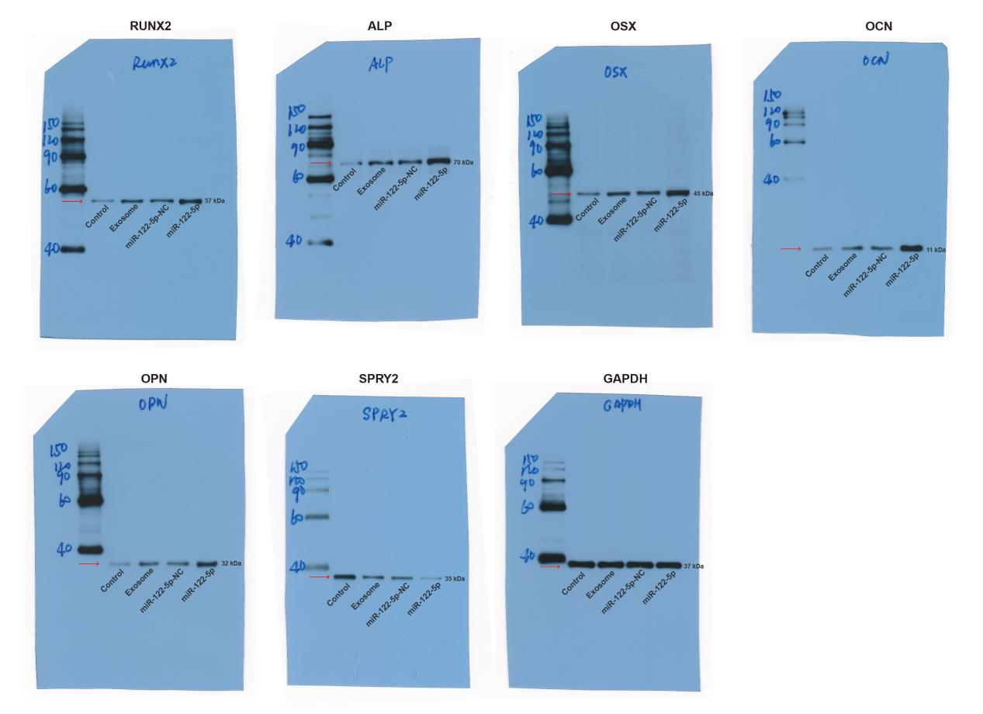
Supplementary Figure 3 Full-length blots of western blotting analysis for RUNX2, ALP, OSX, OCN, OPN, and SPRY2. The protein expression of GAPDH was regarded as an endogenous control for homogenization. The red arrow represents the location of the crop.

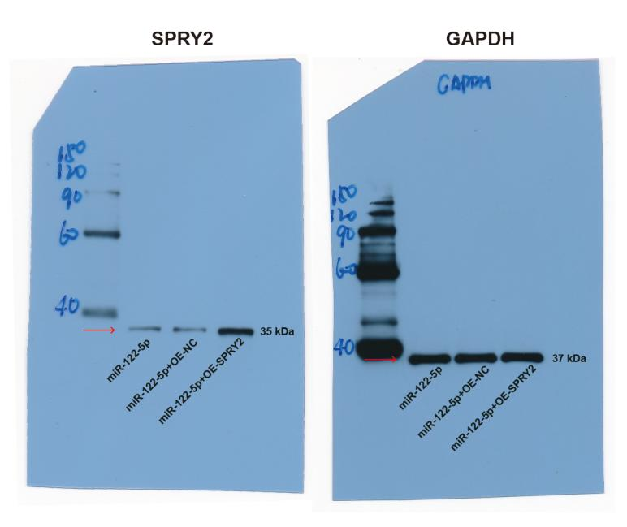
Supplementary Figure 4 Full-length blots of western blotting analysis for SPRY2. The protein expression of GAPDH was regarded as an endogenous control for homogenization. The red arrow represents the location of the crop.

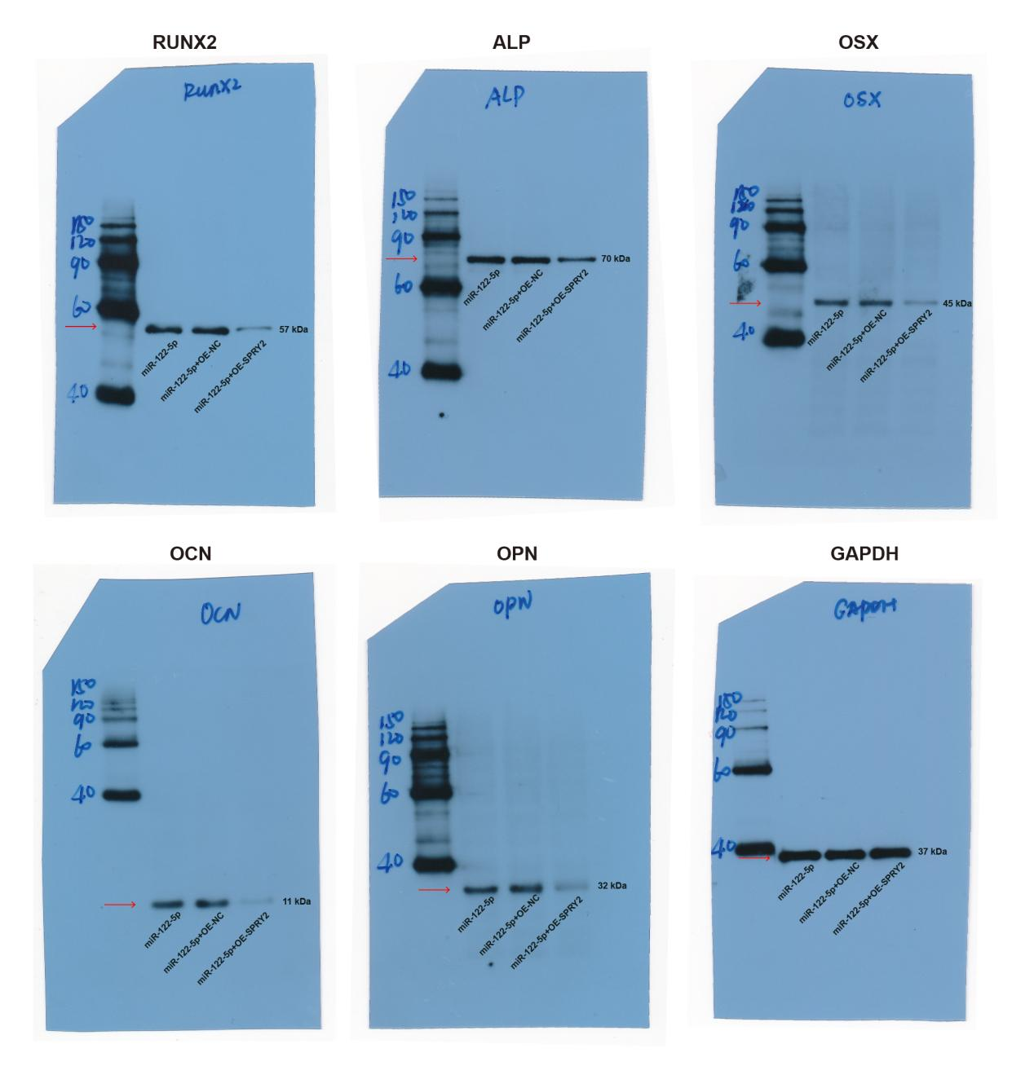
Supplementary Figure 5 Full-length blots of western blotting analysis for RUNX2, ALP, OSX, OCN, and OPN in miR-122-5p, miR-122-5p+OE-NC, and miR-122-5p+OE-SPRY2 groups. The protein expression of GAPDH was regarded as an endogenous control for homogenization. The red arrow represents the location of the crop.

