Supplementary Information for
Dielectric Fano Nanoantennas for Enabling Sub nanosecond Lifetime in NV-based Single Photon Emitters
Shu An¹, Dmitry Kalashnikov¹, Wenqiao Shi², Zackaria Mahfoud¹, Ah Bian Chew¹, Yan Liu¹, Jing Wu^{1,3}, Di Zhu^{1,4}, Weibo Gao⁵, Cheng-Wei Qiu^{2,*}, Victor Leong^{1,*}, and Zhaogang Dong^{1,4 ,*}
¹Institute of Materials Research and Engineering, A*STAR (Agency for Science, Technology and Research), 2 Fusionopolis Way, #08-03 Innovis, 138634 Singapore
²Department of Electrical and Computer Engineering, National University of Singapore, 4 Engineering Drive 3, Singapore 117583, Singapore
³School of Electronic Science & Engineering, Southeast University, Nanjing, 211189, China
⁴Department of Materials Science and Engineering, National University of Singapore, 9 Engineering Drive 1, 117575, Singapore
⁵Division of Physics and Applied Physics, School of Physical and Mathematical Sciences, Nanyang Technological University, Singapore 637371, Singapore

*Correspondence and requests for materials should be addressed to Z.D. (email: dongz@imre.a-star.edu.sg), L.X.H.V. (email: Victor_Leong@imre.a-star.edu.sg), and C.-W.Q. (email: chengwei.qiu@nus.edu.sg).

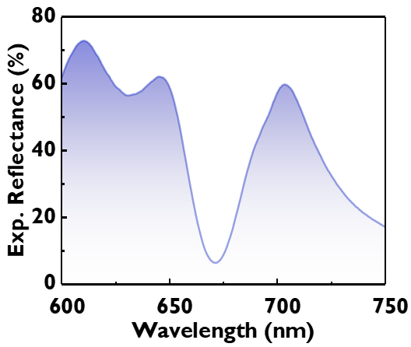
Fig. S1. Measured reflectance spectrum of the fabricated metasurface under y-polarized illumination.

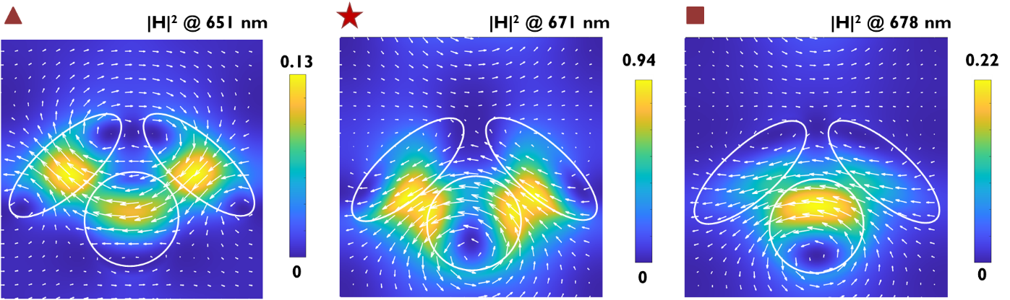
Fig. S2. Magnetic field intensity distributions at the respective wavelengths under y-polarized incident light.
Fig. S2 shows the magnetic field distribution of the metasurface at the wavelength of 651, 671 and 678 nm, respectively. Combined with the electric field distribution, it is clearly shown that quasi-BIC dominants at the wavelength of 651 nm and Mie resonance becomes stronger at the wavelength of 678 nm. At the dip of the reflectance, the resonance is a hybrid of Mie and qBIC resonance, corresponding to the wavelength where the electric field intensity reaches the maximum enhancement.

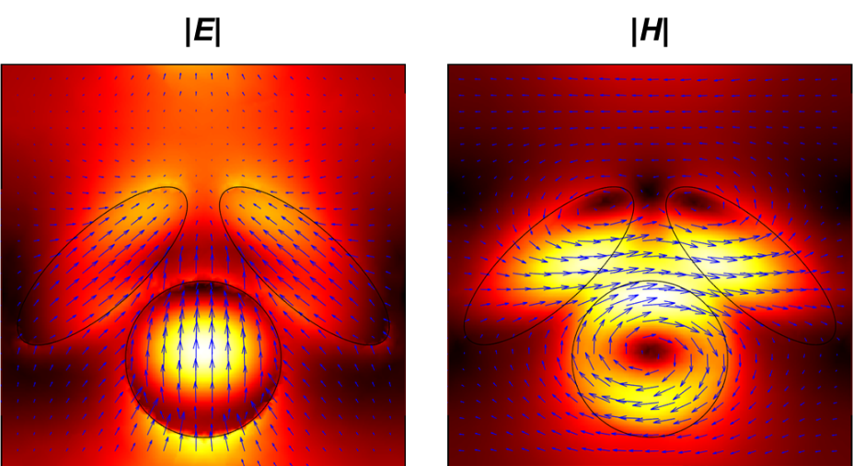
Fig. S3. Simulated electric and magnetic field distributions of hybridization mode ($\left|m_{∥},\left.-p_{z}\right\rangle \right.$) from the coupling between $\left|\left.m_{∥}\right\rangle \right.$ along +x axis and clockwise $\left|\left.p_{z}\right\rangle \right.$at the wavelength of 534 nm.

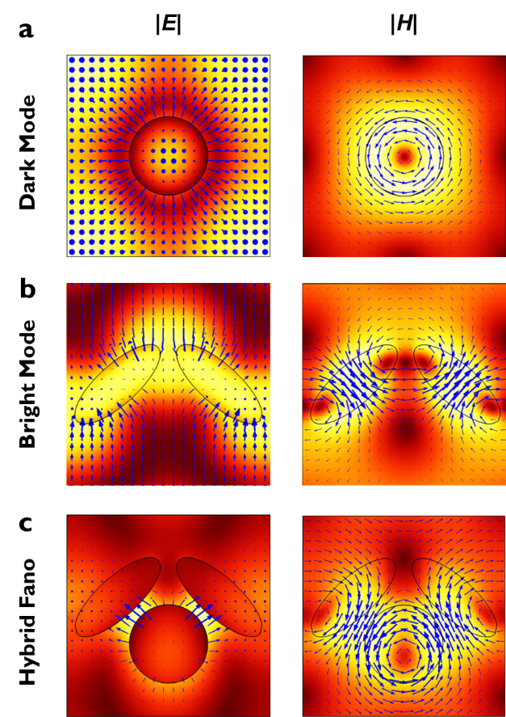
Fig. S4. Simulated spatial electric and magnetic field distribution at dark mode of disk, bright mode of the ellipsis pairs and hybrid Fano resonance mode at z =25 nm.

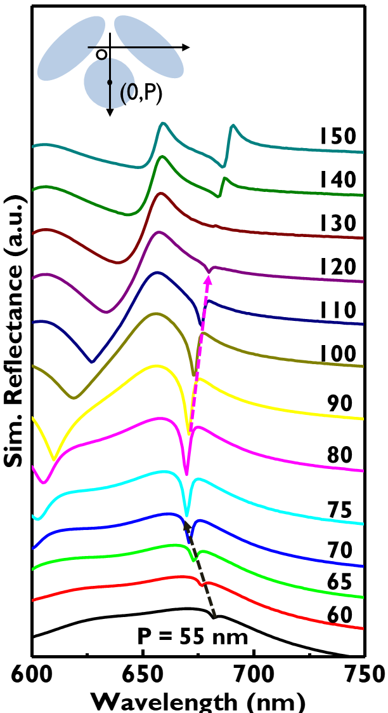
Fig. S5. Simulated reflectance spectra of nanoantenna with disks position varying from 55 to 150 nm.

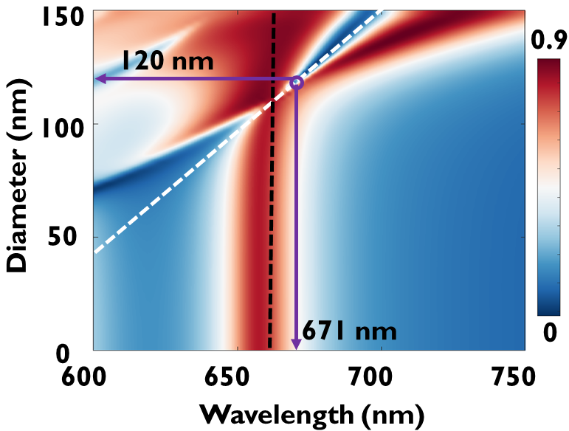
Fig. S6. Simulated reflectance spectra of nanoantenna with disks diameters varying from 0 to 150 nm. The black dash line stands for the BIC mode, while the black dash line is the Mie resonance.

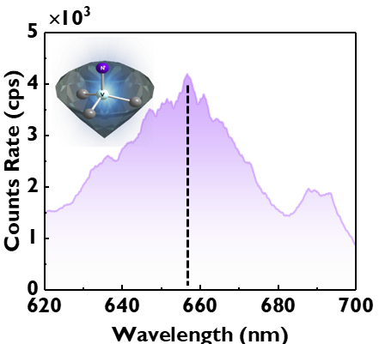
Fig. S7. Fluorescence spectrum from NV centers in ND under 532 nm excitation. The photoluminescence peak was measured to be located at 657 nm, indicating the existence of negatively charged nitrogen-vacancy (NV⁻), instead of NV⁰.

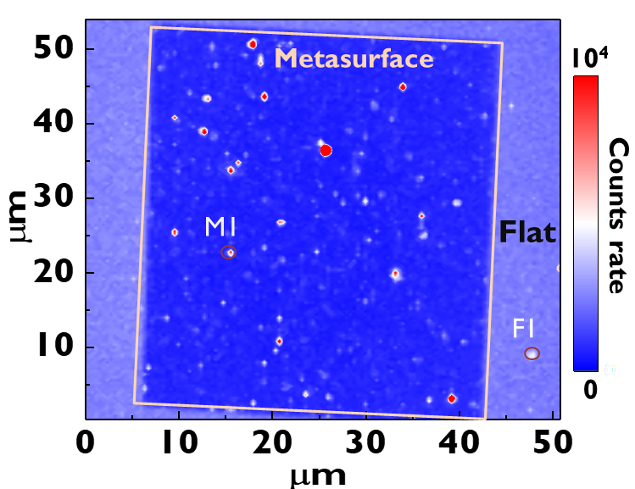
Fig. S8. Measured photoluminescence (PL) intensity map of the emitters as deposited on metasurface (enclosed by a rectangular) and flat region. Some bright spots were observed on the metasurfaces (M1), which exhibited PL intensities larger than 5000 counts/s (cps).

Table S1. Measured lifetime and g⁽²⁾(0) of emitters on metasurface and on flat region
Emitter number | Metasurface | Lifetime (ns) | g²(0)
1 | On | 0.92 | 0.74
2 | On | 1.33 | 0.53
3 | On | 0.93 | 0.24
4 | On | 0.84 | 0.86
5 | On | 0.84 | 0.39
6 | On | 0.99 | 0.77
7 | Off (flat region) | 7.49 | 1
8 | Off (flat region) | 10.3 | 1
9 | Off (flat region) | 9.56 | 0.8
10 | Off (flat region) | 7.6 | 1
11 | Off (flat region) | 8.5 | 1

