Investigation of morphologies and structures of Phloretin drug and PEG-b-PLA diblocks: A Dissipative particle dynamics simulations study
Ye Lin,¹ Yongchao Jin,¹ Dongmei Liu,^{*1} Huifeng Bo,¹ and Xiyin Wang,^{*1}

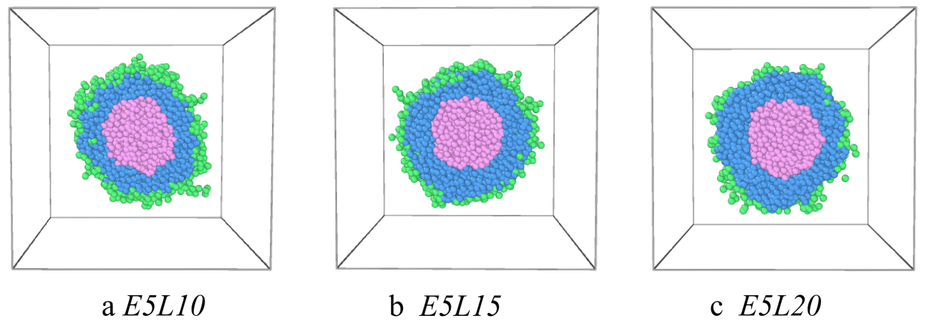
Fig. S1 The sectional view of Phloretin-loaded PEG-b-PLA micelles with (a) PEG₅-b-PLA₁₀, (b) PEG₅-b-PLA₁₅, (c) PEG₅-b-PLA₂₀. The green, yellow, blue and pink pheres represent beads PEG, PLA, and phloretin respectively.

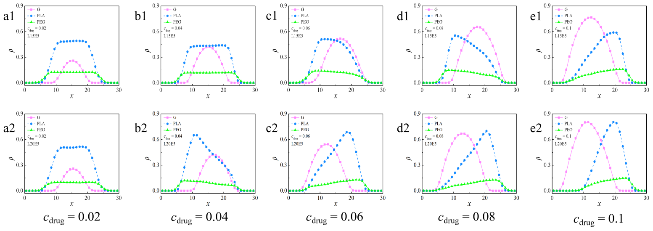
Fig. S2 Density profiles of different beads of Phloretin-loaded PEG₅-b-PLA₁₅ (a1-e1) and PEG₅-b-PLA₂₀ (a2-e2) micelles with different phloretin drug content. The green, yellow, blue and pink pheres represent beads PEG, PLA, and phloretin respectively.
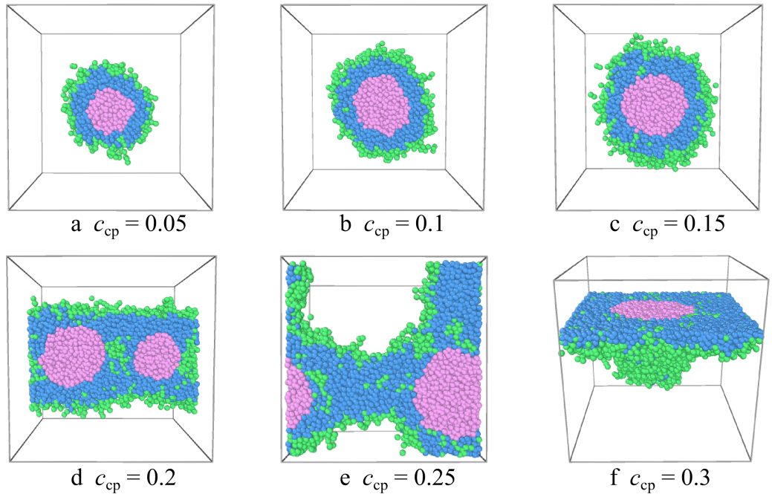
Fig. S3 The sectional view of phloretin-loaded PEG₅-b-PLA₁₀ micelles with different copolymer concentrations. The green, yellow, blue and pink pheres represent beads PEG, PLA, and phloretin respectively.

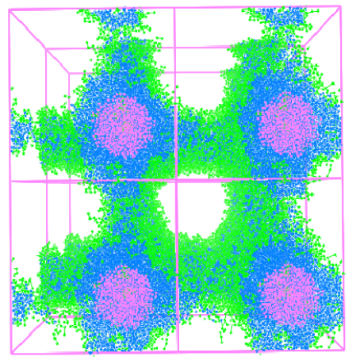
Fig. S4 Morphology snapshots of phloretin-loaded PEG₅-b-PLA₁₀ micelles with copolymer concentrations c_{cp} = 25%. The green, yellow, blue and pink dots represent beads PEG, PLA, and phloretin respectively.

