Supplementary Information
Nature-inspired low carbon building materials with lightweight, strong and tough properties by tailoring hierarchically porous structure

Jinyang Jiangª, Han Wangª, Junlin Linª, Fengjuan Wangª, Zhiyong Liuª, Liguo Wangª, Yali Li^{b}, Zongjin Li^{c}, Yunjian Li^{c*}, Zeyu Lu^{a*}

a. Jiangsu Key Laboratory of Construction Materials, School of Materials Science and Engineering, Southeast University, Nanjing 211189, China;
b. Centre for Smart Infrastructure and Digital Construction, School of Engineering, Swinburne University of Technology, Hawthorn, Victoria, 3122 Australia.
c. Faculty of Innovation Engineering, Macau University of Science and Technology, Macau SAR, 999078, China
Corresponding Author*: Yunjian Li, yunjianli@must.edu.mo; Zeyu Lu, 101012819@seu.edu.cn.

1. Microstructure
S.1 (a) illustrates the structure of the pure hydrogel after gelation, forming a porous network-like structure. S.1 (b) depicts the structure of LLST-1 after seven days of hydration, showcasing a porous network structure similar to that of the pure water hydrogel, with hydration products attaching and growing on the gel network. In contrast, S.1 (c) displays the microstructure of ordinary cement after 28 days of hydration, revealing an unordered accumulation of different hydration products, leading to poor toughness in ordinary cementitious materials. Additionally, the irregular arrangement of hydration products results in irregularly shaped pores, causing stress concentration during loading and impeding the mechanical performance development of cementitious materials. Furthermore, S.1 (c) supplements the depiction by highlighting the uniform distribution of micropores within the LLST system.which plays a crucial role in materials to obtain outstanding mechanical strength, including particular stiffness, energy absorption efficiency and specific strength.
S. 1. Microstructure of pure hydrogel and LLST at different hydration ages, (a) 10 min after fabrication (b) after 7 days hydration, (c) after 28 days hydration
2. Pore structure
As shown in S 2. (a), the total porosity and cumulative pore area of LLST are in the range of 36.9% ~ 75.2% and 27.7 ~ 55.3%, respectively, representing a notable increase compared with Ref., which is attribute to the in situ self-assembly strategy adopted in LLST fabrication. Besides, the density of LLST is around 0.75 ~ 1.45 g/cm3, which is 11% to 43% lower than that of Ref., as shown in S. 2 (b).
It should be noted that the porous structure endows the LLST with excellent thermal insulation performance with the thermal conductivity coefficient as low as 0.18 W/m.k, as shown in S. 2 (c), which is 85% lower than that of normal cement paste. Furthermore, LLST displays great potential applications in thermal insulation materials and absorption materials with strong stability and good corrosion resistance, since the majority of its constituents are inorganic cement-based materials.
S. 2. (a) Pore size distribution and total porosity of LLST, (b) simulation of heat conduction.
3. Strength
The flexural strength, maximum deformation rate and fracture energy of LLST-1 cement are 220%, 780% and 1460% higher than Ref. (S. 3 (a)). It can be seen that Ref. (S. 3 (b)) exhibits the quasi-brittleness failure mode, that the stress is rapidly increased with the increase of strain until the yield point, followed by a sudden drop in stress. The density of LLST is around 0.75 ~ 1.45 g/cm³, which is 11% to 43% lower than Ref, as shown in S. 3 (c).
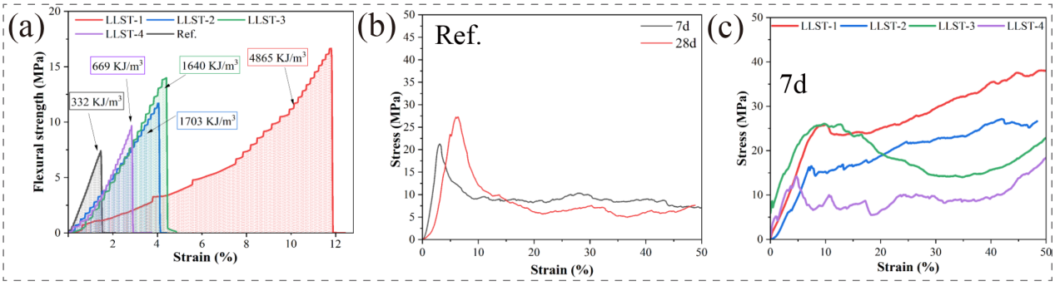
S. 3. (a) midspan deformation rate and fracture energy of LLST, (b-c) Load-displacement curve of Ref., and LLST.
4. Computational methods

The CN is calculated as shown in supplementary (equation 1) :
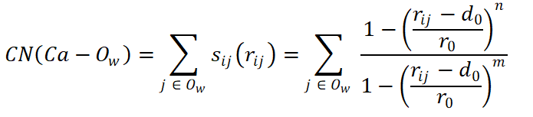 (1)
where r_{ij} is the distance between atom i and atom j. s_{ij} (r_{ij}) is a switching function describing the coordination between atom i and j. d₀ is the central value of the function. r₀ is the acceptance distance of the switching function. The d₀ and r₀ were set as 2.42 Å and 0.4 Å, respectively, which were tested to be appropriate^{1, 2}. n and m are 6 and 12, respectively^{3, 4}.
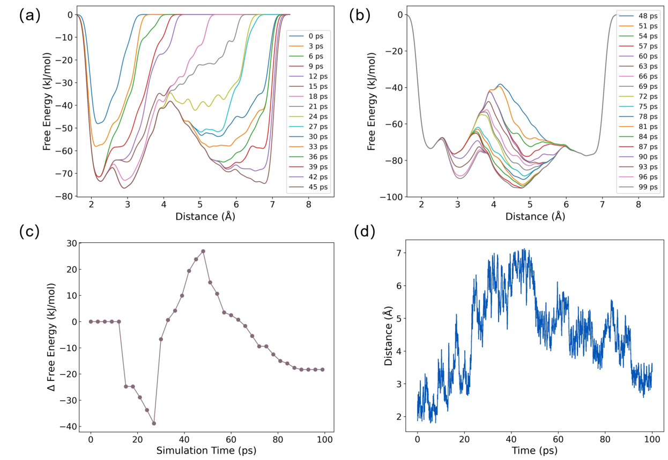
S. 4 (a) and (b) Convergence tests for free energy surfaces as a function of the distance between the Ca ion and center of mass of two O_{c} ions, which is performed every 3 ps (100 Gaussian kernels deposited) along the 100 ps simulation time. (c) Convergence test for free energy difference along the distance between the Ca ion and center of mass of two Oc ions between two basins (state I and II) as a function of the simulation time. The metadynamics is converged after 100 ps. (d) Time evolution of distance between the Ca ion and center of mass of two O_{c} ions during the simulation time.
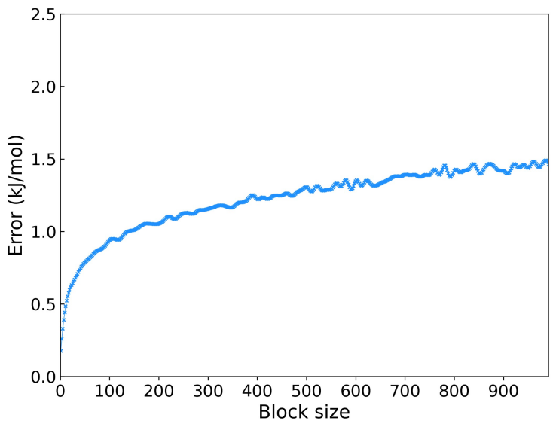
S.5 Block analysis of a metadynamics simulation for the average errors in different blocks from 0 to 900.
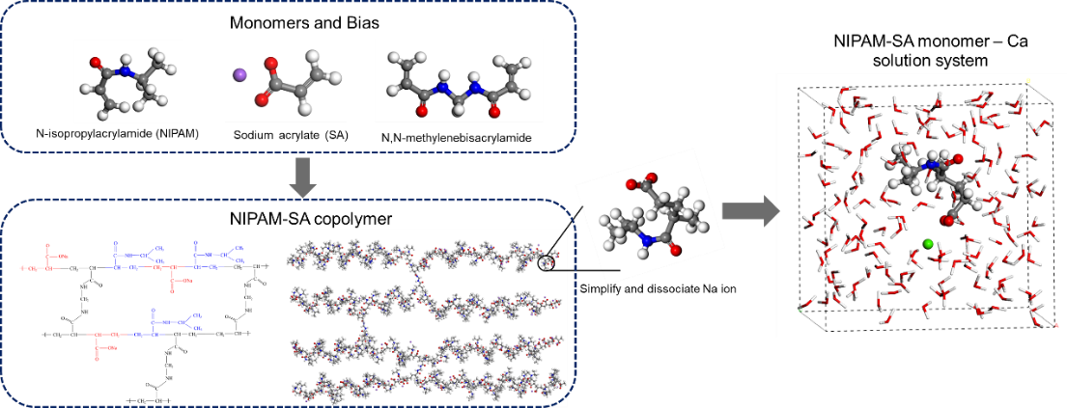
S. 6. Schematic diagrams of the model construction. Green sphere - Ca; red sphere – O; blue sphere – N; grey sphere – C and white sphere – H.

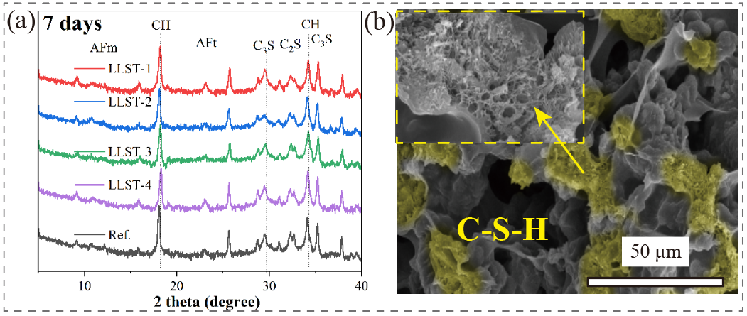
S. 7. (a) types of cement hydrates after 7 days of cement hydration, (b) morphology of different cement hydrates
5. Carbon emissions
CO₂ emission of cement-based materials mainly comes from the production and transportation of cement and related products⁵ and can be calculated using the model shown in S. 8 (Supplementary document contains detailed information of the model). The novel cementitious material LLST developed in this study was characterized with a) significantly less amount of cement thus reduced CO₂ emissions from the cement production and b) much less density therefore lower energy consumption during the transportation process. Considering these two factors, the CO₂ emissions of LLST1-3 were estimated to be 545, 890, and 1036 respectively, which were 56%, 28% and 17% lower than that of Ref. 1243 kg/m³. Though not included in the model, further carbon emission benefits are expected from the significantly enhanced strength and toughness of LLST contributing to prolonged service life of cement-based materials, reduced demand for new materials and decreased carbon emissions generated during the disposal of waste materials. This result highlights that the newly developed LLST is a low-carbon building material and possesses huge potential to reduce carbon emissions of cement industry.
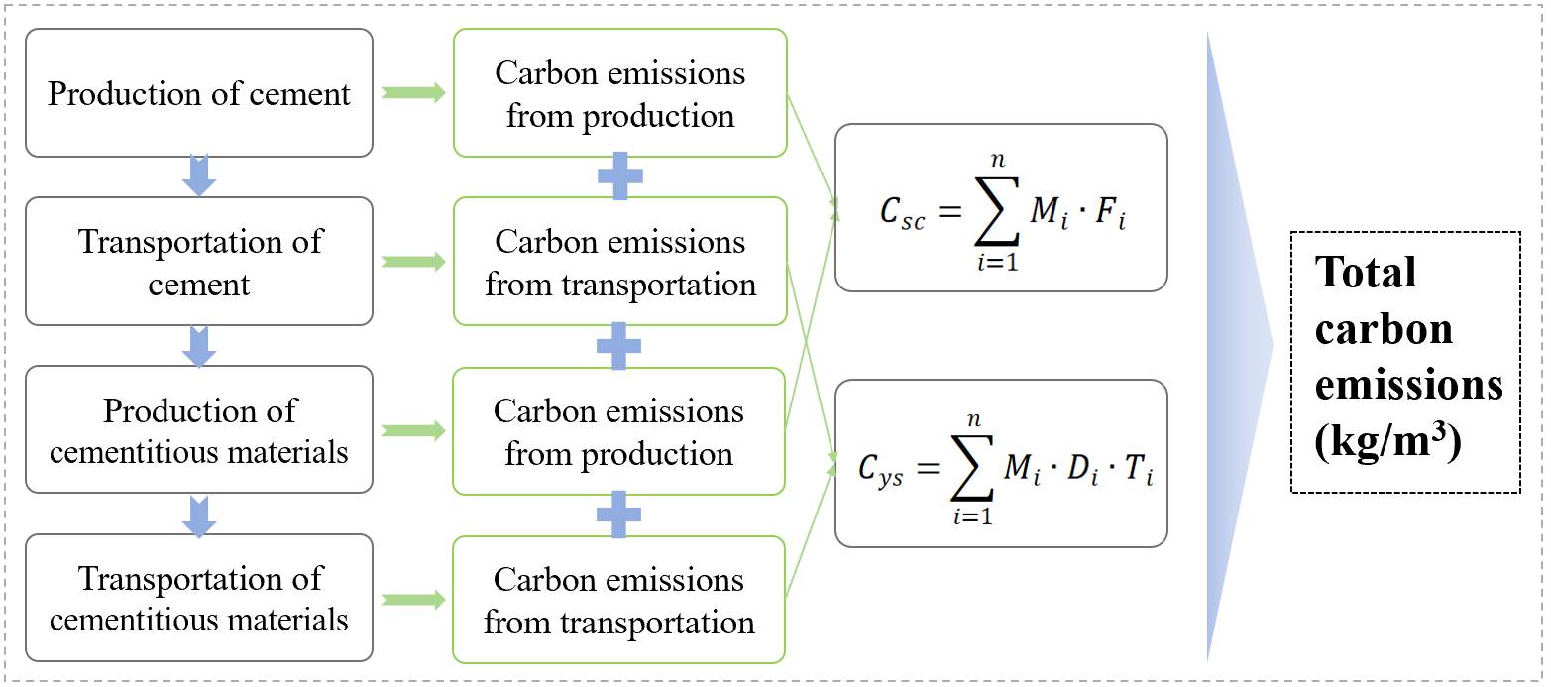
S. 8. Computing model of carbon emissions for LLSTs.
The details of the carbon emission of LLST cement are displayed as follows, which is mainly includes four formulas:
$C_{jc}=C_{sc}+C_{ys}$ (1)
C_{jc}: Carbon emissions during the production and transportation of each building materials
C_{sc}: Carbon emissions from production stage of each building materials (kgCO₂e);
C_{ys}: Carbon emissions from Transportation stage of each building materials (kgCO₂e);

$C_{sc}=\sum_{i=1}^{n}{M_{i}∙F_{i}}$ (2)
M_{i}: Consumption of each building materials (ton);
F_{i}: Carbon emission factor of each building material per unit weight(kgCO₂e/ton), according to Appendix D of this standard. The carbon emissions from the production of LLST (F_{ip}) were also taken into F_{i}, according to the formula (3):

$F_{ip}=\frac{E_{ip}∙k_{ip}}{N}$ (3)
F_{ip}: Carbon emissions from the production of LLST
E_{ip}: The total amount of electricity consumed
k_{ip}: Carbon emission factor of electric energy (around 086 (kg/kWh) )
N: Total amount of LLST productions

$C_{ys}=\sum_{i=1}^{n}{M_{i}∙D_{i}∙T_{i}}$ (4)
M_{i}: Consumption of each building materials (ton);
D_{i}: Average transport distance of each building materials (km);
T_{i}: Carbon emission factor of ach building materials per unit weight and per unit transportation distance (kgCO₂e/(ton·km)).
The raw data about was obtained from the previous research^{6, 7, 8}. It should be mentioned that the CO2 emission from the production of NIPAm, SA, Bis, APS, and TEMED are also considered into the calculation based on other’s research and the reports provided by Shanghai Macklin Biochemical Co., Ltd ⁹.

1. Li Y, Pan H, Liu Q, Ming X, Li Z. Ab initio mechanism revealing for tricalcium silicate dissolution. Nature Communications 13, 1253 (2022).
2. Li Y, Pan H, Li Z. Unravelling the dissolution dynamics of silicate minerals by deep learning molecular dynamics simulation: A case of dicalcium silicate. Cement and Concrete Research 165, 107092 (2023).
3. Li Y, Sun Z, Li Z, Chen B, Li Z. Dimeric and oligomeric interactions between calcium silicate aqua monomers before calcium silicate hydrate nucleation. Cement and Concrete Research 173, 107297 (2023).
4. Li Y, Pan H, Li Z. Ab initio metadynamics simulations on the formation of calcium silicate aqua complexes prior to the nuleation of calcium silicate hydrate. Cement and Concrete Research 156, 106767 (2022).
5. Dong J. Quantitative Study on the Life-Cycle Carbon Emissions of a Nearly Zero Energy Building in the Severe Cold Zones of China. Sustainability 14, (2022).
6. Ali MB, Saidur R, Hossain MS. A review on emission analysis in cement industries. Renewable and Sustainable Energy Reviews 15, 2252-2261 (2011).
7. Shen W, Cao L, Li Q, Zhang W, Wang G, Li C. Quantifying CO2 emissions from China’s cement industry. Renewable and Sustainable Energy Reviews 50, 1004-1012 (2015).
8. Zhang J, Liu G, Chen B, Song D, Qi J, Liu X. Analysis of CO2 Emission for the Cement Manufacturing with Alternative Raw Materials: A LCA-based Framework. Energy Procedia 61, 2541-2545 (2014).
9. Schiefer C, Plank J. CO2 emission of polycarboxylate superplasticizers (PCEs) used in concrete. Journal of Cleaner Production 427, (2023).

