Figure S1 IFS had no toxicity on brain and peripheral major organs in adolescent and adult mice
At the end of the behavioral tests, mice were sacrificed, the brains and major organs were removed and then fixed in 4% paraformaldehyde. Hematoxylin and Eosin (H&E) staining of brain (Scale bars=100 μm) and peripheral major organs (Scale bars=50 μm) in control or PTSD mice.
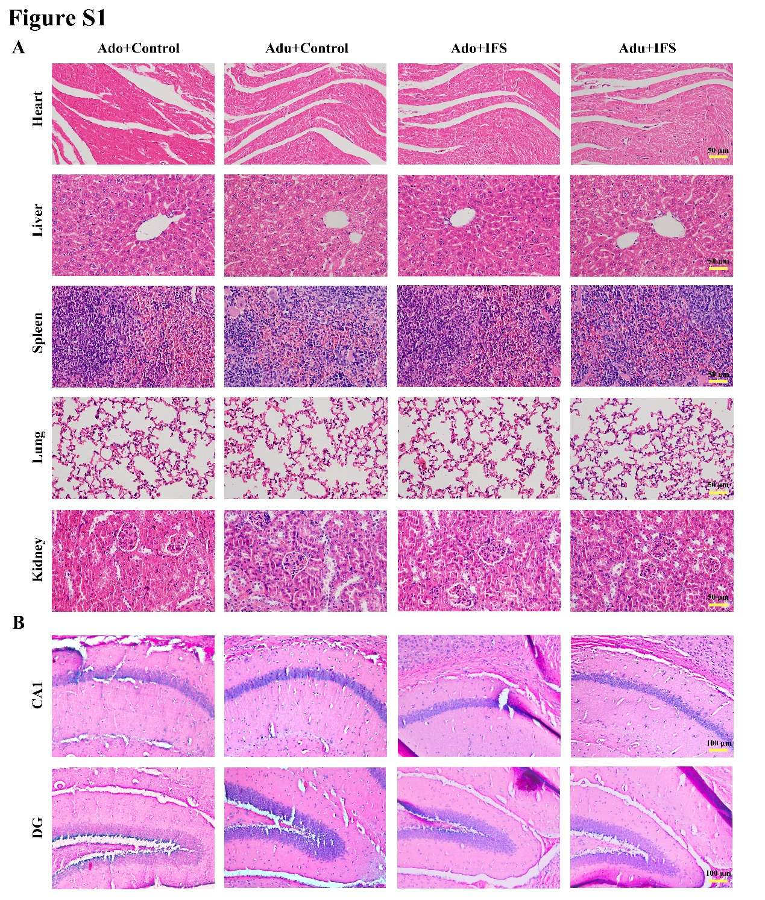
Figure S2 NaHS treatment had no toxicity on brain and peripheral major organs in adolescent and adult mice
At the end of the behavioral tests, mice were sacrificed, the brains and major organs were removed and then fixed in 4% paraformaldehyde. H&E staining of brain (Scale bars=100 μm) and peripheral major organs (Scale bars=50 μm) in PTSD or NaHS-treatment mice.
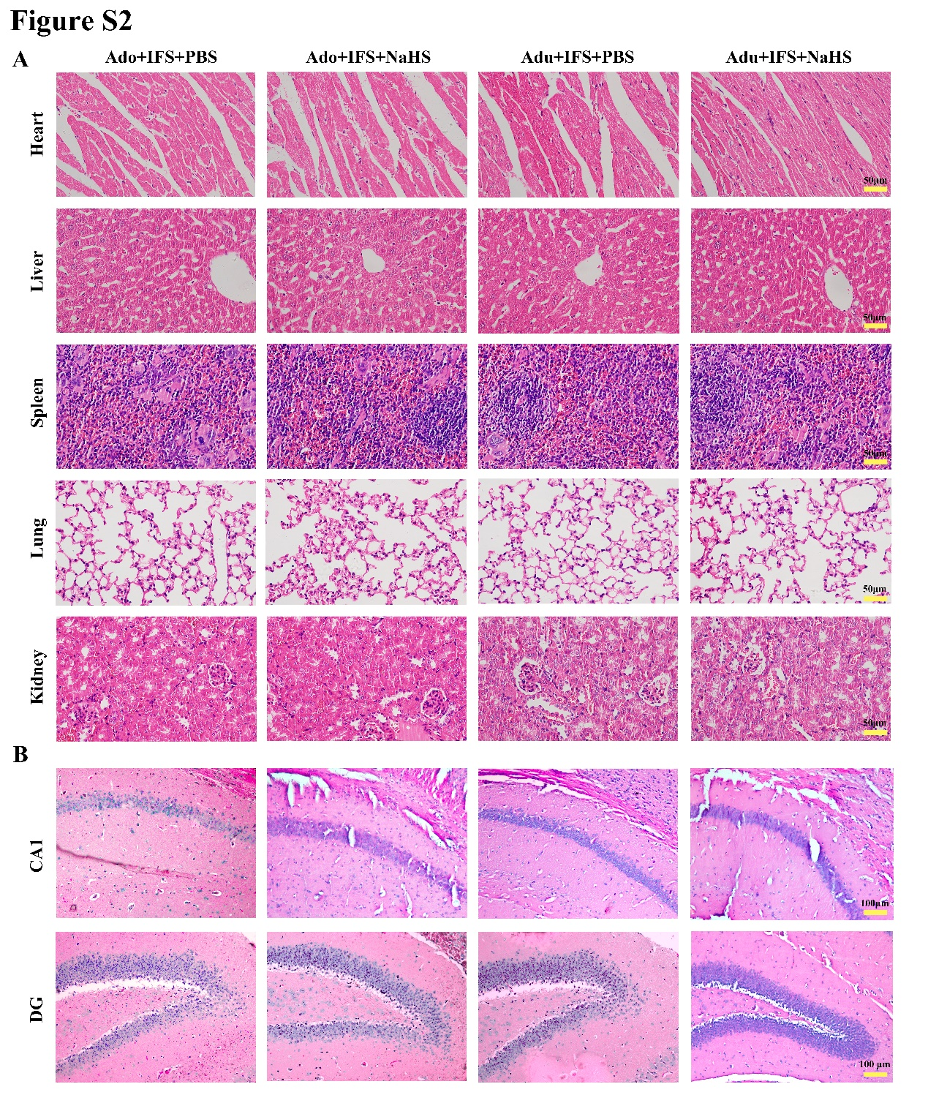
Figure S3 Increasing dose of NaHS treatment had no toxicity on brain and peripheral major organs in adult mice
At the end of the behavioral tests, mice were sacrificed, the brains and major organs were removed and then fixed in 4% paraformaldehyde. H&E staining of brain (Scale bars=100 μm) and peripheral major organs (Scale bars=50 μm) in PTSD or two doses of exogenous H₂S treatment mice.
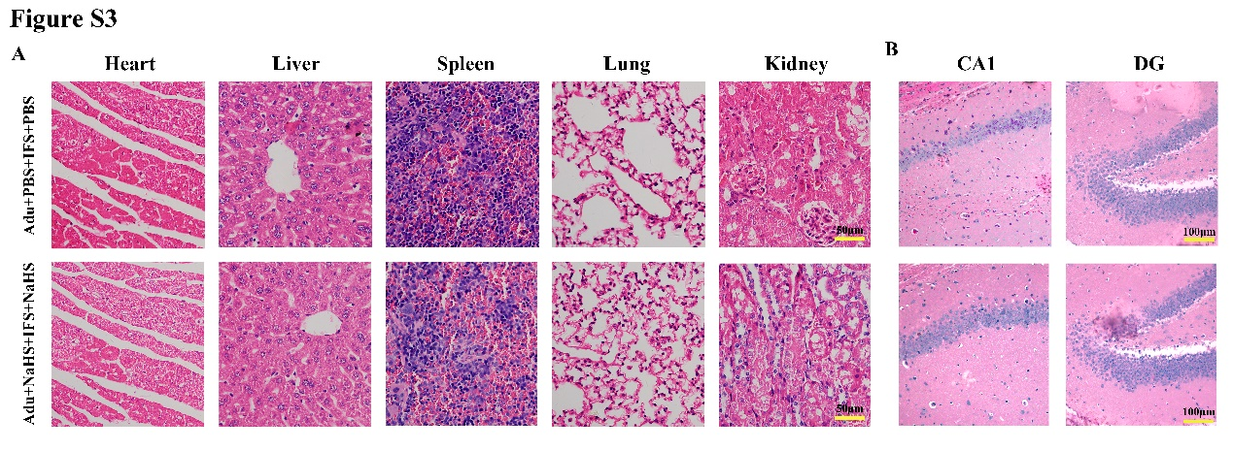

Table S1 Primary antibody information
Antibody | Company | Catalog number
CBS | Proteintech group (Rosemont, IL, USA) | 14787-1-AP
CREB | Cell Signaling Technology, Inc. (Boston, MA, USA) | 9198S
BDNF | Proteintech group (Rosemont, IL, USA) | 17465-1-AP
PSD95 | Proteintech group (Rosemont, IL, USA) | 20665-1-AP
p-CREB | Cell Signaling Technology, Inc. (Boston, MA, USA) | 9197S
β-Actin | ZSGB-BIO (Beijing, China) | TA-09

