Table 1. Optimization Data for EAO Reactions with Heterogeneous Ni-Based Electrocatalysts with Aminoxyl Co-Catalysts.ª
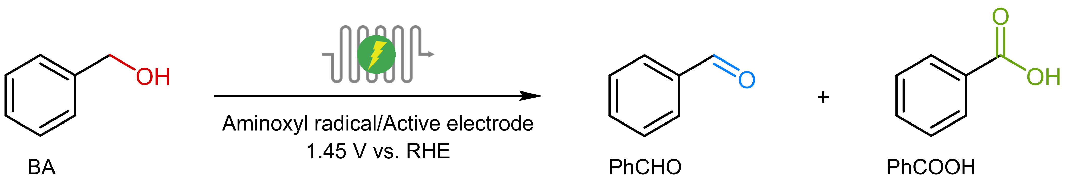
Entry | Aminoxyl radical (mol%) | Active electrode | Yield of PhCHO (%)^{b}
1 | － | Ni(OH)₂ | 5
2 | AcNH-TEMPO (5) | － | 38
3 | AcNH-TEMPO (5) | Ni(OH)₂ | 52
4 | － | NiV-LDH | 9
5 | AcNH-TEMPO (5) | NiV-LDH | 99
6 | AcNH-TEMPO (5) | NiMn-LDH | 86
7 | AcNH-TEMPO (5) | NiFe-LDH | 78
8 | AcNH-TEMPO (5) | NiCo-LDH | 72
9 | AcNH-TEMPO (5) | NiCu-LDH | 56
10 | H-TEMPO (5) | NiV-LDH | 80
11 | 4-HO-TEMPO (5) | NiV-LDH | 93
12 | 4-MeO-TEMPO (5) | NiV-LDH | 78
13 | 4-oxo-TEMPO (5) | NiV-LDH | 61
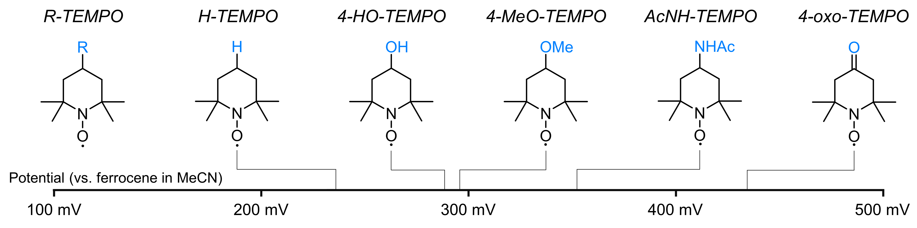
ªReaction conditions: Ni-based materials anode, nickel foam cathode, electrode surface (10 cm²), flow rate = 200 mL/min, BA (10 mmol), 0.5 M Na₂CO₃ (90 mL), MeCN (10 mL), reaction time = 17 min. ^{b}Yields determined by GC. Further information about the NiM-LDH materials alone in provide below and in the Supporting Information (Supplementary Fig. 1)

