Supplementary Information

Synergistic Enhancement of Electrochemical Alcohol Oxidation by Combining NiV-Layerd Double Hydroxide with an Aminoxyl Radical

Suiqin Li^{1,#}, Shibin Wang^{1,#}, Yuhang Wang^{1,#}, Jiahui He¹, Kai Li¹, James B. Gerken², Shannon S. Stahl², Xing Zhong^{1,*}, Jianguo Wang^{1,*}

¹Institute of Industrial Catalysis, State Key Laboratory Breeding Base of Green-Chemical Synthesis Technology, College of Chemical Engineering, Zhejiang University of Technology, Hangzhou 310032, P.R. China.
²Department of Chemistry, University of Wisconsin-Madison, 1101 University Avenue, Madison, Wisconsin 53706, United States.

#S. Li, S. Wang and Y. Wang contribute to this work equally

*Correspondence and requests for materials should be addressed to X.Z. (email: zhongx@zjut.edu.cn) or to J.G.W. (email: jgw@zjut.edu.cn).

Table of Contents

Supplementary Fig. 1 3

Supplementary Fig. 2 4

Supplementary Fig. 3 5
Supplementary Fig. 4 6
Supplementary Fig. 5 7

Supplementary Fig. 6 8

Supplementary Fig. 7 9

Supplementary Fig. 8 10

Supplementary Fig. 9 11
Supplementary Fig. 10 12
Supplementary Fig. 11 13

Supplementary Fig. 12 14

Supplementary Fig. 13 15

Supplementary Fig. 14 16

Supplementary Fig. 15 17

Supplementary Fig. 16 18

Supplementary Fig. 17 19
Supplementary Fig. 18 20
Supplementary Fig. 19 21

Supplementary Fig. 20 22

Supplementary Fig. 21 23

Supplementary Fig. 22 24

Supplementary Fig. 23 25
Supplementary Fig. 24 26
Supplementary Fig. 25 27

Supplementary Fig. 26 28

Supplementary Fig. 27 29
Supplementary Figures

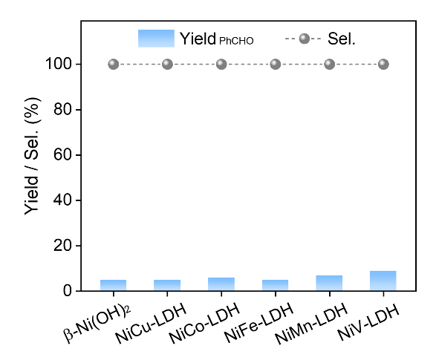
Supplementary Fig. 1. Electrochemical performances. Yield and selectivity (%) of Ph-CHO during the EAO of BA for different Ni-based materials in a continuous-flow electrolyzer.

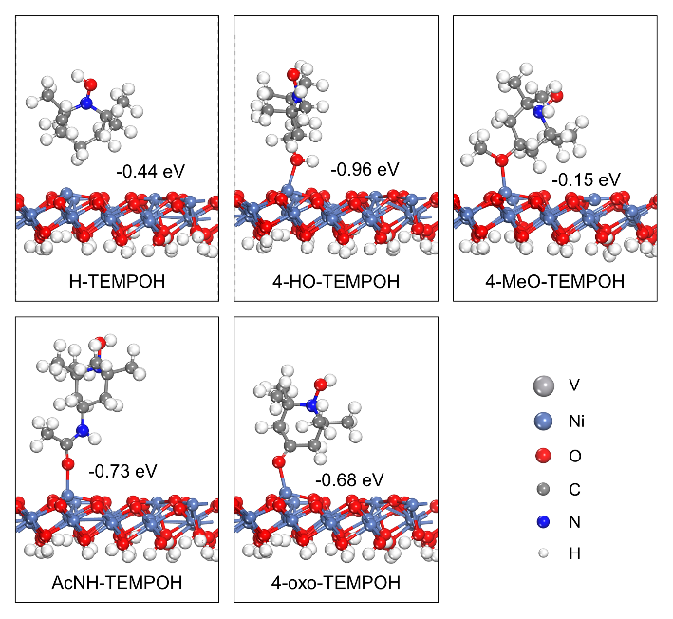
Supplementary Fig. 2. Theoretical calculation. Optimized structures of R-TEMPOH on clean NiOOH surface, corresponding adsorption energies are also shown in the figure.

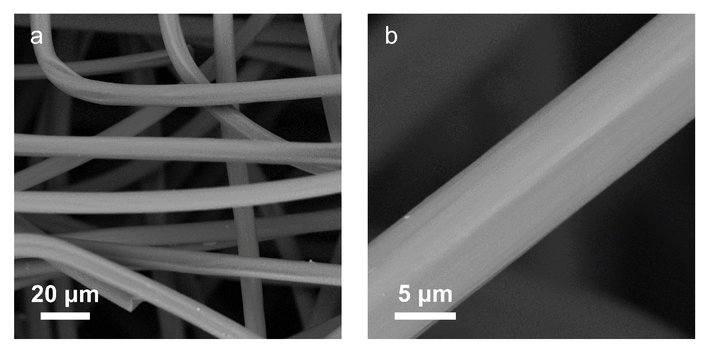
Supplementary Fig. 3. Morphology characterization. SEM images of pure graphite felt (GF).

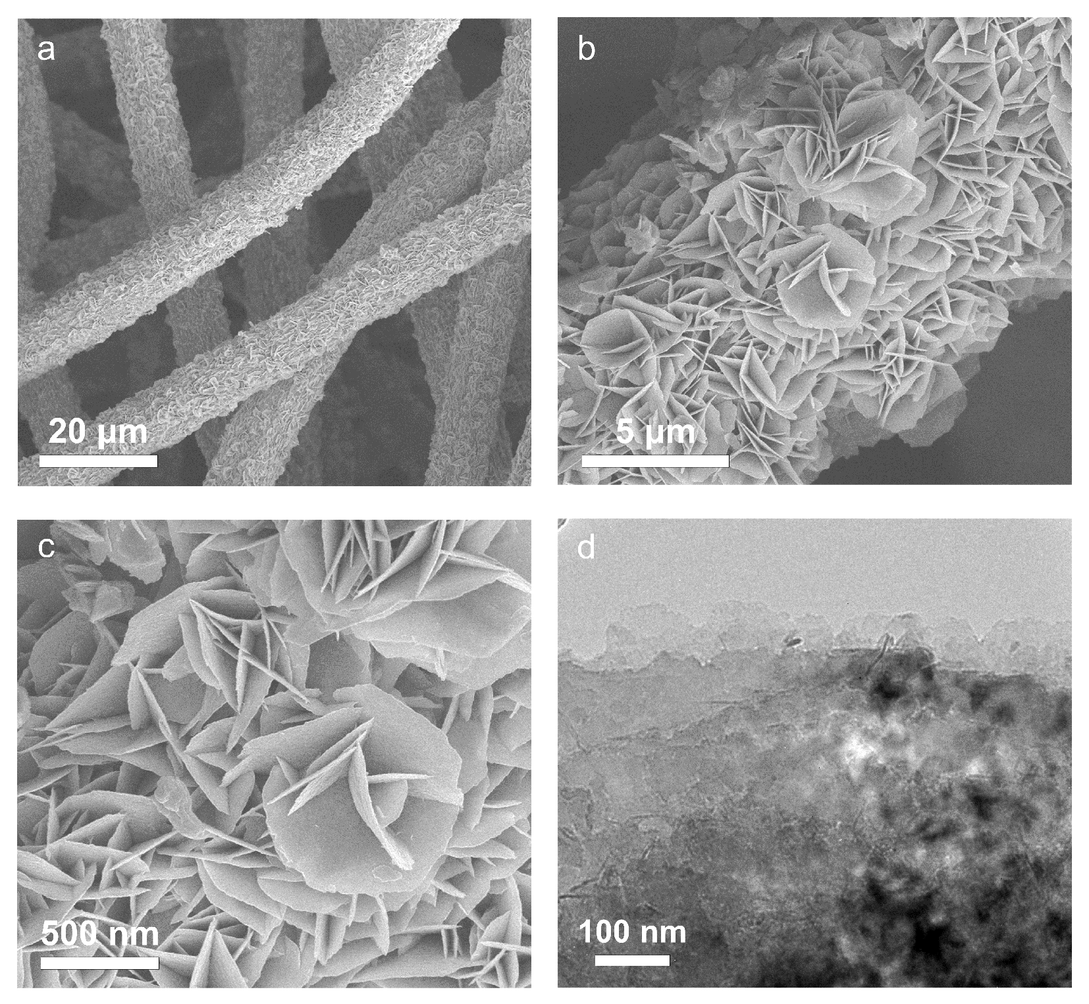
Supplementary Fig. 4. Morphology characterization. a-c SEM and (d) TEM of Ni(OH)₂/GF.

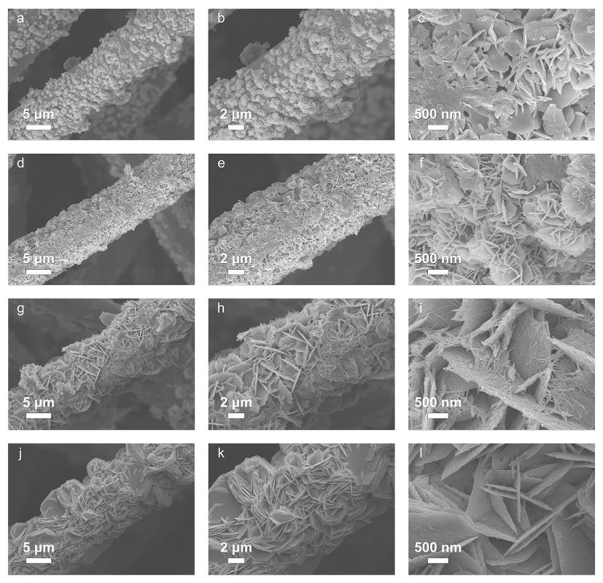
Supplementary Fig. 5. Morphology characterization. SEM of (a-c) NiMn-LDH, (d-f) NiFe-LDH, (g-i) NiCo-LDH and (j-l) NiCu-LDH.

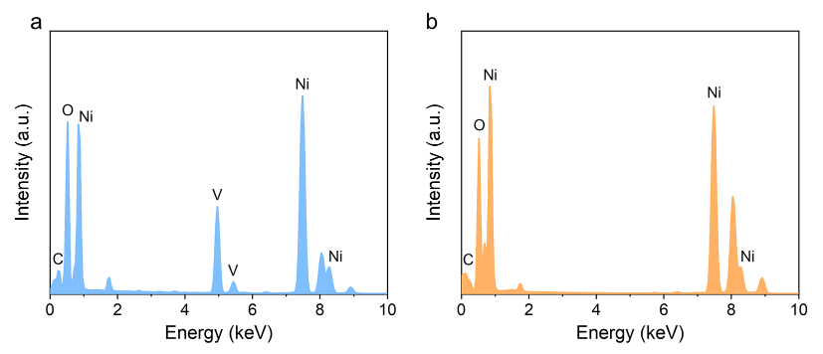
Supplementary Fig. 6. EDX characterization. EDX of (a) Ni_{0.67}V_{0.33}-LDH and (b) Ni(OH)₂.

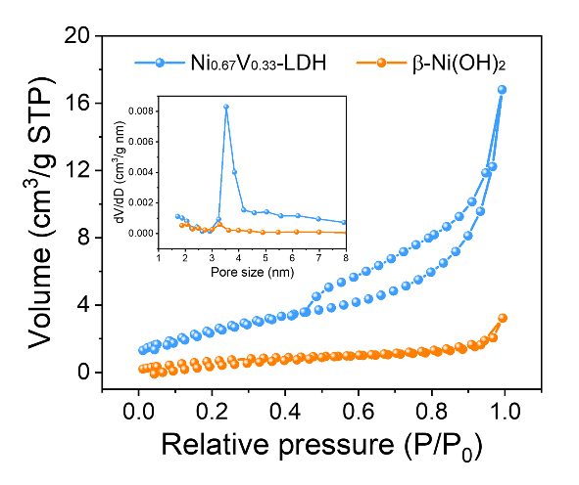
Supplementary Fig. 7. BET tests. BET spectra of Ni_{0.67}V_{0.33}-LDH and β-Ni(OH)₂.

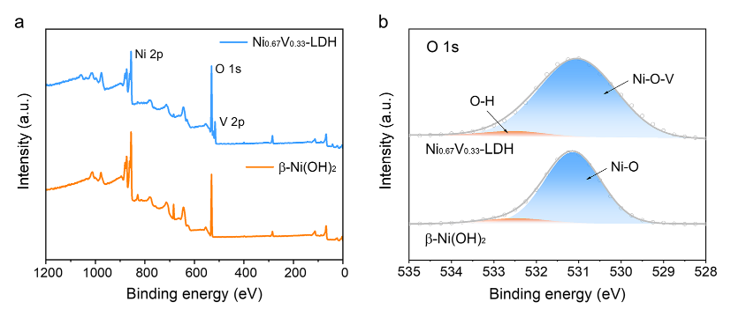
Supplementary Fig. 8. XPS tests. a XPS survey spectra of Ni_{0.67}V_{0.33}-LDH and β-Ni(OH)₂. b XPS spectra of O 1s for Ni_{0.67}V_{0.33}-LDH and β-Ni(OH)₂.

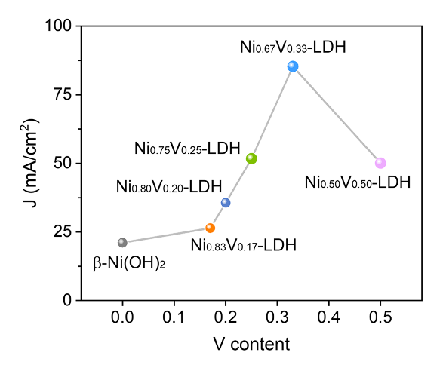
Supplementary Fig. 9. Electrochemical performances. The maximum current density of NiV-LDHs with different V contents in 0.5 M Na₂CO₃ electrolyte in batch reactor.

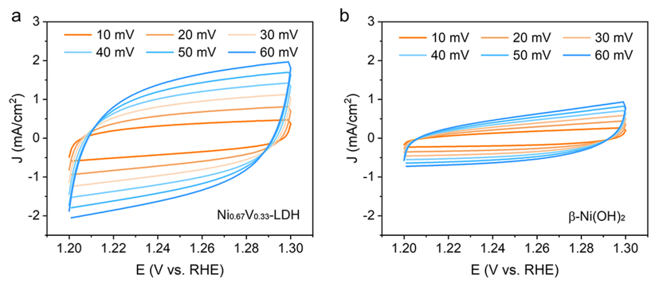
Supplementary Fig. 10. Double-layer capacitance tests. CVs curves at various scan rates of (a) Ni_{0.67}V_{0.33}-LDH and (b) β-Ni(OH)₂ are taken in a potential window (1.20–1.30 V vs. RHE) at various scan rates of 10, 20, 30, 40, 50, and 60 mV s⁻¹ in 0.5 M Na₂CO₃ electrolyte.

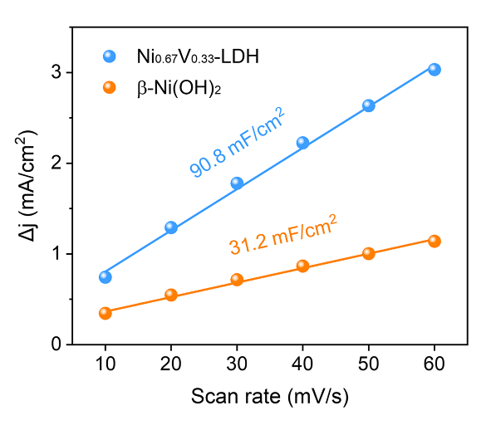
Supplementary Fig. 11. Double-layer capacitance tests. The capacitive current densities of the Ni_{0.67}V_{0.33}-LDH and β-Ni(OH)₂.

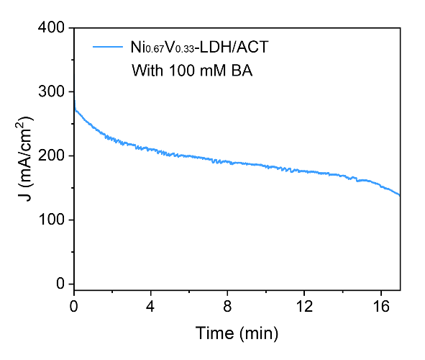
Supplementary Fig. 12. Electrochemical performances. I-t curve of Ni_{0.67}V_{0.33}-LDH/ACT at 1.45 V vs. RHE in 0.5 M Na₂CO₃ with 100 mM BA in a continuous-flow electrolyzer.

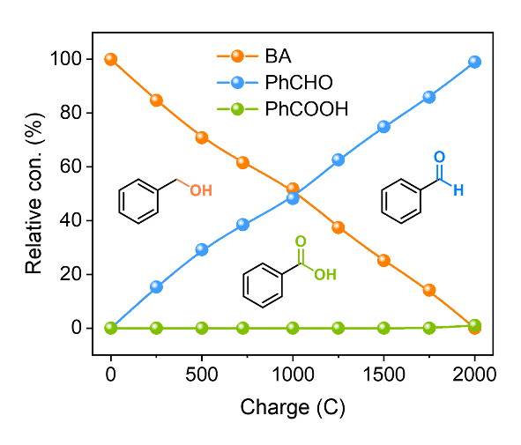
Supplementary Fig. 13. Electrochemical performances. Relative concentration of benzyl alcohol (BA), benzaldehyde (PhCHO) and benzoic acid (PhCOOH).

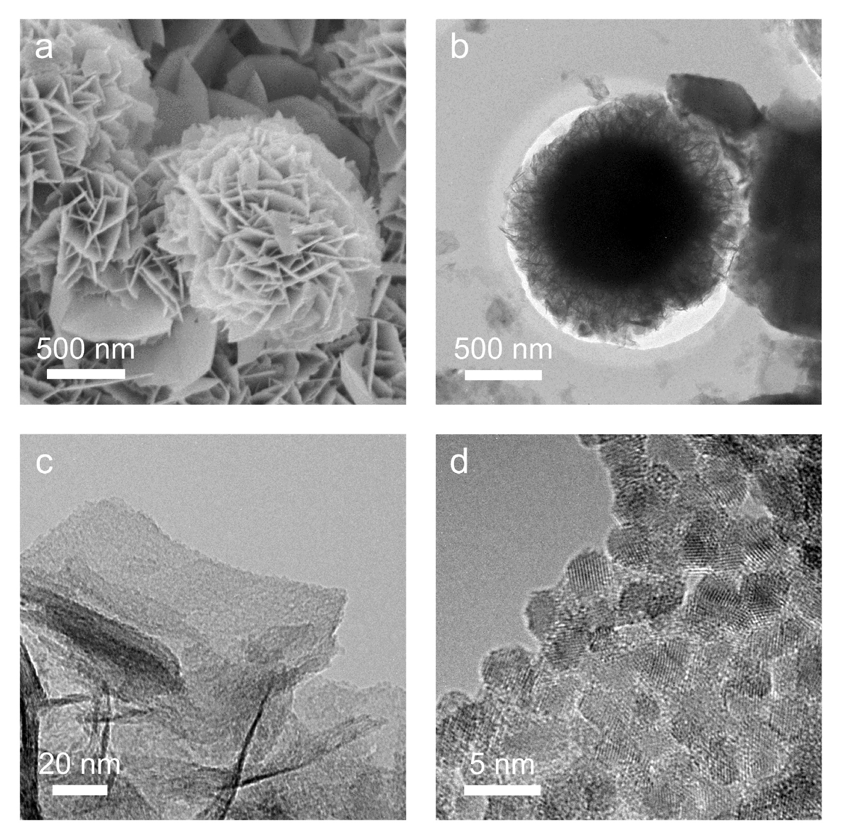
Supplementary Fig. 14. SEM and TEM images of Ni_{0.67}V_{0.33}-LDH. a SEM and (b-d) TEM images of the Ni_{0.67}V_{0.33}-LDH after EAO measurement.

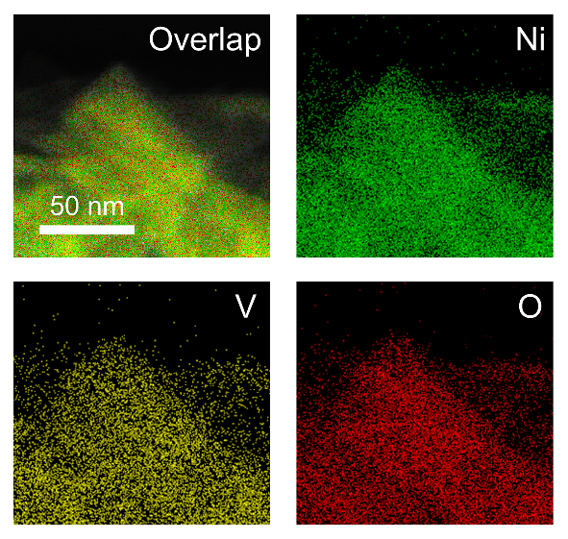
Supplementary Fig. 15. Element mapping images of Ni_{0.67}V_{0.33}-LDH. Element mapping images of the Ni_{0.67}V_{0.33}-LDH after EAO measurement.

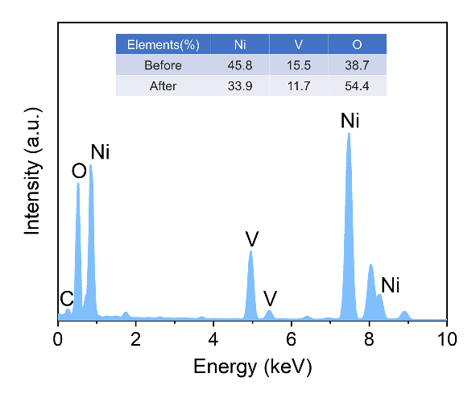
Supplementary Fig. 16. EDX characterization. EDX of the Ni_{0.67}V_{0.33}-LDH after EAO measurement.

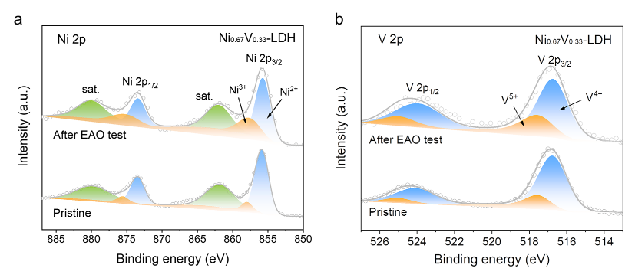
Supplementary Fig. 17. XPS tests. XPS spectra of (a) Ni 2p and (b) V 2p for the Ni_{0.67}V_{0.33}-LDH after EAO measurement.

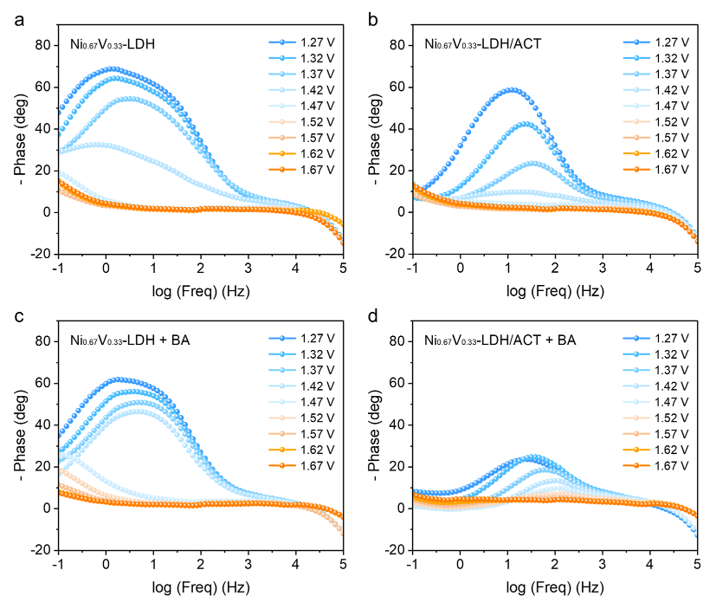
Supplementary Fig. 18. EIS tests. Phase angle vs. log (frequency) plots of EIS data recorded at various voltages (increased from 1.27 to 1.67 V vs. RHE) for (a) Ni_{0.67}V_{0.33}-LDH, (b) Ni_{0.67}V_{0.33}-LDH/ACT, (c) Ni_{0.67}V_{0.33}-LDH + BA, and (d) Ni_{0.67}V_{0.33}-LDH/ACT + BA.

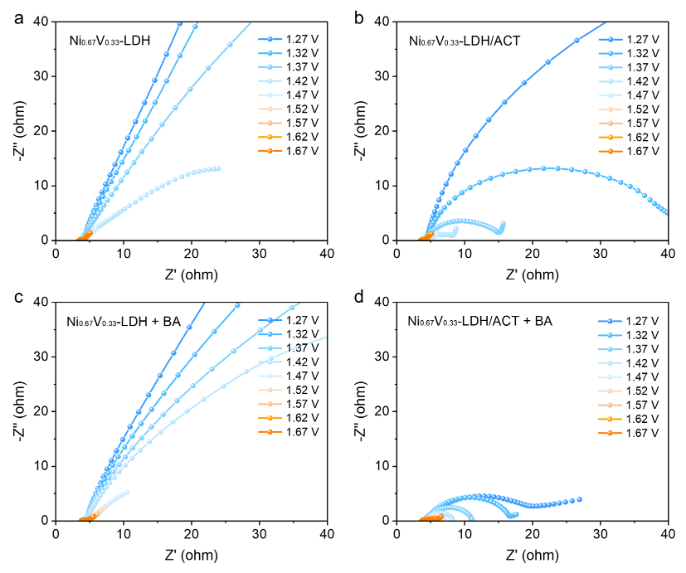
Supplementary Fig. 19. EIS tests. The corresponding Nyquist plots of EIS data recorded at various voltages (increased from 1.27 to 1.67 V vs. RHE) for (a) Ni_{0.67}V_{0.33}-LDH, (b) Ni_{0.67}V_{0.33}-LDH/ACT, (c) Ni_{0.67}V_{0.33}-LDH + BA, and (d) Ni_{0.67}V_{0.33}-LDH/ACT + BA.

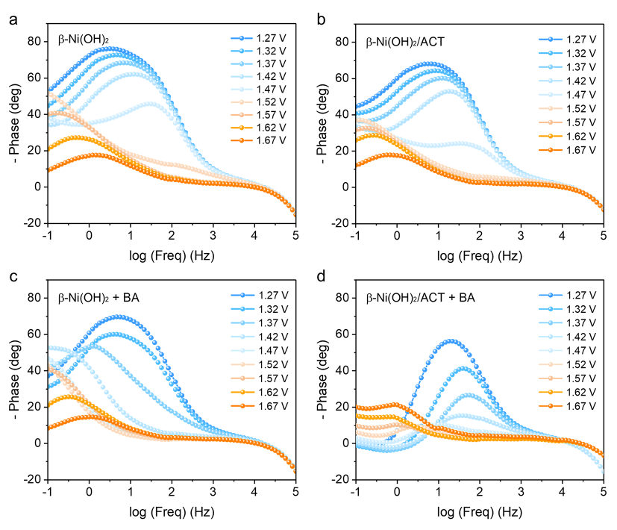
Supplementary Fig. 20. EIS tests. Phase angle vs. log (frequency) plots of EIS data recorded at various voltages (increased from 1.27 to 1.67 V vs. RHE) for (a) β-Ni(OH)₂, (b) β-Ni(OH)₂/ACT, (c) β-Ni(OH)₂ + BA, and (d) β-Ni(OH)₂/ACT + BA.

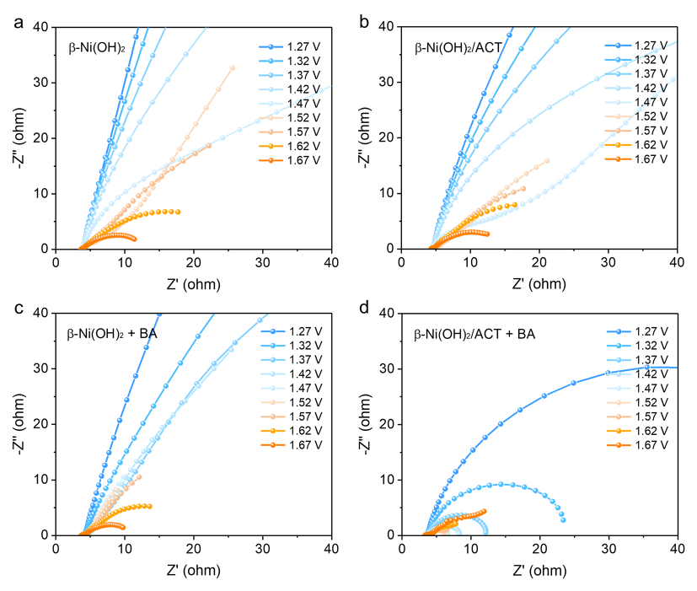
Supplementary Fig. 21. EIS tests. The corresponding Nyquist plots of EIS data recorded at various voltages (increased from 1.27 to 1.67 V vs. RHE) for (a) β-Ni(OH)₂, (b) β-Ni(OH)₂/ACT, (c) β-Ni(OH)₂ + BA, and (d) β-Ni(OH)₂/ACT + BA.

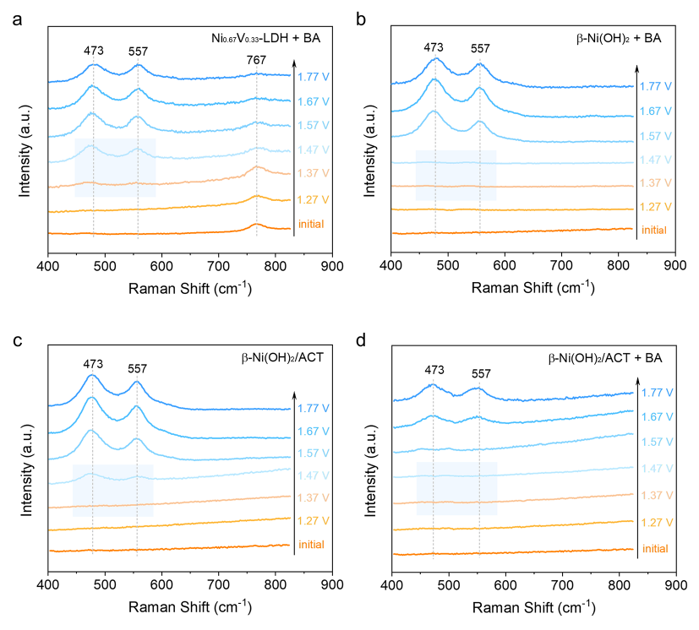
Supplementary Fig. 22. Raman tests. In situ Raman spectra of (a) Ni_{0.67}V_{0.33}-LDH + BA, (b) β-Ni(OH)₂ + BA, (c) β-Ni(OH)₂/ACT, and (d) β-Ni(OH)₂/ACT + BA at various constant potentials (increased from 0.4 to 0.9 V vs. Ag/AgCl).

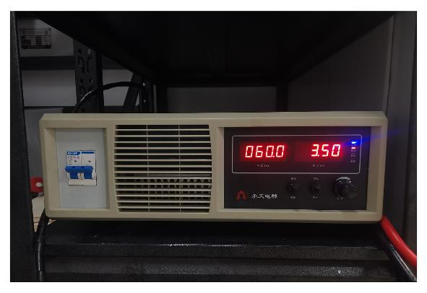
Supplementary Fig. 23. Constant current electrolysis tests. Photograph of constant current device, and corresponding current and voltage during EAO are also shown in the figure.

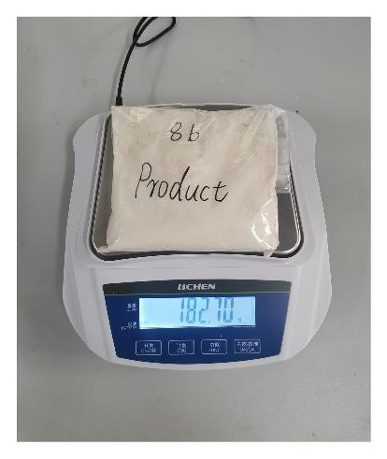
Supplementary Fig. 24. Photograph of the product. Photograph of product 8b.

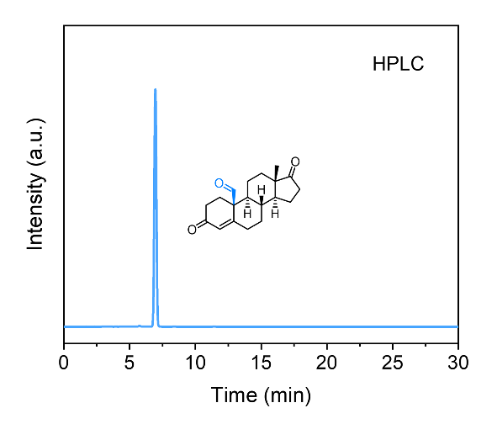
Supplementary Fig. 25. HPLC spectra of the product. HPLC analysis of 8b.

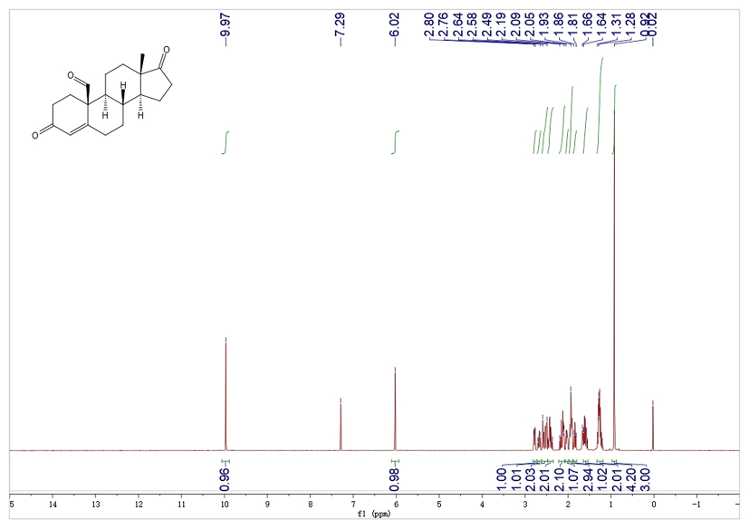
Supplementary Fig. 26. NMR spectra of the product. ¹H NMR of 8b.

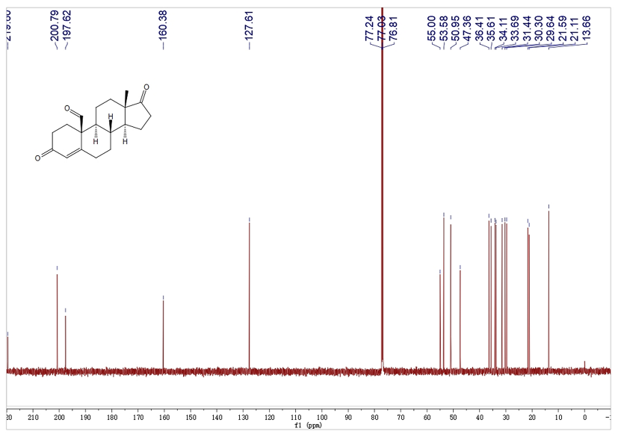
Supplementary Fig. 27. NMR spectra of the product. ¹³C NMR of 8b.

