Supplementary Information for

Effectiveness of strain and dopants on breaking the activity-stability trade-off of RuO₂ acidic oxygen evolution electrocatalysts

Yang Liu^{1,2#}, Yixuan Wang^{2#}, Hao Li^{2#}, Min Gyu Kim⁵, Mingbo Wu⁶, Hyoyoung Lee^{2,3,4}*

¹Shandong Provincial Key Laboratory for Science of Material Creation and Energy Conversion, Institute of Frontier Chemistry, School of Chemistry and Chemical Engineering, Shandong University, Qingdao, 266237 P. R. China
²Department of Chemistry, Sungkyunkwan University, Seobu-Ro 2066, Suwon, 16419, Republic of Korea
³Creative Research Institute, Sungkyunkwan University, Seobu-Ro 2066, Suwon, 16419, Republic of Korea
⁴Institute of Quantum Biophysics, Sungkyunkwan University, Seobu-Ro 2066, Suwon, 16419, Republic of Korea
⁵Beamline Research Division, Pohang Accelerator Laboratory, Pohang University of Science and Technology, Pohang, 37673, Republic of Korea
⁶State Key Laboratory of Heavy Oil Processing, College of Chemical Engineering, College of New Energy, China University of Petroleum (East China), Qingdao 266580, China
#These authors contributed equally to this work.
*e-mail: hyoyoung@skku.edu

Experimental Section
Materials
RuCl₃·xH₂O, NH₄OH (25-30 wt%), H₂SO₄ (98wt%), NaNO₃, NaCl, TaCl₅, Sr(NO₃)₂, ethanol, citric acid, commercial RuO₂ (c-RuO₂), and Naﬁon (5 wt%) were purchased from Sigma-Aldrich. Carbon paper (CP GDL) and Platinized Ti foam (Pt/Ti GDL) were purchased from the Fuel Cell Store. All chemicals were used as received without further puriﬁcation. The water used in all experiments was puriﬁed using a Millipore system.
Synthesis of tensile strained and Sr/Ta doped RuO_{2-x} electrocatalysts
The preparation of precursors for the synthesis of RuO_{2-x} nanocatalysts was based on the sol-gel method. Specifically for the synthesis process of TS-Sr_{0.1}Ta_{0.1}Ru_{0.8}O_{2-x}, the mixed solution was prepared with water (30 mL) and ethanol (50 mL) containing citric acid (0.125 mmol) and 5 g (92wt% NaNO₃ + 8 wt %NaCl) under sonication 1 h. 0.24 mmol of RuCl₃·H₂O, 0.03 mmol of TaCl_{5,} and 0.03 mmol of Sr(NO₃)₂ were added into the above solution under vigorous stirring in an ice bath. After stirring for 2 h, ammonia solution was added dropwise into the reaction solution within 1 h to adjust the pH to around 6. After ball milling for 4 h, the reaction solution bottle was quickly frozen using liquid N₂ and freezing dried.
A pot-type quartz crucible was used to anneal precursor in the muffle furnace under 400 ℃ (10 ℃/min) for 2 hours and then was quickly take out the quartz crucible and pour mixture into enough water (1 L water) at room temperature (with vigorous stirring) to obtain the TS-Sr_{0.1}Ta_{0.1}Ru_{0.8}O_{2-x} nanocatalysts.
The other ratios in feed (0.28 mmol of RuCl₃·H₂O, 0.01 mmol of TaCl_{5,} and 0.01 mmol of Sr(NO₃)₂) and (0.2 mmol of RuCl₃·H₂O, 0.05 mmol of TaCl_{5,} and 0.05 mmol of Sr(NO₃)₂) were also prepared and performance was investigated. A similar process was conducted but with only Sr or Ta salt to obtain TS-Sr_{0.1}Ru_{0.9}O_{2-x} and TS-Ta_{0.1}Ru_{0.9}O_{2-x} nanocatalysts. Substituting the quenching with the natural cooling process gave the Sr_{0.1}Ta_{0.1}Ru_{0.8}O_{2-x} samples.
Material characterizations.
The morphology of the samples was investigated by using a JSM 7401F (JEOL Ltd., Tokyo, Japan) scanning electron microscope (SEM) operated at 3.0 kV. High-resolution TEM (HRTEM) images and scanning transmission electron microscopy (STEM) images were collected on a JEOL ARM-200F ﬁeld-emission transmission electron microscope operating at a 200 kV accelerating voltage. X-ray photoelectron spectroscopy (XPS) was performed using a VG Microtech ESCA 2000 equipped with a monochromic Al X-ray source (97.9 W, 93.9 eV). X-ray diffraction (XRD) patterns were acquired using a Rigaku Ultima IV, using the substrates directly. ICP-OES was measured on 5110 ICP-OES (Varian, US) for samples after diluent 100 μL electrolytes using 0.5 M H₂SO₄ (5 mL total) at regular intervals when measuring in the cell as shown in Fig. S15 at a current density of 10 mA cm⁻².
The X-ray absorption spectroscopy (XAS) measurements were performed at the BL10C beamline of the Pohang Light Source (PLS-II, Korea) under an operation mode of 3.0 G eV with a ring current of 250 mA. The acquired XAFS data were analyzed by Athena and Artemis software according to the standard process. The spectra were calibrated, averaged, pre-edge background subtracted, and post-edge normalized using the Athena program in the IFEFFIT software package. The Fourier transformation of EXAFS oscillations from k space to R space was achieved to obtain a radial distribution function. All data fitting was completed in the Artemis program. The in-situ attenuated total reﬂection surface-enhanced infrared absorption spectroscopy (ATR-SEIRAS) was conducted using a Bruker INVENIO-R spectrometer equipped with a mercury cadmium telluride (MCT) detector, a Veemax III ATR accessory (Kromatek), and an electrochemical reaction cell equipped with a CaF₂ bottom. The electrochemical tests were performed on a CHI 760E workstation in a typical three-electrode configuration with a Pt wire and Ag/AgCl (saturated KCl electrolyte) electrode as the counter and reference electrodes, respectively. Our electrodes were directly stuck on the working electrode (Pt coin surface) surface using conductive adhesive tape. The Ar inlet was connected and flowed the electrolyte for 30 min with 20 ccm on two sides.
Electrochemical measurements
To prepare all RuO_{2-x} electrodes, the catalyst ink was prepared by suspending 5 mg of catalyst powder in a 1 mL solution consisting of 500 μL of 5 wt% Nafion® (117 solutions, Aldrich), 250 μL of ethanol, and 710 μL of distilled water. 200 μL ink was carefully distributed dropwise on the surface of CP(1cm²) and dried in the vacuum oven at 40℃.
Electrochemical measurements were performed in a standard three-electrode system (CHI 660E, USA) consisting of a RuO_{2-x} catalyst working electrode, a Pt mesh counter electrode, and a Hg/Hg₂SO₄ reference electrode. All potentials reported in our work are referenced to a reversible hydrogen electrode (RHE) via the Nernst equation (Eqn(1)), and the Hg/Hg₂SO₄ reference electrode was calibrated in a hydrogen-saturated 0.5 M H₂SO₄ (Figure S7). The linear sweep voltammetry curves were recorded at a scan rate of 2 mV s⁻¹ in 0.5 M H₂SO₄ (PH=0).
E_{RHE}=E_{Hg/Hg2SO4}+0.059pH+ E⁰_{Hg/Hg2SO4} (1)
where E_{RHE} is the converted potential vs. RHE, E_{Hg/Hg2SO4} is the experimentally measured potential against the Hg/Hg₂SO₄ reference electrode, and E⁰_{Hg/Hg2SO4} is the standard potential of Hg/Hg₂SO₄ at 25ºC (0.65 V). All the potentials were automatically iR-corrected for the ohmic resistance of the solution unless specified.
The tests of the two-electrodes electrolyzer were conducted after coating the TS-Sr_{0.1}Ta_{0.1}Ru_{0.8}O_{2-x} or c-RuO₂ for the anode and Pt/C for the cathode, respectively. LSV curves were recorded in a certain region of 1~1.8 V with a scan of 2 mV s⁻¹. The chronoamperometry measurements were carried out at the current densities of 10 mA cm⁻² and 50 mA cm⁻² during the long term.
Before recording the electroactivity in 0.5 M H₂SO₄, the catalysts were activated by 10 cycles of CV scans in a certain region (0.3~0.9 V vs. Hg/Hg₂SO₄). To study the OER electrocatalytic activity in acid conditions, the polarization curves were created from 0.2 to 0.9 V (vs. Hg/Hg₂SO₄) at a negative scan (scan rate of 2 mV/s) to avoid the non-faradaic capacitance/current contribution. And chronopotentiometric (V-t) measurements were carried out on CP or Pt/Ti GDL at a constant current density in the 0.5 M H₂SO₄ solution.
In-situ electrochemical impedance spectroscopy (EIS) was carried out on a Bio-Logic workstation in a frequency range from 100 kHz to 0.01 Hz and a potential range from 1.0 to 1.5 V (vs. RHE). Then simulation and analysis of EIS data were carried out using ZSimpWin software^{1, 2}.
The electrochemical double-layer capacitance (Cdl) of every electrocatalyst was assessed using cyclic voltammetry in a non-Faradaic region (0 ~ 0.1 V vs. Hg/Hg₂SO₄) at scan rates of 20, 40, 60, 80, and 100 mV s⁻¹. Based on a plot of the difference between anodic and cathodic current densities at the mid-potential (0.05 V vs. Hg/Hg₂SO₄) vs. the scan rate, the resulting linear slope was twice the value of Cdl.
¹⁸O isotope-labelled experiments
The ¹⁸O isotope-labeled experiments were conducted in two sealed compart electrolyzers with proton exchange membrane separated (Fig. S15)^{3, 4}. A Hg/Hg₂SO₄ electrode and a Pt mesh were used as reference electrode and counter electrode, respectively. The working electrodes were prepared by coating our nanocatalyst powder on CP and dried in a vacuum oven. Firstly, the catalysts on the working electrode (anode) were activated by performing 10 CV cycles at 2 mV s⁻¹ in an ¹⁸O-labelled H₂SO₄ electrolyte in a potential window of 0.3~0.9 V vs. Hg/Hg₂SO₄, resulting in the ¹⁸O-labelled surface oxygen. The working electrodes were carefully and thoroughly washed using ¹⁶O-H2O and dried in a vacuum oven. Then blow the Ar gas for 20 min to eliminate the pollution gas and the electrolyzer was tightly sealed. After that, an oxygen gas sample (100μL) produced at the anode cell was collected using a syringe needle when conducting the chronoamperometry experiments at 5 mA cm⁻². Injecting in the gas chromatograph mass spectrometer (GC-MS) system (YL 6900, YL instrument CO., LTD. Korea) to determine the composition of gas products and the relative ratio of ³⁴O₂ (¹⁸O¹⁶O), ³⁶O₂ (¹⁸O¹⁸O), and ³²O₂ (¹⁶O¹⁶O) signals, which can reflect the LOM level during the OER on our catalysts.
Calculation methods
The spin-polarized DFT calculations were performed to investigate the structural properties of the catalysts in the Vienna ab initio simulation package (VASP)⁵. The generalized gradient approximation (GGA) along with the revised Perdew-Burke-Ernzerhof (RPBE) function was used to account for electron exchange and correction, and the cut of the plane-wave kinetic energy was 450 eV. The DFT + D3 correction was employed to describe the van der Waals interaction. A vacuum layer of around 15 Å was employed to avoid interactions between periodic slab images. A periodic slab model of the RuO₂ (110) surface was constructed using 2*3 surface supercells with four metal-oxide layers, resulting in a chemical composition of Ru₄₈O₉₆. Corresponding tensile strain (5 %) is applied by changing the lattice constant. Then a series of models were established in this work, including undoped RuO₂ (110), TS-RuO₂ (110), Sr/Ta co-doped RuO₂ (110), and Sr/Ta co-doped TS-RuO₂ (110) surfaces. The k-point grid was set to 3*2*1 for geometry optimization and electronic properties calculations. Energy and force convergence were set to 10⁻⁵ eV and -0.05 eV/Å, respectively. In the electrocatalytic simulation process, the lattice strain was fixed in these slab models. All simulation processes adopt the same optimization parameters and keep the lattice constant.
To investigate the activity of AEM (adsorbate evolution mechanism) and LOM (a lattice-oxygen-mediate mechanism), the Gibbs free energy changes (ΔG) were calculated using the computational hydrogen electrode (CHE) ⁶ model:
ΔG = ΔE + ΔZPE + ∫C_{p}dT - TΔS
where ΔE is the difference of electron energies obtained from DFT calculations. ΔZPE, ∫C_{p}dT, and ΔS are the change in zero-point energy, enthalpic temperature correction, and the entropy difference, respectively.

Fig. S1| Schematic diagram of synthesizing the RuO_{2-x} with tensile strain and electronic modifications via a molten salt assistant quench process. This strategy presents attractive advantages for the formation of uniform high-crystal and small-sized nanocatalysts.

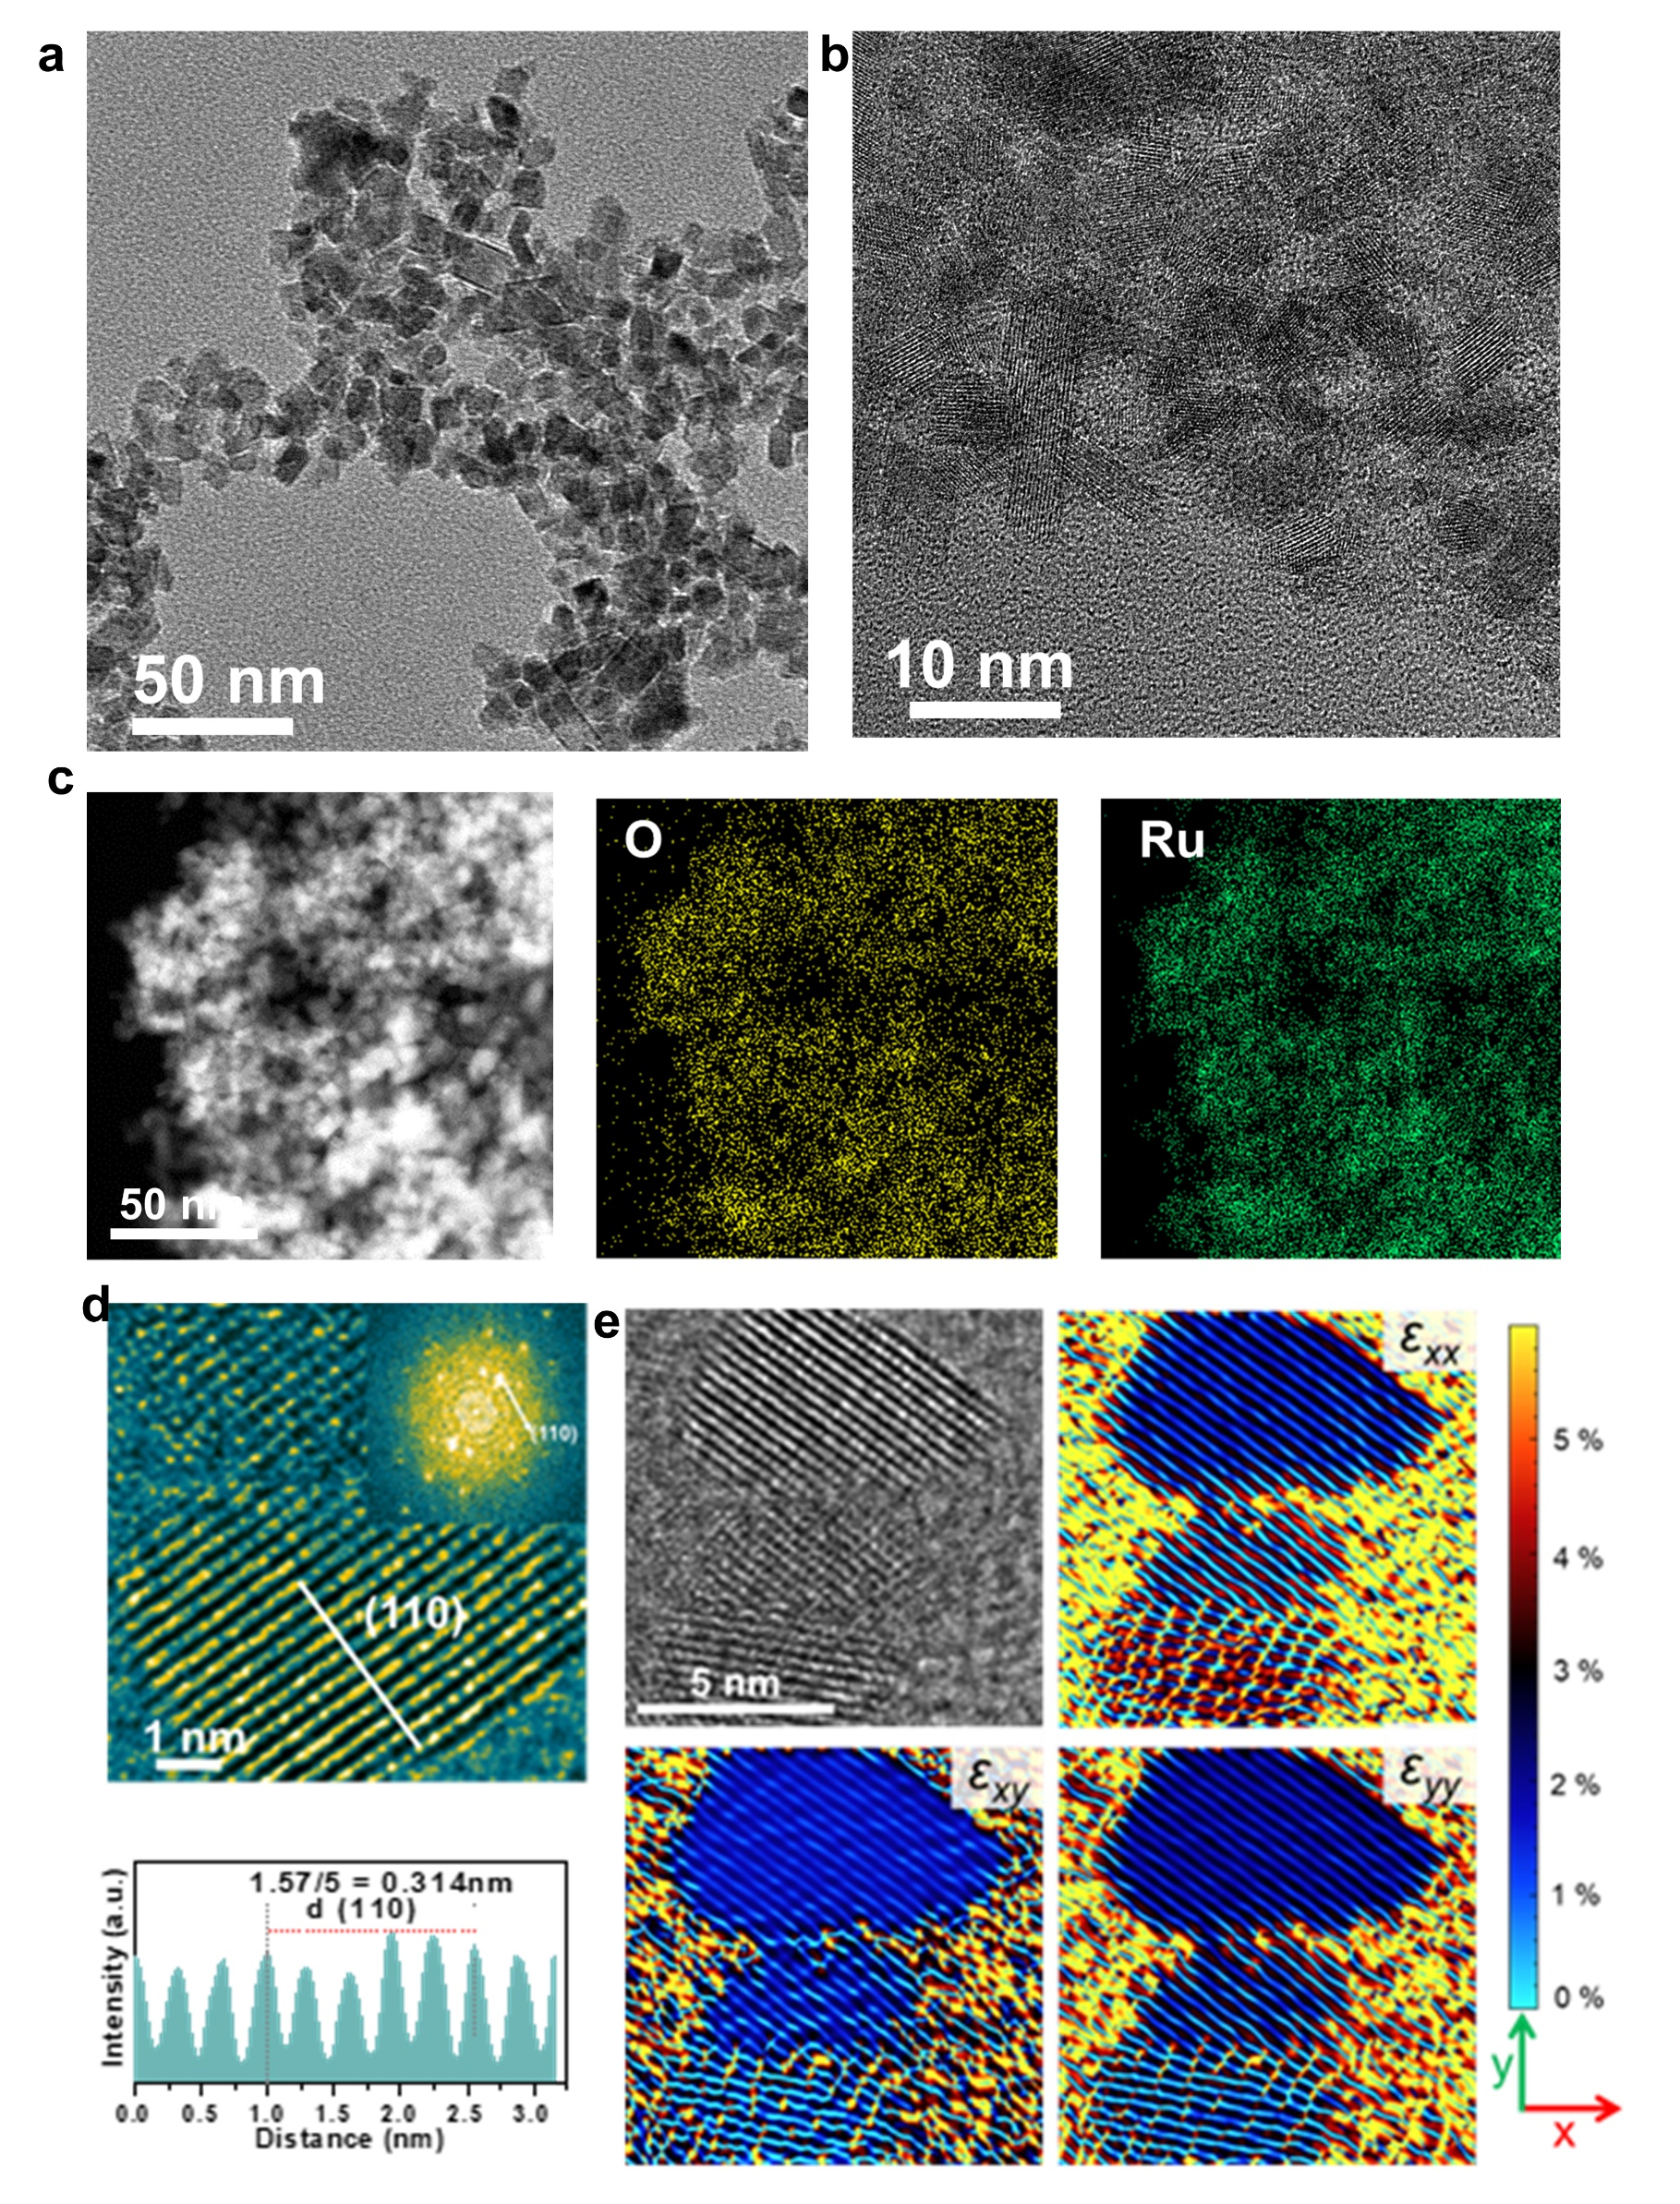
Fig. S2| HRTEM images (a,b) and HAADF-STEM with corresponding EDS mapping images (c) of RuO_{2-x}. d Rendered HRTEM image, inset is selected area electron diffraction (SEAD) patterns (110 facet), below is intensity profiles along white line and (e) GPA contour map of the strain components ε_{xx}, ε_{xy}, and ε_{yy} relative to the RuO_{2-x} reference values on the surface of RuO_{2-x}.

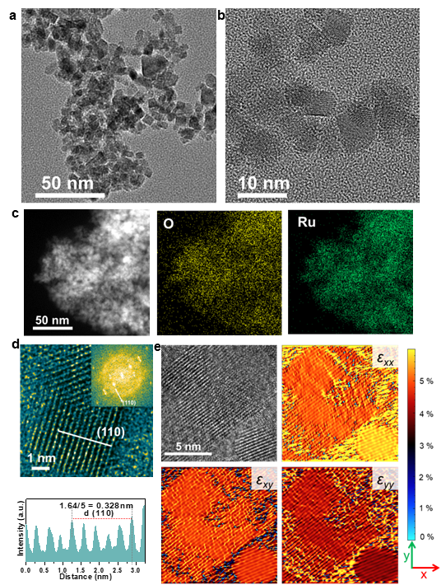
Fig. S3| HRTEM images (a,b) and HAADF-STEM with corresponding EDS mapping images (c) of TS-RuO_{2-x}. d Rendered HRTEM image, inset is selected area electron diffraction (SEAD) patterns (110 facet), below is intensity profiles along white line and (e) GPA contour map of the strain components ε_{xx}, ε_{xy}, and ε_{yy} relative to the RuO_{2-x} reference values on the surface of TS-RuO_{2-x}. The lattice of (110) is expanded to 0.328 nm, combined with GPA confirms the tensile strain of about 5 %.

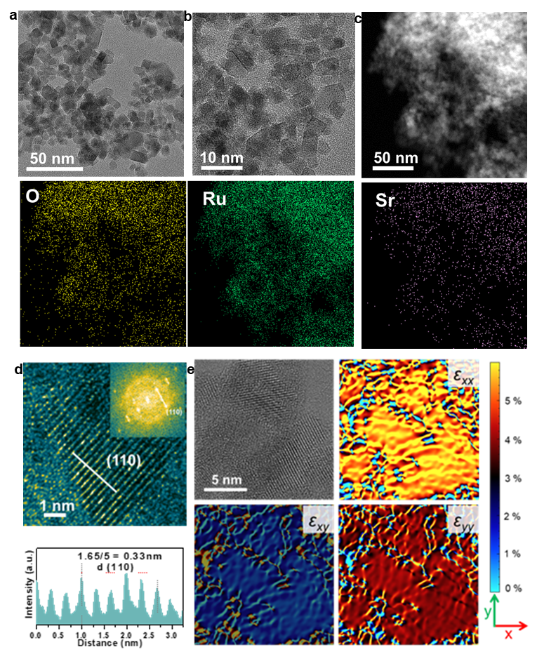
Fig. S4| HRTEM images (a,b) and HAADF-STEM with corresponding EDS mapping images (c) of TS-Sr_{0.1}Ru_{0.9}O_{2-x}. d Rendered HRTEM image, inset is selected area electron diffraction (SEAD) patterns (110 facet), below is intensity profiles along white line and (e) GPA contour map of the strain components ε_{xx}, ε_{xy}, and ε_{yy} relative to the RuO_{2-x} reference values on the surface of TS-Sr_{0.1}Ru_{0.9}O_{2-x}.

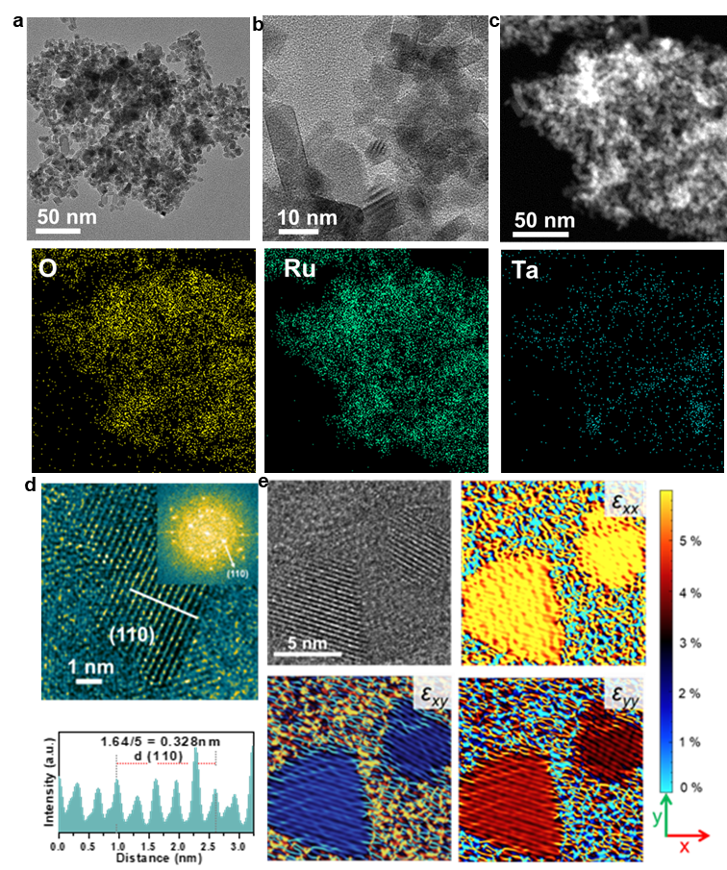
Fig. S5| HRTEM images (a,b) and HAADF-STEM with corresponding EDS mapping images (c) of TS-Ta_{0.1}Ru_{0.9}O_{2-x}. d Rendered HRTEM image, inset is selected area electron diffraction (SEAD) patterns (110 facet), below is intensity profiles along white line and (e) GPA contour map of the strain components ε_{xx}, ε_{xy}, and ε_{yy} relative to the RuO_{2-x} reference values on the surface of TS-Ta_{0.1}Ru_{0.9}O_{2-x}.

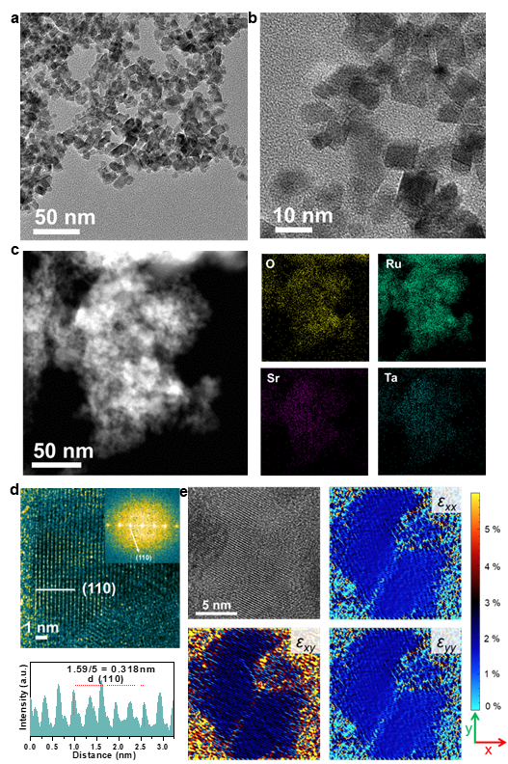
Fig. S6| HRTEM images (a,b) and HAADF-STEM with corresponding EDS mapping images (c) of Sr_{0.1}Ta_{0.1}Ru_{0.8}O_{2-x}. d Rendered HRTEM image, inset is selected area electron diffraction (SEAD) patterns (110 facet), below is intensity profiles along white line and (e) GPA contour map of the strain components ε_{xx}, ε_{xy}, and ε_{yy} relative to the RuO_{2-x} reference values on the surface of Sr_{0.1}Ta_{0.1}Ru_{0.8}O_{2-x}.
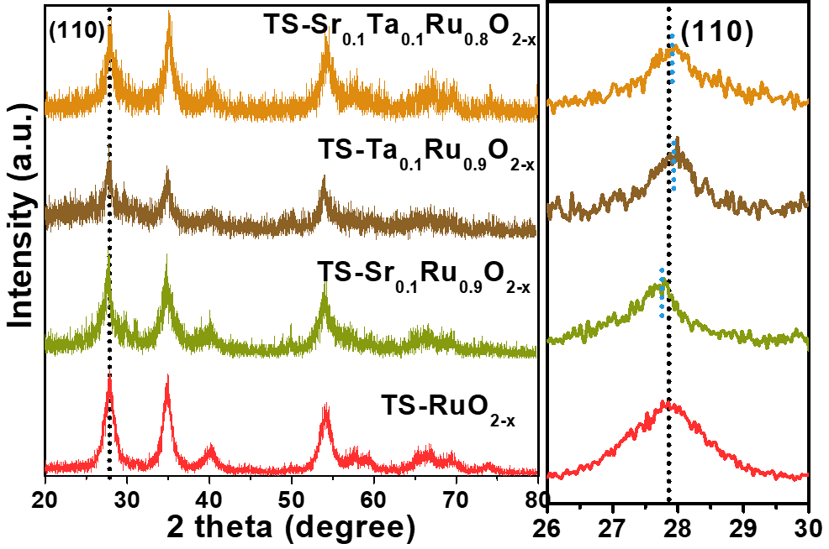
Fig. S7| XRD patterns with local magnificent (110) peak of all strained catalysts.

Fig. S8| a,b O 1s and Ru 3d XPS spectra of all strained catalysts. c,d Sr 3d XPS spectra of all Sr doped samples, e,f Ta 4f XPS spectra of all Ta doped samples. The tensile strain has less effect on the peaks shifting, whereas co-doped Sr and Ta redistribute the local electrons among Sr-Ru-Ta groups since more electrons are transferred to nearby O and Ru.

Fig. S9| a,b Corresponding EXAFS fitting curve of all catalysts in k spaces, respectively. c,d The Ru K-edge XANES and EXAFS spectra of TS-RuO_{2-x}, TS-Sr_{0.1}Ru_{0.9}O_{2-x}, TS-Ta_{0.1}Ru_{0.9}O_{2-x}, and TS-Sr_{0.1}Ta_{0.1}Ru_{0.8}O_{2-x} catalysts with those of r-Ru, r-RuCl₃, and, r-RuO₂ references, showing the vibration of Ru valence states on doped samples and elongated Ru-O and Ru-O-M bonding in strained samples. In addition, the case of Sr and Ta co-doping induces the suitable modulation of the valence state of Ru.

Fig. S10| The Sr K-edge XANES (a,b) and EXAFS spectra (e,f) of all Sr-doped catalysts. The Ta K-edge XANES (c,d) and EXAFS spectra (g,h) of all Ta-doped catalysts. Sr and Ta co-dopants interplay on electronic and bonding structure.
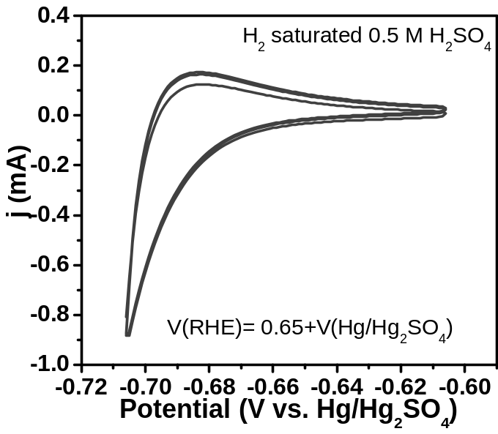
Fig. S11| The CV curves (scan rate of 2 mV/s) of the Pt electrode in a hydrogen-saturated 0.5 M H₂SO₄ with Pt counter and Hg/Hg₂SO₄ reference electrode.

Fig. S12| a,b Tafel plots of all prepared RuO_{2-x} catalysts obtained from the geometry-normalized LSV curves. c,d Mass-normalized (Ru mass) LSV curves of all prepared RuO_{2-x} catalysts, which indicates that compared to the tensile strain, Sr and Ta co-doping induce more favorable electronic modulations, resulting in superior mass activity.

Fig. S13| CV curves (0-0.1 V vs. Hg/Hg₂SO₄) of all as-synthesized RuO_{2-x} catalysts were obtained at various scan rates in 0.5 M H₂SO₄ electrolyte, and corresponding double-layer capacitance (C_{dl}) obtained based on the scan rate and current density gap at a 0.05 V vs. Hg/Hg₂SO₄.

Fig. S14| a,c,e,g Geometry-normalized LSV curves of Sr_{0.1}Ta_{0.1}Ru_{0.8}O_{2-x}, TS-Sr_{0.1}Ru_{0.9}O_{2-x}, TS-Ta_{0.1}Ru_{0.9}O_{2-x}, and TS-Sr_{0.1}Ta_{0.1}Ru_{0.8}O_{2-x} electrodes in various pH-H₂SO₄ electrolytes, b,d,f,h Corresponding curves of overpotentials-dependent pH values at 5, 10, 20 mA cm⁻², respectively. Those suggest tensile strained samples show the almost no-pH dependent relation, mainly lowering the possibility of the LOM pathway.

Fig. S15| a Schematic diagram and (b) sealed electrolyzer photo of the isotopic oxygen (¹⁸O) labeling experiments process for detecting the LOM portion and related O₂ composition.

Fig. S16| a,b The GC and MS spectra measured from GC-MS equipment of standard gas. The GC and MS spectra measured when injecting gas collected on (c,d) c-RuO₂, (e,f) RuO_{2-x}, and (g,h) Sr_{0.1}Ta_{0.1}Ru_{0.8}O_{2-x} electrodes, showing the different intensity of ³⁴O₂ (¹⁸O¹⁶O) and ³⁶O₂ (¹⁸O¹⁸O) but similar ³²O₂ (¹⁶O¹⁶O) signals.

Fig. S17| The GC and MS spectra measured when injecting gas collected on (a,b) TS-RuO_{2-x}, (c,d) TS-Sr_{0.1}Ru_{0.9}O_{2-x}, (e,f) TS-Ta_{0.1}Ru_{0.9}O_{2-x}, and (g,h) TS-Sr_{0.1}Ta_{0.1}Ru_{0.8}O_{2-x} electrodes, showing the different intensity of ³⁴O₂ (¹⁸O¹⁶O) and ³⁶O₂ (¹⁸O¹⁸O) but similar ³²O₂ (¹⁶O¹⁶O) signals and further suggesting the reduced LOM possibility on strained catalysts.

Fig. S18| a In-situ ATR-SEIRAS spectra measured on TS-Sr_{0.1}Ta_{0.1}Ru_{0.8}O_{2-x} electrode in D₂O based electrolyte from open circuit potential to 1.6 V (vs. RHE). b In-situ ATR-SEIRAS absorption intensity comparison of *OOD intermediates on RuO_{2-x}, TS-RuO_{2-x}, and TS-Sr_{0.1}Ta_{0.1}Ru_{0.8}O_{2-x} electrodes in H₂O-based electrolyte, which illustrates that the higher AEM catalysts ability on TS-Sr_{0.1}Ta_{0.1}Ru_{0.8}O_{2-x} electrodes. In-situ ATR-SEIRAS spectra were measured in H₂O and D₂O, along with the comparison among every signal at 1.6 V on (c,d,e) RuO_{2-x} and (f,g,h) TS-RuO_{2-x}.

Fig. S19| a ICP-OES measured dissolved concentration curves of Ru from RuO_{2-x} with and without strain working electrodes, demonstrating the stability improvement induced by the lattice expansion. b Standard curves of O₂ gas measured on GC equipment. c,d,e Collected O₂ gas and theoretical gas amount at 10 mA cm⁻² on TS-RuO_{2-x}, Sr_{0.1}Ta_{0.1}Ru_{0.8}O_{2-x}, and TS-Sr_{0.1}Ta_{0.1}Ru_{0.8}O_{2-x} electrodes, which shows the selectivity as high as 100 % on our electrodes.

Fig. S20| a,b O 1s and Ru 3d XPS spectra on RuO_{2-x} and TS-RuO_{2-x} samples before and after OER reaction. c,d Ta 4f and Sr 3d XPS spectra on strained or without strained samples before and after reaction. The higher proportion of OH and Vo on post-reaction samples reflects the O sites are active for deprotonation, and slightly riched Ru^{>4+} species suggest the improved stability on strained catalysts.

Fig. S21| a,c,e The Ru K-edge, Sr K-edge, and Ta K-edge XANES and (b,d,f ) EXAFS spectra of TS-Sr_{0.1}Ta_{0.1}Ru_{0.8}O_{2-x} before and after reaction, showing the reasonable increase of Ru valence states induced by the OER reaction and almost unchanged Ru-O bonding.

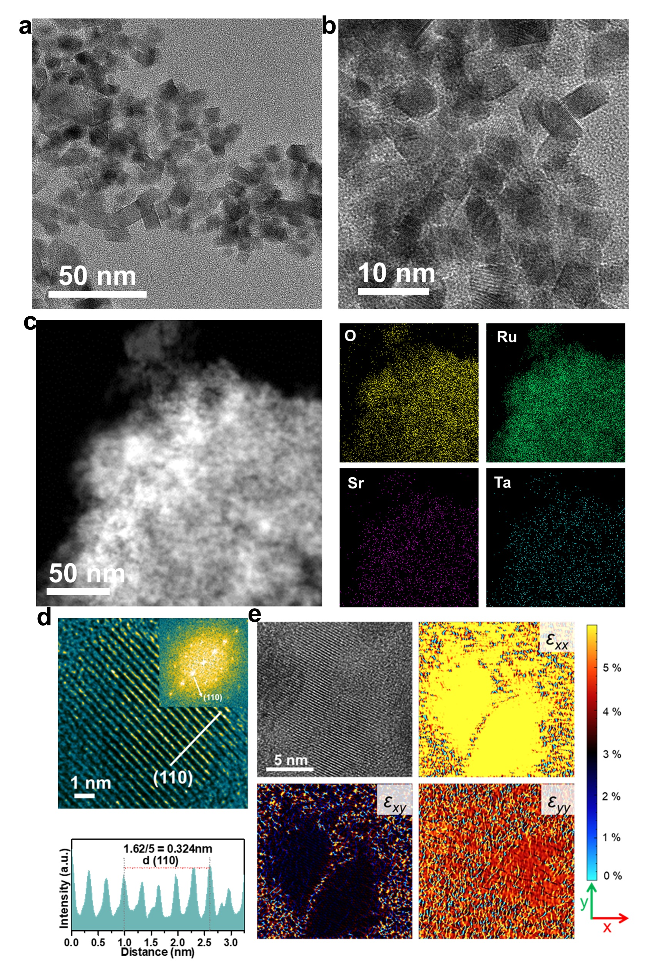
Fig. S22| HRTEM images (a,b) and HAADF-STEM with corresponding EDS mapping images (c) of post-TS-Sr_{0.1}Ta_{0.1}Ru_{0.8}O_{2-x}. d Rendered HRTEM image, inset is selected area electron diffraction (SEAD) patterns (110 facet), below is intensity profiles along white line and (e) GPA contour map of the strain components ε_{xx}, ε_{xy}, and ε_{yy} relative to the RuO_{2-x} reference values on the surface of post-TS-Sr_{0.1}Ta_{0.1}Ru_{0.8}O_{2-x}. The lattice of (110) remains at 0.324 nm, combined with GPA confirms the tensile strain is well preserved.

Fig. S23| a,c,e In-situ EIS spectra and (b,d,f) corresponded bode plots on c-RuO₂, RuO_{2-x}, and TS-RuO_{2-x} electrodes measured from 1.0 to 1.5 V (vs. RHE) with 50 mV amplitude in 0.5 M H₂SO₄. No evidence supporting the promotion of strain on activity can be found due to that compared to RuO_{2-x} the even higher phase angle is achieved on TS-RuO_{2-x}.

Fig. S24| a,c,e,g In-situ EIS spectra and (b,d,f,h) corresponded bode plots on Sr_{0.1}Ta_{0.1}Ru_{0.8}O_{2-x}, TS-Sr_{0.1}Ru_{0.9}O_{2-x}, TS-Ta_{0.1}Ru_{0.9}O_{2-x}, and TS-Sr_{0.1}Ta_{0.1}Ru_{0.8}O_{2-x}, electrodes measured from 1.0 to 1.5 V (vs. RHE) with 50 mV amplitude in 0.5 M H₂SO₄.

Fig. S25| a,b Simulated Q₁R₁ values on c-RuO₂, RuO_{2-x}, TS-RuO_{2-x}, Sr_{0.1}Ta_{0.1}Ru_{0.8}O_{2-x}, and TS-Sr_{0.1}Ta_{0.1}Ru_{0.8}O_{2-x} catalysts. Simulated (c,d) Q₁R₁ and (e,f) Q₂R₂ values of doped catalysts. Those comparisons evidence that the enhanced OER activity mainly originated from the co-doping of Sr and Ta, in terms of lower R₁ and R₂, as well as much higher Q₂.

Fig. S26| a,b,c,d The built configurations with oxygen vacancy (V_{O}) on RuO_{2-x}, TS-RuO_{2-x}, Sr_{0.1}Ta_{0.1}Ru_{0.8}O_{2-x}, and TS-Sr_{0.1}Ta_{0.1}Ru_{0.8}O_{2-x} catalysts surface. e Corresponded V_{O} formation energy. It suggests the strain significantly increases the V_{O} formation energy, even though the co-doping also does, similar to the experimental investigations.

Fig. S27| a,b Calculated AEM mechanism energy barrier diagrams on Sr_{0.1}Ta_{0.1}Ru_{0.8}O_{2-x} (g) and TS-RuO_{2-x} (f) configurations. This higher overpotential of LOM on TS-RuO_{2-x} reflects a suppressed LOM pathway due to the presence of tensile strain.

Fig. S28| The theoretical configurations during calculating AEM pathway energy barrier diagrams on RuO_{2-x} catalyst.

Fig. S29| The theoretical configurations during calculating LOM pathway energy barrier diagrams on RuO_{2-x} catalyst.

Fig. S30| The theoretical configurations during calculating AEM pathway energy barrier diagrams on TS-RuO_{2-x} catalyst.

Fig. S31| The theoretical configurations during calculating LOM pathway energy barrier diagrams on TS-RuO_{2-x} catalyst.

Fig. S32| The theoretical configurations during calculating AEM pathway energy barrier diagrams on Sr_{0.1}Ta_{0.1}Ru_{0.8}O_{2-x} catalyst.

Fig. S33| The theoretical configurations during calculating LOM pathway energy barrier diagrams on Sr_{0.1}Ta_{0.1}Ru_{0.8}O_{2-x} catalyst.

Fig. S34| The theoretical configurations during calculating AEM pathway energy barrier diagrams on TS-Sr_{0.1}Ta_{0.1}Ru_{0.8}O_{2-x} catalyst.

Fig. S35| The theoretical configurations during calculating LOM pathway energy barrier diagrams on TS-Sr_{0.1}Ta_{0.1}Ru_{0.8}O_{2-x} catalyst.

Table S1 Performance summary of recently reported representative OER catalysts in the acidic electrolyte (η_{10:} the overpotential at 10 mAcm⁻²).
Catalysts | Electrolyte | η₁₀ (mV) | Tafel Slope (mV/dec) | Stability  (Voltage-Time) | Reference
RuO_{2-x} | 0.5M H₂SO₄ | 243 | 154.5 | 300 h @  10 mA cm⁻² | This work
TS-RuO_{2-x} | 0.5M H₂SO₄ | 210 | 57.5 | 1000 h @  10 mA cm⁻² | This work
Ta_{0.1}Sr_{0.1}Ru_{0.8}O_{2-x} | 0.5M H₂SO₄ | 183 | 67.9 | 300 h @  10 mA cm⁻² | This work
TS-Ta_{0.1}Sr_{0.1}Ru_{0.8}O_{2-x} | 0.5M H₂SO₄ | 166 | 56.6 | 1000 h @  10 mA cm⁻² | This work
Li_{0.52}RuO₂ | 0.5M H₂SO₄ | 156 | 83.3 | 70 h @  10 mA cm⁻² | Nat. Commun, 2022, 13(1): 3784.
Ru₅W₁O_{x} | 0.5M H₂SO₄ | 227 | 42 | 550 h @  10 mA cm⁻² | Nat. Commun, 2022, 13(1): 4871.
Ni-RuO₂ | 0.1 M HClO₄ | 214 | 42.6 | 200 h @  10 mA cm⁻² | Nat. Mater., 2023, 22(1): 100-108.
W_{0.2}Er_{0.1}Ru_{0.7} O_{2−δ} | 0.5M H₂SO₄ | 168 | 66.8 | 500 h @  10 mA cm⁻² | Nat. Commun, 2020, 11(1): 5368.
PtCo–RuO₂/C | 0.1 M HClO₄ | 212.6 | 48.5 | 20 h @  10 mA cm⁻² | Energy Environ. Sci., 2022, 15(3): 1119-1130.
Ta_{x}Tm_{y}Ir_{1−x−y} O_{2−δ} | 0.5M H₂SO₄ | 198 | 64 | 500 h @  10 mA cm⁻² | Nat. Nano., 2021, 16(12): 1371-1377.
SS Pt­RuO₂ | 0.5M H₂SO₄ | 228 | 51.0 | 100 h @  10 mA cm⁻² | Sci. Adv., 2022, 8(9): eabl9271.
3R-IrO₂ | 0.1 M HClO₄ | 188 | 52 | 500 h @  10 mA cm⁻² | Joule, 2021, 5(12): 3221-3234.
RuO₂ NSs | 0.5M H₂SO₄ | 199 | 38.2 | 6 h @  10 mA cm⁻² | Energy Environ. Sci., 2020, 13(12): 5143-5151
Ru/MnO₂ | 0.1 M HClO₄ | 161 | 29.4 | 200 h @  10 mA cm⁻² | Nat. Catal, 2021, 4(12): 1012-1023.
Re_{0.06}Ru_{0.94}O₂ | 0.1 M HClO₄ | 190 | 45.5 | 200 h @  10 mA cm⁻² | Nat. Commun, 2023, 14(1): 1-11.
Rh-RuO₂/G | 0.5M H₂SO₄ | 161 | 45.8 | 700 h @  50 mA cm⁻² | Nat. Commun, 2023, 14(1): 1412.
Ru/RuS₂-2 | 0.5M H₂SO₄ | 201 | 47.2 | 24 h @  50 mA cm⁻² | Angew. Chem. Int. Ed., 2021, 133(22): 12436-12442.
Ir-MnO₂ | 0.5M H₂SO₄ | 181 | 87.4 | 180 h @  10 mA cm⁻² | Adv. Sci., 2023: 2205920.
Ir–MnO₂ | 0.5M H₂SO₄ | 218 | 59.61 | 700 h @  10 mA cm⁻² | Joule, 2021, 5(8): 2164-2176.
Ir/Nb₂O_{5−x} | 0.5M H₂SO₄ | 218 | 52.3 | 105 h @  10 mA cm⁻² | Angew. Chem. Int. Ed., 2022: e202212341.
Ir₁-Co₃O₄-NS-350 | 0.5M H₂SO₄ | 226 | 74.4 | 500 h @  10 mA cm⁻² | ACS Catal, 2023, 13: 3757-3767.
Nd_{0.1}RuO_{x} | 0.5M H₂SO₄ | 211 | 50 | 25 h @  10 mA cm⁻² | Adv. Funct. Mater., 2023: 2213304.
IrO₂@TaB₂ | 0.1 M HClO₄ | 288 | 42.6 | 120 h @  10 mA cm⁻² | Nat. Commun, 2023, 14(1): 5119.
Ba_{0.3}(SO₄)_{δ}W_{0.2}Ru_{0.5}O_{2−δ} | 0.5M H₂SO₄ | 206 | 43.3 | 1000 h @  10 mA cm⁻² | Nat. Commun., 2023, 14(1): 8093.
py-RuO₂:Zn | 0.5M H₂SO₄ | 173 | 41.2 | 1000 h @  10 mA cm⁻² | Nat. Commun, 2023, 14(1): 2517.
(Ru–W)O_{x} | 0.5M H₂SO₄ | 170 | 46.2 | 300 h @  10 mA cm⁻² | Adv. Mater., 2023: 2305939
Al-doped RuOx | 0.5M H₂SO₄ | 192 | 48 | 300 h @  10 mA cm⁻² | Chem, 2023, 9(12): 3600-3612.
Bi_{x}Er_{2-x}Ru₂O₇ | 0.1 M HClO₄ | 180 | 51.3 | 100 h @  10 mA cm⁻² | Nat. Commun, 2022, 13(1): 4106.
Ru/Se-RuO₂ | 0.5M H₂SO₄ | 190 | 43.7 | 24 h @  10 mA cm⁻² | Adv. Funct. Mater., 2023: 2211102.

Table S2 Elemental composition analysis measured by the HAADF-STEM EDS and XPS.
 | HAADF-STEM-EDS (at %) |  |  |  | XPS (at %)
Elements Samples | Sr | Ta | Ru | O | Sr | Ta | Ru | O
Sr_{0.1}Ta_{0.1}Ru_{0.8}O_{2-x} | 2.86 | 2.62 | 34.65 | 59.87 | 1.33 | 1.216 | 25.989 | 71.465
TS-Sr_{0.1}Ta_{0.1}Ru_{0.8}O_{2-x} | 3.02 | 2.51 | 36.1 | 58.37 | 1.48 | 1.247 | 26.43 | 70.843
TS-Sr_{0.1}Ru_{0.9}O_{2-x} | 3.43 |  | 32.67 | 63.9 | 1.632 |  | 26.347 | 72.021
TS-Ta_{0.1}Ru_{0.9}O_{2-x} |  | 2.53 | 36.63 | 60.84 |  | 1.229 | 27.191 | 71.58
Post-TS-Sr_{0.1}Ta_{0.1}Ru_{0.8}O_{2-x} | 2.8 | 2.45 | 35.02 | 59.73 | 1.196 | 1.153 | 26.52 | 71.131

Table S3 The fitted parameters of the in-situ EIS data of c-RuO₂ catalyst for OER in 0.5 M H₂SO₄.
Potential (vs. RHE) | R_{s}(Ω) | Q₁(F) | Q₁-n | R₁(Ω) | Q₂ (F) | Q₂-n | R₂(Ω)
1.00 | 2.074 | 0.0021 | 0.8923 | 86310 | 0.0037 | 0.5840 | 64.90
1.05 | 2.095 | 0.0021 | 0.8960 | 70560 | 0.0039 | 0.8000 | 63.59
1.10 | 2.093 | 0.0030 | 0.9051 | 52130 | 0.0042 | 0.5183 | 62.88
1.15 | 2.098 | 0.0026 | 0.9072 | 36980 | 0.0047 | 0.5714 | 61.41
1.20 | 2.101 | 0.0053 | 0.6013 | 30250 | 0.0029 | 0.9029 | 61.10
1.25 | 2.103 | 0.0030 | 0.9098 | 25800 | 0.0053 | 0.5711 | 60.96
1.30 | 2.101 | 0.0030 | 0.9103 | 18390 | 0.0053 | 0.5729 | 60.61
1.35 | 2.103 | 0.0033 | 0.9142 | 5894 | 0.0058 | 0.5704 | 60.48
1.40 | 2.104 | 0.0040 | 0.8884 | 891 | 0.0075 | 0.8838 | 60.14
1.45 | 2.055 | 0.0046 | 0.4142 | 343 | 0.0079 | 0.6771 | 59.25
1.50 | 2.061 | 0.0047 | 0.4298 | 65.5 | 0.0088 | 0.7000 | 58.94

Table S4 The fitted parameters of the in-situ EIS data of RuO_{2-x} catalyst for OER in 0.5 M H₂SO₄.
Potential (vs. RHE) | R_{s}(Ω) | Q₁(F) | Q₁-n | R₁(Ω) | Q₂ (F) | Q₂-n | R₂(Ω)
1.00 | 2.403 | 0.0216 | 0.8983 | 62210 | 0.0668 | 0.4759 | 43.23
1.05 | 2.429 | 0.0276 | 0.9087 | 53425 | 0.0782 | 0.4992 | 40.21
1.10 | 2.451 | 0.0288 | 0.8852 | 49820 | 0.0895 | 0.4753 | 39.09
1.15 | 2.528 | 0.0345 | 0.8799 | 35460 | 0.1063 | 0.4709 | 35.19
1.20 | 2.574 | 0.0457 | 0.4550 | 24610 | 0.1279 | 0.8791 | 29.5
1.25 | 2.582 | 0.0679 | 0.8673 | 15840 | 0.1387 | 0.4492 | 28.21
1.30 | 2.588 | 0.0707 | 0.8818 | 2678 | 0.1557 | 0.4643 | 27.73
1.35 | 2.591 | 0.1103 | 0.8981 | 354 | 0.1676 | 0.4674 | 26.41
1.40 | 2.588 | 0.1557 | 0.4466 | 25.14 | 0.1884 | 0.8237 | 25.02
1.45 | 2.596 | 0.1574 | 0.8000 | 8.831 | 0.1976 | 0.8025 | 8.94
1.50 | 2.618 | 0.1673 | 0.8352 | 2.828 | 0.1972 | 0.8000 | 7.33

Table S5 The fitted parameters of the in-situ EIS data of TS-RuO_{2-x} catalyst for OER in 0.5 M H₂SO₄.
Potential (vs. RHE) | R_{s}(Ω) | Q₁(F) | Q₁-n | R₁(Ω) | Q₂ (F) | Q₂-n | R₂(Ω)
1.00 | 2.190 | 0.0207 | 0.9159 | 14140 | 0.0641 | 0.5083 | 31.56
1.05 | 2.186 | 0.0620 | 0.8000 | 11033 | 0.0727 | 0.8000 | 26.83
1.10 | 2.179 | 0.0745 | 0.9158 | 9413 | 0.0864 | 0.5224 | 24.2
1.15 | 2.167 | 0.1057 | 0.5006 | 6793 | 0.1051 | 0.9048 | 23.8
1.20 | 2.183 | 0.1328 | 0.7270 | 4565 | 0.1354 | 0.8542 | 22.1
1.25 | 2.171 | 0.1475 | 0.9185 | 1284 | 0.1634 | 0.8000 | 20.15
1.30 | 2.138 | 0.1760 | 0.8899 | 845 | 0.1769 | 0.4221 | 13.54
1.35 | 2.163 | 0.1776 | 0.5178 | 68.4 | 0.1884 | 0.9265 | 9.16
1.40 | 2.143 | 0.2007 | 0.8539 | 18.18 | 0.1915 | 0.8000 | 1.74
1.45 | 2.143 | 0.1905 | 0.8718 | 6.227 | 0.2003 | 0.9505 | 0.62
1.50 | 2.150 | 0.1925 | 0.9031 | 2.34 | 0.2032 | 0.4878 | 0.50

Table S6 The fitted parameters of the in-situ EIS data of TS-Ta_{0.1}Ru_{0.9}O_{2-x} catalyst for OER in 0.5 M H₂SO₄.
Potential (vs. RHE) | R_{s}(Ω) | Q₁(F) | Q₁-n | R₁(Ω) | Q₂ (F) | Q₂-n | R₂(Ω)
1.00 | 2.022 | 0.0109 | 0.6367 | 81540 | 0.0050 | 0.9333 | 43.9
1.05 | 1.998 | 0.0420 | 0.8723 | 65320 | 0.0290 | 0.8000 | 42.94
1.10 | 1.995 | 0.0490 | 0.8796 | 51540 | 0.0295 | 0.8585 | 32.98
1.15 | 1.982 | 0.0560 | 0.8683 | 38565 | 0.0484 | 0.5537 | 27.64
1.20 | 1.968 | 0.0605 | 0.8547 | 30254 | 0.0751 | 0.9000 | 18.37
1.25 | 1.937 | 0.0622 | 0.8752 | 21940 | 0.0729 | 0.5681 | 17.64
1.30 | 1.956 | 0.0670 | 0.5229 | 8540 | 0.0748 | 0.8651 | 16.56
1.35 | 1.970 | 0.0740 | 0.8927 | 2010 | 0.0827 | 0.5866 | 14.89
1.40 | 1.907 | 0.0971 | 0.8367 | 154.8 | 0.1225 | 0.4254 | 10.56
1.45 | 1.957 | 0.1069 | 0.9667 | 12.55 | 0.1430 | 0.5689 | 7.49
1.50 | 1.913 | 0.1240 | 0.6947 | 4.779 | 0.1520 | 0.9457 | 5.314

Table S7 The fitted parameters of the in-situ EIS data of TS-Sr_{0.1}Ru_{0.9}O_{2-x} catalyst for OER in 0.5 M H₂SO₄.
Potential (vs. RHE) | R_{s}(Ω) | Q₁(F) | Q₁-n | R₁(Ω) | Q₂ (F) | Q₂-n | R₂(Ω)
1.00 | 3.177 | 0.0361 | 0.4583 | 6127 | 0.0299 | 0.9107 | 46.21
1.05 | 3.178 | 0.0516 | 0.8461 | 4812 | 0.0330 | 0.9103 | 38.6
1.10 | 3.168 | 0.0906 | 0.4480 | 3307 | 0.0363 | 0.9038 | 25.79
1.15 | 3.142 | 0.1253 | 0.8124 | 2540 | 0.0494 | 0.8981 | 21.05
1.20 | 3.137 | 0.1714 | 0.8970 | 1834 | 0.1545 | 0.3843 | 18.13
1.25 | 3.133 | 0.2015 | 0.9007 | 778 | 0.2561 | 0.8000 | 16.14
1.30 | 3.143 | 0.2264 | 0.9089 | 552 | 0.2985 | 0.4067 | 14.38
1.35 | 3.144 | 0.2334 | 0.4143 | 19.18 | 0.3019 | 0.9052 | 13.1
1.40 | 3.252 | 0.2438 | 0.9001 | 11.30 | 0.3661 | 0.6896 | 5.54
1.45 | 3.149 | 0.2593 | 0.4546 | 1.58 | 0.4247 | 0.8505 | 3.075
1.50 | 3.163 | 0.2545 | 0.4196 | 0.82 | 0.4257 | 0.9419 | 1.119

Table S8 The fitted parameters of the in-situ EIS data of TS-Sr_{0.1}Ta_{0.1}Ru_{0.8}O_{2-x} catalyst for OER in 0.5 M H₂SO₄.
Potential (vs. RHE) | R_{s}(Ω) | Q₁(F) | Q₁-n | R₁(Ω) | Q₂ (F) | Q₂-n | R₂(Ω)
1.00 | 3.030 | 0.0273 | 0.8672 | 3290 | 0.0989 | 0.5502 | 16.48
1.05 | 3.047 | 0.0605 | 0.8700 | 1683 | 0.1059 | 0.5445 | 13.62
1.10 | 3.056 | 0.0807 | 0.5854 | 945.8 | 0.1244 | 0.8986 | 12.5
1.15 | 3.056 | 0.1252 | 0.5646 | 565.5 | 0.1801 | 0.8759 | 8.36
1.20 | 3.057 | 0.1768 | 0.8423 | 321.4 | 0.2036 | 0.5071 | 5.42
1.25 | 3.052 | 0.2045 | 0.7429 | 165.3 | 0.2964 | 0.6415 | 3.54
1.30 | 3.067 | 0.2426 | 0.9161 | 111.7 | 0.3847 | 0.5775 | 2.67
1.35 | 3.062 | 0.2558 | 0.5904 | 22.62 | 0.4621 | 0.9161 | 1.72
1.40 | 3.053 | 0.3054 | 0.4946 | 3.39 | 0.4835 | 0.8560 | 1.47
1.45 | 3.020 | 0.3369 | 0.8618 | 1.26 | 0.4606 | 0.3807 | 1.13
1.50 | 3.045 | 0.3417 | 0.8892 | 0.47 | 0.4711 | 0.3858 | 0.64

Table S9 The fitted parameters of the in-situ EIS data of Sr_{0.1}Ta_{0.1}Ru_{0.8}O_{2-x} catalyst for OER in 0.5 M H₂SO₄.
Potential (vs. RHE) | R_{s}(Ω) | Q₁(F) | Q₁-n | R₁(Ω) | Q₂ (F) | Q₂-n | R₂(Ω)
1.00 | 2.445 | 0.0326 | 0.8675 | 4535 | 0.0483 | 0.8000 | 20.69
1.05 | 2.484 | 0.0366 | 0.8725 | 2678 | 0.0700 | 0.8001 | 18.61
1.10 | 2.489 | 0.0418 | 0.8721 | 1955 | 0.0925 | 0.8073 | 16.16
1.15 | 2.486 | 0.0549 | 0.8740 | 1294 | 0.1359 | 0.8954 | 14.44
1.20 | 2.490 | 0.0843 | 0.9515 | 993 | 0.2582 | 0.8765 | 13.54
1.25 | 2.480 | 0.1015 | 0.8766 | 675 | 0.3408 | 0.5805 | 11.50
1.30 | 2.451 | 0.1542 | 0.6463 | 423.5 | 0.3605 | 0.8689 | 7.77
1.35 | 2.452 | 0.1643 | 0.8793 | 300.6 | 0.4554 | 0.8492 | 5.50
1.40 | 2.468 | 0.1960 | 0.8550 | 19.38 | 0.4668 | 0.5846 | 3.81
1.45 | 2.480 | 0.2236 | 0.7704 | 2.1 | 0.4784 | 0.8735 | 2.20
1.50 | 2.540 | 0.2350 | 0.8676 | 1.51 | 0.5050 | 0.7714 | 0.68

Reference
1. Gu K, et al. Defect-Rich High-Entropy Oxide Nanosheets for Efficient 5-Hydroxymethylfurfural Electrooxidation. Angew Chem Int Ed Engl 60, 20253-20258 (2021).
2. Liu Y, et al. Unveiling the Protonation Kinetics-Dependent Selectivity in Nitrogen Electroreduction: Achieving 75.05 % Selectivity. Angew Chem Int Ed Engl 61, e202209555 (2022).
3. Zhang N, et al. Lattice oxygen activation enabled by high-valence metal sites for enhanced water oxidation. Nat Commun 11, 4066 (2020).
4. Wen Y, et al. Stabilizing Highly Active Ru Sites by Suppressing Lattice Oxygen Participation in Acidic Water Oxidation. J Am Chem Soc 143, 6482-6490 (2021).
5. Kresse G, Furthmuller J. Efficient iterative schemes for ab initio total-energy calculations using a plane-wave basis set. Phys Rev B 54, 11169-11186 (1996).
6. Norskov JK, et al. Origin of the overpotential for oxygen reduction at a fuel-cell cathode. J Phys Chem B 108, 17886-17892 (2004).

