Supporting Information
for
Visualizing Mitochondrial Membrane Potential with FRET Probes: Integrating Fluorescence Intensity Ratio and Lifetime Imaging

Fei Peng^{a,b,1, *}, Xiangnan Ai^{a,1}, Xiaoyu Buª, Zixuan Zhaoª and Baoxiang Gao^{a,b,**},

ª College of Chemistry and Materials Science, Hebei University, Baoding, 071002, China
^{b} Key Laboratory of Analytical Science and Technology of Hebei Province, Hebei University, Baoding 071002, Hebei, China
¹ Fei Peng and Xiangnan Ai make equal contributions.
* To whom correspondence may be addressed.
Email: peng_fei2011@163.com, bxgao@hbu.edu.cn.

Content
Experimental section S3
Materials and reagents S3
Apparatus and methods S3
Preparation of lipid membrane solution S3
Synthesis details S4
Fig. S1 S4
Optical measurement S6
Supporting results S7
Fig. S2 S7
Fig. S3 S7
Fig. S4 S8
Fig. S5 S8
Fig. S6 S9
Fig. S7 S9
Fig. S8 S9
Reference S10

Experimental section
Materials and reagents. 1,2-Dimyristoyl-sn-glycero-3-phosphocholine (DMPC), 1,2-dimyristoyl-sn-glycero-3-phospho-(1-rac-glycerol) (DMPG), O-(7-azabenzotriazol-1-yl)-N,N,N',N'-tetramethyluronium hexafluorophosphate (HATU), 1,2-bis(chlorodimethylsilyl)ethane, 4-bromo-3-(trifluoromethyl)aniline, and carbonyl cyanide 3-chlorophenylhydrazone (CCCP) were purchased from Shanghai Bide Pharmaceutical Technology Co. n-Butyllithium was obtained from Anhui Senrise Technology Co. MitoTracker Green, carbonyl cyanide 3-chlorophenylhydrazone (CCCP), and the Cell Counting Kit-8 were sourced from Shanghai Beyotime Biotechnology Co. All other reagents were procured from Aladdin and used without further purification.
Apparatus and methods. Liquid nuclear magnetic resonance (NMR) spectra were obtained using Bruker AV-400 or Avance NEO 600 NMR spectrometers. High-resolution mass spectra (HR-MS) were acquired with a Thermo Scientific High-Resolution MS. UV-visible absorption spectra were recorded on a Shimadzu UV-1800 UV-visible spectrophotometer. Fluorescence spectra were measured using a Hitachi F-4600 fluorescence spectrophotometer. In vitro fluorescence lifetime measurements were conducted with an Edinburgh FLS980 fluorescence spectrometer, featuring pulsed NanoLED excitation at 485 nm. Fluorescence imaging was performed with an Olympus FV 1000 microscope. Structured illumination super-resolution imaging was conducted using the DeltaVision OMX SR system. Fluorescence lifetime and STED imaging were obtained using a Leica STELLARIS 8 confocal laser scanning microscope.
Preparation of lipid membrane solution. Preparation of lipid membrane solution involved the formation of a 2 mM solution containing a 4:1 mixture of DMPC and DMPG using the thin-film hydration method. Initially, DMPC (3.23 mg) and DMPG (0.821 mg) were dissolved in a 4:1 mixture of dichloromethane and methanol (2 mL). The solvent was then evaporated under reduced pressure to form a lipid thin film, which was subsequently dried under high vacuum for 2 h to remove any remaining solvent traces. The lipid film was hydrated by adding 2.98 mL of PBS, previously purged with nitrogen. After sonication for 5 min, the solution was extruded 10 times through a polycarbonate membrane with a pore size of 200 nm. The freshly prepared stock solution of lipid membrane solution (2 mM) was promptly utilized for subsequent experiments, with a final concentration of 200 μM used in all experiments.

Synthesis details
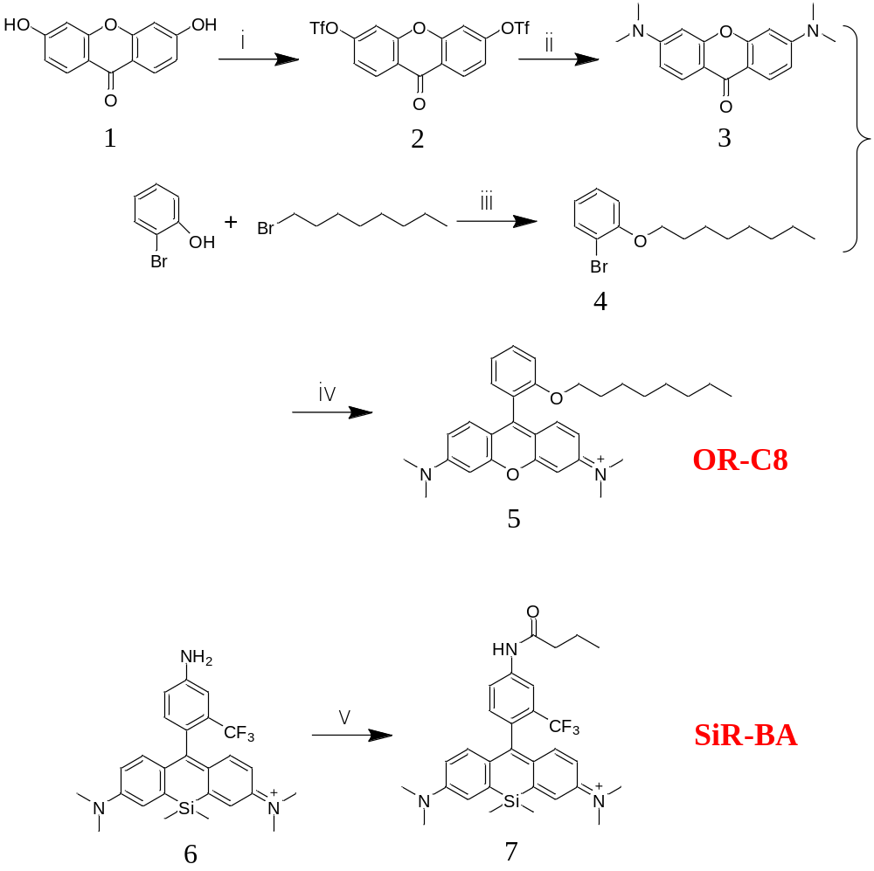
Fig. S1 Synthetic route of OR-C8 and SiR-BA.
Synthesis of 9-Oxo-9H-xanthene-3,6-diyl Bis(trifluoromethanesulfonate) (2). Compound 2 was synthesized following the procedure described in the literature.[1]
Synthesis of 3,6-Bis(dimethylamino)-9H-xanthen-9-one (3). To a solution of 9-Oxo-9H-xanthene-3,6-diyl bis(trifluoromethanesulfonate) (2, 1.00 g, 2.03 mmol) in dry THF in a high-pressure glass tube, tetrakis(triphenylphosphine)palladium (100 mg, 0.142 mmol) was added, and the mixture was cooled to -78 °C. A THF solution of dimethylamine (2M, 15 mL) was then added, and the vessel was sealed. The reaction mixture was stirred overnight at 90 °C and subsequently cooled to room temperature. The solvent was removed via vacuum evaporation, and DCM was added to dissolve the residue. The organic phase was washed twice with saturated brine and dried over anhydrous magnesium sulfate. Following the removal of DCM, the crude product was purified by column chromatography using EA/PE (1:8, v/v) as the eluent, yielding a yellow solid with a 79% yield. ¹H NMR (400 MHz, Chloroform-d) δ 8.20 (d, J = 9.0 Hz, 2H), 6.77 (dd, J = 9.0, 2.3 Hz, 2H), 6.60 (d, J = 2.3 Hz, 2H), 3.12 (s, 12H).
Synthesis of 1-(4-bromo-3-(trifluoromethyl)phenyl)-2,2,5,5-tetramethyl-1,2,5-azadisilolidine (4). To a solution of 2-bromophenol (0.49 g, 28.05 mmol) in DMF (100 mL), 1-bromooctane (16.25 g, 84.14 mmol) and K₂CO₃ (19.38 g, 140.24 mmol) were added. The reaction mixture was stirred overnight at 80 °C and then cooled to room temperature. The solvent was removed under vacuum evaporation, followed by the addition of DCM for dissolution. The organic phase was washed twice with distilled water, and dried over anhydrous magnesium sulfate. After DCM was removed, the crude product was purified by column chromatography with PE/DCM (20:1, v/v) as eluent, and finally, the colorless liquid was obtained with a yield of 95%. ¹H NMR (400 MHz, Chloroform-d) δ 7.38 – 7.33 (m, 2H), 6.77 (d, J = 8.7 Hz, 2H), 3.91 (t, J = 6.6 Hz, 2H), 1.76 (p, J = 6.7 Hz, 2H), 1.43 (q, J = 6.8 Hz, 2H), 1.36 – 1.25 (m, 8H), 0.89 (t, J = 6.7 Hz, 3H).
Synthesis of N-(9-(4-amino-2-(trifluoromethyl)phenyl)-6-(dimethylamino)-3H-xanthen-3-ylidene)-N-methylmethanaminium (5). Compound 4 (1911 mg, 6.73 mmol) was dissolved in a 50 mL pear-shaped reaction flask using 15 mL dry THF. The mixture was cooled to -78 °C and stirred for 30 min under a nitrogen atmosphere. n-Butyllithium (2.4 mL, 3.12 mmol) was added dropwise to the reaction mixture. Compound 3 (119 mg, 0.37 mmol) was dissolved in 10 mL anhydrous THF and added dropwise to the reaction mixture. Then, the mixture was slowly warmed to room temperature and reacted overnight. Following the reaction, 2M hydrochloric acid (5 mL) was added. The THF was removed under reduced pressure. DCM extraction was performed, followed by washing with distilled water, and then dried over anhydrous magnesium sulfate. After DCM was removed, the crude product was purified by column chromatography with methanol/ DCM (1:10, v/v) as eluent, and finally, the red solid was obtained with a yield of 70%. 1H NMR (600 MHz, DMSO-d6) δ 7.65 (t, J = 7.9 Hz, 1H), 7.34 (d, J = 8.3 Hz, 2H), 7.25 – 7.19 (m, 3H), 7.15 (dd, J = 9.5, 1.9 Hz, 2H), 6.98 – 6.94 (m, 2H), 3.96 (t, J = 5.9 Hz, 2H), 3.28 (s, 12H), 1.37 (p, J = 6.3 Hz, 2H), 1.15 (h, J = 7.3 Hz, 2H), 1.01 (p, J = 7.3 Hz, 2H), 0.96 – 0.86 (m, 6H), 0.80 (t, J = 7.3 Hz, 3H). HRMS: m/z calculated for [M]⁺: 471.3012, found: 471.3086.
Synthesis of N-(10-(4-butyramido-2-(trifluoromethyl)phenyl)-7-(dimethylamino)-5,5-dimethyldibenzo[b,e]silin-3(5H)-ylidene)-N-methylmethanaminium (7). To a solution of n-Butyric acid (5 mg, 0.057 mmol) in DCM (3 mL), HATU (25.7 mg, 0.068 mmol) and DIEA (20.2 mg, 0.156 mmol) was added and stirred for 30 min at 0 ℃. Then, N-(10-(4-amino-2-(trifluoromethyl)phenyl)-7-(dimethylamino)-5,5-dimethyldibenzo[b,e]silin-3(5H)-ylidene)-N-methylmethanaminium (6, 24.3 mg, 0.052 mmol) was added to the above solution and kept stirring overnight at room temperature. After DCM was removed, the crude product was purified by column chromatography with methanol/ DCM (1:20, v/v) as eluent, and finally, the blue solid was obtained with a yield of 70%. ¹H NMR (600 MHz, DMSO-d₆) δ 8.30 (s, 1H), 7.98 (d, J = 8.4 Hz, 1H), 7.42 (d, J = 2.5 Hz, 2H), 7.36 (d, J = 8.4 Hz, 1H), 6.87 – 6.80 (m, 4H), 3.31 (s, 12H), 2.38 (t, J = 7.3 Hz, 2H), 1.67 (h, J = 7.3 Hz, 2H), 0.96 (t, J = 7.4 Hz, 3H), 0.64 (s, 3H), 0.50 (s, 3H). HRMS: m/z calculated for [M]⁺: 538.2501, found: 538.2509.

Optical measurement. All spectra were obtained at 37°C in PBS solution or model membrane solution (DMPC/DMPG). Stock solutions of OR-C8 (10 mM) and SiR-BA (10 mM) were prepared in DMSO. Initially, both dyes were individually diluted to 10 μM in PBS, and their respective UV-visible absorption spectra were recorded. Subsequently, a mixed solution of OR-C8 and SiR-BA was prepared in PBS to achieve a final concentration of 10 μM, and the UV absorption and fluorescence spectra under 520 nm laser excitation were measured. Following this, a mixed solution of both dyes was prepared in model membrane solution to achieve a final concentration of 10 μM, and the UV absorption and fluorescence spectra under 520 nm laser excitation were recorded. Finally, OR-C8 was diluted to 10 μM in model membrane solution, and SiR-BA was gradually added in varying proportions. The fluorescence emission spectra were measured under 520 nm laser excitation.

Supporting results
Fig. S2 Cytotoxicity assays of OR-C8 and SiR-BA at different concentrations for HeLa cells. Data represent mean standard error (n = 3).

Fig. S3 ¹H NMR spectrum of 3,6-Bis(dimethylamino)-9H-xanthen-9-one (3) in CD₃Cl₃.

Fig. S4 ¹H NMR spectrum of 1-bromo-2-(octyloxy)benzene (4) in CDCl₃.

Fig. S5 ¹H NMR spectrum of OR-C8 in DMSO.

Fig. S6 ¹H NMR spectrum of SiR-BA in DMSO.
Fig. S7 HRMS spectra of OR-C8.
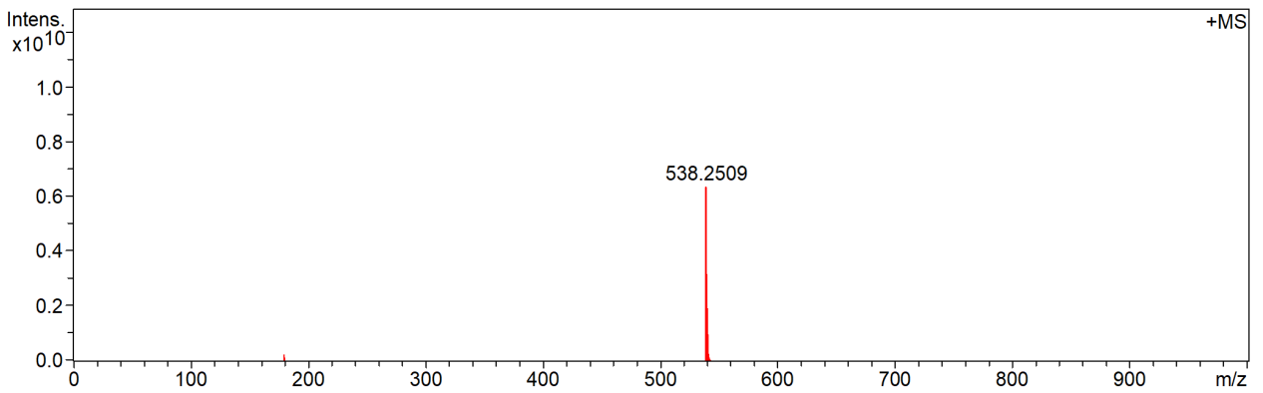
Fig. S8 HRMS spectra of SiR-BA.

Reference
[1] P. Horvath; P. Sebej; T. Solomek; P. Klan, Small-molecule fluorophores with large stokes shifts: 9-iminopyronin analogues as clickable tags, J. Org. Chem. 80 (2015) 1299-1311, https://doi.org/10.1021/jo502213t.

