Supporting Information

Mouse model of uncoupled bone remodeling upon discontinuation of anti-RANKL antibody therapy

Koji Ishikawa^{1,2}, Soji Tani¹, Nobuhiro Sakai³, Yoshifumi Kudo¹, Hideyo Horiuchi⁴, Hiromi Kimura-Suda⁵, Masamichi Takami⁶, Mayumi Tsuji², Katsunori Inagaki¹, Yuji Kiuchi², Takako Negishi-Koga^{1,7,8,9}*

*Corresponding author: Takako Negishi-Koga (T. N-K.)
Department of Pathophysiology for Locomotive Diseases, Juntendo University Graduate School of Medicine, Tokyo, Japan
Address: 2-1-1, Hongo, Bunkyo-ku, 113-8421, Tokyo, Japan
Email: t.negishi.ob@juntendo.ac.jp

Supporting Information includes:
Figure S1 to S8
Table S1 and S2
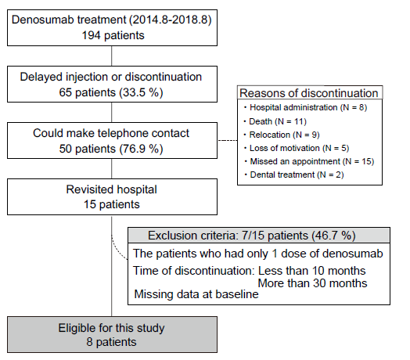
Fig. S1. Flow diagram of eligible patients

We screened 194 patients with postmenopausal osteoporosis who had received multiple anti-RANKL antibody injections from August 2015 to August 2018. After meeting the inclusion criteria, eight patients were enrolled in this study. Age- and sex- matched non-treated patients who had had at least two DXA scans were enrolled as the control group.

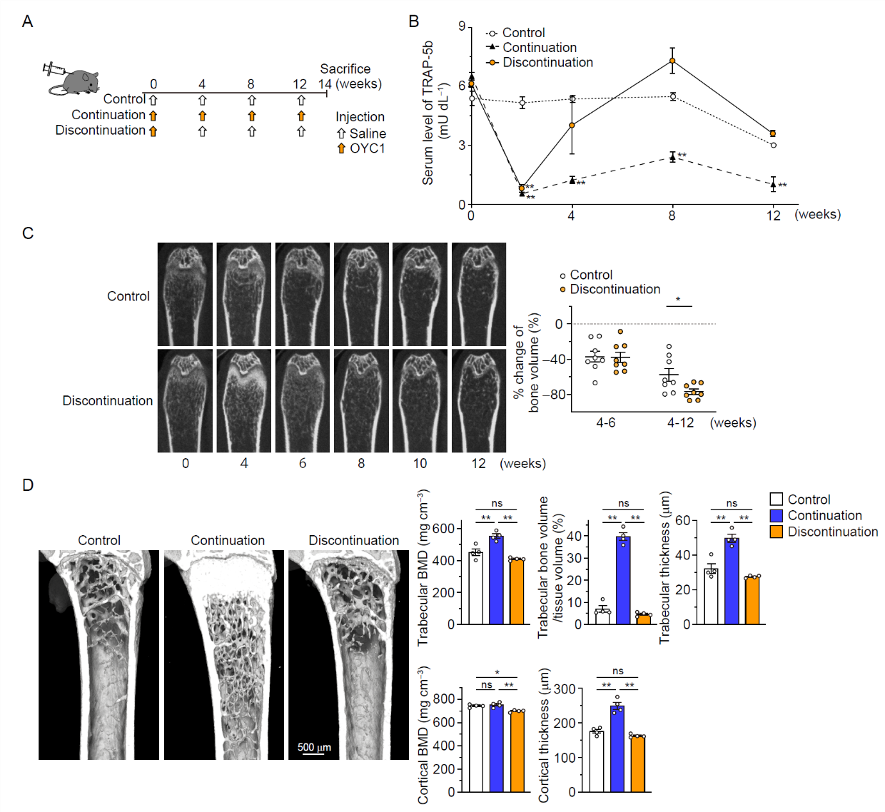
Fig. S2. Alterations in the TRAP level and bone volume in mice treated with a single injection of anti-RANKL antibody
(A) A schematic diagram of the experimental design. (B) Time course of the TRAP-5b serum levels (n = 5). (C) Representative in vivo CT images of the femur in both groups (left), and the percentage change in bone volume between the groups (right) (n = 8). (D) Representative μCT images of the femur metaphysis at 14 weeks (left) and parameters of the distal femur (n = 4). All values are representative of at least three independent experiments and are displayed as the mean ± SEM. *: p < 0.05, **: p < 0.01. Holm-Sidak post hoc test (B, D) and Student’s t-test (C) were performed.
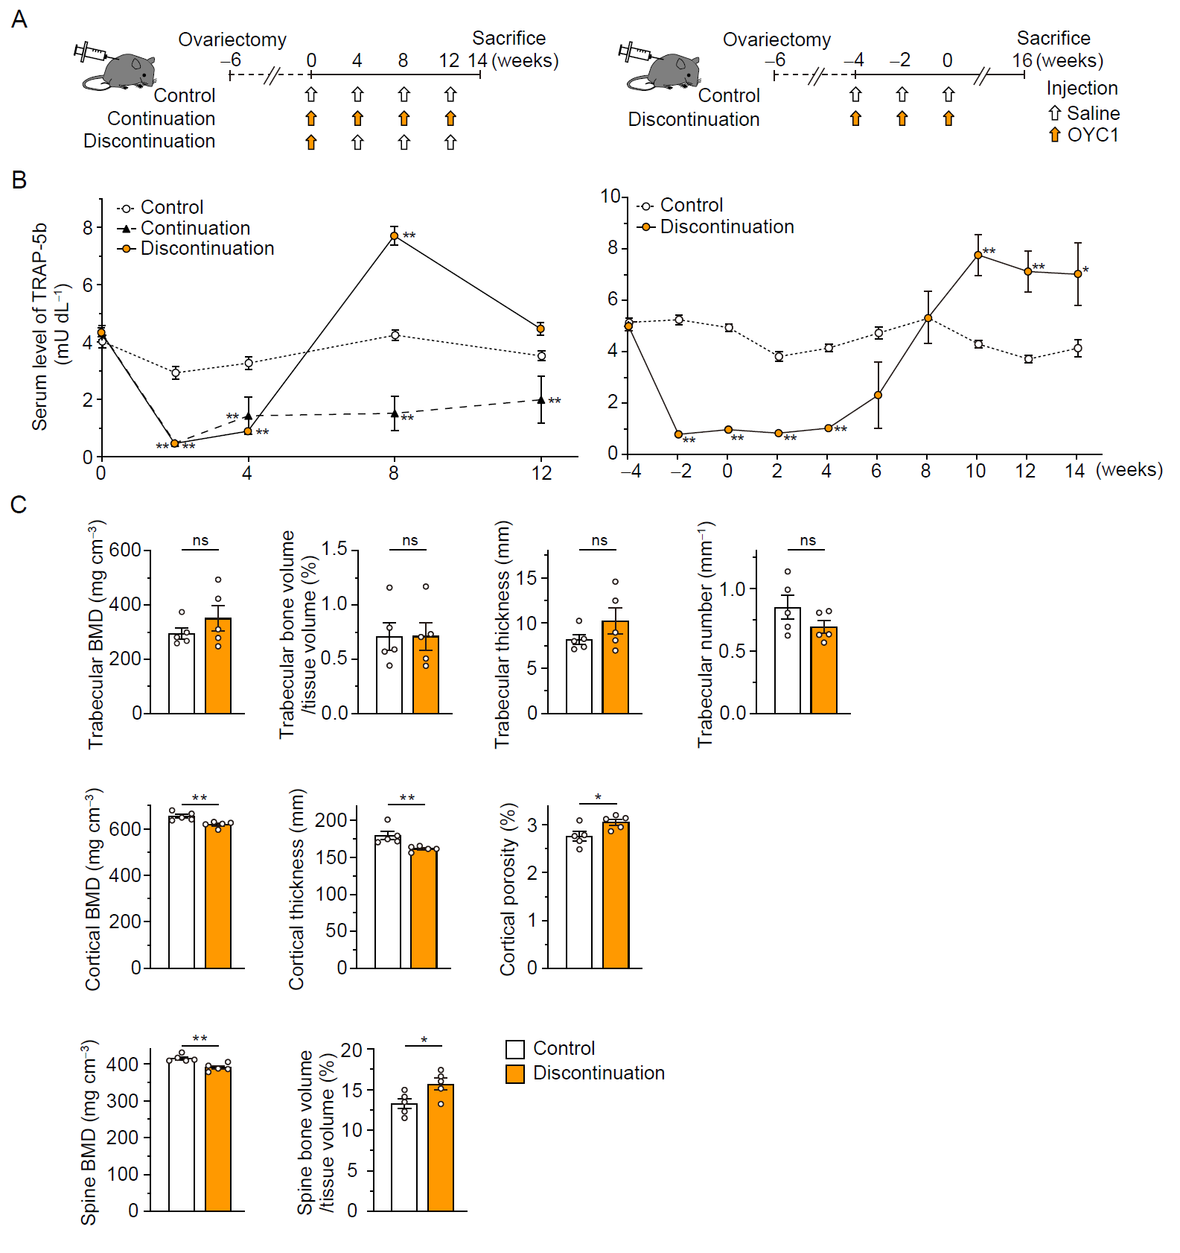
Fig. S3. Bone metabolism in ovariectomized mice after discontinuation of anti-RANKL antibody
(A) A schematic diagram of the experimental design in mice treated with a single injection (left) and multiple injections (right) of the anti-RANKL antibody. (B) Time course of the TRAP-5b serum levels in the case of a single injection (left model: n = 5) and multiple injections (right model: n = 6). (C) μ-CT parameters of the distal femur in ovariectomized mice treated with multiple injections (right model: n = 5). All values are representative of at least three independent experiments and are displayed as the mean ± SEM. *: p < 0.05, **: p < 0.01. Holm-Sidak post hoc test (B) and Student’s t-test (C) were performed.
Fig. S4. Parameters of bone metabolism in mice during TRAP overshoot
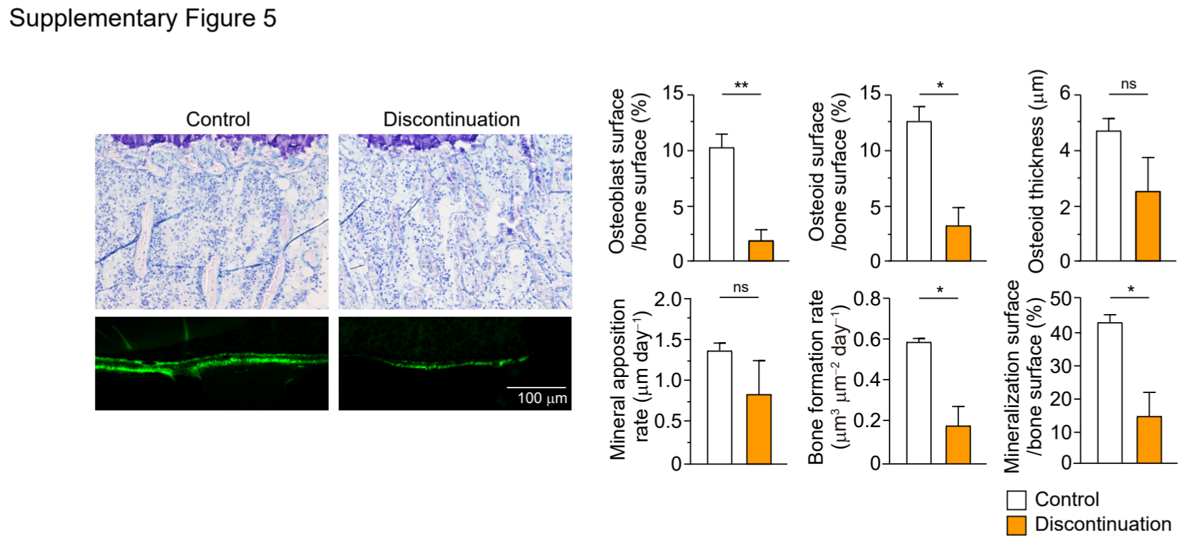Bone morphometric analysis in the proximal tibia at 8 weeks. Representative image of toluidine blue staining (left upper) and bone formation, as observed by calcein double labeling at an interval of 4 d (left lower). Parameters for osteoblastic bone formation (right) (n = 3). All values are representative of at least three independent experiments and are displayed as the mean ± SEM. *: p < 0.05, **: p < 0.01. Student’s t-test was performed.
Fig. S5. Gating strategy to distinguish osteoclast precursor cells (left) and the percentage of B220⁻CD3⁻CD11b^{dull}Ly6C^{high} cells (right).
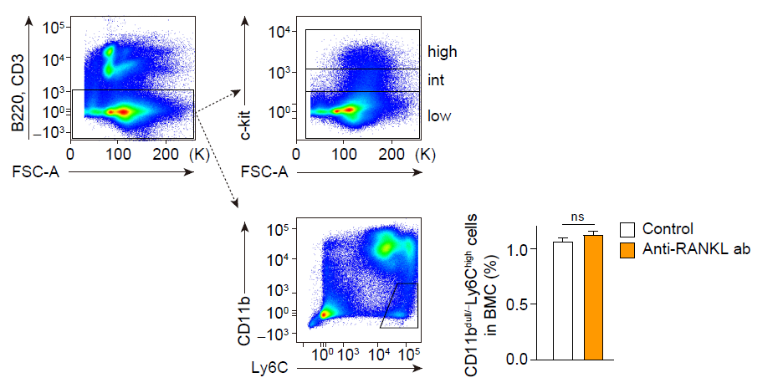All values are representative of at least three independent experiments and are displayed as the mean ± SEM (n = 5). *: p < 0.05, **: p < 0.01. Student’s t-test was performed.

Fig. S6. Effect of RANKL-bearing extracellular vesicles on osteoclastogenesis
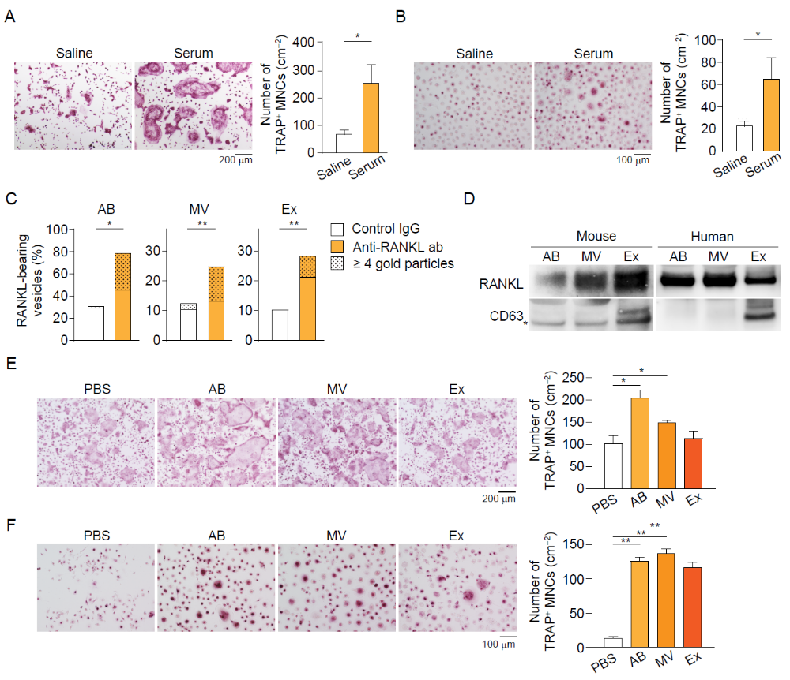 (A) Representative images of osteoclast differentiation of BMCs cultured with serum (left). Number of TRAP⁺ MNCs (right) (n = 6). (B) Representative images of osteoclast differentiation of PBMCs cultured with serum (left). Number of TRAP⁺ MNCs (right) (n = 6). (C) Ratio of RANKL-bearing vesicles in the EVs. (D) RANKL expression in EVs isolated from mice and human serum. *: non-specific. (E) Representative images of osteoclast differentiation of BMMs cultured with the EVs isolated from normal mouse serum (left). Number of TRAP⁺ MNCs (right) (n = 4). (F) Representative images of osteoclast differentiation of PBMCs cultured with the EVs isolated from non-treated patients (left). Number of TRAP⁺ MNCs (right) (n = 4). All values are representative of at least three independent experiments and are displayed as the mean ± SEM. *: p < 0.05, **: p < 0.01. Student’s t-test (A and B), χ² test (C) and Dunnett’s test (E and F) were performed.
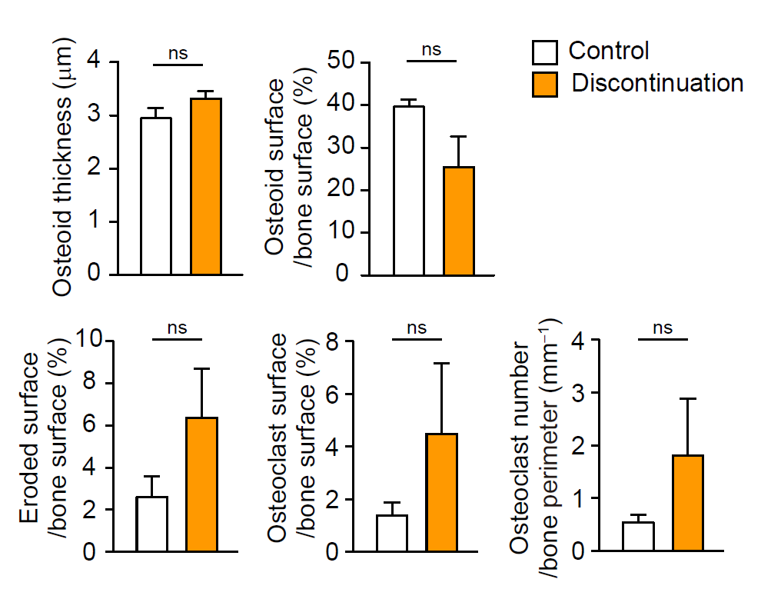
Fig. S7. Bone morphometric parameters of bone metabolism in mice long after discontinuation of the anti-RANKL antibody
Bone morphometric analysis in the proximal tibia at 16 weeks (n = 4). All values are representative of at least three independent experiments and are displayed as the mean ± SEM. *: p < 0.05, **: p < 0.01. Student’s t-test was performed.

Fig. S8. Suppression of osteoblast lineage cells after discontinuation
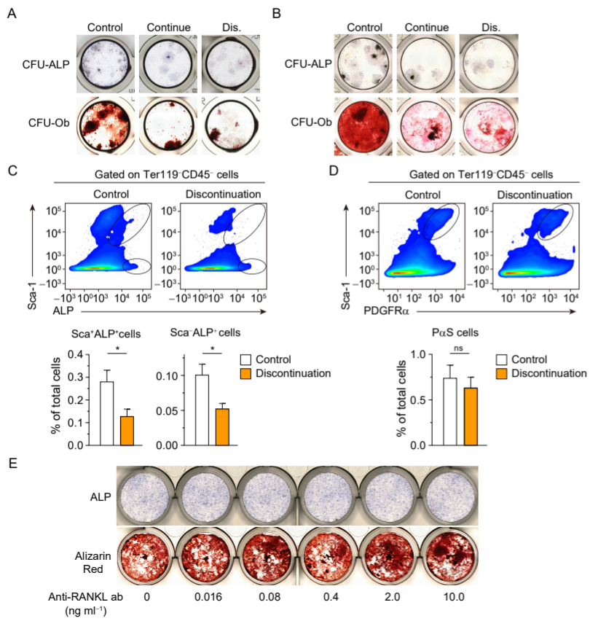
(A) Generation of CFU-ALP and CFU-Ob in the bone marrow cells. Representative images of the single injection experiment in male mice obtained at 14 weeks. (B) Generation of CFU-ALP and CFU-Ob in the bone marrow cells. Representative images of the single injection experiment in OVX mice obtained at 14 weeks. (C and D) Flow cytometric analysis of the multiple injections experiment in OVX mice performed at 16 weeks. Osteoblastic precursors characterized by the cell surface markers Ter119⁻CD45⁻ALP⁺Sca-1⁺ cells, Ter119⁻CD45⁻ALP⁺Sca1⁻ cells (upper left) and Ter119⁻CD45⁻Sca-1⁺PDGFRα⁺ (upper right). The percentage of osteoblastic precursors (n = 4). (E) Osteoblast differentiation and bone nodule formation in calvarial cell-derived osteoblasts. All values are representative of at least three independent experiments and are displayed as the mean ± SEM. *: p < 0.05, **: p < 0.01. Student’s t-test was performed.
Table. S1. Comparison of baseline patient characteristics with anti-RANKL treatment discontinuation and age- matched control.
Parameters | Control | Discontinuation | p
Age (years) | 74.1±6.2 | 79.9±5.4 | n.s.
Serum Ca (mg/dL) | 9.3±0.3 | 9.3±0.3 | n.s.
Serum P (mg/dL) | 3.5±0.2 | 3.7±0.2 | n.s.
Serum Alb (g/dL) | 4.4±0.5 | 4.1±0.3 | n.s.
eGFR (mL/min/1.73 m²) | 60.5±12.2 | 55.3±25.2 | n.s.
Serum intact-PTH (pg/mL) | 34.9±10.0 | 42.0±17.5 | n.s.
Lumber spine-BMD (g/cm²) | 0.76±0.04 | 0.85±0.14 | n.s.
Femoral neck-BMD (g/cm²) | 0.60±0.05 | 0.54±0.13 | n.s.

Comparison of the clinical parameters (n = 8). The data shown as n (%) were analyzed by χ² test. The data expressed as the mean ± SD were analyzed with Student’s t-test. N.s.: not significant, *: p < 0.05, **: p < 0.01. Ca: calcium, p: phosphorus, Alb: albumin, eGFR: estimated glomerular filtration rate, intact-PTH: intact-parathyroid hormone, BMD: bone mineral density

 | Control | Discontinuation | p
Eotaxin | 1912.1 ± 243.0 | 2308.2 ± 516.2 | n.s.
G-CSF | 73.2 ± 16.8 | 98.2 ± 18.3 | < 0.01
INF-γ | 31.5 ± 9.9 | 37.3 ± 11.9 | n.s.
IL-1α | 15.5 ± 2.9 | 15.9 ± 1.7 | n.s.
IL-1β | 11.6 ± 7.4 | 17.1 ± 6.9 | n.s.
IL-3 | 4.2 ± 2.0 | 6.6 ± 4.6 | n.s.
IL-4 | 2.0 ± 1.3 | 2.3 ± 1.2 | n.s.
IL-5 | 10.3 ± 4.6 | 13.5 ± 5.7 | n.s.
IL-6 | 2.2 ± 2.2 | 6.2 ± 3.9 | < 0.05
IL-9 | 15.5 ± 2.7 | 19.1 ± 9.8 | n.s.
IL-10 | 37.1 ± 14.5 | 50.2 ± 16.2 | n.s.
IL-12(p40) | 360.0 ± 58.9 | 305.0 ± 107.2 | n.s.
IL-12(p70) | 233.4 ± 68.0 | 229.7 ± 35.5 | n.s.
IL-17A | 92.7 ± 62.9 | 103.8 ± 41.1 | n.s.
KC | 52.8 ± 10.5 | 78.4 ± 35.6 | n.s.
MCP-1 | 147.0 ± 35.9 | 182.3 ± 36.5 | n.s.
MIP-1α | 4.2 ± 1.4 | 3.6 ± 0.6 | n.s.
MIP-1β | 50.9 ± 14.5 | 57.5 ± 13.7 | n.s.
RANTES | 65.4 ± 15.5 | 55.2 ± 16.4 | n.s.
TNF-α | 106.0 ± 40.7 | 145.9 ± 66.6 | n.s.
Table. S2. Production of inflammatory cytokines in mouse serum during the overshoot period (n = 9).

The data expressed as the mean ± SD (pg ml⁻¹) were analyzed with the Student t-test. n.s.: not significant

