Table of Contents: Supplementary Information

Supplementary Tables

Supplementary Table 1: Supplementary Table 1: Descriptive statistics for the key variables in the GxE GWAS analysis of Low Density Lipoprotien Cholesterol (LDL), High Density Lipoprotien (HDL) and Triglycerides (TG)………………………………………………………………Excel Spreadsheet 1 (E1)
Supplementary Table 2: Statin codes for the UK Biobank self-reported medication use……..…E2
Supplementary Table 3: SNP-based heritability and genetic correlations for Statin use and No Statin use for LDL Cholesterol, HDL Cholesterol, and Triglycerides………………………………………..E3
Supplementary Table 4: LDL Cholesterol summary statistics of genome-wide significant loci for the interaction coefficient, the marginal genetic effect for non-statin users, and the marginal genetic effect for statin users………………………………………………………………………………..E4
Supplementary Table 5: HDL Cholesterol summary statistics of genome-wide significant loci for the interaction coefficient, the marginal genetic effect for non-statin users, and the marginal genetic effect for statin users………………………………………………………………………………..E5
Supplementary Table 6: Triglycerides summary statistics of genome-wide significant loci for the interaction coefficient, the marginal genetic effect for non-statin users, and the marginal genetic effect for statin users ………………………………………………………………………………………..…….E6
Supplementary Table 7: Gene-Targets for the 6 individual statins used to define the statins moderator………………………………………………………………………………………………………………………..…E7

Supplementary Figures

Supplementary Figure 1: Manhattan and QQ Plots for LDL-c for the marginal genetic effect in non-statin users, statin users and the interaction coefficient 2
Supplementary Figure 2: Manhattan and QQ Plots for HDL-c for the marginal genetic effect in non-statin users, statin users and the interaction coefficient 3
Supplementary Figure 3: Manhattan and QQ Plots for TG for the marginal genetic effect in non-statin users, statin users and the interaction coefficient 4
Supplementary Figure 4: Regional Plots of the Difference in the marginal genetic effects on LDL Cholesterol depending on statin use, and -log₁₀ p-values of the corresponding SNP-Statin interactions for APOB 5
Supplementary Figure 5: Regional Plots of the Difference in the marginal genetic effects on LDL Cholesterol depending on statin use, and -log₁₀ p-values of the corresponding SNP-Statin interactions for FADS2 6
Supplementary Figure 9: Regional Plots of the Difference in the marginal genetic effects on HDL Cholesterol depending on statin use, and -log₁₀ p-values of the corresponding SNP-Statin interactions for CETP 10
Supplementary Figure 10: Regional Plots of the Difference in the marginal genetic effects on HDL Cholesterol depending on statin use, and -log₁₀ p-values of the corresponding SNP-Statin interactions for APOE 11
Supplementary Figure 11: Regional Plots of the Difference in the marginal genetic effects on Triglycerides depending on statin use, and -log₁₀ p-values of the corresponding SNP-Statin interactions for LPA 12
Supplementary Figure 12: Regional Plots of the Difference in the marginal genetic effects on Triglycerides depending on statin use, and -log₁₀ p-values of the corresponding SNP-Statin interactions for TMEM258 13
Supplementary Figure 13: Regional Plots of the Difference in the marginal genetic effects on Triglycerides depending on statin use, and -log₁₀ p-values of the corresponding SNP-Statin interactions for APOA4. 14
Supplementary Figure 14: Regional Plots of the Difference in the marginal genetic effects on Triglycerides depending on statin use, and -log₁₀ p-values of the corresponding SNP-Statin interactions for APOE 15

Supplementary Information

Supplementary Information 15: Simulation study to probe for biases in the parameter estimates of the GxE GWAS results. 16

Supplementary Figure 1: Manhattan and QQ Plots for LDL-c for the marginal genetic effect in non-statin users, statin users and the interaction coefficient

Marginal Genetic Effect  for Non-Statin Users | 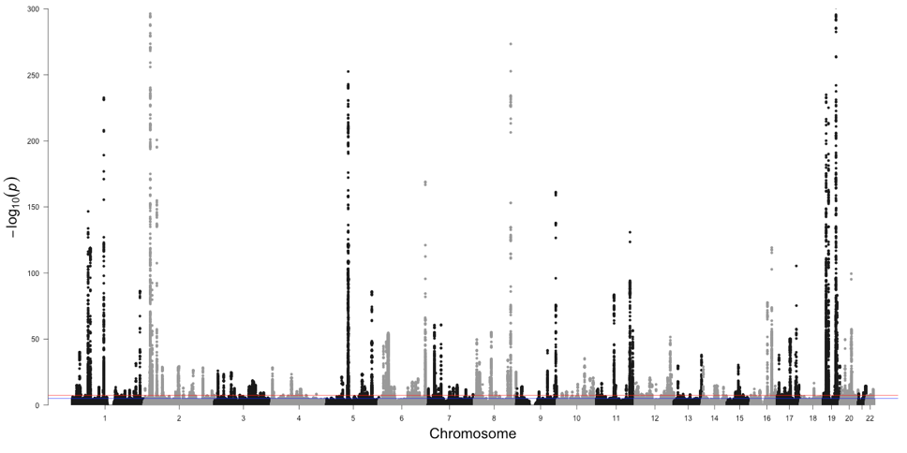 | 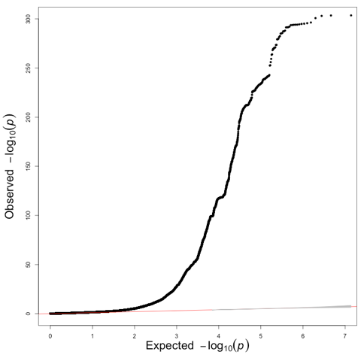
Marginal Genetic Effect  for Statin Users | 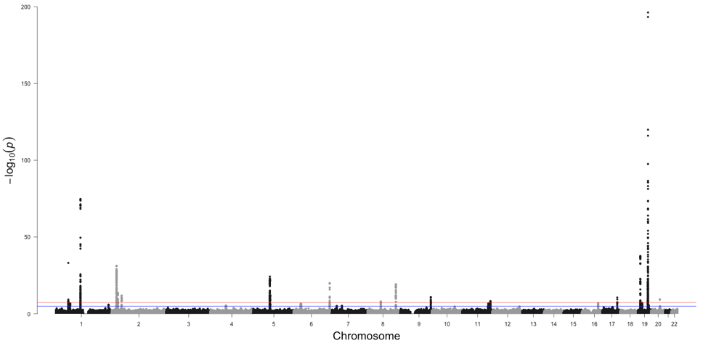 | 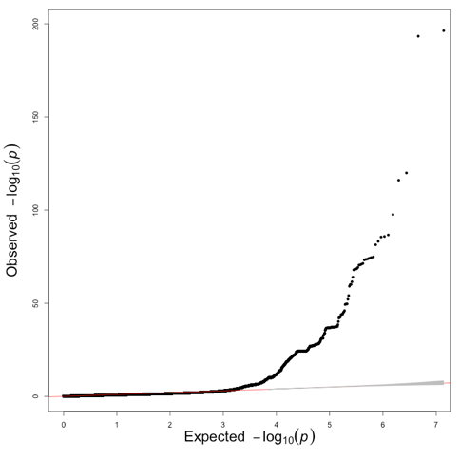
Interaction Coefficient | 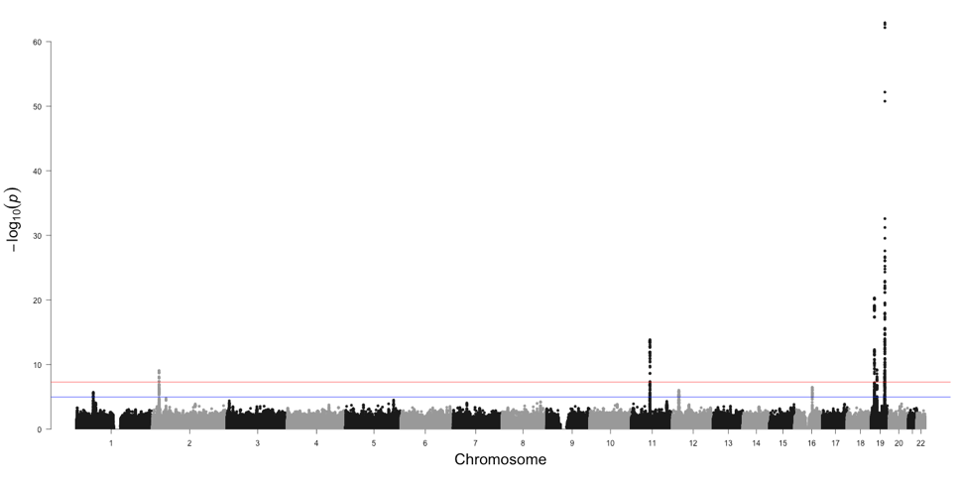 | 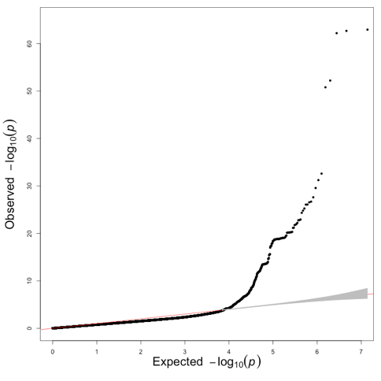

Supplementary Figure 2: Manhattan and QQ Plots for HDL-c for the marginal genetic effect in non-statin users, statin users and the interaction coefficient

Marginal Genetic Effect  for Non-Statin Users | 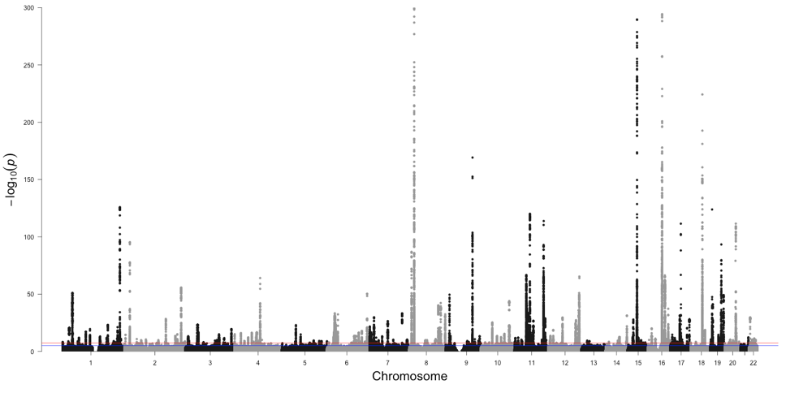 | 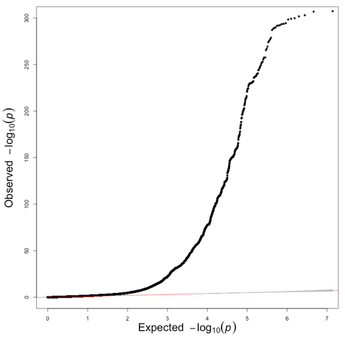
Marginal Genetic Effect  for Statin Users | 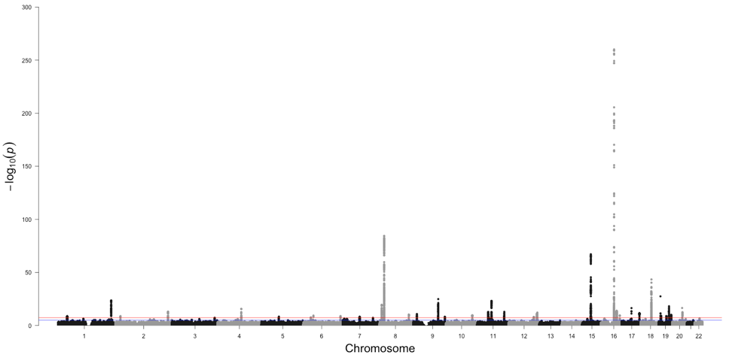 | 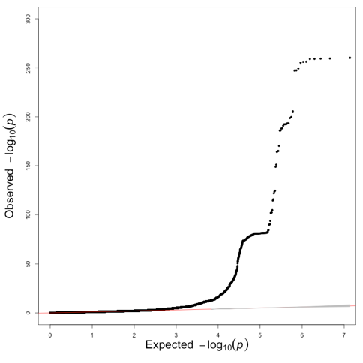
Interaction Coefficient | 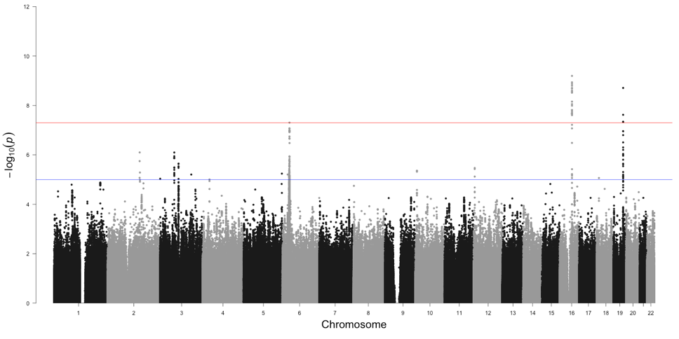 | 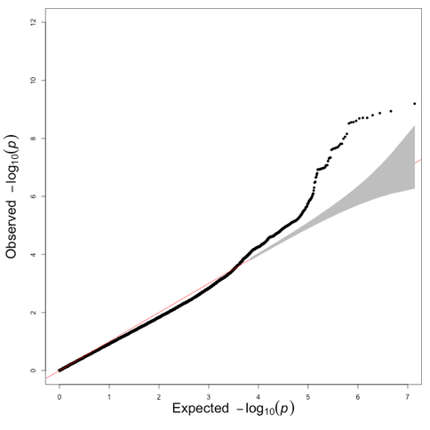

Supplementary Figure 3: Manhattan and QQ Plots for TG for the marginal genetic effect in non-statin users, statin users and the interaction coefficient

Marginal Genetic Effect  for Non-Statin Users | 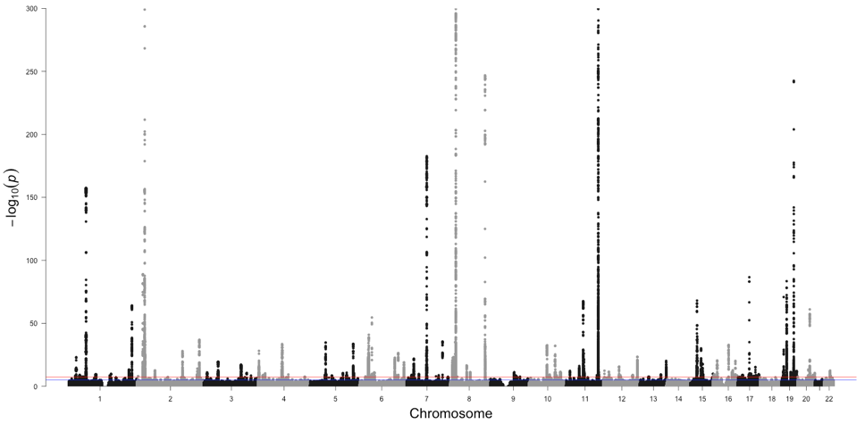 | 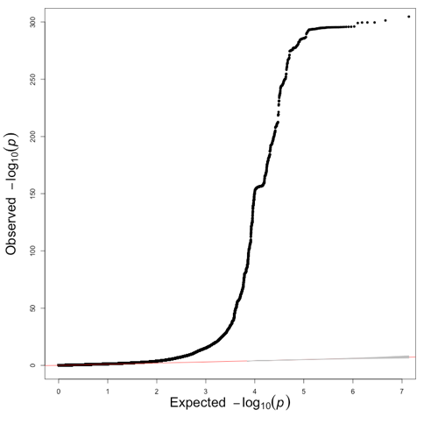
Marginal Genetic Effect  for Statin Users | 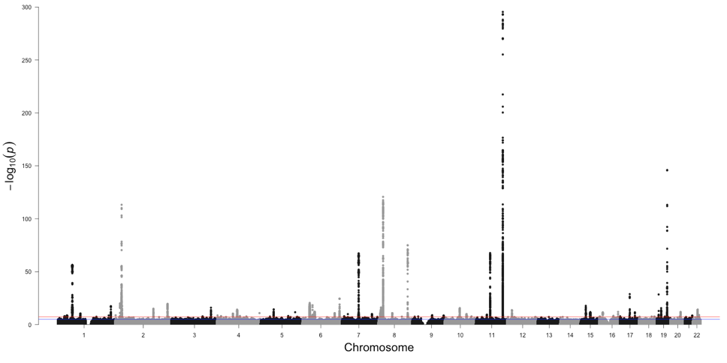 | 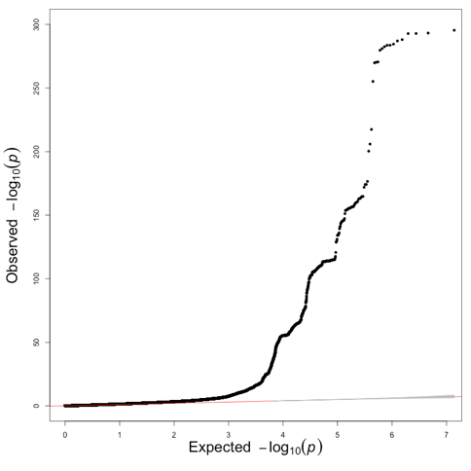
Interaction Coefficient | 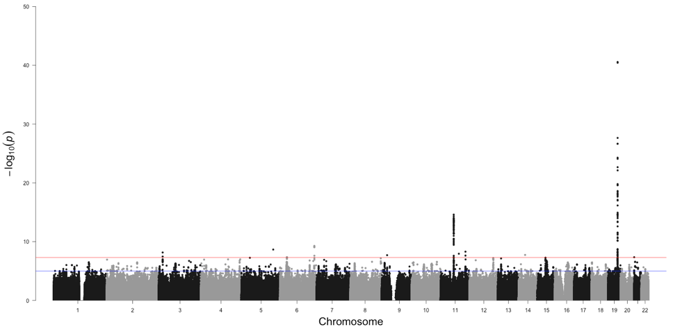 | 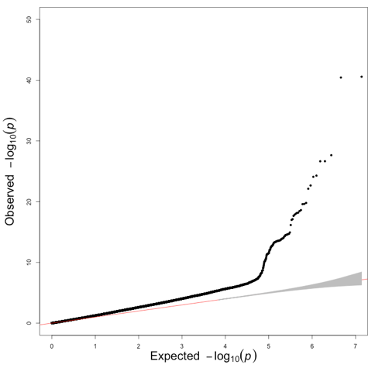

Supplementary Figure 4: Regional Plots of the Difference in the marginal genetic effects on LDL Cholesterol depending on statin use, and -log₁₀ p-values of the corresponding SNP-Statin interactions for APOB

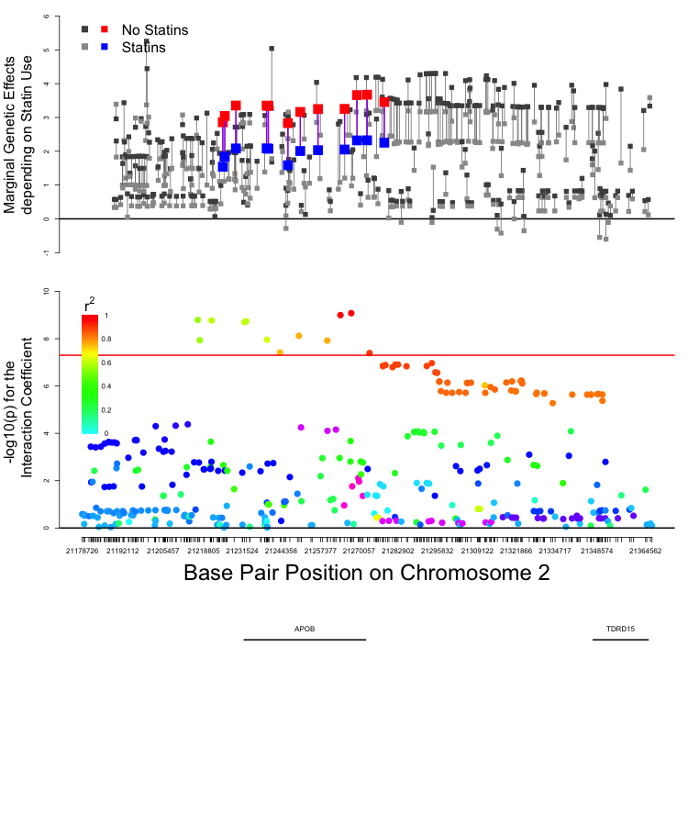

Supplementary Figure 5: Regional Plots of the Difference in the marginal genetic effects on LDL Cholesterol depending on statin use, and -log₁₀ p-values of the corresponding SNP-Statin interactions for FADS2

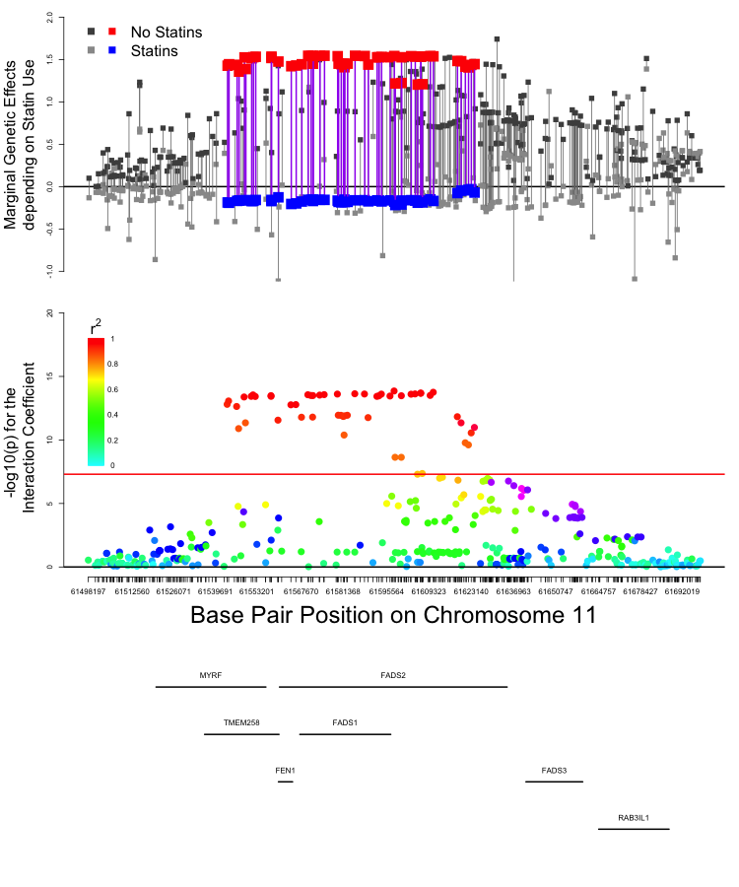
Supplementary Figure 6: Regional Plots of the Difference in the marginal genetic effects on LDL Cholesterol depending on statin use, and -log₁₀ p-values of the corresponding SNP-Statin interactions for LDLR

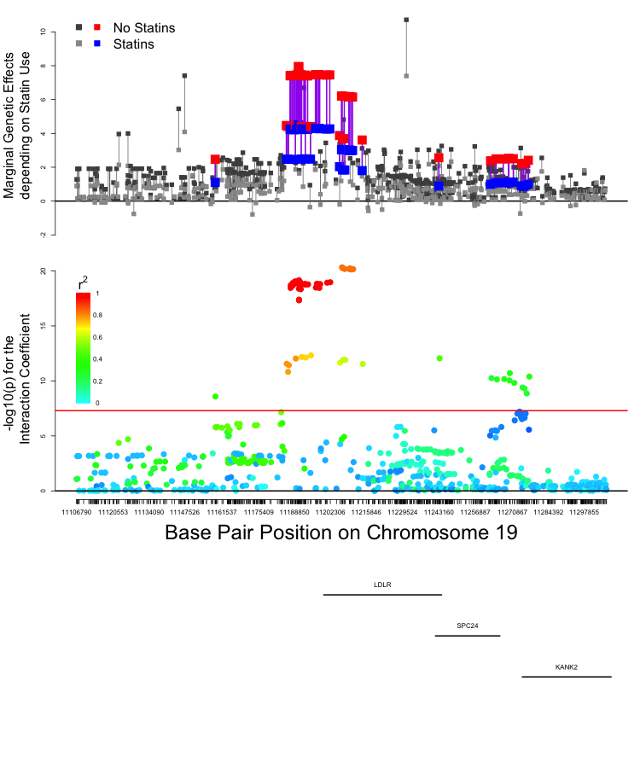
Supplementary Figure 7: Regional Plots of the Difference in the marginal genetic effects on LDL Cholesterol depending on statin use, and -log₁₀ p-values of the corresponding SNP-Statin interactions for SUGP1

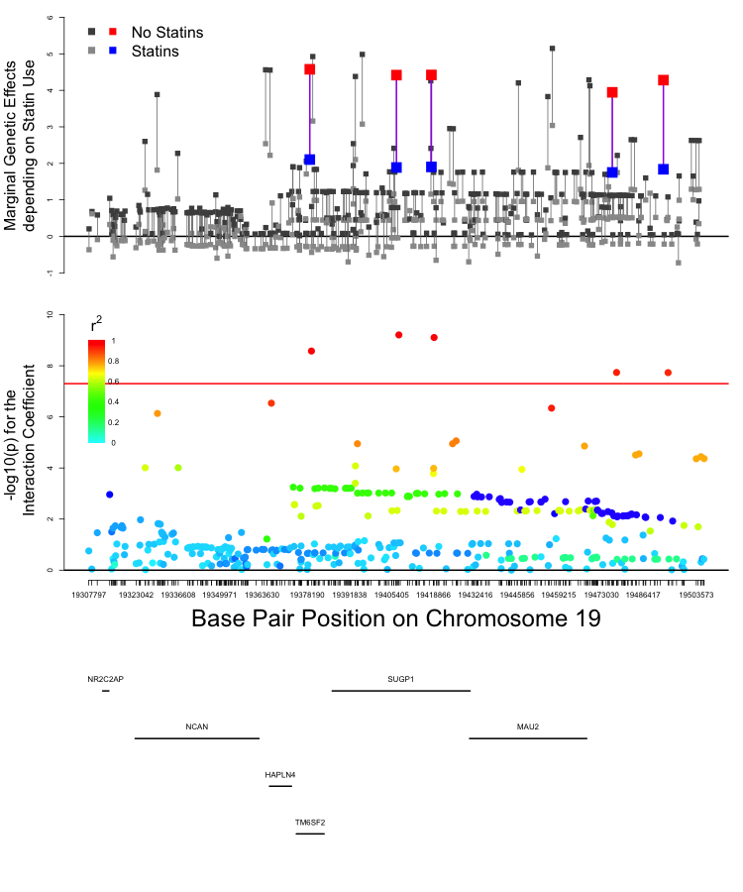
Supplementary Figure 8: Regional Plots of the Difference in the marginal genetic effects on LDL Cholesterol depending on statin use, and -log₁₀ p-values of the corresponding SNP-Statin interactions for APOE

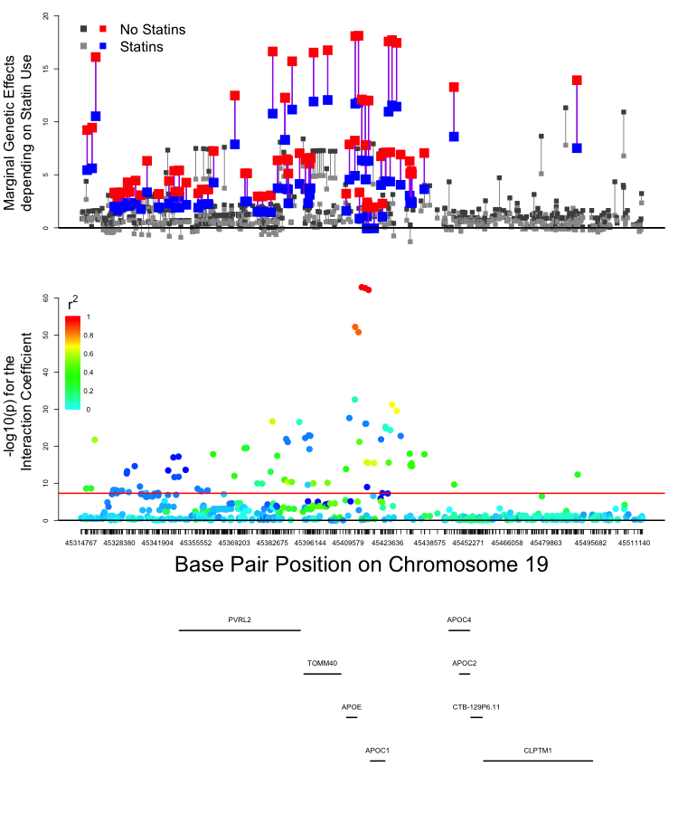

Supplementary Figure 9: Regional Plots of the Difference in the marginal genetic effects on HDL Cholesterol depending on statin use, and -log₁₀ p-values of the corresponding SNP-Statin interactions for CETP

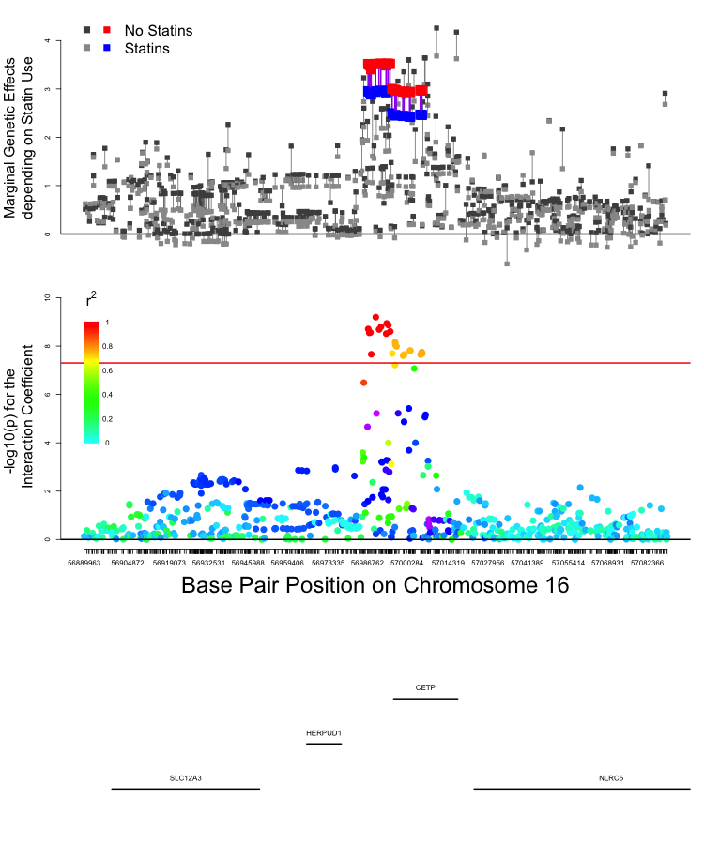

Supplementary Figure 10: Regional Plots of the Difference in the marginal genetic effects on HDL Cholesterol depending on statin use, and -log₁₀ p-values of the corresponding SNP-Statin interactions for APOE

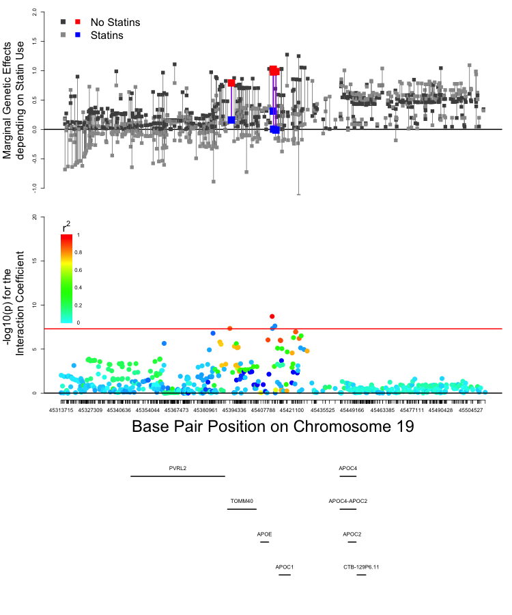

Supplementary Figure 11: Regional Plots of the Difference in the marginal genetic effects on Triglycerides depending on statin use, and -log₁₀ p-values of the corresponding SNP-Statin interactions for LPA

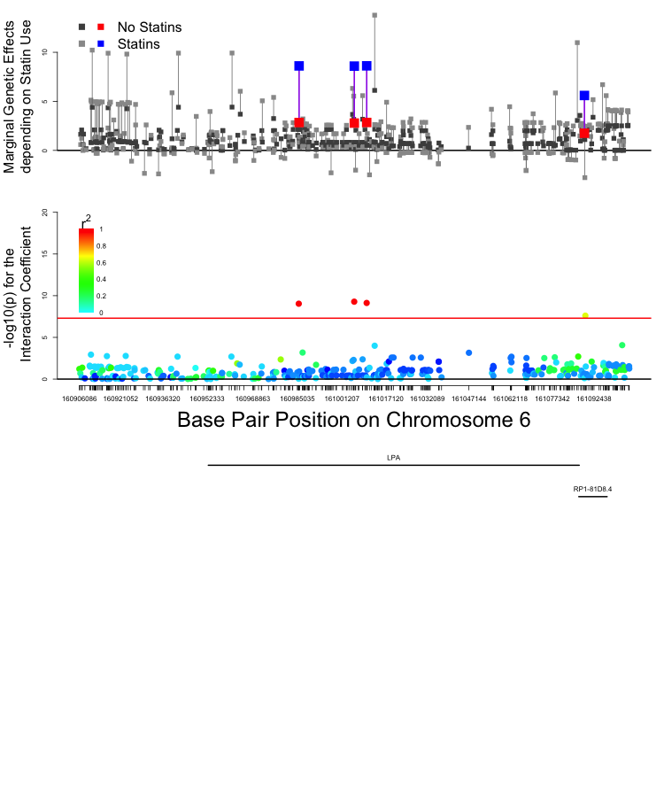

Supplementary Figure 12: Regional Plots of the Difference in the marginal genetic effects on Triglycerides depending on statin use, and -log₁₀ p-values of the corresponding SNP-Statin interactions for TMEM258

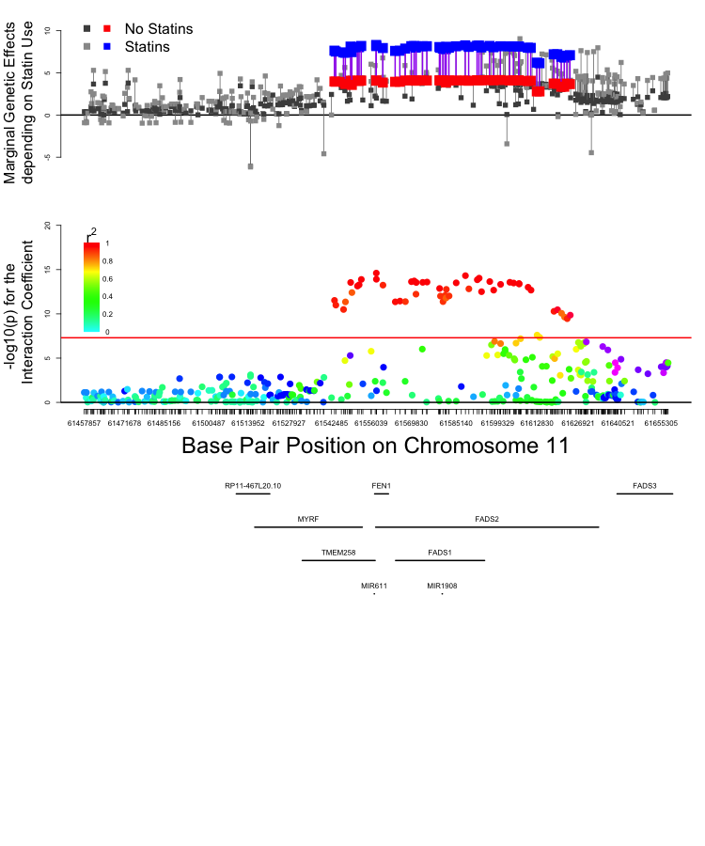

Supplementary Figure 13: Regional Plots of the Difference in the marginal genetic effects on Triglycerides depending on statin use, and -log₁₀ p-values of the corresponding SNP-Statin interactions for APOA4.

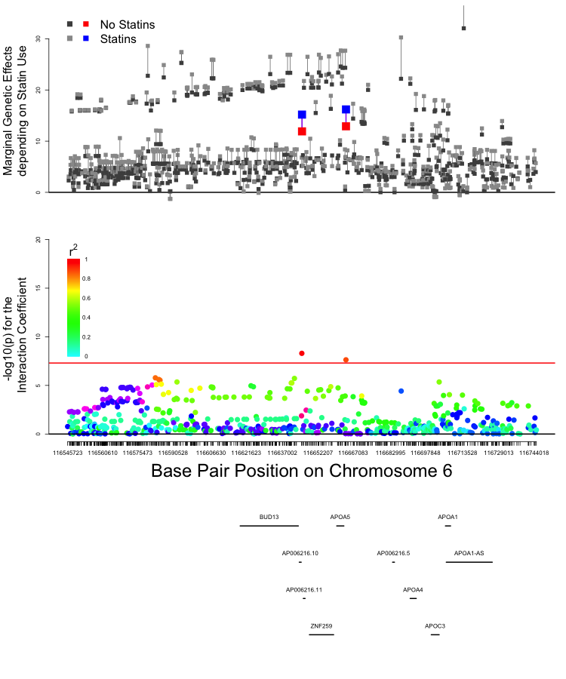

Supplementary Figure 14: Regional Plots of the Difference in the marginal genetic effects on Triglycerides depending on statin use, and -log₁₀ p-values of the corresponding SNP-Statin interactions for APOE

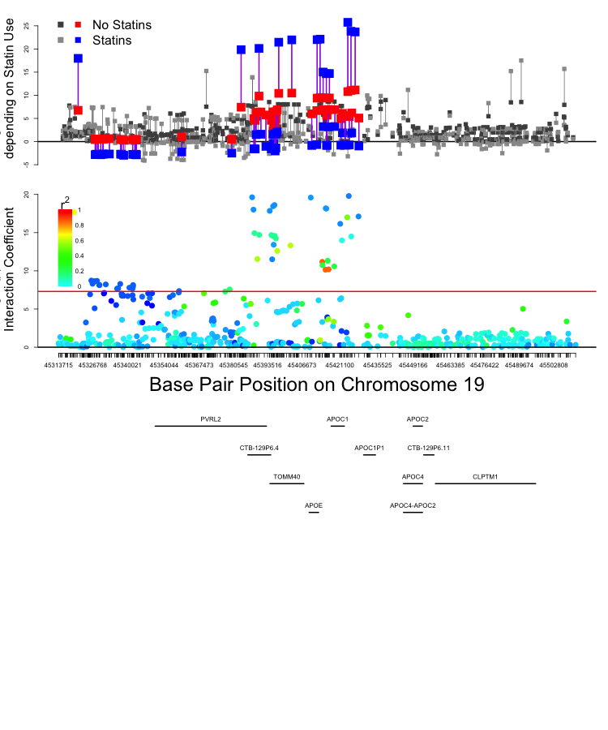

Supplementary Information 15: Simulation study to probe for biases in the parameter estimates of the GxE GWAS results.

In a traditional pharmaceutical trial, participants are recruited from a pool of individuals with a defined condition the target drug is intended to treat. The individuals are then randomly assigned to either a placebo (control) or a drug condition. In such cases, random assignment makes it equally likely that a participant will receive the placebo or the treatment, and that any confounding factors (observed or unobserved) will be evenly distributed between the groups. While we cannot be certain that the placebo and drug groups are identical, in repeated testing there should be no inherent bias in the resulting statistics. In a specific sample, simple follow-up comparisons of general demographic characteristics or pre-test severity assessments should provide additional confidence in the randomization. This procedure can be easily extended to pharmacogenomic studies by genotyping the participants prior to random assignment, treating genotypes as a quasi-experimental factor. In such situations, gene-drug interaction analyses can be conducted in a straightforward manner. In population-based cross-sectional studies, however, random assignment is not possible. People only take medications when they are affected by the disorder, and if a trait has a genetic component, people with risk alleles at particular loci will be overrepresented in the cases violating any semblance of random assignment. Accordingly, ascertainment biases could affect the critical estimates of the parameters.

To probe for biases in the parameter estimates of the GxE GWAS results, we conducted a simulation study where we generated phenotypic, genetic, and drug data that corresponded with the cross-sectional data we analyzed in the main paper. To begin, we simulated a normally distributed variable with a mean of 135 and a standard deviation of 34 in 500,000 observations. These values correspond with the observed levels of LDL-c in our data.

We then simulated a single genomic variant (SNP) from a binomial distribution with a minor allele frequency of 0.2 for each observation. We assume the SNP increases the likelihood of the disease by 5 units, corresponding with a small effect size (d = 0.15). While it may seem simplistic to focus on a single SNP in a polygenic disease, the variation in the phenotype is a suitable proxy for other variants that are not in LD with the simulated SNP. When we conduct a linear regression of LDL-c on the SNP, we recover the simulated values for the SNP (b_{snp} = 5.00) and the mean (intercept = 134.99).

From here, we simulate the statin effect. To mirror typical drug trials, we first “randomly assign” all individuals in the sample to a statin or a non-statin condition by generating a binomial variable with a probability of being in the statin group of 0.5. As people are only prescribed statins if they have high LDL-c, we define the “treatment group” as individuals who have an LDL-c value of over 160 and have been “randomly assigned” to the statin group. Accordingly, approximately 75% of the sample does not meet the criteria for treatment, 12.5% of the sample meets the criteria for treatment but is not prescribed a statin, and the remaining 12.5% of the sample meets criteria for the treatment and receives a statin. We assume that statins strongly reduce LDL-c by 60 points.

Now, if we do not include the statin in the analysis, when we look at the regression of LDL-c on the SNP, the SNP effect is underestimated (b_{snp} = 3.59) because some of the people with the risk alleles are taking statins, altering the genetic association. If we look at the people who would not have been randomly assigned a statin, the SNP effect is almost perfectly recovered (b_{snp} = 5.01). However, if we look at the people who would have been assigned a statin (but were only actually assigned one if they had high cholesterol), the SNP effect is muted (b_{snp} = 2.16). Importantly, we must look at the observations who were randomly assigned to the “no statin” condition and not those who were not prescribed a statin, as the genetic effect on LDL-c will disproportionately push some people who would otherwise be slightly under the “high cholesterol” threshold above it, making them treatment eligible, and thus biasing the genetic association. As such, the SNP effect in the total sample is a mixture of the two randomly assigned groups (in this case it is an even mixture as half the people were assigned to the no treatment or statin groups).

When we then add the statin treatment effect into the analysis of the total sample, we underestimate the SNP effect (b_{snp} 3.83), and massively underestimating the magnitude of the statin effect (b_{statin} = -10.58). Again, when we look only at the people who were randomly assigned to the “no statin” condition, the SNP effect is still estimated correctly (b_{snp} = 5.01). In this group, there is no statin effect because no one would have been assigned a statin (i.e. there is no variation in statin use). However, when we look in the high LDL-c group, the statin effect is estimated accurately (b_{statin} = -59.89). When we look at both the SNP and statin effects in the people who had high cholesterol, the statin effect is again estimated accurately, but the snp effect is vastly underestimated, as people with the risk alleles are more likely to have high cholesterol, and thus take statins.

At this point, we can add the SNP by statin interaction to the simulation. Specifically, we simulate a situation where each additional allele a person has for the target SNP, the statin further reduces LDL-c by an additional 10-points. Now, when we only regress the SNP and statins on LDL-c (i.e. without adding the interaction), both are strongly underestimated (b_{snp} = 2.45, b_{statin} = -15.09). After adding the interaction term to the regression, the conditional SNP effect is slightly underestimated (b_{snp} = 4.25), the statin effect is severely underestimated (b_{statin} = -9.23), and the interaction is slightly overestimated (-12.99). However, when we look just in the high cholesterol group, the SNP effect is highly underestimated (b_{snp} = 1.27), but both the statin effect (b_{statin} = -59.89) and the interaction effect (b_{snp*statin} = -10.01) are almost perfectly estimated. Notably, the SNP effect is underestimated because the individuals with the genetic risk for high ldl-c are more likely to be included in the treatment group, thus reducing the genetic effect.

In psychology, this method is often called simple main effects. This is analogous to the marginal genetic effect process that we, but is limited to categorical independent variables, while the marginal genetic effect method generalizes to continuous independent variables.

