Supplementary Figures
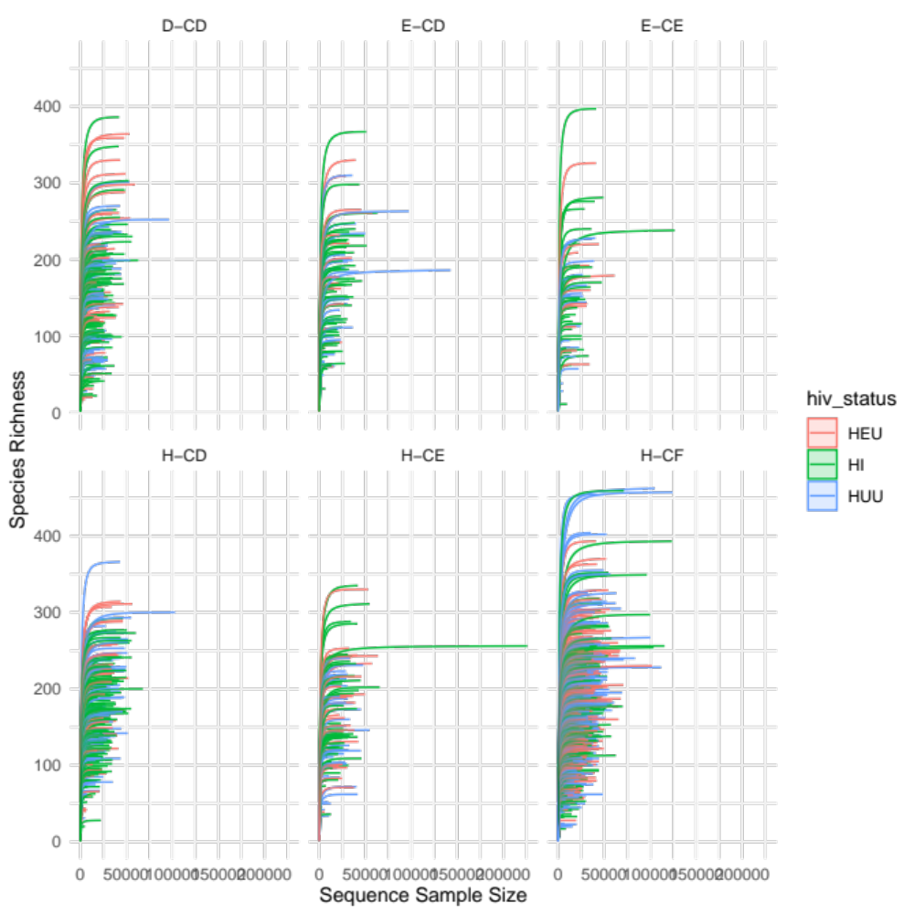

Figure S1: Rarefaction analysis of all samples. Samples are split by oral health group. Line colors indicate HIV health group of individual.

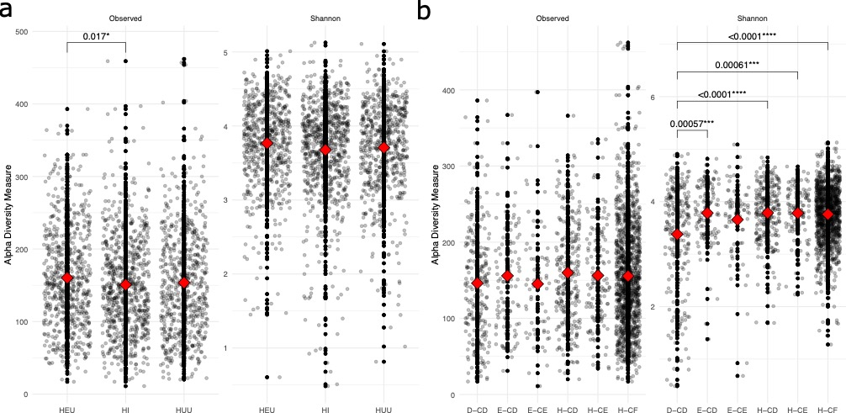
Figure S2: Alpha diversity. Shannon diversity and the number of observed ASV by (a) HIV status group and (b) individual tooth health category.

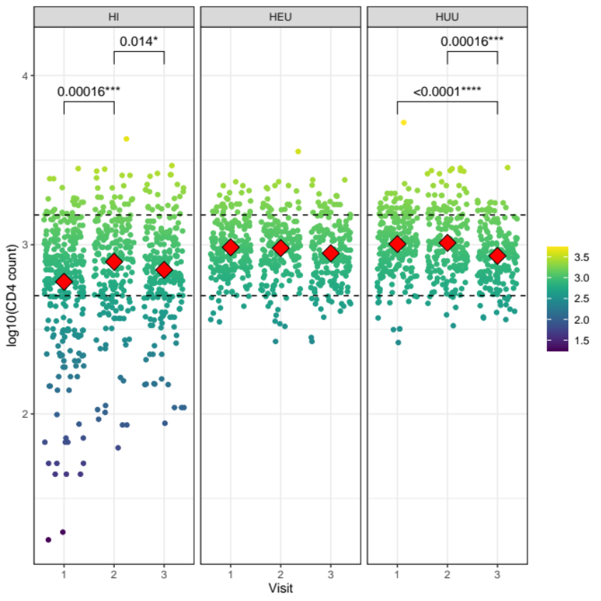
Supplementary Figure 3: CD4 counts fluctuate over time in HI and HUU children but not in HEU children. Jitter plot of individual CD4 counts (by plaque sample) over each sampling visit for each of the three HIV status groups. Dotted lines represent the typical range of CD4 counts in healthy individuals (500 to 1500 cells/mm³). Red diamond represents median value for each group.

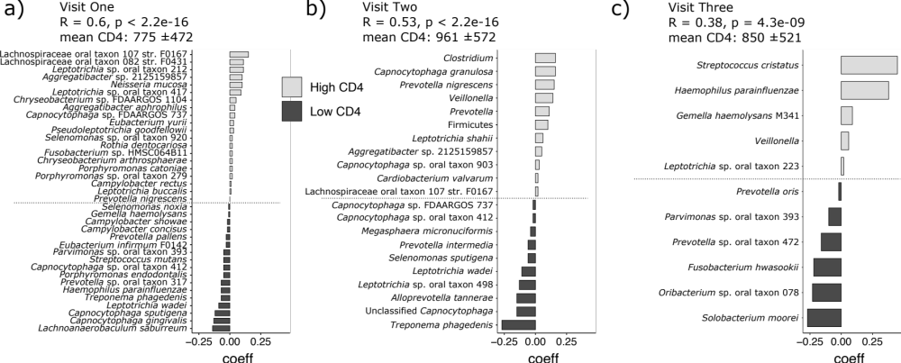
Supplementary Figure 4: Balance of taxa associated with CD4 count among children living with HIV over all three clinical visits. (a) Balance of taxa at visit one that correspond to either high or low CD4 counts. (b) Balance of taxa at visit two that correspond to high or low CD4 counts. (c) Balance of taxa at visit three that correspond to high or low CD4 counts. The strength of the correlation between taxonomic groups is indicated by the R score and p value at each visit. Mean and standard deviation of the CD4 counts at each visit listed above each figure. Low CD4 count among children living with HIV is associated with diverse and discordant potential and actual cariogenic taxa, the signature of which is lessened with improving CD4 counts across the three visits.

