SUPPLEMENTARY INFORMATION
“Transcriptome signatures of the medial prefrontal cortex underlying GABAergic control of resilience to chronic stress exposure”

Meiyu Shao^{1,3}, Julia Botvinov¹, Deepro Banerjee ^{2,3}, Santhosh Girirajan ^{2,3}, and Bernhard Lüscher ^{1,2,3}

¹Department of Biology, The Pennsylvania State University, University Park, PA 16802

²Department of Biochemistry and Molecular Biology, The Pennsylvania State University, University Park, PA 16802

³The Huck Institutes of the Life Sciences, The Pennsylvania State University, University Park, PA 16802

Correspondence: Bernhard Luscher, Ph.D, Department of Biology, Penn State University, 301 Life Sciences Building, University Park, PA 16802, E-mail: BXL25@psu.edu, Phone office: 814-865 5549

SUPPLEMENTARY FIGURES

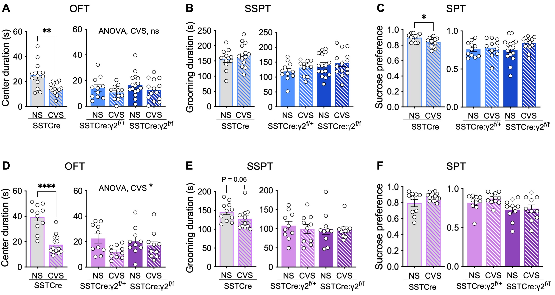
Figure S1. SSTCre:γ2^{f/f} mice are resilient to CVS-induced behavior independent of sex. A–C) Male mice. In the OFT (A), CVS reduced the center duration in SSTCre mice (p < 0.01, t-test), but not SSTCre:γ2^{f/+} and SSTCre:γ2^{f/f} mice. In the SSPT (B), CVS had no effect on grooming duration independent of genotype. In the SPT (C), CVS reduced the sucrose preference of SSTCre mice (p < 0.05, t-test) but not SSTCre:γ2^{f/+} and SSTCre:γ2^{f/f} mice (F_{1, 48} = 2.56, p, ns). D–F) Female mice. In the OFT (D), CVS reduced the center duration of SSTCre mice (p < 0.0001) with less robust effects in the SSTCre:γ2^{f/+} and SSTCre:γ2^{f/f} mutants (F_{1, 36}= 4.866, p < 0.05). In the SSPT (E), CVS resulted in a trend of a reduction in grooming duration in SSTCre (p = 0.06, Mann Whitney test), but not SSTCre:γ2^{f/+} and SSTCre:γ2^{f/f} mice (F_{1, 36} = 0.2067, ns). In the SPT (F), CVS had on effect on sucrose preference independent of genotype. Bar graph represent means ± SE. *p < 0.05, n = 11–14 for all groups, t-test or Mann Whitney test.

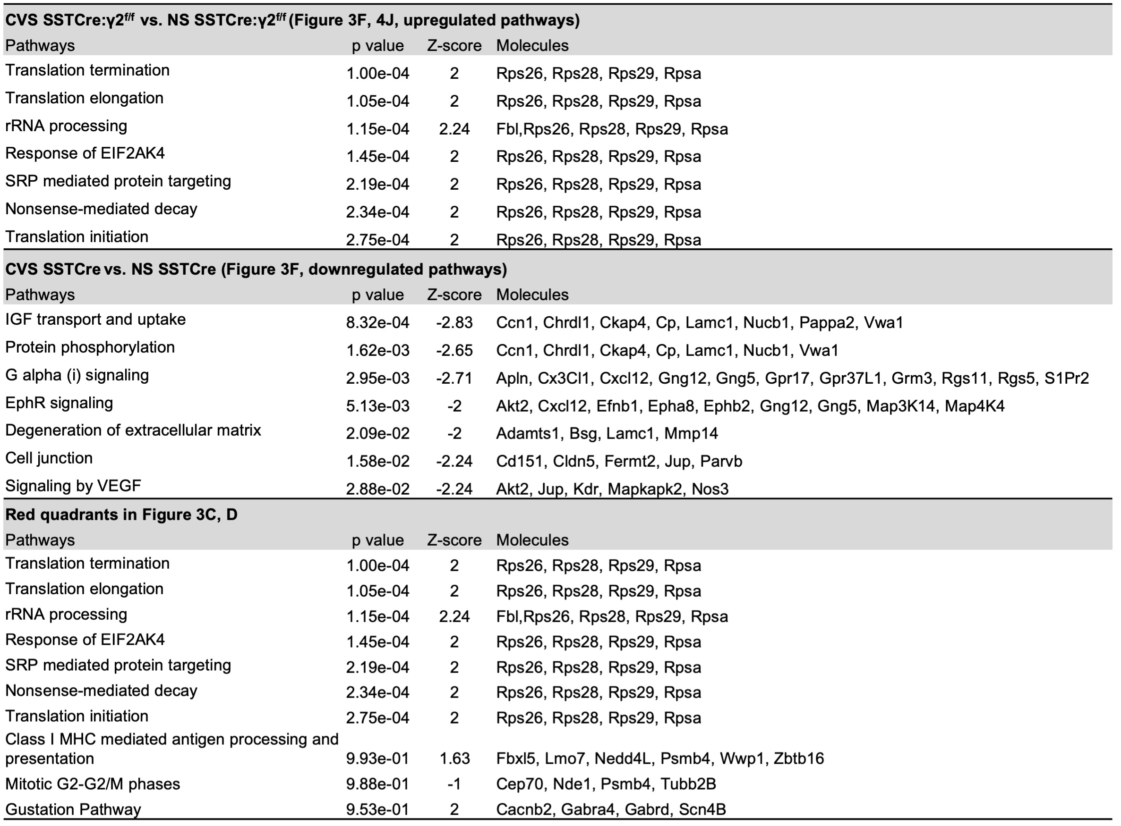
Figure S2. Key genes underlying differential pathway activation and inhibition

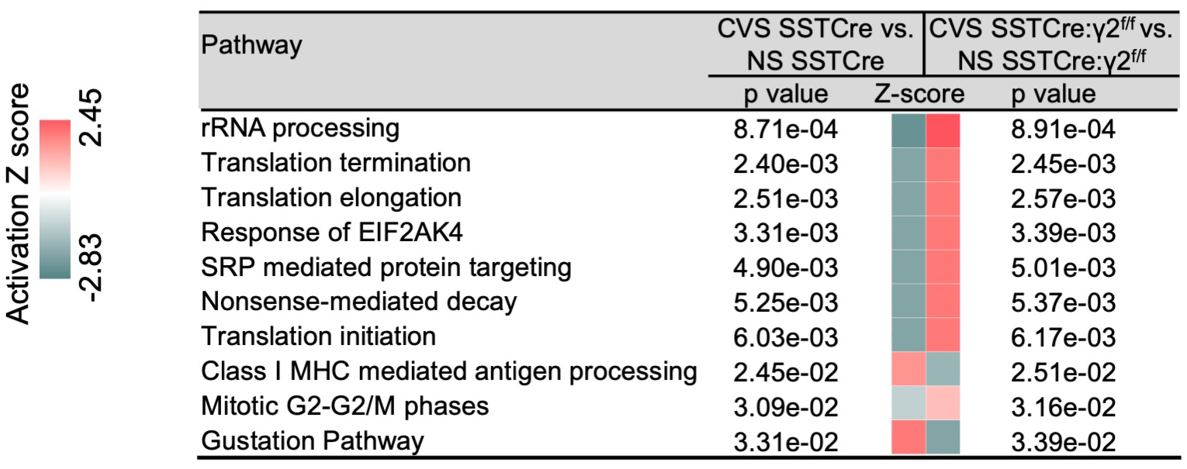

Figure S3. IPA of genes differentially affected by CVS in SSTCre compared to SSTCre:γ2^{f/f} mice. IPA of the sum of the 180 genes in the four red quadrants of Figure 3C and D that showed opposite CVS effects in stress vulnerable compared to stress resilient mice. Shown are the top 10 pathways affected based on z-scores, displayed from top to bottom in order of increasing p value. Note that nine of the ten most prominently affected pathways are downregulated by CVS in stress vulnerable mice and upregulated by CVS in stress-resilient mice.

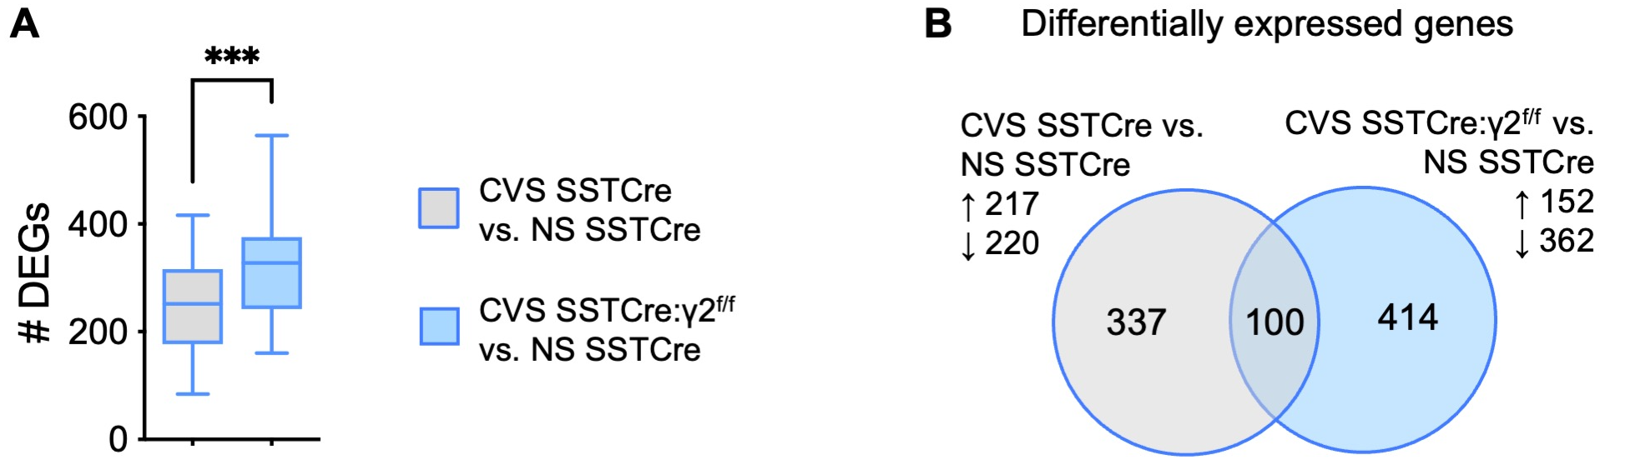
Figure S4. Comparison of DEGs between CVS exposed SSTCre:γ2^{f/f} stress-resilient male mice vs. NS SSTCre controls and CVS exposed SSTCre stress-vulnerable vs. NS SSTCre controls. A) The average number of CVS plus genotype induced DEGs (p < 0.01) in CVS SSTCre:γ2^{f/f} vs. NS SSTCre is greater than the DEGs of CVS SSTCre vs. NS SSTCre. B) Venn diagram of DEGs ***p < 0.001, t-test.

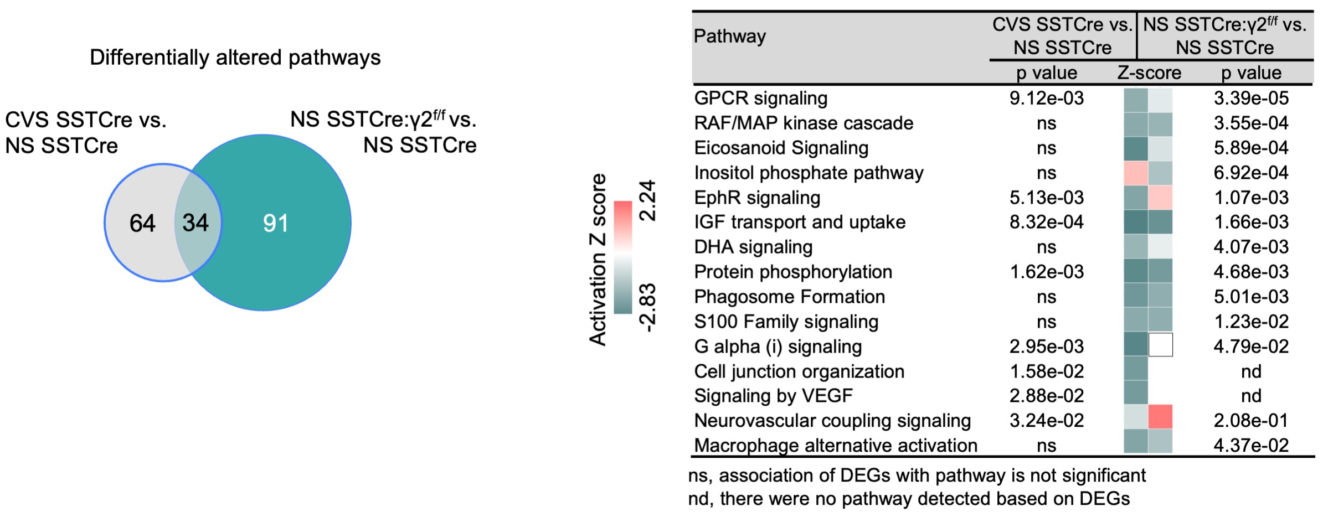
Figure S5. Venn diagram illustrating overlap between pathways induced by CVS in SSTCre stress-vulnerable mice and disinhibition of SST neurons in the absence of stress [NS SSTCre:γ2^{f/f} vs. NS SSTCre mice]. Note that most pathways are inhibited under both conditions. White squares indicate pathways that were detected but a directional Z-score could not be determined. ns, not significant; nd, not detected.

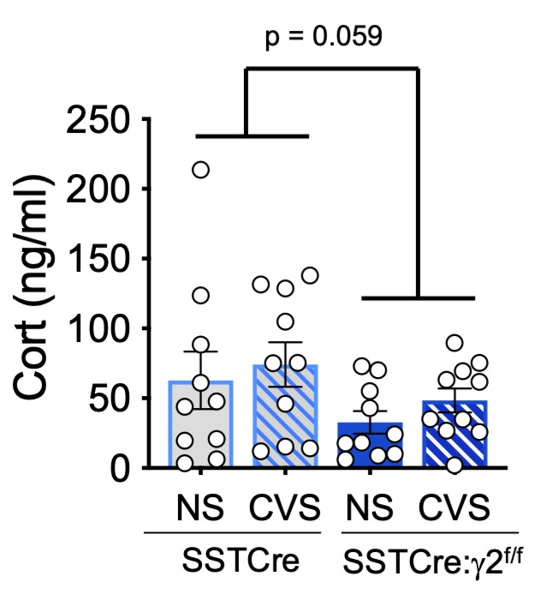
Figure S6. Analyses of serum corticosterone. The serum of CVS-exposed, NS SSTCre and SSTCre:γ2^{f/f} male mice harvested 9 days after the end of CVS was subjected to Cort measurements by ELISA. The Cort levels trended lower in stress resilient mice compared to SSTCre controls (F_{1, 36} = 3.81, p = 0.059) . Bar graphs represent means ± SE.

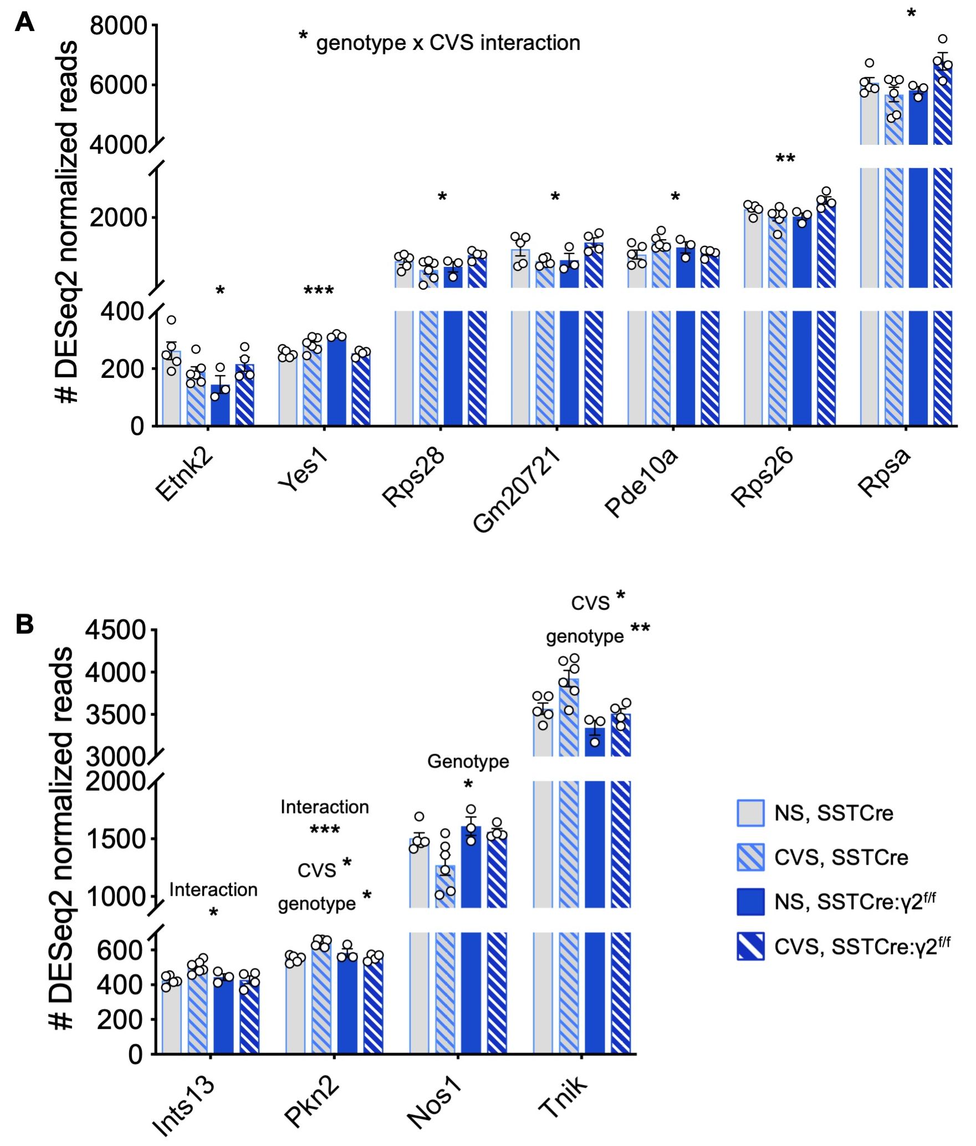
Figure S7. Two mRNA expression patterns of putative stress-resilient genes. A) Representative genes that show similar changes in expression in CVS SSTCre and NS SSTCre:γ2^{f/f} compared to NS SSTCre mice that is then normalized by CVS in SSTCre:γ2^{f/f} mice towards NS SSTCre levels, 2-way ANOVAs showed a genotype x CVS interaction for all these genes: Etnk2 (F_{1, 14} = 7.521, p = 0.0159), Yes1 (F_{1, 14} = 27.89, p = 0.0001), Rps28 (F_{1, 14} = 6.508, p = 0.0231), Gm20721 (F_{1, 14} = 8.840, p = 0.0101), Pde10a (F_{1, 14} = 5.254, p = 0.0379), Rps26 (F_{1, 14} = 10.44, p = 0.0060), Rpsa (F_{1, 14} = 7.783, p = 0.0145). B) Representative genes that show smaller CVS effects in SSTCre:γ2^{f/f} vs. SSTCre mice. Inst13, showed a genotype x CVS interaction (F_{1, 14} = 7.395, p = 0.0166). Genotype, CVS and interaction effects were found for Pkn2 (Genotype, F_{1, 14} = 4.654, p = 0.0489; CVS, F_{1, 14} = 7.764, p = 0.0146; interaction, F_{1, 14} = 24.5, p = 0.0002). Nos1 showed a genotype effect (F_{1, 14} = 7.055, p = 0.0188). Tnik showed CVS (F_{1, 14} = 8.777, p = 0.0103) and genotype effects (F_{1, 14} = 13.29, p = 0.0026; CVS,). *p < 0.05, **p < 0.01, ***p < 0.001.

